Business Analysis Requirements Document
Document Prepared By:
Roman Radchenko and Aliaksandr Samatyia
Prepared For:
Academic Review Committee
Date:
October 15, 2025
Status:
Final for Review

1. Introduction

1.1 Objectives
The primary objectives of this document are to:
- Define clear project boundaries and scope
- Establish measurable success criteria and business objectives
- Document functional requirements through user stories and use cases
- Identify technical architecture and integration points
- Assess risks, dependencies, and mitigation strategies
- Provide a foundation for project evaluation and stakeholder alignment

1.2 Audience
This document is intended for:
- Academic reviewers and professors evaluating the diploma project
- Project stakeholders including development team members
- Technical evaluators assessing architecture and design decisions
- Future maintainers requiring comprehensive project understanding

2. Vision

2.1 Vision Statement
Automaspec is an AI-powered test specification and automation platform that revolutionizes how development teams manage, document, and generate test cases.
By combining intelligent test generation with collaborative specification management, Automaspec empowers QA engineers and developers to create comprehensive test coverage faster while maintaining centralized documentation and real-time synchronization with CI/CD pipelines.

2.2 Problem Statement
Modern software development teams face significant challenges in test management and documentation.

Current Problems:
- Scattered Documentation: Test specifications are fragmented across multiple tools (Jira, Confluence, Excel, code comments), making it difficult to maintain a single source of truth.
- Manual Test Creation: Writing test code is time-consuming and repetitive, requiring developers and QA engineers to spend significant effort on boilerplate code.
- Lack of Structure: No standardized hierarchy for organizing test specifications leads to inconsistent documentation practices.
- Poor Visibility: Limited real-time visibility into test coverage and status across projects.
- No AI Assistance: Existing tools lack intelligent automation for test generation, forcing teams to write every test manually.
- Integration Gaps: Disconnect between test documentation and CI/CD execution results.

Business Impact:
- Increased time-to-market due to slow test creation
- Higher maintenance costs from scattered documentation
- Reduced test coverage leading to quality issues
- Team inefficiency from manual, repetitive work

2.3 Business Goals & Objectives

Primary Objectives:
- Centralize Test Documentation: Provide a single platform for all test specifications with hierarchical organization.
- Accelerate Test Creation: Reduce test creation time by 20–30% using AI-powered code generation.
- Improve Test Coverage Tracking: Increase visibility into test coverage by 40% through automated status tracking and reporting.
- Enable Team Collaboration: Facilitate real-time collaboration between QA engineers and developers.
- Automate CI/CD Integration: Seamlessly sync test results from GitHub Actions to maintain up-to-date status.

Secondary Objectives:
- Establish standardized test documentation practices
- Reduce technical debt in testing infrastructure
- Improve team productivity and satisfaction
- Create foundation for future multi-framework support

2.4 Stakeholders Analysis
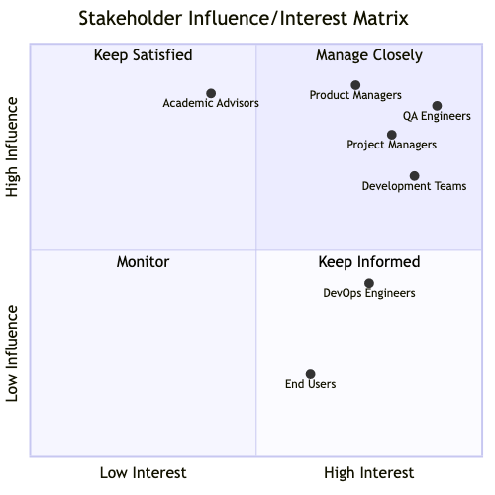
Stakeholder Descriptions:
Stakeholder | Role | Interest | Influence | Engagement Strategy
QA Engineers | Primary Users | High | High | Direct involvement in requirements, beta testing, feedback
Development Teams | Primary Users | High | High | Co-design features, continuous feedback, adoption support
Product Managers | Decision Makers | Medium-High | High | Regular updates, demos, ROI metrics
Project Managers | Oversight | High | Medium-High | Status reports, risk management
Academic Advisors | Evaluators | Medium | High | Documentation, presentations, quality assurance
DevOps Engineers | Integration Support | Medium | Medium | Technical consultation for CI/CD
End Users | Indirect Users | Medium | Low | Training materials, documentation

2.5 Success Criteria
Measurable KPIs:
- Test Creation Efficiency
  - Target: 20-30% reduction in average time to create test code
  - Measurement: Time from requirement definition to completed test code
  - Baseline: Manual test creation time (pre-AI)
- Platform Adoption
  - Target: 80% of invited users actively using platform within 2 months
  - Measurement: Monthly active users / Total registered users
  - Success threshold: >=5 organizations onboarded for beta
- Test Coverage Improvement
  - Target: 40% improvement in test coverage visibility
  - Measurement: Percentage of specs with tracked status vs. undocumented
  - Success threshold: 90% of test specs have associated status tracking
- User Satisfaction
  - Target: Net Promoter Score (NPS) >= 40
  - Measurement: User survey responses
  - Success threshold: >=70% users rate experience as “Good” or “Excellent”
- System Performance
  - Target: Page load time < 2 seconds, AI generation < 60 seconds
  - Measurement: Performance monitoring metrics
  - Success threshold: 95th percentile within targets
- CI/CD Integration Success
  - Target: Automated test result sync in >=80% of connected repositories
  - Measurement: Successful sync events / Total test runs
  - Success threshold: Zero data loss, < 5-minute sync delay

3. Scope

3.1 In-Scope
Core Functionality: 1. Test Specification Management - Hierarchical organization (Folders → Specs → Requirements → Tests) - CRUD operations for all entities - Drag-and-drop reordering - Rich text descriptions and documentation
- AI-Powered Test Code Generation
  - Vitest framework support
  - AI SDK integration for intelligent code generation
  - Context-aware test generation based on requirements
  - Code review and editing capabilities
- Multi-Organization Support
  - Organization creation and management
  - Role-based access control (Owner, Admin, Member)
  - Team invitation system
  - Organization-level isolation
- Test Status Tracking and Reporting
  - Real-time status updates (passed, failed, pending, skipped, etc.)
  - Aggregated status at spec level
  - Visual status indicators
  - Basic reporting dashboards
- Authentication and User Management
  - Email/password authentication via Better Auth
  - User profile management
  - Session management
  - Secure password handling
- CI/CD Integration (GitHub Actions)
  - GitHub Actions API integration
  - Automated test result synchronization
  - Test status updates from CI/CD runs
  - Webhook support for real-time updates
- Docker Containerization
  - Dockerfile for application deployment
  - Docker Compose for local development
  - Container optimization for cloud deployment

3.2 Out-of-Scope
Explicitly Excluded from Current Phase: 1. Test Execution Engine - Automaspec manages specifications and code, but does not run tests - Test execution handled by external test runners (Vitest, CI/CD)
- Mobile Applications
  - No native iOS or Android applications
  - Responsive web design for mobile browsers only
- Multi-Framework Support (Future Phase)
  - Current version supports Vitest only
  - Jest, Playwright, Cypress support planned for future releases
- Jira Integration (Future Phase)
  - Integration with Jira for issue tracking
  - Bidirectional sync with Jira test management
  - Planned as post-MVP feature
- Advanced Analytics and Reporting (Future Phase)
  - Custom report builders
  - Trend analysis and historical data
  - Predictive quality metrics

3.3 Assumptions
The project is built on the following key assumptions:
- User Competency
  - Users have basic knowledge of software testing concepts
  - Users are familiar with Vitest testing framework
  - Users understand version control and CI/CD basics
- Technical Environment
  - Organizations use Vitest for their testing needs
  - Users have access to modern web browsers (Chrome, Firefox, Safari, Edge)
  - GitHub Actions is available and accessible for CI/CD integration
  - Stable internet connection for cloud-based platform access
- AI Service Availability
  - AI SDK and underlying LLM APIs remain available and stable
  - API rate limits are sufficient for expected usage
  - AI-generated code quality meets minimum standards
- Data and Security
  - Users consent to storing test specifications in cloud database
  - Organizations accept shared hosting environment (multi-tenancy)
  - GDPR compliance measures are sufficient for target markets

3.4 Constraints
Technical Constraints: 1. Hosting Platform Limitations - Cloudflare free tier bandwidth and compute limits - Turso database storage and read/write quotas - Potential cold start delays on free hosting
- Team Resources
  - Two-developer team limits development velocity
  - Limited time for extensive feature development
  - No dedicated designer or UX specialist
- Database Technology
  - Turso (SQLite) as primary database for MVP
  - SQLite limitations on concurrent writes
  - Limited advanced database features compared to PostgreSQL
- Framework Lock-in
  - Initial version limited to Vitest framework
  - AI code generation templates specific to Vitest
  - Migration to multi-framework support requires significant refactoring
Business Constraints: 1. Budget Limitations - Free/low-cost services preferred (Cloudflare, Turso, Better Auth) - AI API costs must remain within reasonable limits - No budget for premium tools or services
- Timeline Pressure
  - Diploma submission deadline drives development schedule
  - Must prioritize Must Have features
  - Limited time for user testing and iteration
- Compliance Requirements
  - Must comply with GDPR for user data
  - Academic integrity requirements for diploma project
  - Open-source licensing considerations

4. High-Level Solution Overview

4.1 Proposed Solution
Automaspec is a web-based SaaS platform built on modern technologies that addresses the test documentation and generation challenges through:
Key Solution Components:
- Intelligent Test Generation Engine
  - Leverages AI SDK to generate Vitest test code from natural language requirements
  - Context-aware generation considering folder structure and existing tests
  - Editable output allowing developers to refine AI suggestions
- Hierarchical Organization System
  - Four-level hierarchy: Folders → Test Specs → Requirements → Tests
  - Drag-and-drop interface for intuitive organization
  - Unlimited nesting of folders for complex project structures
- Real-Time Collaboration Platform
  - Multi-user support within organizations
  - Role-based permissions (Owner, Admin, Member)
  - Real-time updates using modern web technologies
- Automated CI/CD Synchronization
  - GitHub Actions integration for test result ingestion
  - Automatic status updates on test execution
  - Webhooks for real-time notification of CI/CD events
- Containerized Deployment
  - Docker containerization for consistent deployment
  - Easy scaling and migration between hosting platforms
  - Simplified local development environment setup
Technical Foundation:
- Frontend: React with Next.js 15 (App Router), styled using TailwindCSS
- Backend: Next.js API Routes with oRPC for type-safe RPC communication
- Database: Turso (distributed SQLite) powered by Drizzle ORM
- AI Integration: AI SDK for seamless LLM-based functionality
- Authentication: Better Auth for secure user management and session control
- Hosting: Cloudflare for global edge deployment and optimized performance
- CI/CD: GitHub Actions for automated build, test, and deployment workflows
- Documentation: Scalar for API documentation and developer reference

4.2 Architecture / Integration Landscape
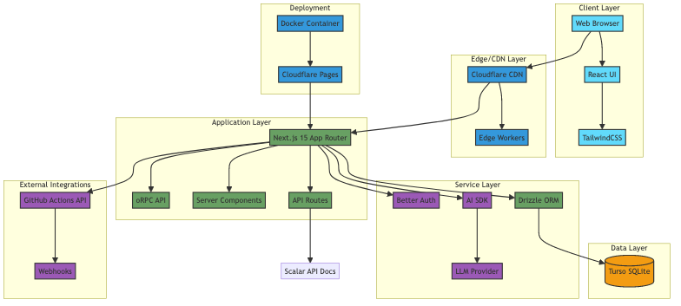
Architecture Description:
Client Layer: - Modern React-based UI with Next.js 15 framework - TailwindCSS for responsive, utility-first styling - Type-safe communication with backend via oRPC
Edge/CDN Layer: - Cloudflare CDN for global content distribution - Edge Workers for optimized routing and caching - SSL/TLS termination and DDoS protection
Application Layer: - Next.js 15 with App Router for server-side rendering and routing - oRPC for type-safe, validated API endpoints - Server Components for optimal performance - API Routes for external integrations and webhooks
Service Layer: - Better Auth: Secure authentication and session management - AI SDK: Unified interface for LLM providers (OpenAI, Anthropic) - Drizzle ORM: Type-safe database queries and migrations
Data Layer: - Turso: Distributed SQLite database with global replication - Automatic backups and point-in-time recovery
External Integrations: - GitHub Actions API for test result synchronization - Webhooks for real-time CI/CD event notifications
Deployment: - Docker containers for consistent deployment - Cloudflare Pages for hosting and continuous deployment

4.3 Alternatives Considered
Alternative 1: Standalone Desktop Application - Description: Electron-based desktop app with local storage - Pros: Offline capability, no hosting costs, faster performance - Cons: Limited collaboration, manual synchronization, no mobile access - Decision: Rejected due to limited accessibility and collaboration needs
Alternative 2: Immediate Jira Integration - Description: Built-in bidirectional sync with Jira from MVP - Pros: Seamless workflow for teams already using Jira - Cons: Significant complexity, vendor lock-in, extended development time - Decision: Postponed to future phase to focus on core features
Alternative 3: Google Sheets-Based Solution - Description: Google Sheets with Apps Script for automation - Pros: Familiar interface, easy setup, built-in collaboration - Cons: No structure enforcement, limited UI/UX, no AI capabilities - Decision: Rejected due to lack of structure and AI integration
Alternative 4: Traditional VPS Hosting (DigitalOcean, AWS EC2) - Description: Self-managed virtual private server - Pros: Full control, predictable pricing, no vendor limitations - Cons: Higher operational overhead, manual scaling, no edge network - Decision: Rejected in favor of Cloudflare for superior performance, automatic scaling, and reduced management overhead
Alternative 5: PostgreSQL Database - Description: Traditional PostgreSQL instead of Turso - Pros: More features, better for complex queries, widely adopted - Cons: Hosting costs, more complex setup, no edge distribution - Decision: Rejected in favor of Turso for free tier benefits and edge distribution

5. Features & Requirements

5.1 Core Features (Epics)
Epic ID | Epic Name | Priority | Description
Epic 1 | User Authentication & Organization Management | Must Have | User registration, login, organization creation, team invitations
Epic 2 | Test Specification Hierarchy | Must Have | Folder/spec/requirement/test management with hierarchical structure
Epic 3 | AI Test Generation | Must Have | AI-powered test code generation using AI SDK
Epic 4 | Test Status Tracking | Must Have | Real-time test status tracking and aggregation
Epic 5 | CI/CD Integration (GitHub Actions) | Must Have | Automated synchronization with GitHub Actions
Epic 6 | Collaboration & Team Management | Should Have | Role-based access control and team collaboration features
Epic 7 | Reporting & Analytics | Could Have | Test coverage reports and data export

5.2 Functional Requirements - Work Breakdown

Epic 1: User Authentication & Organization Management (Must Have)
US-1.1: User Registration - As a new user - I want to sign up with email/password - So that I can access the platform and create test specifications
Acceptance Criteria:
- Users can register using a valid email and password.
- Password meets complexity requirements (minimum 8 characters).
- Successful registration creates a user record and returns a success response.
- New users can log in immediately after registration or receive a confirmation flow if email verification is enabled.
US-1.2: Organization Creation - As a registered user - I want to create an organization - So that I can manage my team’s test specifications in an isolated workspace
Acceptance Criteria:
- Registered users can create an organization with a unique name.
- Creating an organization assigns the creator the Owner role.
- Organization creation returns the organization ID and an initial empty workspace.
US-1.3: Team Member Invitations - As an organization owner - I want to invite team members via email - So that they can collaborate on test specifications
Acceptance Criteria:
- Owners can invite users by entering one or more email addresses.
- Invitees receive an email with an invitation link and instructions.
- Accepted invitations add the user to the organization with the specified role.
- The system prevents duplicate invitations to existing org members.
US-1.4: User Profile Management - As a registered user - I want to update my profile information - So that my account details remain current
Acceptance Criteria:
- Users can view and edit their profile fields (name, display name, avatar, etc.).
- Profile updates persist and are reflected across the application immediately.
- Validation prevents invalid profile data (e.g., malformed email).

Epic 2: Test Specification Hierarchy (Must Have)
US-2.1: Folder Creation and Organization - As a QA engineer - I want to create folders with nested structure - So that I can organize test specs by feature/module/component
Acceptance Criteria:
- Users can create folders at the root and inside other folders (nesting).
- Folder names are editable and unique within the same parent.
- Folders can be collapsed/expanded in the UI and persist across sessions.
US-2.2: Test Spec Creation - As a developer - I want to create test specifications with name and description - So that I can document test scenarios for specific features
Acceptance Criteria:
- Users can create a test spec with a name and optional description.
- New specs appear in the selected folder and are immediately editable.
- Spec creation validates required fields and returns the new spec ID.
US-2.3: Requirement Definition - As a QA engineer - I want to add requirements to test specs - So that I can break down test coverage into granular testable units
Acceptance Criteria:
- Users can add, edit, and delete requirements inside a test spec.
- Requirements support rich text or markdown (as configured).
- Each requirement can be linked to one or more tests and saved successfully.
US-2.4: Item Reordering - As a developer - I want to reorder folders, specs, and requirements via drag-and-drop - So that I can maintain logical structure that matches project organization
Acceptance Criteria:
- Drag-and-drop reordering updates the order in the UI and persists to the backend.
- Reordering preserves parent/child relationships and updates indexes consistently.
- Concurrent reorder attempts are handled gracefully with last-write-wins or optimistic locking.
US-2.5: Bulk Operations - As a QA engineer - I want to move or copy multiple specs between folders - So that I can efficiently reorganize test documentation
Acceptance Criteria:
- Users can select multiple specs and perform move or copy operations.
- Bulk operations provide progress feedback and report failures per item.
- Copied specs retain their content but receive new IDs in the destination.

Epic 3: AI Test Generation (Must Have)
US-3.1: AI-Powered Code Generation - As a developer - I want to generate Vitest test code from requirements using AI SDK - So that I can save time on writing boilerplate test code
Acceptance Criteria:
- Users can request AI generation for a requirement and receive a code suggestion within configured time limits.
- Generated code is syntactically valid and follows Vitest conventions.
- Users can preview, accept, or reject generated code; accepted code is saved to the spec/test.
US-3.2: Code Review Interface - As a QA engineer - I want to review AI-generated test code before saving - So that I can ensure code quality and correctness
Acceptance Criteria:
- The UI presents generated code with syntax highlighting and diff view against existing code.
- Reviewers can add inline comments and request regeneration.
- Only accepted code is persisted to the test record
US-3.3: Test Code Editing - As a developer - I want to edit generated test code directly in the platform - So that I can customize tests to match specific needs
Acceptance Criteria:
- Users can edit test code in an editor with syntax highlighting and save changes.
- The editor validates basic syntax and warns about obvious errors.
- Saved edits update the associated test record and are versioned if applicable.
US-3.4: Code Export - As a developer - I want to export generated test code to files - So that I can integrate tests into my codebase
Acceptance Criteria:
- Users can export one or more tests/specs as files in a zip or repository-friendly structure.
- Exported files contain all necessary metadata and are downloadable.
- Export reports any conflicts or missing fields that prevent export

Epic 4: Test Status Tracking (Must Have)
US-4.1: Test Status Visualization - As a QA engineer - I want to see test status (passed/failed/pending/skipped/missing) - So that I can track test coverage and identify failing tests
Acceptance Criteria:
- Test items display a clear status indicator reflecting the latest known state.
- Status updates propagate to the UI within expected sync windows after CI events.
- Missing or unlinked tests are flagged for review
US-4.2: Aggregated Status at Spec Level - As a developer - I want to see aggregated status for entire test specs - So that I can quickly identify problematic areas
Acceptance Criteria:
- Spec-level aggregation shows counts of passed/failed/pending tests.
- Aggregation updates when individual test statuses change.
- Aggregated view supports filtering by status and time range
US-4.3: Status History - As a QA lead - I want to view status change history for tests - So that I can track test stability over time
Acceptance Criteria:
- Users can view a timeline of status changes for a test or spec.
- History entries include timestamp, source (CI or manual), and user if applicable.
- History can be exported or filtered by date range

Epic 5: CI/CD Integration (GitHub Actions) (Must Have)
US-5.1: GitHub Actions Connection - As a developer - I want to connect my GitHub repository to Automaspec - So that test results automatically sync from CI/CD runs
Acceptance Criteria:
- Users can authorize a GitHub repository and configure which workflows to ingest.
- Successful connection shows repository metadata and last sync time.
- Connection errors are surfaced with actionable messages
US-5.2: Automated Test Result Sync - As a developer - I want to have test results from GitHub Actions automatically update spec status - So that I don’t need to manually track test execution results
Acceptance Criteria:
- CI run results are parsed and mapped to tests/specs; statuses are updated automatically.
- Syncs are idempotent and retry on transient failures.
- Mapping failures are logged and surfaced for manual reconciliation
US-5.3: Test Spec Export for CI/CD - As a developer - I want to export test specs in CI/CD-compatible format - So that I can integrate generated tests into GitHub Actions workflows
Acceptance Criteria:
- Exported specs include file layout and metadata required by CI workflows.
- Export operation validates compatibility and reports issues.
- Developers can download or push exported files to a configured repo.
US-5.4: Failure Notifications - As a QA engineer - I want to receive notifications when tests fail in CI/CD - So that I can quickly respond to quality issues
Acceptance Criteria:
- Notification channels (email, in-app) send alerts for failing runs based on user preferences.
- Notifications include a link to the failed spec/test and CI logs.
- Users can configure thresholds to reduce noise (e.g., only notify on repeated failures)

Epic 6: Collaboration & Team Management (Should Have)
US-6.1: Role-Based Access Control - As an organization owner - I want to assign roles (Owner, Admin, Member) to team members - So that I can control who can modify test specifications
Acceptance Criteria:
- Owners can assign and change roles for organization members.
- Role changes take effect immediately and enforce UI/backend permissions.
- Attempts to perform unauthorized actions return permission errors
US-6.2: Real-Time Updates - As a team member - I want to see changes made by other users in real-time - So that I can collaborate effectively without conflicts
Acceptance Criteria:
- Real-time edits and structural changes appear to collaborators within expected latency.
- The system handles edit conflicts with clear indicators and merge options.
- Presence and change indicators show which user made recent edits.
US-6.3: Activity Feed - As an organization admin - I want to view activity log of changes to specs - So that I can track team contributions and changes
Acceptance Criteria:
- Activity feed records create/edit/delete actions with timestamp and actor.
- Feed supports basic filtering (user, action type, date range).
- Admins can export activity logs for audits

Epic 7: Reporting & Analytics (Could Have)
US-7.1: Test Coverage Reports - As a project manager - I want to view test coverage reports and statistics - So that I can assess quality and identify coverage gaps
Acceptance Criteria:
- Reports summarize coverage metrics (e.g., percent of requirements with tests, pass rates).
- Reports can be generated for a given time range and exported as PDF/CSV.
- Report data aligns with latest synced CI results
US-7.2: Specification Export - As a QA lead - I want to export test specifications to PDF/Excel - So that I can share documentation with stakeholders
Acceptance Criteria:
- Users can export selected specs or entire folders to PDF or Excel.
- Exports include spec metadata, requirements, and linked tests.
- Export process reports success/failure and provides downloadable artifacts
US-7.3: Dashboard Widgets - As a developer - I want to customize dashboard with widgets showing key metrics - So that I can monitor important KPIs at a glance
Acceptance Criteria:
- Users can add, remove, and arrange dashboard widgets.
- Widgets display live or near-real-time metrics and update on refresh intervals.
- Widget configuration persists per user or organization settings

5.3 Priority Labelling (MoSCoW Method)
Must Have (Critical for MVP): - Epic 1: User Authentication & Organization Management - Epic 2: Test Specification Hierarchy - Epic 3: AI Test Generation - Epic 4: Test Status Tracking - Epic 5: CI/CD Integration (GitHub Actions)
Should Have (Important but not critical): - Epic 6: Collaboration & Team Management - Real-time updates and activity tracking - Advanced role-based permissions
Could Have (Desirable): - Epic 7: Reporting & Analytics - Custom dashboard widgets - Advanced export formats - Historical trend analysis
Won’t Have (Future Phase): - Mobile native applications (iOS/Android) - Multi-framework support (Jest, Playwright, Cypress) - Jira integration - Advanced AI features (test case optimization, intelligent suggestions) - Custom theming and white-labeling

5.4 Non-Functional Requirements

Performance Requirements
- Page Load Time: Initial page load under 2 seconds on a 3G connection
- AI Generation Time: Test code generation under 60 seconds per requirement
- API Response Time: 95th percentile under 500 ms for CRUD operations
- Database Query Time: 95th percentile under 100 ms for standard queries
- Concurrent Users: Support 50 concurrent users per organization

Security Requirements
- Authentication: Secure email/password authentication with bcrypt hashing
- Authorization: Role-based access control with organization-level isolation
- Data Encryption: HTTPS / TLS 1.3 for all data in transit
- Password Policy: Minimum 8 characters with complexity requirements
- Session Management: Secure session handling with automatic timeout
- API Security: Rate limiting (100 requests / minute per user)
- SQL Injection Protection: Parameterized queries via Drizzle ORM
- XSS Protection: Input sanitization and output encoding

Scalability Requirements
- User Capacity: Support 1,000 registered users in MVP phase
- Organization Capacity: Support 100 organizations
- Data Storage: Handle 10,000 test specifications per organization
- Horizontal Scaling: Docker containers enable horizontal scaling
- Database Scaling: Turso edge replication for read scalability

Usability Requirements
- Intuitive UI: User can create the first test spec within 5 minutes without documentation
- Keyboard Shortcuts: Common actions accessible via keyboard (e.g., Ctrl + N for new)
- Responsive Design: Full functionality on desktop, tablet, and mobile browsers
- Accessibility: WCAG 2.1 Level AA compliance for core features
- Error Handling: Clear, actionable error messages
- Loading States: Visual feedback for all asynchronous operations

Availability Requirements
- Uptime: 99 % uptime SLA on Cloudflare hosting
- Recovery Time Objective (RTO): < 4 hours
- Recovery Point Objective (RPO): < 24 hours (daily database backups)
- Monitoring: Real-time monitoring with downtime alerts

Maintainability Requirements
- Code Quality: TypeScript for type safety, ESLint for standards enforcement
- Documentation: API documentation via Scalar and inline code comments
- Automated Testing: Unit test coverage ≥ 70 %, integration tests for critical paths
- Version Control: Git with conventional commits
- CI/CD Pipeline: Automated builds, tests, and deployments
- Database Migrations: Versioned migrations via Drizzle Kit

Portability Requirements
- Containerization: Docker support for deployment flexibility
- Cross-Platform: Runs on Linux, macOS, and Windows via Docker
- Browser Compatibility: Support Chrome, Firefox, Safari, Edge (latest two versions)
- Cloud Agnostic: Can migrate between Cloudflare, Vercel, AWS, or self-hosted environments

Compatibility Requirements
- Vitest Integration: Compatible with Vitest v1.x and v2.x
- GitHub Actions: Support GitHub Actions API v3
- Modern Browsers: Utilizes ES2020 JavaScript features
- Database: SQLite 3.x compatible (Turso)

5.5 Regulatory / Compliance Needs

GDPR Compliance (General Data Protection Regulation)
- Right to Access: Users can download all their personal data
- Right to Deletion: Users can request complete account deletion
- Right to Rectification: Users can update personal information
- Data Minimization: Collect only necessary user data
- Consent Management: Clear consent for data collection and processing
- Data Portability: Export user data in machine-readable format (JSON)
- Privacy Policy: Clear privacy policy outlining data usage
- Data Retention: Defined and enforced data retention policies
- Breach Notification: Established process for notifying users of breaches

Academic Integrity
- Original Work: All code and documentation are original work for the diploma project
- Attribution: Proper attribution for third-party libraries and frameworks
- Code Repository: Public GitHub repository showing development history
- Documentation: Comprehensive documentation of design decisions

Open Source Licensing
- License Selection: MIT or Apache 2.0 license for the core application
- Dependency Licensing: Verify compatibility of all dependencies
- Attribution: Maintain NOTICE file with third-party attributions

Data Residency
- Turso Regions: Data stored in Turso’s closest edge location
- User Control: Users can request specific region preferences (future feature)

5.6 Use Case Diagram
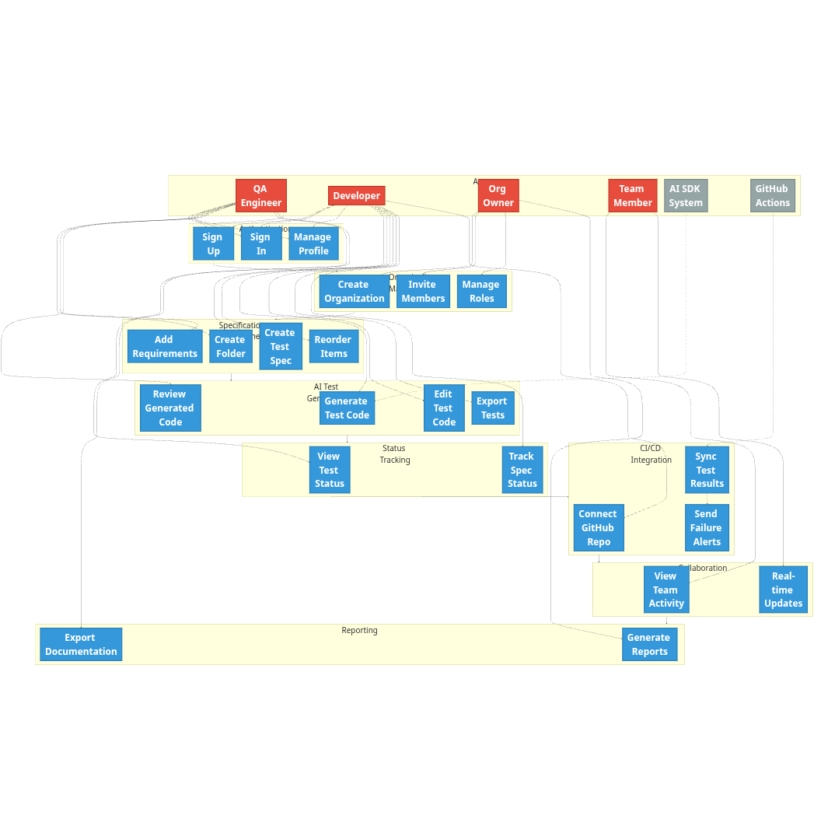

Use Case Descriptions:
Use Case | Actor(s) | Description
UC1: Sign Up | QA Engineer, Developer | Register new user account with email/password
UC2: Sign In | QA Engineer, Developer | Authenticate and access platform
UC3: Manage Profile | QA Engineer, Developer | Update user profile information
UC4: Create Organization | Org Owner | Create new organization workspace
UC5: Invite Members | Org Owner | Invite team members to organization
UC6: Manage Roles | Org Owner | Assign roles and permissions to members
UC7: Create Folder | QA Engineer | Create folder for organizing test specs
UC8: Create Test Spec | Developer | Create new test specification document
UC9: Add Requirements | QA Engineer | Define testable requirements within spec
UC10: Reorder Items | Developer | Reorganize folder/spec hierarchy
UC11: Generate Test Code | Developer, AI SDK | Generate Vitest code from requirements
UC12: Review Generated Code | QA Engineer | Review and validate AI-generated tests
UC13: Edit Test Code | Developer | Modify generated test code
UC14: Export Tests | Developer | Export test code to files
UC15: View Test Status | QA Engineer | Monitor test execution status
UC16: Track Spec Status | Developer | View aggregated status for specs
UC17: Connect GitHub Repo | Developer | Link GitHub repository for CI/CD sync
UC18: Sync Test Results | GitHub Actions | Automatically sync test execution results
UC19: Send Failure Alerts | System | Notify team of test failures
UC20: View Team Activity | Team Member | Monitor team changes and updates
UC21: Real-time Updates | Team Member | Receive live updates from collaborators
UC22: Generate Reports | Org Owner | Create test coverage reports
UC23: Export Documentation | QA Engineer | Export specs to shareable formats

6. Risks & Dependencies

6.1 Risks
Risk ID | Risk Description | Likelihood | Impact | Severity | Owner
R1 | AI SDK API costs exceed budget due to high usage | Medium | High | High | Development Team
R2 | Limited real user testing leads to usability issues | High | Medium | Medium | Development Team
R3 | GitHub Actions integration complexity causes delays | Medium | Medium | Medium | Development Team
R4 | Cloudflare/Turso free tier limitations impact performance | Low | Low | Low | Development Team
R5 | AI-generated test quality is insufficient | Medium | High | High | Development Team
R6 | Better Auth service outage disrupts authentication | Low | High | Medium | Third-party Service
R7 | SQLite limitations cause performance bottlenecks | Low | Medium | Low | Development Team
R8 | Scope creep delays MVP delivery | Medium | High | High | Project Management

6. Risk Matrix
Likelihood ↓ / Impact → | Low | Medium | High
High | R4 | R2 | R1, R5, R8
Medium | R7 | R3, R6 | —
Low | — | — | —

6.2 Dependencies
Critical Dependencies:
- AI SDK and LLM API Availability
  - Type: External Service
  - Criticality: High
  - Description: Platform relies on AI SDK for core test generation feature
  - Contingency: Implement fallback to manual test creation if AI unavailable
- Cloudflare Hosting Platform
  - Type: Infrastructure
  - Criticality: High
  - Description: Application hosting and CDN services
  - Contingency: Docker containerization allows migration to alternative hosting
- Turso Database Service
  - Type: Infrastructure
  - Criticality: High
  - Description: Primary data storage for all test specifications
  - Contingency: Regular backups, ability to migrate to self-hosted SQLite
- Better Auth Service
  - Type: External Service
  - Criticality: High
  - Description: User authentication and session management
  - Contingency: Implement fallback to basic auth if service unavailable
- GitHub Actions API
  - Type: External Integration
  - Criticality: Medium
  - Description: CI/CD test result synchronization
  - Contingency: Manual test result upload feature
Supporting Dependencies:
- Modern Browser Support
  - Type: Client Requirement
  - Criticality: Medium
  - Description: Platform requires modern browsers with ES2020 support
  - Contingency: Progressive enhancement for older browsers
- Node.js Ecosystem
  - Type: Development Dependency
  - Criticality: Medium
  - Description: Next.js, React, and build tools require Node.js
  - Contingency: Stable Node.js LTS version
- Vercel AI SDK Library
  - Type: Software Dependency
  - Criticality: High
  - Description: Abstraction layer for LLM providers
  - Contingency: Direct API integration if SDK unavailable

6.3 Mitigation Strategies
Below are identified risks with corresponding prevention and response strategies to minimize project impact.

Risk R1 — AI SDK API Costs May Exceed Budget
Prevention:
- Implement strict API request quotas per user/organization
- Cache AI-generated code to avoid regeneration
- Provide a usage dashboard for cost monitoring
- Set hard limits on generation requests per day
Response:
- Implement tier-based pricing if costs escalate
- Switch to more cost-effective LLM providers
- Reduce AI context size to minimize token usage

Risk R2 — Limited Testing with Real Users
Prevention:
- Conduct early beta testing with 5–10 users from the target audience
- Create detailed test scenarios covering common workflows
- Implement analytics to track user behavior
Response:
- Rapid iteration based on feedback
- Prioritize critical usability issues
- Conduct post-MVP user testing for continuous improvement

Risk R3 — GitHub Actions Integration Complexity
Prevention:
- Start with basic integration and iterate gradually
- Use well-documented GitHub Actions APIs
- Implement comprehensive error handling
- Test with multiple repository types
Response:
- Simplify integration scope if complexity exceeds estimates
- Provide detailed integration documentation
- Offer manual result upload as fallback

Risk R4 — Cloudflare / Turso Free Tier Limitations
Prevention:
- Implement aggressive caching strategies
- Optimize database queries and indexes
- Monitor usage metrics proactively
- Implement request throttling
Response:
- Upgrade to a paid tier if necessary
- Migrate to alternative hosting (Docker enables this)
- Implement usage-based access controls

Risk R5 — AI-Generated Test Quality is Insufficient
Prevention:
- Apply AI prompt engineering best practices
- Provide rich context to AI (folder structure, existing tests)
- Add a code review step before accepting generated code
- Iterate on prompts based on output quality
Response:
- Allow manual editing of all generated code
- Provide templates and examples for better generation
- Collect user feedback on generation quality

Risk R6 — Better Auth Service Outage
Prevention:
- Monitor Better Auth status page proactively
- Implement graceful degradation for authentication features
- Cache authentication tokens appropriately
Response:
- Implement basic email/password authentication as fallback
- Communicate outage to users transparently
- Consider a self-hosted authentication solution for critical situations

Risk R7 — SQLite Limitations Cause Performance Bottlenecks
Prevention:
- Optimize queries with proper indexes
- Implement read replicas via the Turso edge network
- Use connection pooling
- Profile slow queries regularly
Response:
- Implement caching for frequently accessed data
- Consider migration to PostgreSQL if bottlenecks persist
- Optimize the data model and normalization

Risk R8 — Scope Creep Delays MVP Delivery
Prevention:
- Enforce strict MoSCoW prioritization
- Conduct weekly sprint reviews with scope validation
- Maintain a feature freeze two weeks before the deadline
- Say “no” to non-essential features
Response:
- Cut Could Have features immediately if the timeline is at risk
- Defer Should Have features to post-MVP
- Focus exclusively on Must Have epics

7. Appendix

7.1 Glossary
Term | Definition
AI SDK | Unified SDK for interacting with multiple LLM providers
Better Auth | Open-source authentication solution
CI/CD | Continuous Integration/Continuous Deployment
Cloudflare | Global CDN and edge computing platform
Drizzle ORM | TypeScript ORM for SQL databases
Epic | Large body of work that can be broken down into user stories
GitHub Actions | CI/CD platform integrated with GitHub
LLM | Large Language Model (e.g., GPT-4, Claude)
MoSCoW | Prioritization method: Must Have, Should Have, Could Have, Won’t Have
MVP | Minimum Viable Product
Next.js | React framework for production applications
oRPC | Type-safe RPC framework
Scalar | API documentation tool
Test Spec | Test specification document containing requirements and tests
Turso | Distributed SQLite database platform
Vitest | Fast unit testing framework for Vite projects

7.2 References
- Business Analysis Body of Knowledge (BABOK)
  - International Institute of Business Analysis (IIBA)
  - Requirements elicitation and documentation standards
- Technical Documentation
  - Next.js Documentation: https://nextjs.org/docs
  - Turso Documentation: https://docs.turso.tech
  - AI SDK Documentation: https://sdk.vercel.ai
  - GitHub Actions API: https://docs.github.com/en/rest/actions
- Industry Standards
  - ISO/IEC 25010: Systems and software quality models
  - IEEE 830: Software Requirements Specifications
  - WCAG 2.1: Web Content Accessibility Guidelines
- Regulatory Compliance
  - GDPR (EU Regulation 2016/679): General Data Protection Regulation

