MDSCP-103

## Question 1

1. Formulate the problem in the Excel file and generate the sensitivity analysis.

Formulation:

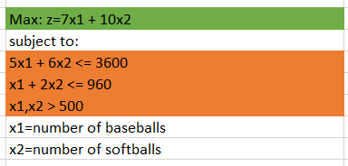

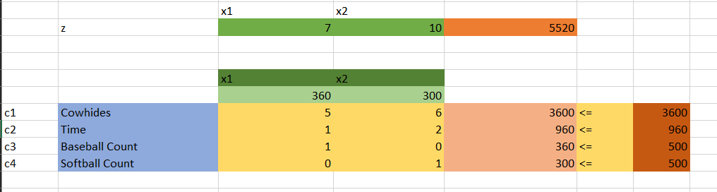

Sensitivity Analysis:

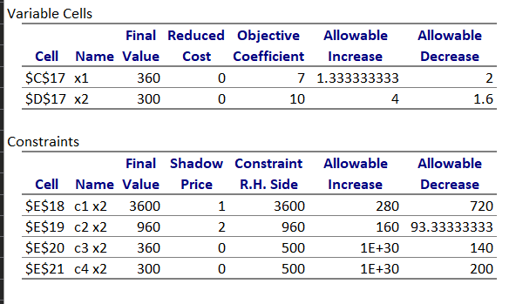

1. Write on cost coefficient sensitivity analysis.

Looking at the cost coefficient sensitivity analysis, the coefficient for variable x1 can be increased by up to 1.333 and decreased by up to 2 without changing the optimal solution. This implies that the x1 coefficient in our objective function can lie in the range: (5,8.33333).

Similarly, the objective coefficient of the variable x2 can be increased by up to 4, and decreased by up to 1.6 without changing the optimal solution. Therefore, x2 lies in the range: (8.4, 14).

1. Write on Right Hand Side Sensitivity Analysis.

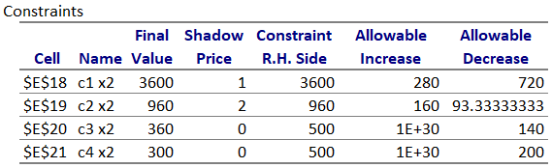

Looking at the right-hand side of the constraints:

* C1 is the constraint of cowhides of the form



Here, the shadow price of 1 unit of cowhide is 1, which implies that 1 unit of cowhide is equivalent to 1 unit of profit in the value of the objective function.

The constraint of 3600 units of cowhide can be increased by up to 280, and decreased by up to 720.

Therefore, the number of units of available cowhides can lie in the range: (2880,3880)

We can also observe that since the shadow price is positive, no unit of cowhide is being wasted. This implies that in the current optimal solution of 360 baseballs and 300 softballs, no unit of cowhide is being wasted.

The shadow price also tells us that if the company is to buy more cowhides at a rate less than $1, then they can expect a profit as long as the total cowhide count is within the range.

* C2 is the constraints of total time available for manufacture



The shadow price is 2. Therefore, 1 unit of time contributes to $2 profit in the value of the objective function.

The constraints of 960 minutes being available everyday can be increased by up to 160, and decreased by up to 93.33333 without changing the optimal solution.

The range for time without changing the optimal solution is: (866.667, 1120)

The slack for this constraint is 0, so no minute of manufacturing time is wasted.

The shadow price tells us that the company can increase its profit by increasing manufacturing time up to 1120 minutes at a price lesser than $2 per minute.

Similarly, the company can also profit by leasing its own manufacturing time at a rate higher than $2 as long as the total manufacturing time remaining with the company is at least 866.667 minutes.

## Question 2

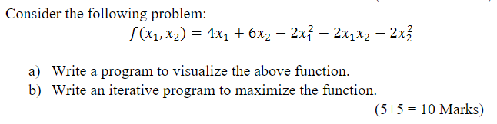

Visualizing the function

* Imports

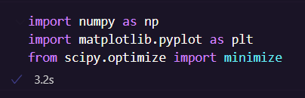

* Defining the function as a lambda

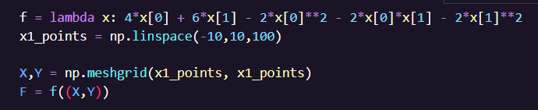

* Plotting the function

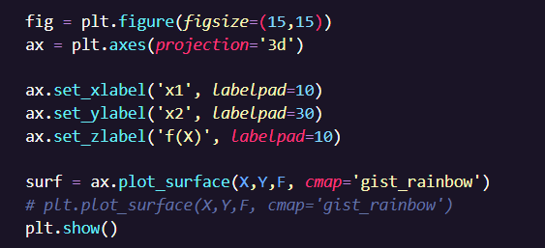

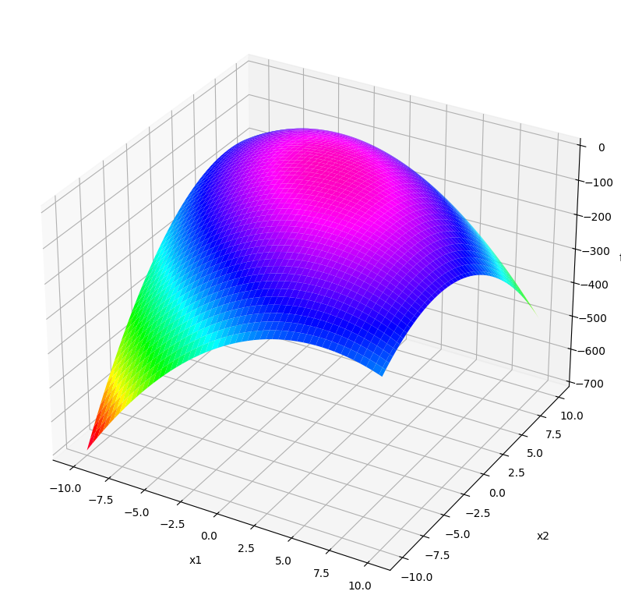

Maximizing the function:

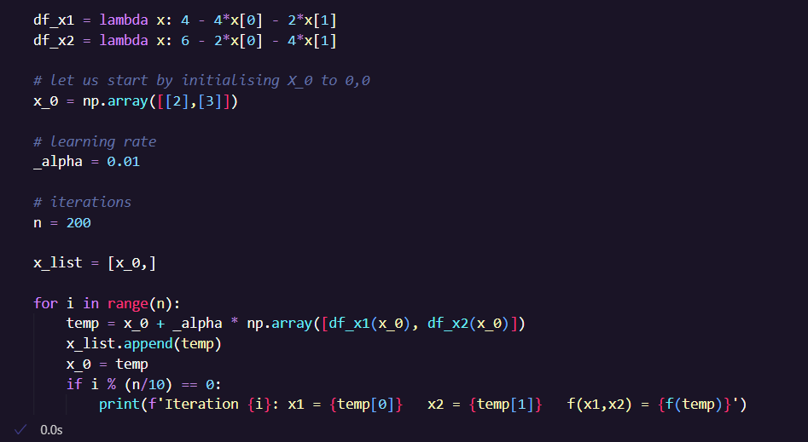

Here, df_x1 and df_x2 are the partial derivatives of the function f(x1,x2) with respect to x1 and x2.

Output:

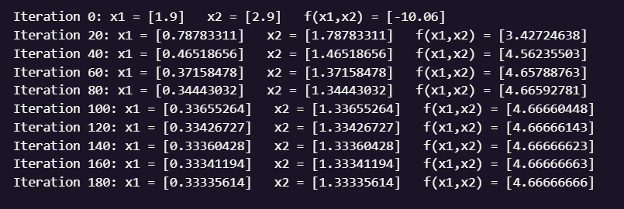

Final Answer:

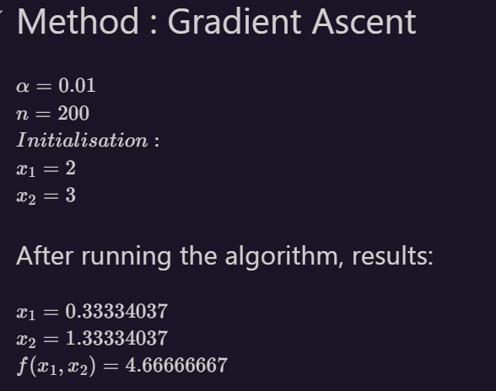

On running the same function through scipy.stats.minimize:

