**Colors**

*Write the correct name of the color in the blank*

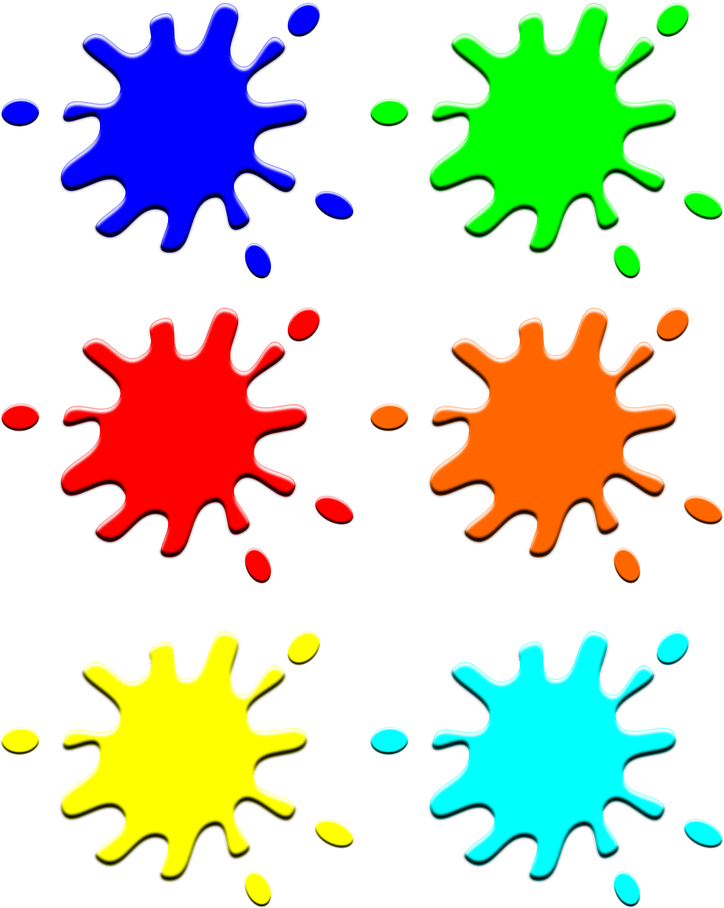













_________________

V ___________Green______________ ________________purple__________

________orange________________

­­­­­­­_______________pink________



_____________white___________

______________blue_____________ _________________brown_______

______________________red_____ ____________gray________

________________yellow____________

____________________

*What colors do you see? Remember to use “light” and “dark”.*

*(Example: I see…..)*

 