**Title:** Analysis of Fixed Volume Swaps for Hedging Financial Risk at Large-Scale Wind Projects

**Authors:** 1Zachary Lucy*, 1Jordan Kern, PhD, 2Adam Hise

*Corresponding Author

1. Department of Forestry and Environmental Resources, North Carolina State University, Raleigh, NC 27695, United States
2. Ascend Analytics

# Abstract

# Introduction

The global energy landscape is in the midst of an urgently needed transition from fossil fuels to renewable energy sources. This change is being pushed by a combination of ambitious policy mandates, as well as the declining costs of variable renewable energy (wind and solar). The United Nations Paris Climate Agreement calls for limiting global warming to well below 2 degrees Celcius, preferably 1.5 degrees Celsius, compared to pre-industrial levels [1]. Paris compatible trajectories of both 1.5 and 2 degrees Celcius will require a sharp reduction in global fossil fuel emissions. In order to meet the 1.5 degrees Celcius target, global CO2 emissions will need to be reduced by 91-104% according to IPCC estimates. Coal, oil, and natural gas production will require global reductions of 74-95%, 47-78%, and 56%, respectively [2]. In accordance with this global effort, the United States government is endeavoring, under the Biden Administration, to eliminate carbon emissions from the electricity sector by 2035. Market forces are accellerating the adoption of renewable energy technologies as well. The levelized cost of electricity (LCOE) for both solar photovoltaics (PV) and onshore wind have declined rapidly in the previous decade, and are expected to decline steadily in the coming decades as capital costs for these technologies decreases [3]. Underscoring these market trends, wind and solar account for 70% of planned U.S. electricity generating capacity additions in 2021 [4]. A major drawback to renewable technologies like wind and solar is the intermittent nature of their energy output, however. Multi-scale variability in wind and solar power production presents both engineering and economic challenges that must be overcome in order to transition away from the current, hydrocarbon-dominated energy landscape.

Despite falling levelized costs of renewable energy, financial instability, caused in part by variability in production (e.g., wind speeds) and in part by variability in market prices, looms large as a threat to slow the energy transition. The International Energy Agency (IEA) estimates that $2.3 trillion in annual investment in clean energy technologies will be required to achieve emissions reduction goals set out in the Paris Climate Agreement (roughly three times the current rate) [3]. Presumably, a significant source of these funds will be private sector investment. While there are myriad approaches for financing and subsidizing renewable energy products, it is generally the case that uncertainty in revenues for renewable energy developers is seen as a credit risk that increases their “cost of capital” (e.g. interest rate on borrowed sums). This in turn increases total project costs, reduces profitability and -- potentially – could slow the rate of investment in zero carbon energy [3].

In the U.S., this problem is particularly acute for wind power producers, who in recent years have been negatively impacted by the phasing out of the production tax credit (PTC) program and low wholesale electricity prices. Strong competition and a limited pool of customers have depressed prices for coveted power purchase agreement (PPA) contracts, in which developers are matched with large “off-take” customers (often utilities) who buy the electricity at a set price for a specific period of time (generally 10-25 years). Instead, wind projects are increasingly selling directly into the wholesale market as “merchant generators”, leaving them exposed not only to fluctuations in the amount of generation they produce, but also fluctuations in the market price of electricity ($/MWh).

To mitigate this financial risk, wind power producers often seek some kind of hedge against price fluctuations in an effort to mimic the protection provided by a traditional PPA. There are a range of hedging structures that producers can utilize to mitigate risk, depending on the type of risk being hedged. Most are purely financial contracts that don’t involve physical delivery of electricity. A widely used hedging model is the “fixed volume price swap,” which was used to manage price risk at 48.4% of all merchant or part-merchant wind capacity in the U.S. in 2017. Fixed volume swaps involves trading actual wholesale electricity prices for a pre-determined fixed price (Figure 1). This fixed price (referred to as the “strike”) is typically lower than the average market price, allowing the hedge-provider to profit. Wind projects have been willing to pay this premium in order to reduce their exposure to electricity price volatility, presumably in order to secure lower cost financing than would be possible if electricity prices were unhedged. However, in some instances, these financial hedging options may limit (or even reduce) the control that wind developers have over projected revenues from their projects, with the end result of dis-incentivizing the expansion of renewable energy.

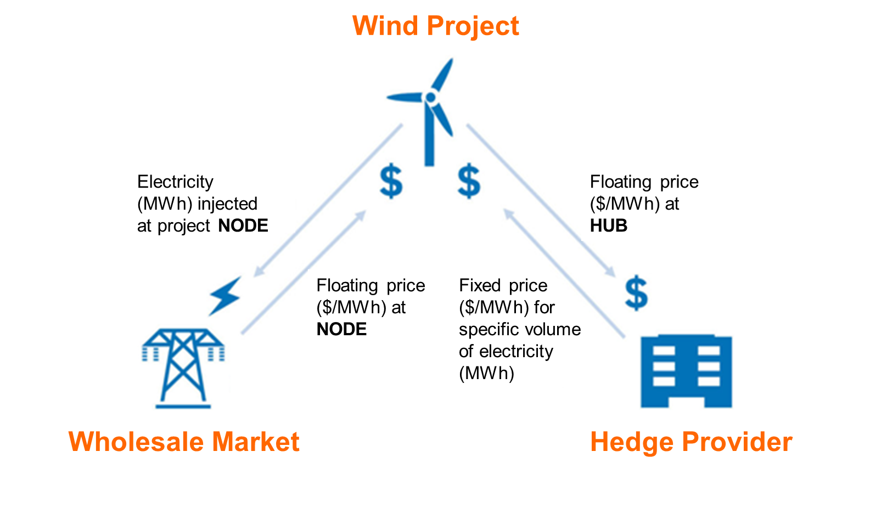

**Figure 1:** Example of a fixed volume price swap between a wind power producer and hedge provider.

The wind developer sells electricity for a price determined locally at the “node”, i.e., the location where the wind project is physically connected to the larger grid. Note, however, the payouts from the financial exchange with the hedge provider are based on the difference between the agreed-upon strike and the “hub” price (i.e. the weighted average price of electricity across the entire system) (Equations 1-2).

(1)

(2)

Where,

= Net revenues for wind producer in hour t

= Price at the node in dollars per megawatt-hour in hour t

= Total wind production in megawatt-hours hour t

= Hedged wind production in megawatt-hours hour t

= Financial exchange (dollars) with hedge provider in hour t

= Agreed-upon strike price in dollars per megawatt-hour

= Price at the hub in dollars per megawatt-hour in hour t

As long as the nodal and hub prices are equal, the contract effectively fixes the price realized by the wind producer at the agreed-upon strike. However, node and hub prices frequently diverge, often the result of transmission congestion that constrains prices from equalizing across the grid, including locational oversaturation of wind power that results in temporary low prices at certain nodes. This price mismatch results in “basis risk” that, from the perspective of the wind developer, prevents the hedge contract from adequately stabilizing the “net” revenues realized. Note as well that typically , meaning pay-outs from the hedge contract only apply to *a portion* of the electricity produced by the wind farm. Typically, unique production targets are set for each hour of the day, in theory representing the “firm” (reliable) production capabilities of the project. If these targets are set improperly, it can result in the wind farm under-producing relative to its contracted obligations and incurring penalties, and/or a small percentage of actual project output benefiting from the hedge. This so-called “shape risk” is another way contract performance can be degraded.

Given their relative simplicity and wide availability, fixed volume price swaps represent an attractive option for merchant wind producers who do not have access to traditional PPAs. But their use can prove to be deleterious for some wind developers, due to improper contract design and structural challenges found in some wholesale markets. In this paper, we examine the structure of fixed volume swaps negotiated between wind developers and hedge providers, and their sensitivity to basis and shape risk. We then explore how improvements could be made to these contracts, specifically by changing hourly wind production targets that the asset owner is required to meet. The results from this study should prove valuable to wind developers seeking to make informed decisions about how to minimize revenue uncertainty, thus helping them to get new projects off the ground.

# Methods

## 2.1. Study Area and Data

We focus our analysis on the Southwest Power Pool (SPP) market in the U.S., which has members in 14 states and a service territory of 546,000 square miles (Figure 2). The SPP market had approximately 22.5 GW of wind energy capacity as of the end of 2019, making up 24.9% of its total generating capacity [4]. In 2020, SPP became the first regional grid operator to have wind as its primary annual fuel source, outpacing SPP’s use of coal and natural gas. To incorporate this large amount of wind and maintain reliability across the grid, SPP has approved an extensive transmission plan for 2021, and is integrating electric storage resources in compliance with FERC Order 2222, which requires grid operators to allow distributed energy resources to participate in wholesale markets [5]. This area was chosen because of its persistent high wind speeds and a history of transmission issues, which are representative of the difficulties wind developers face in finding a suitable site with high enough potential revenues to justify project development. In addition, fixed volume price swaps are particularly common in SPP.

Despite high average wind speeds over much of the SPP footprint, wind power faces challenges there due to limited transmission capabilities and so-called “covariance risk”. Wind speeds exhibit significant correlation across space, with these correlations declining as a function of distance. But wind power production increases cubically with wind speeds, so wind power projects tend to cluster around the locations with the greatest wind resources. As a result, when one wind farm is experiencing a period of high wind production, it is more likely that other nearby wind farms are also delivering large amounts of electricity onto the grid simultaneously. This can overload existing transmission capacity, resulting in local saturation of wind power and forced curtailment of excess wind power. Furthermore, because wind power plants’ marginal costs are zero, congestion can cause prices at the node drop to zero (or even become negative, since some wind farms receiving PTCs can bid below zero and still experience positive revenues). To alleviate some of these issues, SPP currently is planning $545 million worth of transmission upgrades for the 20-year planning horizon that includes 78 projects in 8 states [5].

Our data consists of hourly wind power production data at a hypothetical wind project location within SPP for two years (2015-2016) provided by the wind farm site. In order to extend our wind power production data to match the same five years of price data, we first obtained daily wind speed data for 2015-2019 from Gage Airport, OK, located 32 miles from the wind farm site. Daily wind speeds over the period 2018-2020 are then used to conditionally bootstrap (re-sample) hourly wind speeds from 2015 and 2016. For example, for a given day in 2018-2020, we identify the average wind speed at Gage Airport, and then select the day from the same calendar month in the 2015-2016 data that experienced the most similar average wind speed. Hourly wind power production on this day in 2018 is then assumed to be identical to the similar wind speed data identified from the 2015-2016 database. Wind farm turbines are assumed to have a rated power of either 2.3 or 2.5 MW, with a total project capacity of 198.6 MW. The two years of historical, hourly production data provided for use in this study consists of the net capacity factor for each hour as well as the net energy produced by the array for each hour in MWh. For the years 2015-2019, the simulated net capacity factors are 49.96%, 52.05%, 55.20%, 54.41%, and 53.17%, respectively.

We also obtained five years of hourly nodal and hub price data (2015-2019) for the SPP market, from 10 nodes in close proximity to the wind farm site (Figure 2), as well as the ‘hub’. In the SPP market, locational marginal prices are determined in dollars per megawatt-hour ($/MWh) at thousands of nodes across the system. These prices are a combination of the electricity price, transmission congestion charges, and line losses. Prices at the trading hub are determined as the weighted average of prices over all system nodes. Typically, financial derivatives related to wholesale electricity markets (including fixed volume swaps for wind farms) are settled based on hub prices, because hub pricing is less volatile, less subject to market power, and easier to project based on historical data.

**Table 1.** Nearest SPP System Nodes to the hypothetical wind project.

|  |  |
| --- | --- |
| **Node** | **Proximity to Wind Farm (km)** |
| 1. OKGEIODINE4LD2 | 4.94 |
| 1. WFECVICILD2 | 4.97 |
| 1. OKGEWDWRD1LD2 | 18.99 |
| 1. OKGEWDWRDEHVUKEENAN_WIND | 19.15 |
| 1. OKGEKEENANWIND | 22.29 |
| 1. OKGECEDAR5LD2 | 25.83 |
| 1. OKGESPIRITWIND | 26.23 |
| 1. OKGE_SEILING | 27.65 |
| 1. OKGECEDAVLD2 | 31.82 |
| 1. WFEC_MOORELAND_2 | 32.49 |

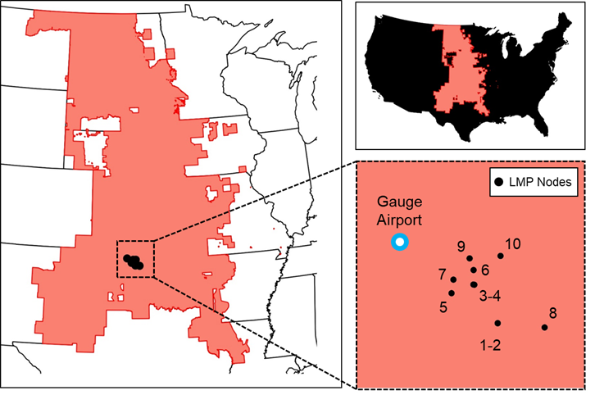

**Figure 2**. Map of Southwest Power Pool (SPP) system. Numbers shown in inset correspond to nodes listed in Table 1, and also denote ranked proximity to the hypothetical wind farm being modeled.

Formal wholesale electricity markets, such as the one run by SPP, typically consist of both “real-time” and “day-ahead” energy markets. The day-ahead market commits generators to produce electricity 24 hours in advance, based on forecasted demand. The real-time market commits projects to produce electricity anywhere from 5-minutes to 1 hour in advance, based on updated forecast information. Wind generators tend to sell into real-time markets because their production is difficult to predict 24 hours in advance, and failing to meet day-ahead obligations can result in costly penalties. Thus, in our analysis, we use real-time price information at both the node and hub.

Figure 3 shows time series of monthly SPP hub prices alongside prices at selected nodes. Basis risk, as described above, is a difference between hub and nodal prices that can reduce the effectiveness of hedging contracts. Figure 3 shows significant variation in nodal prices across the nodes in our fairly small study area, as well as through time. The wide disparity seen in nodal and hub prices during certain time intervals within our study region suggests that there is transmission congestion affecting the grid during these times. With no congestion, nodal prices should be uniform across space (and equal to hub prices). Thus, gradients in locational marginal prices (LMPs) can be seen as an indicator of transmission constraints, and/or as an indicator of insufficient, or excess, generating capacity at that point in space and time [16]. From September 2016 to May 2017, for example, wide swings in nodal prices are seen, leveling off in June 2017. April 2017 has average monthly prices ranging from -$32.40/MWh in the OKGEWDWRD1LD2 node, to $90.30/MWh in the WFEC_MOORELAND_2 node. This month had the highest average wind speeds in this 5-year time span at 15.4 meters per second. Without adequate transmission, extremely high wind speeds create “pockets” of extremely high wind power penetration at certain nodes, causing prices to crash, while prices at other nodes (and the hub) remain high. With a few exceptions, nodal prices are consistently lower than hub prices across the 5-year time frame. Rarely do we see hub prices go negative, but nodal prices experience negative prices frequently, sometimes for extended periods of time. Wind projects located at nodes experiencing negative pricing may be forced to frequently curtail power production, or else effectively pay to send electricity generated into the wholesale market, representing a significant financial liability. The severity of negative price events appears to resolve beyond 2018 (as do major disparities in prices across nodes) likely due to structural improvements to the SPP grid.

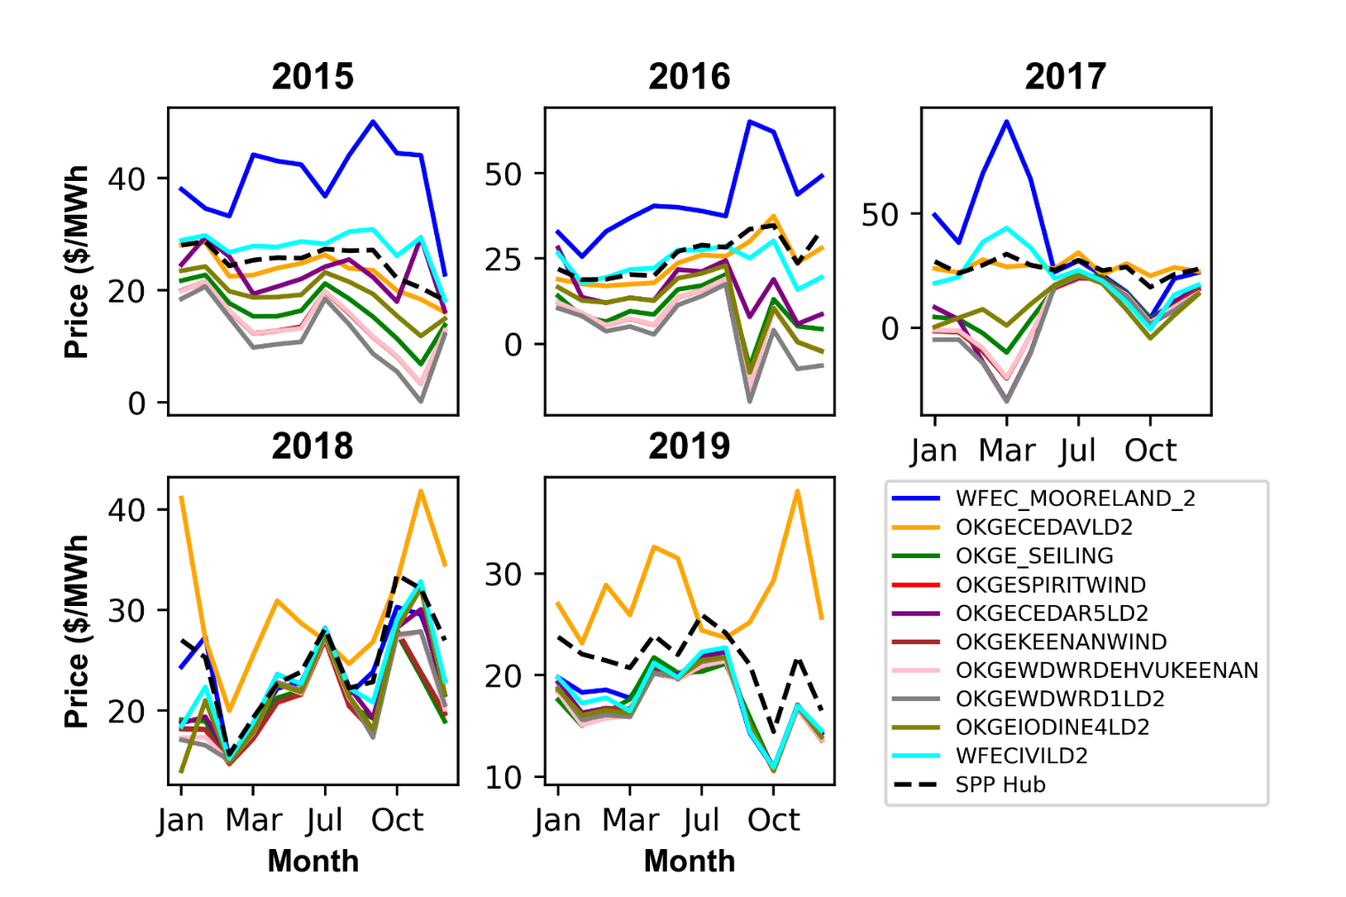

**Figure 3:** Average monthly hub and nodal prices by year.

Figure 4a shows the cumulative density of prices ordered from least to greatest across 5 years. A significant element of this plot is the high density of instances in which prices go negative as well as the number of instances in which prices are extremely high. Figure 4b shows Pearson R correlation coefficients among prices for the SPP hub and the 10 nodes considered (higher correlation values between each node and the hub indicate lower basis risk). The average correlation between hub and node is 0.63, and none of the correlations exceed 0.75, indicating there is a significant amount of basis risk across all nodes. Also of significance is the very low correlation between certain nodes, particularly nodes of different “families,” again confirming that there are likely considerable transmission constraints preventing prices from equalizing across the grid.

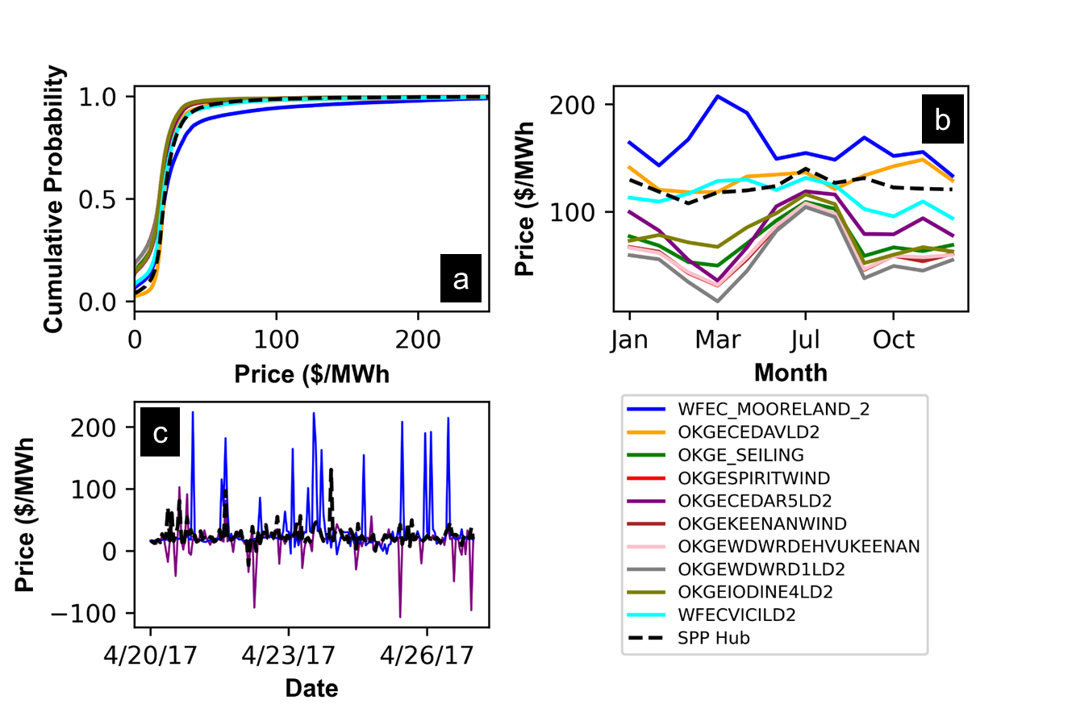

**Figure 4:** a) Cumulative density plots of hub/nodal prices; b) monthly average prices over the 5-year period. c) disparity in prices between the hub and selected nodes for 10 days between 4/20/2017 and 4/30/2017.

Figure 4c shows monthly prices for the hub and each node averaged across the 5-year period. This graph shows the typical seasonality in market prices, with certain months associated with lower nodal prices (April and September) and other months associated with elevated nodal prices (June, July, August); average hub prices remain remarkably stable across the year. Figure 4d zooms-in to explore the dynamic nature of basis risk for a few nodes, showing that the difference between nodal and hub prices can alternate between being negligible and very large.

Wind power production, like nodal pricing, shows strong seasonal patterns (Figure 5). Average monthly wind speeds at Gauge Airport (20 miles from our hypothetical wind farm site) show peaks in the Spring and early Fall and troughs in late Summer and Winter. Depending on the node in question, these wind speed patterns are out-of-phase with locational marginal prices, an example of “covariance risk.” For example, compare prices at the “OKGE” nodes in Figure 4 against average monthly wind speeds in Figure 5c. Combined seasonality in wind production and market prices may lead to the wind developer being exposed to varying levels of risk throughout the year, and this may need to be reflected in the developers use of financial hedging tools.

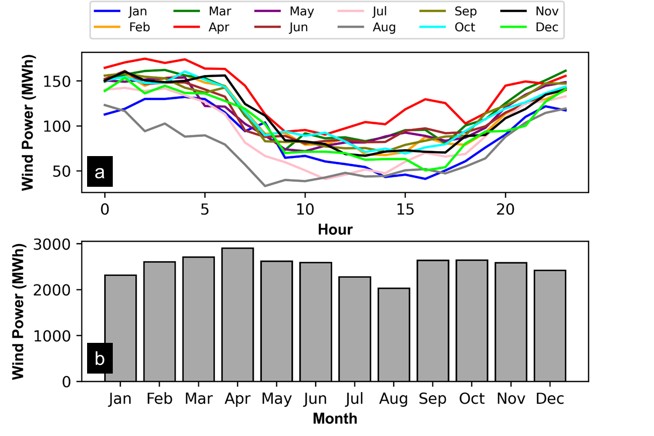

**Figure 5:** a) wind speeds for each month averaged over 5 years; b) within day wind power production patterns and the hypothetical wind farm.

2.2. Proposed Interventions

Our study explores two possible interventions to alleviate challenges for developers participating in fixed volume swaps and improve solvency for potential wind projects: 1) improved contract design; and 2) reducing basis risk (here represented as a proxy for investment in transmission infrastructure).

2.2.1. Improved Contract Design

First, we explore ways to modify the hourly hedge targets (i.e. the shape) of fixed volume price swaps to reduce shape risk for wind power producers, while also maintaining targets that are satisfying to hedge providers. Hedge providers prefer to trade electricity prices in “blocks” of energy, with minimal hour-to-hour differences in hedged electricity production. Typically, a fixed volume swap only applies to a portion of the electricity produced by a wind farm (see Equations 1-2). This amount is often determined somewhat heuristically, but the goal is to hedge only the “firm” (reliable) output of a wind farm. For example, from a wind farm’s distribution of annual power production estimated from historical wind speed data, a hedge provider may estimate the median (P50) year, and multiply this number by 80% as an approximation of the 1st percentile (P99) year – in other words, an amount of generation that will be exceeded roughly 99 out of 100 years. This annual amount is allocated over 8760 hours based on historical averages for each month. Hourly targets for each month are calculated by taking the average value for off-peak and peak hours, resulting in blocks of energy that are eligible for a fixed volume swap (Figure 6). Table 2 shows P99 peak and off-peak wind power production targets calculated from 5-years of wind power production data for the hypothetical wind farm.

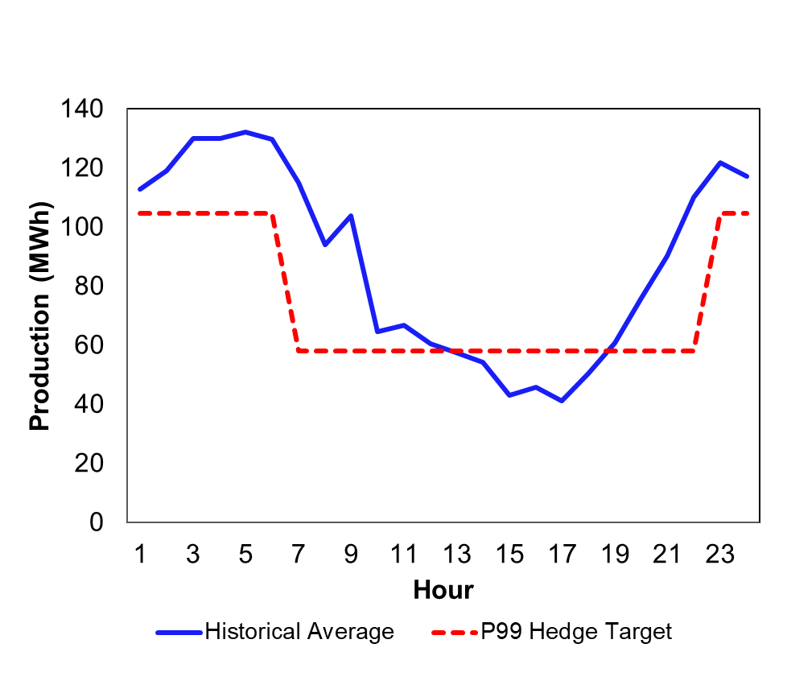

**Figure 6:** Average hourly wind power production vs. “P99” hedge targets for January for the hypothetical wind farm.

These blocks generally track (but are often below) average wind power production experienced at the farm. An important feature of the fixed volume swaps is that if actual wind power production falls below the hedge target in any given hour, the wind power producer is obligated to buy “make-up” power on the real-time market (typically at a higher than average price). In addition, any electricity production that exceeds the hourly target is not subject to the hedge, and is simply sold as usual in the real-time market, potentially at much lower prices. Previous analyses have shown that this mismatch between actual wind power production and hourly targets (also known as “shape” risk) can significantly degrade the efficacy of fixed volume swap contracts for wind developers [3]. An initial research question here is whether “compromise” hedge targets can be identified that improve financial performance for the wind producer, while also satisfying financial performance requirements for the hedge provider. For the wind producer in particular, there is likely to be a tradeoff between maximizing profits and reducing exposure to periods of extremely low revenues.

**Table 2.** Peak and off-peak hourly wind production volumes (in MWh) for each calendar month.

|  |  |  |
| --- | --- | --- |
| Month | Peak | Off-peak |
| *Jan* | 58.03 | 104.74 |
| *Feb* | 76.47 | 123.88 |
| *Mar* | 82.69 | 130.79 |
| *Apr* | 98.55 | 139.63 |
| *May* | 77.00 | 123.22 |
| *Jun* | 79.78 | 122.94 |
| *Jul* | 57.75 | 114.36 |
| *Aug* | 44.35 | 88.43 |
| *Sep* | 78.12 | 125.61 |
| *Oct* | 79.26 | 124.89 |
| *Nov* | 76.34 | 124.21 |
| *Dec* | 67.59 | 114.02 |

To simulate (and optimize) the financial performance of a hypothetical wind farm, we embed a simple simulation model of the wind farm’s operations (including use of fixed volume swaps) within a many-objective evolutionary algorithm (MOEA) to identify optimal peak and off-peak hedge targets for each calendar month. We make use of a widely used MOEA known as the Non-Dominated Sorting Genetic Algorithm II (NSGA-II) [25]. NSGA-II has been used widely in the past to help solve problems dealing with conflicting dual objectives (when one objective increases, the other decreases), which is likely the case in our problem. MOEAs, such as the NSGA-II, can be used to help developers of renewable energy projects and grid operators optimize the construction and operations of new plants by taking into consideration cost and reliability [18]. In our use of the NSGA-II algorithm, we used default parameters for population size and mutation rate.

The function evaluated by NSGA-II is a simulation model of wind power revenues for the hypothetical project, which employs an hourly time step and calculates revenues as follows:

(Equation 3)

The first part of the equation calculates revenues from selling all wind farm output directly into the wholesale market at the nodal price, with the function preventing these revenues from going negative during periods of local oversupply (i.e. wind power production is curtailed rather than sold at a negative price). The second part of the equation, , accounts for any “makeup” power the wind power producer must purchase at the node if it underproduces relative to a pre-specified wind production volume .

The fixed volume swap contract is made up of 24 unique values of , an off-peak and peak value for each calendar month. These targets represent the volume of wind energy whose value (price) would be covered by the hedge contract. The values shown in Table 1 represent values of for a conventional P99 contract. In our experiment, however, these 24 hourly hedge targets are the primary decision variables (unknowns to be optimized). Here, peak hours are defined as any hour of the day between 0600 and 2100, with the remaining hours defined as off-peak. The final part of the equation represents the financial exchange between the wind power producer and the contract counterparty, the hedge provider. Note that when , the financial exchange is negative, with the wind power producer paying the hedge provider.

The MOEA evaluates the function shown in Equation 3 over a predefined number of iterations known as ‘generations’, along the way identifying combinations of decision variables (here, the hedge targets , that yield ‘non-dominated’ solutions in terms of two objectives: 1) maximize profits of the wind power producer; and 2) maximize “floor improvement,” or the increase in revenues over the worst performing 10 months during a 5-year period (2015-2019). A non-dominated solution is a set of hedge targets for which no other solution exists with higher values in both objectives. Over many generations, the MOEA gradually builds a population of non-dominated solutions that spans the possible range of both objectives, showing a tradeoff between the two objectives that approximates a Pareto frontier. In this experiment, the function in Equation 3 was evaluated over 75,000 generations for each scenario tested.

We define the two objectives relative to a scenario in which no hedging occurs. In theory, effective hedging via a fixed volume swap should have two main effects for the wind power producer: 1) reduce total profits (the net exchange with the hedge provider will be negative, representing a “premium” paid by the wind developer to incentivize the hedge provider to participate); and 2) increased revenues during the worst performing months, with the latter benefiting the wind power producer by stabilizing its financial flows. The “strike price” ( in Equation 3) is kept constant across every scenario tested, and calculated assuming a ‘P99’ hedging structure. We assume to be the $-per-megawatt ($/MWh) price that results in the contract counterparty making a profit of 10% in its exchange with the wind power producer ($22.64/MWh). In order to maintain hedge provider profits at 10%, the simulation model calculates the ratio of hedge provider revenues divided by developer revenues for the 5-year period. We include as a constraint on this value within the MOEA such that it is between 9% and 11%, meaning any solution considered must result in acceptable profits for the hedge provider. Given these two objectives and a constraint guaranteeing profitability for the hedge provider, the MOEA then allows us to analyze a frontier of solutions over which profits for the wind power producer (expressed as % of maximum theoretical profits with no contract in place), as well as “floor improvement” (increase in revenues over the 10 worst performing months) are balanced to varying degrees. Accompanying each solution are corresponding values of decision variables (peak and off-peak hedge targets) for each month of the year.

2.2.2. Reduced Basis Risk (Adding Transmission Capacity)

We also explore the potential for reducing frequency and magnitude of divergences between nodal and hub prices (i.e. lower “basis risk”) to improve the performance of fixed volume swaps. In the context of our modeling analysis, reducing basis risk can be thought of as a proxy for a real-world decision to add or improve transmission infrastructure. While wind power developers likely have limited control over whether or not new transmission capacity is added at specific locations, a better understanding of the relationship between basis risk and contract performance may aid significantly in the future selection of wind project sites. In order to explore the sensitivity of fixed volume swaps to basis risk, we experimentally control basis risk by gradually altering the bias and standard deviation of errors between nodal and hub prices across several testable scenarios (Table 3).

**Table 3:** Basis risk scenarios explored.

|  |  |
| --- | --- |
| **Scenario Name** | **Altered Basis Risk** |
| No Basis Risk | 0 |
| Mean Zero 10 | (B - )/(*(1-.10)) |
| Mean Zero 20 | (B - )/(*(1-.20)) |
| Mean Zero 30 | (B - )/(*(1-.30)) |
| Mean Zero 40 | (B - )/(*(1-.40)) |
| Mean Zero 50 | (B - )/(*(1-.50)) |
| Mean Zero 60 | (B - )/(*(1-.60)) |
| Mean Zero 70 | (B - )/(*(1-.70)) |
| Mean Zero 80 | (B - )/(*(1-.80)) |
| Mean Zero 90 | (B - )/(*(1-.90)) |
| Mean Zero | B - |
| Standard Normal | (B - )/ |
| Observed | Observed Basis Risk |

Here, we measure basis risk as the hourly difference between hub prices and the prices at a given node, as follows:

(Equation 4)

where,

Keeping hub prices constant, we can then systematically alter basis risk several ways, including reducing mean bias (Equation 5) and standard deviation (Equation 6).

(Equation 5)

where,

(Equation 6)

where

By gradually decreasing the value of from 0.9 to 0, we can suppress the magnitude of positive and negative differences between nodal and hub prices until they approximate a standard normal distribution. We also explore a scenario in which basis risk is completely eliminated ( = 0). Nodal prices are then altered by back-calculating with the new values of :

(Equation 7)

where,

Table 2 lists the 13 basis risk scenarios tested. For scenarios in which the standard deviation of price differences is altered, the corresponding values of are shown. For example, under the “standard normal” scenario, the mean difference between nodal and hub prices is equal to zero and the standard deviation is 1 ( = 0). In the “Mean Zero 10” scenario ( = 0.10), the mean of the differences between nodal and hub prices is zero and the standard deviation is only 10% of observed basis risk. In the “Mean Zero 90” scenario ( = 0.90), the mean is again zero and the standard deviation is 90% of observed basis risk (i.e. close to historical conditions). We test each basis risk scenario over the same 5-year period (2015-2019), keeping the same strike price ( = $22.64/MWh) and constraints on the dual-objective problem (namely, that the hedge provider must make between 9-11% in profit).

# Results and Discussion

Our discussion of results is organized as follows. First, we compare the performance of a traditional P99 fixed volume swap to alternative contract designs identified, and discuss how wind power production targets could be adjusted to improve outcomes for the wind power producer. Then we examine the approximate Pareto frontiers identified by NSGA-II and explore how tradeoffs between the wind developer’s dual competing objectives (maximizing average profits and “floor” improvement) changes across the 10 nodes considered in the SPP system, and as a function of basis risk.

Alternative Contract Designs

Figure 7a shows the performance of non-dominated solutions identified for each of the 10 SPP nodes under observed (historical) levels of basis risk. Each point represents a single alternative hedge design (i.e. a distinct set of 24 hourly wind power production targets, 2 (1 peak and 1 off peak) for each calendar month)). The ideal point for a wind power producer would be the upper right corner (i.e., x = 1, indicating total revenues equal to the theoretical maximum (revenues with no hedge in place); and maximized improvement in the 10 worst-performing months (y-axis). The fact that no solution is able to achieve this means that, in examining their preferred hedge contract design, wind developers will need to balance their desire for increased revenues during the worst-performing months against total revenues. Note that there is considerable variation in the position and range of the tradeoff curves identified across nodes. For example, results for the node ‘WFEC_MOORELAND_2’ show that a maximum improvement of nearly $700,000 is possible for the 10 worst performing months, though the contract design that achieves this would cause a roughly 1.75% loss in total profits over the 5-year period, relative to the theoretical maximum (no hedge) (see black star in Figure 7A). Comparing contract performance frontiers shown in Figure 7a, we find that nodal sites with the poorest floor improvement (e.g. ‘OKGEIODINE4LD2,’ ‘OKGESPIRITWIND,’ ‘OKGEWDWRD1LD2’) are generally the locations that have the lowest prices relative to the hub in our study time frame. The nodes ‘ ‘ and ‘ ‘ also exhibit relatively low correlations with hub prices (see Figure 4). These nodal price conditions disrupt the ability of the hedging contracts to improve performances during low revenue months due to basis risk.

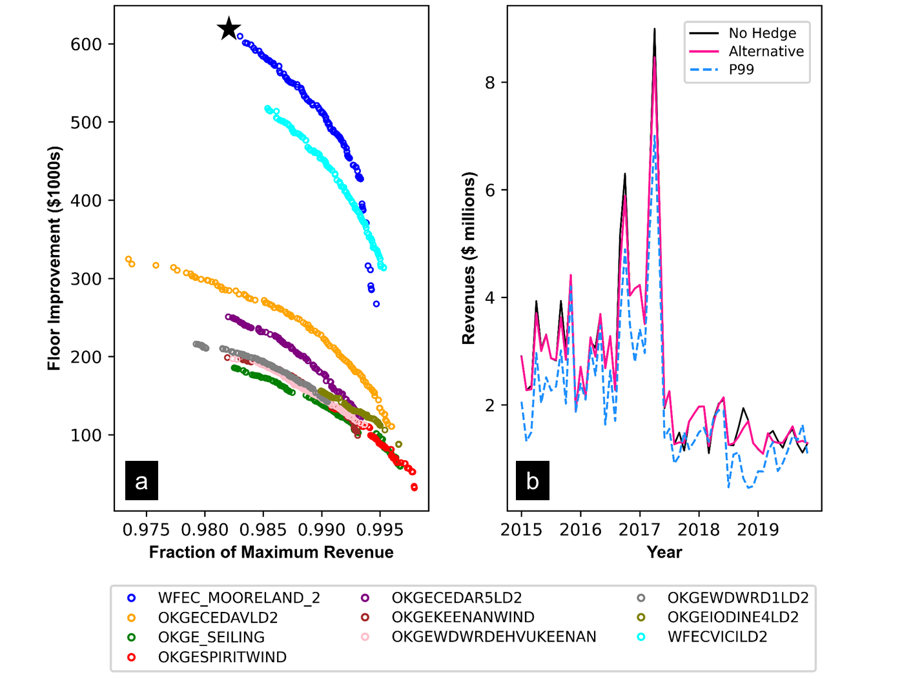

**Figure 7.** a) Comparison of tradeoffs between profits (measured as a fraction of theoretical maximum) (x-axis) and “floor improvement” ($) (y-axis) for each SPP node considered; b) Monthly revenues for the wind power producer at the WFEC_MOORELAND_2 node with hedging (orange), without hedging (blue), and with the P99 hedge (green) under the maximum floor improvement solution, resulting in a roughly $600,000 increase over the 10 worst-performing months.

Figure 7b shows the performance of this same contract design over the 5-year simulation period (60 months), with revenue improvement occurring during a handful of low performing months. With no hedge in place, wind developer revenues calculated for the ‘WFEC_MOORELAND_2’ node show elevated monthly revenues until a major spike in April 2017; after that revenues fall low and remain persistently so throughout the rest of the simulation period. These revenue fluctuations for the wind power producer are directly correlated with spikes in nodal prices during this time frame (see Figure 3). Average monthly prices at ‘WFEC_MOORELAND_2’ average around $33/MWh over the 5-year period, with average monthly prices above hub prices for much of 2016-2018, spiking to roughly $90/MWh in April 2017 (Figure 3). Throughout the remainder of the study period, the average price at the ‘WFEC_MOORELAND_2’ hovers around $20/MWh, which explains the depressed monthly revenues seen in the second half of Figure 7b.

Note that with the hedge in place, the overall structure of these revenue dynamics remains mostly unchanged compared to conditions with no hedge in place, with small increases during low performing months (contract payouts from the hedge provider to the wind developer), which are offset by slightly larger decreases during high performing months (payments from the wind develop to the hedge provider). Although improvements are modest compared to conditions with no hedge in place, the alternative hedge design compares very favorably to a traditional P99 contract, which negatively impacts financial performance across nearly every month in the 5-year period. The use of a P99 contract over the period 2015-2019 in the SPP market would have resulted in a considerable financial loss for a wind power producer (yielding total revenues 25-30% lower than if they had not hedged at all). At the same time, there is no evidence that the use of a P99 fixed volume swap would protect the wind power producer from low revenue months; in fact, it reduces the revenue floor by nearly $1 million in the worst performing month. The comparatively poor performance of the P99 contract is a phenomenon we find to be consistent across every node considered. Figure A1 in the Appendix shows similar information to Figure 7b for the remaining nine nodes, with hedged revenues reflecting performance under an alternative contract that maximizes floor improvement.

We also explore the underlying structures of alternative hedging contracts identified and compare these alongside a traditional P99 contract. Figure 8 shows the monthly peak and off-peak wind production targets for the alternative fixed volume swap contract designs that maximized the floor improvement at each node under observed basis risk. Uniformly, the alternative contract designs all involve hedging significantly lower volumes of wind power production than conventional P99 contracts. The heuristic manner in which hourly production volumes in Equation 3) are calculated in P99 contracts often does a poor job of tracking intra-day wind patterns, instead assigning peak- and off-peak targets as “blocks” that wind power producers must meet (see Figure 5). This regularly create conditions where the quantity in Equation 3 is non-zero, triggering a need for the wind developer to purchase “make-up” power on the spot market to deliver to the hedge provider. Lower wind hours tend to be hours with higher nodal prices, and these purchases of make-up power can be expensive. Although less of the wind power production is hedged with the production volumes set lower, the alternative contract designs help mitigate some negative consequences of the widely known “shape risk” problem in P99 contracts [17].

Moreover, we find that in several months it would be beneficial to the developer to not to hedge at all. In general, our results suggest that in summer (when nodal prices tend to be high and wind production tends to be low), it is not advantageous for developers to cover large volumes of wind power production (if any) using fixed volume swaps. The strike price in the contract ( in Equation 3) is $22.64/MWh; this is lower than the hub price more often than not during summer months, meaning the contract disproportionately pays out to the hedge provider (the quantity in Equation 3 becomes negative). Thus, the alternative contract designs tend to minimize during these months. An added advantage of hedging much lower amounts of wind generation during summer (or not hedging at all), is that the wind developer can avoid buying particularly expensive “make-up” power as a result of missing its hourly production targets. Instead, we find that the developer should concentrate on hedging wind production against low prices during the 2 or 3 months out of the year when wind production is high and hub prices are low, i.e. Spring and Fall. Concentrating on hedging during these months allows the wind developer to more effectively protect against low prices, while avoiding paying exorbitant sums to the hedge provider.

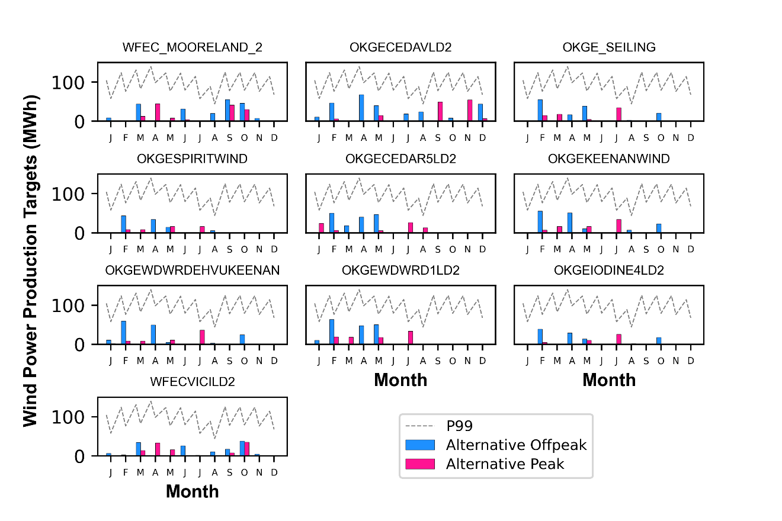

**Figure 8.** Monthly wind power production targets () identified for the maximum floor improvement contract design at each node, compared alongside targets specified by a conventional P99.

We do notice important differences in the monthly hedge targets identified for each node; these differences are entirely due to differences in nodal prices, and they likely explain observed differences in the shape and position of the tradeoff frontiers shown in Figure 7. For example, as noted above, the “WFEC_MOORELAND_2” node experienced a significant spike in its nodal price in April 2017 (see Figure 3). If a hypothetical wind power producer engaged in a P99 fixed volume swap at this node simultaneously experienced lower than normal wind speeds (causing it to under-produce relative to the hourly targets specified in the contract), the wind producer would be required to purchase make-up power on the spot market at a very high price. Figure 7b shows that the net effect on the wind producer’s monthly revenues would be a loss of roughly $600,000, compared to conditions in which no hedge is in place. Figure A2 in the appendix also shows similar information to Figure 8, but for every level of basis risk considered. In general, the wind power production volumes identified for the alternative contracts appear robust to changes in basis risk. We observe that, like Figure 8, production volumes tend to be much lower, and typically concentrated in months that exhibit higher wind speeds and lower prices.

Sensitivity of Performance Frontiers to Altered Basis Risk

Figure 9 shows similar tradeoff frontiers as Figure 7a, but for several selected basis risk scenarios. Note that contracts are re-optimized for each scenario (e.g. for any given node, new Pareto optimal wind power production volumes are identified for each level of basis risk considered). This assumption would approximate real-world conditions if the parameters of fixed volume swaps could be re-calibrated each year, for example, to address gradual changes in basis risk (e.g. resulting from transmission upgrades). As basis risk is gradually decreased, ranging from “Mean Zero 100”, “Mean Zero 90”, to “Standard Normal” and “No Basis Risk” (hub prices = nodal prices), we see the nodal differences in contract performance frontiers collapse. In theory, a “No Basis Risk” scenario would occur if transmission constraints were eliminated across the system, allowing locational marginal prices to equalize across the grid. These conditions would ensure that when the wind power producer experiences nodal prices below the contract strike price ( in Equation 3), the hub price also reflects these conditions and triggers a payout. Note however, that even if basis risk is eliminated, the maximum revenue improvement identified is on the order of $375,000 over the 10 worst performing months. As basis risk is diminished, some nodes (e.g. ‘OKGEKEENANWIND’) show higher upper bounds in revenue improvement. At the same time, other nodes (most notably ‘WFEC_MOORELAND_2’, which often exhibited higher average prices than the node) show reduced potential to improve revenue performance under lower basis risk, likely because this would entail lower nodal prices.

For several nodes, we observe some degree of threshold behavior in the position of the contract performance frontiers. For example, starting at the “No Basis Risk” scenario (Figure 9F), and gradually adding more basis risk (moving backwards through the alphabet, from Figure 9E to Figure 9C), the performance frontiers mostly retain their shape and position, thought divergence across nodes increases. For some nodes, we find that allowing up to 70% or even 80% of mean adjusted basis risk still permits the position of the tradeoff frontiers to remain fairly stable across all nodes. The relatively robust performance of the fixed volume swap contracts at levels of basis risk below 70% for most nodes suggests that completely eliminating basis risk may not be not necessary for the fixed volume price swap to perform at a near optimal level. Reducing the standard deviation of the difference between nodal and hub prices only 20-30% could substantially improve contract performance in many cases. In theory, this would come in the form of targeted transmission upgrades to reduce congestion in areas with large wind power penetration into the grid.

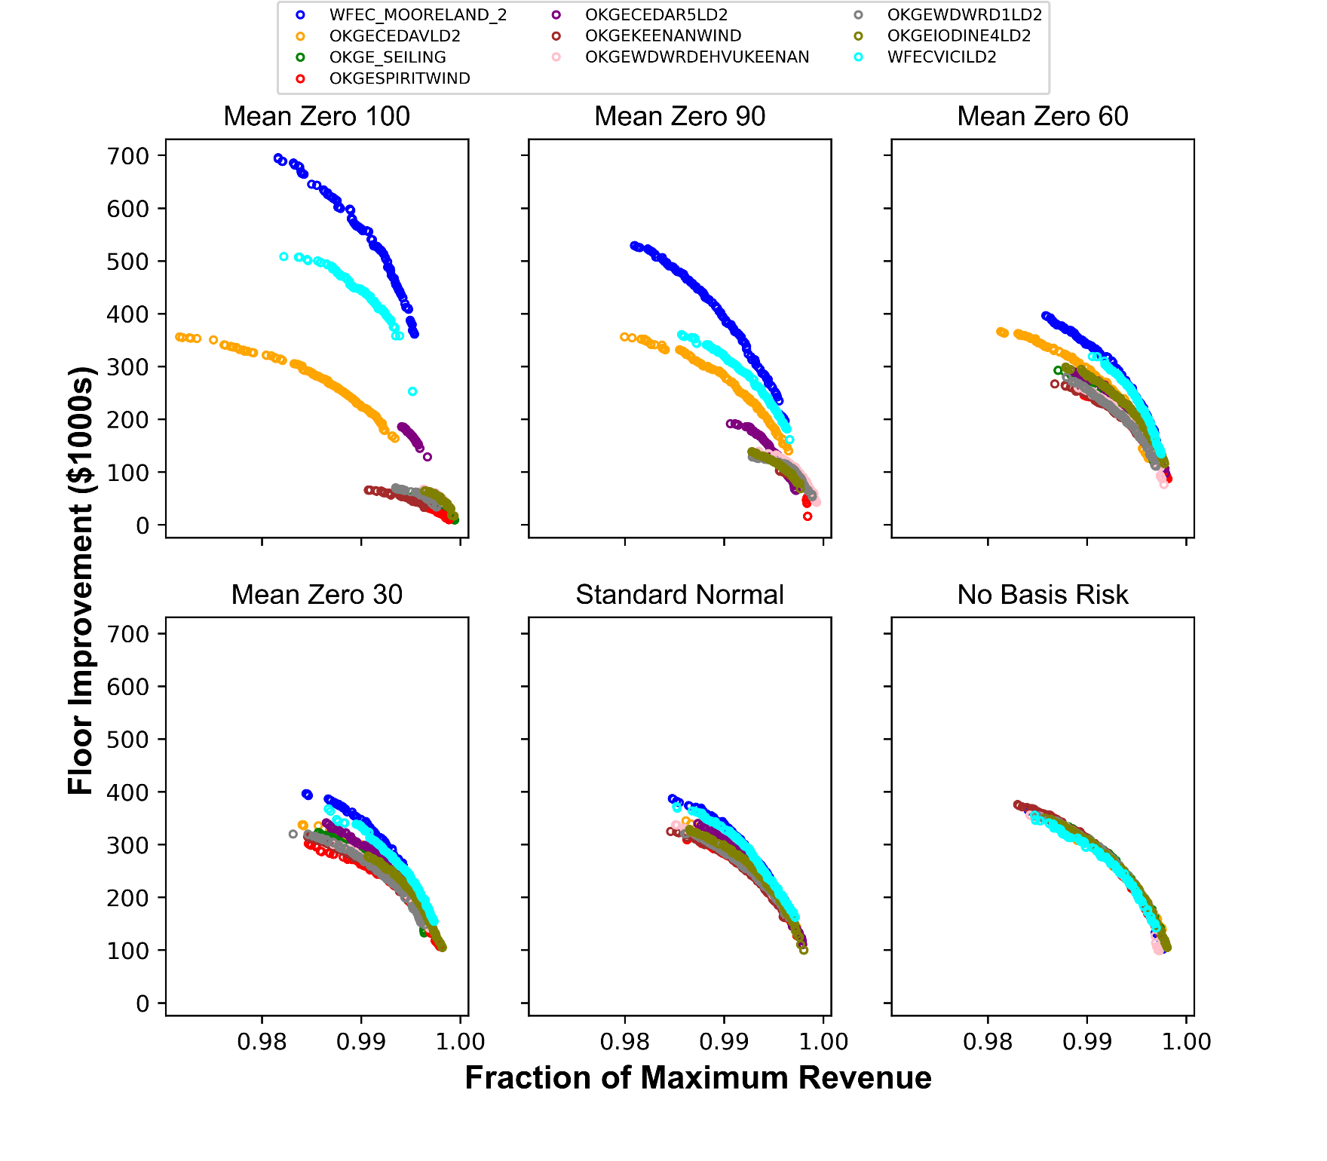

**Figure 9**. Contract performance frontiers for each node across six selected basis risk scenarios.

However, there is a tipping point beyond which basis risk appears to significantly worsen the tradeoff frontiers, at least in terms of maximum floor improvement (y-axis). For example, at 90% of actual basis risk, the floor improvement of the worst 10 performing months is cut in half for most nodes, relative to the No Basis Risk scenario, even as the cost (in terms of reduced revenues) remains the same. At “Mean Zero 100,” floor improvement does not exceed $100,000 for most nodes, with the contracts appearing much less cost effective.

The results of our analysis also show that groupings of nodes react differently to changing basis risk. The two major groupings of nodes in the case of our study are those beginning with “OKGE” and “WFEC.” The WFEC grouping of nodes actually increases floor improvement in higher basis risk scenarios. This grouping of nodes tends to experience significantly higher electricity prices compared to the OKGE grouping of nodes during the 5-year study period, even exceeding the hub price in March, April, and May, on average (see Figure 4). The results of our model show that nodes with higher prices generally demonstrate higher maximum floor improvement through the use of fixed volume swaps – a somewhat unexpected result, given the designed purpose of the swamps to protect against periods of low prices. This phenomenon could be due to someone reduced levels of basis risk at higher priced nodes, may allow the contract payments (which are triggered on hub prices) to more accurately reflect local price conditions.

Figure A3 in the appendix shows similar information as Figure 9, but with the contract performance frontiers grouped by node, instead of basis risk scenario. This provides an additional way to observe how gradual changes in basis risk may (or may not, in some cases) disrupt the performance of fixed volume swap contracts. For example, the shape and position of the performance frontiers at some nodes appears quite persistent (with contract recalibration), even as basis risk is dramatically altered. We also see the results differ by node family, with OKGE nodes generally showing increased maximum floor performance as basis risk declines, while the WFEC nodes show the opposite.

1. Conclusions

Our model uses hourly wind production, and hourly hub and nodal prices to predict hedge targets that optimize floor improvement of the 10 worst performing months as well as percentage of maximum profits to the developer. The model analyzed different levels of basis risk and predicted optimal hedge targets for each basis risk scenario. In certain months, there were meaningful differences in the amount of energy hedged depending on the level of basis risk and in other months the amount hedged was relatively constant. Generally speaking, all basis risk scenarios hedged a similar amount in all months until the “mean zero 90” and “mean zero” scenarios, in which the model predicted the project should hedge little to no wind production in all months. The model also differentiated between peak and off-peak hedge targets when calculating the amount to be hedged.

# References

1] The Paris Agreement. (2015, December 12). United Nations Framework Convention on Climate Change. Retrieved from: <https://unfccc.int/process-and-meetings/the-paris-agreement/the-paris-agreement>.

2] IPCC Special Report on Global Warming of 1.5°C. (June 2019). Intergovernmental Panel on Climate Change. Retrieved from: https://www.ipcc.ch/site/assets/uploads/sites/2/2019/06/SR15_Full_Report_Low_Res.pdf.

3] Sukunta, Manussawee. U.S. Energy Information Administration. (2020, March 6). EIA’s Long-Term Power Plant Projections Trade Off the Cost and Value of New Capacity. Last accessed: 2020, December 11. Retrieved from: <https://www.eia.gov/todayinenergy/detail.php?id=43095>

4] Renewables Account for Most New U.S. Electricity Generating Capacity in 2021. (2021, January 11). U.S. Energy Information Administration. Retrieved from: https://www.eia.gov/todayinenergy/detail.php?id=46416.

# 5] Bartlett, J. (2019). Reducing Risk in Merchant Wind and Solar Projects through Financial Hedges. Resources for the Future (2019, February 22). https://www.rff.org/publications/working-papers/reducing-risk-merchant-wind-and-solar-projects-through-financial-hedges/

# 6] Fast Facts: An Overview of the SPP System. Southwest Power Pool (2020). Retrieved from: <https://www.spp.org/about-us/fast-facts/>

7] SPP becomes first regional grid operator with wind as No. 1 annual fuel source, considers electric storage participation in markets, approves 2021 transmission plan. (2021, January 26). Southwest Power Pool. Retrieved from: <https://spp.org/newsroom/press-releases/spp-becomes-first-regional-grid-operator-with-wind-as-no-1-annual-fuel-source-considers-electric-storage-participation-in-markets-approves-2021-transmission-plan/>.

8] 2020 SPP Transmission Expansion Plan Report. (2020, January 14). Southwest Power Pool. Retrieved from:https://www.spp.org/documents/56611/2020%20spp%20transmission%20expansion%20plan%20report.pdf

9] Electric Storage Resources White Paper. (2020, January 7). Southwest Power Pool. Last accessed: 2020, December 11. Retrieved from: <https://www.documentcloud.org/documents/6745871-Electric-Storage-Resource-White-Paper.html>

10] Lazard’s Levelized Cost of Storage Analysis - Version 5.0. Lazard. Last accessed: 2020, December 11. Retrieved from: https://www.lazard.com/media/451087/lazards-levelized-cost-of-storage-version-50-vf.pdf

11] Energy Storage Options for North Carolina. (2019, February 2). NC State Energy Storage Team. Last accessed: 2020, December 11. Retrieved from: <https://energy.ncsu.edu/storage/wp-content/uploads/sites/2/2019/02/NC-Storage-Study-FINAL.pdf>

12] Guido Francesco Frate, Lorenzo Ferrari, Umberto Desideri,

Energy storage for grid-scale applications: Technology review and economic feasibility analysis,

Renewable Energy, Volume 163 (January 2021), Pages 1754-1772, ISSN 0960-1481,

<https://doi.org/10.1016/j.renene.2020.10.070>.

13] Mehdi Jafari, Magnus Korpås, Audun Botterud, Power system decarbonization: Impacts of energy storage duration and interannual renewables variability, Renewable Energy, Volume 156, (August 2020), Pages 1171-1185, ISSN 0960-1481. <https://doi.org/10.1016/j.renene.2020.04.144>.

14] Wei-qi Zhang, Xin-yan Zhang, Shao-wei Huang, Yu-kai Xia, Xiao-chao Fan, Sheng-wei Mei,

Evolution of a transmission network with high proportion of renewable energy in the future, Renewable Energy, Volume 102, Part B, (March 2017), Pages 372-379, ISSN 0960-1481. <https://doi.org/10.1016/j.renene.2016.10.057>.

15] Mohammad Javad Poursalimi Jaghargh, Habib Rajabi Mashhadi, An analytical approach to estimate structural and behavioral impact of renewable energy power plants on LMP, Renewable Energy, Volume 163, (January 2021), Pages 1012-1022, ISSN 0960-1481. <https://doi.org/10.1016/j.renene.2020.08.089>.

16] Matthew D. Leonard, Efstathios E. Michaelides, Dimitrios N. Michaelides, Energy storage needs for the substitution of fossil fuel power plants with renewables, Renewable Energy, Volume 145 (January 2020), Pages 951-962, ISSN 0960-1481. <https://doi.org/10.1016/j.renene.2019.06.066>.

17] Thanaporn Sriyakul, Kittisak Jermsittiparsert, Risk-controlled economic performance of compressed air energy storage and wind generation in day-ahead, intraday and balancing markets, Renewable Energy, Volume 165, Part 1 (January 2021), Pages 182-193, ISSN 0960-1481. <https://doi.org/10.1016/j.renene.2020.11.025>.

18) Igbinovia, Famous & Křupka, Jiří. (August 2019). An Appraisal of Multi Objective Evolutionary Algorithm for Possible Optimization of Renewable Energy Systems. Research Gate. https://www.researchgate.net/publication/337945634

19) Geoffrey McD. Lewis, High value wind: A method to explore the relationship between wind speed and electricity locational marginal price, Renewable Energy, Volume 33, Issue 8 (August 2008), Pages 1843-1853, ISSN 0960-1481, https://doi.org/10.1016/j.renene.2007.09.016.

20) Lee Taylor, Adam Reeve, Tim Belden. The “P99 Hedge” That Wasn’t. Resurety (May 2018). Retrieved from: <https://resurety.com/uploads/The-P99-Hedge-That-Wasnt-a-REsurety-and-Energy-GPS-White-Paper.pdf>.

21) Short Term Energy Outlook. (2021, January 12). U.S. Energy Information Administration. Retrieved from: <https://www.eia.gov/outlooks/steo/>.

22) SPP becomes first regional grid operator with wind as No. 1 annual fuel source, considers electric storage participation in markets, approves 2021 transmission plan. (2021, January 26). Southwest Power Pool. Retrieved from: <https://spp.org/newsroom/press-releases/spp-becomes-first-regional-grid-operator-with-wind-as-no-1-annual-fuel-source-considers-electric-storage-participation-in-markets-approves-2021-transmission-plan/>.

23] Yang, Charles & Brockett, Patrick & Wen, Min-Ming. (2009). Basis risk and hedging efficiency of weather derivatives. Journal of Risk Finance, The. 10. 517-536. 10.1108/15265940911001411.

24] Cheng-Ta Chu, Adam D. Hawkes, Optimal mix of climate-related energy in global electricity systems, Renewable Energy, Volume 160, 2020, Pages 955-963, ISSN 0960-1481, https://doi.org/10.1016/j.renene.2020.06.104.

25] Platypus NSGA-II Model. Genetic Multi-Objective Optimization Algorithm. Retrieved from: https://platypus.readthedocs.io/en/latest/getting-started.html.

Appendix

**Figure A1:** Monthly revenues for the wind power producer under observed basis risk.



