Contact support and practical identifiability of spur gear microgeometry from transmission error
Romulo Sandoval Flórez¹; Claudia Patricia Parra Medina²; German Leandro Vargas Fonseca².
¹ Universidad ECCI. ² Grupo GAV, Universidad Militar Nueva Granada.
Corresponding author: Romulo Sandoval Flórez, romulo@ecci.edu.co.

Abstract
Transmission error constrains gear microgeometry through the part of the flank that carries load. We establish a sufficient condition under which dedendum relief is exactly invisible to a quasistatic contact operator with fixed geometry and compliance, and extend the argument to coupled elastic contact. An implicit contact tangent relates this invariance to parameter sensitivities and to the resolution of a discretized relief field. Nonlinear profiles and noise experiments distinguish exact invariance from weak practical identifiability as relief enters loaded support. For the nominal pair, the median scaled dedendum error decreases from 0.394 to 0.106 when the relief start moves deeper into contact, using 100 realizations, 120 observations, 300 Nm and 0.1 µm Gaussian noise. Equal-budget controls reveal angular-sampling effects and no statistically resolved benefit of the tested two-load allocation. A finite-element contact comparison isolates a dedendum signal of 0.179 µm RMS, close to the analytical 0.197 µm. Nevertheless, an addendum-only inverse attains the same residual as the unrestricted fit, and dedendum profiles remain flat across their tested domains. Interface and angular-mask controls delimit the discretization dependence. A separate eight-phase material-removal control gives approximately 0.4–2.1 nm centred changes outside contact, delimiting exact invariance to fixed compliance. Across twelve external amplitude targets evaluated with four formulations, none meets the adopted 5% research target. These results establish operator-conditioned limits on observability and distinguish contact sensitivity from reliable geometrical recovery.
Keywords: Gear microgeometry; Transmission error; Contact support; Identifiability; Profile likelihood; Inverse problems

1 Introduction
Profile modifications influence gear transmission error through normal separation, elastic deformation and load sharing. Their design has been studied through classical profile synthesis, genetic algorithms and response-surface optimization [1,2,3], with standardized descriptions of modification geometry [4] and broader reviews and tolerance-design studies [5,6]. The inverse problem is different: given a measured response, which aspects of the manufactured profile are determined by that response? A small transmission-error residual is insufficient to answer this question because mechanically inactive relief can change the geometry without changing the observable.
Inverse gear analysis has several precedents. Vibration-based methods identify mesh stiffness while accounting for mapping uncertainty [7], tooth-root stresses have been used to estimate meshing transmission error [8], and inverse tooth-contact and double-flank roll-test analyses recover other geometrical quantities [9,10]. Here the unknown is a pinion profile modification and the observable is mean-removed quasistatic transmission error. Spitas et al. prescribe tooth-contact behaviour to synthesize a mating flank [9], whereas Kalligeros et al. infer geometrical deviations from double-flank radial measurements [10]. The present contribution is a pre-inversion observability diagnostic: loaded support defines invariant relief sets, a coupled-contact argument establishes their persistence under fixed elastic coupling, and contact tangents quantify the transition from exact invariance to weak information. It is not a new general framework for inverse gear analysis.
That connection is necessarily conditional on the forward mechanics. Comparisons between analytical and finite-element stiffness models [11], contact-analysis software benchmarks [12] and nonlinear formulations [13] show why response fidelity must be assessed independently. Modified-profile contact studies link relief to load sharing, stiffness and transmission error [14,15]. Sánchez et al. also synthesize relief for prescribed load-sharing or transmission-error functions [14]. Such inverse design does not establish uniqueness when a manufactured relief must be inferred from a measured, centred response. Wide-faced gears [16], mounting deviations [17] and experimental tooth-loading comparisons [18] introduce mechanisms beyond the present profile-only reduction. We therefore distinguish numerical consistency, recovery within a model and agreement with an external mechanical reference.
Structural and practical identifiability provide complementary descriptions of these limitations [19,20]. Profile likelihood [21], structural analyses [22,23], sensitivity spectra [24] and Fisher-information diagnostics [25] distinguish exact parameter invariance from finite-noise ambiguity. Applied to gear contact, these tools must also accommodate changes in the active contact set. We combine a sufficient invisibility result with an implicit contact tangent, nonlinear profiles, fixed-budget sampling comparisons and noise experiments. Finite-element contact inversions and external amplitude comparisons then delimit the mechanical interpretation of those results.

2 Geometry and mechanical model

2.1 Profile coordinates
An involute spur pair has tooth numbers z₁ and z₂, module m, reference pressure angle α, face width b and centre distance a [26]. Pair index k identifies a candidate tooth pair, i an angular observation and ℓ an applied load. The line-of-action coordinate is ℓₖ=rᵦ₁φ+k pᵦ, measured from the working pitch point, with nominal contact window [−g_{f},g_{a}]. We describe pinion relief using ξ=clip(u/u_{tip},0,1), where u=tan(αᵣ). This coordinate runs from the base circle to the tip; it is not a normalized distance from the start of active profile.
The four parameters θ=(Cₐ,sₐ,C_{d},s_{d}) specify addendum and dedendum depths in millimetres and dimensionless start positions. Positive relief increases normal separation. The wheel is unmodified except in the external benchmark. Unless stated otherwise, the relief exponent is p=2.
$h(ξ; θ) = C_{a} {[\frac{ξ − s_{a}}{1 − s_{a}}]₊}^{p} + C_{d} {[\frac{s_{d} − ξ}{s_{d}}]₊}^{p} (1)$
Here [x]₊=max(0,x). At C_{d}=0, s_{d} is redundant. For C_{d}>0, a different source of ambiguity arises if the relief does not intersect loaded contact. We keep these two mechanisms distinct.

2.2 Contact and compliance
The elastic constants are E=210000 MPa and ν=0.30 for both gears. Each candidate pair has one effective normal contact, combined tooth compliance cₖ, force pₖ and residual separation wₖ. The approach δ satisfies unilateral contact and the prescribed normal-force budget:
$g_{k} = max(0, ℓ_{k} − g_{a}, −g_{f} − ℓ_{k}) + h_{1}(ξ₁ₖ) + h_{2}(ξ₂ₖ) (2)$
$w_{k} = g_{k} − δ + c_{k}p_{k} + w_{H}(p_{k}); p_{k} ≥ 0, w_{k} ≥ 0, p_{k}w_{k} = 0 (3)$
$\sum_{k}{p_{k}} = \frac{1000 T}{r_{b1}} (4)$
The extension outside the nominal contact window in equation (2) is a separation approximation, rather than an exact corner-contact construction. Contact elasticity follows the classical elastic-contact setting [27,28] and its application to gear models [29]. Tooth bending, shear and foundation terms provide the remaining compliance [30,11]. All geometrical sections, contact coordinates and normals remain fixed when relief parameters change.
We retain four compliance formulations to assess the dependence of the results on this approximation. The baseline integrates a radial variable-section beam with 24-point Gauss–Legendre quadrature, thickness floor 0.2m and fixed radius r_{fix}=max(r_{f},1.0001rᵦ). Its tooth compliance is
$c_{tooth} = \int_{0}^{H}{\frac{{(H − x)}^{2}}{E I(x)} dx} + 1.2 \int_{0}^{H}{\frac{1}{E A(x)} dx} + \frac{{cos(αᵣ)}^{2}}{E b} (5)$
$I(x) = \frac{b {t(x)}^{3}}{12}; A(x) = b t(x) (6)$
The baseline shear term uses E rather than the shear modulus and is mechanically inconsistent. It serves as a reference implementation, not as a preferred constitutive law. The shear-G variant replaces that denominator by G=E/[2(1+ν)]. The radial-energy variant also resolves the normal force into transverse and axial components and includes its flank offset in the bending moment. The centre-line variant evaluates the energy along the tooth centre line. In the radial-energy formulation,
$G = \frac{E}{2(1 + ν)}; c_{energy} = \int_{0}^{H}{\frac{{(M(x)/P)}^{2}}{E I(x)} + \frac{1.2 cos²αᵣ}{G A(x)} + \frac{sin²αᵣ}{E A(x)} dx} + c_{foundation} (7)$
For a beam height below 0.001m the implementation assigns compliance 10⁻⁶ mm/N. This local approximation and the foundation term remain part of the declared operator. None of these formulations reconstructs a manufactured root fillet or the section changes caused by material removal. ISO 6336-1 distinguishes tooth and mesh stiffness [31]; the incremental tangents reported here are diagnostics of the implemented contact problem, rather than complete ISO-method predictions.
The Hertz contribution uses equivalent radius ρₑ and effective modulus E*:
$a_{H} = \sqrt{\frac{4(p/b) ρₑ}{π E*}}; w_{H} = \frac{p/b}{π E*}\{2 log(\frac{4 ρₑ}{a_{H}}) − 1\} (8)$
The implemented logarithm is clipped when 4ρₑ/a_{H}<1. With Kₖ=1/(πE*b), its derivative is bounded below by −2Kₖ. The sufficient condition cₖ>2Kₖ makes each complete pair law strictly increasing and the load-controlled solution unique. We check this condition numerically before using the batched operator. It is a property of the declared law and does not validate its high-load extrapolation.

2.3 Observation and inverse problem
For each load we observe F_{ℓ}(θ)=δ_{ℓ}(θ)−mean[δ_{ℓ}(θ)] at the selected angular positions. Encoder synchronization and angular sampling affect the measured counterpart [32]. The noise experiments add independent errors to the already centred prediction:
$y_{ℓi} = F_{ℓi}(θ*) + ε_{ℓi}; ε_{ℓi} ∼ N(0, {σ_{ℓ}}^{2}) (9)$
Consequently, an individual noise realization may have a nonzero mean. That component contributes to cost but not to parameter gradients. If measurements were centred after adding noise, their covariance would instead be σ²(I−11ᵀ/N), requiring a projected likelihood. The stated experiments use the independent-error convention throughout.
Bounds are Cₐ∈[0,0.100] mm, sₐ∈[0.30,0.95], C_{d}∈[0,0.050] mm and s_{d}∈[0.05,0.50]. We scale parameters by s=(0.05,1,0.01,1), write q=θ/s and solve bounded least squares with a trust-region reflective method [33,34]:
$q̂ = arg min \sum_{ℓ,i}{{(\frac{F_{ℓi}(diag(s)q) − y_{ℓi}}{σ_{ℓ}})}^{2}}; θ_{min} ≤ diag(s)q ≤ θ_{max} (10)$
Bounds are not evidence of observability. Regularization [35,36] or Bayesian priors [37] could select a profile in an unresolved set but would supply information beyond transmission error. Synthetic data generated and inverted with the same operator measure internal recovery, whereas cross-operator data also include mechanical discrepancy [38]. We report parameter errors, full-flank profile errors and response residuals separately.

3 Contact support and identifiability

3.1 A sufficient invisibility condition
Consider the zero-dedendum solution with addendum relief, contact coordinates and compliance fixed. Suppose every loaded pinion contact satisfies ξ≥s_{max}. Any nonnegative dedendum depth with s_{d}≤s_{max} leaves the gaps of loaded contacts unchanged and can only increase the gaps of unloaded candidates. The original forces and approach therefore satisfy the modified complementarity equations and force equilibrium. Under the monotonicity condition in Section 2.2, uniqueness implies identical approach and identical transmission error.
The statement is sufficient, not necessary. It applies to every phase at which its support hypothesis holds. A finite angular grid verifies only those sampled phases, and a continuous-cycle claim requires a support bound over the whole cycle. Changes in section stiffness, normals or contact coordinates caused by physical material removal lie outside the hypotheses.
The same invariance holds for coupled linear compliance. Let H be symmetric positive definite. The force-constrained contact solution uniquely minimizes the strictly convex potential
$Ψ(p) = \frac{1}{2}p^{T}H p + g^{T}p; p ≥ 0, 1^{T}p = F$
Its KKT conditions are w=Hp+g−δ1≥0 and pᵢwᵢ=0. If Δg≥0 and Δgᵢ=0 at every positive-force contact, the same p and δ satisfy the modified conditions. Uniqueness establishes unchanged approach even with cross-pair elastic coupling. For two load-controlled solutions, the variational inequalities give
${(p₂ − p₁)}^{T}H(p₂ − p₁) ≤ (δ₂ − δ₁)(F₂ − F₁)$
The inequality implies strict increase of total force with approach on a loaded branch; it does not imply monotonic increase of every individual contact force. An added nonlinear Hertz term requires positive definiteness of H+diag(w′_{H}) over the force domain. For the clipped law, λ_{min}(H)>2 max Kᵢ is sufficient. The FE contact used below has no additional Hertz spring. All versions of this argument retain fixed compliance, stations and normals.

3.2 Implicit contact tangent
On a fixed active contact set A, differentiating compatibility and force equilibrium gives the approach derivative
$\frac{∂δ}{∂θⱼ} = \frac{\sum_{k ∈ A}{\frac{∂gₖ/∂θⱼ}{cₖ + w′ₕ(pₖ)}}}{\sum_{k ∈ A}{\frac{1}{cₖ + w′ₕ(pₖ)}}} (11)$
Subtracting its angular mean gives the prediction Jacobian. This expression is piecewise valid away from contact switches; one-sided or generalized derivatives are needed at a switch. The batched implementation caches geometry but recomputes forces and active sets at every evaluation. Comparisons with the scalar solver and central finite differences verify its response and tangent.
The scaled, whitened Jacobian is J_{q}=σ⁻¹(∂F/∂θ)diag(s), with information matrix
$𝓘_{q} = \sum_{ℓ}{{J_{q,ℓ}}^{T}J_{q,ℓ}} (12)$
We use direct singular-value decomposition and rank tolerance 10⁻⁷ relative to the largest singular value. The condition number of the information matrix is the squared Jacobian condition number. Null directions are retained rather than filled by an eigenvalue floor. Local rank measures first-order sensitivity [19,20,22,23,24]; finite-noise precision additionally depends on scale, bounds and nonlinearity [25].

3.3 Nonlinear profiles and sampling design
For each fixed parameter value v, the profile objective minimizes the same weighted residual over the remaining coordinates:
$Δχ²(v) = min \sum_{ℓ,i}{{(\frac{F_{ℓi}(θ) − y_{ℓi}}{σ_{ℓ}})}^{2}} − {χ_{min}}^{2}; θⱼ = v (13)$
The nominal Δχ²=3.841 line is a visual diagnostic, not a coverage-certified threshold near a bound or an invariant set [21,25]. The same caution applies more strongly to finite-element cross-operator residuals, which contain deterministic discrepancy. For the null model C_{d}=0 we also fix the redundant s_{d}, leaving only the two addendum coordinates free.
D- and E-optimality [39,40,41] are compared at a fixed total of 120 measurements: one load receives 120 angular positions and two loads receive 60 each. Repeating a load controls for replication. Conditional addendum information holds the dedendum fixed and is distinct from information marginalized over unknown dedendum parameters. These are local designs at specified truths; design under uncertain geometry would require a broader treatment [42].
A pre-inversion diagnostic follows from these results. First solve the zero-dedendum contact problem on the intended load and phase grid and compare its loaded-support minimum with the admissible relief starts. A region satisfying the sufficient condition defines an invariant parameter set before optimization. Where support overlaps relief, inspect the scaled tangent and nonlinear profiles rather than equating nonzero rank with usable precision. Finally compare the unrestricted fit with the addendum-only model and report the complete reconstructed profile. Each step concerns the same declared mechanical operator and retained observations; physical interpretation additionally requires an independent fidelity check.

4 Numerical results

4.1 Forward response and external fidelity
The nominal pair G0 has z₁=24, z₂=48, m=3 mm, α=20° and b=20 mm. Equilibrium and complementarity tests assess solution consistency. Angular convergence is assessed separately for cycle RMS, extrema and sensitivities because contact transitions can dominate the latter two quantities.
The external amplitude reference is Korta and Mundo [1]. The symmetric 57/57 pair has m=2.6 mm, α=20°, b=23 mm, a=150 mm, tip and root diameters 154.50 and 141.70 mm, circular tooth thickness 3.78 mm and tool-radius coefficient 0.555. Explicit diameters and thickness override standard proportions without reconstructing the manufacturing tool setting. Linear relief acts on both gears. The three modified cases use depth and start radius (16.3 µm,74.134 mm), (15.4 µm,74.402 mm) and (13.4 µm,74.190 mm). We map each start radius to sₐ=√[(r_{t}/rᵦ)²−1]/√[(rₐ/rᵦ)²−1].
The twelve targets comprise four profiles at three torques, using the FE-derived rows of the reference Tables 6–8 rather than its surrogate predictions. Evaluating four formulations gives 48 comparisons with those same twelve targets, not 48 independent validations. The adopted 5% peak-to-peak criterion is a research target and has no status as a journal rule or standardized validation tolerance.
The computed working pressure angle is 21.811° and the contact ratio is 1.4557. All 48 signed amplitude errors are positive (Table 1). The twelve targets therefore reject amplitude agreement at the adopted tolerance for every tested formulation. Agreement in sign does not determine the discrepancy waveform or its covariance.
Table 1 FE peak-to-peak targets and signed differences in µm at 240 positions. Each variant fails the adopted 5% target in all twelve cases.
Case | Nm | FE µm | Baseline Δ | G shear Δ | Radial energy Δ | Centre-line Δ
unmodified | 350 | 6.078 | +0.543 | +2.348 | +1.083 | +1.229
unmodified | 500 | 8.276 | +1.028 | +3.608 | +1.801 | +2.008
unmodified | 650 | 10.527 | +1.422 | +4.708 | +2.426 | +2.696
Sol1 | 350 | 3.542 | +0.516 | +2.229 | +0.957 | +1.098
Sol1 | 500 | 5.689 | +0.982 | +3.447 | +1.643 | +1.846
Sol1 | 650 | 7.960 | +1.287 | +4.504 | +2.167 | +2.432
Sol2 | 350 | 2.434 | +0.905 | +2.567 | +1.293 | +1.432
Sol2 | 500 | 4.462 | +1.452 | +3.856 | +2.054 | +2.254
Sol2 | 650 | 6.670 | +1.781 | +4.926 | +2.598 | +2.860
Sol3 | 350 | 3.775 | +0.442 | +2.142 | +0.876 | +1.016
Sol3 | 500 | 5.930 | +0.883 | +3.330 | +1.534 | +1.736
Sol3 | 650 | 8.162 | +1.209 | +4.446 | +2.097 | +2.366

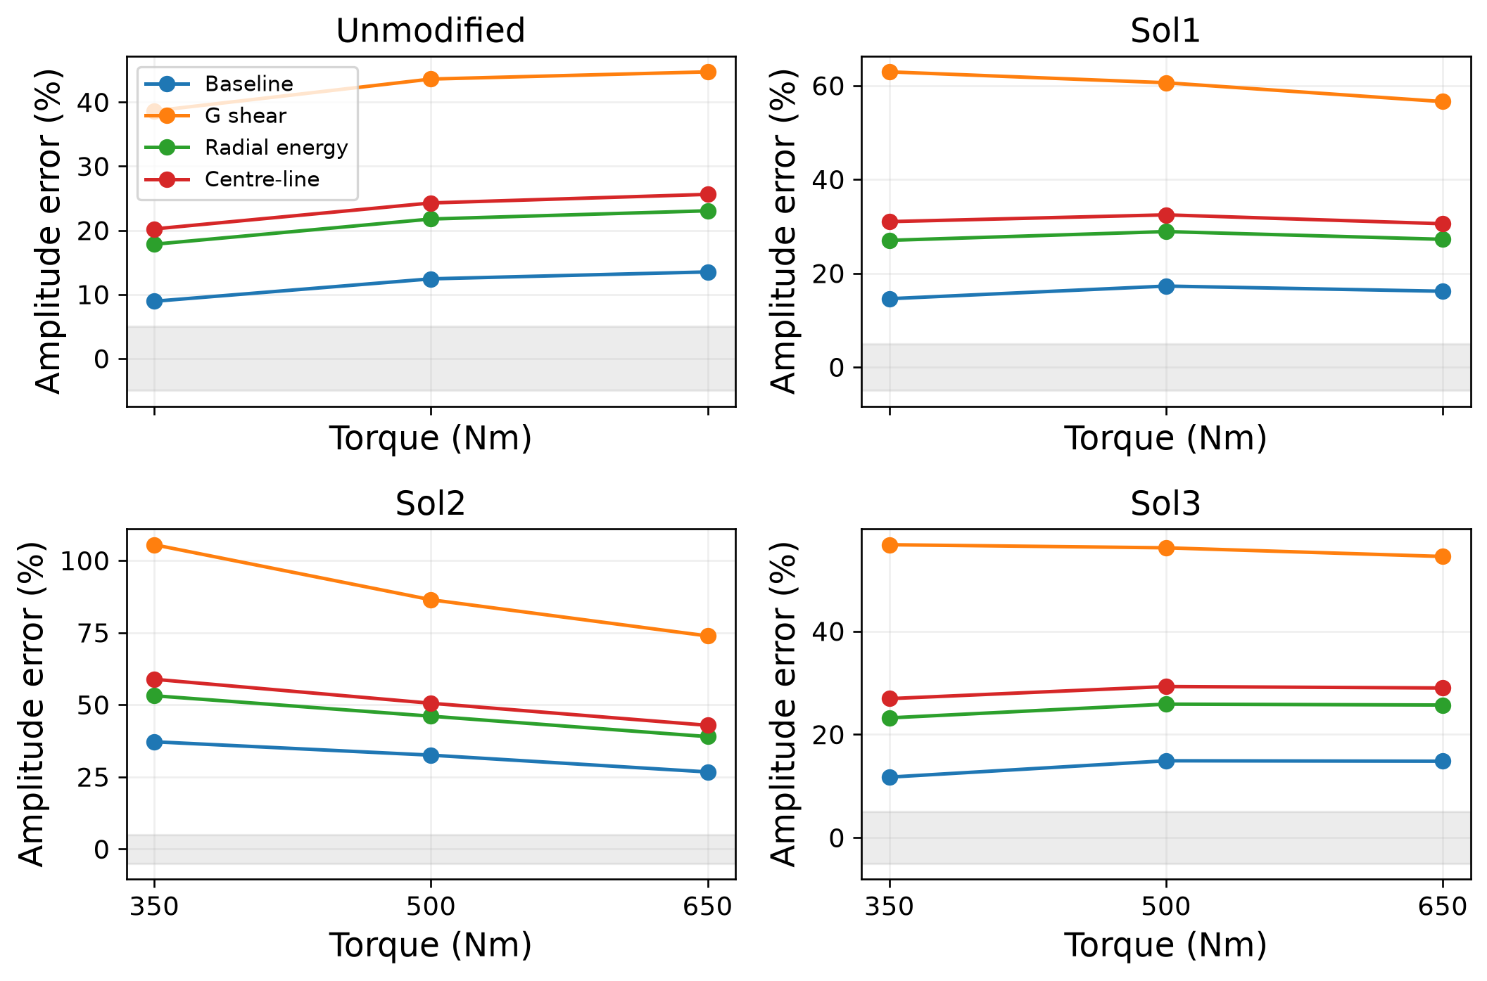
Figure 1 Compliance variants compared with external FE amplitudes. The shaded ±5% band is the adopted research target.
Baseline relative amplitude errors span 8.9–37.2%, compared with 38.6–105.5% for the shear-G variant, 17.8–53.1% for radial energy and 20.2–58.8% for centre-line energy (Table 2). The constitutive correction does not close the external discrepancy. Internal approach and stiffness curves in Figure 2 explain differences among operators but provide no additional external validation.
Narrow engagement transitions make peak-to-peak amplitude more sensitive to angular sampling than cycle RMS. Refining a local 0.06° transition window reduces the maximum adjacent response change approximately in proportion to angular step. This is consistent with a narrow continuous transition in the analytical operator; it does not establish the physical transition shape. The reference angular increment is 0.21°, and offset controls for the analytical waveform cannot replace a resolved reference waveform.
The full numerical reference waveforms, original CAD and complete solver configuration are not included in the numerical target data. We therefore compare the stated gear dimensions, torque and relief convention, while treating support, root geometry, contact discretization and dimensional reduction as unmatched assumptions. The available amplitude targets permit an amplitude-fidelity test, not a pointwise waveform validation or a decomposition of discrepancy into its mechanical causes.
Table 2 Error ranges over twelve benchmark cases and internal unmodified response at 650 Nm, 1920 positions. Approach and RMS are µm; stiffness is N/µm.
Variant | Relative % | Signed Δ µm | 1 pair | 2 pairs | RMS | Stiffness
Baseline | 8.9–37.2 | 0.442–1.781 | 28.52 | 18.12 | 5.25 | 323.9–535.5
G shear | 38.6–105.5 | 2.142–4.926 | 35.69 | 22.16 | 6.81 | 258.2–435.6
Radial energy | 17.8–53.1 | 0.876–2.598 | 29.87 | 18.22 | 5.84 | 312.2–533.1
Centre-line | 20.2–58.8 | 1.016–2.860 | 30.46 | 18.57 | 5.97 | 305.8–522.7

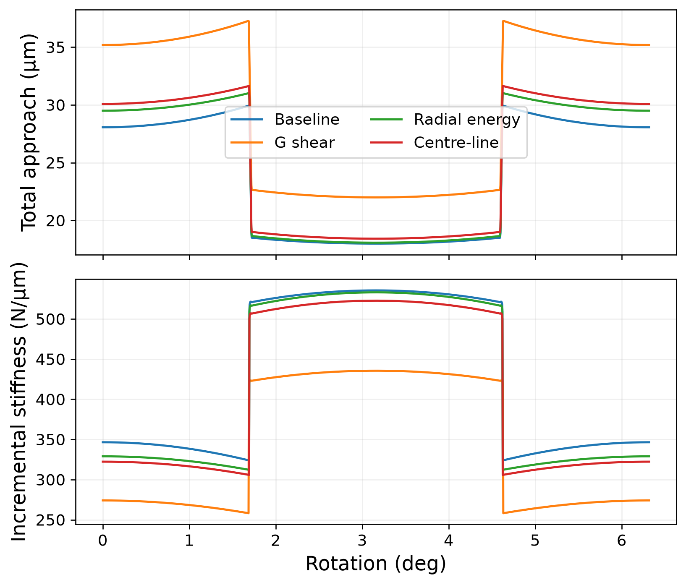
Figure 2 Internal total approach and incremental mesh stiffness for the unmodified benchmark at 650 Nm. Variant names match the tables.

4.2 Transition into loaded support
We hold Cₐ=0.020 mm, sₐ=0.75 and C_{d}=0.005 mm and vary s_{d} from 0.20 to 0.50 in increments of 0.01 at 100 Nm with 240 angular positions. The isolated dedendum signal is the RMS difference from C_{d}=0 at identical addendum settings. Two fixed starts, (0.030,0.65,0.010,0.35) and (0.015,0.85,0.020,0.45), are independent of the generating truth. Parameter errors use the scales in Section 2.3.
Starts from 0.20 to 0.23 have zero sampled dedendum signal and rank two. Once the relief reaches loaded contact, the rank rises to four while the signal can remain small compared with the imposed noise. It first exceeds 0.1 µm at the tested start 0.43. This per-sample signal comparison is descriptive: the information in an entire cycle also depends on sample count and coupling between depth and start.
The deeper-support cases show that the nominal weak regime is not universal. Figure 3 connects the onset of nonzero response to improved noiseless recovery. The contact-support condition explains the zero-signal cases; singular values and nonlinear profiles are needed to assess the nonzero-signal cases.
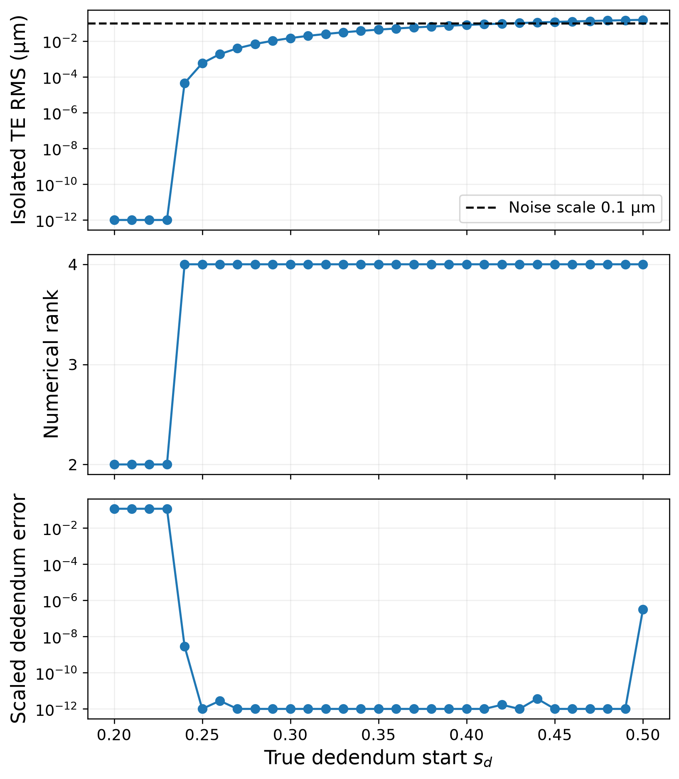
Figure 3 Transition in dedendum signal, local rank and noiseless multistart recovery as the true relief start moves into the loaded flank.

4.3 Nonlinear uncertainty and noise recovery
We compare s_{d}=0.25 and 0.40 using the same depths and addendum start, at either 300 Nm or 50/300 Nm and 120 observations. The depth profile uses 41 points from 0 to 50 µm; the start profile uses 46 points from 0.05 to 0.50. Three starts per profile point comprise the unrestricted estimate and the two fixed guesses. Each of twelve Monte Carlo cells contains 100 independent Gaussian realizations at σ=0.1,0.5 or 1.0 µm. Both fixed starts are optimized and the smaller objective is retained, including its convergence status. Seed indices act as common random numbers in paired design comparisons.
The error metrics are the maximum scaled error within each relief block, profile RMS on 1001 full-flank coordinates, fit residual and prediction RMS on a noise-free held-out 200 Nm curve with 240 positions. The latter tests transfer within the same operator. These noise scenarios do not include mechanical discrepancy. To assess optimizer termination, the 65 flagged fits across the main and complementary-phase experiments were refitted from four additional starts with an increased evaluation budget. Per-cell median dedendum errors changed by at most 0.0034. This supports stability of those summaries under the tested search expansion without establishing global minimization.
At s_{d}=0.25, the sampled profiles remain nearly flat over both tested parameter domains (Table 3). Fits on the exactly invariant subset C_{d}=0 with an unloaded start incur little additional objective. The noisy observations cannot distinguish the weakly active truth from this subset. This is practical non-identifiability at the truth, rather than proof that its nonzero local sensitivity vanishes.
At s_{d}=0.40, the invariant subset is penalized and the profiles are more concentrated (Figure 4). All selected profile-point fits report convergence. The sampled accepted-grid extrema remain resolution-dependent diagnostics and should not be interpreted as confidence endpoints with established coverage.
Table 3 Profile grid resolution and accepted-grid extrema at Δχ²≤3.841. Values are sampled extrema, not interpolated or coverage-certified confidence endpoints.
True s_{d} | Nm | Parameter | Step | Grid extrema | Max Δχ²
0.25 | 300 | s_{d} | 0.01 | 0.05–0.5 | 7.25e-13
0.25 | 300 | C_{d} µm | 1.25 | 0–50 | 0
0.25 | 50/300 | s_{d} | 0.01 | 0.05–0.5 | 0.0927
0.25 | 50/300 | C_{d} µm | 1.25 | 0–50 | 0.0927
0.4 | 300 | s_{d} | 0.01 | 0.39–0.5 | 43.8
0.4 | 300 | C_{d} µm | 1.25 | 2.5–5 | 43.8
0.4 | 50/300 | s_{d} | 0.01 | 0.33–0.4 | 60.6
0.4 | 50/300 | C_{d} µm | 1.25 | 5–15 | 60.6

The main campaign contains 1200 selected fits, with 1155 reporting convergence; all 1200 enter the summaries. At 300 Nm and σ=0.1 µm, median scaled dedendum error is 0.394 at s_{d}=0.25 and 0.106 at s_{d}=0.40 (Table 4). Full-profile and held-out response errors distinguish geometrical uncertainty from the ability to reproduce a response inside the same model.
Box constraints affect high-noise errors and their quantiles (Table 5). A 50 µm depth bound caps the relevant scaled error at 4.5; saturation is therefore not evidence of a well-determined parameter. The paired summaries in Table 6 compare the original load allocations, whose marginal-support contrast also changes phase sampling.
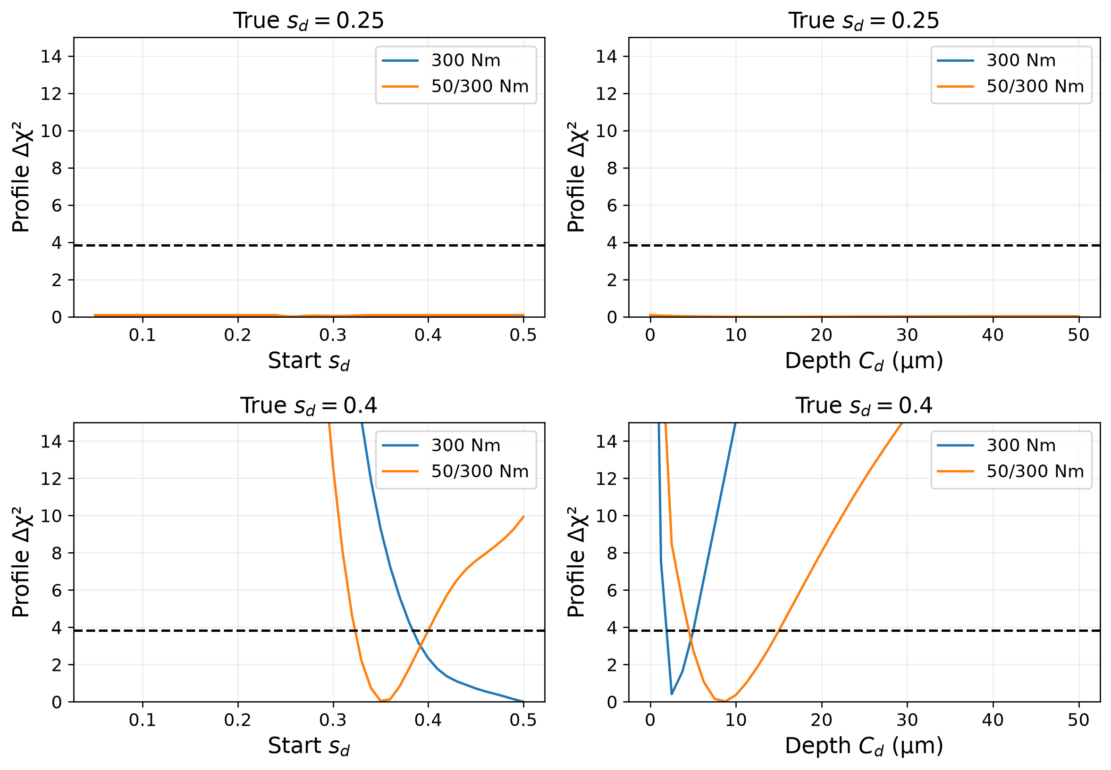
Figure 4 Profiles with other coordinates refitted. Values above Δχ²=15 are clipped only for display; grid steps are 0.01 in start and 1.25 µm in depth.
The complementary-phase experiment uses 50 Nm on even canonical indices and 300 Nm on odd indices, retaining 120 observations and pairing noise by canonical phase. It adds 600 selected fits, including 20 nonconverged fits. All six percentile-bootstrap intervals for paired dedendum error include zero (Table 7). No statistically resolved advantage of this allocation is demonstrated at either start. Ties at bounds and finite optimization tolerances preclude treating this result as an equivalence test.
In the deeper 300 Nm case, the weakest-direction Fisher prediction gives an absolute-error median of 0.1059 against 0.1075 after projecting the Monte Carlo errors onto that direction. The Gaussian prediction for maximum dedendum error is 0.1041 against 0.1058. At marginal support, unconstrained local Gaussian errors extend beyond the admissible box, so profile objectives and nonlinear simulations provide the more informative uncertainty description. Supplementary Table S1 separates these statistics.
Table 4 Monte Carlo medians at 120 observations. Parameter errors use declared scales; profile and held-out errors are µm. Success is out of 100 seeds.
True s_{d} | Nm | σ µm | Success | Addendum | Dedendum | Profile RMS | Held-out RMS
0.25 | 300 | 0.1 | 94 | 0.00149 | 0.394 | 0.878 | 0.0106
0.25 | 300 | 0.5 | 96 | 0.00708 | 0.295 | 0.779 | 0.0541
0.25 | 300 | 1 | 92 | 0.015 | 0.37 | 0.987 | 0.111
0.25 | 50/300 | 0.1 | 97 | 0.00173 | 0.467 | 1.05 | 0.0142
0.25 | 50/300 | 0.5 | 95 | 0.00876 | 0.433 | 0.978 | 0.0682
0.25 | 50/300 | 1 | 89 | 0.0181 | 0.445 | 1.13 | 0.136
0.4 | 300 | 0.1 | 100 | 0.00171 | 0.106 | 0.269 | 0.0155
0.4 | 300 | 0.5 | 99 | 0.00758 | 0.325 | 0.847 | 0.0675
0.4 | 300 | 1 | 98 | 0.0146 | 0.337 | 1.1 | 0.112
0.4 | 50/300 | 0.1 | 100 | 0.00177 | 0.107 | 0.269 | 0.017
0.4 | 50/300 | 0.5 | 100 | 0.00906 | 0.32 | 0.941 | 0.0765
0.4 | 50/300 | 1 | 95 | 0.0177 | 0.495 | 1.48 | 0.139

Table 5 Bound-hit percentages and median maximum scaled dedendum movement from the selected start. A hit is within 10⁻⁶ of box width from a bound; all selected fits are included.
True s_{d} | Nm | σ µm | Any ded. % | C_{d} upper % | s_{d} bound % | Movement
0.25 | 300 | 0.1 | 17 | 12 | 5 | 0.947
0.25 | 300 | 0.5 | 25 | 14 | 11 | 1.66
0.25 | 300 | 1 | 31 | 11 | 20 | 1.32
0.25 | 50/300 | 0.1 | 17 | 12 | 5 | 1.35
0.25 | 50/300 | 0.5 | 18 | 12 | 5 | 1.63
0.25 | 50/300 | 1 | 23 | 15 | 8 | 1.66
0.4 | 300 | 0.1 | 3 | 0 | 3 | 1.36
0.4 | 300 | 0.5 | 33 | 9 | 24 | 1.02
0.4 | 300 | 1 | 38 | 12 | 25 | 1.3
0.4 | 50/300 | 0.1 | 2 | 0 | 2 | 1.3
0.4 | 50/300 | 0.5 | 16 | 8 | 8 | 1.21
0.4 | 50/300 | 1 | 27 | 16 | 11 | 1.21

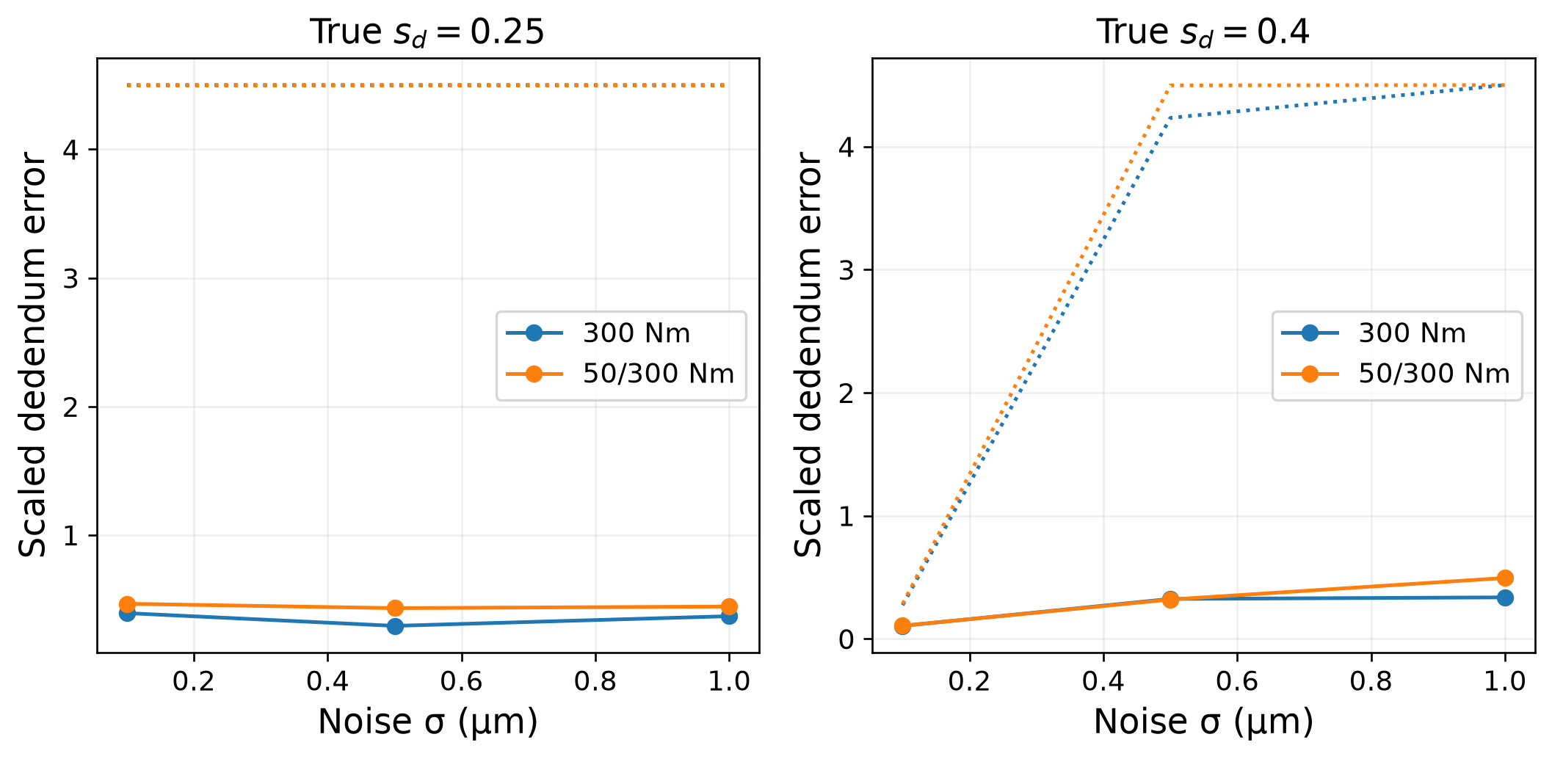
Figure 5 Dedendum error under 100 realizations per cell. Solid lines are medians; dotted lines are 90th percentiles and can reach the imposed error cap 4.5.
Table 6 Paired two-load-minus-single-load dedendum error, with 5000 bootstrap resamples of 100 seed pairs. Negative favours 50/300 Nm. Bounds concern a simulation statistic, not physical parameter intervals.
True s_{d} | σ µm | Median Δ | Lower 2.5% | Upper 97.5% | Pair better %
0.25 | 0.1 | +0.05072 | -0.001187 | +0.1208 | 41
0.25 | 0.5 | +0.08965 | -0.06502 | +0.218 | 46
0.25 | 1 | +0.04639 | -0.05177 | +0.2127 | 46
0.4 | 0.1 | -0.006372 | -0.02485 | +0.01801 | 54
0.4 | 0.5 | +0.02225 | -0.07659 | +0.182 | 48
0.4 | 1 | +0.1406 | -0.03583 | +0.3354 | 43

Table 7 Complementary-phase control, 100 realizations per cell. Dedendum errors use declared scales. Δ is the median of paired error differences, not the difference of the two medians; 95% percentile bounds use 5000 seed-pair bootstrap samples.
True s_{d} | σ µm | Success | Single median | Pair median | Paired Δ | Lower | Upper
0.25 | 0.1 | 95 | 0.394 | 0.422 | 0.00607 | -0.000265 | 0.0222
0.25 | 0.5 | 96 | 0.295 | 0.35 | 4.72e-07 | 0 | 0.0299
0.25 | 1 | 94 | 0.37 | 0.386 | 0 | -0.00845 | 0.0259
0.4 | 0.1 | 100 | 0.106 | 0.115 | -0.000154 | -0.011 | 0.00758
0.4 | 0.5 | 98 | 0.325 | 0.294 | -0.00827 | -0.0277 | 0
0.4 | 1 | 97 | 0.337 | 0.443 | 1.94e-05 | 0 | 0.0149

4.4 Load and geometry dependence
The singular spectra show that higher torque does not by itself remove the weak direction (Figure 6). At marginal support, the smallest singular value is especially sensitive to the angular grid. Shared dense grids normalized to 120 observations and actual interleaved designs distinguish this sampling effect from a torque effect (Supplementary Tables S2–S4).
At s_{d}=0.25, repeating 300 Nm on the original 60-position grid gives a smallest singular value of 0.01501, close to 0.01524 for the original 50/300 Nm allocation. Complementary phases restore values near the 120-position single-load result 0.03581. At s_{d}=0.40, the two complementary-load values 6.157 and 6.106 remain below the single-load value 6.368. These are local comparisons at specified truths, not a universal torque-selection rule.
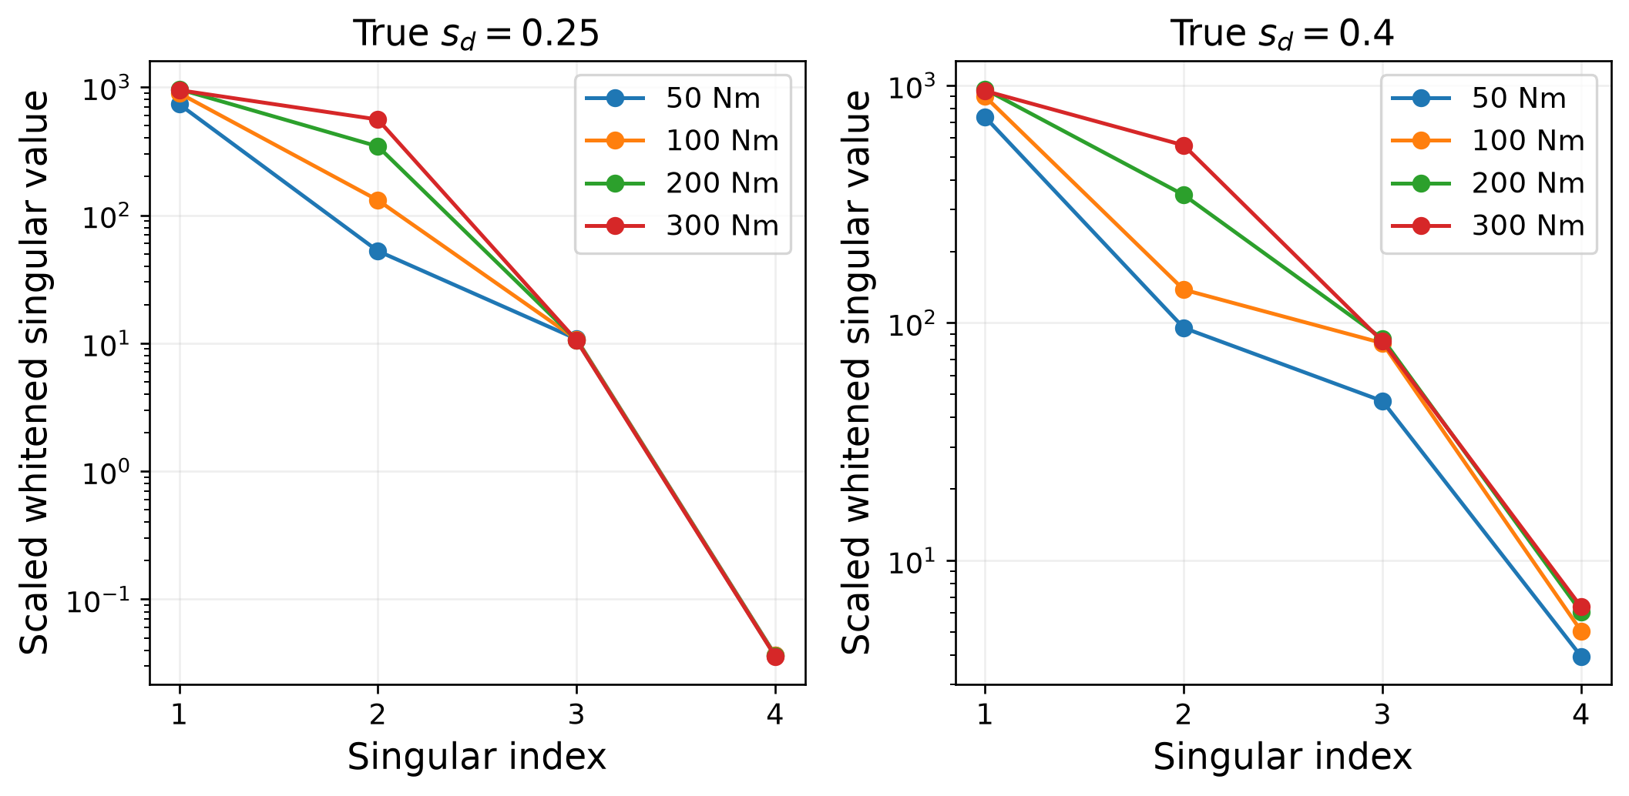
Figure 6 Full scaled whitened singular spectra at 120 positions and σ=0.1 µm. Marginal smallest singular values are grid dependent; see Supplementary Tables S2–S4.
At fixed budget, the conditional addendum log-determinant is 26.3587 for 300 Nm and 25.9955 for 200/300 Nm. Replication at 100/100 Nm is nearly equivalent to one 100 Nm cycle. These scores concern a specified block and phase grid. Allocating half the observations to 50 Nm reduces addendum information; whether it benefits the dedendum must be assessed from its spectrum and nonlinear recovery rather than from an addendum score.
The additional pairs are G1=(20,60,2.5,15), G2=(30,45,4.0,25) and G3=(18,64,2.0,12), with fields (z₁,z₂,m mm,b mm), α=20° and depths scaled with module. All pinions exceed the standard unshifted undercut threshold 2/sin²20°≈17.1. These ideal involute examples test the geometry dependence of the operator, not manufacturing fidelity.
At s_{d}=0.25 and 300 Nm, G1 and G3 have minimum loaded coordinates near 0.138 and 0.079 and appreciable dedendum sensitivity. G0 is marginal, whereas G2 has no loaded dedendum support and rank two (Table 8). At s_{d}=0.40, G2 gains support overlap and noiseless four-parameter recovery. The useful pre-inversion diagnostic is therefore the loaded-coordinate range for the intended geometry and loads, followed by phase refinement and sensitivity analysis when overlap exists.
Table 8 Support and sensitivity by geometry and design: 120 observations, σ=0.1 µm for scaling. Count includes repeated phases and pairs; dedendum error is scaled noiseless recovery error.
Pair | True s_{d} | Nm | ξ_{min} | ξ<s_{d} count | σ₄ | Rank | Ded. error
G0 | 0.25 | 300 | 0.2356 | 4 | 0.036 | 4 | 7.9e-14
G0 | 0.25 | 50/300 | 0.2400 | 4 | 0.015 | 4 | 2.14e-13
G0 | 0.4 | 300 | 0.2356 | 43 | 6.37 | 4 | 2.78e-16
G0 | 0.4 | 50/300 | 0.2400 | 42 | 5.87 | 4 | 1.67e-16
G1 | 0.25 | 300 | 0.1383 | 26 | 6.7 | 4 | 9.55e-13
G1 | 0.25 | 50/300 | 0.1431 | 26 | 6.3 | 4 | 1.04e-15
G1 | 0.4 | 300 | 0.1383 | 61 | 19 | 4 | 1.13e-14
G1 | 0.4 | 50/300 | 0.1431 | 60 | 17.8 | 4 | 3.09e-14
G2 | 0.25 | 300 | 0.3401 | 0 | 0 | 2 | 1.8
G2 | 0.25 | 50/300 | 0.3406 | 0 | 0 | 2 | 0.354
G2 | 0.4 | 300 | 0.3401 | 19 | 0.494 | 4 | 3.64e-15
G2 | 0.4 | 50/300 | 0.3406 | 18 | 0.515 | 4 | 1.72e-14
G3 | 0.25 | 300 | 0.0794 | 37 | 23 | 4 | 8.05e-16
G3 | 0.25 | 50/300 | 0.0799 | 38 | 24 | 4 | 2.5e-16
G3 | 0.4 | 300 | 0.0794 | 69 | 26.4 | 4 | 1.5e-15
G3 | 0.4 | 50/300 | 0.0799 | 70 | 26.6 | 4 | 8.67e-16

Controlled compliance cross-inversions use the same geometry and Hertz law. One replaces the baseline by a constant derived from mean approach divided by force; another scales its variation about the pitch point. Their nonlinear load sharing prevents interpretation as pure stiffness-wave perturbations. They diagnose sensitivity to an operator change rather than furnish an independent mechanical validation. A separate gain-bias experiment likewise illustrates this distinction: at 5% unmodelled gain error, dedendum depth shifts reach 0.045 mm and start shifts reach 0.14, while addendum changes remain below 0.0024 mm and 0.012. Weak relief coordinates can absorb measurement-chain error.

4.5 Cross-operator contact tests
The finite-element generator uses two-dimensional plane-strain elasticity, fixed normals and frictionless unilateral contact. Relief enters as an added gap on a nominal contour; the compliance matrix is shared by the unmodified, addendum-only and combined-relief cases. This changes the elastic discretization relative to the beam operator but retains fixed sections. The tests therefore assess sensitivity and inversion across two contact operators under a shared geometrical assumption. A separate contour-modification experiment below changes the elastic domain itself. Its limited phase set and geometry differ from the gap-only inverse experiment; the two tests answer distinct questions.
For the 57/57 pair at 650 Nm, nineteen interior phases of a 25-phase FE calculation are used after excluding six restricted phases. The minimum loaded coordinate over the retained phases is 0.6953, above the tested dedendum starts 0.30 and 0.45. Combined-relief and addendum-only curves are identical. This verifies the support prediction within a coupled, fixed-compliance FE gap model; the shared nominal sections limit its independence as a test of physical material removal.
Table 9 Analytical inversion of the 57/57 interior FE observations. Depths are mm; residual and predicted versus FE sampled range are µm. The dedendum estimates retain their initial values because no dedendum signal is present.
Variant | Case | Cₐ | sₐ | C_{d} | s_{d} | TE RMS | Range pred/FE
legacy | addendum | 0.0175 | 0.7413 | 0.0200 | 0.45 | 0.109 | 12.30 / 12.42
legacy | dedendum | 0.0175 | 0.7413 | 0.0200 | 0.45 | 0.109 | 12.30 / 12.42
legacy | dedendum-deep | 0.0175 | 0.7413 | 0.0200 | 0.45 | 0.109 | 12.30 / 12.42
projected-energy | addendum | 0.0206 | 0.7722 | 0.0100 | 0.35 | 0.151 | 12.90 / 12.42
projected-energy | dedendum | 0.0206 | 0.7722 | 0.0100 | 0.35 | 0.151 | 12.90 / 12.42
projected-energy | dedendum-deep | 0.0206 | 0.7722 | 0.0100 | 0.35 | 0.151 | 12.90 / 12.42

Addendum depth errors are approximately 2.5 µm for the baseline and 0.6 µm for radial energy, with TE residuals of 0.109–0.151 µm. Dedendum coordinates that remain at their initialization carry no geometrical information. A residual in TE units is not a bound on profile accuracy; such a bound would also require inverse stability and a discrepancy model.
The 24/24 test uses m=3 mm, b=20 mm, 300 Nm and true θ=(0.020,0.75,0.010,0.50). Of 120 phases, 102 share unrestricted contact patches. A minimum loaded coordinate below 0.50 establishes overlap at some sampled contacts, rather than penetration at every phase. The combined-relief response differs from the nominal profile by 1.7684 µm RMS, and the addendum-only response by 1.7876 µm. Isolating dedendum requires subtracting the latter from the former: the signal is 0.1790 µm RMS, compared with 0.1966 µm for radial energy, a ratio of 0.910. The combined-versus-nominal contrast does not measure dedendum sensitivity.
A two-start radial-energy inversion estimates θ=(0.01626, 0.80278, 0.01022, 0.30062), with a dedendum-depth error of 0.2214 µm but a start error of 0.1994. Its full-profile RMS error is 1.759 µm, compared with a TE residual of 0.278 µm. Over 50 noise realizations, the median profile RMS error is 2.065 µm. These profile errors preclude treating a close depth estimate as validation of the complete relief shape.
The restricted comparison uses 26 fixed and broadly distributed starts per fit. Depth profiles cover 41 values and start profiles 46 values, with five starts per point. The assumed objective scale is 0.1 µm; under cross-operator discrepancy, objective increases are conditional diagnostics rather than calibrated physical significance levels.
The legacy formulation gives θ=(0.01569, 0.84733, 0.00262, 0.17949), a TE residual of 0.8545 µm and profile RMS error 3.435 µm. Fixing C_{d}=0 and the redundant s_{d} gives residual 0.8545 µm and objective increase Δχ²=8.582e-07 (Figure 7).
The projected-energy formulation gives θ=(0.01626, 0.80278, 0.02584, 0.23683), a TE residual of 0.2778 µm and profile RMS error 3.402 µm. Fixing C_{d}=0 and the redundant s_{d} gives residual 0.2778 µm and objective increase Δχ²=5.223e-09 (Figure 7).
Neither formulation distinguishes the presence of dedendum relief in these data: the null-model objective increases are below 10⁻⁶. Both depth profiles remain flat over 0–50 µm and both start profiles over 0.05–0.50 at the numerical resolution of the search. At each broad-start optimum, the dedendum Jacobian columns vanish and the numerical rank is two. The same holds for the two-start radial-energy fit: s_{d}=0.300621 is below its first loaded coordinate 0.303605. Deleting its fitted dedendum leaves the predicted TE exactly unchanged. The near-true depth is consequently one arbitrary value in an invariant fit set, rather than evidence of depth recovery. A nonzero signal in the FE generator has not translated into identifiable relief in the inverse operator.
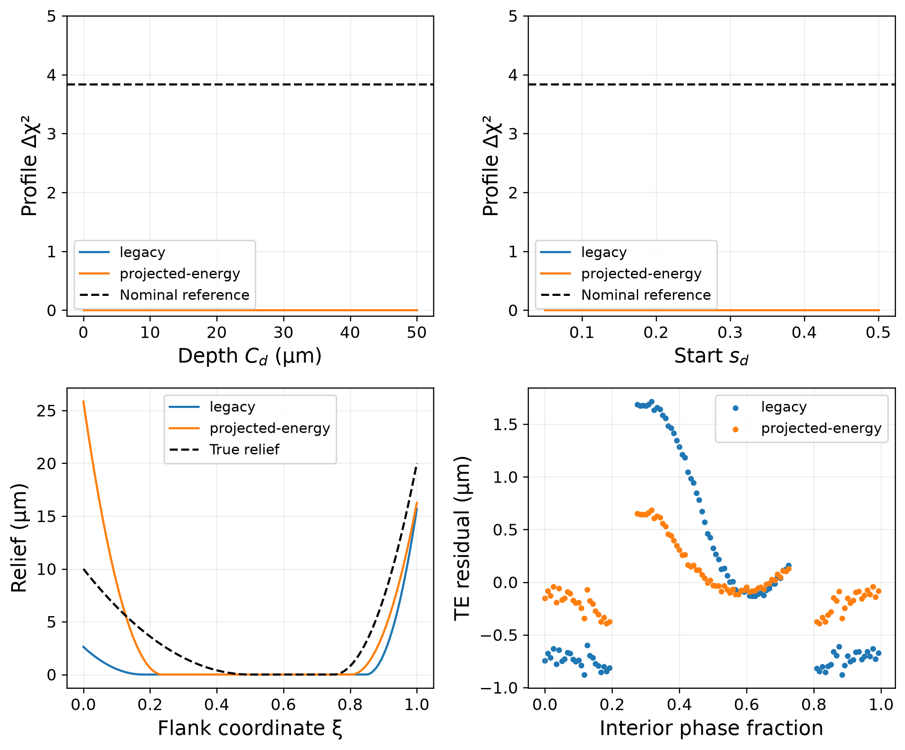
Figure 7 Cross-operator uncertainty for the 24/24 gap test. Profile objectives refit the remaining parameters; 3.841 is an uncalibrated nominal reference. Lower panels compare full-flank profiles and TE residuals at retained interior phases. Curves above the displayed objective range remain available in the numerical records.
A dedicated bulk-mesh study uses h=0.50, 0.35 and 0.25 mm with P1 elements, the same 102 interior phases and fixed 0.02 mm nodal contact spacing. For each level, both the isolated dedendum response and the radial-energy inverse are recomputed. This controls bulk discretization for the actual inversion geometry while keeping the interface and nominal contour fixed; it is not a contact-interface or physically modified-geometry convergence certificate.
Across these levels, isolated dedendum signals are 0.17899, 0.17899, 0.17897 µm RMS and inverse TE residuals are 0.27775, 0.36776, 0.42389 µm. Supplementary Table S16 reports the associated parameter and profile errors. Parameter stability is interpreted separately from forward-signal stability, because a flat inverse objective can amplify small discretization changes.
The isolated signal changes by only 0.0137% on the last refinement, whereas the inverse residual changes by 15.26%. The arbitrary dedendum estimates and full-profile errors also vary. Thus this sequence supports stability of the isolated response contrast, but does not establish mesh-independent inverse recovery. A converged inversion is not claimed.
Full-waveform and mask controls distinguish stability of a response contrast from convergence of the observations themselves. On the same 102 phases, the combined-relief waveform changes by 0.1413 and 0.2179 µm RMS from h=0.50 mm to 0.35 and 0.25 mm, respectively, despite correlations exceeding 0.9998. The corresponding changes in the isolated dedendum waveform are only 0.00106 and 0.00114 µm RMS (Figure 8; Supplementary Table S17). Subtraction cancels much of the common elastic-discretization change. A stable differential signal can therefore coexist with a moving total waveform and a larger residual against an unchanged analytical operator. These comparisons diagnose the tested mesh sequence, not its asymptotic limit.
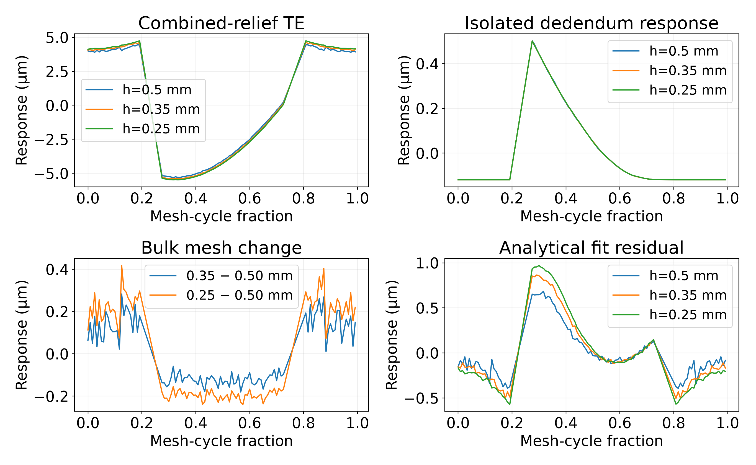
Figure 8 Mean-removed waveforms on the 102 common interior observations: combined-relief response, isolated dedendum contrast, change from the coarsest bulk mesh, and analytical inverse residual. Lines connect retained samples; unresolved transition values are not supplied.
The phase mask excludes 18 of the original 120 stations where the nominal interior contact patch is clipped. Eroding the retained mask by one, two and three neighbouring stations around each excluded block leaves 98, 94 and 90 observations. Eight starts are used for both unrestricted and addendum-only fits on each mask. Residuals decrease from 0.2778 to 0.2524 µm with erosion, but unrestricted and restricted objectives remain equal within 1.1×10⁻⁷ in χ² (Supplementary Table S18). Failure to establish dedendum presence is therefore robust to these additional exclusions, within resolved interior data. At the generating truth, the analytical full-cycle smallest singular value, normalized to 120 observations, is 3.706 versus 0.981 on the original interior mask and 0.821 after three-station erosion. The omitted region is informative in the analytical model; it cannot be counted as observed FE information without resolving its contact geometry.
A separate interface control uses P2 elasticity at h=0.35 mm and pressure-hat spacings 0.04, 0.02 and 0.01 mm. The 71 geometric trace vertices, 0.02 mm local mesh target, normals and body meshes are fixed across pressure spacings; gaps are averaged with the consistent linear-hat mass matrix. Twenty-four common phases are selected uniformly from 68 of the 102 interior phases whose candidate traces lie above both root-blend boundaries. This eligibility rule is saved with the records. The test isolates interface spacing on that subset rather than replacing the original P1 inverse data.
The isolated dedendum RMS values at successive interface spacings are 0.083208, 0.085275, 0.085008 µm. The last refinement changes that RMS by -0.313% and the combined waveform by 0.000716 µm RMS (Supplementary Table S19). Identical body node counts are checked phase by phase. Three interface levels provide a sensitivity check; no asymptotic convergence order, full-cycle transition convergence or inverse-parameter convergence follows from them.
A second P2 experiment physically removes material from the upper pinion flanks and their root blends. Quadratic relief with start s_{d}=0.25 and depths 10 and 50 µm displaces the polygonal contour inward. A harmonic boundary-fitted mesh deformation updates interior coordinates; elastic stiffness is reassembled and condensed anew for each depth. Bore constraints and wheel geometry are fixed, and addendum relief is absent in this controlled comparison. No extra contact gap is added. All candidate contacts lie above the modified region, so their locations, normals and pressure-load operator are unchanged by construction. Positive removed area, positive signed element-area ratios and compliance symmetry are verified. This isolates a structural effect excluded from the invariance proof.
Eight common phases are selected from 88 of the 102 interior phases for which every candidate pinion contact has ξ>0.251. The modified contour uses a 0.10 mm root-blend trim and twice the baseline contour-point density, with h=0.50, 0.35 and 0.25 mm. These settings differ from the P1 gap test and are not used to recalibrate it. The centred displacement difference is evaluated on the same eight phases at each mesh, not extrapolated to an entire cycle.
For 10 µm removal, the eight-phase centred response differences are 0.000406, 0.000400, 0.000397 µm RMS across the three bulk meshes. For 50 µm removal, the eight-phase centred response differences are 0.002110, 0.002079, 0.002063 µm RMS across the three bulk meshes. Last-refinement changes are below 0.78% for these contrasts. Nonzero compliance and displacement changes show that unloaded relief can influence transmission error through structural flexibility when fixed compliance is relaxed. They do not contradict conditional gap invariance. Their small magnitude in this test does not establish general physical invisibility, and the limited phase set does not validate physical profile recovery (Supplementary Table S20).
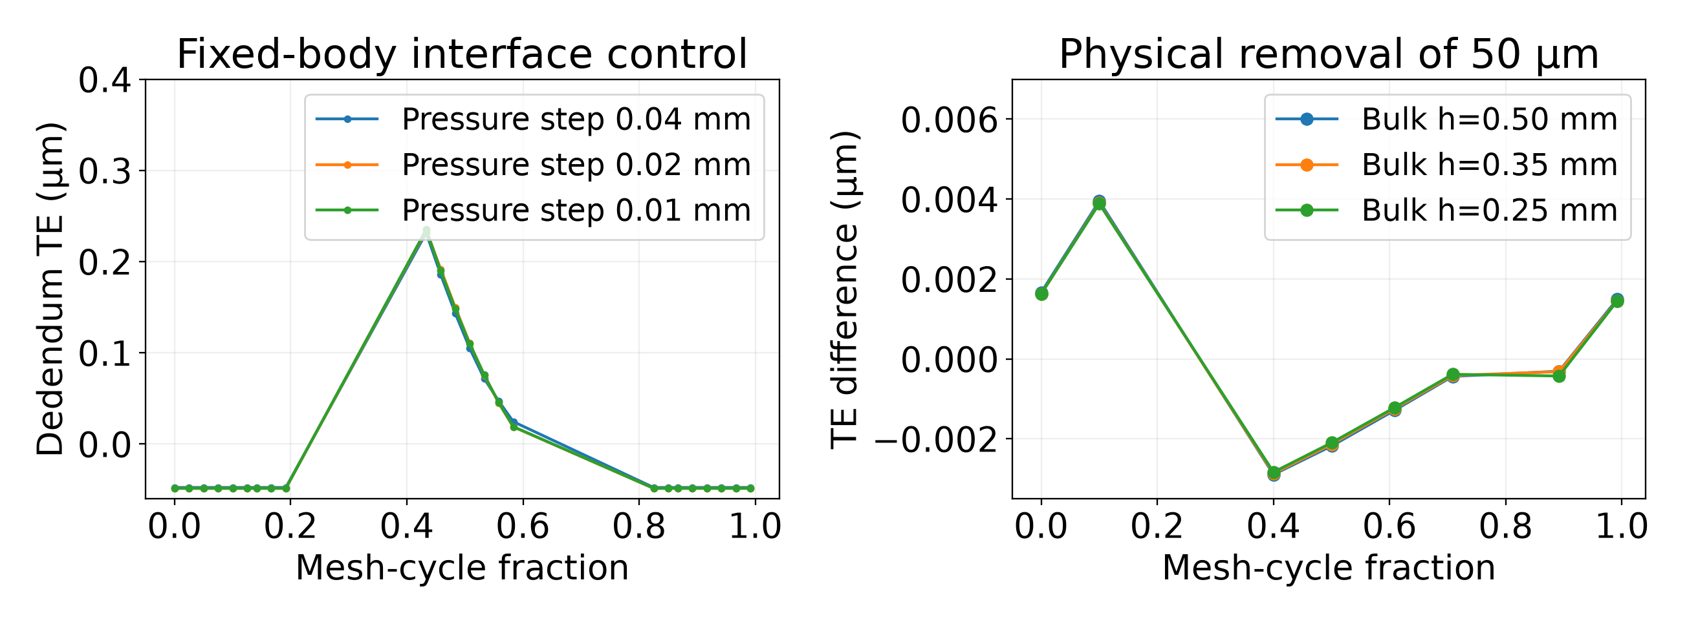
Figure 9 Dedicated P2 controls. Left: isolated dedendum contrast at three pressure-hat spacings on 24 common eligible phases and identical body meshes. Right: eight-phase centred approach change after physical 50 µm removal and elastic-stiffness reassembly at three bulk mesh sizes. Lines connect tested phases and do not imply resolution of unsampled transitions. The two panels use different phase subsets and geometry settings.
Numerical stability of the nanometre contrasts is assessed separately from their detectability in noise. On the same eight phases at h=0.35 mm, the elastic systems are refactored with an alternative sparse-LU ordering and four residual-correction steps; the condensed active-contact equations are then polished at 80 decimal digits. This tests sensitivity to algebraic solution choices without converting the full FE assembly to arbitrary precision. A zero-removal reassembly checks the numerical null contrast. A radially weighted harmonic extension changes interior mesh coordinates while preserving the identical boundary polygon. Finally, halving pressure spacing from 0.02 to 0.01 mm repeats the physical-removal contrast on these same eight phases, independently of the 24-phase interface study.
The repeated baseline contrasts are 0.399676, 2.078703 nm RMS for 10 and 50 µm removal. Relative to these centred curves, maximum RMS changes across the two depths are 9.05806e-09 nm, 0.000358193 nm, 0.0197247 nm for enhanced algebra, alternative mesh extension and halved pressure spacing, respectively (Supplementary Table S21). The largest tested curve change is 0.949% of its same-depth baseline contrast. The largest zero-removal approach difference is 2.13995e-08 nm. These are empirical numerical-stability controls, not rigorous bounds on the continuum or geometric-discretization error.
The structural contrast must also be distinguished from an observable experimental signal. Its approximately 0.4–2.1 nm RMS is 48–250 times smaller than the assumed 100 nm per-sample noise. Numerical resolution of such a contrast does not establish its detectability or identify physical relief parameters. The controls preserve the eight-phase boundary geometry and do not certify unresolved corner contacts, the complete cycle, or the 102-phase P1 inverse operator.

4.6 Resolution of a discretized relief field
A piecewise-linear relief field on 41 uniform nodes replaces the four-parameter family. At G0, 300 Nm, 120 observations and the marginal-support truth, the whitened tangent J_{h}=σ⁻¹∂F/∂h has size 120×41. We compute R=V diag[sₖ²/(sₖ²+ε²)]Vᵀ, with ε=10⁻⁶s₁, from its SVD. The diagonal describes damped resolution in that basis; it is not a probability of physical recovery.
The recomputed matrix has rank 31 and ten null directions. Nine columns vanish for nodes ξ≤0.20. The first sensitive node is ξ=0.225, below the minimum sampled contact ξ=0.235629, because its hat function extends into loaded support. Thus a sensitive nodal coordinate need not itself be a contact point. The interpolation-basis support, rather than the nodal coordinate alone, determines a zero column.
The remaining null direction is a constant over the 32 sensitive coefficients. Their hat functions sum to one at loaded contacts, so that direction shifts approach uniformly and is removed by centring. Numerically ‖J_{h1}‖/s₁≈5.5×10⁻¹⁶. In this particular discretization the resolved-subspace projector has diagonal 1−1/32 on sensitive coefficients and zero on the other nine; the damped resolution diagonal approximates it. Equality of rank to the number of sensitive coefficients minus one is a verified result for these grids, not a theorem for every sampling scheme.
At σ=0.1 µm, 26 of the 31 resolved singular directions have conditional standard deviation below 1 µm; the two weakest have 5.26 and 14.69 µm. These are local linearized uncertainties after excluding null directions and assuming the stated independent noise, fixed mechanics and fixed gauge. They do not quantify absolute nodal uncertainty or uncertainty from mechanical discrepancy. Precision is heterogeneous within loaded support, even where the resolution diagonal is near one.
A uniform 5 µm gap shift changes centred TE only at numerical roundoff. Finite perturbations supported on an unloaded basis function also leave the tested responses unchanged. Such examples verify particular finite invariances; arbitrary SVD null directions remain first-order statements unless their finite perturbations preserve the active-set and gap hypotheses. Supplementary Table S12 reports refinement of flank and angular grids.
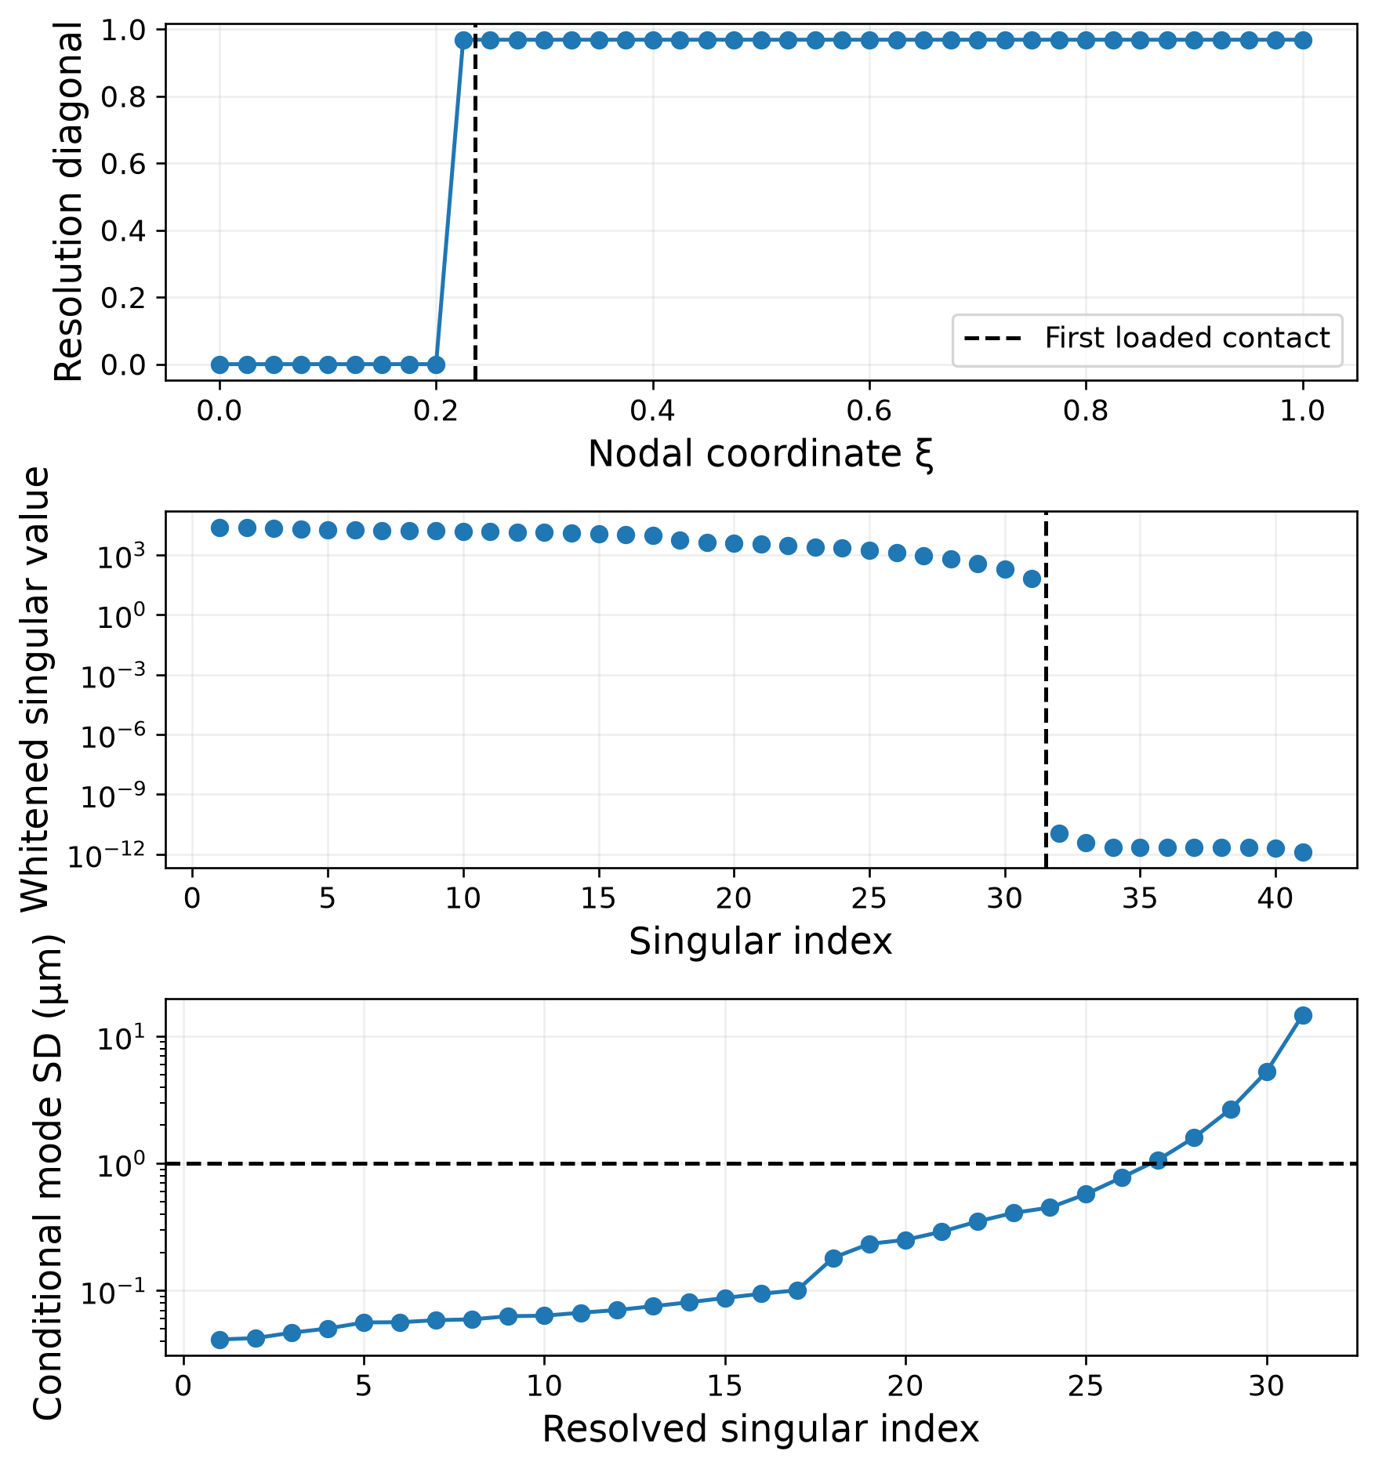
Figure 10 Resolution and conditional precision of the discretized relief. Basis support explains sensitivity at a node below the first contact. The singular spectrum and resolved-direction standard deviations refer to the local operator with σ=0.1 µm; null-direction uncertainty is not finite.

5 Discussion
Loaded support explains why a precise transmission-error fit can coexist with an uncertain profile. Outside that support, nonnegative gap relief satisfying the sufficient condition is exactly invariant. Near its boundary, nonzero sensitivity may be too weak to resolve depth and start in noise. The nominal s_{d}=0.25 experiment belongs to this second regime: rank four does not prevent its profile objectives from reaching invariant subsets. Deeper penetration improves local conditioning and nonlinear recovery, but contact overlap alone is not a sufficient identifiability test.
Sampling and load must be considered together. Changing a 120-position cycle into two 60-position cycles changes both the torque allocation and the angular grid. Common-grid, interleaved and complementary-phase controls separate these effects for the tested designs. Their bootstrap intervals do not resolve an advantage of the selected two-load allocation. This neither establishes equivalence nor implies that maximum torque is universally optimal; a load that exposes a previously unloaded relief region may have a different value.
The cross-operator experiments distinguish detecting a relief effect from reconstructing its geometry. Their isolated 24/24 dedendum signal is close to the analytical prediction. That agreement concerns an RMS response difference, not agreement of complete waveforms, stiffness fields or inverse parameters. Restricted fits and profile objectives test whether an addendum-only model explains the data and whether depth and start can compensate for each other. Bulk refinement stabilizes the isolated signal but leaves substantial changes in the inverse residual, so mesh-independent inverse recovery is not established. The inability to identify dedendum in the retained FE observations does not establish insufficiency of all possible observations. Transition phases omitted by this generator may contain additional information; their value cannot be quantified as FE evidence until their contact is resolved. Interpretation remains conditional on the phase mask, parameter bounds, numerical mesh and assumed 0.1 µm objective scale. In particular, deterministic discrepancy prevents a nominal likelihood threshold from certifying physical confidence intervals.
The external benchmark supplies a separate fidelity constraint. All four formulations systematically overpredict the twelve reference amplitudes. Correcting the shear modulus is necessary for constitutive consistency even though it worsens this comparison; closer amplitude agreement cannot validate an incorrect shear law. Projected forces and centre-line geometry reduce part of the increase but leave substantial disagreement. Root transitions, hub support, body coupling, three-dimensional effects, contact normals and engagement geometry remain possible contributors. The available amplitude targets cannot isolate their effects or determine a waveform-discrepancy covariance.
Absolute parameter accuracy would require a geometrically faithful reference or measured dataset with known modifications, compatible boundary conditions, calibrated measurement scale and resolved angular waveforms. A physically modified FE contour must also update elastic stiffness and contact geometry. The modified-contour control tests the elastic consequence of removal while keeping the candidate contact geometry unchanged by construction. It is a controlled test of a theorem hypothesis, not a validation of a complete manufactured profile, contact transitions or inverse reconstruction. The results define what follows from the declared operator and identify which additional information physical reconstruction requires.
The non-parametric analysis adds an observation-level limitation. Mean removal annihilates a uniform gap shift even where contact is loaded. Nodal resolution and uncertainties must therefore be interpreted in the resolved subspace after fixing this additive gauge. Zero columns depend on the support of the interpolation basis, while the sufficient invisibility result concerns actual contact coordinates. Neither a damped resolution diagonal nor a first-order null vector establishes global recovery of an arbitrary finite-amplitude profile.

6 Conclusions
For a fixed-geometry quasistatic gap operator, nonnegative relief outside loaded contact support can be exactly invisible to transmission error. The result extends to symmetric positive-definite coupled compliance and gives a mechanical explanation for invariant parameter sets. An implicit contact tangent connects that explanation with local rank and with the null space of a discretized relief field.
Nonlinear profiles and noise experiments distinguish this exact invariance from practical non-identifiability near the support boundary. In the nominal low-noise experiment, moving the dedendum start from 0.25 to 0.40 reduces median scaled error from 0.394 to 0.106. Local Fisher predictions are useful in the deeper regime but fail near invariant sets. Fixed-budget controls establish that angular sampling must be assessed alongside torque allocation.
Finite-element gap tests yield an isolated dedendum response of 0.179 µm RMS against an analytical 0.197 µm. However, the addendum-only inverse attains the same residual, the fitted dedendum block has zero local sensitivity and both dedendum profile objectives remain flat over the tested domains. This cross-operator test does not identify dedendum presence or geometry. The three-level bulk study stabilizes the isolated signal but does not establish convergence of inverse recovery. Physically modifying unloaded relief and reassembling stiffness gives approximately 0.4–2.1 nm centred differences in an eight-phase P2 control. Exact invariance therefore remains conditional on fixed compliance; the small physical effect does not validate profile inversion. None of the four analytical formulations meets the 5% external amplitude target across the twelve reference cases. The defensible outcome is an operator-conditioned account of observability and uncertainty, with physical profile reconstruction remaining contingent on independent mechanical and experimental validation.

Appendix A Continuum contact and discretization controls
The 57/57 continuum controls use complete plane-strain bodies with benchmark involute dimensions, E=210000 MPa, ν=0.30 and width 23 mm. Circular bores of assumed radius 25 mm are clamped relative to hub motion. A quadratic blend and 0.4 mm root trim approximate the missing manufactured fillet. These supports and contours are modelling assumptions, rather than a reconstruction of the reference CAD.
Gmsh meshes and scikit-fem elasticity yield condensed compliance H=P₁ᵀK₁⁻¹P₁+P₂ᵀK₂⁻¹P₂. Nonnegative contact coefficients minimize elastic potential under a prescribed force budget. The quadratic displacement formulation uses distributed pressure hats and matching weak gap averages; the original linear nodal formulation is recorded separately. Force equilibrium, weak-contact residuals, matrix symmetry and local force perturbations check numerical consistency.
At eight matched phases, the quadratic FE approach range is 12.463 µm and the baseline range is 11.662 µm (Table 10). These are sampled ranges of restricted operators. Two phases load clipped endpoints, and nominal contact windows omit pre-engagement corner contact. Consequently these values do not define a converged full-cycle FE amplitude or establish disagreement with the external 10.527 µm target independently of those contact assumptions.
Supplementary Tables S5–S8 distinguish bulk, interface and formulation controls for the 57/57 pair. The pressure-interface sequence is nonmonotonic, so small last-step changes are observed stability rather than an asymptotic error bound. The 0.21° sampling envelopes in Supplementary Table S9 concern specified interpolants; the eight-node FE interpolant cannot resolve the missing transition ramp.
Locally refined analytical engagement coordinates for G0 differ slightly across mechanical formulations despite coincident coarse-grid minima (Table 11). These controls establish why a support diagnostic needs phase refinement; the 57/57 continuum controls do not certify the 24/24 mesh or G0 support. The dedicated 24/24 study is reported separately in Supplementary Table S16.
Table 10 Quadratic-element weak-contact FE and baseline at identical sampled phases. Approach is µm; k/b is incremental stiffness per width, N/(mm·µm). Edge denotes load reaching a clipped flank endpoint.
Cycle fraction | Pairs | FE approach | Baseline approach | FE k/b | Baseline k/b | Edge
0.000000 | 1 | 40.575 | 28.060 | 10.276 | 15.066 | No
0.247147 | 1 | 41.962 | 29.655 | 9.955 | 14.223 | No
0.297147 | 2 | 29.909 | 18.396 | 13.887 | 22.781 | Yes
0.332147 | 2 | 29.764 | 18.265 | 13.950 | 22.941 | No
0.500000 | 2 | 29.499 | 17.992 | 14.071 | 23.282 | No
0.667853 | 2 | 29.764 | 18.265 | 13.951 | 22.941 | No
0.702853 | 2 | 29.909 | 18.396 | 13.887 | 22.781 | Yes
0.752853 | 1 | 41.962 | 29.655 | 9.955 | 14.223 | No

Table 11 Local engagement-onset coordinate for nominal G0, zero dedendum depth. Bisection starts from the 960-position support and uses force >10⁻⁸ N. This is a local numerical onset estimate, not a continuous-domain certificate.
Compliance variant | ξ onset at 50 Nm | ξ onset at 300 Nm
Baseline | 0.235526917 | 0.234681524
G shear | 0.235488940 | 0.234453741
Radial energy | 0.235507297 | 0.234563798
Centre-line | 0.235503860 | 0.234543205

Declarations
Declaration of competing interest. The authors declare that they have no competing financial interests or personal relationships that could have influenced the work reported in this article.
Declaration of generative AI use. During preparation of this work, Kimi (Moonshot AI) and ChatGPT with Codex (OpenAI) were used to assist with code inspection, numerical analysis and manuscript drafting. The authors are responsible for reviewing and verifying the assisted content and for the scientific accuracy and integrity of the submitted article.
CRediT authorship contribution statement. Romulo Sandoval Flórez: Conceptualization, Methodology, Software, Formal analysis, Investigation, Writing – original draft, Writing – review & editing, Visualization, Supervision. Claudia Patricia Parra Medina: Conceptualization, Methodology, Software, Formal analysis, Investigation, Writing – original draft, Writing – review & editing, Visualization, Supervision. German Leandro Vargas Fonseca: Conceptualization, Methodology, Software, Formal analysis, Investigation, Writing – original draft, Writing – review & editing, Visualization, Supervision.
Data availability. The baseline source code and numerical records are available at https://github.com/romusan/gears-inversion-reproducibility/tree/manuscript-v10. The accompanying MMT_{reproducibility}_v13.zip package contains the final article, supplementary tables, scripts, new numerical records, bibliographic verification and a SHA-256 manifest. The manuscript-v10 tag identifies only the historical baseline; the current additional evidence requires the version-13 package. The versioned package is deposited at https://github.com/romusan/gears-inversion-reproducibility/tree/manuscript-v13 with its numerical records and SHA-256 manifest. The historical v10 calculations are preserved separately; no DOI is assigned.
Funding. This research received no funding from any entity.

References
[1] J.A. Korta, D. Mundo, Multi-objective micro-geometry optimization of gear tooth supported by response surface methodology, Mechanism and Machine Theory 109 (2017) 278-295. https://doi.org/10.1016/j.mechmachtheory.2016.11.015
[2] M.S. Tavakoli, D.R. Houser, Optimum Profile Modifications for the Minimization of Static Transmission Errors of Spur Gears, Journal of Mechanisms, Transmissions, and Automation in Design 108 (1986) 86-94. https://doi.org/10.1115/1.3260791
[3] D.J. Fonseca, S. Shishoo, T.C. Lim, D.S. Chen, A genetic algorithm approach to minimize transmission error of automotive spur gear sets, Applied Artificial Intelligence 19 (2005) 153-179. https://doi.org/10.1080/08839510590901903
[4] W. Mei, J. Na, F. Yang, G. Shen, J. Chen, The Optimal Design Method and Standardized Mathematical Model of Tooth Profile Modification of Spur Gear, Mathematical Problems in Engineering 2016 (2016) 1-7. https://doi.org/10.1155/2016/6347987
[5] L. Roth, C. Westphal, C. Brecher, Design of profile corrections and tolerances in cylindrical gears for noise-sensitive applications in line with production efforts, Forschung im Ingenieurwesen 89 (2025) 11. https://doi.org/10.1007/s10010-025-00786-2
[6] L. Han, Y. Qi, Recent Progress and Prospect on Tooth Modification of Involute Cylindrical
Gear, Recent Patents on Mechanical Engineering 15 (2022) 163-177. https://doi.org/10.2174/2212797614666210415111613
[7] B. Zhang, W. Teng, D. Peng, S. Han, Y. Liu, Inverse modeling with physical constraints and uncertainty correction for mesh stiffness identification in gear crack fault, Mechanical Systems and Signal Processing 250 (2026) 114142. https://doi.org/10.1016/j.ymssp.2026.114142
[8] E. Aoyama, T. Hirogaki, Y. Uenishi, Z. Kou, J. Kojima, 419 A study on meshing transmission error of spur gear used inverse problems, The Proceedings of Conference of Kansai Branch 2000.75 (2000) 4-31–4-32. https://doi.org/10.1299/jsmekansai.2000.75._4-31_
[9] C. Spitas, T. Costopoulos, V. Spitas, Direct analytical solution of the inverse gear tooth contact analysis problem, Inverse Problems in Science and Engineering 16 (2008) 171-186. https://doi.org/10.1080/17415970701256486
[10] C. Kalligeros, C. Papalexis, G. Vasileiou, P. Tzouganakis, C. Spitas, V. Spitas, Exploiting double-flank roll testing spur gear measurements to determine gear parameter deviations through numerical simulation of free-form meshing gears, Simulation Modelling Practice and Theory 126 (2023) 102757. https://doi.org/10.1016/j.simpat.2023.102757
[11] J. Flek, M. Dub, J. Kolář, F. Lopot, K. Petr, Determination of Mesh Stiffness of Gear—Analytical Approach vs. FEM Analysis, Applied Sciences 11 (2021) 4960. https://doi.org/10.3390/app11114960
[12] F. Bejar, J. Perret-Liaudet, O. Bareille, M. Ichchou, M. Fontana, Review and benchmarking study of different gear contact analysis software in terms of the static transmission error response, Results in Engineering 22 (2024) 102286. https://doi.org/10.1016/j.rineng.2024.102286
[13] P. Riera, M. Vieira, R. Rego, J. Aguirrebeitia, L.M. Macareno, Efficient nonlinear spur gear analysis using an interpolated analytical model, Journal of the Brazilian Society of Mechanical Sciences and Engineering 48 (2026) 437. https://doi.org/10.1007/s40430-026-06384-9
[14] M.B. Sánchez, M. Pleguezuelos, J.I. Pedrero, Influence of profile modifications on meshing stiffness, load sharing, and trasnsmission error of involute spur gears, Mechanism and Machine Theory 139 (2019) 506-525. https://doi.org/10.1016/j.mechmachtheory.2019.05.014
[15] M. Autiero, G. Paoli, M. Cirelli, P.P. Valentini, The effect of different profile modifications on the static and dynamic transmission error of spur gears, Mechanism and Machine Theory 201 (2024) 105752. https://doi.org/10.1016/j.mechmachtheory.2024.105752
[16] M. Ajmi, P. Velex, A model for simulating the quasi-static and dynamic behaviour of solid wide-faced spur and helical gears, Mechanism and Machine Theory 40 (2005) 173-190. https://doi.org/10.1016/j.mechmachtheory.2003.06.001
[17] P. Velex, M. Maatar, A mathematical model for analyzing the influence of shape deviations and mounting errors on gear dynamic behaviour, Journal of Sound and Vibration 191 (1996) 629-660. https://doi.org/10.1006/jsvi.1996.0148
[18] S. Baud, P. Velex, Static and Dynamic Tooth Loading in Spur and Helical Geared Systems-Experiments and Model Validation, Journal of Mechanical Design 124 (2002) 334-346. https://doi.org/10.1115/1.1462044
[19] T.J. Rothenberg, Identification in Parametric Models, Econometrica 39 (1971) 577-591. https://doi.org/10.2307/1913267
[20] R. Bellman, K.J. Åström, On structural identifiability, Mathematical Biosciences 7 (1970) 329-339. https://doi.org/10.1016/0025-5564(70)90132-x
[21] A. Raue, C. Kreutz, T. Maiwald, J. Bachmann, M. Schilling, U. Klingmüller, et al., Structural and practical identifiability analysis of partially observed dynamical models by exploiting the profile likelihood, Bioinformatics 25 (2009) 1923-1929. https://doi.org/10.1093/bioinformatics/btp358
[22] O.T. Chis, J.R. Banga, E. Balsa-Canto, Structural Identifiability of Systems Biology Models: A Critical Comparison of Methods, PLoS ONE 6 (2011) e27755. https://doi.org/10.1371/journal.pone.0027755
[23] A.F. Villaverde, A. Barreiro, A. Papachristodoulou, Structural Identifiability of Dynamic Systems Biology Models, PLOS Computational Biology 12 (2016) e1005153. https://doi.org/10.1371/journal.pcbi.1005153
[24] R.N. Gutenkunst, J.J. Waterfall, F.P. Casey, K.S. Brown, C.R. Myers, J.P. Sethna, Universally Sloppy Parameter Sensitivities in Systems Biology Models, PLoS Computational Biology 3 (2007) e189. https://doi.org/10.1371/journal.pcbi.0030189
[25] F.G. Wieland, A.L. Hauber, M. Rosenblatt, C. Tönsing, J. Timmer, On structural and practical identifiability, Current Opinion in Systems Biology 25 (2021) 60-69. https://doi.org/10.1016/j.coisb.2021.03.005
[26] F.L. Litvin, A. Fuentes, Gear Geometry and Applied Theory, Cambridge University Press, 2004. https://doi.org/10.1017/cbo9780511547126
[27] K.L. Johnson, Contact Mechanics, Cambridge University Press, 1985. https://doi.org/10.1017/cbo9781139171731
[28] H. Hertz, Ueber die Berührung fester elastischer Körper, Journal für die reine und angewandte Mathematik 92 (1882) 156-171. https://doi.org/10.1515/crll.1882.92.156
[29] D.C.H. Yang, J.Y. Lin, Hertzian Damping, Tooth Friction and Bending Elasticity in Gear Impact Dynamics, Journal of Mechanisms, Transmissions, and Automation in Design 109 (1987) 189-196. https://doi.org/10.1115/1.3267437
[30] P. Sainsot, P. Velex, O. Duverger, Contribution of Gear Body to Tooth Deflections—A New Bidimensional Analytical Formula, Journal of Mechanical Design 126 (2004) 748-752. https://doi.org/10.1115/1.1758252
[31] International Organization for Standardization, ISO 6336-1:2019 Calculation of load capacity of spur and helical gears — Part 1: Basic principles, introduction and general influence factors, ISO, Geneva, 2019. https://www.iso.org/standard/63819.html
[32] D. Remond, J. Mahfoudh, From Transmission Error Measurements to Angular Sampling in Rotating Machines with Discrete Geometry, Shock and Vibration 12 (2005) 149-161. https://doi.org/10.1155/2005/205291
[33] M.A. Branch, T.F. Coleman, Y. Li, A Subspace, Interior, and Conjugate Gradient Method for Large-Scale Bound-Constrained Minimization Problems, SIAM Journal on Scientific Computing 21 (1999) 1-23. https://doi.org/10.1137/s1064827595289108
[34] P. Virtanen, R. Gommers, T.E. Oliphant, M. Haberland, T. Reddy, D. Cournapeau, et al., SciPy 1.0: fundamental algorithms for scientific computing in Python, Nature Methods 17 (2020) 261-272. https://doi.org/10.1038/s41592-019-0686-2
[35] H.W. Engl, M. Hanke, A. Neubauer, Regularization of Inverse Problems, Springer Netherlands, 1996. https://doi.org/10.1007/978-94-009-1740-8
[36] P.C. Hansen, Discrete Inverse Problems: Insight and Algorithms, Society for Industrial and Applied Mathematics, 2010. https://doi.org/10.1137/1.9780898718836
[37] A.M. Stuart, Inverse problems: A Bayesian perspective, Acta Numerica 19 (2010) 451-559. https://doi.org/10.1017/s0962492910000061
[38] M.C. Kennedy, A. O'Hagan, Bayesian Calibration of Computer Models, Journal of the Royal Statistical Society Series B: Statistical Methodology 63 (2001) 425-464. https://doi.org/10.1111/1467-9868.00294
[39] F. Pukelsheim, Optimal Design of Experiments, Society for Industrial and Applied Mathematics, 2006. https://doi.org/10.1137/1.9780898719109
[40] J. Kiefer, General Equivalence Theory for Optimum Designs (Approximate Theory), The Annals of Statistics 2 (1974) 849-879. https://doi.org/10.1214/aos/1176342810
[41] J. Kiefer, J. Wolfowitz, The Equivalence of Two Extremum Problems, Canadian Journal of Mathematics 12 (1960) 363-366. https://doi.org/10.4153/cjm-1960-030-4
[42] K. Chaloner, I. Verdinelli, Bayesian Experimental Design: A Review, Statistical Science 10 (1995) 273-304. https://doi.org/10.1214/ss/1177009939

