What is Marx?

Marx is a simple load-balancing distributed batch job scheduler that uses a benchmark scores
injected into binary tree to load balance scheduled jobs across a network of nodes (peers).

The only dependency for this application is Libconfig:
http://www.hyperrealm.com/libconfig/

Marx is created in C, is very light weight, and only has one dependence.

General Operations of Marx

Marx utilizes Unix network sockets, TCP/IP, and the client/server model to distribute jobs to machines.
The process that sends a list of jobs to the server, is the client.
The process that distributes the jobs in an orderly fashion to the machines is the server.
The process that receives jobs to process, are the peers (can get a little confusing).
General Operations Graphical Representation:
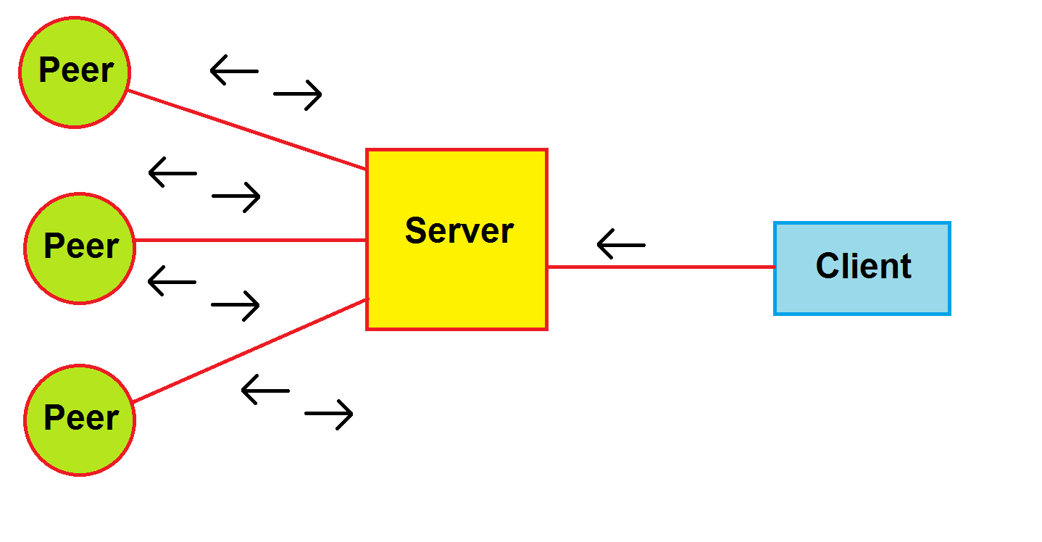
Internals of Marx

Marx itself is a combination of binary trees, linked lists, queues, and priority queues.
Each peer process, when ran will run a benchmark, and send the results to the server. The results of the benchmark (time it took to complete), is matched with other benchmarks within a range. If the bench score does not fall into a range, then a new node is added to the tree with peer information (in a linked list), otherwise the peer data is added to a linked list structure inside of a chosen tree node. The linked list that is linked in a given tree node contains peer host information used to connect to servers. The actual jobs that are sent to the peers, from the server, come from a regular text file that is sent to the server from the client. The jobs are regular terminated strings added into a queue. Then these queues are then placed inside of a priority queue that allows explicit privatization from user input, and explicit privatization from the amount of time the queues have been in the collection (heart beats).

Binary Tree and Linked Lists Graphical Representation:
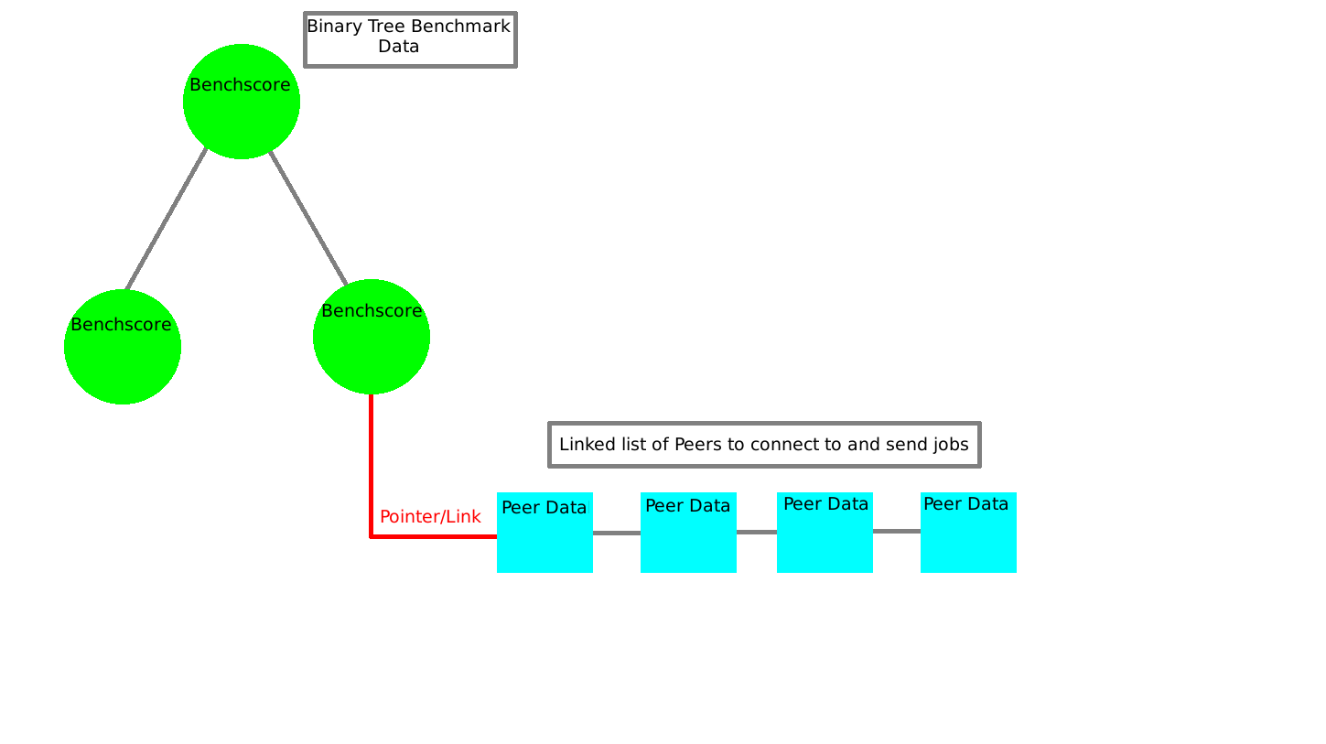
Queue and Priority Queue Graphical Representation:
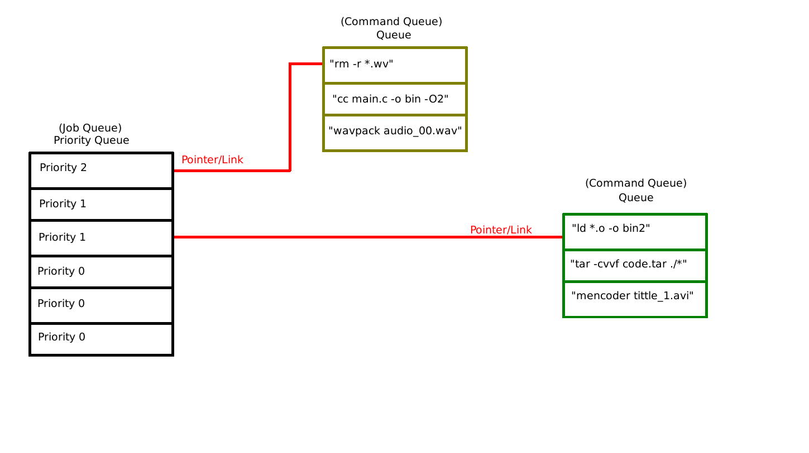
With all of the data gathered, and utilized in the application’s data structures, decisions can be made as to where to launch jobs.
Why?

Questions could be asked about the simpleness, the use of the C language, the point of the project, and its usage. Although it appears simple, a lot of the operations were not that simple to implement in the beginning (especially the socket handling). The reason why C was used instead of C++, or a scripting language was to learn more about the language, and to work close to the hardware as possible with a higher level language (performance). Linux itself is completely written in C, and embedded hardware released in these days only utilize C, and architecture specific assembly- the language is more relevant today than it has ever been despite contrary belief. The point of the project was to learn more about socket handling, inter process communication, the C language, and message passing, as well as distributed multiprocessing. Another point of the project was to refine portions, and make them very modular so that the distributed nature will eventually be utilized in other fields of computing research (artificial intelligence, super computing, bioinformatics simulations, etc). Its usage is to dispatch a multitude of jobs to a collection of servers, but to be so modular that the way to execute jobs is left to the systems administrator. In a demonstration, I used a 2 core Athlon machine to encode WAV files into a lossless open source format called WAVPACK. On the 2 core Athlon, it would take a significant amount of time to process 12 wav files at once. So I utilized 2 4 core Xeon servers to process the files. In doing so I set up a distributed file system called GlusterFS that allowed me to share the files among all three computers. I set the server up on the Athlon, and set the peers up on the Xeons. I then wrote a script that would make a list of jobs to execute on the peers from the server. Instead of taking a significant amount of time, the tasks were instantly done within seconds. That is just one way to utilize the Marx application framework.

