EASTWEST RETAIL CORE BANKING PLATFORM
Notification & Alert Microservice (:8083)
Technical Email & Backend Verification Guide
Pure Email & Backend Architecture • Dual Debit/Credit Advice Architecture • BSP MORB & AMLA Compliance
Group 3 — Full Stack Engineering (FSE) Capstone Project
1. Architectural Overview & Pure Notification Engine
The Notification & Alert Microservice (running on port :8083) is an asynchronous, event-driven Spring Boot 3.3.x backend engine designed in strict accordance with the Bangko Sentral ng Pilipinas (BSP) Manual of Regulations for Banks (MORB) and the Anti-Money Laundering Act (RA 9160).
This documentation focuses exclusively on backend email dispatch, SMTP delivery via MailHog (:8025), Redis deduplication, and regulatory compliance audit records. Frontend UI dependencies are completely decoupled from this verification guide.
Dual Email Architecture: Debit Advice (Sender) vs. Credit Advice (Beneficiary)
A fundamental tenet of retail banking (BSP Circular 980 & 1033) and the Data Privacy Act of 2012 (RA 10173) is that the two counter-parties in a fund transfer must receive distinct and asymmetric transaction notifications:
1. Sender Debit Advice (Transaction Receipt): Sent to the initiating customer (Juan Dela Cruz). Explicitly details the amount debited (-₱7,500.00), the masked recipient account (ACC-****7192), the transaction reference, and the sender's remaining account balance. Serves as legal proof of payment.
2. Beneficiary Inward Credit Advice: Sent to the receiving beneficiary (Maria Santos). Confirms inward funds credited (+₱7,500.00), shows the sender's masked origin (ACC-****8471), and confirms cleared availability. To comply with RA 10173, the sender's private bank balance is strictly suppressed and never exposed.
2. System Actors & Segregation of Duties (SoD) Directory
User ID | Full Name | DB Role | Maker / Checker Designation | Approval Authority & Email Address
U1001 | Juan Dela Cruz | CUSTOMER | Maker (Initiator) | juan.delacruz@retailbank.ph | Initiates retail transfers; receives debit receipts.
U1002 | Maria Santos | CUSTOMER | Beneficiary (Inward) | maria.santos@retailbank.ph | Destination account (ACC-****7192); receives inward credit advice.
U3002 | Beatriz Ocampo | MANAGER | Checker 1 (Operations Manager) | compliance-officer@corebank.ph | Level 1 reviewer for Tier 2 (up to P499,999.99) & Tier 3 AMLA.
U3003 | Carlos Mendoza | MANAGER | Approver 2 (Senior Manager) | carlos.mendoza@retailbank.ph | Branch Head; mandatory second sign-off for AMLA CTR transfers.
U0001 | Diana Vance | ADMIN | System Auditor / IT Admin | diana.vance@retailbank.ph | Monitors circuit breaker, retry spool & audit logs; approval limit 0.00.

3. Comprehensive Notification Scenarios Master Matrix
The matrix below details all 10 distinct operational, technical, and regulatory scenarios implemented within the Notification Service, explicitly mapping actors, notification recipients, and legal mandates:
# | Scenario & Threshold | Maker | Checker / Approver | Whom is Notified? | Notification Content & Subject | Governing Philippine Law
1 | Tier 1: Normal Retail Transfer (<= P50k, e.g. P7,500) | Juan Dela Cruz (U1001) | None (Automated STP) | 1. Juan Dela Cruz (Debit)  2. Maria Santos (Credit) | Sender: Transaction Receipt: P7,500.00  Beneficiary: Credit Advice: You Received P7,500.00 | BSP Circular 980 (InstaPay STP)  BSP Circular 1033  RA 10173 (Masking & Privacy)
2 | Tier 2: Dual Control Hold (P50,000.01 - P499,999.99) | Juan Dela Cruz (U1001) | Beatriz Ocampo (U3002, L1) | 1. Beatriz Ocampo (Checker)  2. Juan Dela Cruz (Maker) | Subject: DUAL CONTROL REVIEW: Transfer P150,000.00 Requires Manager Approval | BSP MORB Sec. 146  BSP Circular 808 / 1033 (Operational Risk)
3 | Tier 2: Manager Approval & Release (P150,000.00) | Juan Dela Cruz (U1001) | Beatriz Ocampo (U3002) | 1. Juan Dela Cruz  2. Maria Santos  3. Beatriz (Task Clear) | Subject: Funds Released: Transfer P150,000.00 Approved  Body: Approved by B. Ocampo (U3002). | BSP Circular 980 (Finality)  BSP Circular 1033
4 | Tier 2: Manager Rejection & Void (P150,000.00) | Juan Dela Cruz (U1001) | Beatriz Ocampo (U3002) | 1. Juan Dela Cruz | Subject: Transfer Disapproved: P150,000.00 Voided  Body: Reason stated, hold unfreezed, P0 debited. | BSP Circular 1033 Sec. 6  RA 7394 (Consumer Act)
5 | Tier 3: AMLA Covered Hold (>= P500,000.00, e.g. P750k) | Juan Dela Cruz (U1001) | Dual: Beatriz (L1) + Carlos Mendoza (L2) | 1. Beatriz Ocampo  2. Carlos Mendoza  3. Juan Dela Cruz | Subject: URGENT AMLA HOLD: Transfer P750,000.00 Requires CTR Filing & Dual Sign-Off | RA 9160 (AMLA) Sec. 3(b)  BSP Circular 1022 (CTR)
6 | Tier 3 Stage 1: Level 1 Sign-Off (P750,000.00) | Juan Dela Cruz (U1001) | Beatriz Ocampo (Signed L1) | 1. Carlos Mendoza (Senior Manager L2) | Subject: ESCALATION: AMLA Transfer P750,000.00 Approved by L1, Awaiting L2 Sign-Off | BSP MORB Sec. 146.4 (Escalation Protocol)
7 | Tier 3 Stage 2: Level 2 Final Sign-Off & Release | Juan Dela Cruz (U1001) | Carlos Mendoza (Signed L2) | 1. Juan Dela Cruz  2. Maria Santos  3. AML Compliance Vault | Subject: AMLA Cleared: Transfer P750,000.00 Released  Body: Dual Signatures (U3002 + U3003). | RA 9160 Sec. 9(c) (5-Day CTR)  BSP Circular 1022
8 | Technical: Redis Deduplication (Double-Click Defense) | Any Customer | Automated Redis Gate | Zero (Duplicate Suppressed) | Server Log: [DEDUPLICATION] Event already seen. Dropping duplicate email dispatch. | ISO 20022 Financial Messaging  RFC 7231 Idempotency
9 | Technical: Circuit Breaker & Retry Spooling | Outbox Relay | Automated Circuit Breaker | Diana Vance (IT Auditor) | Metric Alert: Circuit OPEN, spool size buffered.  Flush: POST /api/v1/notifications/flush-spool | BSP Circular 808 App. 75 (Business Continuity)
10 | Security: Account Lockout Warning (3 Bad Logins) | Security Daemon | Diana Vance (U0001) | 1. Juan Dela Cruz (Holder)  2. Security Team | Subject: SECURITY ALERT: Account Access Temporarily Restricted  Body: Unlock helpline, IP log. | BSP Circular 1033 Sec. 4  RA 10173 (Breach Notice)

4. Step-by-Step Scenario Showcase Playbook & Screenshot Frames
This section provides the end-to-end execution walkthrough for each scenario, accompanied by designated screenshot placement frames for capstone defense compilation.
Scenario 1: Tier 1 Everyday Retail Transfer (Straight-Through Processing — PHP 7,500.00)
Customer Juan Dela Cruz (U1001) transfers PHP 7,500.00 to Maria Santos (U1002). Because the amount is within the retail threshold (<= PHP 50,000.00), the transaction is automatically settled via Straight-Through Processing (STP) per BSP Circular 980 without requiring human management intervention.
• Dual Email Delivery Output:
1. Sender Debit Advice (Navy Theme): Dispatched to juan.delacruz@retailbank.ph with subject 'Transaction Receipt: ₱7,500.00 [TRX-XXXX]'. Shows masked destination account ACC-****7192, settlement status COMMITTED, remaining available balance, and SHA-256 verification hash.
2. Beneficiary Inward Credit Advice (Emerald Theme): Dispatched to maria.santos@retailbank.ph with subject 'Credit Advice: You Received ₱7,500.00 from Juan Dela Cruz [TRX-XXXX]'. Confirms incoming funds credited to ACC-****7192 with status CLEARED & AVAILABLE. The sender's private account balance is completely hidden.
• Run Live Command in PowerShell:
Invoke-RestMethod -Uri "http://localhost:8083/api/v1/notifications/simulate-transfer" -Method Post
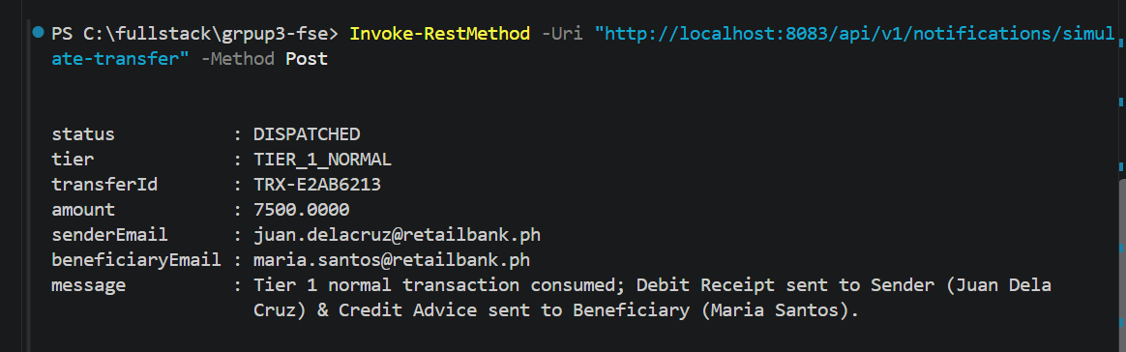
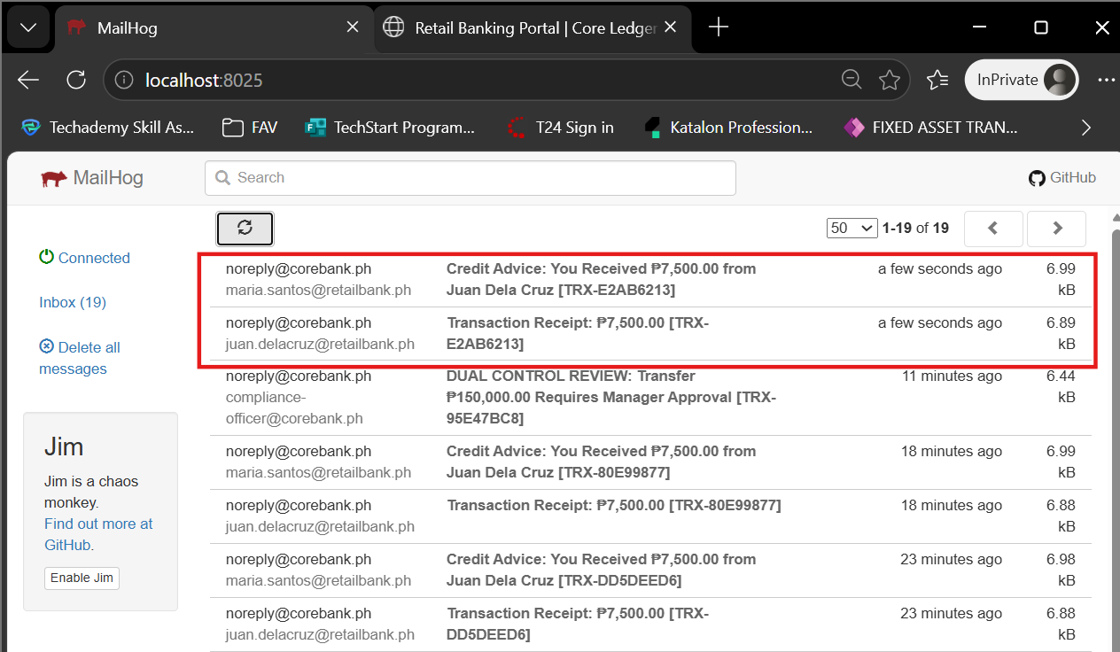
📧 [SCREENSHOT PLACEHOLDER]
Scenario 1A: Sender Debit Advice (Juan Dela Cruz) in MailHog
Suggested View: Screenshot of MailHog Web UI at http://localhost:8025 viewing email to Juan Dela Cruz with subject 'Transaction Receipt: ₱7,500.00'.
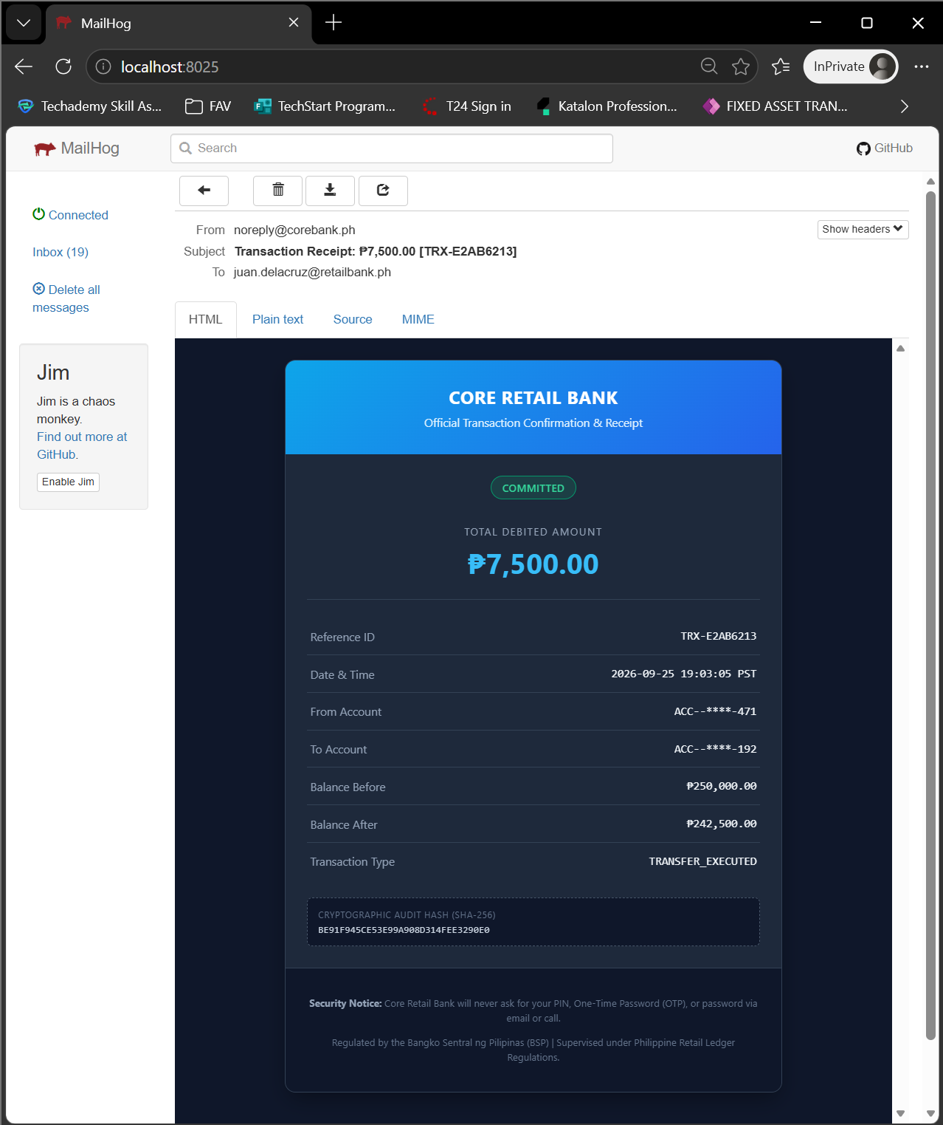
(Paste your screenshot here in Word. The frame will automatically scale.)
Figure: MailHog Inbox showing Debit Receipt sent to juan.delacruz@retailbank.ph with remaining balance & SHA-256 hash
📧 [SCREENSHOT PLACEHOLDER]
Scenario 1B: Beneficiary Inward Credit Advice (Maria Santos) in MailHog
Suggested View: Screenshot of MailHog Web UI at http://localhost:8025 viewing email to Maria Santos with subject 'Credit Advice: You Received ₱7,500.00 from Juan Dela Cruz'.
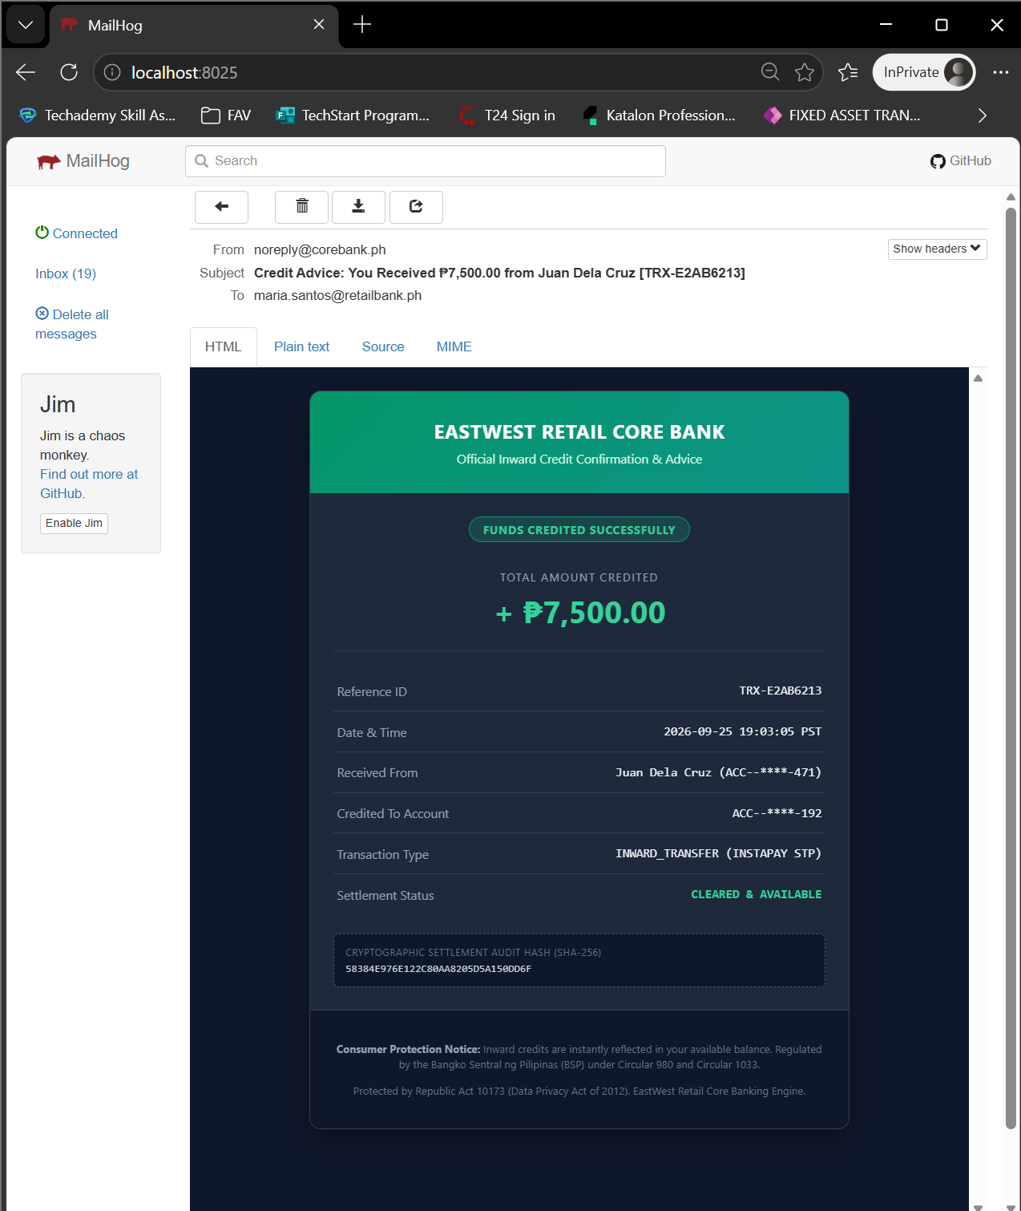
(Paste your screenshot here in Word. The frame will automatically scale.)
Figure: MailHog Inbox showing Inward Credit Advice sent to maria.santos@retailbank.ph without exposing sender balance
Scenario 2: Tier 2 Dual-Control Hold (Mid-Tier Maker-Checker — PHP 150,000.00)
Customer Juan Dela Cruz (Maker) transfers PHP 150,000.00. Because the amount exceeds the retail limit (PHP 50,000.01 – PHP 499,999.99), the system places the transfer on HOLD (PENDING_APPROVAL) per BSP MORB Section 146. Available balance is decremented to prevent double-spending, while the ledger dispatches an urgent dual-control review email to Bank Operations Manager Beatriz Ocampo (U3002).
• Notification Outputs:
1. Manager Action Email: High-priority review email dispatched to Beatriz Ocampo (compliance-officer@corebank.ph) detailing maker, amount, accounts, and regulatory guidelines.
2. Customer Hold Notice: Advisory email sent to Juan Dela Cruz confirming his transfer is pending manager authorization.
• Run Live Command in PowerShell:
Invoke-RestMethod -Uri "http://localhost:8083/api/v1/notifications/simulate-tier2-maker-checker" -Method Post

📧 [SCREENSHOT PLACEHOLDER]
Scenario 2A: PowerShell Terminal Output (Simulate Tier 2 Maker-Checker)
Suggested View: Screenshot of PowerShell terminal displaying the JSON response with transferId, amount PHP 150,000.00, and 'Manager compliance email dispatched'.
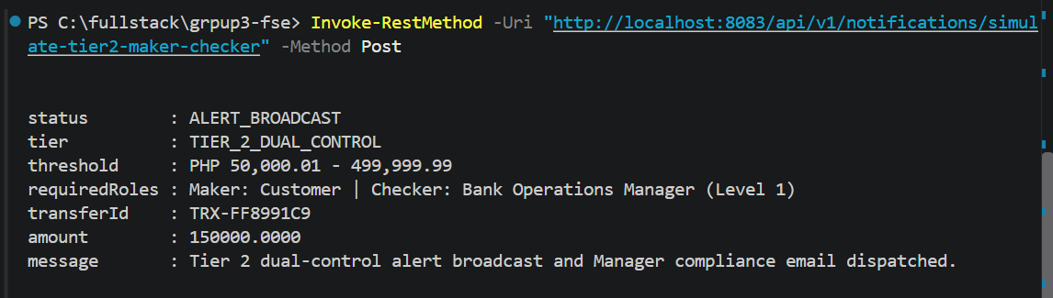
(Paste your screenshot here in Word. The frame will automatically scale.)
Figure: PowerShell console showing successful execution of simulate-tier2-maker-checker returning status ALERT_BROADCAST
📧 [SCREENSHOT PLACEHOLDER]
Scenario 2B: Dual Control Review Request Email in MailHog
Suggested View: Screenshot of MailHog Web UI at http://localhost:8025 with subject 'DUAL CONTROL REVIEW: Transfer ₱150,000.00 Requires Manager Approval'.
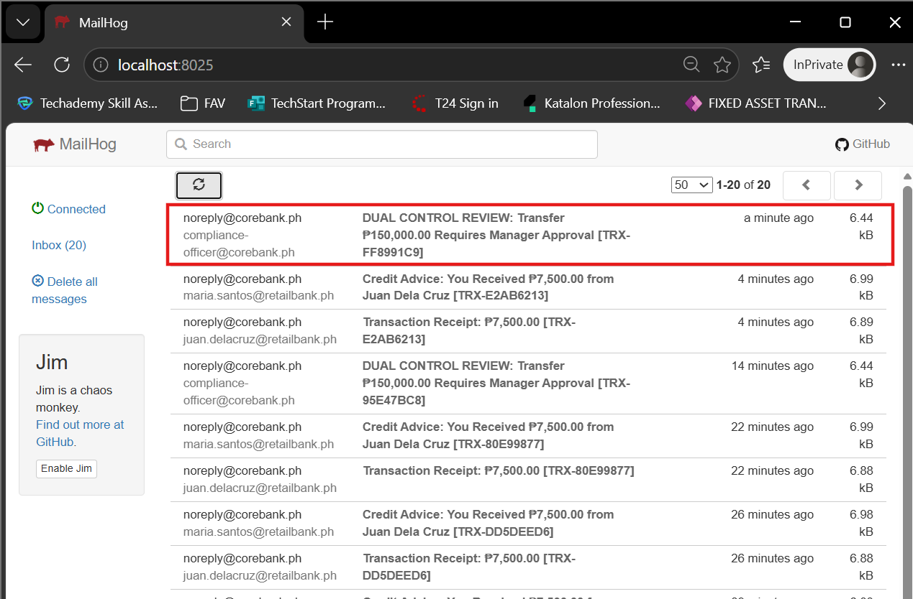
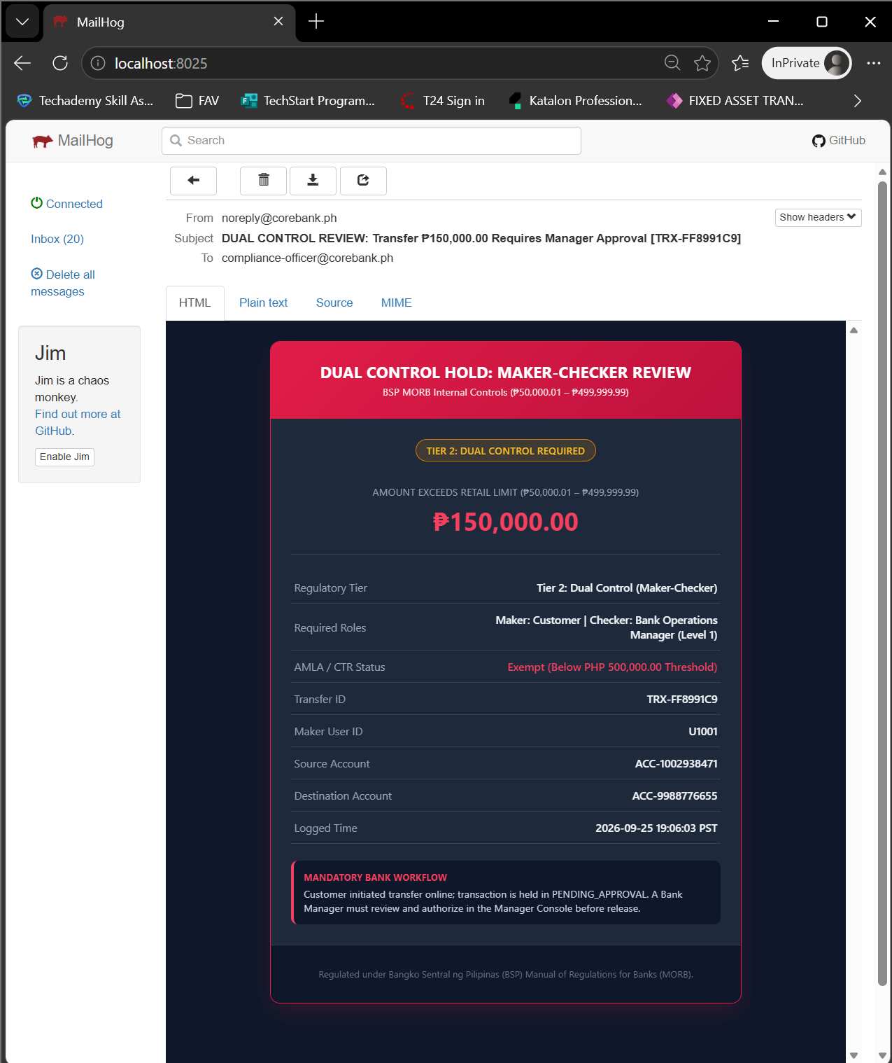
(Paste your screenshot here in Word. The frame will automatically scale.)
Figure: MailHog Inbox showing Tier 2 Review Request Email sent to Manager Beatriz Ocampo (compliance-officer@corebank.ph)
Scenario 3 & 4: Tier 2 Manager Resolution (Approval vs Rejection)
When Manager Beatriz Ocampo (U3002) reviews the transfer:
• On Approval: Dispatches official release receipts to Juan Dela Cruz and Maria Santos with an approval stamp.
• On Rejection: Dispatches a Disapproval Notice explaining why the transaction was voided per BSP Circular 1033.
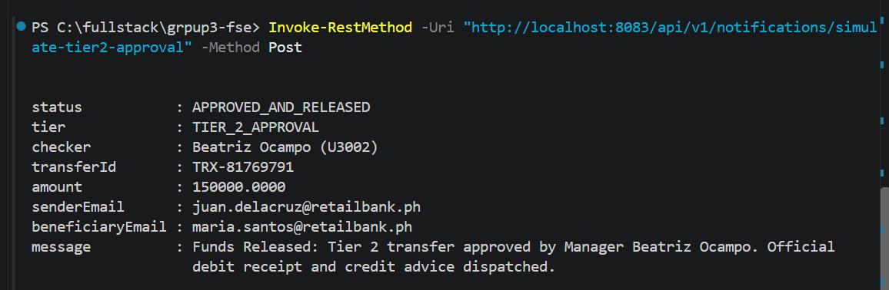
📧 [SCREENSHOT PLACEHOLDER]
Scenario 3: Manager Approval & Funds Released Email in MailHog
Suggested View: Screenshot of MailHog email showing 'Funds Released: Transfer PHP 150,000.00 Approved' with updated balance.
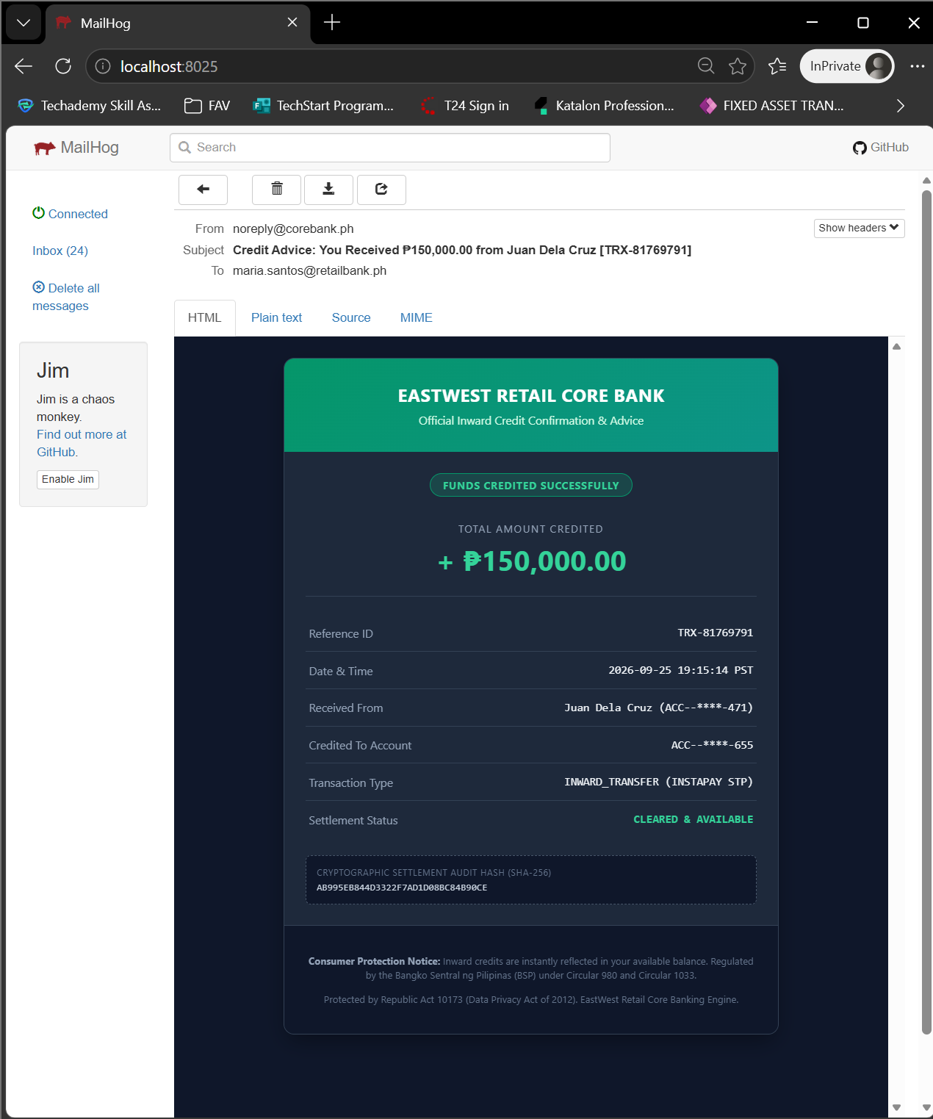
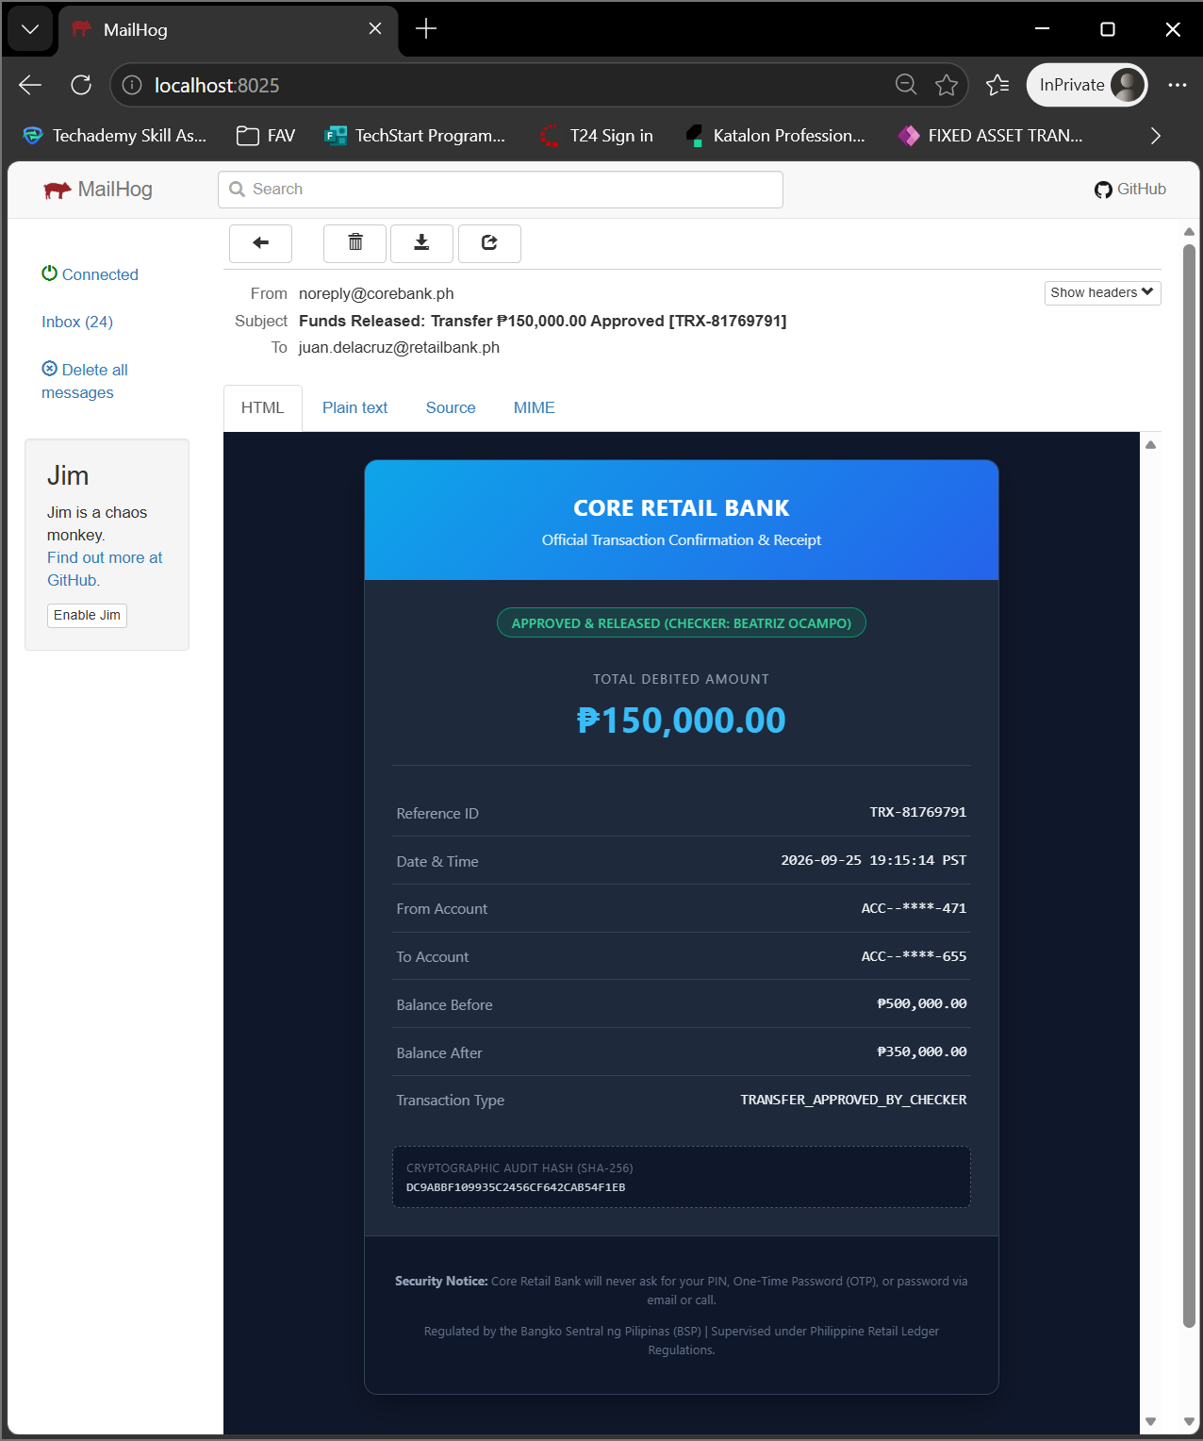
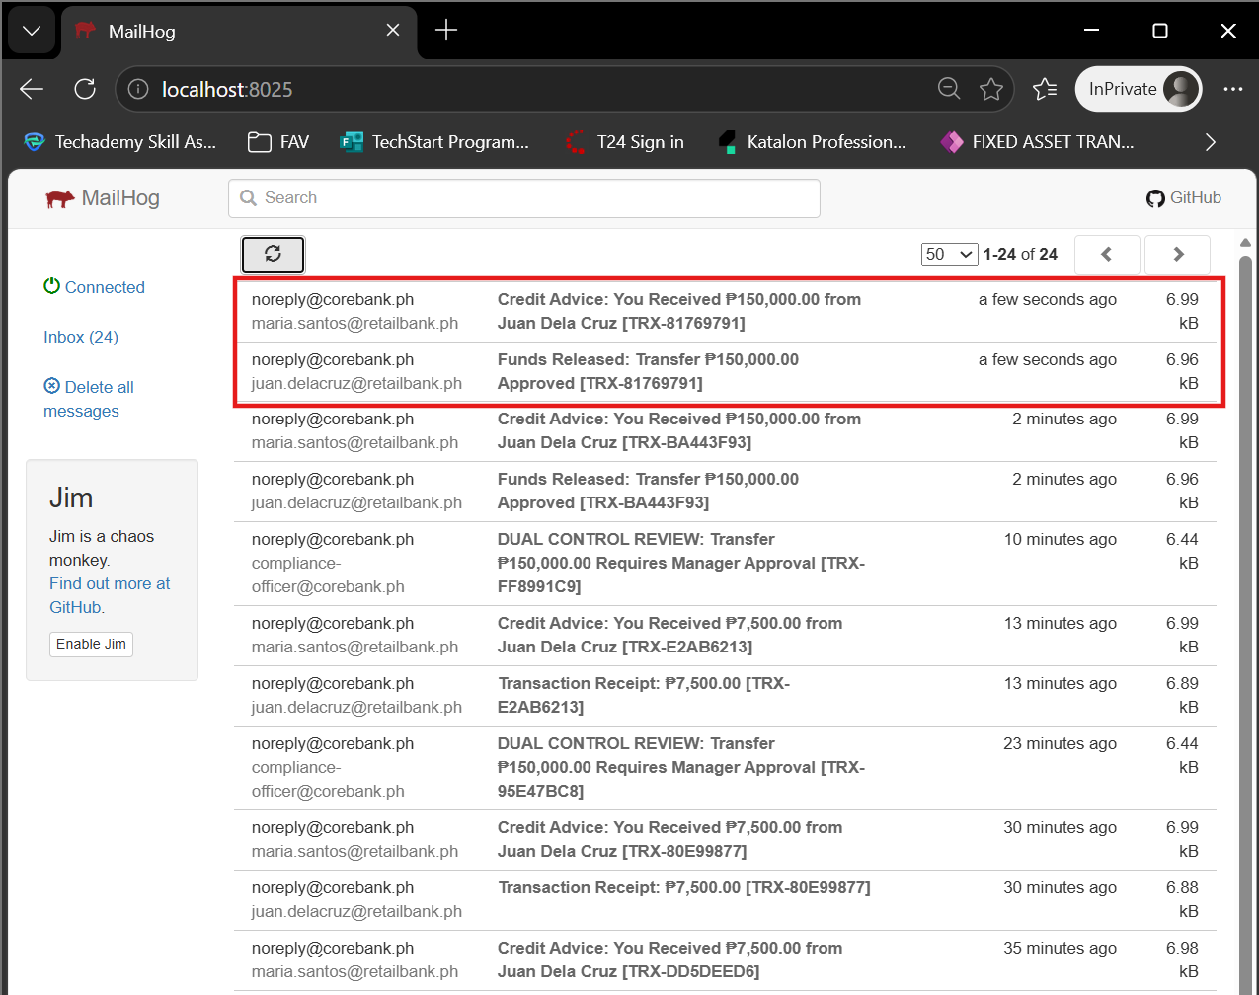
(Paste your screenshot here in Word. The frame will automatically scale.)
Figure: Execution email receipt in MailHog displaying Manager Approval Stamp by Beatriz Ocampo (U3002)
Scenario 5, 6 & 7: Tier 3 AMLA High-Value Covered Transaction (Dual Management — PHP 750,000.00)
Customer Juan Dela Cruz transfers PHP 750,000.00. Under Republic Act 9160 (AMLA Section 3b) and BSP Circular 1022, amounts >= PHP 500,000.00 trigger mandatory Covered Transaction Reporting (CTR) and require Dual Management Sign-off (Manager 1 + Senior Manager 2) before funds can be released.
• Run Live Command in PowerShell:
Invoke-RestMethod -Uri "http://localhost:8083/api/v1/notifications/simulate-tier3-amla" -Method Post

📧 [SCREENSHOT PLACEHOLDER]
Scenario 5A: PowerShell Terminal Output (Simulate Tier 3 AMLA)
Suggested View: Screenshot of PowerShell terminal displaying the JSON response with amount PHP 750,000.00 and 'Dual manager compliance emails dispatched'.
(Paste your screenshot here in Word. The frame will automatically scale.)
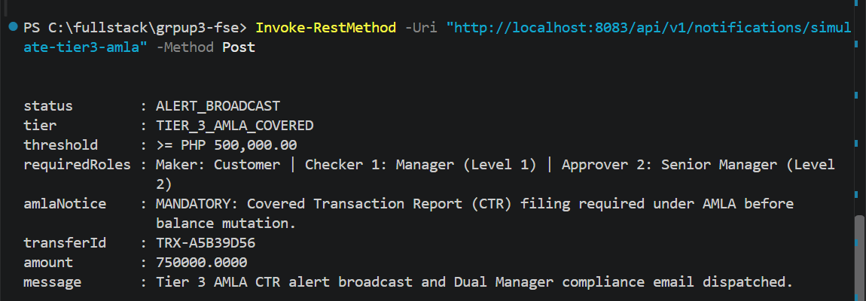
Figure: PowerShell console showing successful execution of simulate-tier3-amla returning status AMLA_CTR_TRIGGERED
📧 [SCREENSHOT PLACEHOLDER]
Scenario 5B: Urgent AMLA Covered Transaction Alert Email in MailHog
Suggested View: Screenshot of MailHog email with subject 'URGENT AMLA HOLD: Transfer ₱750,000.00 Requires CTR Filing & Dual Manager Approval'.
(Paste your screenshot here in Word. The frame will automatically scale.)
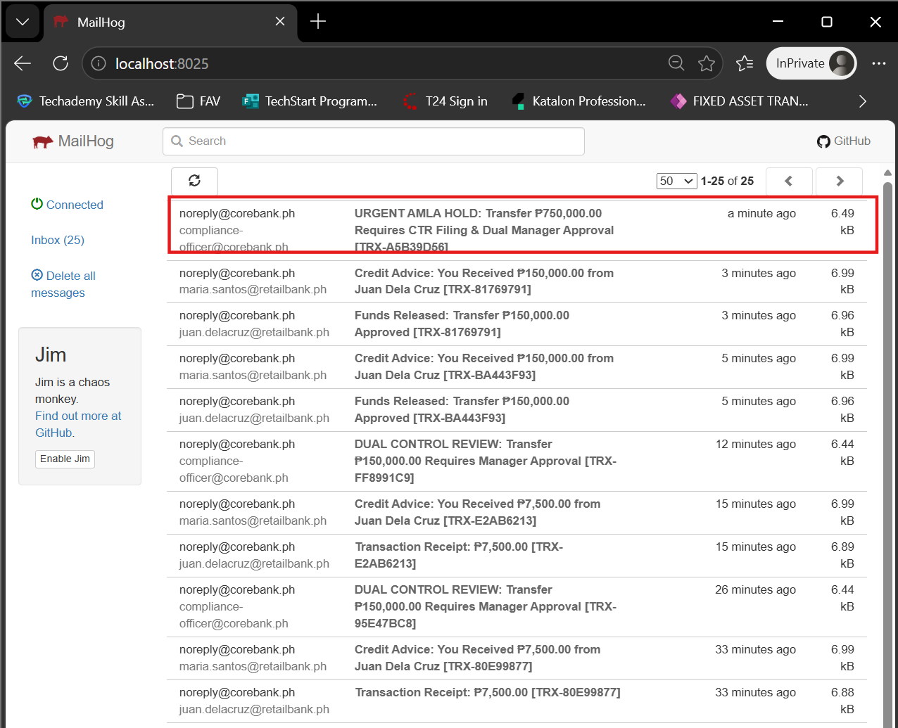
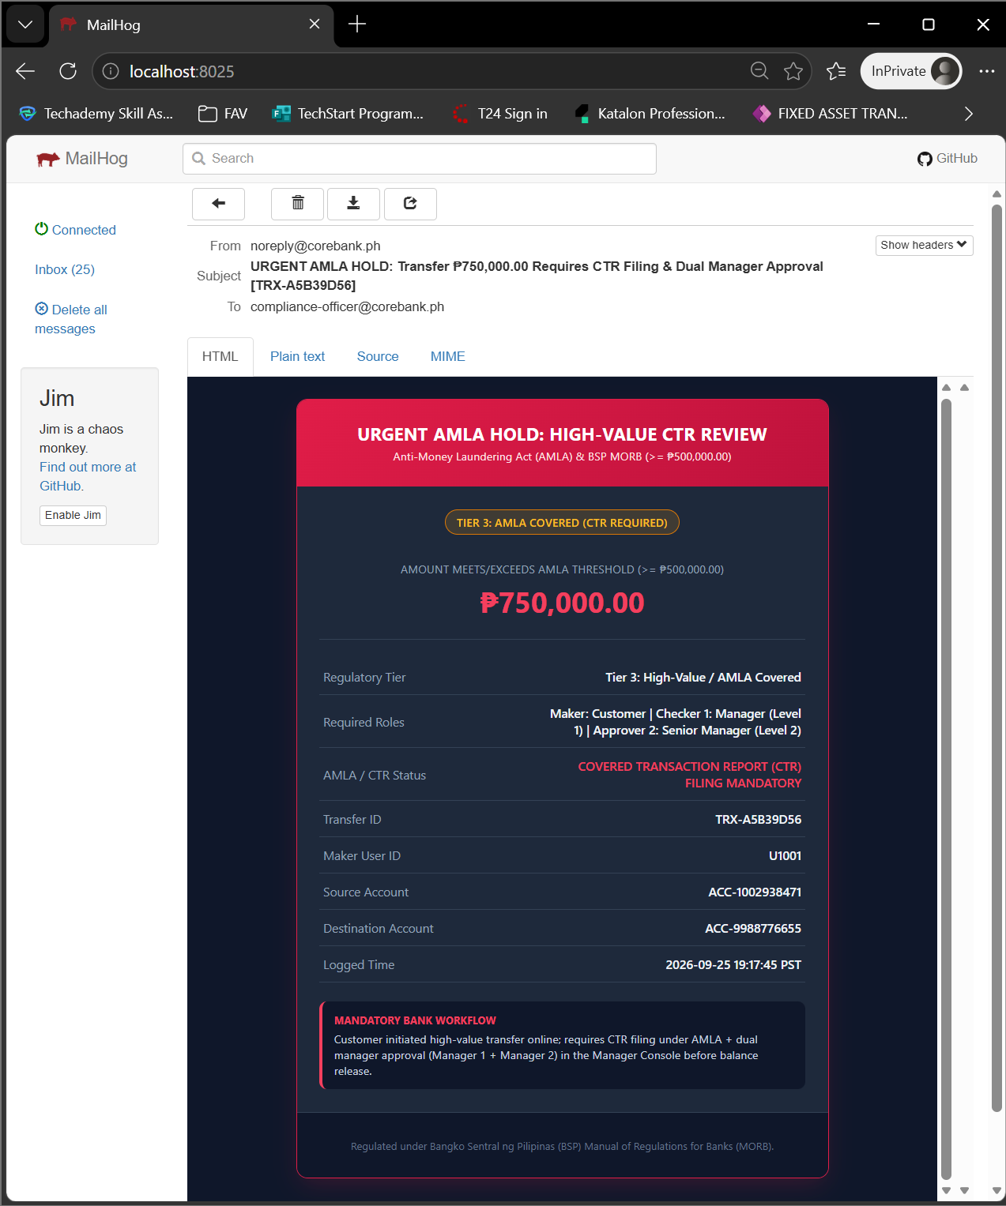
Figure: High-Priority AMLA CTR notification dispatched to dual managers (Beatriz & Carlos)
Scenario 8 & 9: Distributed Idempotency (Redis) & Circuit Breaker Spooling
To protect against network replays and service outages, the Notification Service implements enterprise-grade resiliency:
• Redis Deduplication (Anti-Spam): Redis SETNX EX 3600 drops duplicate transfer events within 1 hour. If a customer double-clicks, exactly 1 email is sent.
• Circuit Breaker & Retry Spool: If downstream SMTP fails, the internal circuit flips to OPEN, buffering emails in an in-memory queue. Once SMTP recovers, /flush-spool flushes all unsent receipts without data loss.
• Run Live Commands in PowerShell:
Invoke-RestMethod -Uri "http://localhost:8083/api/v1/notifications/spool-status" -Method Get
Invoke-RestMethod -Uri "http://localhost:8083/api/v1/notifications/flush-spool" -Method Post

📧 [SCREENSHOT PLACEHOLDER]
Scenario 8: PowerShell Live Verification of Spool Status & Telemetry
Suggested View: Screenshot of PowerShell terminal executing GET /api/v1/notifications/spool-status displaying spool_size and circuit status.
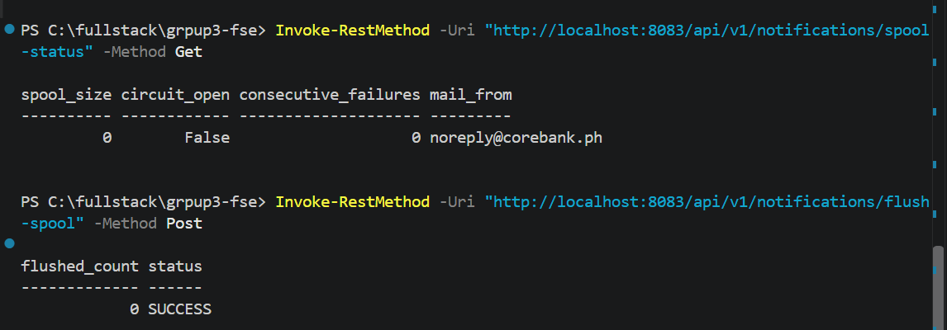
(Paste your screenshot here in Word. The frame will automatically scale.)
Figure: PowerShell console showing spool-status or deduplication telemetry
5. Cryptographic Receipt Verification Formula (Non-Repudiation)
Every digital receipt issued by the Notification Service includes an immutable SHA-256 HMAC digest computed across four deterministic fields:
Verification Hash = SHA-256( transferId || ':' || sourceAccount || ':' || amount || ':' || timestamp )

This guarantees non-repudiation and complies with BSP Circular 1033 Section 5, ensuring that neither the customer nor the bank can alter the recorded financial settlement terms after receipt generation.

