VoipStorm
User's Guide

Contents

Chapter 1 Starting the Manager
Licence Activation
Manager Introduction
Manager UserInterface

Chapter 2 Starting ECallCenter21
ECallCenter21 Introduction
ECallCenter21 UserInterface

Chapter 3 Starting EPhone
EPhone Introduction
EPhone UserInterface

Chapter 4 Working Directory

Chapter 1 Starting the Manager

Save and extract the voipstorm.zip somewhere on you computer (Desktop)

Make sure you have the latest java software installed (click here for Java)

Brows to the install directory (Desktop) and double click: VoipStorm.jar
Or from DOS cd to install directory and type: java -jar VoipStorm.jar &

The VoipStorm Manager will now start and appear as follows:

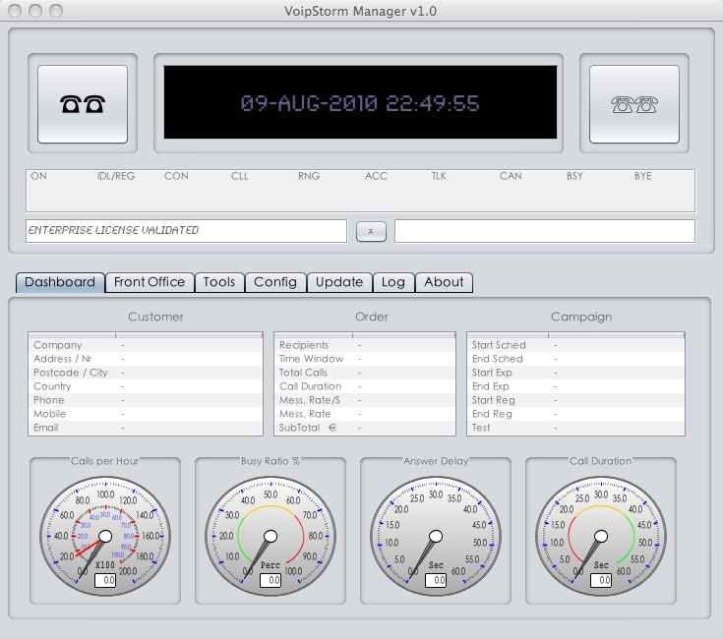
2. Start ECallCenter21 (Left)
4. CallCenter Status Bar
14. Show / Hide Administration
1. Date / Time Monitor
5. Manager Dashboard
6. FrontOffice Order Mgt
7. General Manager Tools
8. Network Configuration
9. Customer Details
11. Order Details
10. Update Manager
12. Performance Meter
Calls Busy Meter
Answer Delay Meter
Call Duration Meter

13. Start ECallCenter21 (Right)

3. Running CalCenter Statistics
15. Status Bar (Inbound)
16. About General Info
17. Activity Logger Info
18. Campaign Timestamps

The first time you run the Manager it will startup ECallCenter21 in order for you to activate your License (without license VoipStorm can not be used).

Once you've activated your license, VoipStorm is ready to be network configured and used straight away to create and run your first campaign.

