MASTER PLAN DOCUMENT
Poli Engine
Hot topics first. Spotlight second. Manual to automated. Solo buildable.
Site concept
A malayalam content website only for politics
It follows the timeline of topics, rather than old news websites, it creates timelines, connecting every incident to the topic.

SECTION 1

The Plan
Everything you need to know before writing a single line of code — what the site is, how it's structured, how automation evolves, and what legal lines not to cross.

What the site includes
Breaking News  On top shows the latest news or incidents, maybe press statements. |  | Main topics  Don’t show news, instead show thread to which news is connected, shows timestamp when it was updated at last.

Spotlight scorer — Phase 2 only
In phase 1 add some dummy info, like some prebuild content –historical figures
Rates the politicians based on their spotlight appearance, don’t judge if they are good or bad.

Screen layout

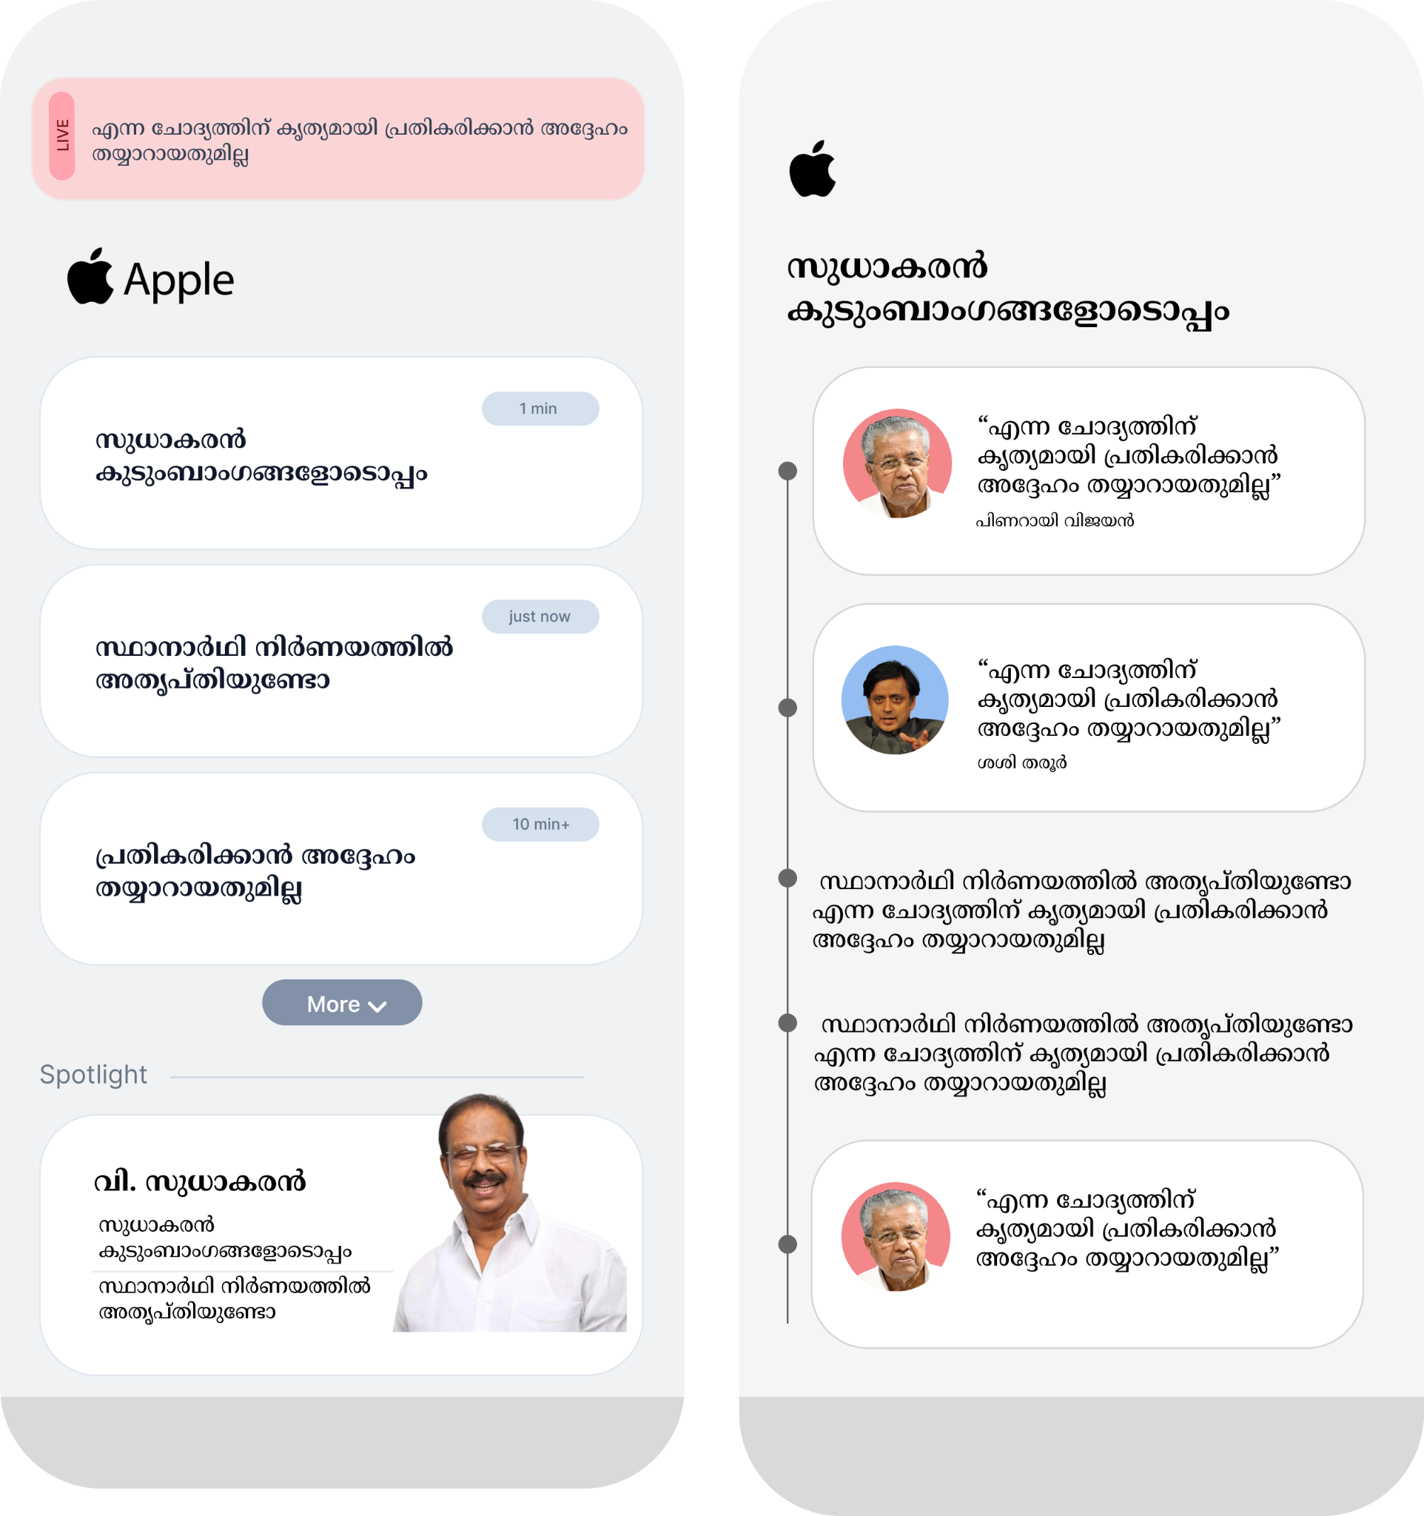

Content phases
Three phases. No hard deadline to move between them — you decide based on traffic and time.

Phase 1  Build basic app  - Breaking news  - Topics wise  - Add something instead of spotlight | Phase 2  Partial Automation  - Let a telegram bot sends what content should be published  Human approves  - Add share feature  LAUNCH
Phase 3  Marketing Phase  - Use every possible marketing methods  - Add and iterate based on feedback | Phase 4  Add Spotlight  - Still at that phase if that finds interesting
Phase 5
Full Automation

Checklist

Phase 1
- Logo and Name
- UI/UX
- Frontend
- Content adding Page or gateway
- Backend
- DB

Phase 2
- Share feature
- Telegram bot - send recommendations

