**DATA ANALYST PORTFOLIO SQL PROJECT**

**TESTING TABLEAU REPORT IN SQL**

**Create Table**

Table data import wizard

**Employee Count:**

SELECT sum(employee_count) as employee_count

FROM hr_data;

**Attrition Count:**

SELECT count(attrition) as attrition_count

FROM hr_data

WHERE attrition= 'Yes';

**Attrition Rate:**

SELECT round((SELECT count(attrition) from hr_data where attrition= 'Yes')*100 / sum(employee_count),2) as attrition_rate

FROM hr_data;

**Active Employee:**

SELECT sum(employee_count)-(SELECT count(attrition) from hr_data where attrition= 'Yes') as active_employees

FROM hr_data;

**Average Age:**

SELECT round(avg(age),0) as avg_age

FROM hr_data;

**Attrition by Gender**

SELECT Gender, count(Attrition) as attrition_count

FROM hr_data

WHERE Attrition = 'Yes'

GROUP BY Gender

ORDER BY count(Attrition) DESC;

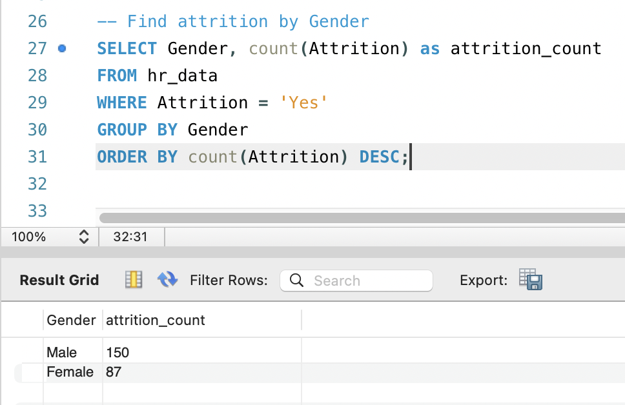

**Department wise Attrition:**

SELECT Department, count(Attrition) as attrition_count,

round(count(attrition)*100/

(Select count(attrition)

from hr_data

where Attrition = 'Yes'),2) as percentage

FROM hr_data

WHERE Attrition = 'Yes'

GROUP BY Department

ORDER BY count(Attrition) DESC;

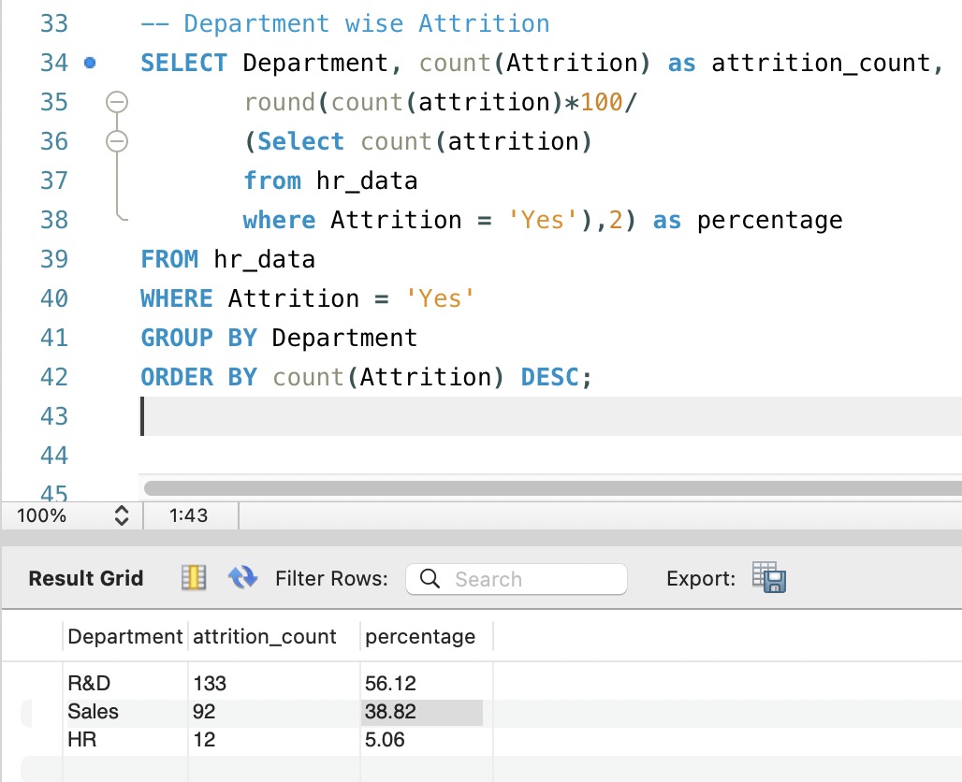

**No of Employee by Age Group**

SELECT age, sum(employee_count)

FROM hr_data

GROUP BY age

ORDER BY age;

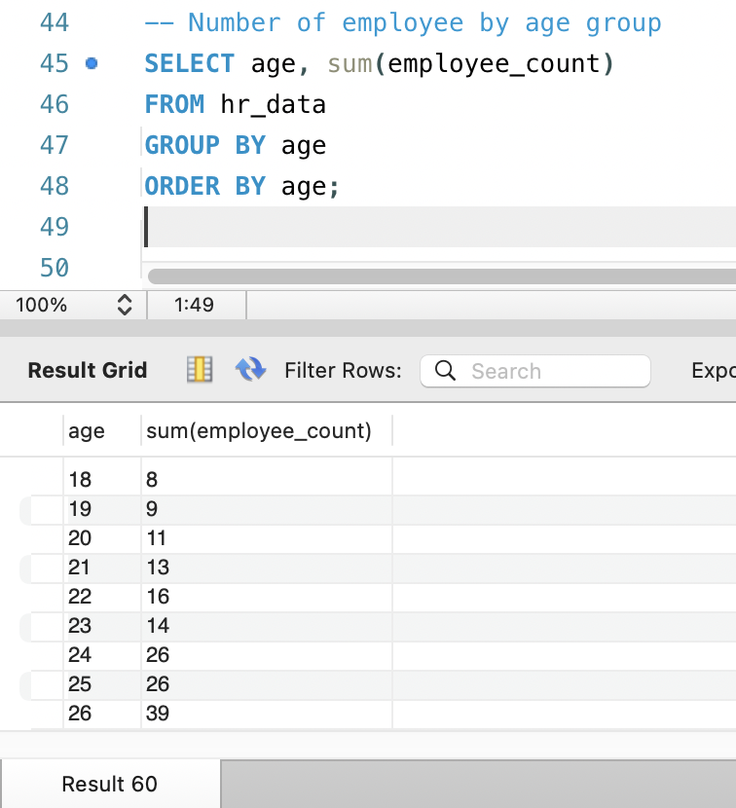

**Education Field wise Attrition:**

SELECT Education_field, count(attrition) as attrition_count

FROM hr_data

WHERE attrition = 'Yes'

GROUP BY Education_field

ORDER BY attrition_count;

**Attrition Rate by Gender for different Age Group**

SELECT age_band,Gender, Count(attrition) as attrition_count, round(count(attrition)*100/ (SELECT count(attrition) from hr_data where attrition= 'Yes'),2) as '%'

FROM hr_data

WHERE attrition = 'Yes'

GROUP BY Gender, age_band

ORDER BY age_band,Gender;

**Job Satisfaction Rating**

-Run this query first to activate the cosstab() function in postgres

CREATE EXTENSION IF NOT EXISTS tablefunc;

-Then run this to get o/p-

SELECT *

FROM crosstab(

'SELECT job_role, job_satisfaction, sum(employee_count)

FROM hrdata

GROUP BY job_role, job_satisfaction

ORDER BY job_role, job_satisfaction'

) AS ct(job_role varchar(50), one numeric, two numeric, three numeric, four numeric)

ORDER BY job_role;