ChatGPT Response when requirements are uploaded in XML format.

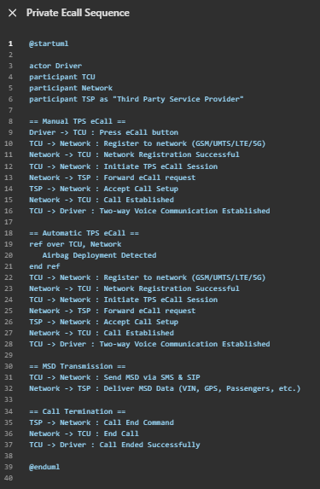

ChatGPT Response when requirements are uploaded in PDF format.

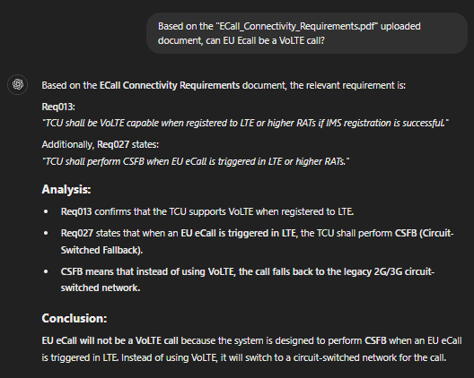

ChatGPT Response when requirements are uploaded in JSON format.

ChatGPT Response when requirements are uploaded in CSV format.

ChatGPT Response when requirements are uploaded in XLSX format.



