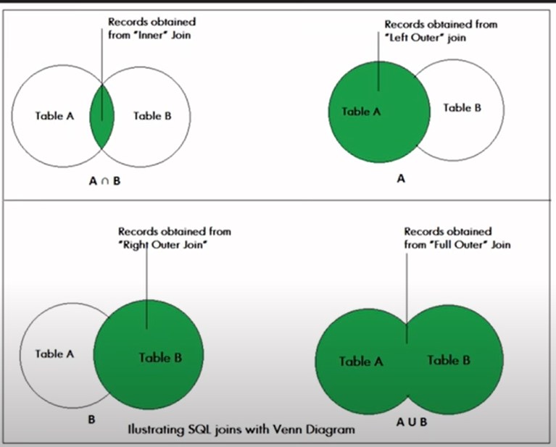

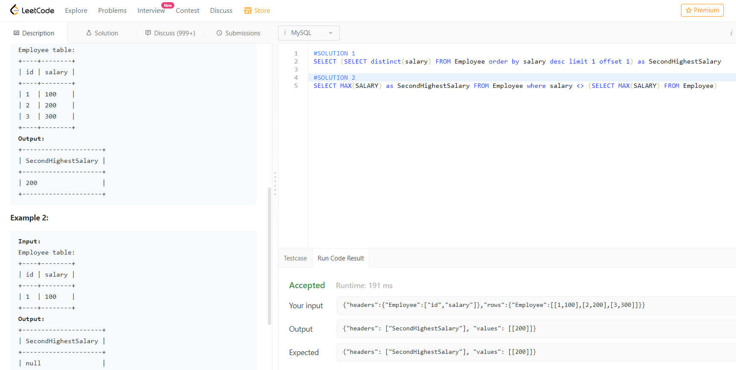

If second salary is not present we have to return NULL that’s why we need to have sub query in first solution([LeetCode – 176. Second Highest Salary - The Coding Bot](https://thecodingbot.com/leetcode-176-second-highest-salary/))

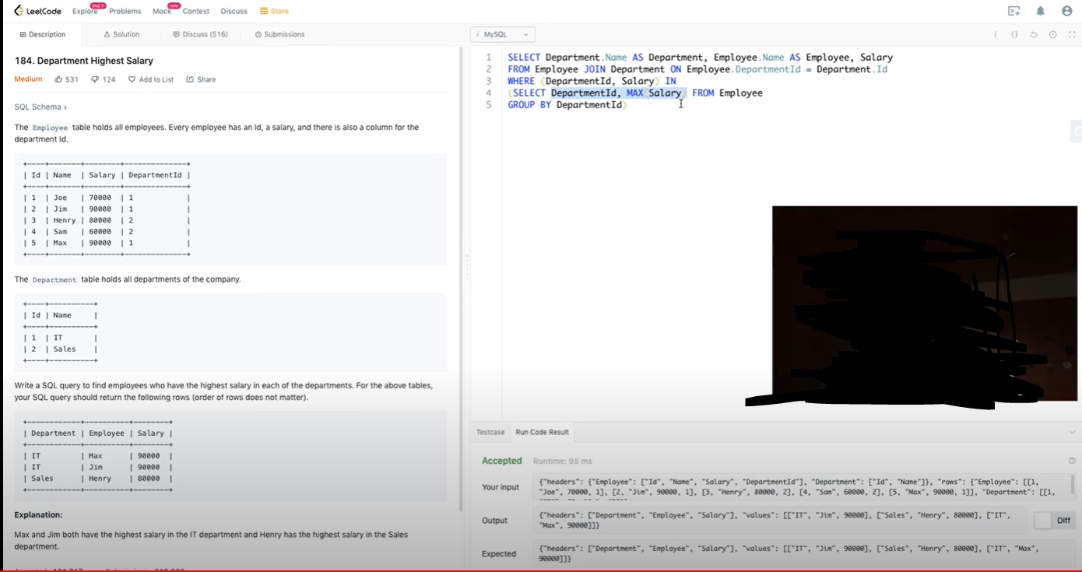

Find Nth highest salary

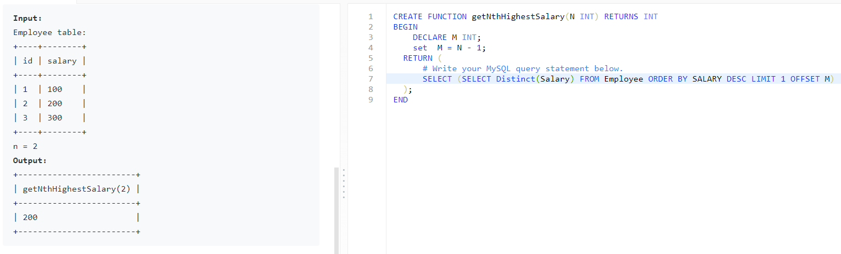

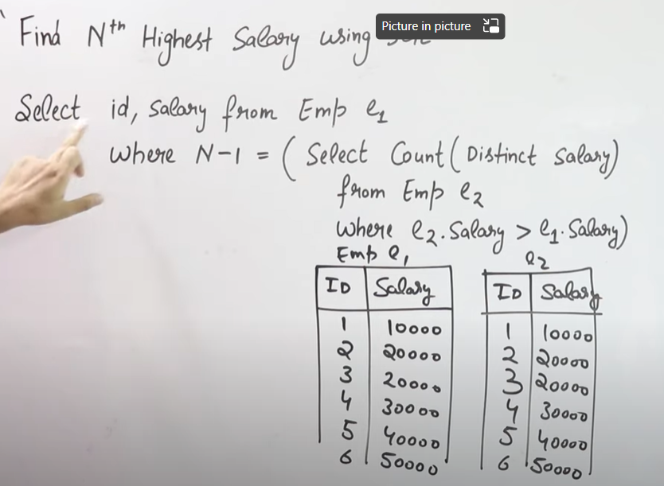

The inner query is basically counting that how many salaries are greater than e1.salary. Example if I want to find the 5th highest salary then first row of e1 i.e 10000 is compared with each and every row of E2 . The count comes as 4 because upon comparison there are 4 DISCTINCT salaries which are greater than 10000. The inner query returns 4 and the outer query where clause is N-1 i.e 5-1 = 4 . Since both match so 10000 is the 5th highest salary

Find name of employee having salary greater than managers salary

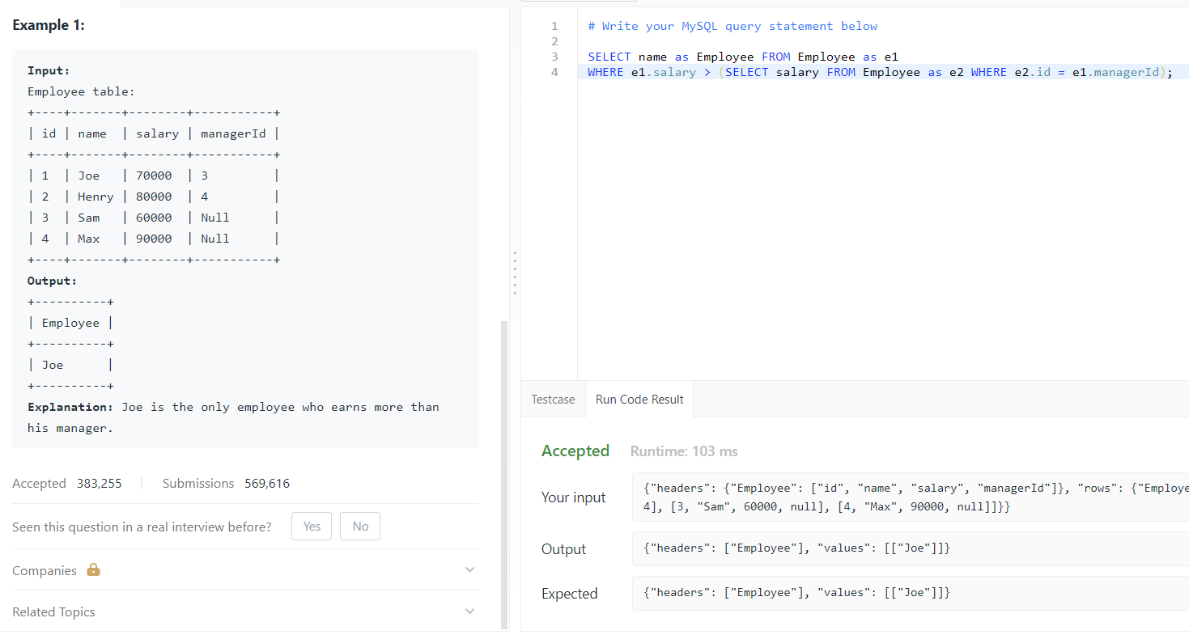

**UNION EXAMPLE**

**Union merges 2 tables with same columns and also removes duplicates**

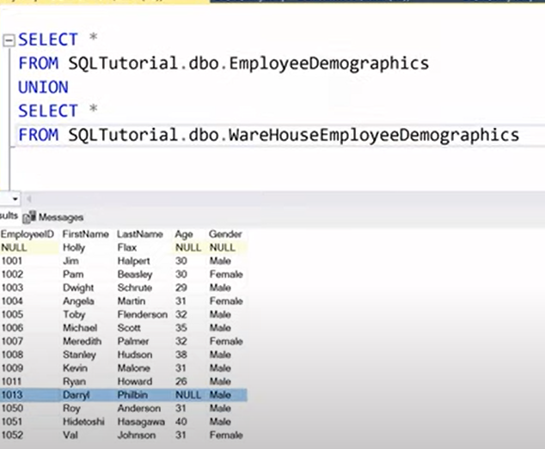

**UNION ALL**

**This queries will also keep the duplicate values present in both tables. As you can see that Darryl rows are repeated twice because it contains in both the tables whereas in the above ss i.e union command Darryl is specified only once**

**NOTE**

**Union Command compares the data type of each column and the number of columns should be same .So we need to be careful not to put different columns in union. In below SS the FirstName consists the Job title(Salesman) as well and age consist salary(43000) as well**

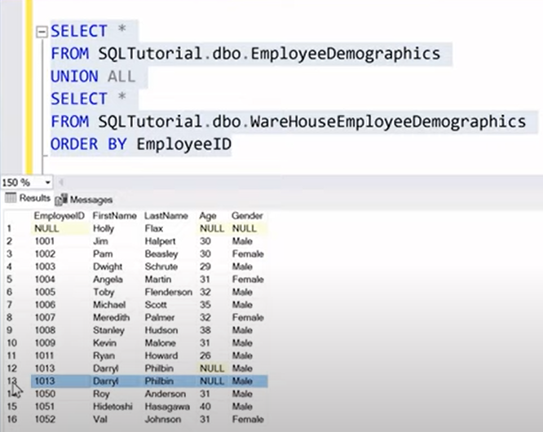

**CASE**

**We can use multiple WHEN inside CASE AND END**

**But if multiple WHEN conditions are satisfied then the very first condition result specified in THEN when be returned**

**PARTITON BY**

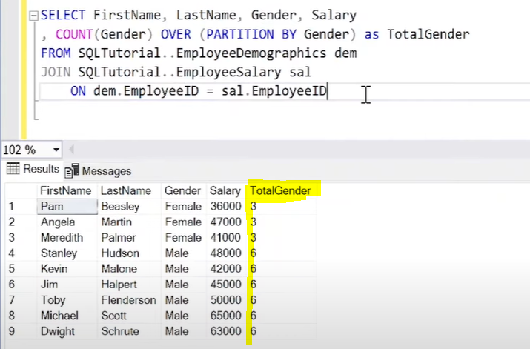

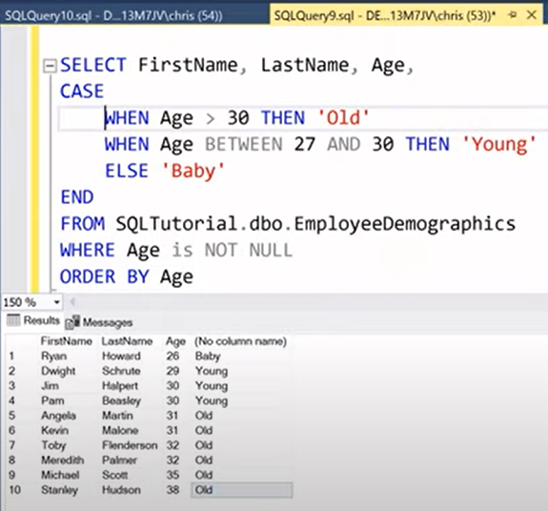

**HAVING CLAUSE**

**Note: We cannot use WHERE for any aggregate functions ,instead we should use HAVING clause after GROUP BY command**

