ERRORS WITH SOLUTIONS

# no match for ‘operator<<’

## ERROR MESSAGE

In file included from **/home/rs2015/Mathematiques/include/mathq.h:40**,

from **testunary.cpp:5**:

/home/rs2015/Mathematiques/include/display.h: In instantiation of ‘**void display::dispval_strm(std::ostream&, const T&) [with T = std::initializer_list; std::ostream = std::basic_ostream]**’:

**/home/rs2015/Mathematiques/include/display.h:1437:19:** required from ‘**void display::dispval_strm(std::ostream&, const std::__cxx11::list&) [with D = std::initializer_list; std::ostream = std::ba**

sic_ostream]’

**/home/rs2015/Mathematiques/include/display.h:1849:19:** required from ‘**static void display::Display::mydisp_type(std::ostream&, const X&, std::string, bool) [with X = std::__cxx11::list<std::initializer_lis**

t, std::allocator<std::initializer_list > >; std::ostream = std::basic_ostream; std::string = std::__cxx11::basic_string]’

**/home/rs2015/Mathematiques/include/display.h:1910:18:** required from ‘**static void display::Display::tmydispcr(std::ostream&, const X&, std::string) [with X = std::__cxx11::list<std::initializer_list<double**

>, std::allocator<std::initializer_list > >; std::ostream = std::basic_ostream; std::string = std::__cxx11::basic_string]’

**/home/rs2015/Mathematiques/include/display.h:1914:16:** required from ‘**static void display::Display::tmydispcr(std::ostream&, const std::initializer_list&, std::string) [with X = std::initializer_list<**

double>; std::ostream = std::basic_ostream; std::string = std::__cxx11::basic_string]’

**testunary.cpp:122:5:** required from here

**/home/rs2015/Mathematiques/include/display.h:1276:12:** **error:** no match for ‘**operator<<**’ (operand types are ‘**std::ostream**’ {aka ‘**std::basic_ostream**’} and ‘**const std::initializer_list**’)

1276 | **stream << d**;

| **~~~~~~~^~~~**

compilation terminated due to -Wfatal-errors.

## STACK TRACE

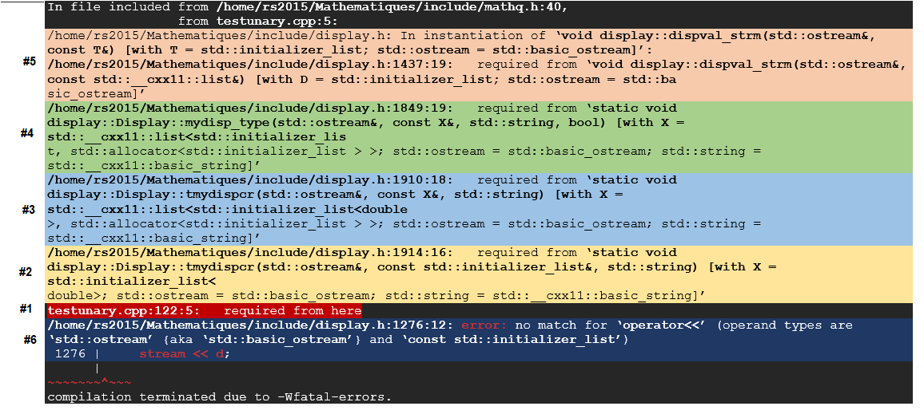

The starting point of the error is in red:

#1

|  |
| --- |
| **testunary.cpp:122:5:** required from here |
|  |

#1A This is a macro call which will not show up in the error message

|  |
| --- |
| **TLDISP** |
|  |

#2

|  |
| --- |
| **/home/rs2015/Mathematiques/include/display.h:1914:16:** required from ‘**static void display::Display::tmydispcr(std::ostream&, const std::initializer_list&, std::string) [with X = std::initializer_list<**  double>; std::ostream = std::basic_ostream; std::string = std::__cxx11::basic_string]’ |
|  |

#3

|  |
| --- |
| **/home/rs2015/Mathematiques/include/display.h:1910:18:** required from ‘**static void display::Display::tmydispcr(std::ostream&, const X&, std::string) [with X = std::__cxx11::list<std::initializer_list<double**  >, std::allocator<std::initializer_list > >; std::ostream = std::basic_ostream; std::string = std::__cxx11::basic_string]’ |
|  |

#4

|  |
| --- |
| **/home/rs2015/Mathematiques/include/display.h:1849:19:** required from ‘**static void display::Display::mydisp_type(std::ostream&, const X&, std::string, bool) [with X = std::__cxx11::list<std::initializer_lis**  t, std::allocator<std::initializer_list > >; std::ostream = std::basic_ostream; std::string = std::__cxx11::basic_string]’ |
|  |

#5

|  |
| --- |
| /home/rs2015/Mathematiques/include/display.h: In instantiation of ‘**void display::dispval_strm(std::ostream&, const T&) [with T = std::initializer_list; std::ostream = std::basic_ostream]**’:  **/home/rs2015/Mathematiques/include/display.h:1437:19:** required from ‘**void display::dispval_strm(std::ostream&, const std::__cxx11::list&) [with D = std::initializer_list; std::ostream = std::ba**  sic_ostream]’ |
|  |

From the above we see that we are picking up the list overload instead of the initializer list. This is our first issue. Fix this first. Fix this by putting a declaration of the initializer_list at the top under the genral case:

|  |
| --- |
| FIX |
|  |

#6 The ending point of the error is in blue

|  |
| --- |
| **/home/rs2015/Mathematiques/include/display.h:1276:12:** **error:** no match for ‘**operator<<**’ (operand types are ‘**std::ostream**’ {aka ‘**std::basic_ostream**’} and ‘**const std::initializer_list**’)  1276 | **stream << d**; |
|  |

Now we get the default most general function for some reason