PostgreSQL Databases & Python

## Introduction

### What will you learn in this class

## Data Storage and Usage

### Introduction

See appendix on using PyCharm

### Store and read data in python with text files

# write to file  
# "w" - overwrite  
# "a" - append  
  
f=open("test.txt","w")  
  
f.write("Hello world in a file!")  
f.close()  
  
f=open("ledger.txt","w")  
f.write("1 Joe 350\n")  
f.write("2 Rob 3500\n")  
f.write("3 Cindy 450\n")  
f.close()  
  
  
# read from file  
# "r"  
f=open("ledger.txt","r")  
  
while True:  
 line=f.readline()  
 split = line.split()  
 try:  
 index = split[0]  
 name = split[1]  
 balance = split[2]  
 print("index=",index)  
 print("name=", name)  
 print("balance=", balance)  
 except:  
 break  
f.close()

### Store and read data in python with EXCEL files

Gnumeric is a linux open source app for excel files

Python needs modules: pandas and openpyxl

pip install pandas

pip install openpyxl

import pandas as pd  
import numpy as np  
  
# by default it assumes a header row to ignore  
df = pd.read_excel('ledger.xlsx')  
arr = df.values  
print("arr=", arr)  
  
print("hello")  
  
# now write to excel file  
df = pd.DataFrame(np.array([[0, "lucas", 100], [1, "tom", 20], [2, "maria", 45]]), columns=['ID', 'name', 'balance'])  
df.to_excel('ledger2.xlsx')  
  
  
df = pd.read_excel('ledger2.xlsx')  
arr = df.values  
print("arr=", arr)

### What is a database and what are the use cases

### What are the different Linux databases

PostgreSQL

MySQL

MariaDB

MongoDB

Oracle Database (SQL)

Microsoft SQL Server

### Why use databases

## PostgreSQL data bases

### Install and run PostgreSQL

Windows

https://www.postgresql.org/download/

Linux

sudo apt-get install postgresql

start

sudo service postgresql start

stop

sudo service postgresql stop

status

sudo service postgresql status

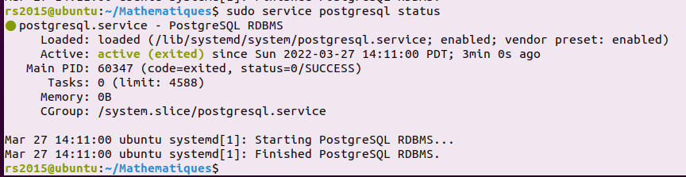

### Create and Delete Users

First start the database

sudo service postgresql start

Ubuntu no longer comes with a root user account so his instructions do not work. See:

<https://launchschool.medium.com/how-to-install-postgres-for-ubuntu-linux-fa06a162348>

sudo -u postgres createuser --superuser $USER

sudo -u postgres createdb $USER

touch ~/.psql_history

psql

In PSQL, you can create and delete users as follows

CREATE USER new_user WITH PASSWORD 'new_password';

To delete

DROP USER new_user;

### Create and Delete Databases

Create a database

CREATE DATABASE new_db;

Delete

DROP DATABASE new_db;

authorization

CREATE USER new_user WITH PASSWORD 'new_password';

CREATE DATABASE new_db;

GRANT ALL PRIVILEGES ON DATABASE new_db TO new_user;

### Dump and Restore Databases

Connect to a specific database

psql -h localhost -U new_user -d new_db

list all the tables

\dt

Create a new table

CREATE TABLE test(id INT, username VARCHAR(50));

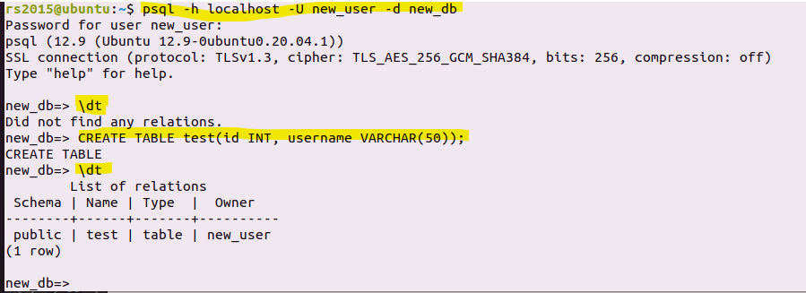

View the schema

\d test

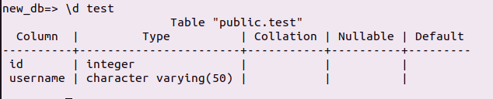

Quit

\q

Write the database to a file as an SQL script

pg_dump -h localhost -U new_user -d new_db -f new_db.sql

cat new_db.sql

--

-- PostgreSQL database dump

--

-- Dumped from database version 12.9 (Ubuntu 12.9-0ubuntu0.20.04.1)

-- Dumped by pg_dump version 12.9 (Ubuntu 12.9-0ubuntu0.20.04.1)

SET statement_timeout = 0;

SET lock_timeout = 0;

SET idle_in_transaction_session_timeout = 0;

SET client_encoding = 'UTF8';

SET standard_conforming_strings = on;

SELECT pg_catalog.set_config('search_path', '', false);

SET check_function_bodies = false;

SET xmloption = content;

SET client_min_messages = warning;

SET row_security = off;

SET default_tablespace = '';

SET default_table_access_method = heap;

--

-- Name: test; Type: TABLE; Schema: public; Owner: new_user

--

CREATE TABLE public.test (

    id integer,

    username character varying(50)

);

ALTER TABLE public.test OWNER TO new_user;

--

-- Data for Name: test; Type: TABLE DATA; Schema: public; Owner: new_user

--

COPY public.test (id, username) FROM stdin;

\.

--

-- PostgreSQL database dump complete

--

Dump just a specific table

pg_dump -h localhost -U new_user -d new_db -t test -f test.sql

--

-- PostgreSQL database dump

--

-- Dumped from database version 12.9 (Ubuntu 12.9-0ubuntu0.20.04.1)

-- Dumped by pg_dump version 12.9 (Ubuntu 12.9-0ubuntu0.20.04.1)

SET statement_timeout = 0;

SET lock_timeout = 0;

SET idle_in_transaction_session_timeout = 0;

SET client_encoding = 'UTF8';

SET standard_conforming_strings = on;

SELECT pg_catalog.set_config('search_path', '', false);

SET check_function_bodies = false;

SET xmloption = content;

SET client_min_messages = warning;

SET row_security = off;

SET default_tablespace = '';

SET default_table_access_method = heap;

--

-- Name: test; Type: TABLE; Schema: public; Owner: new_user

--

CREATE TABLE public.test (

    id integer,

    username character varying(50)

);

ALTER TABLE public.test OWNER TO new_user;

--

-- Data for Name: test; Type: TABLE DATA; Schema: public; Owner: new_user

--

COPY public.test (id, username) FROM stdin;

\.

--

-- PostgreSQL database dump complete

--

## SQL Commands

### Intro

### CREATE/DROP TABLE

### PRIMARY KEY

### INSERT INTO

### SELECT

### UPDATE

### DELETE

### CREATE/DROP INDEX

### SELECT DISTINCT

### ORDERB Y

### GROUP BY

### BETWEEN

### JOIN

### LIMIT

### EXISTS

### FOREIGN KEY

### GRANT

### COUNT

### MAX MIN AVG

### SUM

### SQL SUBQUERY

## Databases for Web Hosting

### Intro

Install and setup your LAPP stack on the cloud

### LAPP = Linux Apache PostgreSQL PHP

### Interacting with the database

## Python and Postgresql with psycopg2

### Connect to database with python psycopg2

### Write changes to databse

### Read data from database

### Passing parameters to SQL queries

Appendix

## Using PyCharm

### Download

<https://www.jetbrains.com/pycharm/download/#section=windows>

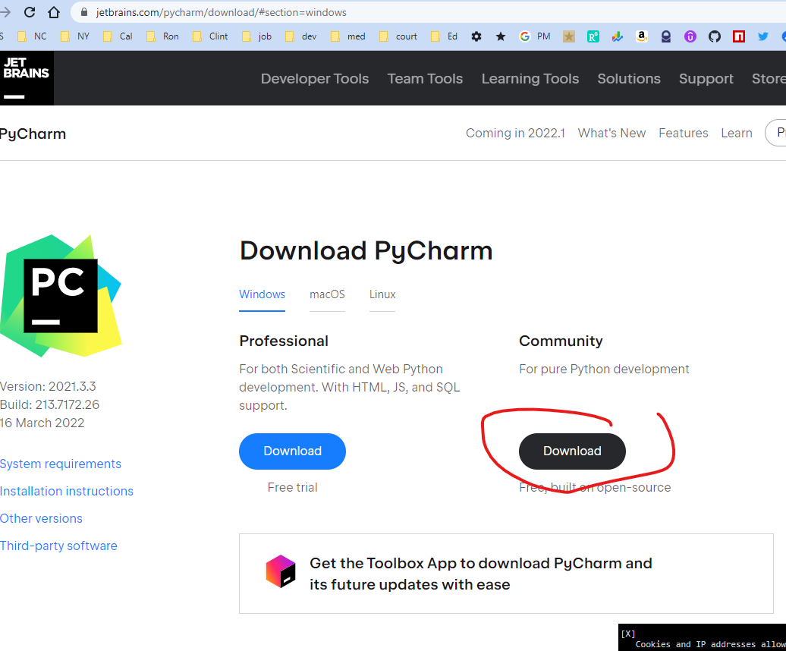

### Create a new project

<https://www.youtube.com/watch?v=HHcZbXsZtm0&list=WL&index=10>

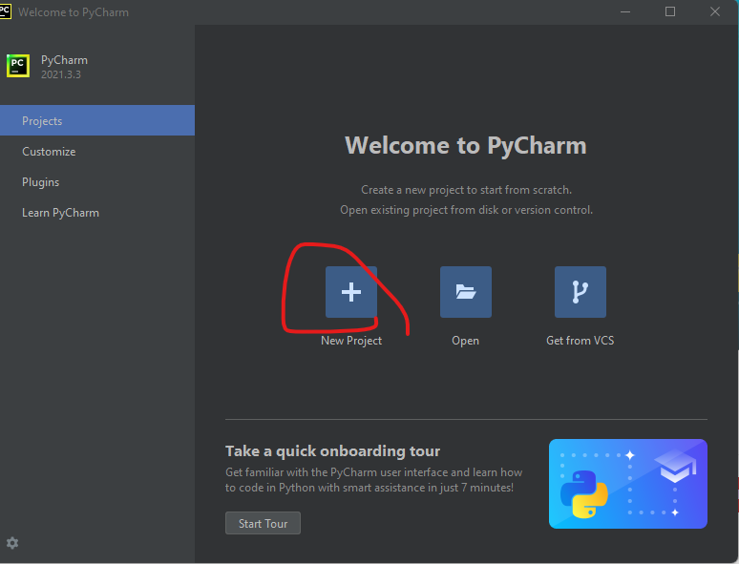

Add project called “first” and use all default settings

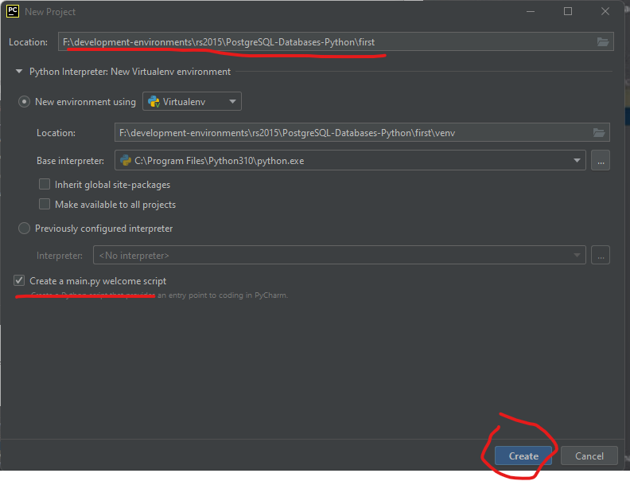

After a few second you should see something like

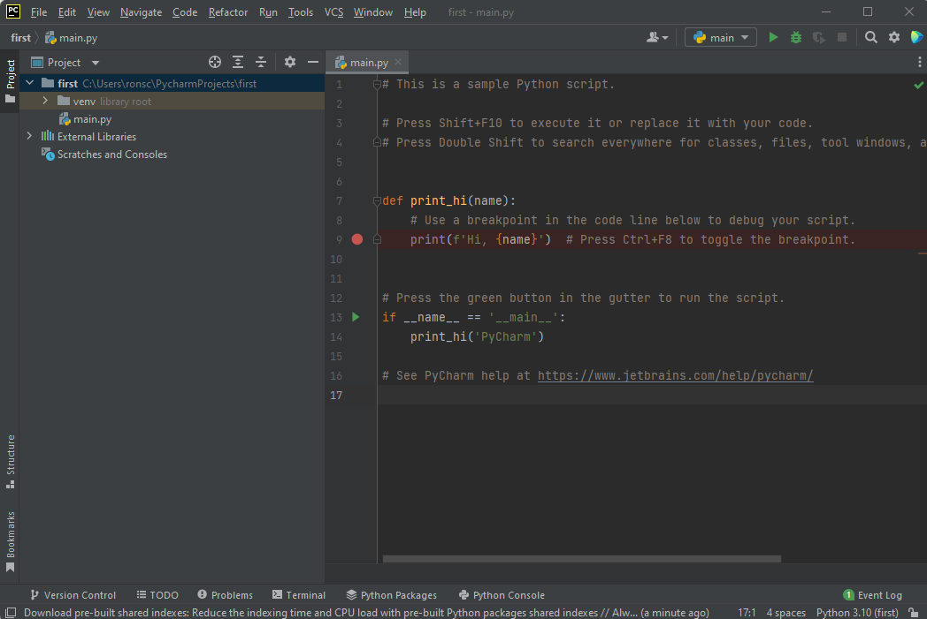

### Run a program

Click on the terminal tab in the bottom frame and type **python main.py** to run

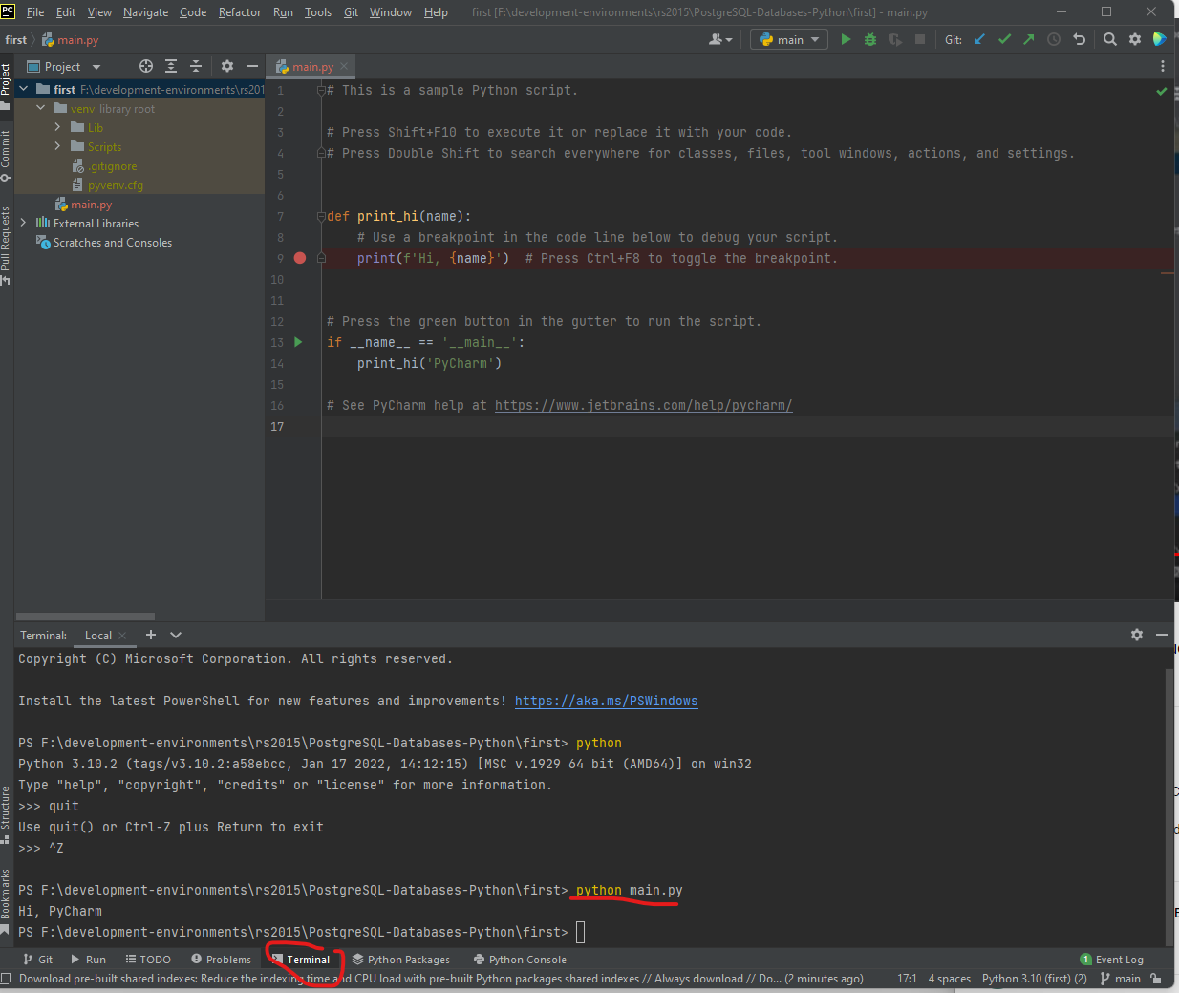

You can also run by clicking the green play arrow in the toolbar. The output will be sent to the Run tab of the bottom frame

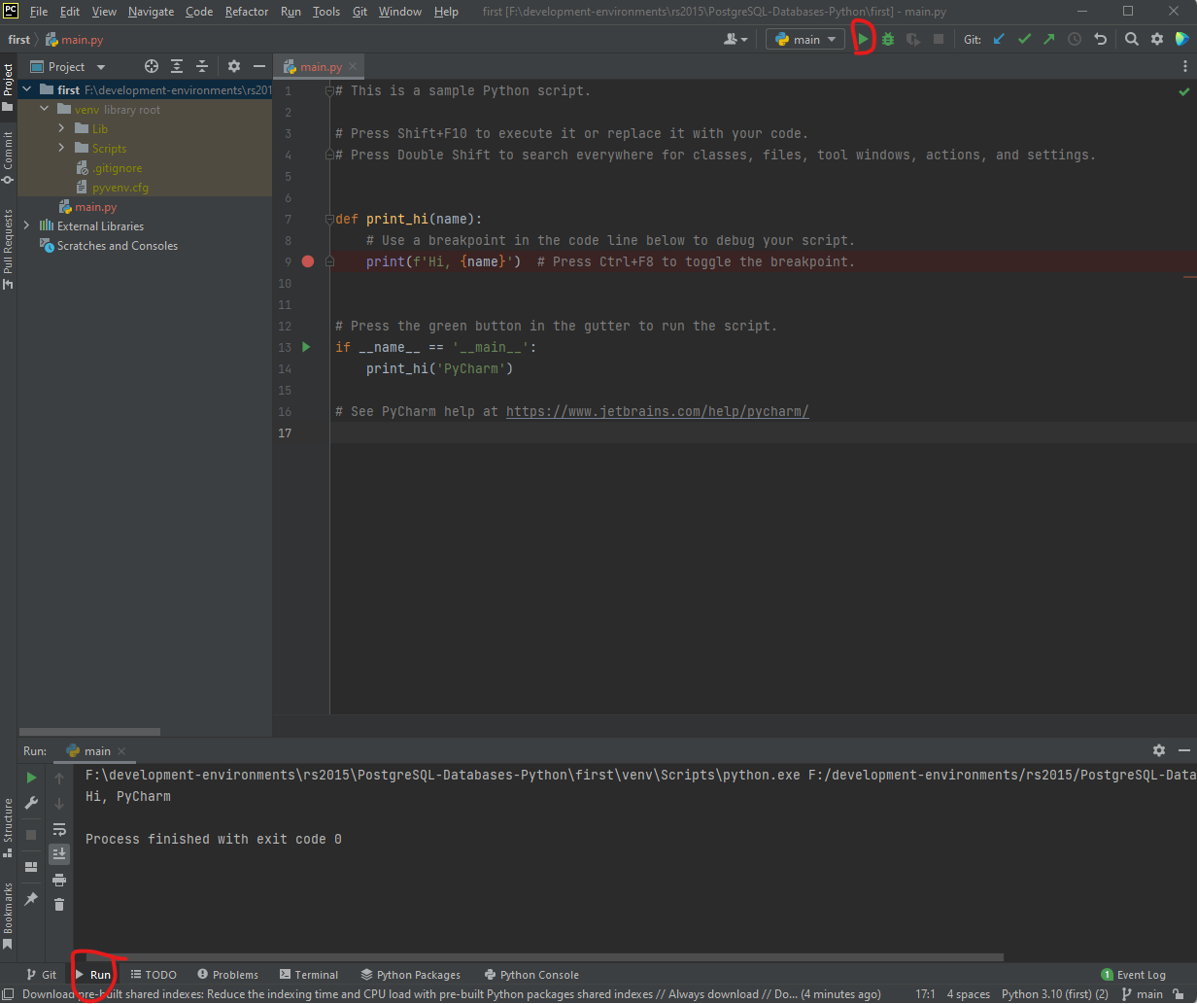

### Python version

Check version of python. Want at least 3

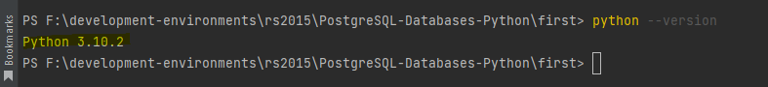

### Pip

The command **pip** is the python module (ie package) loader

Update **pip**

python.exe -m pip install --upgrade pip

Example: install the **NumPy** module using the package load for python, **pip.**

pip install numpy