React vs Angular vs Vue.js by Example

## Project Design

### Project Introduction & Resource files

### Navigation Design

#### Bulma

Bulma CSS framework <https://bulma.io/>

We will use the

* **navbar** <https://bulma.io/documentation/components/navbar/>
* **button** <https://bulma.io/documentation/elements/button/>

We will install Burma later using npm

#### Adobe XD

<https://www.adobe.com/products/xd/learn/get-started/what-is-adobe-xd-used-for.html>

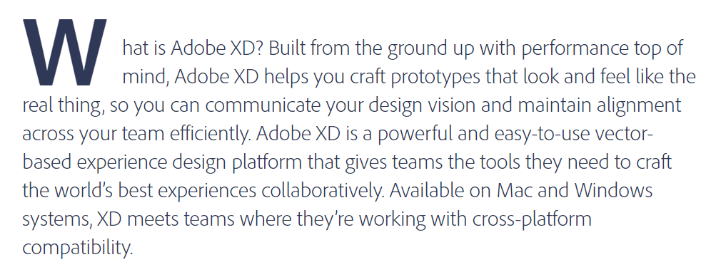

Need to view his Adobe XD files. Free online viewers:

* <https://www.photopea.com/>
* <https://psdetch.com/>
* Can also lease Adobe XD for $10/month or $120/year

I tried **photopea**, but it can only import Xd files. It then exports as psd

I went with Adobe XD 7-day free trial, $9.99/month after that.

Open file

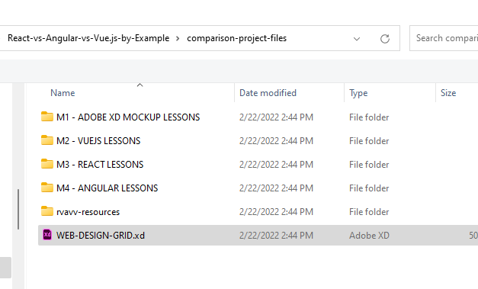

We first add a rectangle to match the specs of the Burma navbar

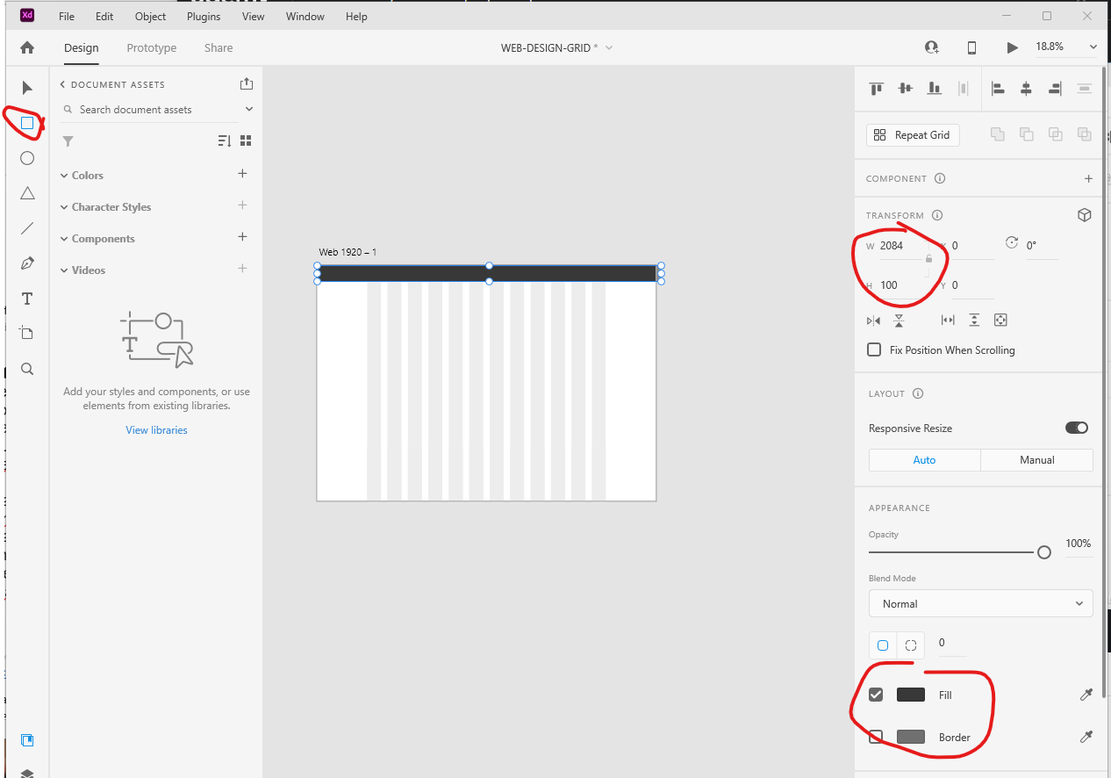

Change color to #383838 gray. Create a rectangle: use the gray color for fill, no outline, 2054px wide, 100px high.

Now use text tool to add text as follows

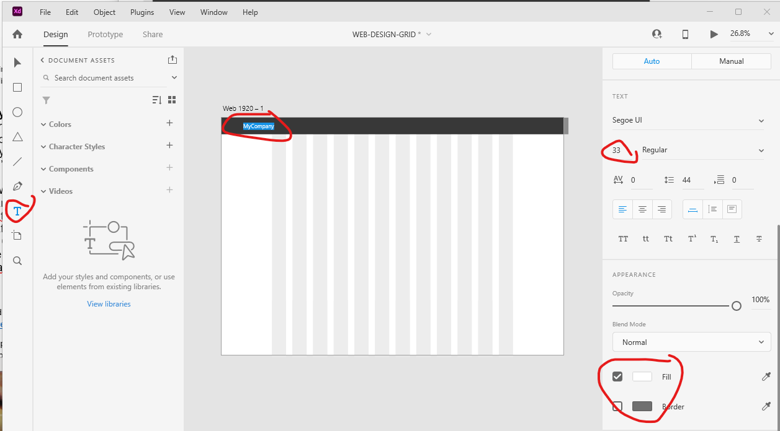

Now add navbar menu items using font size 25. Align vertically and space even horizontally

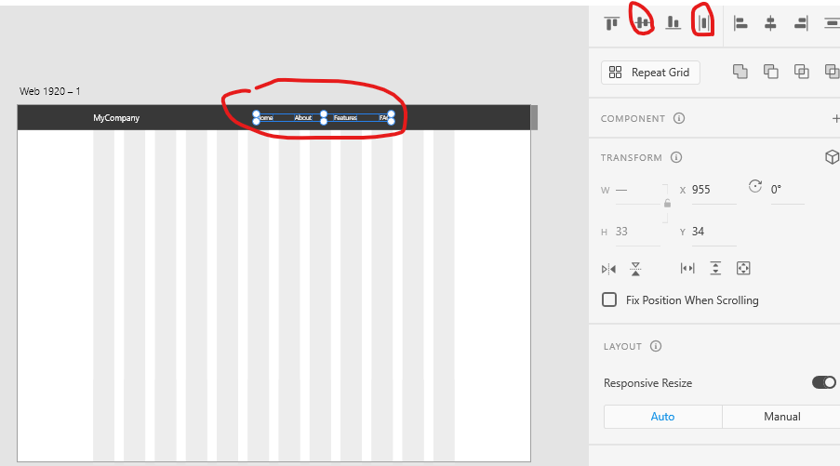

Add a rectangle as follows which will be a button. Color is #1EC9AC

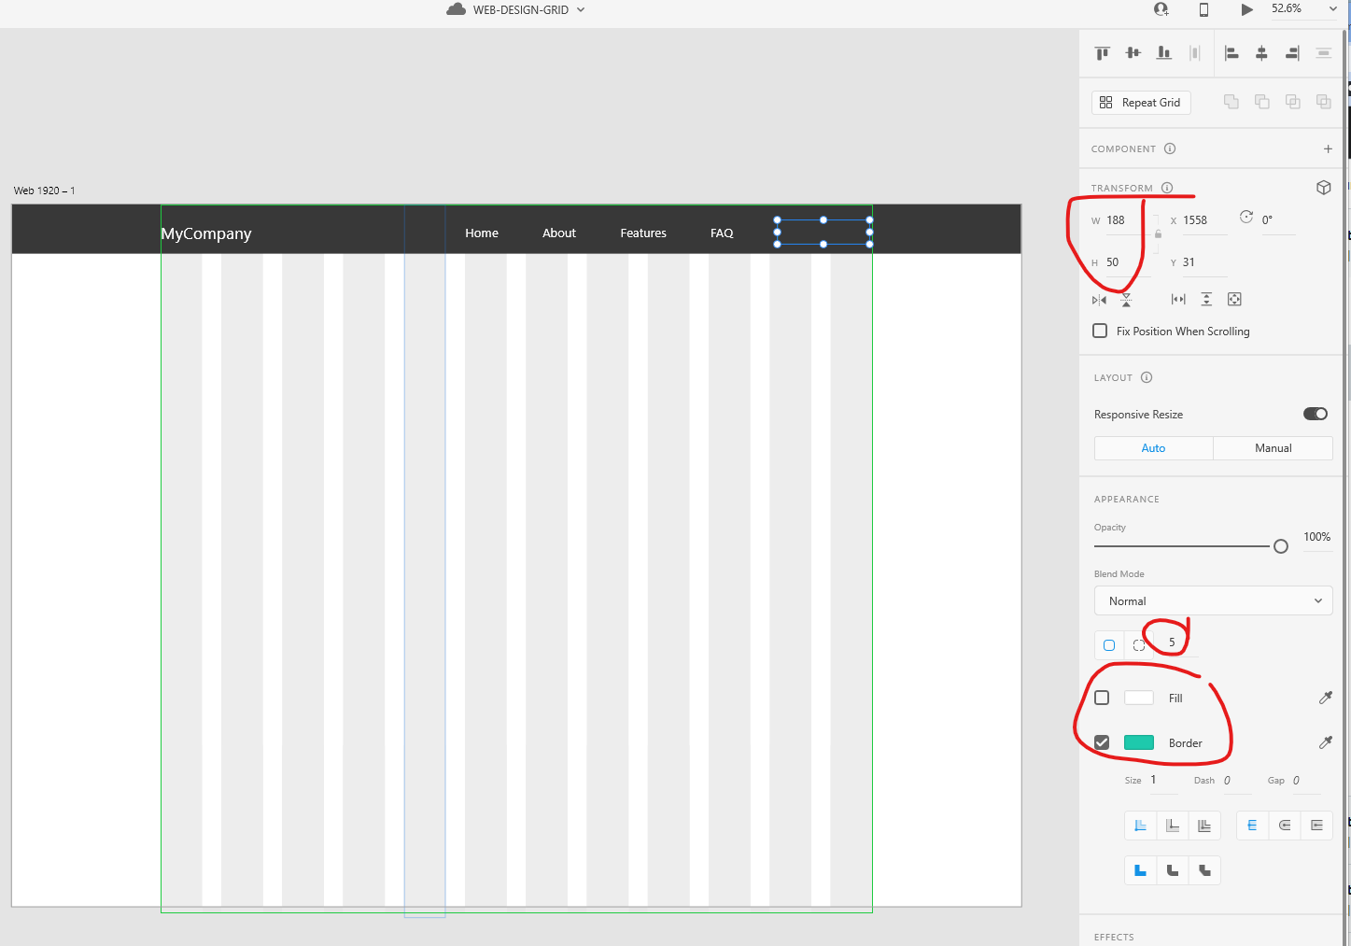

Now add the text for the button

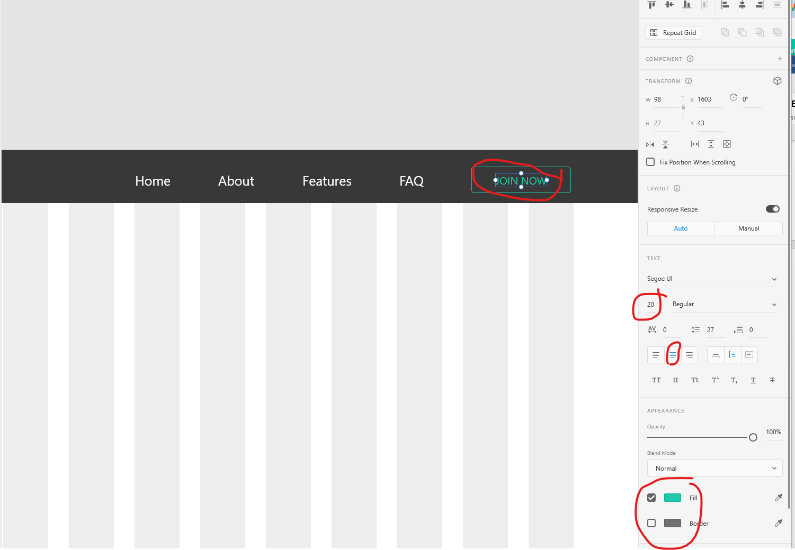

Lastly we add a shadow to the navbar to match Burma

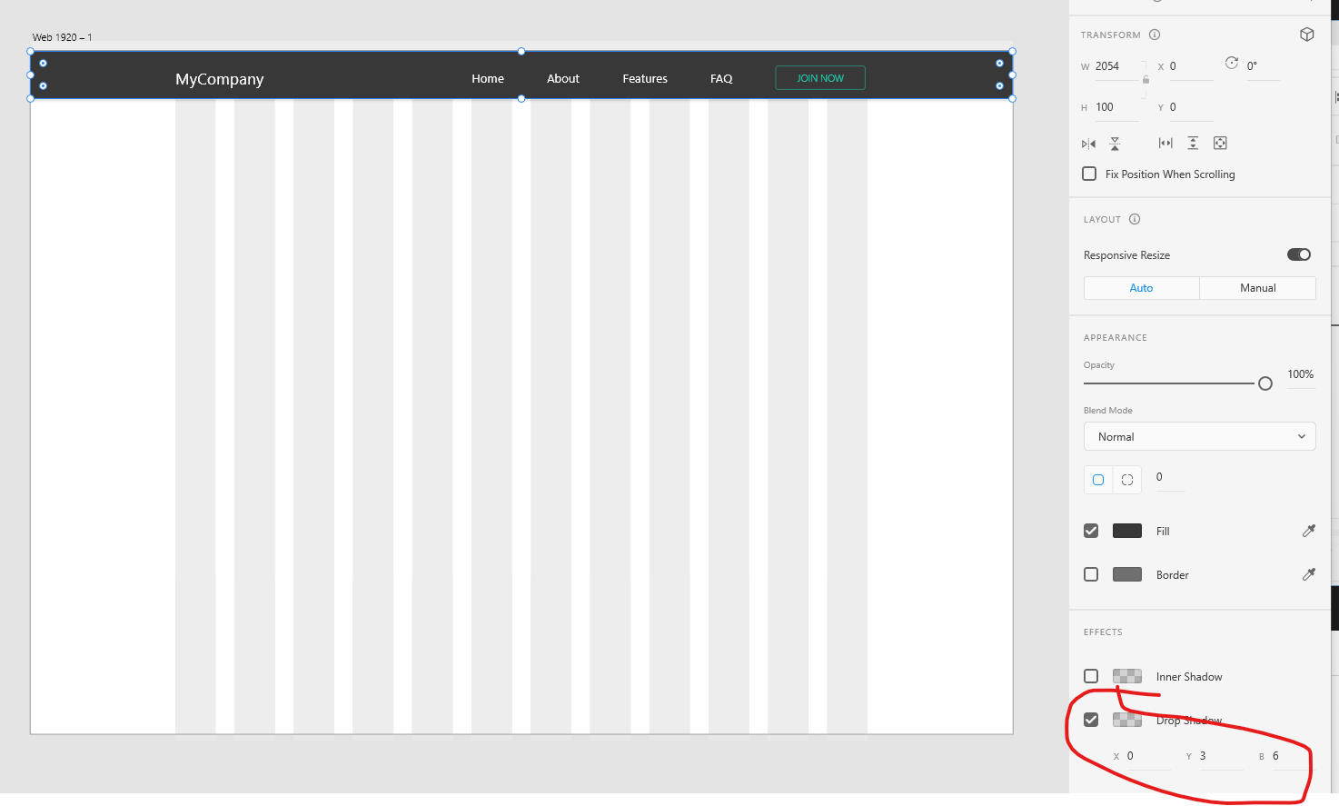

### Hero Section

<https://bulma.io/documentation/layout/hero/>

Example Hero section

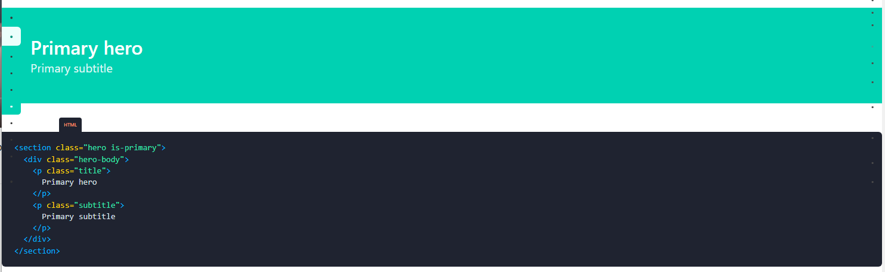

Draw rectangle as follows

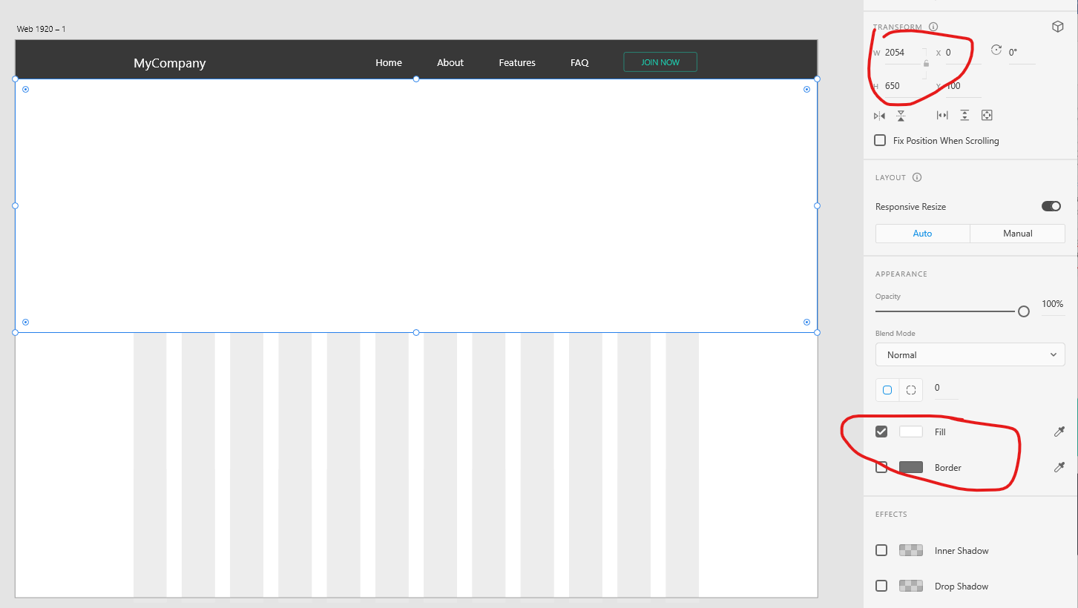

Drag file clouds.jpg onto this rectangle

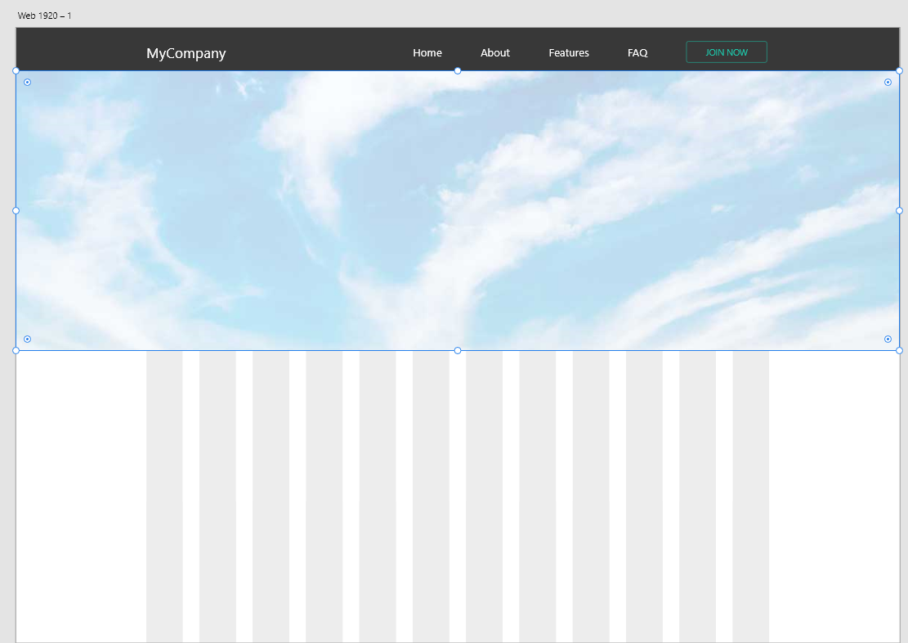

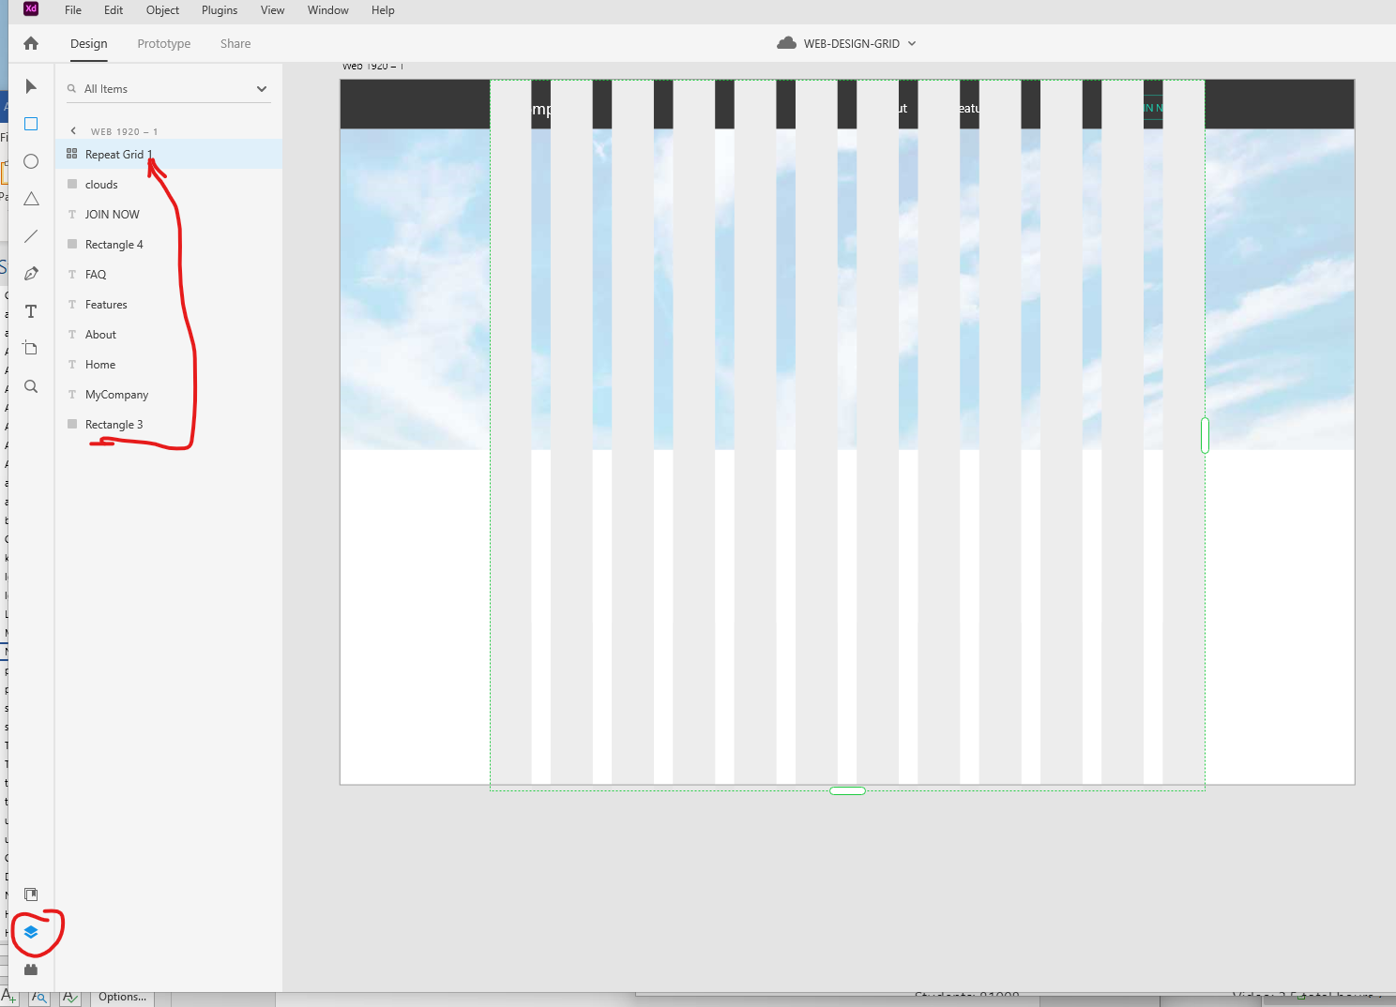

Change opacity of grid layer to 40% or so

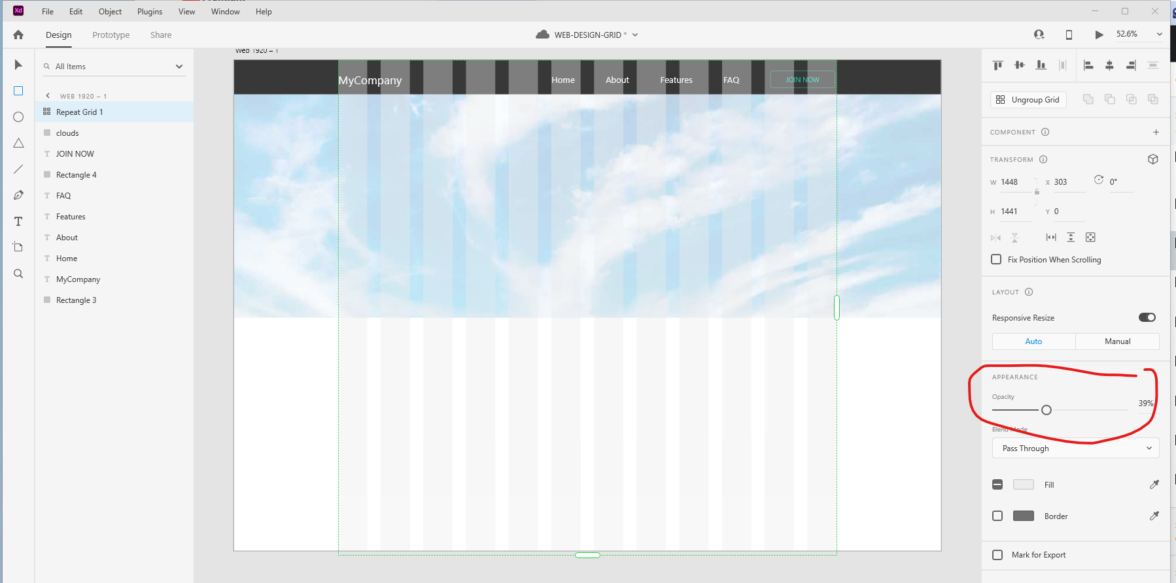

Create heading

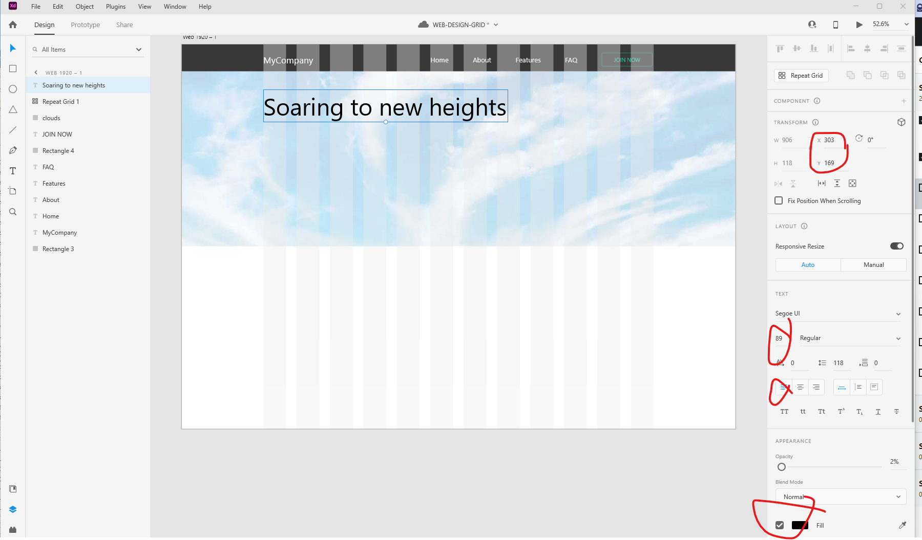

Create sub heading

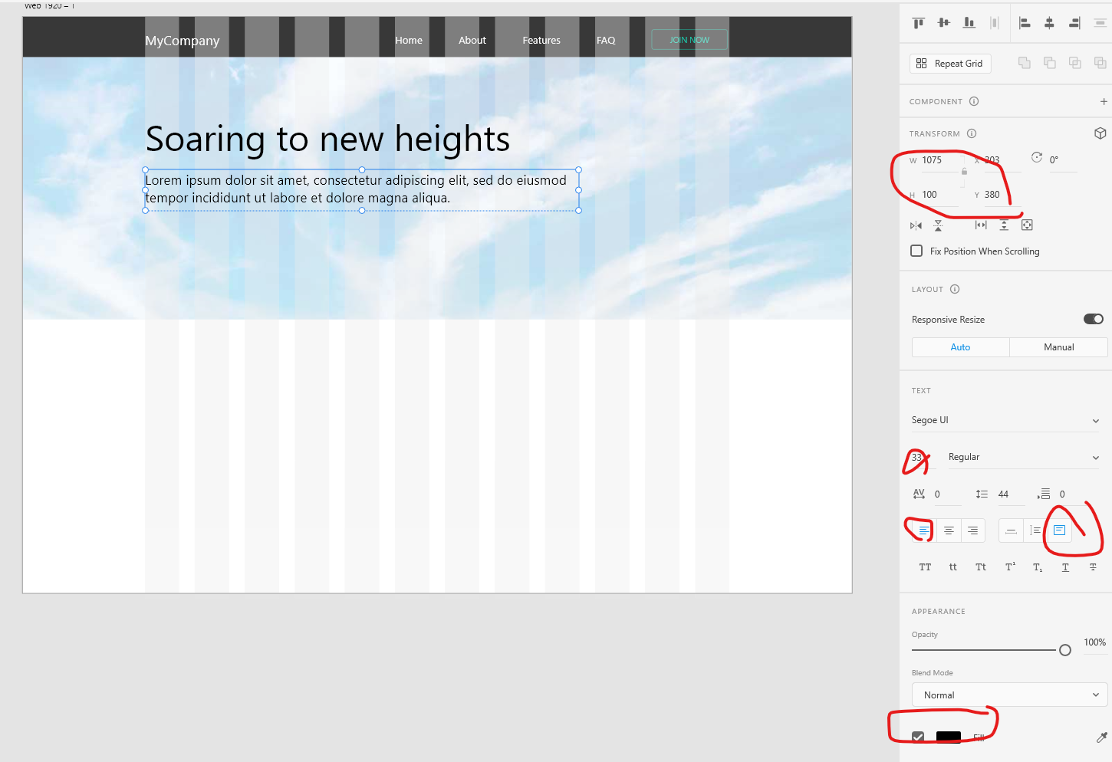

Create Our Service button by copying the JOIN NOW button layers and modify as follows.

The rectangle:

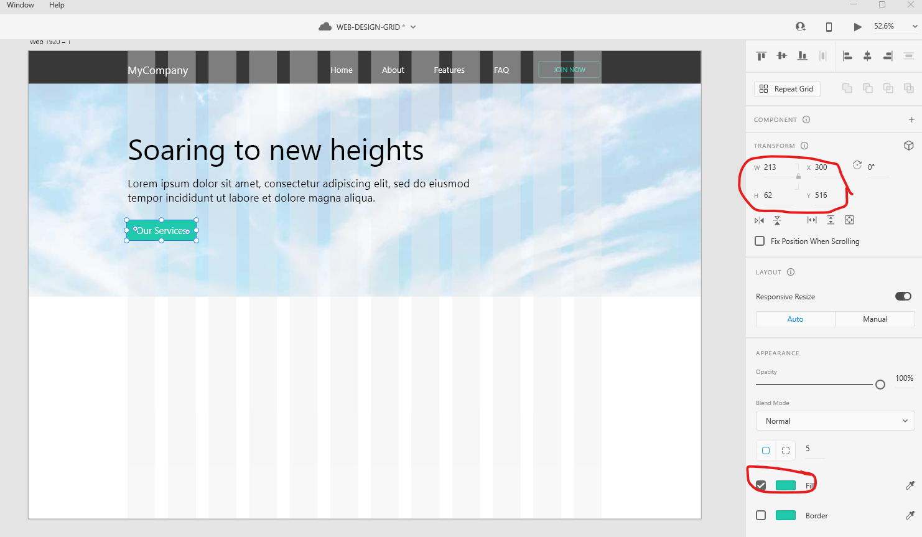

The text:

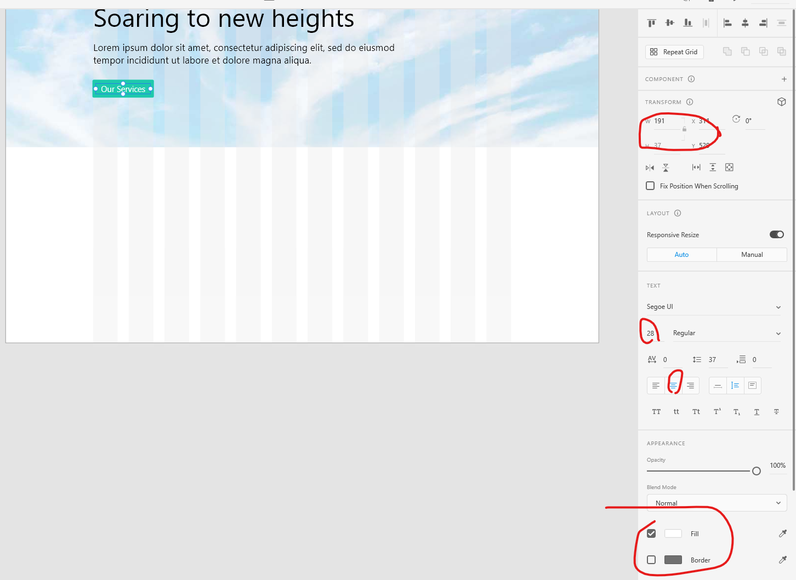

Tweak layout a little using his suggestions

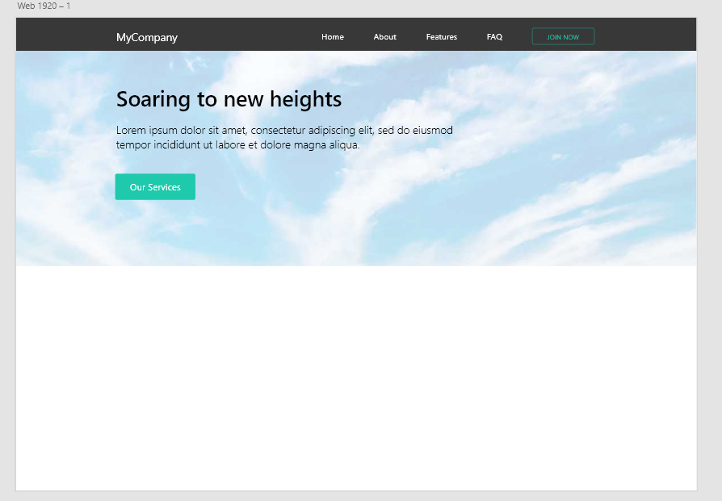

### Supporting Content

### Footer Design

### FAQ Page

### Mobile Home Page

### Mobile Navigation

### Mobile FAQ Page

## Vue

## React

## Angular

|  |
| --- |
| **name. component.html** |
|  |

|  |
| --- |
| **name. component.ts** |
|  |