SIA101- SYSTEM INTEGRATION AND ARCHITECTURE

NAME: Pagente, Aaron Philip C.

SCORE

PERCENTAGE
STUDENT NO: 23-2271
YEAR/SECTION: SBIT-3C
DATE: 11/15/2025

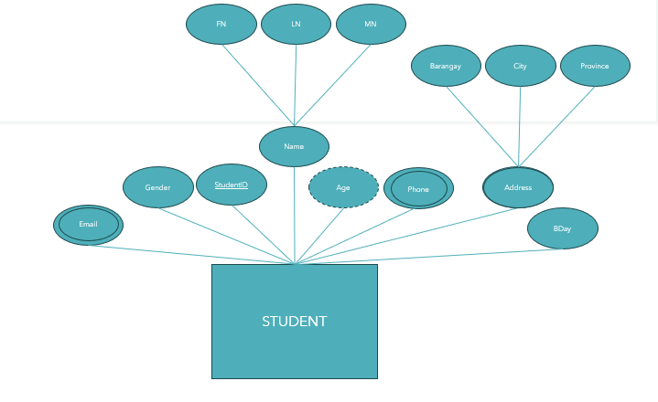

- Using the Entity on top, Create Table SQL Script (15pts)
- Using item no1 Create Data Dictionary (15pts)
- Create Database Schema (15pts)

1.
create table STUDENT {
StudentId int auto_increment primary_key,
Email varchar(100) unique,
Gender varchar(100),
FN varchar(100),
MN varchar(100),
LN varchar(100),
age int (3),
phone varchar(100),
Barangay varchar(100),
City varchar(100),
Province varchar(100),
Bday varchar(100)
};

2. Data Dictionary

FieldName | Data type | Field size | Description
StudentId | int | 5 | student’s id
Email | varchar | 100 | student’s email
Gender | varchar | 100 | student’s gender
FN | varchar | 100 | student’s first name
MN | varchar | 100 | student’s middle name
LN | varchar | 100 | student’s last name
age | int | 3 | student’s age
phone | varchar | 100 | student’s contact number
Barangay | varchar | 100 | student’s residence barangay
City | varchar | 100 | student’s city
Province | varchar | 100 | student’s province
Bday | varchar | 100 | student’s birthday

3. Schema
