Metrics of models:

Environment: 8X8 size, 0.2 density

Results were measured and averaged over 500 episodes

Best Model with 1 agent in the MAPF problem, 50 steps before truncation:

Agent: PPO

Network Architecture: 2 hidden layers of 256 neurons, fully connected.

average sum_of_costs 29.352

average makespan 29.352

percentage of solved instances 45%

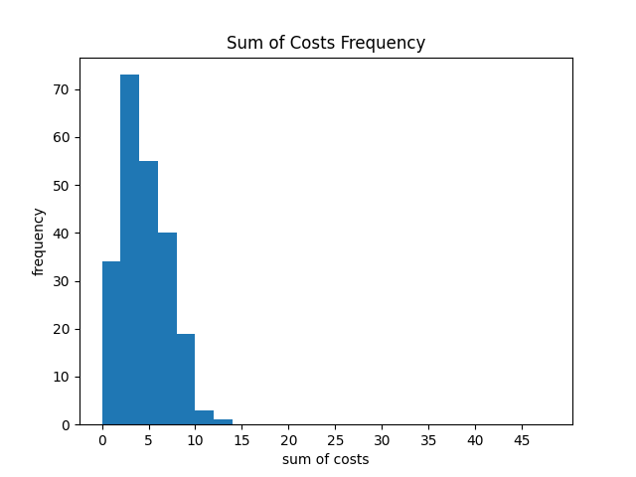

Best Model with 2 agent in the MAPF problem, 50 steps before truncation:

Agent: PPO

Network Architecture: 2 hidden layers of 512 neurons, fully connected.

average sum_of_costs 86.944

average makespan 46.882

percentage of solved instances 7.8%

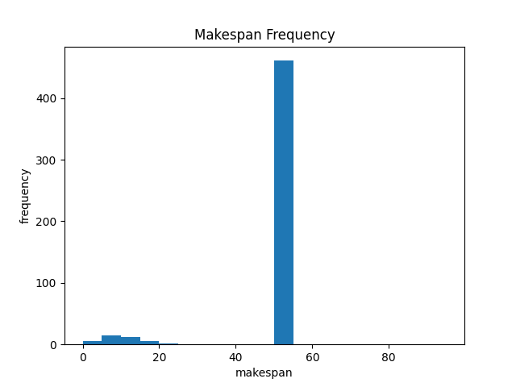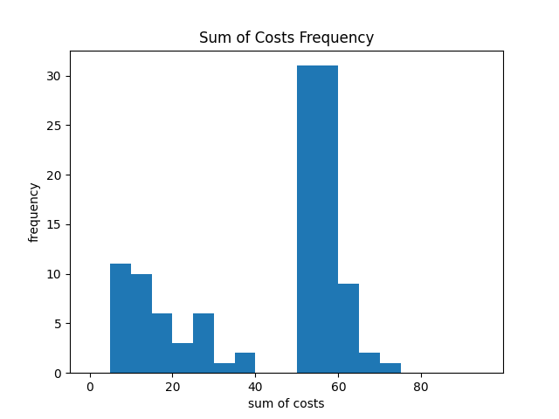

Best Model with 3 agent in the MAPF problem, 100 steps before truncation:

Agent: PPO

Network Architecture: 2 hidden layers of 512 neurons, fully connected.

average sum_of_costs 280.512

average makespan 100.0

percentage of solved instances 0.0%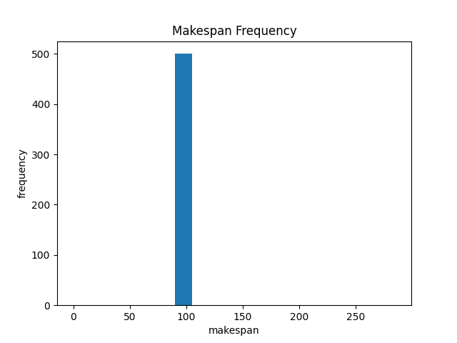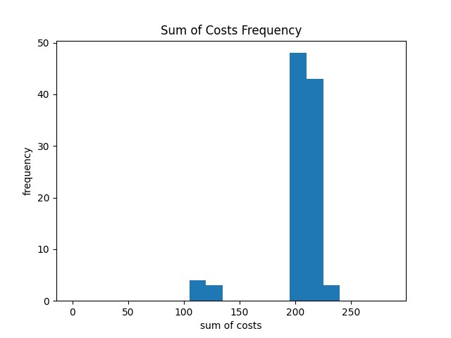

Best Model with 4 agent in the MAPF problem, 100 steps before truncation:

Agent: PPO

Network Architecture: 2 hidden layers of 512 neurons, fully connected.

average sum_of_costs 373.062

average makespan 100.0

percentage of solved instances 0.0%