CSC8360 S2 2022 ASSIGNMENT 1

**RF Fundamentals** Due Date: xx/xx/2022

# Objective

The objective of this assignment is to set the scope and requirements of the proposed project.

# Marks

Assignment 1 comprises 10% of your final mark.

# Submission

You need to submit the assignment in word or pdf format using the Assignment 1 submission link on the Study Desk.

**For the assignment, you need to demonstrate understanding of the following:**

* + RF Behaviour (propagation characteristics, frequency band selection and range)
  + Relationship between frequency (f) and distance (d)
  + Signal to Noise Ratio (SNR)
  + Impact of Interference (sources of noise and interference)
  + Antenna Systems (type selection)
  + Channel Bandwidth (vs frequency bands)
  + Shannons Law
    - C = W log2(1 + S/N)
  + System Gain
    - Free Space Loss
    - Antenna Gain
    - Feeder Loss
    - Transmitter Power
    - Receiver Sensitivity
  + Reflection and Refraction (LOS and nLOS)

**Assignment 1:**

In your own words, describe under what circumstances that a wireless network solution would be considered over a non-wireless (wireline) solution in a home and in a business office environment.

Your answer is to incorporate the following:

* *Provide a marked version of diagrams below, showing the positioning and quantity of network devices that should be deployed for each scenario.*
* *Set out the rationale for all of your decisions, in terms of connected users, bandwidth per connected user, propagation, interference, frequency choices.*
* *Describe the pros and cons of your solution (eg; wireless over wireline, wireline over wireless).*

Scenario #1: House Plan

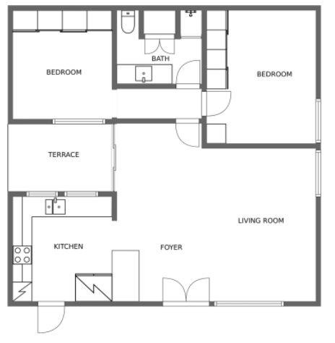

Scenario #2: Office Plan

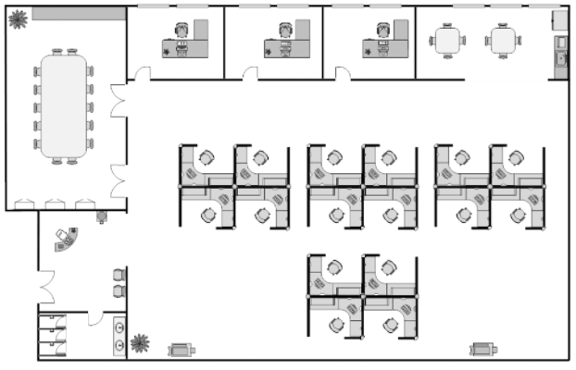

# Late Submission of Assignments

Students can apply for an extension of time to submit an assignment at any time up to the deadline. Students are advised to make a request for an extension as soon as their need becomes apparent.

Delay in making a request involves the risk of losing marks if the request is refused. The examiner may grant a short extension of the deadline for submission of an assignment. Extensions are usually granted only in cases of [Compassionate and Compelling](https://policy.usq.edu.au/documents/131150PL) [Circumstances](https://policy.usq.edu.au/documents/131150PL) in accordance with the assessment of [Compassionate and Compelling](https://policy.usq.edu.au/documents/131150PL) [Circumstances Procedure](https://policy.usq.edu.au/documents/131150PL). Generally, extensions will be limited to a maximum of five University Business Days. A Student requiring an extension for a period more than this should consider applying for a Deferred Assessment as per Section 4.4 of the assessment procedure.

Applications for extensions must be made via the [request for extension link](https://usqassist.custhelp.com/app/forms/deferred_assessment). An Assignment submitted after the deadline without an approved extension of time will be penalized. The penalty for late submission without a pre-approved extension is a reduction by 5% of the maximum mark applicable for the assignment, for each University business day or part business day that the assignment is late. An assignment submitted more than ten University business days after the deadline will have a mark of zero recorded for that assignment.

The examiner may refuse to accept assignments for assessment purposes after marked assignments and/or feedback have been released.

# Student Responsibilities

The [Assessment Procedure](https://policy.usq.edu.au/documents/14749PL) Section 4.2.2, also outlines the following student responsibilities:

* If requested, Students must be capable of providing a copy of the Assignments submitted. Copies should be dispatched to the University within 24 hours of receiving a request.
* Students are responsible for submitting the correct assignment.
* Assignment submissions must contain evidence of student effort to address the requirements of the assignment. In the absence of evidence of Student effort to address the requirements of the assignment, no Mark will be recorded for that Assessment Item.
* A Student may re-submit an Assignment at any time up to the deadline. A request to re-submit after the deadline is dealt with in accordance with section 4.4 ‘Deferred, Supplementary and Varied Assessment and Special Consideration’ of these procedures.

# Academic Integrity

Academic misconduct is unacceptable and includes plagiarism, collusion, and cheating:

* *Plagiarism*: involves the use of another person’s work without full and clear referencing and acknowledgement.
* *Cheating*: involves presenting another student’s work as your own.
* *Collusion*: is a specific type of cheating that occurs when two or more students fail to abide by directions from the examiner regarding the permitted level of collaboration on an assessment.

All are seen by the University as acts of misconduct for which you can be penalized. For further details, go to the [Library’s site on plagiarism](https://www.usq.edu.au/library/referencing/plagiarism).