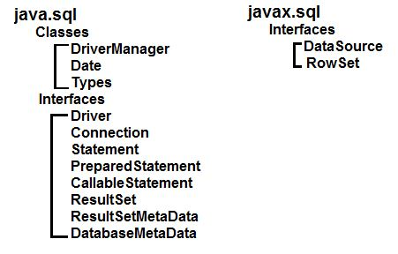

1. **Load Drivers:-**

**Class**.forName("com.mysql.jdbc.Driver");

1. **Connection** [**URL:-**](URL:-)**.**

conn = [DriverManager](http://www.google.com/search?hl=en&q=allinurl%3Adocs.oracle.com+javase+docs+api+drivermanager).getConnection("jdbc:mysql://localhost:3306/EXPDB" , "root", "root");

1. **Create** [**Statement**](http://www.google.com/search?hl=en&q=allinurl%3Adocs.oracle.com+javase+docs+api+statement) **object:-**

[Statement](http://www.google.com/search?hl=en&q=allinurl%3Adocs.oracle.com+javase+docs+api+statement) stmt = conn.createStatement();

1. **Create** [**Statement**](http://www.google.com/search?hl=en&q=allinurl%3Adocs.oracle.com+javase+docs+api+statement) **object:-**

[ResultSet](http://www.google.com/search?hl=en&q=allinurl%3Adocs.oracle.com+javase+docs+api+resultset) rs = stmt.executeQuery("SELECT * FROM table_name ");

1. **Execute Query:-**

stmt.executeUpdate("INSERT INTO table_name (NAME) VALUES (**\"**Ronak K**\"**)");

1. **Process Result:-**

rs = stmt.executeQuery("SELECT * FROM table_name ");

1. **Close the connection:-**

conn.close();

|  |  |
| --- | --- |
| Statement | Use for general-purpose access to your database. Useful when you are using static SQL statements at runtime. The Statement interface cannot accept parameters. |
| PreparedStatement | Use the when you plan to use the SQL statements many times. The PreparedStatement interface accepts input parameters at runtime. |
| CallableStatement | Use the when you want to access the database stored procedures. The CallableStatement interface can also accept runtime input parameters. |