**REPORT**

**Project Name:** Handwriting to Text (OCR – Optical Character Recognition Model)

**Purpose:** Learning the basics of Artificial Intelligence and Machine Learning

**Description:** This project aims to build a simple OCR system. Users will write a single capital letter (A-Z) or number (0-9) on a designated area, and the system will analyse the image using trained model. After processing the image, the predicted character will be displayed in a designated output box, offering a user-friendly and interactive way to test the system's recognition capabilities.

**Languages used**:

1. **Python (v3.10.13):**

* **Libraries:** Flask, OpenCV, Matplotlib, TensorFlow, Keras, Pandas, Numpy, SciKit-Learn, CSV, Random

1. **HTML5**
2. **CSS3**
3. **JavaScript:**

* **Frameworks:** JQuery, Ajax

**Dataset:** 884, 900 Samples (Originally, there were 442, 450, which we duplicated and inversed the colour scale and combined with the original dataset). Used Train – Test Split

**Train – Test Split Ratio:** 70 - 30

**Training Set:** 619, 429

**Testing Set:** 265, 470

**Model Summary:**

1. **Total params:** 683044 (2.61 MB)
2. **Trainable params:** 683044 (2.61 MB)

**Model Compilation:**

1. **Loss Function:** Categorical Cross Entropy
2. **Optimizer:** Adam

**Model Accuracy:** 0.9794289469718933 (97.9429 %)

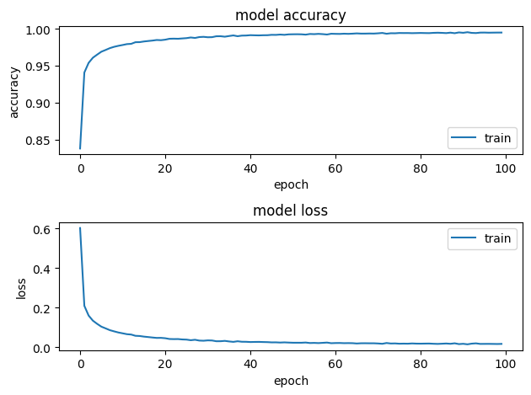

**Future Scope:** This OCR Model Is trained using ANN (Artificial Neural Network) which often provides the wrong output as the ANN model doesn’t recognize patterns. Therefore, this model should be trained using CNN (Covulational Neural Network).

**References:**

1. https://www.kaggle.com/ (for datasets)

**Guided By:** Mr. Sheel Shah

**Efforts By:**

1. Mr. Neelotpal Santra
2. Mr. Ronak Manishkumar Parmar