WEEK 4 TASK
Developing Basic Machine Learning Models
for Agricultural Data
End-to-End Strategy, Implementation Guide & Demonstration

Student | Arav Jain
Task | Week 4 — Basic Machine Learning Models
Domain | Agricultural / Agribusiness Data Analytics
Model Problem | Crop-yield prediction (regression)

Executive Summary
This report presents a complete, reproducible strategy for developing a basic machine-learning model for agricultural yield prediction. The proposed target is crop yield in tonnes per hectare, with explanatory variables covering rainfall, temperature, soil properties, irrigation, cropped area, crop/state identity and previous-year yield. The workflow covers problem definition, public data selection, data quality, feature engineering, model selection, time-aware training, evaluation, error analysis, computational considerations and agribusiness use cases.
A synthetic demonstration dataset is included so that the workflow can be executed locally without misrepresenting simulated observations as official government data. Public Government of India OGD sources were used to justify the data architecture: the crop-production resource contains district-, crop-, season- and year-level area/production information, while the rainfall catalog provides historical rainfall resources. citeturn0search1turn0search9

1. Predictive Problem Definition

1.1 Business / Agribusiness Question
Can historical weather, soil, irrigation and crop-management context be used to estimate crop yield for a state-crop-year observation? A reliable estimate can support production planning, procurement, storage capacity planning, resource allocation and risk monitoring.

1.2 ML Formulation
Task type | Supervised learning — regression
Target | yield_t_ha (tonnes/hectare)
Unit of prediction | State × crop × year
Primary metrics | MAE, RMSE, R²
Deployment intent | Planning / decision support, not autonomous agricultural control
MAE provides an average absolute prediction error in the same unit as yield. RMSE gives greater weight to larger errors. R² summarizes explained variance relative to a constant-mean baseline; it can also be negative when predictions are worse than that baseline. citeturn0search13

2. Data Selection

2.1 Public Data Sources
Source | Key variables | Why relevant | Use in ML
India OGD — Crop Production Statistics | year, state/district, crop, season, area, production | Provides the agricultural outcome context and historical crop-production structure. | Target construction, historical yield and area features.
India OGD / IMD — Rainfall in India | monthly/seasonal rainfall, rainfall departure | Weather availability is a key agricultural driver and risk variable. | Weather features and stress indicators.
The Government of India crop-production OGD resource states that it contains district-wise, crop-wise, season-wise and year-wise crop area and production data. The rainfall catalog includes month-wise and sub-division-wise rainfall resources and departure from normal. citeturn0search0turn0search9

2.2 Dataset Design Used in This Submission
The included demonstration dataset covers 2012–2025, four states (Maharashtra, Madhya Pradesh, Punjab and Gujarat), and three crops (Soybean, Wheat and Cotton). It contains weather, soil, irrigation, area and yield variables. The data are synthetic and intended only for demonstrating the ML process.

3. Feature Selection & Engineering
Feature | Type | Rationale | Expected role
annual_rainfall_mm | Numeric | Captures annual water availability. | Weather signal
avg_temp_c | Numeric | Represents thermal conditions affecting crop development. | Weather signal
soil_n_mgkg | Numeric | Nitrogen availability is relevant to crop productivity. | Soil fertility
soil_ph | Numeric | Extreme pH can affect nutrient availability. | Soil condition
irrigation_index | Numeric | Represents supplementary water availability. | Risk mitigation
area_ha | Numeric | Scale of cultivation can help explain production context. | Production context
state | Categorical | Captures regional agronomic and climatic differences. | Regional effect
crop | Categorical | Different crops have different yield ranges and responses. | Crop effect
rainfall_deviation_mm | Engineered | Measures rainfall relative to state baseline. | Weather anomaly
temp_stress_index | Engineered | Captures departure from a reference temperature. | Nonlinear stress
rainfall_irrigation_interaction | Engineered | Allows combined water effects to be represented. | Interaction
soil_n_ph_interaction | Engineered | Simple interaction between two soil properties. | Interaction
previous_yield_t_ha | Lagged | Provides prior state-crop performance context. | Temporal signal
year_index | Numeric | Captures gradual time trend. | Trend
Feature engineering should be performed using only information that would genuinely be available at the prediction time. For operational forecasting, any feature that becomes known only after harvest must be excluded.

4. Data Preprocessing Pipeline
1. Load and profile the source data.
2. Standardize field names, units and category labels.
3. Remove duplicate natural-key records.
4. Impute missing numeric values using a training-data-derived strategy.
5. Encode categorical variables with one-hot encoding.
6. Scale numeric variables for linear models; tree models do not require scaling.
7. Create time-aware lag and deviation features.
8. Separate training and future test periods before model fitting to avoid temporal leakage.
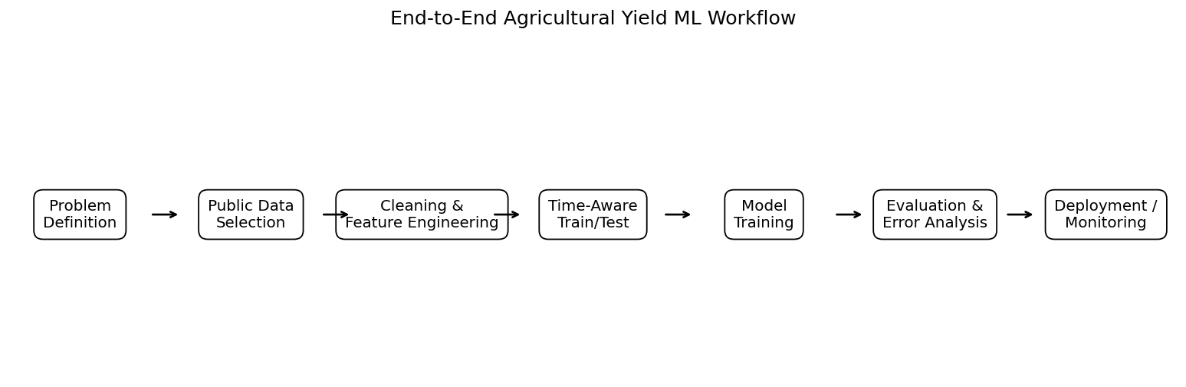

5. Model Selection Strategy
Model | Strength | Limitation | Role
Linear Regression | Simple, interpretable baseline; fast. | Limited nonlinear representation. | Baseline
Decision Tree Regressor | Captures nonlinear rules and interactions. | Can overfit without constraints. | Interpretable nonlinear benchmark
Random Forest Regressor | Strong baseline for mixed nonlinear tabular data; robust. | Less transparent and more computationally expensive. | Primary candidate
Simple Neural Network | Can model complex nonlinear relationships. | Needs more tuning/data and is less transparent. | Optional extension
The recommended progression is baseline first, then progressively more flexible models. A model should not be selected solely because it is more complex; performance, stability, interpretability and operational cost all matter.

6. Training & Validation

6.1 Time-Aware Holdout
The demonstration uses 2012–2022 for training and 2023–2025 as a future-style holdout. This is more appropriate for forecasting than randomly mixing all years. scikit-learn documents TimeSeriesSplit as a time-series cross-validator that keeps later observations in test folds and avoids training on future data. citeturn0search2turn0search11

6.2 Expanding Validation
For model stability, the package also includes expanding validation for the Random Forest across later historical years. In each validation step, earlier years are used for training and the next year is evaluated.

6.3 Leakage Controls
- Never use post-harvest production information to predict the same harvest.
- Fit imputers, scalers and encoders on training data only.
- Build lagged variables after sorting by time and within the correct state-crop group.
- Do not randomly shuffle time-ordered observations when evaluating a forecasting scenario.
- Keep the final holdout untouched until model selection decisions are substantially complete.

7. Evaluation Framework
Metrics and interpretation:
- MAE: average absolute error; lower is better and directly interpretable in tonnes/hectare.
- RMSE: square-root of mean squared error; lower is better and emphasizes larger mistakes.
- R²: proportion of target variance explained relative to a constant predictor; higher is generally better.
- Residual analysis: inspect where the model systematically over- or under-predicts.
- Segment analysis: compare errors across crops and states to identify uneven model performance.

8. Demonstration Results
Model | MAE (t/ha) | RMSE (t/ha) | R²
Linear Regression | 0.113 | 0.147 | 0.962
Decision Tree | 0.210 | 0.245 | 0.895
Random Forest | 0.163 | 0.195 | 0.934
In this synthetic demonstration, the model with the lowest holdout MAE is Linear Regression. This is a result on the simulated sample only and should not be interpreted as evidence that the model would achieve the same performance on official agricultural observations.
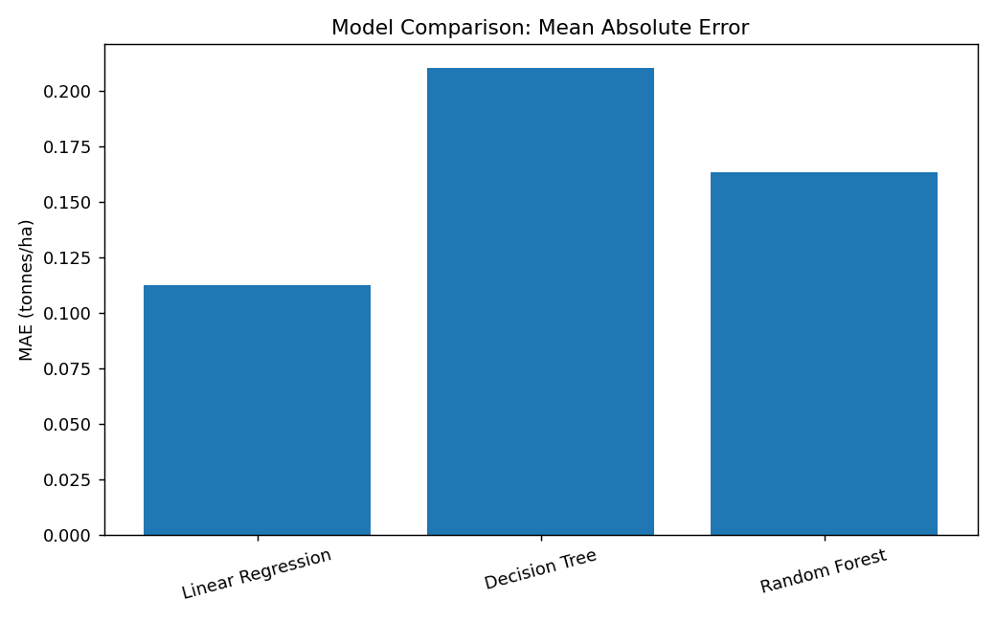
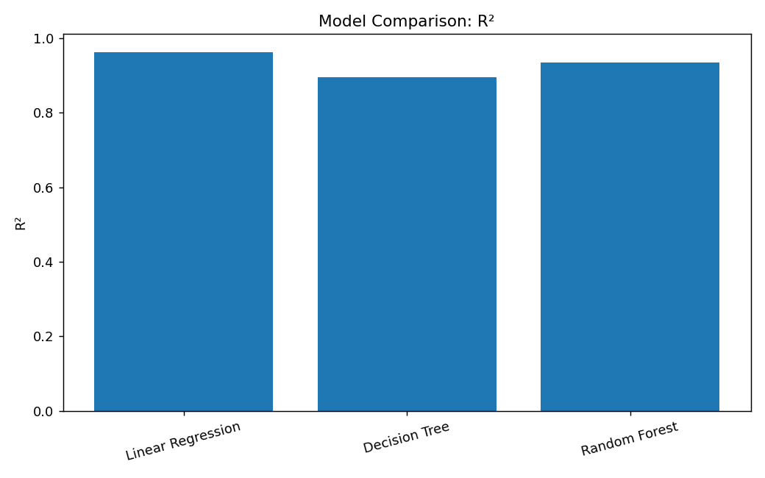
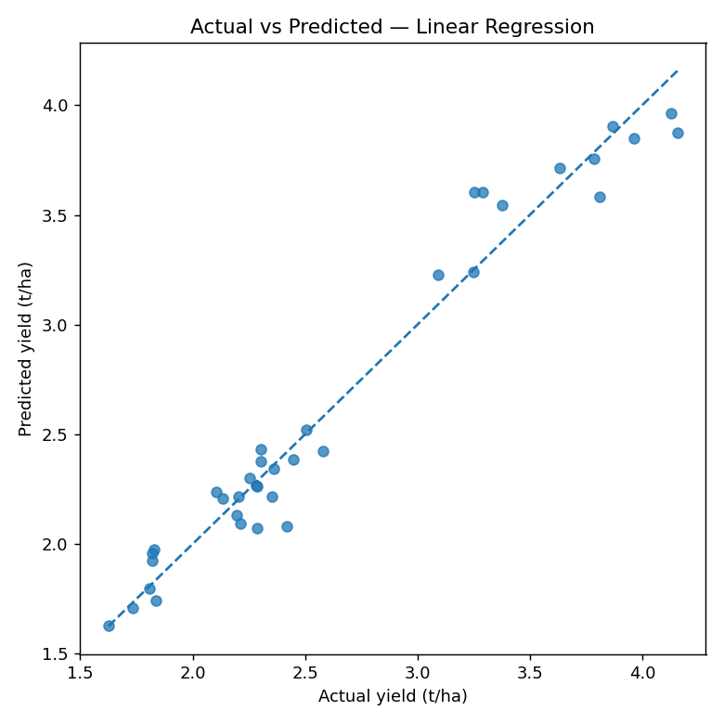

9. Feature Importance & Error Analysis
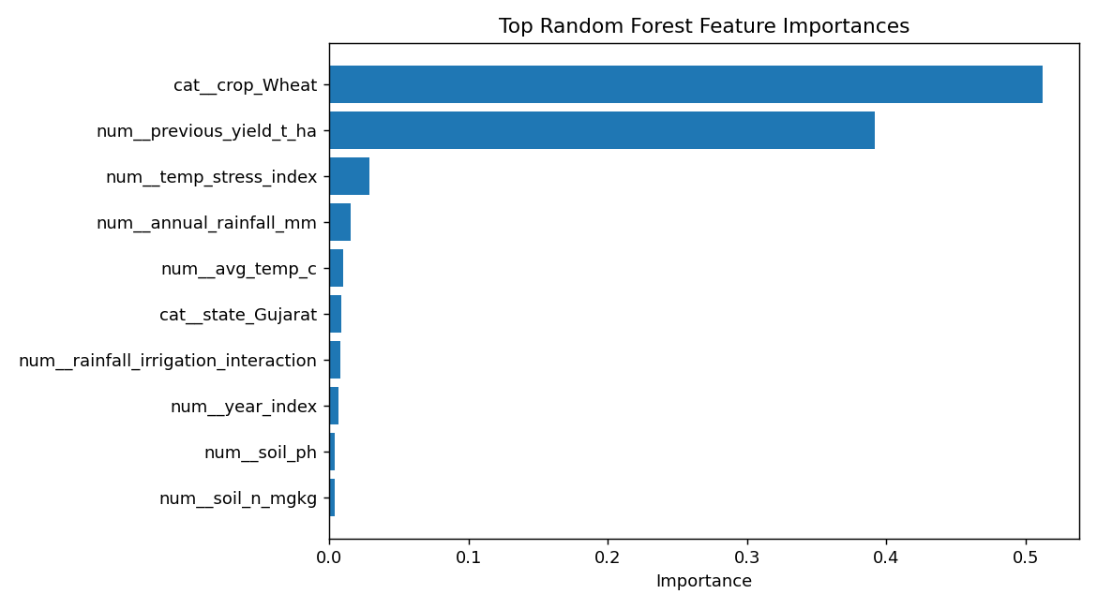
Feature importance from a tree ensemble is useful for diagnostic interpretation, but it should not be treated as causal evidence. A high-importance feature can be correlated with another unobserved driver. For a production system, permutation importance or SHAP-style analysis could be added alongside domain review.
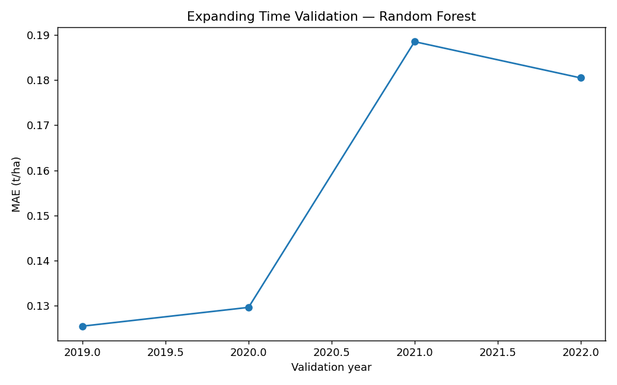

10. Agribusiness Applications
Procurement planning: Estimate expected yield ranges to support sourcing and supplier planning.
Storage & logistics: Translate production expectations into warehouse and transport requirements.
Input planning: Use expected productivity and risk indicators to support resource allocation.
Risk monitoring: Flag years or regions where weather conditions imply higher uncertainty.
Market analysis: Combine yield forecasts with price/market datasets in later stages.
Decision support: Provide scenario estimates to analysts while retaining human review.

11. Computational Considerations
- Small tabular datasets can be handled on a standard laptop using pandas and scikit-learn.
- Random Forest training cost rises with the number of trees, depth and feature count; n_jobs=-1 can parallelize tree construction on available CPU cores.
- Neural networks require additional tuning, normalization and monitoring and are not necessary for a strong first baseline.
- Memory can become important when joining high-resolution weather, soil and satellite datasets at district or field level.
- Feature pipelines should be saved and versioned with the model so inference uses exactly the same transformations.
- For production, use experiment tracking, model versioning, automated validation and drift monitoring.

12. Key Challenges & Risks
Challenge | Potential impact | Mitigation
Data leakage | Overly optimistic evaluation | Strict time split and training-only preprocessing
Missing / inconsistent data | Biased or unstable predictions | Profiling, imputation logs and quality checks
Weather extremes | Large prediction errors | Add anomaly features and uncertainty analysis
Regional differences | Uneven performance across states | Segment metrics and regional validation
Small sample size | Overfitting | Simple models, regularization and careful CV
Concept drift | Performance declines over time | Monitor post-deployment error and retrain
Synthetic demonstration | Results do not represent official performance | Validate on official observations before use

13. Step-by-Step Implementation Guide
1. Define the target, prediction horizon and business decision.
2. Identify official agricultural, weather and soil sources.
3. Create a data dictionary and define the observation grain.
4. Collect historical data and preserve raw copies.
5. Clean types, categories, duplicates and missing values.
6. Construct only prediction-time-available features.
7. Sort data chronologically and build lagged features within entity groups.
8. Split into historical training and future holdout periods.
9. Build a preprocessing pipeline.
10. Train Linear Regression as a baseline.
11. Train a constrained Decision Tree.
12. Train a Random Forest and tune a small number of hyperparameters.
13. Evaluate MAE, RMSE and R² on the holdout.
14. Inspect residuals and segment performance by crop/state.
15. Document limitations and determine whether the model is fit for the intended decision.
16. Only after validation, package the model for inference and establish monitoring.

14. Recommended Next Phase
The next iteration should replace the synthetic demonstration dataset with a properly joined official dataset containing crop outcomes and weather variables at a common spatial and temporal resolution. The model can then be benchmarked against a naïve historical-average baseline, followed by hyperparameter tuning and uncertainty estimation. Market prices, fertilizer use, irrigation coverage and remote-sensing indicators can be introduced only after confirming their availability at the prediction timestamp.

15. Reproducibility & Submission Contents
All supporting files are included in the accompanying ZIP. The Python script reproduces the core preprocessing and model training logic. CSV outputs contain the cleaned model dataset, predictions, metrics, validation results and feature-importance output.
- 01_Final_Document — this report
- 02_Raw_Data — raw synthetic demonstration data with intentional quality issues
- 03_Model_Data — cleaned and engineered model-ready data
- 04_Code — reproducible Python implementation
- 05_Visualizations — workflow and model-analysis figures
- 06_Model_Results — metrics, predictions, validation and feature importance
- 07_Research_Notes — public-source and technical research
- 08_Model_Logs — preprocessing and feature-engineering audit log
- 09_Submission_Checklist — final quality checklist

16. Final Recommendations
- Use time-aware evaluation whenever the model is intended to forecast future agricultural outcomes.
- Start with interpretable baselines before increasing model complexity.
- Treat data quality and leakage prevention as first-class ML requirements.
- Report errors in agribusiness units such as tonnes/hectare, not only abstract scores.
- Validate performance separately across crops and regions before operational adoption.
- Use model predictions as decision-support inputs and retain domain/expert review.
- Retrain and monitor the model as agricultural conditions and data-generating processes change.

End of Week 4 Report

