WEEK 5 TASK
Model Evaluation, Optimization,
and Reporting in Agribusiness
End-to-End Evaluation Report & Optimization Strategy

Student | Arav Jain
Task | Week 5 — Model Evaluation, Optimization & Reporting
Previous model | Agricultural crop-yield regression model from Week 4
Evaluation target | Crop yield (tonnes/hectare)

Executive Summary
This report provides a systematic evaluation and optimization framework for the agricultural yield prediction model developed in Week 4. The process begins with an untouched future-style holdout set, continues through model comparison and time-series cross-validation, and then applies hyperparameter tuning and regularization. Error analysis is performed at overall, crop, state and year levels so that average performance does not hide uneven model behavior.
The demonstration compares six baseline/candidate models and two optimized variants. The final optimized candidate selected in this run is Tuned Ridge. On the synthetic holdout sample, its MAE is 0.112 t/ha. These figures are illustrative only because the included numerical agricultural data are synthetic.

1. Evaluation Objective
The objective is to determine whether the Week 4 model generalizes to future agricultural observations, identify where prediction errors occur, and improve reliability without introducing temporal leakage or unnecessary complexity.
- Measure predictive accuracy using multiple complementary metrics.
- Compare against simple and machine-learning baselines.
- Use time-aware validation for model selection.
- Identify systematic error patterns by crop, state and year.
- Tune model complexity and regularization.
- Document a reproducible final reporting and monitoring process.

2. Model and Dataset Under Evaluation
The model predicts crop yield (tonnes/hectare) for a state-crop-year observation. The input features include rainfall, temperature, soil nitrogen, soil pH, irrigation, cultivated area, state, crop, lagged yield and engineered interaction/deviation variables.
Dataset element | Design | Purpose
Training period | 2012–2022 | Fit models and conduct time-series validation
Final holdout | 2023–2025 | Future-style evaluation after model selection
States | 4 | Regional error comparison
Crops | 3 | Crop-specific performance comparison
Data type | Synthetic demonstration | Reproducible evaluation without misrepresenting official observations

3. Model Evaluation Process
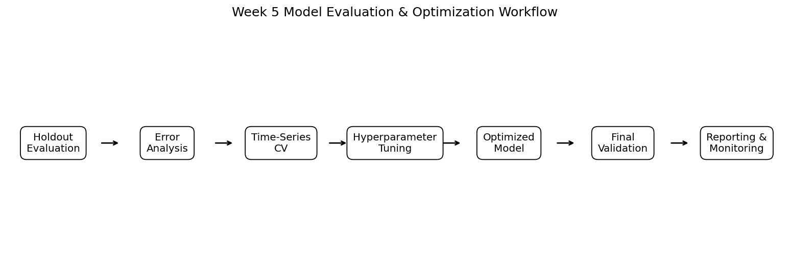
1. Freeze the final holdout data before optimization.
2. Establish a naïve previous-year baseline and simple regression baseline.
3. Evaluate candidate models on the holdout.
4. Run chronological cross-validation on the training period.
5. Tune hyperparameters using only training-period folds.
6. Refit the selected optimized model on the full training period.
7. Evaluate once on the untouched holdout.
8. Perform residual and segment-level error analysis.
9. Document limitations, business implications and monitoring requirements.

4. Data Splitting & Validation Strategy

4.1 Chronological Holdout
The evaluation keeps 2023–2025 as a future-style holdout while using 2012–2022 for model development. This avoids mixing future information into historical training.

4.2 Time-Series Cross-Validation
Five expanding time-series folds are used on the training period. Each validation fold represents a later period than its corresponding training data. This provides multiple historical checks while preserving time order.

4.3 Why Random K-Fold Is Not the Primary Strategy
Random k-fold can place observations from later years into a training fold while earlier observations appear in validation. For a forecasting problem this can produce an unrealistically easy evaluation. Random splitting can still be useful for genuinely independent, non-temporal observations, but it is not the preferred primary strategy here.

5. Performance Metrics
Metric | Meaning | Agricultural interpretation | Caution
MAE | Mean absolute error | Average yield error in t/ha; easy to communicate to agribusiness users. | Treats all errors equally.
RMSE | Root mean squared error | Highlights large misses that may matter during shocks. | More sensitive to outliers.
R² | Explained variance relative to mean baseline | Shows how much variation is captured by the model. | Can be misleading without context; not an error in physical units.
MAPE | Mean absolute percentage error | Scale-free percentage error useful for comparing relative accuracy. | Unstable or misleading when actual values are near zero.
The recommended reporting practice is to present MAE and RMSE together, use R² as a secondary explanatory measure, and report MAPE only when the target has no problematic near-zero values.

6. Baseline & Candidate Model Evaluation
Model | MAE | RMSE | R² | MAPE %
Linear Regression | 0.113 | 0.147 | 0.962 | 4.22
Ridge Regression | 0.122 | 0.156 | 0.957 | 4.66
Lasso Regression | 0.113 | 0.147 | 0.963 | 4.24
Decision Tree | 0.210 | 0.245 | 0.895 | 8.02
Random Forest | 0.167 | 0.200 | 0.930 | 6.40
Gradient Boosting | 0.146 | 0.184 | 0.941 | 5.64
The model comparison is used to establish a performance reference before optimization. A more complex algorithm is not automatically preferred; its improvement should be stable and meaningful relative to the simpler baseline.
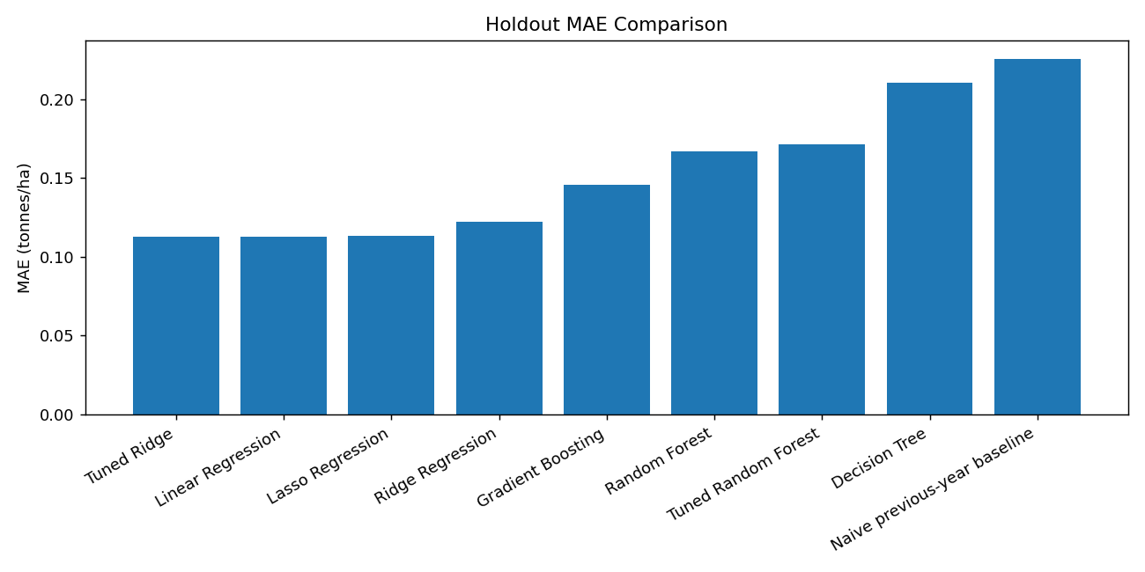
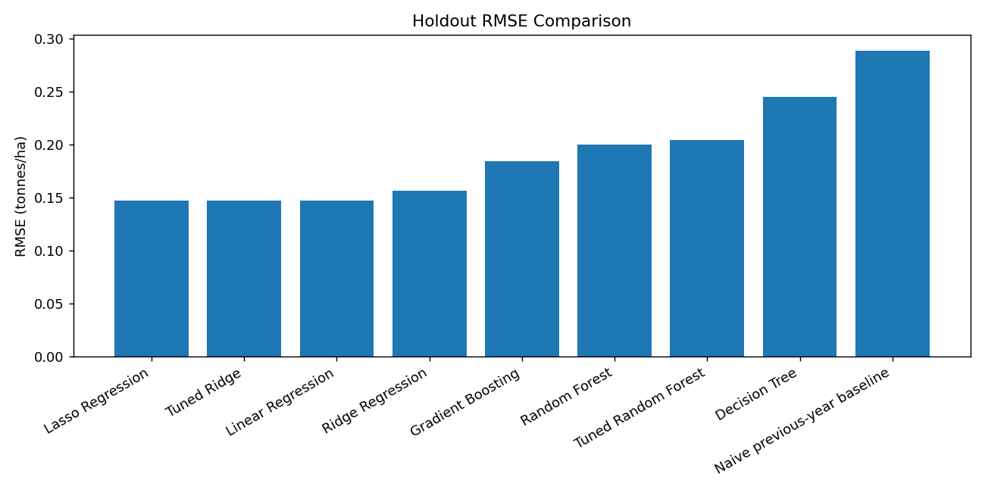
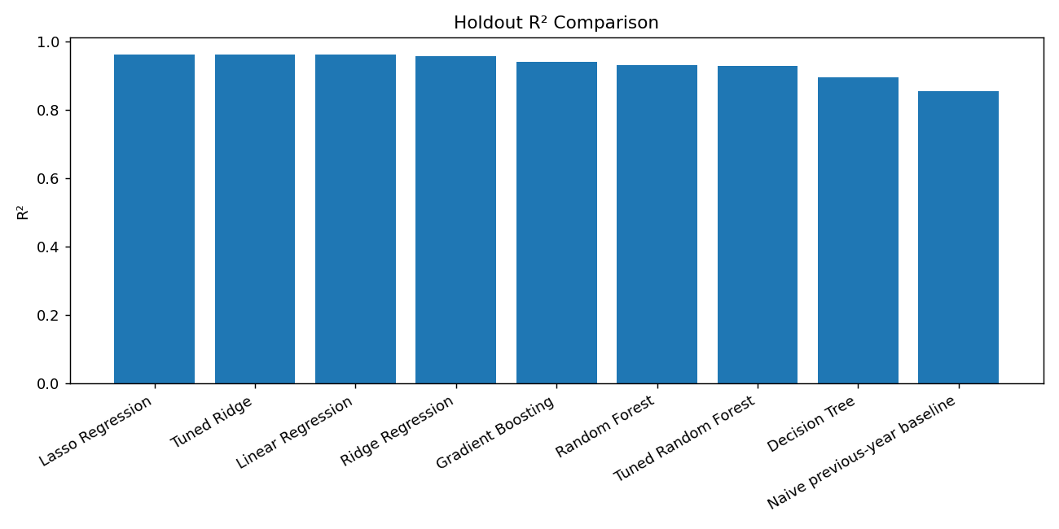

7. Error Analysis

7.1 Residual Analysis
Residuals are calculated as actual yield minus predicted yield. Positive residuals mean under-prediction; negative residuals mean over-prediction. A useful residual plot should not show a strong curve, funnel shape or long runs of errors in one direction.
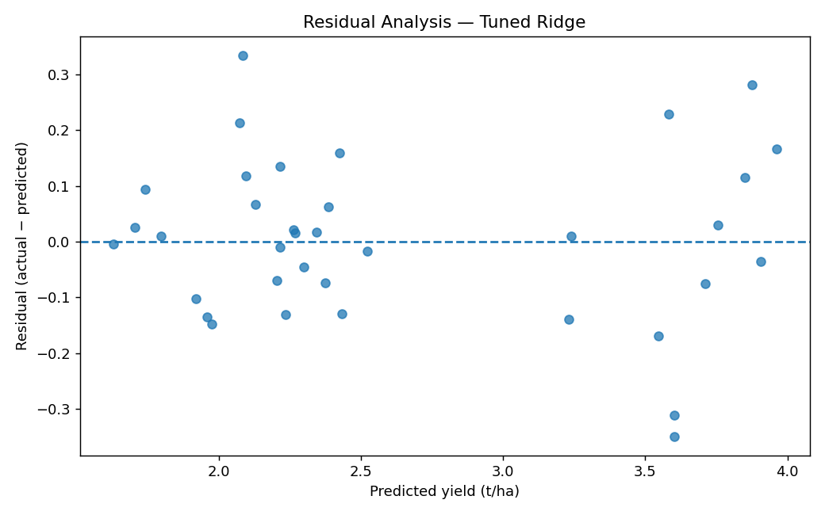

7.2 Segment-Level Error
Average MAE can hide poor performance in one crop or region. Therefore, errors are summarized by crop, state and year. Bias is calculated as mean(actual − predicted): a positive value indicates systematic under-prediction, while a negative value indicates systematic over-prediction.
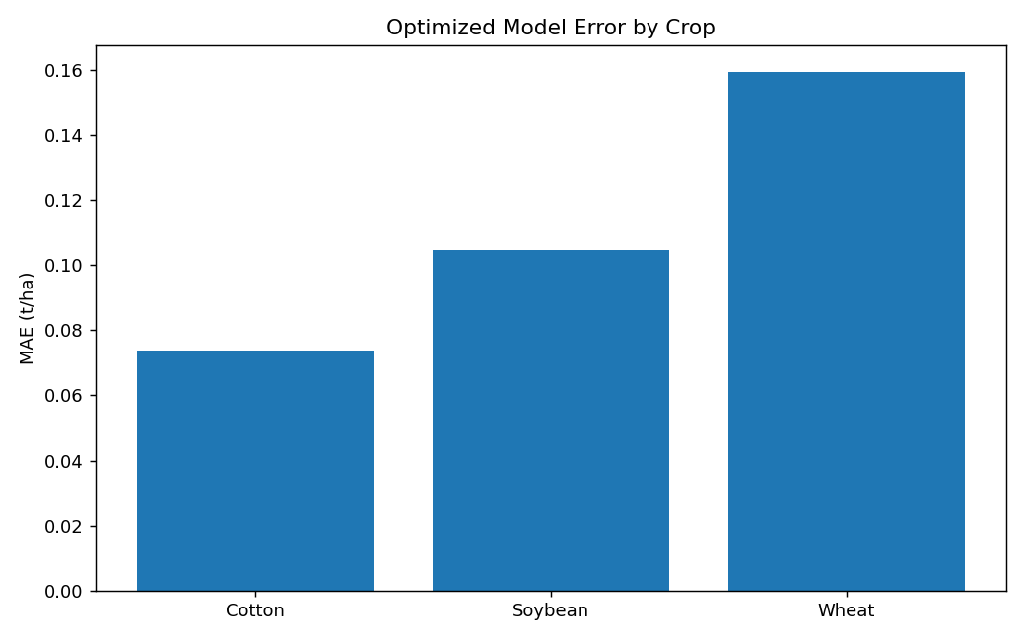
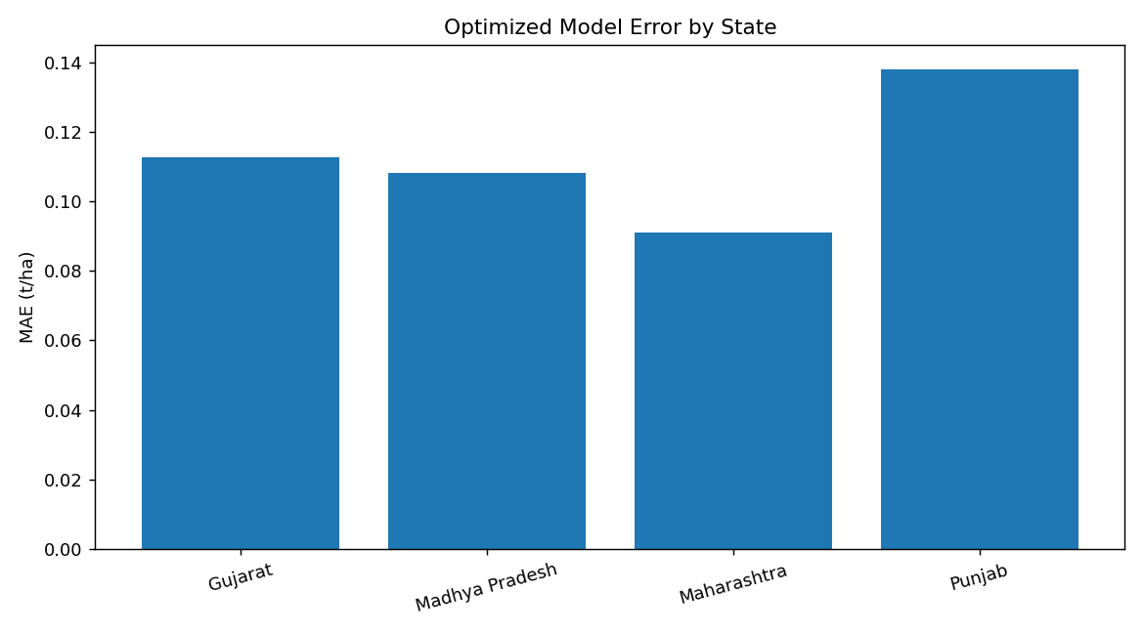

7.3 Hypothetical Agricultural Error Examples
Scenario | Possible pattern | Action
Extreme rainfall year | Model systematically over-predicts yield in one rainfed region. | Add rainfall anomaly/extreme-event features and test nonlinear models.
Irrigated crop | Errors are lower than rainfed crop. | Report segment performance; avoid assuming one global error applies to all farms.
New regional regime | Prediction error increases in later years. | Investigate concept drift and retrain with recent observations.
High-yield observations | Residual variance increases with predicted yield. | Consider target transformation or a model suited to heteroscedasticity.

8. Optimization Strategies

8.1 Cross-Validation
Time-series cross-validation is used to compare models using multiple historical validation windows. This reduces dependence on one arbitrary split and helps identify unstable models.
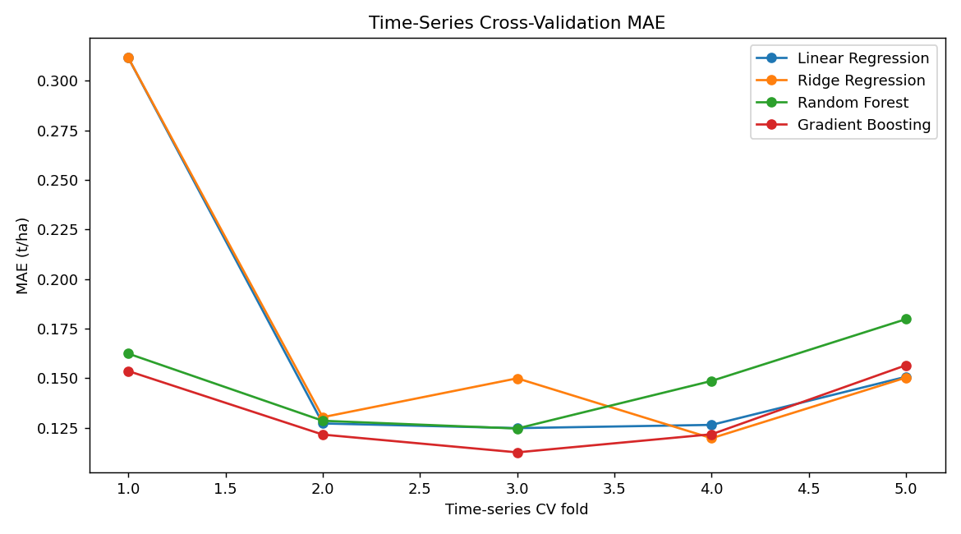

8.2 Hyperparameter Tuning
For Random Forest, the search varies number of trees, maximum depth and minimum leaf size. The objective is to reduce validation MAE while avoiding unnecessary model complexity. GridSearchCV selects settings based only on training-period cross-validation.
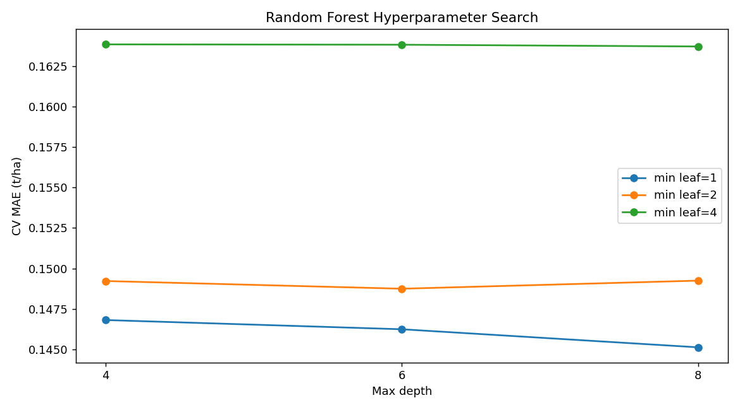

8.3 Regularization
Ridge regression adds an L2 penalty controlled by alpha. Regularization can reduce sensitivity to noisy or correlated features and is especially useful when one-hot encoded categories and engineered variables increase the feature space.

8.4 Model Complexity Controls
- Limit tree depth.
- Increase minimum leaf size when overfitting is observed.
- Use an appropriate number of trees rather than arbitrarily maximizing it.
- Prefer a simpler model if accuracy is similar and interpretability is materially better.
- Tune only a manageable set of parameters first; expand the search only when evidence supports it.

9. Optimization Results
Model | MAE | RMSE | R² | MAPE %
Linear Regression | 0.113 | 0.147 | 0.962 | 4.22
Ridge Regression | 0.122 | 0.156 | 0.957 | 4.66
Lasso Regression | 0.113 | 0.147 | 0.963 | 4.24
Decision Tree | 0.210 | 0.245 | 0.895 | 8.02
Random Forest | 0.167 | 0.200 | 0.930 | 6.40
Gradient Boosting | 0.146 | 0.184 | 0.941 | 5.64
Naive previous-year baseline | 0.226 | 0.289 | 0.855 | 9.06
Tuned Random Forest | 0.171 | 0.204 | 0.928 | 6.59
Tuned Ridge | 0.112 | 0.147 | 0.962 | 4.22
On this synthetic demonstration, the tuned Random Forest changed MAE from 0.167 to 0.171 t/ha, a -2.4% change relative to the untuned Random Forest. This numerical change is dataset-specific and should not be treated as a guaranteed real-world improvement.
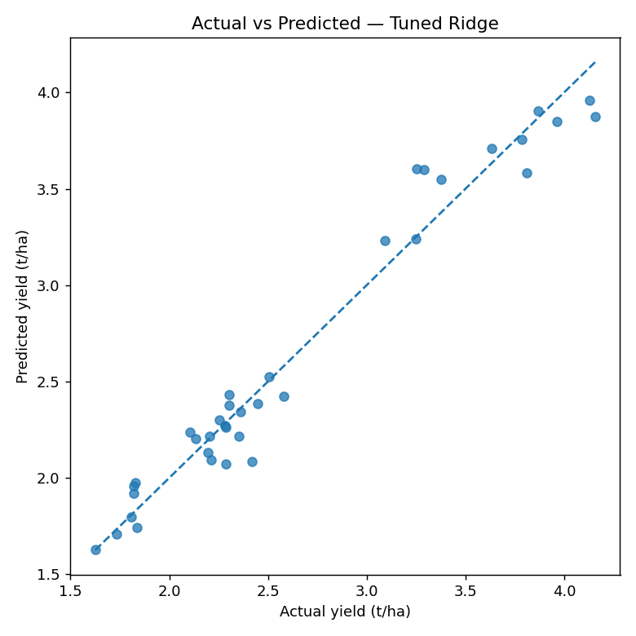

10. Model Reliability & Bias Checks
- Compare error by crop, state and year rather than relying only on aggregate metrics.
- Check whether one group consistently receives positive or negative residuals.
- Compare against a naïve previous-year baseline.
- Inspect the largest absolute errors individually.
- Check whether missing-data patterns differ by region or crop.
- Test performance under extreme weather conditions when enough observations are available.
- Monitor drift after deployment.

11. Limitations
- The numerical dataset in this submission is synthetic; performance is not evidence of real-world accuracy.
- The demonstration covers only four states and three crops.
- The feature set does not include full soil chemistry, fertilizer application, pests, satellite indices, farm-level management or detailed market variables.
- A single holdout period cannot guarantee future performance.
- Feature importance does not prove causal relationships.
- MAPE may become unreliable when actual yields approach zero.
- Model uncertainty is not fully quantified in this basic workflow.
- Agricultural systems are affected by shocks that may be rare in historical data.

12. Future Improvements
- Join official crop-production, rainfall and temperature data at a consistent geographic and temporal grain.
- Add soil, fertilizer, irrigation coverage, remote sensing and pest/disease indicators where available.
- Use rolling forecasts with explicit prediction horizons.
- Benchmark against seasonal historical averages and other naïve baselines.
- Evaluate uncertainty intervals using quantile regression, conformal prediction or ensemble dispersion.
- Perform systematic hyperparameter optimization after the data pipeline is validated.
- Introduce model monitoring for drift, missingness and segment-level degradation.
- Validate on multiple geographically and temporally separated test periods.

13. Agribusiness Reporting Guidelines
Report section | What to include | Decision value
Executive summary | Model purpose, holdout metrics, key limitations | Fast management understanding
Data & methodology | Sources, grain, features, split and validation | Traceability
Model comparison | Baseline and candidate metrics | Transparent model selection
Error analysis | Residuals and segment performance | Risk identification
Optimization | Tuning approach and changes | Evidence for improvement
Business implications | Procurement, storage, planning implications | Actionable interpretation
Limitations | Data, model and uncertainty constraints | Responsible use
Monitoring plan | Drift, accuracy, missingness and retraining triggers | Operational reliability

14. Final Recommendations
- Keep the final future-style holdout isolated until optimization is complete.
- Use MAE as the primary communication metric for yield forecasting because it is expressed in tonnes/hectare.
- Use RMSE to detect whether large misses are a material risk.
- Use time-series cross-validation for model selection in forecasting settings.
- Tune only after establishing strong baselines and confirming the data pipeline is leakage-safe.
- Inspect segment-level errors before operational deployment.
- Prefer the simplest model that meets the decision requirement when performance differences are small.
- Revalidate the model when new seasons, weather regimes or crops are introduced.
- Do not treat synthetic demonstration results as evidence of field performance.

15. Submission Package Contents
- 01_Final_Document — this complete Week 5 report.
- 02_Input_Data — Week 4 model-ready data and raw traceability sample.
- 03_Evaluation_Data — evaluation-ready artifacts.
- 04_Code — reproducible evaluation and optimization script.
- 05_Visualizations — all charts used in the report.
- 06_Evaluation_Results — metrics, predictions, CV results and optimized comparisons.
- 07_Research_Notes — methodology and public-source research.
- 08_Error_Analysis — record-level and segment-level error analysis.
- 09_Optimization_Logs — tuning grids, selected parameters and optimization plan.
- 10_Submission_Checklist — final quality-control checklist.

16. Conclusion
A robust agricultural ML evaluation process must go beyond a single accuracy score. The combination of future-style holdout testing, time-series cross-validation, multiple complementary metrics, segment-level error analysis, controlled hyperparameter tuning and regularization provides a defensible framework for improving model reliability. For real agribusiness deployment, the next critical step is validation on official, sufficiently granular agricultural and weather observations followed by ongoing monitoring.
End of Week 5 Report

