WEEK 2 DATA SCIENCE PROJECT
Advanced Data Visualization and Storytelling with Python
Iris Dataset – Visual Narrative for a Non-Technical Audience

Item | Details
Dataset
 | Iris Dataset
Records
 | 150 observations
Domain
 | Botanical classification / measurement data
Visualization tools
 | Matplotlib, Pandas, Scikit-learn
Visualizations
 | 6 complementary visual narratives
Core question
 | Which measurements make species differences easiest to see?

1. Introduction
Visualization is not only a method for displaying numbers; it is a way to organize evidence into a sequence that a reader can understand. This Week 2 project develops a visual story around the public Iris dataset. The audience is assumed to be non-technical, so the analysis emphasizes plain-language questions, readable titles, direct comparisons, and captions that explain why each visual matters.
The story follows a deliberate progression: first establish the overall distributions, then focus on the feature that most visibly separates the groups, examine a relationship between two measurements, quantify broader relationships with a correlation matrix, summarize multivariate species profiles, and finally compress the four measurements into a two-dimensional PCA map.

2. Dataset and Analytical Question
The Iris dataset contains 150 observations from three Iris species: setosa, versicolor, and virginica. Each observation has four measurements: sepal length, sepal width, petal length, and petal width. The dataset is publicly documented by the UCI Machine Learning Repository.
Source: https://archive.ics.uci.edu/dataset/53/iris
Feature | Meaning
sepal_length_cm
 | Sepal length in centimetres
sepal_width_cm
 | Sepal width in centimetres
petal_length_cm
 | Petal length in centimetres
petal_width_cm
 | Petal width in centimetres

Analytical question
Which measurements make the differences among the three species easiest to understand, and how can those differences be communicated progressively to someone without a technical background?

3. Storytelling Method
Stage | Question | Visual response
1. Explore
 | What does each measurement look like across species?
 |  | Small-multiple distributions
2. Focus
 | Which individual feature shows a clear group difference?
 |  | Petal-length box plot + observations
3. Connect
 | Do important petal measurements move together?
 |  | Scatter plot + fitted lines
4. Quantify
 | Which variables have the strongest relationships?
 |  | Correlation heatmap
5. Profile
 | How does each species differ across all four features?
 |  | Standardized radar profile
6. Simplify
 | Can four dimensions be summarized visually?
 |  | PCA two-dimensional map

4. Visualization 1 – Feature Distributions
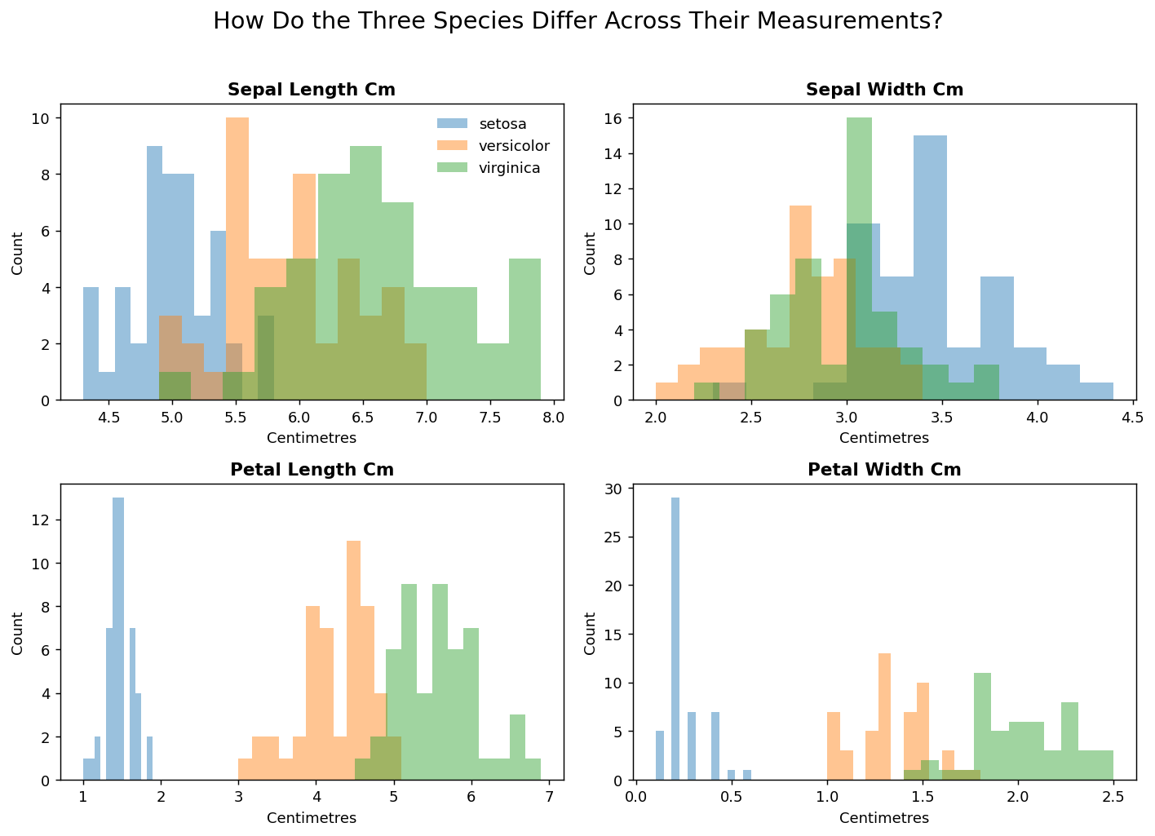

What the audience should notice
The four panels establish the baseline. The distributions show that the species are not equally separated across every measurement. Petal measurements display stronger visual differences between groups, while the sepal measurements show more overlap.

Why this visual was chosen
Small multiples let the audience compare the same type of chart across four variables without changing the visual grammar. Histograms are appropriate here because the first storytelling question concerns distribution, spread, and overlap.

Narrative contribution
This visual acts as the opening scene. It prevents the later conclusions from appearing arbitrary: the reader first sees where the strongest visual separation occurs.

5. Visualization 2 – Petal Length Focus
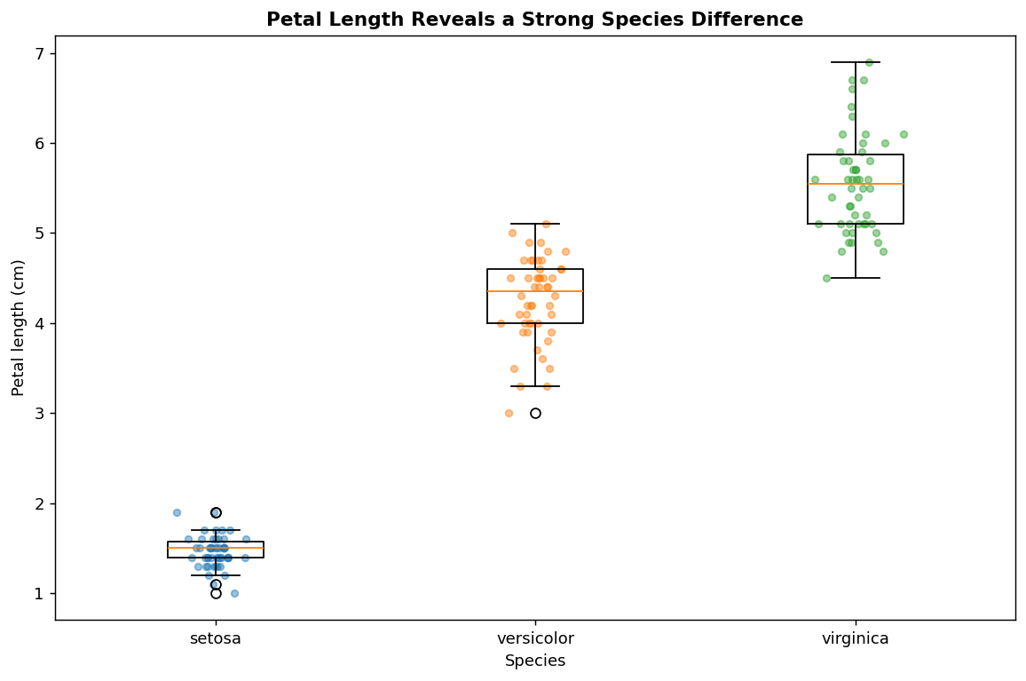

What the audience should notice
Petal length shows a pronounced difference among the species. Setosa occupies a distinctly smaller range, while versicolor and virginica occupy larger ranges with some overlap.

Why this visual was chosen
A box plot makes the median, spread, and range easy to compare across categories. Individual points are overlaid so the audience can see that the summary boxes represent real observations rather than abstract statistics.

Narrative contribution
After the opening overview, this chart zooms in on a feature that appears particularly informative. It turns a general pattern into a specific, easy-to-explain observation.

6. Visualization 3 – Petal Relationship
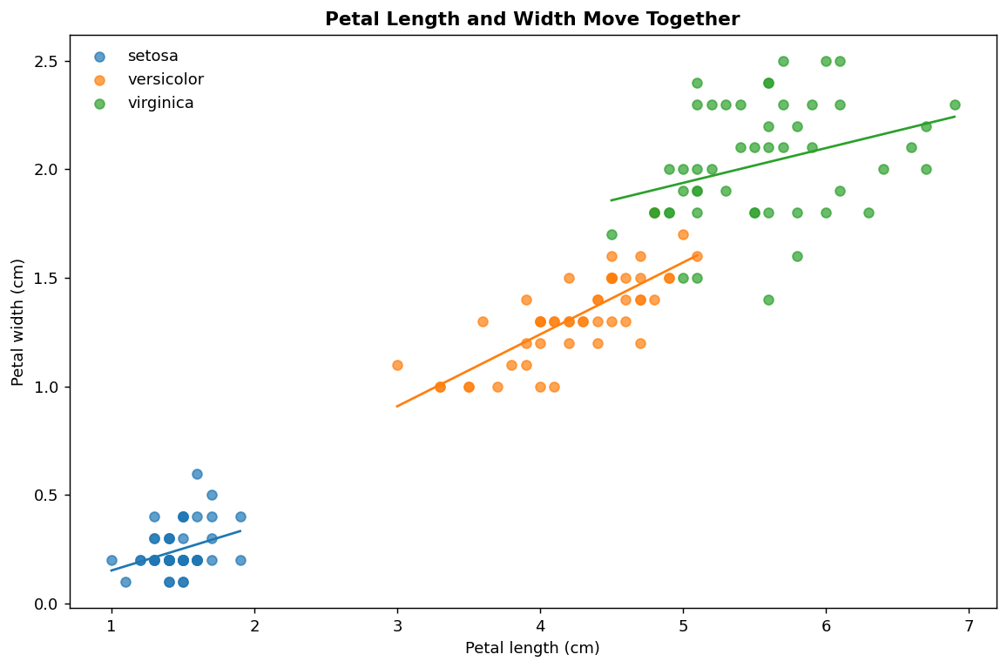

What the audience should notice
Petal length and petal width move upward together. The fitted lines make the direction of that relationship visible within each species, while the point clouds show the actual observations and their overlap.

Why this visual was chosen
A scatter plot is more informative than a single summary number when the goal is to show both relationship and variation. Trend lines provide a visual guide without replacing the underlying observations.

Narrative contribution
The story now moves from 'groups differ' to 'features are related.' This helps explain why petal measurements can be jointly informative.

7. Visualization 4 – Correlation Heatmap
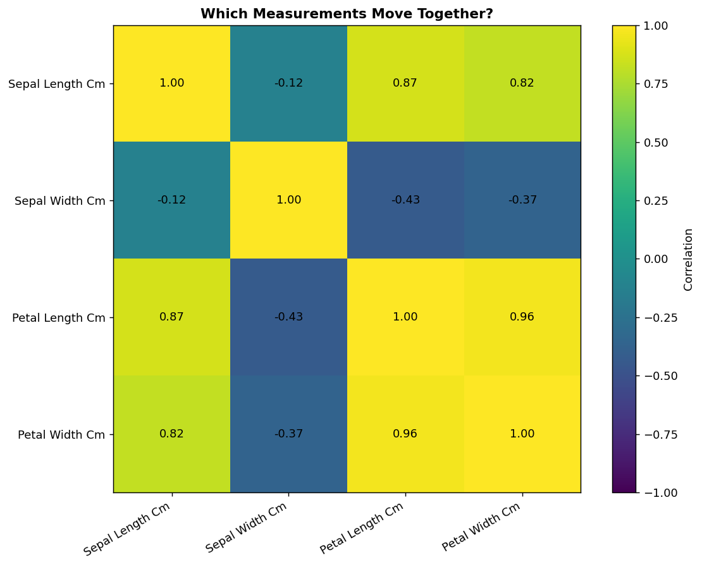

What the audience should notice
The strongest positive association among the four numeric measurements is between petal length and petal width (correlation 0.96). Sepal width has comparatively weaker relationships with the other measurements.

Why this visual was chosen
A heatmap is efficient for comparing many pairwise relationships at once. Numeric annotations prevent the audience from having to estimate values solely from color intensity.

Narrative contribution
This visual validates and broadens the previous scatter-plot observation. Instead of examining one pair, the audience can see the relationship structure across all four measurements.

8. Visualization 5 – Species Profile Radar
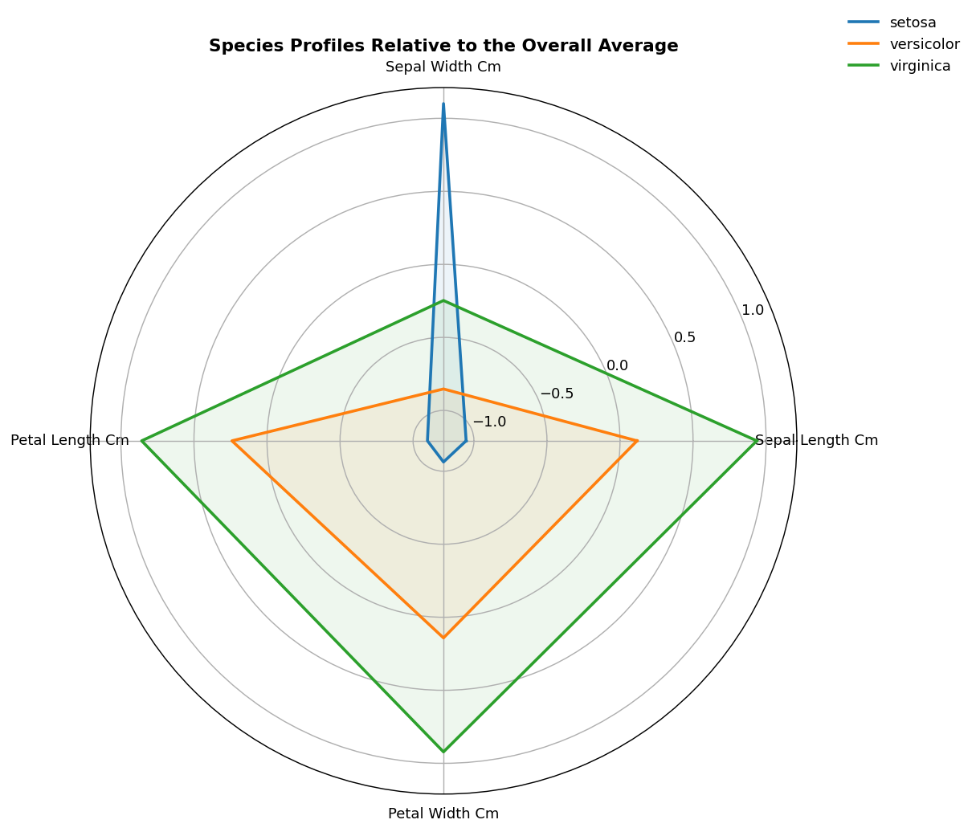

What the audience should notice
The radar chart uses standardized values relative to the overall average, allowing features measured on the same physical scale to be compared as a profile. The shapes show that the species have distinct combinations of high and low measurements rather than differing in only one variable.

Why this visual was chosen
Radar charts can be useful when the communication goal is to compare a small number of multivariate profiles. Here, it is used as a storytelling device rather than as the sole analytical evidence.

Narrative contribution
The story shifts from individual variables to the overall 'shape' of each species. This provides an intuitive bridge toward multivariate analysis.

9. Visualization 6 – PCA Species Map
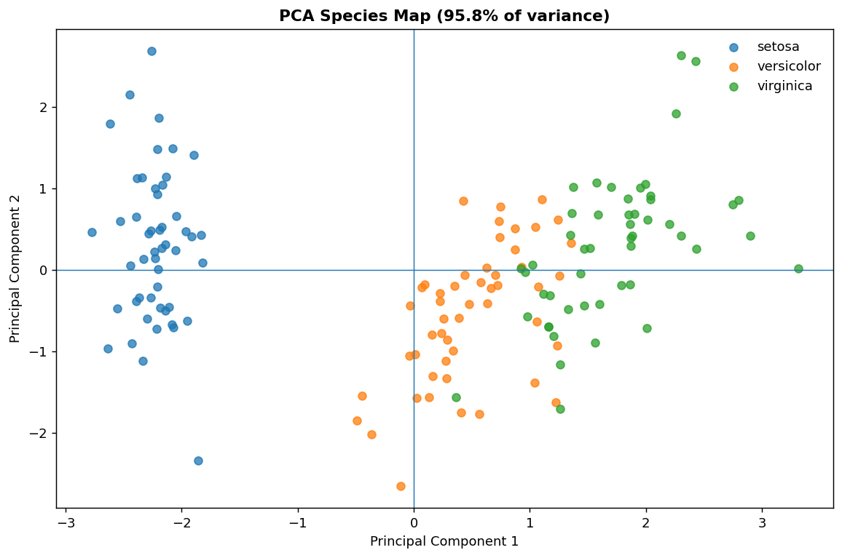

What the audience should notice
PCA compresses the four standardized measurements into two dimensions. The first two principal components together explain 95.8% of the variance in the standardized feature space. The resulting map makes the broad structure of the species groups visible in a single coordinate system.

Why this visual was chosen
PCA is useful when four or more variables need to be summarized visually. Standardization prevents features with larger numerical variance from dominating the transformation.

Narrative contribution
This is the synthesis view. It brings the earlier distribution and relationship findings together into one multivariate picture.

10. Cross-Visualization Insights
- Petal measurements provide clearer visual separation among the three species than the sepal measurements.
- Petal length and petal width have a strong positive association, supporting their joint use in exploratory classification analysis.
- Setosa is visually distinct in the petal-based views, while versicolor and virginica show more overlap.
- The species profiles differ across multiple measurements, indicating that the classification structure is multivariate rather than dependent on a single variable.
- The PCA map provides a compact summary of the four-dimensional measurement space and preserves substantial variation in two dimensions.
- Different charts answer different questions: distributions explain spread, box plots support category comparison, scatter plots explain relationships, heatmaps summarize pairwise structure, radar charts communicate profiles, and PCA communicates multivariate structure.

11. Business and Scientific Implications

Scientific implications
For botanical or biological measurement workflows, the analysis suggests that measurement selection matters. Petal characteristics appear especially informative for distinguishing these three classes in this benchmark. A future scientific analysis could test this formally using classification models, confidence intervals, or species-specific statistical tests.

Business / operational implications
The same visualization principles apply to business data. When a non-technical stakeholder needs to understand segmentation, the analysis should progress from overview to focused evidence and then to a synthesized multivariate view. For example, customer segments could be compared using distributions, a key-driver scatter plot, a correlation matrix, profile chart, and dimensionality-reduction map.
These implications are methodological rather than claims that the Iris dataset itself represents a commercial market.

12. Design and Storytelling Decisions
Decision | Rationale
Question-led titles
 | Readers can understand the purpose before interpreting the chart.
Consistent species categories
 | Repeated category encoding makes comparisons easier across figures.
Limited visual clutter
 | Minimal unnecessary decoration keeps attention on patterns.
Direct captions
 | Each figure is followed by a plain-language interpretation.
Progressive complexity
 | The narrative moves from simple distributions to multivariate methods.
Multiple evidence types
 | No single visualization is treated as sufficient evidence.

13. Limitations
- The Iris dataset is small and highly curated, so findings should not be generalized to broader botanical populations without additional evidence.
- The visualizations are descriptive and exploratory; they do not establish causal relationships.
- Correlation measures association, not causation.
- Radar charts can become difficult to interpret with many variables; this project keeps the number of dimensions small.
- PCA is a mathematical projection, so visual distances in two dimensions are not a complete representation of the original feature space.

14. Estimated Workload – 30 to 35 Hours
Activity | Estimated Hours
Dataset selection, framing and audience definition
 | 4
Visualization research and design planning
 | 5
Python visualization development
 | 10
Statistical exploration and validation
 | 5
Narrative writing and figure annotations
 | 5
Documentation, testing and packaging
 | 3
Total
 | 32

15. Conclusion
The Week 2 project demonstrates that effective data storytelling is a sequence of evidence rather than a collection of unrelated charts. The six visualizations move from broad distributions to focused feature comparison, relationships, correlations, multivariate profiles, and a PCA synthesis. Together they show how careful chart selection and plain-language commentary can make a technical dataset understandable to a non-technical audience.

16. References
1. UCI Machine Learning Repository, “Iris,” Dataset 53. https://archive.ics.uci.edu/dataset/53/iris
2. F. Pedregosa et al., “Scikit-learn: Machine Learning in Python,” Journal of Machine Learning Research, vol. 12, pp. 2825–2830, 2011.
3. W. McKinney, Python for Data Analysis, 3rd ed., O’Reilly Media, 2022.
4. T. Hastie, R. Tibshirani, and J. Friedman, The Elements of Statistical Learning, 2nd ed., Springer, 2009.

