WEEK 3 DATA SCIENCE PROJECT
Statistical Analysis and Hypothesis Testing in Python
Testing Differences in Mean Petal Length Across Iris Species

Item | Details
Dataset
 | Iris Dataset – public benchmark
Sample size
 | 150 observations; 50 per species
Outcome
 | Petal length (cm)
Groups
 | Setosa, Versicolor, Virginica
Primary analysis
 | One-way ANOVA with assumption checks
Robust analysis
 | Welch's ANOVA + Holm-adjusted pairwise Welch t-tests
Significance level
 | α = 0.05

1. Introduction
Statistical hypothesis testing provides a structured way to determine whether an observed difference in sample data is compatible with a stated null hypothesis. This project uses the public Iris dataset to investigate whether average petal length differs among three Iris species.
The study is intentionally framed as a scientific measurement problem. Petal length is a continuous measurement and species is a categorical grouping variable with three independent groups, making a one-way comparison of means appropriate.

Research Question
Do the mean petal lengths differ among setosa, versicolor, and virginica?

2. Hypotheses
Null hypothesis (H₀): μsetosa = μversicolor = μvirginica. The population mean petal length is equal across the three species.
Alternative hypothesis (H₁): At least one population mean differs from the others.
The significance level is α = 0.05. The null hypothesis will be rejected when the relevant p-value is below 0.05. Confidence intervals and effect sizes are also reported so the analysis is not based on p-values alone.

3. Dataset
The Iris dataset contains 150 observations from three species, with four continuous measurements per observation. The analysis uses petal length as the outcome because it provides a clear, scientifically interpretable measurement for testing whether species groups differ.
Public source: https://archive.ics.uci.edu/dataset/53/iris
Group | n | Mean | Median | Std. Dev. | 95% CI for Mean
setosa
 | 50
 |  | 1.462
 |  |  | 1.500
 |  |  |  | 0.174
 |  |  |  |  | [1.413, 1.511]
versicolor
 | 50
 |  | 4.260
 |  |  | 4.350
 |  |  |  | 0.470
 |  |  |  |  | [4.126, 4.394]
virginica
 | 50
 |  | 5.552
 |  |  | 5.550
 |  |  |  | 0.552
 |  |  |  |  | [5.395, 5.709]

4. Methodology

4.1 Statistical Design
The design compares one continuous outcome across three independent categorical groups. Each observation represents a measured flower, and each flower belongs to one species group.

4.2 Planned Analysis
- Inspect group distributions and descriptive statistics.
- Check normality within groups using Shapiro-Wilk tests.
- Check equality of variances using Levene's test.
- Run classical one-way ANOVA as the standard mean-comparison test.
- Calculate eta-squared as an effect-size measure.
- Because variance equality must be evaluated explicitly, run Welch's ANOVA as a robust alternative when heteroscedasticity is detected.
- Use Tukey HSD for the classical ANOVA follow-up and Holm-adjusted Welch pairwise comparisons for variance-robust pairwise inference.
- Report 95% confidence intervals and interpret statistical significance together with effect magnitude.

5. Assumption Checks
Species | Shapiro-W statistic | p-value | Interpretation at α=.05
setosa
 | 0.9550
 |  | 0.05481
 |  |  | No evidence against normality
versicolor
 | 0.9660
 |  | 0.1585
 |  |  | No evidence against normality
virginica
 | 0.9622
 |  | 0.1098
 |  |  | No evidence against normality
Levene's test: statistic = 19.4803, p = 3.129e-08. This provides evidence that the group variances are not equal at the 0.05 level.
This matters because the classical one-way ANOVA assumes homogeneity of variance. Rather than treating the assumption as satisfied, the analysis therefore reports Welch's ANOVA as the primary variance-robust omnibus inference.

6. Classical One-Way ANOVA
The standard one-way ANOVA produced F = 1180.161, p = 2.8568e-91. The estimated eta-squared effect size is η² = 0.941, meaning that approximately 94.1% of the observed variation in petal length is associated with species membership in this sample.
Because the homogeneity-of-variance assumption was not supported, this classical result is treated as descriptive/supplementary rather than the sole basis for the final inference.
Source | Sum of Squares | df | F | p-value
Species
 | 437.1028
 |  | 2
 |  |  | 1180.161
 |  |  |  | 2.8568e-91
Residual
 | 27.2226
 |  | 147
 |  |  | -
 |  |  |  | -

7. Welch's ANOVA – Variance-Robust Inference
Welch's ANOVA produced a statistic of 1828.092 with approximate numerator degrees of freedom 2.00 and p = 2.6933e-66. This result remains far below α = 0.05, providing strong evidence against the null hypothesis of equal population means even after accounting for unequal group variances.
Interpretation: the data provide statistical evidence that mean petal length is not the same across all three species. The test does not by itself identify which specific groups differ; that question is addressed by pairwise comparisons.

8. Post-Hoc Comparisons
The classical Tukey HSD output is included as a conventional post-hoc analysis. Because the variance assumption was not supported, the report also uses pairwise Welch t-tests with Holm adjustment for the primary variance-robust pairwise interpretation.
Comparison | Welch t | Raw p | Holm-adjusted p | Decision at α=.05
setosa vs versicolor
 | -39.493
 |  | 9.9344e-46
 |  |  | 1.9869e-45
 |  |  |  | Reject H₀
setosa vs virginica
 | -49.986
 |  | 9.2696e-50
 |  |  | 2.7809e-49
 |  |  |  | Reject H₀
versicolor vs virginica
 | -12.604
 |  | 4.9003e-22
 |  |  | 4.9003e-22
 |  |  |  | Reject H₀
All three pairwise comparisons remain statistically significant after Holm adjustment. The direction of the differences follows the group means: setosa has the smallest mean petal length, virginica the largest, and versicolor lies between them.

9. Visual Evidence

9.1 Box Plot with Individual Observations
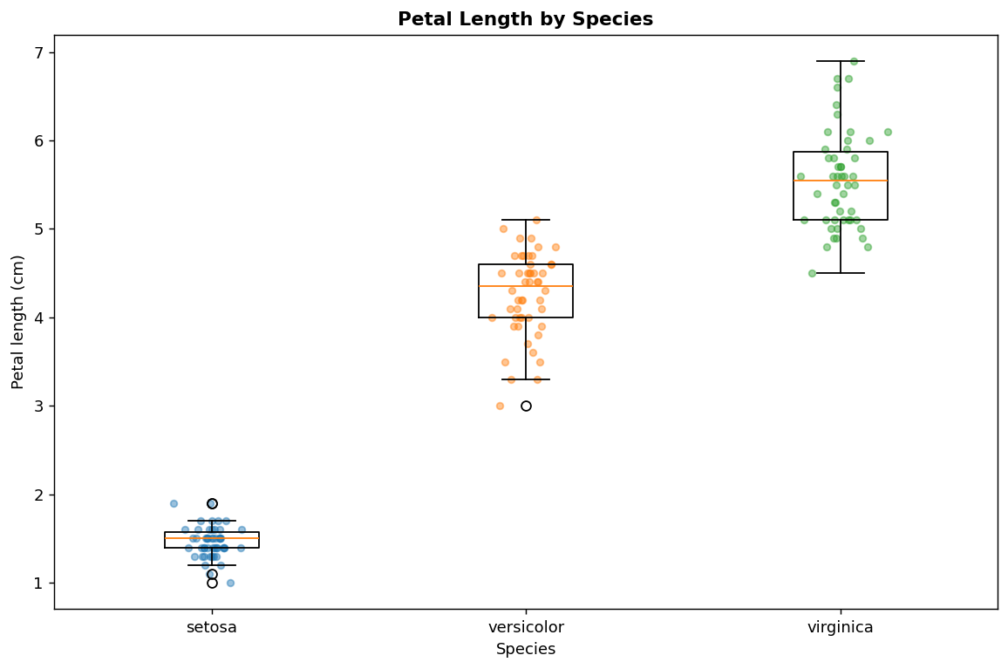
This figure shows the central tendency, spread, and individual observations for each species. It makes the large separation in petal length visible before formal testing.

9.2 Means with 95% Confidence Intervals
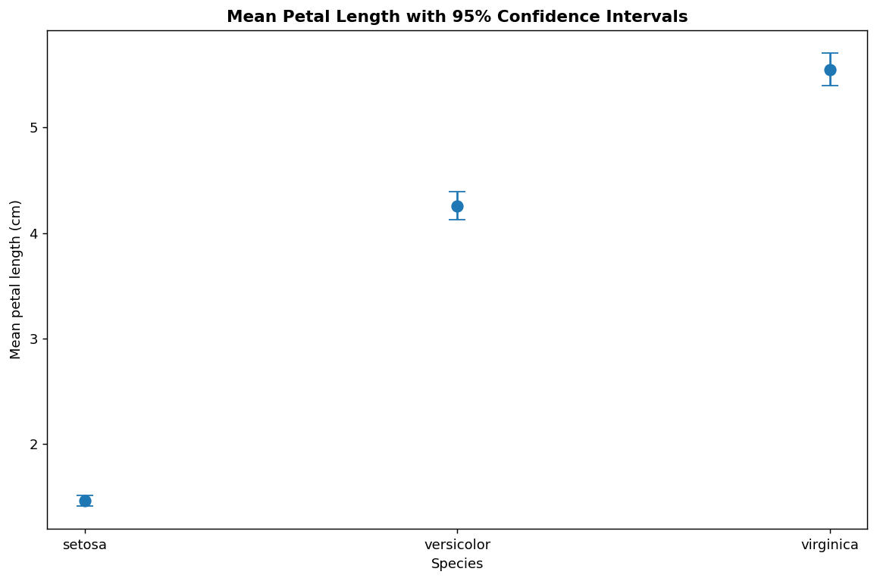
The points show group means and the vertical intervals show 95% confidence intervals. This communicates both estimated differences and uncertainty around each mean.

9.3 Distribution Comparison
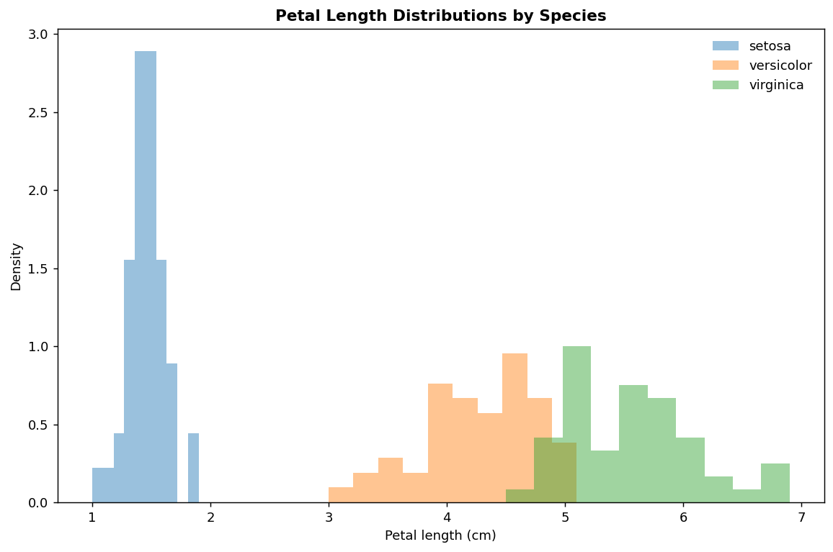
The overlaid distributions show the shape and overlap of petal length measurements. Setosa is concentrated at substantially smaller values, while the other two groups occupy larger ranges.

9.4 ANOVA Residual Diagnostic
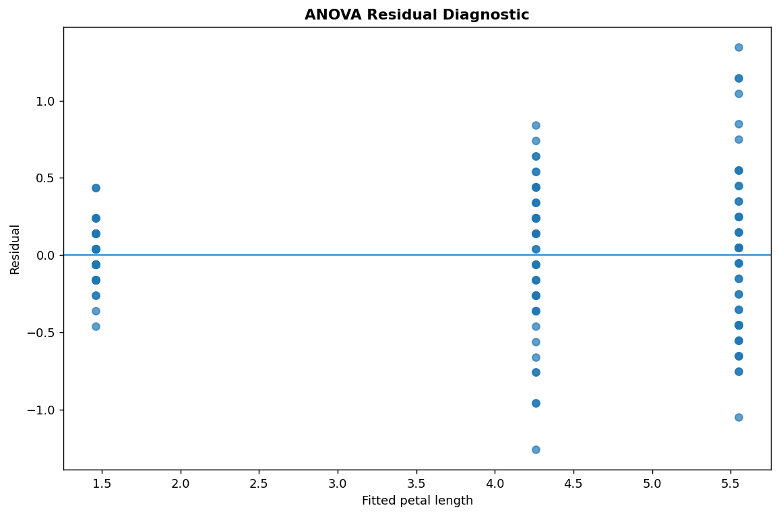
Residuals are plotted against fitted values to inspect systematic patterns. This is a diagnostic check rather than a significance test; it helps identify whether the model leaves obvious structure unexplained.

9.5 Pairwise Mean Differences
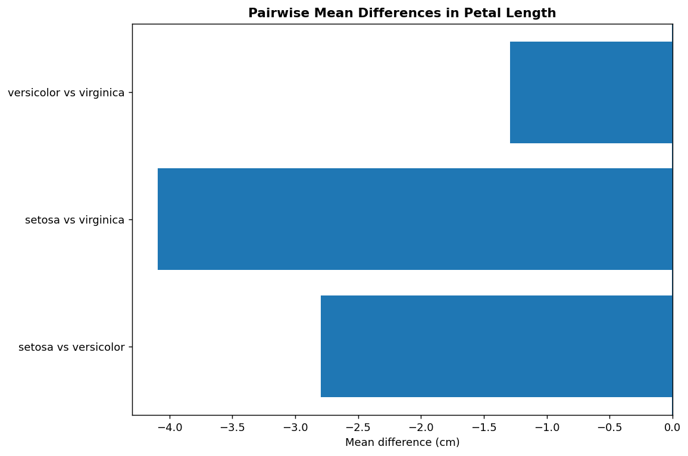
The chart summarizes the direction and magnitude of the three pairwise sample mean differences. It complements the adjusted p-values by showing practical separation in the measurement scale.

10. Statistical Interpretation
At the 5% significance level, the evidence is inconsistent with the null hypothesis that all three population means are equal. The variance-robust Welch ANOVA confirms an overall group difference, and Holm-adjusted pairwise Welch tests indicate statistically significant differences for each species pair.
The estimated eta-squared of 0.941 is large in this sample, indicating that species accounts for a substantial proportion of the variation in petal length. Effect size should nevertheless be interpreted in the context of the dataset and should not be treated as a universal estimate for all Iris populations.
The confidence intervals provide uncertainty around each group mean. They are useful for understanding estimation precision, but overlap or non-overlap of separate confidence intervals should not be used as a substitute for the formal pairwise tests.

11. Decision on the Hypothesis
Decision: Reject H₀ at α = 0.05.
Conclusion: The sample provides strong statistical evidence that mean petal length differs among the three Iris species. The robust analysis is preferred because the equal-variance assumption was not supported.

12. Scientific Implications
The results indicate that petal length is strongly associated with species membership in this benchmark dataset. This supports further scientific or classification-oriented investigation of petal morphology. A follow-up study could examine additional morphological variables, assess generalization to independent samples, and evaluate predictive models.
The finding is an association in observational measurements; it does not establish that species membership causally changes petal length.

13. Limitations
- The Iris dataset is small and curated, so statistical results should not be generalized to all Iris populations without additional sampling.
- Statistical significance is affected by sample size and does not by itself measure scientific importance.
- Unequal variances were detected, which is why Welch's ANOVA and variance-robust pairwise tests are emphasized.
- Multiple testing requires adjustment; Holm correction was used for the three pairwise comparisons.
- The analysis focuses on one outcome variable and does not model possible interactions among multiple measurements.

14. Python Code
The complete executable analysis is included in the submission folder under src/. The core testing logic is reproduced below.
import pandas as pd, numpy as np
from scipy import stats
import statsmodels.api as sm
from statsmodels.formula.api import ols
from statsmodels.stats.multicomp import pairwise_tukeyhsd
df=pd.read_csv("data/iris_statistical_analysis.csv")
cats=["setosa","versicolor","virginica"]
groups=[df.loc[df.species==s,"petal_length_cm"] for s in cats]
# Assumption checks
for s,g in df.groupby("species"):
print("Shapiro",s,stats.shapiro(g.petal_length_cm))
print("Levene:",stats.levene(*groups,center="median"))
# One-way ANOVA
model=ols("petal_length_cm ~ C(species)",data=df).fit()
print(sm.stats.anova_lm(model,typ=2))
# Effect size
tab=sm.stats.anova_lm(model,typ=2)
eta=tab.loc["C(species)","sum_sq"]/tab["sum_sq"].sum()
print("Eta squared:",eta)
# Post-hoc Tukey HSD
print(pairwise_tukeyhsd(df.petal_length_cm,df.species))
# 95% confidence intervals
for s,g in df.groupby("species"):
ci=stats.t.interval(.95,len(g)-1,loc=g.petal_length_cm.mean(),scale=stats.sem(g.petal_length_cm))
print(s,"mean=",g.petal_length_cm.mean(),"95% CI=",ci)

15. Estimated Workload – 30 to 35 Hours
Activity | Estimated Hours
Hypothesis development and dataset research
 | 4
Statistical design and assumption planning
 | 5
Python statistical implementation
 | 8
Assumption checks and robust analysis
 | 5
Visualization and interpretation
 | 4
Documentation, validation and packaging
 | 6
Total
 | 32

16. Reproducibility and Project Structure
Path | Purpose
data/iris_statistical_analysis.csv
 | Analysis dataset
data/group_summary_ci.csv
 | Group means and 95% CIs
data/anova_table.csv
 | Classical ANOVA output
data/welch_anova.csv
 | Variance-robust omnibus test
data/tukey_posthoc.csv
 | Tukey HSD results
data/welch_pairwise_holm.csv
 | Robust pairwise comparisons
data/shapiro_tests.csv
 | Normality tests
data/levene_test.csv
 | Variance homogeneity test
data/pairwise_effect_sizes.csv
 | Cohen's d estimates
visualizations/
 | Five statistical figures
src/
 | Reproducible Python scripts

17. References
UCI Machine Learning Repository, “Iris,” Dataset 53. https://archive.ics.uci.edu/dataset/53/iris
Scipy documentation, Statistical functions and hypothesis tests.
Statsmodels documentation, ANOVA and multiple-comparison procedures.
F. Pedregosa et al., “Scikit-learn: Machine Learning in Python,” Journal of Machine Learning Research, vol. 12, pp. 2825–2830, 2011.
W. McKinney, Python for Data Analysis, 3rd ed., O’Reilly Media, 2022.

