WEEK 4 DATA SCIENCE PROJECT
Machine Learning Model Development and Evaluation
Iris Species Classification – End-to-End Python Pipeline

Item | Details
Dataset
 | Iris Dataset – public benchmark
Records
 | 150 observations
Task
 | Multiclass classification
Algorithms
 | Logistic Regression and Decision Tree
Validation
 | Stratified 80/20 split + 5-fold cross-validation
Evaluation
 | Accuracy, precision, recall, F1, confusion matrix, ROC/AUC, error analysis
Visualizations
 | 6 model-development and evaluation figures

1. Introduction
This Week 4 project develops a complete supervised machine-learning workflow in Python. The objective is to predict Iris species from four numeric measurements: sepal length, sepal width, petal length, and petal width.
The project emphasizes not only model training but also critical evaluation. Two interpretable baseline algorithms are trained and compared, the preprocessing steps are placed inside a reproducible pipeline where appropriate, and performance is evaluated on a held-out stratified test set as well as through five-fold cross-validation.

2. Problem Definition

Machine-learning task
Given four measurements of an Iris flower, predict whether it belongs to setosa, versicolor, or virginica.

Target variable
The target is a three-class categorical variable: setosa, versicolor, and virginica.

Success criteria
- High generalization performance on unseen test observations.
- Similar performance across classes rather than strong performance on only one species.
- Limited evidence of overfitting between training and validation results.
- An interpretable workflow that can be reproduced from the supplied code.

3. Dataset and Data Preparation
The Iris dataset contains 150 observations and four numeric predictors. The classes are balanced at 50 observations per species. No additional missing-value imputation is required for the benchmark copy used here.
Feature | Type | Role
sepal_length_cm
 | Numeric
 |  | Predictor
sepal_width_cm
 | Numeric
 |  | Predictor
petal_length_cm
 | Numeric
 |  | Predictor
petal_width_cm
 | Numeric
 |  | Predictor
species
 | Categorical
 |  | Target
The public dataset is documented by the UCI Machine Learning Repository: https://archive.ics.uci.edu/dataset/53/iris

4. Train/Test Design
The data are divided into 80% training and 20% testing data using train_test_split with stratification and random_state=42. Stratification preserves the class proportions in both partitions. The test set is kept separate from model fitting and is used only for final performance assessment.
Five-fold Stratified Cross-Validation is then applied to the full dataset for a more stable estimate of model performance across different training/validation partitions.

5. Model Selection

5.1 Logistic Regression
Logistic Regression was selected as a strong interpretable baseline for multiclass classification. StandardScaler is placed inside a Scikit-learn Pipeline so scaling parameters are learned only from each training fold, avoiding data leakage.

5.2 Decision Tree
A Decision Tree with max_depth=4 was selected as a second, non-linear and highly interpretable baseline. The depth restriction limits unnecessary complexity and provides a simple demonstration of controlling model capacity.
Model | Main Strength | Main Risk
Logistic Regression
 | Simple, fast, interpretable linear decision boundaries
 |  | May miss complex non-linear relationships
Decision Tree
 | Captures non-linear rules and is easy to visualize
 |  | Can overfit if allowed to grow too deeply

6. Training and Evaluation Code
import pandas as pd
from sklearn.model_selection import train_test_split, StratifiedKFold, cross_val_score
from sklearn.pipeline import Pipeline
from sklearn.preprocessing import StandardScaler
from sklearn.linear_model import LogisticRegression
from sklearn.tree import DecisionTreeClassifier
from sklearn.metrics import accuracy_score,precision_score,recall_score,f1_score,classification_report
df=pd.read_csv("data/iris_ml.csv")
features=["sepal_length_cm","sepal_width_cm","petal_length_cm","petal_width_cm"]
X=df[features]; y=df["target"]
X_train,X_test,y_train,y_test=train_test_split(X,y,test_size=.20,stratify=y,random_state=42)
models={
"Logistic Regression":Pipeline([("scaler",StandardScaler()),("model",LogisticRegression(max_iter=1000,random_state=42))]),
"Decision Tree":DecisionTreeClassifier(max_depth=4,random_state=42)
}
cv=StratifiedKFold(n_splits=5,shuffle=True,random_state=42)
for name,model in models.items():
model.fit(X_train,y_train)
pred=model.predict(X_test)
print("\n",name)
print("Accuracy:",accuracy_score(y_test,pred))
print("Precision:",precision_score(y_test,pred,average="weighted"))
print("Recall:",recall_score(y_test,pred,average="weighted"))
print("F1:",f1_score(y_test,pred,average="weighted"))
print(classification_report(y_test,pred,target_names=["setosa","versicolor","virginica"]))
print("CV accuracy:",cross_val_score(model,X,y,cv=cv,scoring="accuracy"))

7. Test-Set Performance
Model | Accuracy | Precision | Recall | F1
Logistic Regression
 | 0.933
 |  | 0.933
 |  |  | 0.933
 |  |  |  | 0.933
Decision Tree
 | 0.933
 |  | 0.933
 |  |  | 0.933
 |  |  |  | 0.933
Both models achieved 93.3% accuracy on the held-out test set. Their weighted precision, recall, and F1 scores are also 0.933, indicating that the overall performance is balanced rather than being driven by one metric alone.

8. Visualization 1 – Confusion Matrices
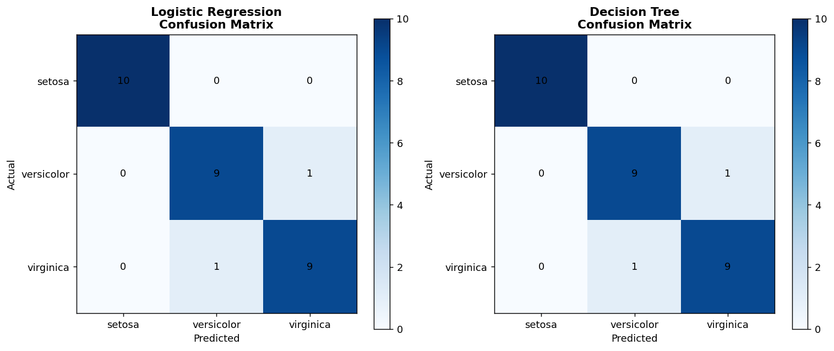
The confusion matrices show exactly which species were classified correctly and which were confused. Most observations fall on the diagonal, indicating correct predictions. The remaining errors occur between the more morphologically similar non-setosa classes rather than across all three classes indiscriminately.

9. Visualization 2 – Model Metric Comparison
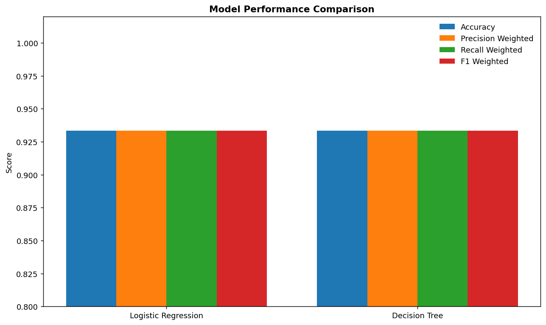
This grouped comparison shows that the two models have the same held-out test performance on this split. Presenting several metrics together prevents the analysis from relying solely on accuracy.

10. Visualization 3 – ROC Curves
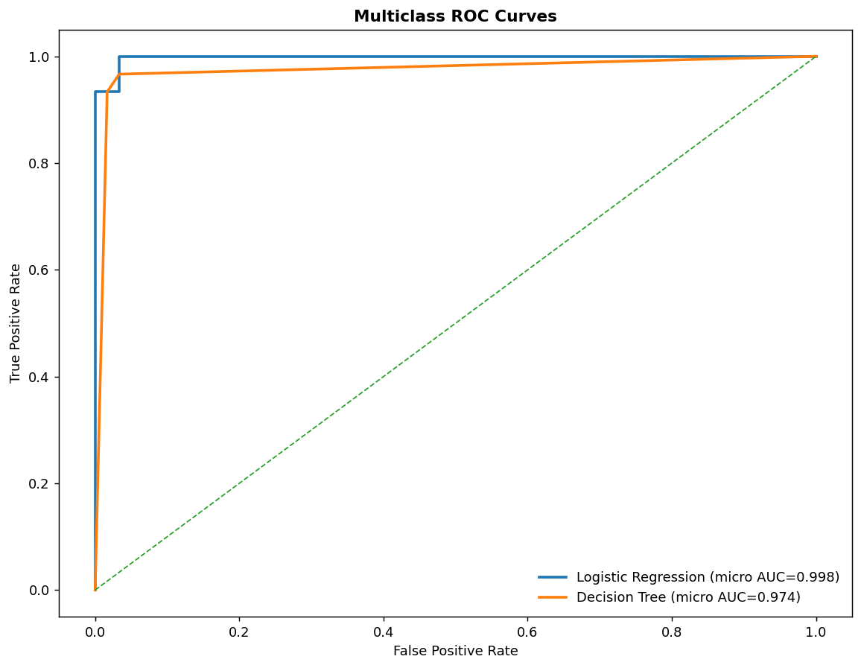
The multiclass ROC curves summarize discrimination across the three classes using a micro-averaged one-vs-rest representation. Curves closer to the upper-left region indicate stronger discrimination. The AUC values are shown directly in the legend.

11. Visualization 4 – Cross-Validation
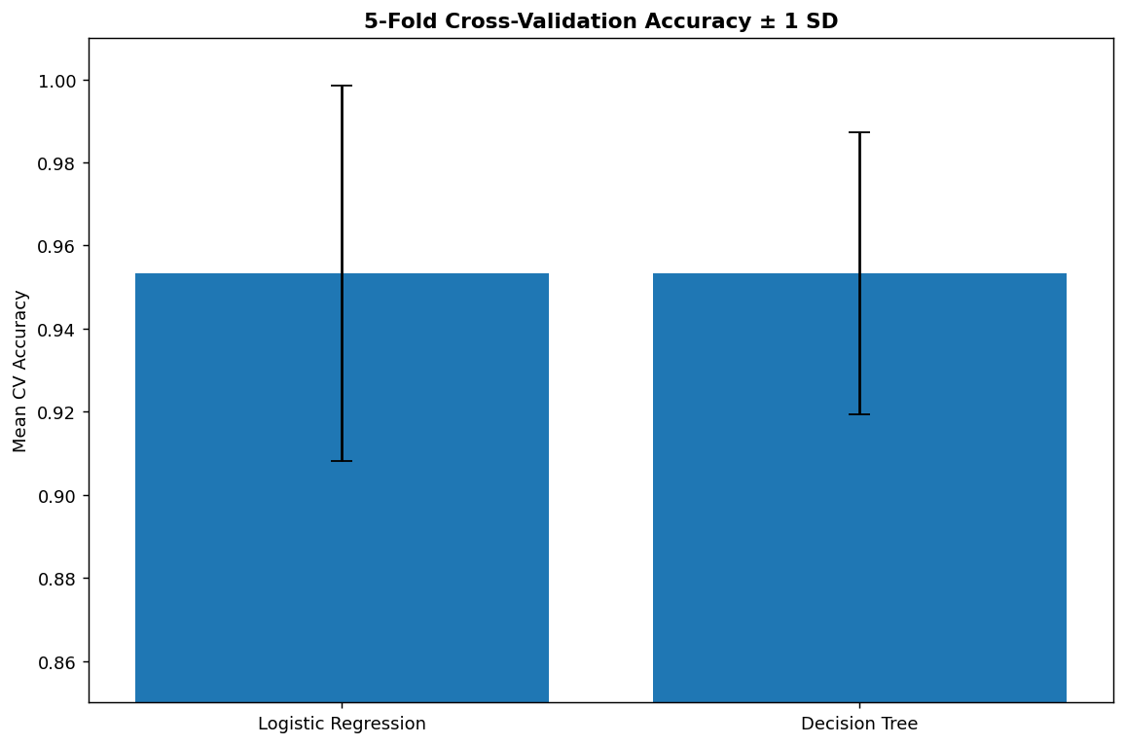
Five-fold cross-validation gives both models a mean accuracy of approximately 0.953. Logistic Regression has a cross-validation standard deviation of 0.045, while the Decision Tree has 0.034. This demonstrates why validation stability should be considered alongside a single test split.

12. Visualization 5 – Decision Tree Structure
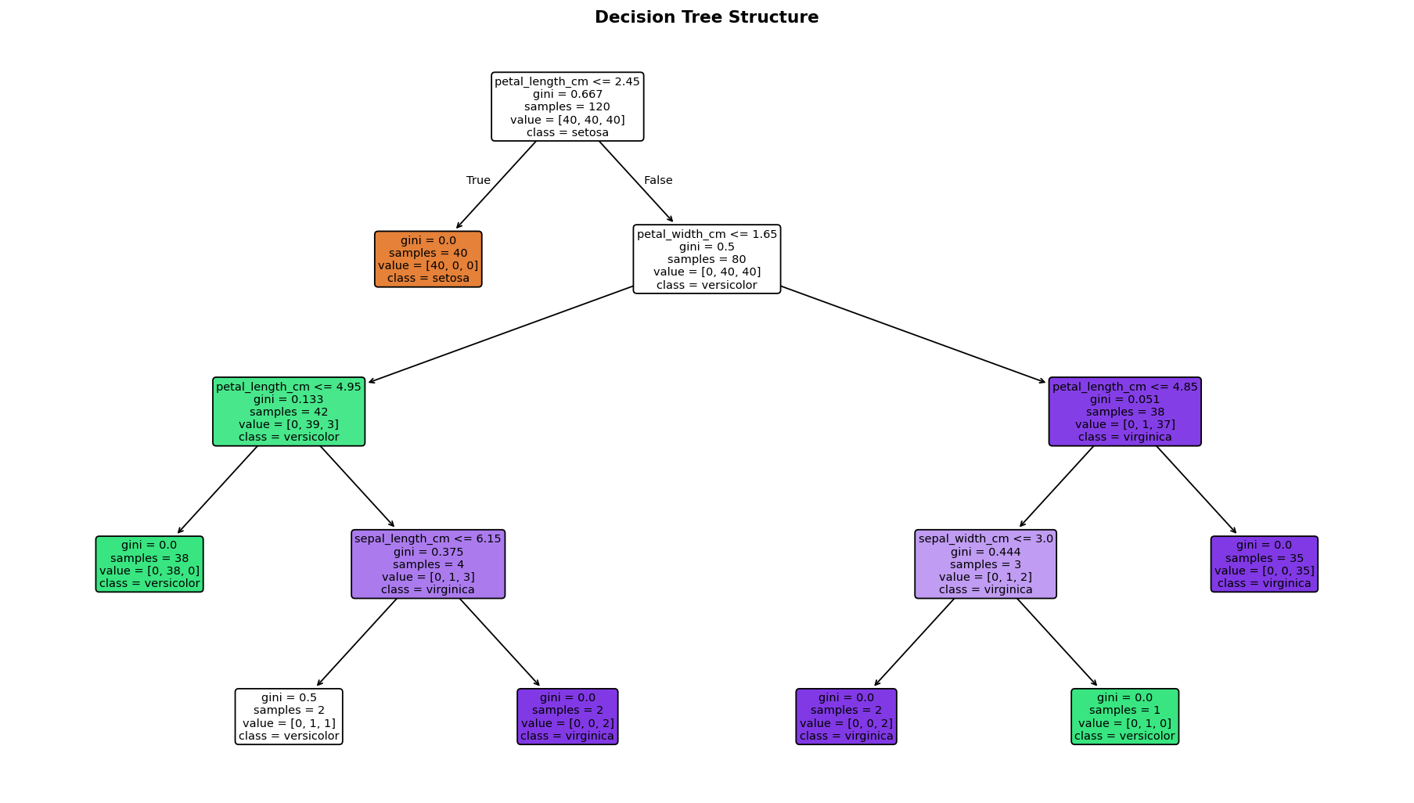
The tree visualization provides a transparent view of the learned decision rules. It shows how threshold-based splits can separate the species. The depth limit keeps the tree compact and reduces the risk of fitting idiosyncratic training observations.

13. Visualization 6 – Permutation Feature Importance
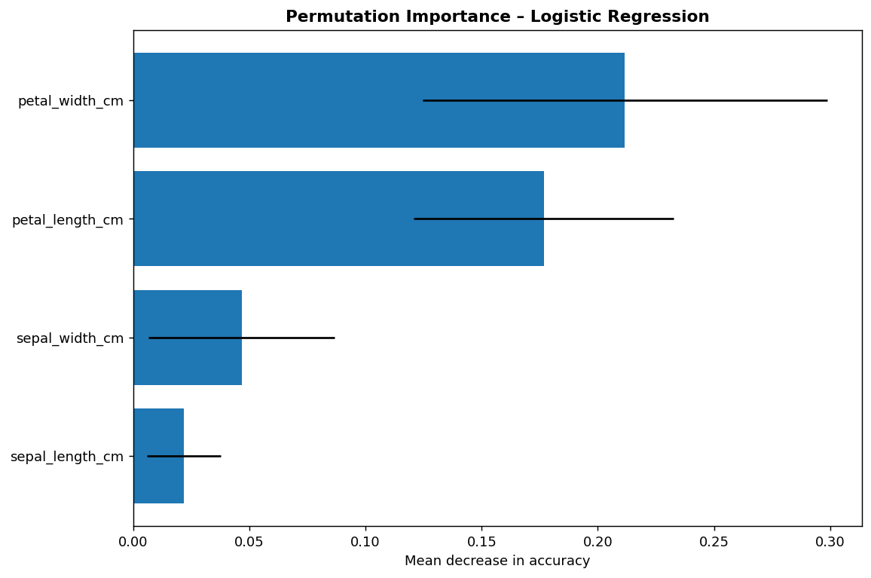
Permutation importance measures the decrease in test accuracy when a feature's values are randomly shuffled. Larger positive values indicate that the model's predictions depend more strongly on that feature in this evaluation sample. This is a model-specific diagnostic, not proof of causality.

14. Cross-Validation and Generalization
Model | Mean CV Accuracy | CV Std. Dev. | Test Accuracy
Logistic Regression
 | 0.953
 |  | 0.045
 |  |  | 0.933
Decision Tree
 | 0.953
 |  | 0.034
 |  |  | 0.933
The close relationship between cross-validation performance and held-out test performance provides no obvious indication that the reported test result is an isolated split-specific outcome. However, the dataset is small, so uncertainty remains and an independent external test set would provide stronger evidence of generalization.

15. Error Analysis
The Logistic Regression model made 2 errors on the 30-observation test set. These errors are concentrated in the more similar species and are useful for understanding the model's limitations.
Row | Actual | Predicted | Sepal L | Sepal W | Petal L | Petal W
134
 | virginica
 |  | versicolor
 |  |  | 6.10
 |  |  |  | 2.60
 |  |  |  |  | 5.60
 |  |  |  |  |  | 1.40
77
 | versicolor
 |  | virginica
 |  |  | 6.70
 |  |  |  | 3.00
 |  |  |  |  | 5.00
 |  |  |  |  |  | 1.70
Misclassifications do not necessarily indicate implementation failure. They can reflect overlapping feature distributions between classes. A useful improvement is to investigate whether additional features, nonlinear boundaries, or larger and more diverse samples reduce these errors.

16. Sources of Error and Model Risks
- Small sample size: 150 observations limits the precision with which generalization can be assessed.
- Feature overlap: some species have similar measurements, creating inherently ambiguous observations.
- Split sensitivity: a single 20% test set can produce slightly different results under another random split.
- Model assumptions: Logistic Regression uses linear decision boundaries in the standardized feature space.
- Tree complexity: an unrestricted Decision Tree could memorize training observations; the depth limit is a basic regularization measure.
- Dataset representativeness: the benchmark is curated and may not represent broader real-world measurement conditions.
- Metric limitations: aggregate accuracy can hide class-specific differences, so confusion matrices and per-class metrics should also be reviewed.

17. Potential Model Improvements
- Evaluate Random Forest and Gradient Boosting as stronger non-linear baselines.
- Perform systematic hyperparameter tuning with GridSearchCV or RandomizedSearchCV.
- Use repeated stratified cross-validation for a more stable performance estimate.
- Collect a larger and more diverse external dataset for independent validation.
- Investigate class-specific precision, recall, and calibration.
- Use feature selection or dimensionality-reduction experiments where scientifically justified.
- Track model performance and errors over time if the workflow is eventually deployed.

18. Strengths and Limitations
Strengths | Limitations
Reproducible Scikit-learn pipeline
 | Small benchmark dataset
Stratified test split
 | Limited external generalization
5-fold cross-validation
 | Only two baseline algorithms
Multiple evaluation metrics
 | Single held-out test split
Confusion matrix and ROC analysis
 | No external validation dataset
Explicit error analysis
 | No production deployment monitoring

19. Conclusion
This project demonstrates a complete machine-learning development lifecycle: defining a classification task, preparing data, selecting algorithms, training models, evaluating unseen observations, validating performance through cross-validation, visualizing results, and examining errors. Both Logistic Regression and a constrained Decision Tree achieved 93.3% test accuracy and approximately 95.3% mean five-fold cross-validation accuracy on this Iris benchmark. The results should be understood as benchmark evidence rather than a guarantee of performance on new populations.
The most important methodological conclusion is that model evaluation should extend beyond a single accuracy value. Confusion matrices, ROC/AUC, cross-validation variability, feature importance, and individual error inspection provide complementary evidence about model behavior.

20. Estimated Workload – 30 to 35 Hours
Activity | Estimated Hours
Problem definition and dataset preparation
 | 4
Preprocessing and train/test design
 | 5
Model selection and implementation
 | 7
Evaluation and cross-validation
 | 6
Visualization and error analysis
 | 5
Documentation, validation and packaging
 | 5
Total
 | 32

21. Project Structure
Path | Purpose
data/iris_ml.csv
 | Modeling dataset
data/model_metrics.csv
 | Test metrics
data/cross_validation_results.csv
 | 5-fold CV results
data/logistic_regression_errors.csv
 | Misclassified observations
data/permutation_importance.csv
 | Feature importance results
visualizations/
 | Six evaluation figures
src/train_evaluate.py
 | Training and evaluation code
src/visualize_evaluation.py
 | Visualization source
src/run_pipeline.py
 | Pipeline runner
requirements.txt
 | Dependencies
README.md
 | Setup instructions

22. References
UCI Machine Learning Repository, “Iris,” Dataset 53. https://archive.ics.uci.edu/dataset/53/iris
F. Pedregosa et al., “Scikit-learn: Machine Learning in Python,” Journal of Machine Learning Research, vol. 12, pp. 2825–2830, 2011.
W. McKinney, Python for Data Analysis, 3rd ed., O’Reilly Media, 2022.

