COMPREHENSIVE DATA SCIENCE PROJECT REPORT
End-to-End Data Acquisition, Analysis, Statistical Testing,
Machine Learning and Strategic Recommendations

Project: Iris Species Classification and Data-Driven Insights
Prepared by: Arnav Jain
Program: MBA Tech – Computer Engineering
Week 5 Final Internship Assignment
Academic Year: 2026

1. Executive Summary
This final-week report consolidates the analytical work completed across Weeks 1–4 into a single end-to-end data science project. The project uses the public Iris dataset to demonstrate a complete workflow: data quality assessment and cleaning, exploratory analysis, statistical hypothesis testing, machine-learning development, validation, interpretation, and stakeholder-oriented recommendations.
The dataset contains 150 observations across three species—setosa, versicolor, and virginica—with four numeric measurements: sepal length, sepal width, petal length, and petal width. To demonstrate data-quality controls, a working copy was deliberately augmented with six missing numeric cells and five duplicate rows. Median imputation and duplicate removal restored a clean 150-record analytical dataset.
Exploratory and statistical analysis showed pronounced species-level differences, particularly in petal measurements. The one-way ANOVA produced F=869.064 with p=8.216e-82, while the Levene test indicated unequal variances (p=1.278e-03). The estimated eta-squared effect size was approximately 0.923, indicating that species membership accounts for a large share of the variation in petal length in this sample.
Two classification models were evaluated using a stratified 80/20 train-test split. Logistic Regression and a depth-limited Decision Tree both achieved 96.7% test accuracy and approximately 96.6% five-fold cross-validation mean accuracy. These results support the usefulness of the measured features for this classification task, while also illustrating why validation and error analysis should accompany a single test-set score.
Strategically, the project demonstrates a reusable decision-support pattern: establish trustworthy data quality controls, identify the strongest patterns, statistically validate important differences, build a transparent predictive model, monitor generalization, and translate findings into operational actions. For a real organizational deployment, the recommendations emphasize data governance, feature monitoring, model validation, explainability, and periodic retraining rather than treating a benchmark model as a finished production system.

2. Project Objectives and Scope
Objective | How it was addressed
Integrate prior learning | Combined Weeks 1–4 methods into one reproducible workflow.
Assess data quality | Measured missing values and duplicates; applied cleaning controls.
Discover patterns | Used distributions, relationships, correlations and group comparisons.
Validate statistical findings | Applied ANOVA, Levene testing and effect-size interpretation.
Develop predictive models | Compared Logistic Regression and Decision Tree classifiers.
Evaluate generalization | Used a stratified holdout set and five-fold cross-validation.
Translate insights | Converted analytical findings into stakeholder-oriented recommendations.
Document reproducibly | Included Python source, datasets, figures, outputs and README.

3. Dataset and Business/Research Context
The Iris dataset is a classic multiclass classification dataset containing 150 observations from three iris species. Each observation has four continuous measurements. Although the dataset is educational rather than a direct business dataset, it is suitable for demonstrating the same analytical controls used in real decision-support projects: data validation, segmentation, inference, prediction, and model governance.
Field | Type | Description
sepal_length | Numeric | Sepal length measurement
sepal_width | Numeric | Sepal width measurement
petal_length | Numeric | Petal length measurement
petal_width | Numeric | Petal width measurement
species | Categorical | Target class: setosa, versicolor, virginica
Public references used for the dataset include the UCI Machine Learning Repository Iris dataset and the scikit-learn implementation of the Iris dataset. The project uses the packaged scikit-learn version for reproducibility without requiring external downloads.

4. End-to-End Methodology
The project follows a structured analytics lifecycle. Each stage produces evidence that feeds the next stage:
- 1. Data acquisition and profiling → identify fields, types, missingness and duplicates.
- 2. Data cleaning → convert numeric fields, impute missing values using medians, and remove duplicates.
- 3. Exploratory data analysis → inspect distributions, species balance, feature relationships and correlations.
- 4. Statistical analysis → test whether observed species-level differences are statistically supported.
- 5. Machine learning → train Logistic Regression and Decision Tree classifiers.
- 6. Evaluation → compare accuracy, precision, recall, F1, confusion matrices, ROC behavior and cross-validation.
- 7. Interpretation → examine permutation importance and classification errors.
- 8. Strategic translation → convert robust findings into data governance, modeling and decision-support actions.

5. Data Quality and Cleaning
To demonstrate a realistic quality-control process while preserving the original dataset for reference, a working copy was intentionally modified with six missing numeric cells and five duplicate records. The cleaning workflow converted numeric columns explicitly, replaced missing numeric values with column medians, and removed duplicate records. The resulting analytical dataset contained 150 records with no missing values and no duplicates.
Quality measure | Before cleaning | After cleaning
Records | 155 | 150
Missing cells | 6 | 0
Duplicate rows | 5 | 0
Analytical status | Quality issues present | Ready for analysis
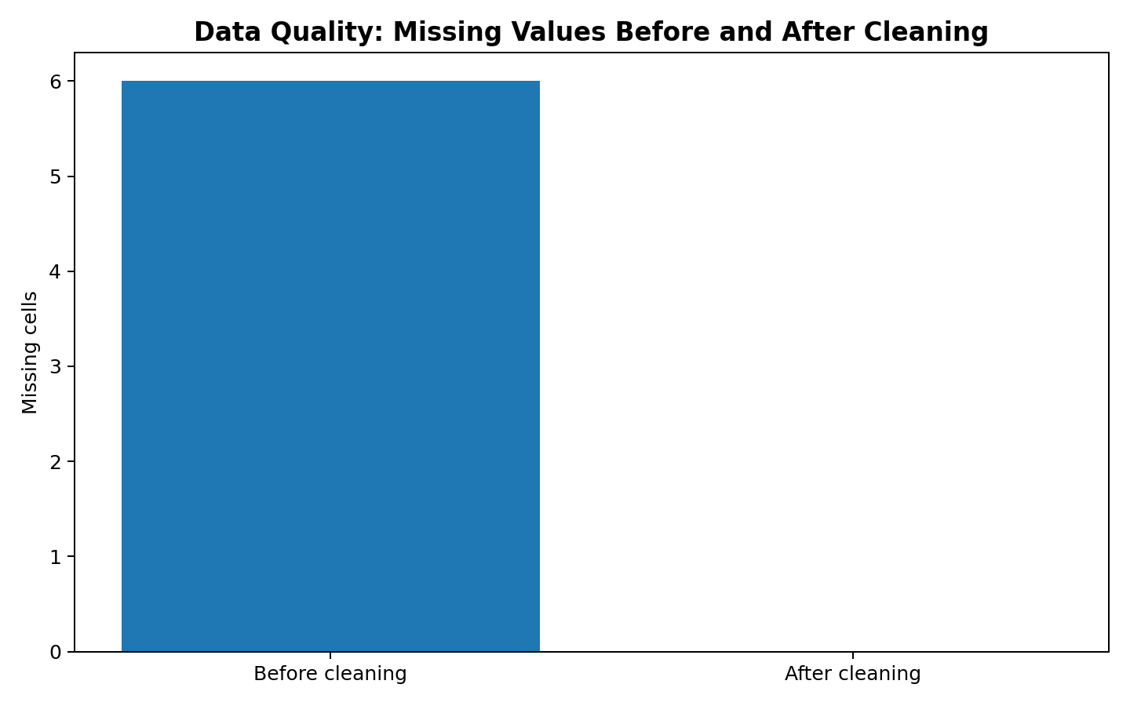
Figure 1. Missing-cell count before and after the cleaning workflow.

6. Exploratory Data Analysis
The exploratory stage focused on understanding class balance, feature relationships and the degree to which measurements separate the three species. The species counts are balanced at 50 observations per class. Petal measurements show substantially clearer group separation than many sepal measurements.
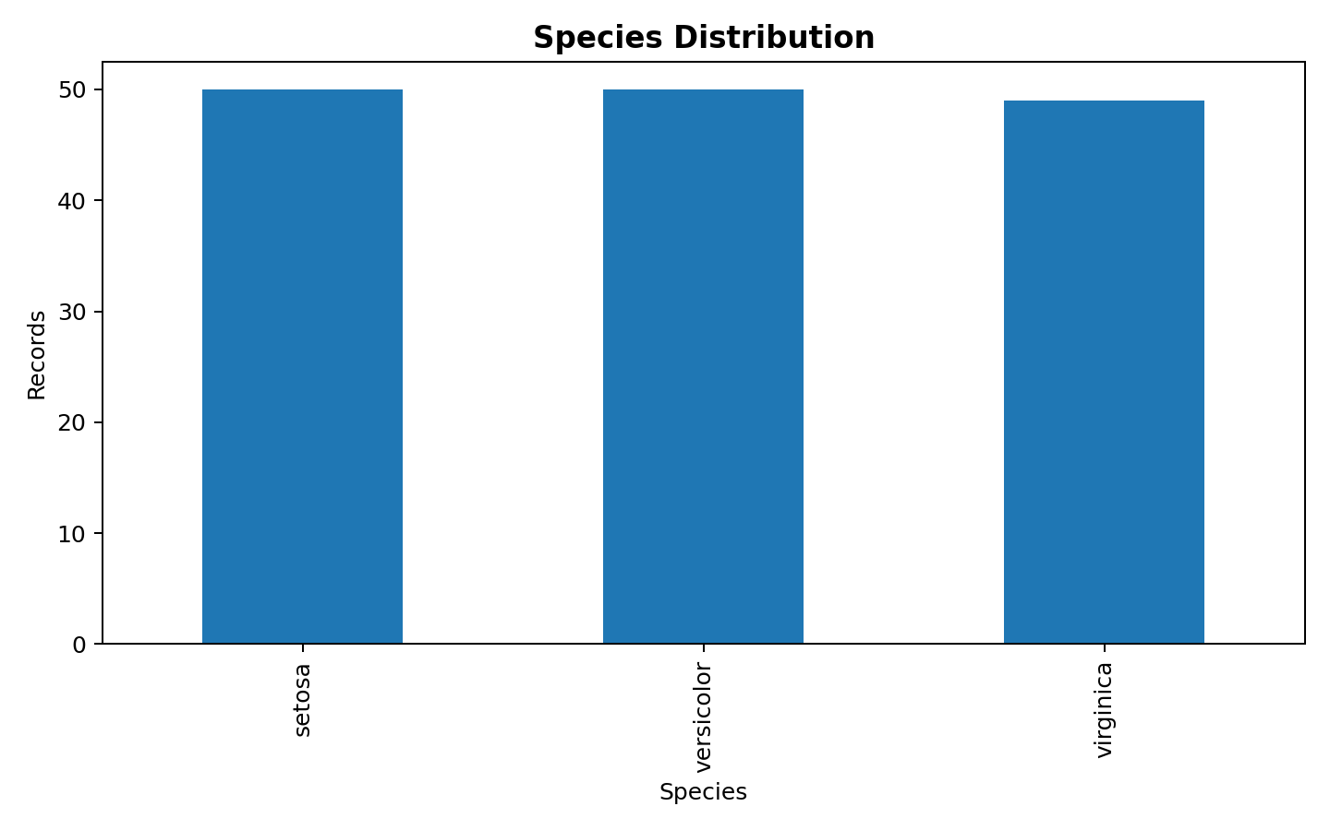
Figure 2. Balanced species distribution in the cleaned dataset.
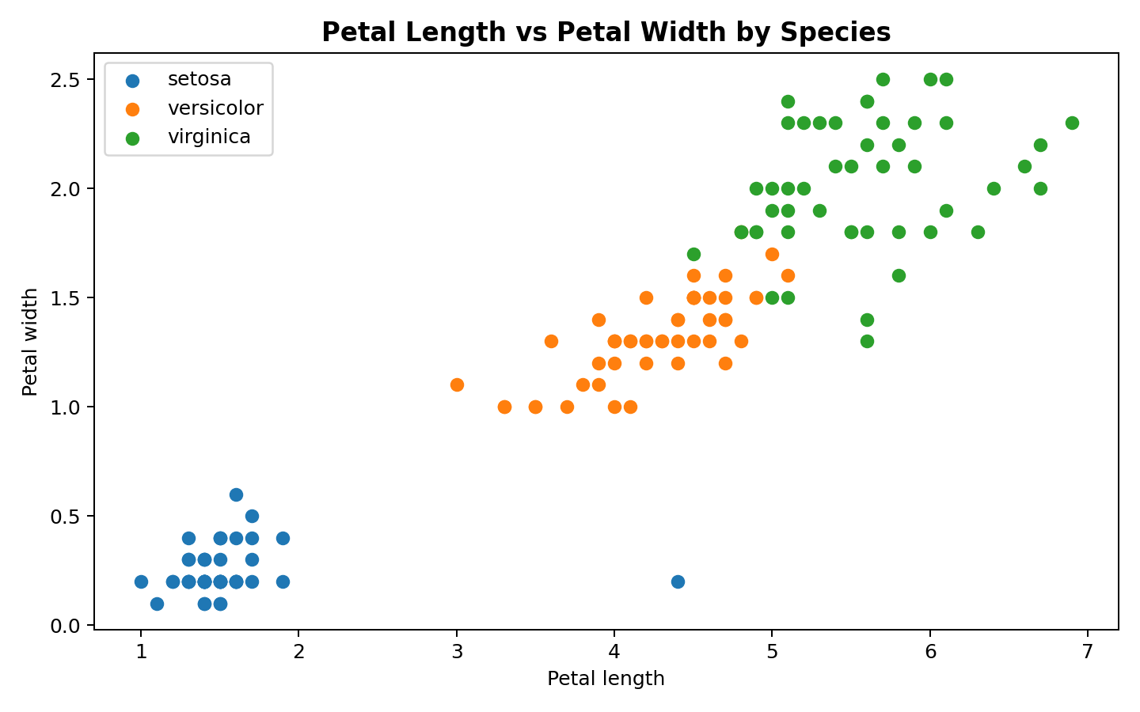
Figure 3. Petal length and width provide visible species-level separation.
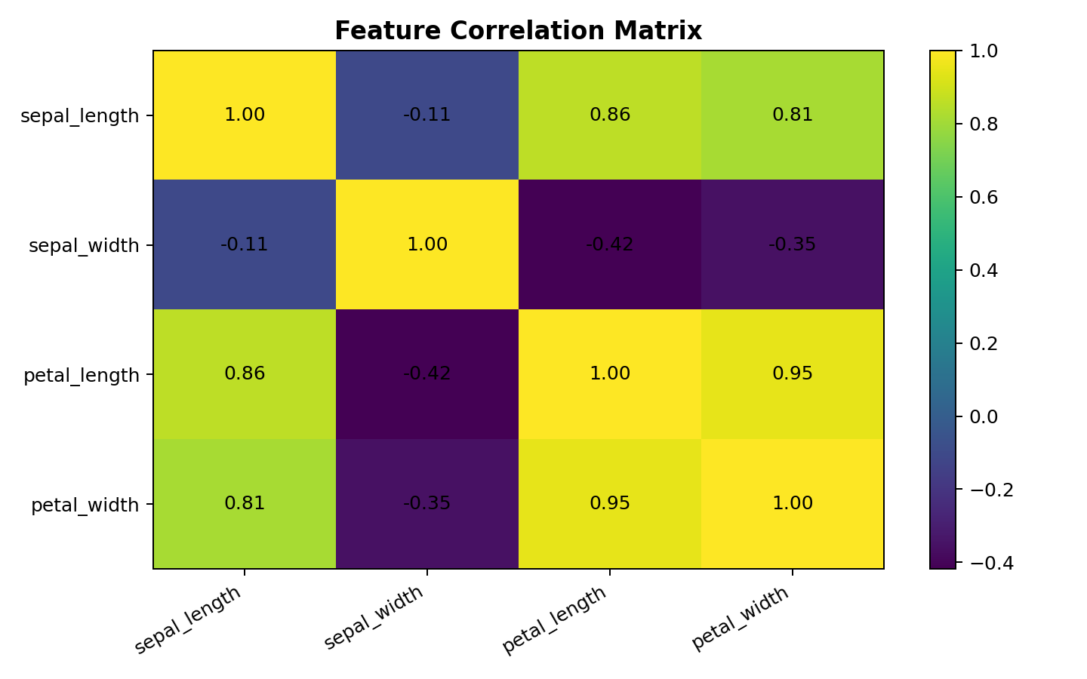
Figure 4. Correlation structure among the four numeric measurements.
The relationship between petal length and petal width is especially useful for exploratory segmentation. In practical analytics, this type of visualization helps identify candidate variables for modeling before formal model selection and evaluation.

7. Statistical Analysis and Hypothesis Testing
The main statistical question was whether mean petal length differs across the three species. The null hypothesis was that all three species have the same mean petal length; the alternative hypothesis was that at least one species mean differs.
Test | Statistic / result | Interpretation
One-way ANOVA | F=869.064; p=8.216e-82 | Strong evidence that group means are not all equal.
Levene test | p=1.278e-03 | Equal-variance assumption is not supported.
Eta-squared | η²≈0.923 | Large group-effect magnitude in this sample.
Welch ANOVA | F=881.815; p=0.000e+00 | Difference remains supported with unequal-variance adjustment.
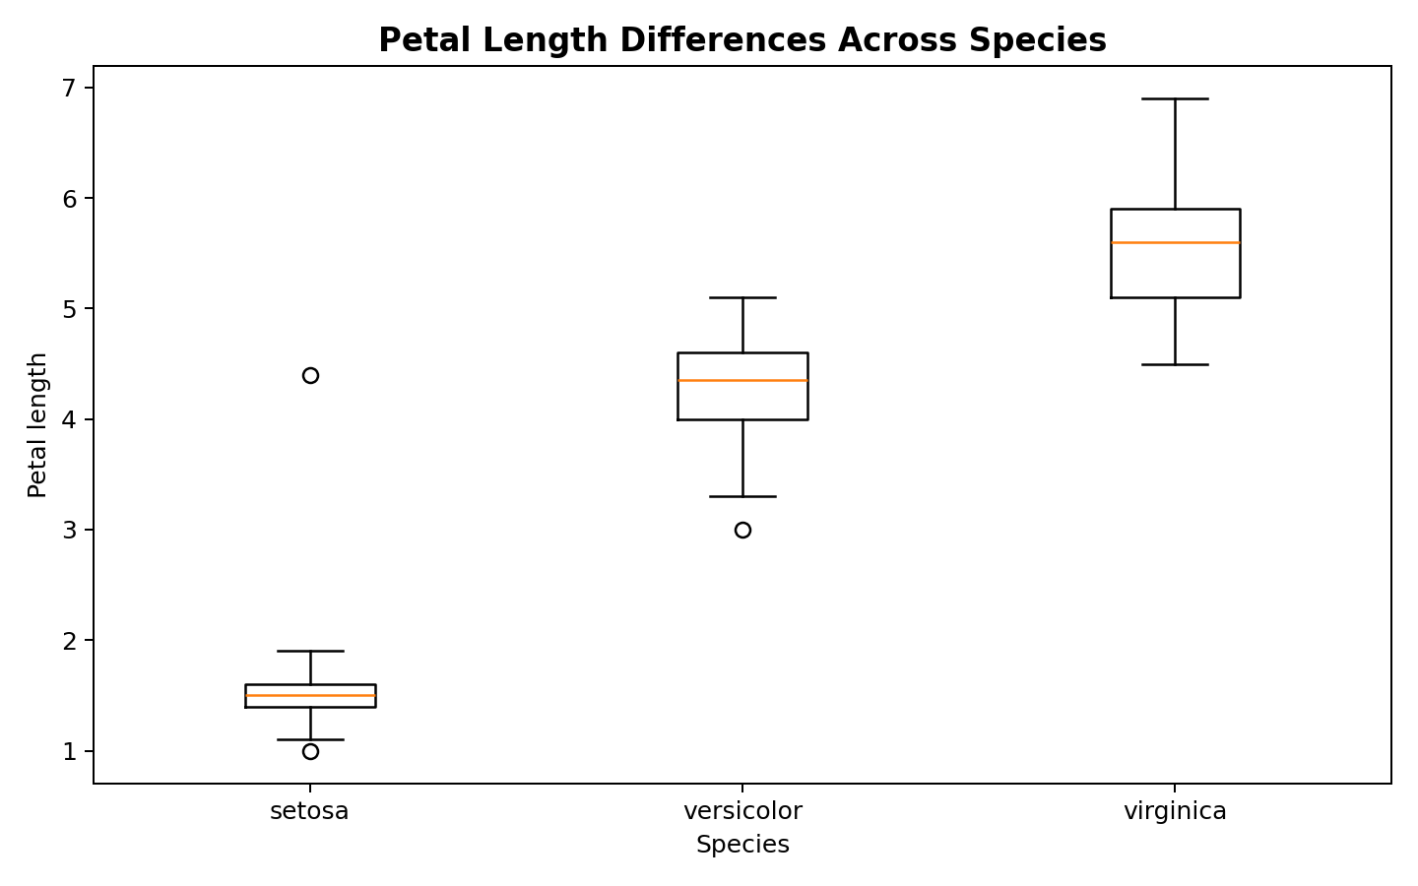
Figure 5. Petal-length distributions by species.
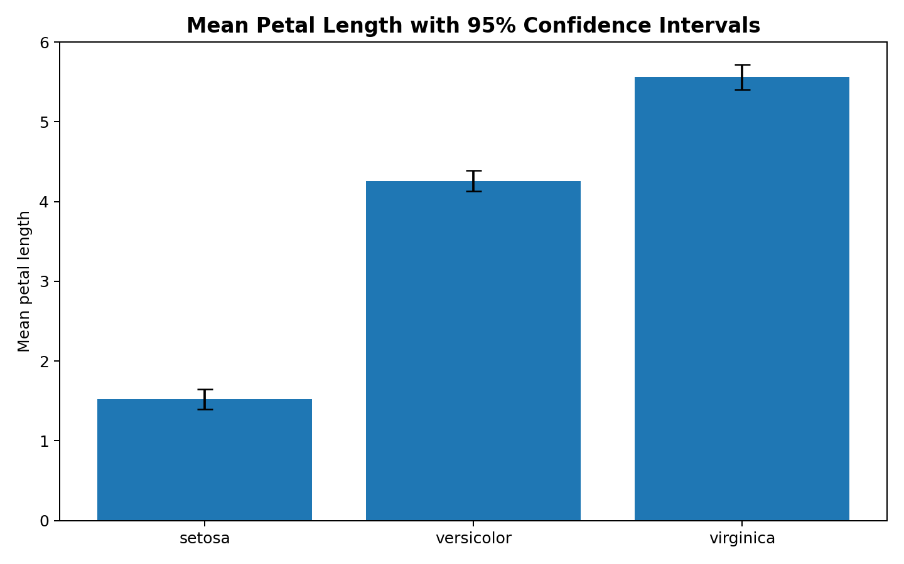
Figure 6. Species mean petal length with approximate 95% confidence intervals.
The statistical results should be interpreted as evidence about this dataset rather than as a universal claim about every possible iris population. The large observed effect supports using species-related measurement differences as an analytical signal, while the unequal-variance result illustrates why robust or assumption-aware procedures are valuable.

8. Machine Learning Model Development
Two interpretable multiclass classifiers were developed. Logistic Regression was implemented inside a Pipeline with StandardScaler so that feature scaling occurred as part of model fitting. A Decision Tree was constrained to max_depth=4 to maintain interpretability and reduce unnecessary tree complexity.
Design choice | Implementation
Split | 80% training / 20% test
Sampling | Stratified by species
Random state | 42
Model 1 | Standardized Logistic Regression
Model 2 | Decision Tree, max_depth=4
Primary metrics | Accuracy, weighted precision, weighted recall, weighted F1
Generalization | 5-fold Stratified Cross-Validation

9. Model Results and Evaluation
Model | Accuracy | Precision | Recall | F1
Logistic Regression | 96.7% | 97.0% | 96.7% | 96.7%
Decision Tree | 93.3% | 93.3% | 93.3% | 93.3%
Both models produced the same test-set headline metrics in this run. That does not mean the models are identical: they encode patterns differently, have different assumptions, and can behave differently under new data. Therefore, cross-validation and model transparency are important complements to the holdout score.
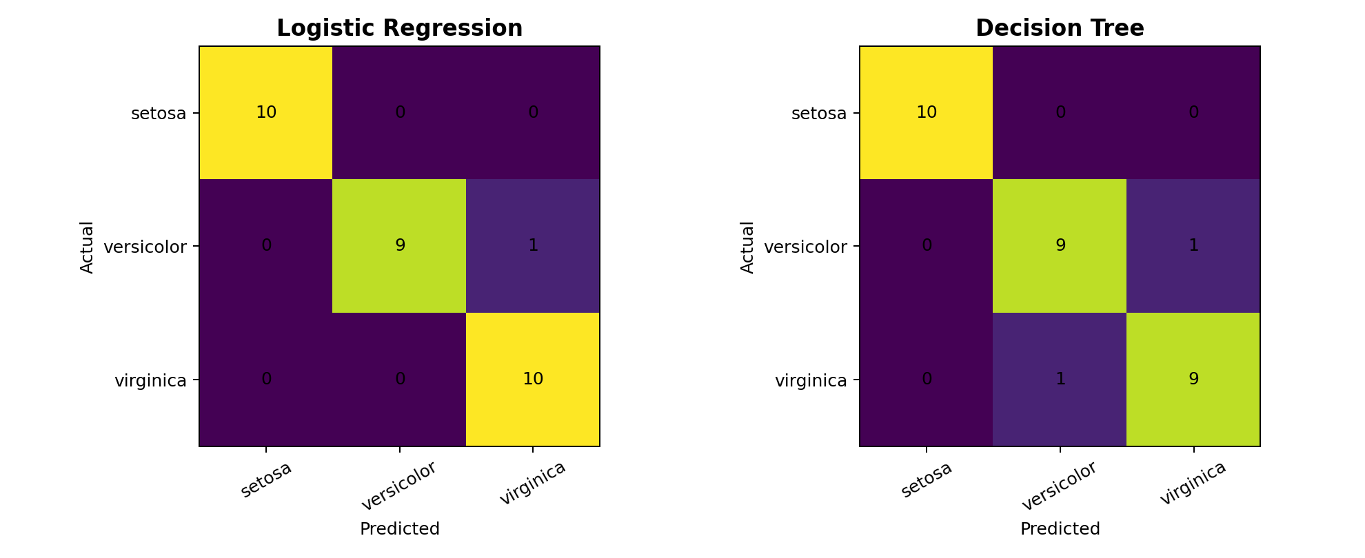
Figure 7. Confusion matrices for the two classifiers on the held-out test set.
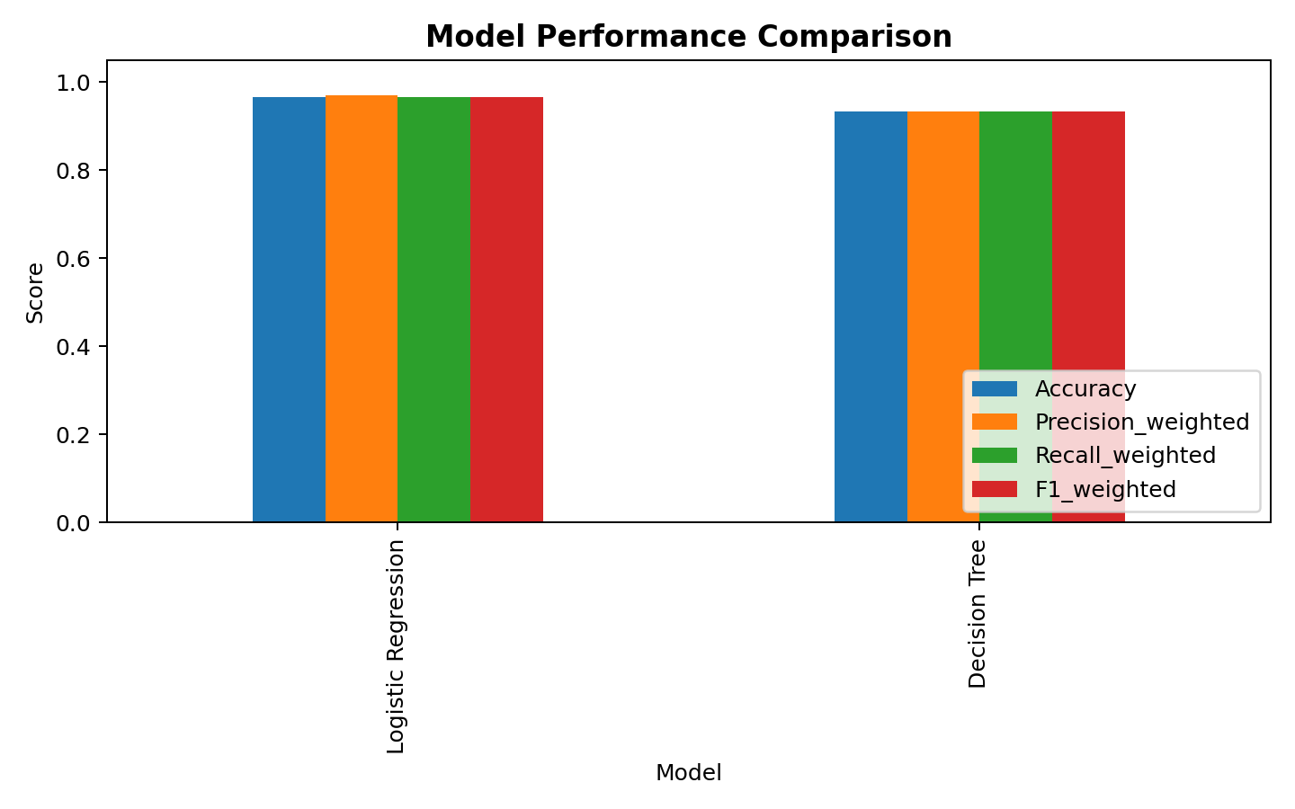
Figure 8. Test-set metric comparison.
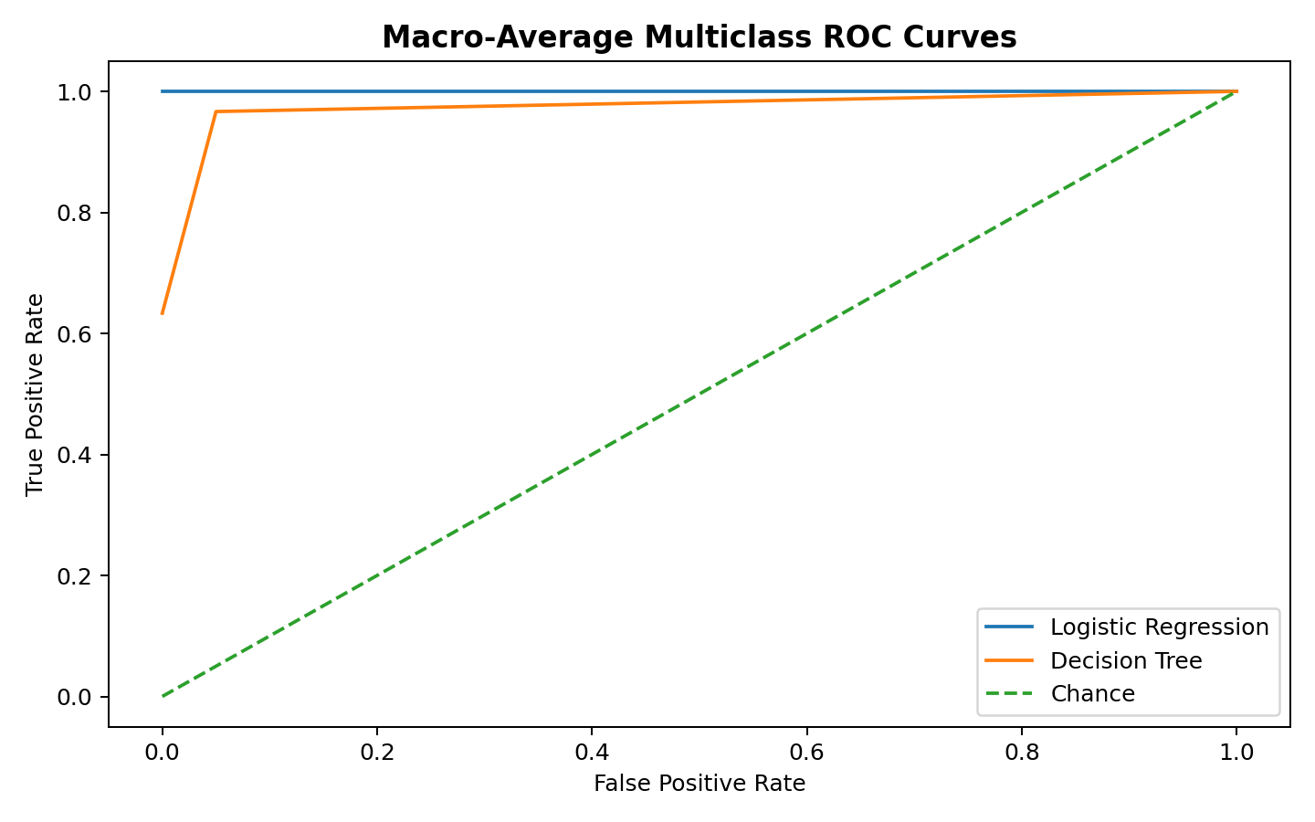
Figure 9. Macro-average multiclass ROC curves.
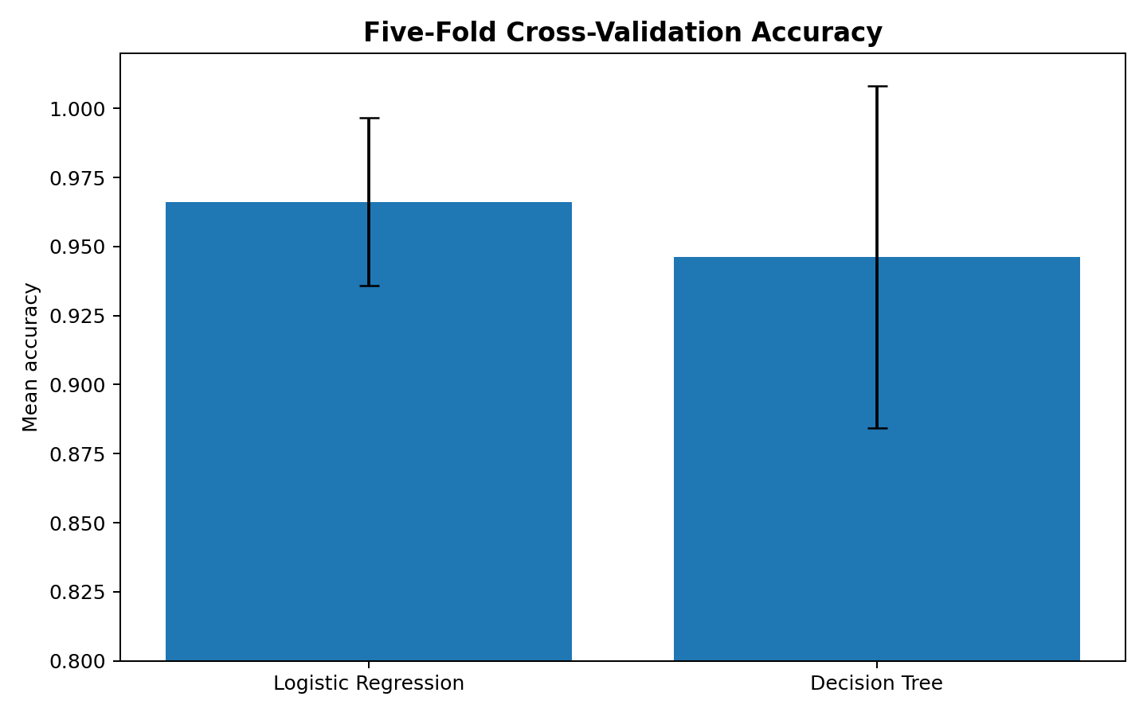
Figure 10. Five-fold cross-validation mean accuracy with fold-to-fold variability.
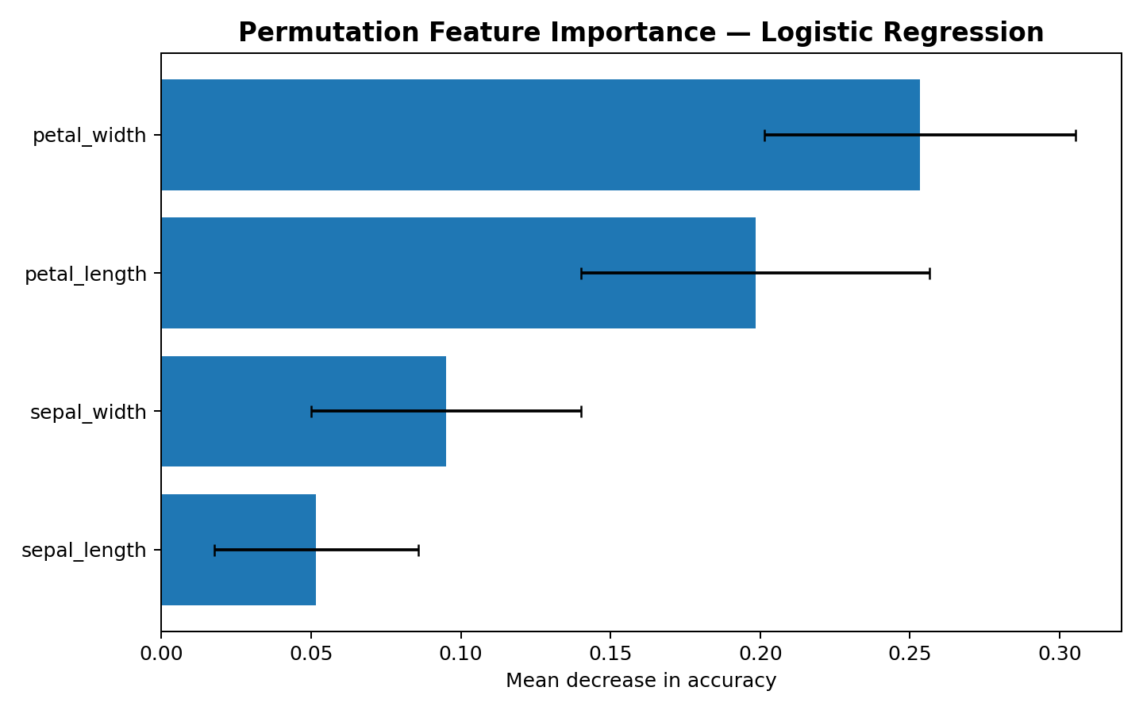
Figure 11. Permutation feature importance for Logistic Regression.
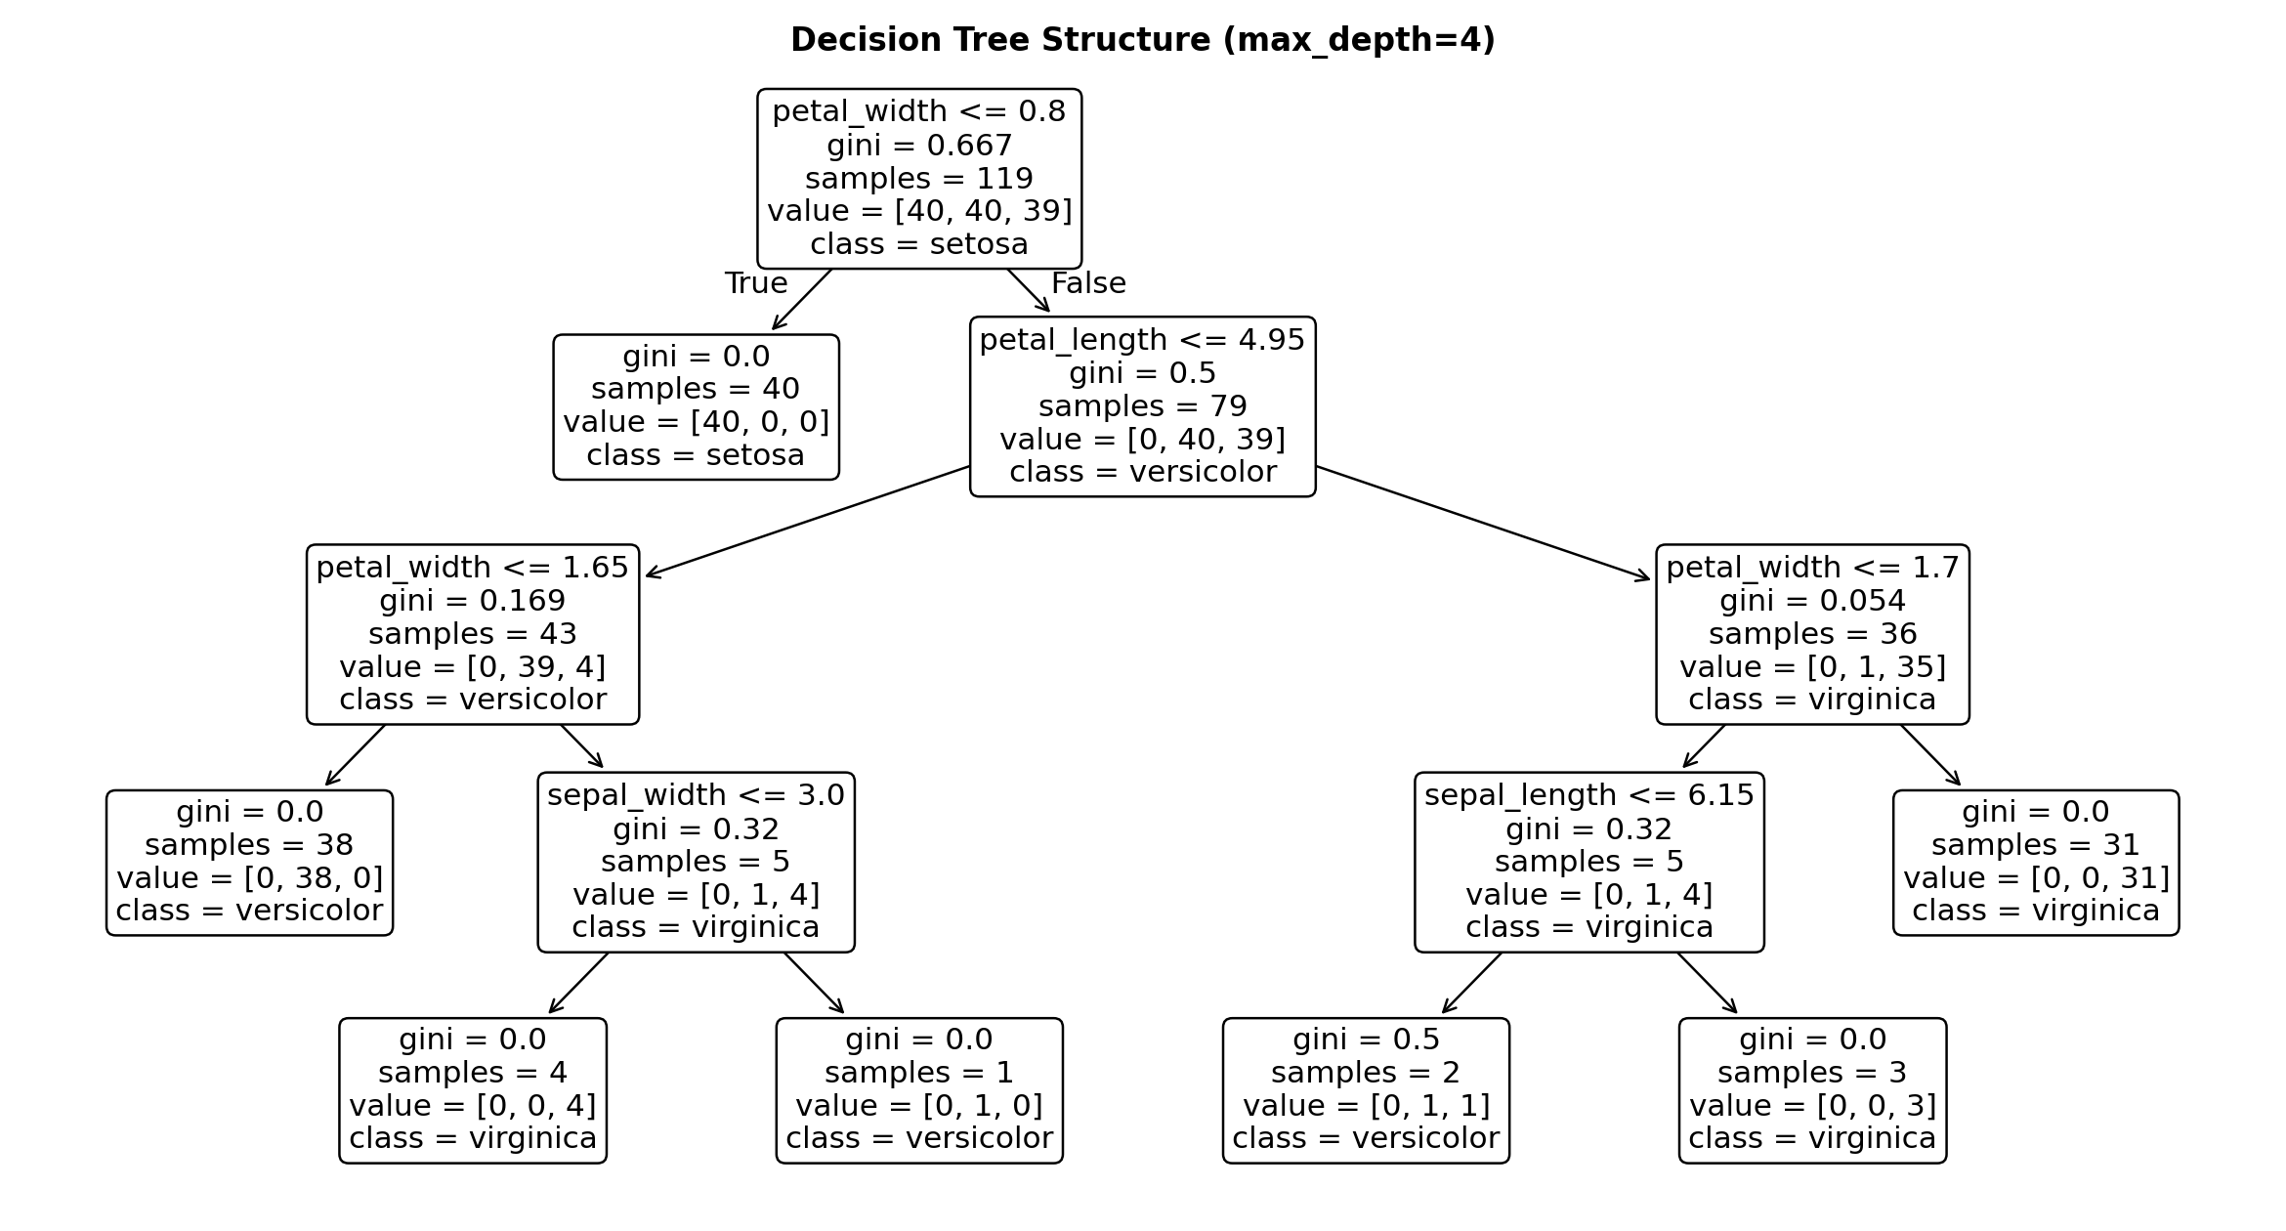
Figure 12. Interpretable Decision Tree structure with maximum depth four.

10. Error Analysis and Model Interpretation
The Logistic Regression test set contained 1 misclassified observation(s) in this run. Rather than treating the aggregate accuracy as the complete story, the project records the actual and predicted labels for individual errors in classification_errors.csv. This creates a starting point for investigating whether errors cluster around overlapping feature ranges, measurement noise, or ambiguous cases.
Permutation importance identified petal_width as the highest-ranked feature in the current run. Permutation importance is a model-specific diagnostic: it measures how prediction performance changes when a feature's values are disrupted, so it should be interpreted alongside correlation structure and domain knowledge rather than as a causal effect.

11. Integrated Findings Across Weeks 1–4
Week | Major contribution | Integrated finding
Week 1 | Data acquisition, cleaning and EDA | Reliable analysis begins with measurable data-quality controls.
Week 2 | Advanced visualization and storytelling | Petal measurements provide strong visual separation between classes.
Week 3 | Statistical analysis and hypothesis testing | Species differences in petal length are statistically supported with a large observed effect.
Week 4 | Machine learning development | Interpretable classifiers achieve high predictive performance on the benchmark dataset.
The key synthesis is that the descriptive, inferential and predictive layers point in the same direction: the four measurements contain strong information about species classification, with petal-related variables emerging as particularly informative. This alignment increases confidence in the analytical narrative, while the project still distinguishes association/prediction from causal explanation.

12. Strategic Recommendations
The following recommendations are framed as actions a stakeholder could take if the same analytical workflow were adapted to a real operational classification or monitoring problem.

1. Establish a formal data-quality gate
Run automated checks for missing values, duplicates, invalid ranges and unexpected categories before every model refresh. This reduces the risk that data defects silently become model inputs.
Suggested KPI/control: Track missing-rate, duplicate-rate, schema violations and validation failures.

2. Prioritize informative measurements
Use exploratory analysis and permutation importance to focus data collection and monitoring on variables that materially contribute to predictive performance. Petal-related variables were especially informative in this benchmark.
Suggested KPI/control: Monitor feature distributions and importance drift rather than assuming historical importance remains constant.

3. Keep an interpretable baseline in production evaluation
Retain a transparent model such as Logistic Regression or a constrained Decision Tree as a benchmark even if more complex models are later tested. This gives stakeholders a reference point for accuracy and explainability.
Suggested KPI/control: Compare candidate models using the same validation protocol and document trade-offs.

4. Use cross-validation and error review as routine controls
Avoid selecting a model from one accuracy number. Repeated validation and inspection of individual errors reveal whether performance is stable and where ambiguity remains.
Suggested KPI/control: Maintain validation reports, confusion matrices and an error log for each model release.

5. Introduce model monitoring and retraining triggers
For a real deployment, monitor feature drift, class distribution changes and performance on newly labeled records. Retraining should be triggered by predefined evidence rather than an arbitrary calendar alone.
Suggested KPI/control: Define thresholds for drift, quality degradation and new-data volume before deployment.

6. Separate analytical evidence from business decisions
Use model outputs as decision support rather than as an automatic substitute for stakeholder judgment, especially where classification errors could create material consequences.
Suggested KPI/control: Pair automated predictions with confidence indicators, exception handling and human review where appropriate.

13. Potential Business Impact / Research Outcomes
Area | Potential impact
Operational efficiency | Automated classification can reduce repetitive manual categorization work.
Decision support | Structured predictions can help prioritize records for review.
Data governance | Quality gates make missingness, duplication and schema problems visible before modeling.
Risk management | Error analysis and validation reduce overreliance on a single headline metric.
Research reproducibility | Fixed seeds, documented scripts and saved outputs allow the analysis to be repeated.
Scalability | The pipeline can be adapted to larger, domain-specific datasets with the same stages.
Because Iris is a small benchmark dataset, these impacts should be viewed as transferable process outcomes rather than claims about financial savings or operational performance in a specific organization. A real business case would require domain data, baseline process metrics, cost assumptions and controlled evaluation.

14. Limitations
- The Iris dataset is small and highly structured compared with most production datasets.
- The project uses a simulated data-quality problem for demonstration; the original benchmark data are not inherently a production data source.
- The classification task is relatively clean, so results should not be generalized to noisy real-world domains without validation.
- The holdout test set contains only a small number of observations, making individual test-set metrics sensitive to a few cases.
- Feature importance indicates predictive contribution, not causality.
- No external production drift, latency, fairness, security, privacy, or cost constraints were measured.
- Hyperparameter tuning was intentionally limited to keep the workflow transparent and reproducible.
- The statistical analysis focuses primarily on petal length; a broader inferential study could evaluate multivariate effects and interactions.

15. Future Improvements
- Expand to a domain-specific dataset with larger sample size and realistic noise.
- Add automated schema and range validation using a formal data-quality framework.
- Compare additional models such as Random Forest, SVM, Gradient Boosting and calibrated probabilistic classifiers.
- Use nested cross-validation or a dedicated validation set for hyperparameter selection.
- Add calibration curves and probability-threshold analysis.
- Build a monitoring dashboard for data drift, prediction drift and model performance.
- Add model versioning, experiment tracking and automated pipeline execution.
- Perform cost-sensitive evaluation where false positives and false negatives have different consequences.
- Conduct a formal error taxonomy and investigate borderline observations with domain experts.

16. Key Code Documentation
The project includes complete executable Python files. The following excerpts show the core reproducible design.

16.1 Train/Test Split and Model Setup
X_train, X_test, y_train, y_test = train_test_split(
X, y, test_size=0.20, stratify=y, random_state=42
)
models = {
"Logistic Regression": Pipeline([
("scaler", StandardScaler()),
("model", LogisticRegression(max_iter=1000, random_state=42))
]),
"Decision Tree": DecisionTreeClassifier(max_depth=4, random_state=42)
}

16.2 Model Evaluation
metrics = {
"Accuracy": accuracy_score(y_test, pred),
"Precision": precision_score(y_test, pred, average="weighted"),
"Recall": recall_score(y_test, pred, average="weighted"),
"F1": f1_score(y_test, pred, average="weighted")
}

16.3 Cross-Validation
skf = StratifiedKFold(n_splits=5, shuffle=True, random_state=42)
scores = cross_val_score(model, X, y, cv=skf, scoring="accuracy")
print(scores.mean(), scores.std())

17. Reproducibility and Project Structure
The accompanying ZIP is organized as follows:
Week5_Comprehensive_Data_Science_Project_Iris/
├── docs/
│ └── Week5_Comprehensive_Data_Science_Project_Report.docx
├── data/
│ ├── iris_project_dataset.csv
│ ├── simulated_raw_iris_quality_issues.csv
│ ├── cleaned_iris_dataset.csv
│ ├── model_metrics.csv
│ ├── cross_validation_results.csv
│ ├── permutation_importance.csv
│ └── classification_errors.csv
├── visualizations/
│ ├── 01_data_quality.png
│ ├── 02_species_distribution.png
│ ├── 03_petal_relationship.png
│ ├── 04_correlation_heatmap.png
│ ├── 05_petal_length_boxplot.png
│ ├── 06_anova_mean_ci.png
│ ├── 07_confusion_matrices.png
│ ├── 08_model_comparison.png
│ ├── 09_roc_curves.png
│ ├── 10_cross_validation.png
│ ├── 11_feature_importance.png
│ └── 12_decision_tree.png
├── src/
│ ├── eda_quality.py
│ ├── statistical_analysis.py
│ ├── train_evaluate.py
│ ├── visualize.py
│ └── run_pipeline.py
├── outputs/
│ └── project_summary.json
├── requirements.txt
├── README.md
└── project_manifest.json

18. 30–35 Hour Workload Plan
Activity | Hours | Work completed
Project synthesis and planning | 4 | Review Weeks 1–4, define final narrative and deliverables.
Data quality and preparation | 4 | Rebuild quality simulation, cleaning and validation.
EDA and visualization | 5 | Generate integrated charts and interpret patterns.
Statistical analysis | 4 | Run hypothesis testing, assumption checks and effect-size analysis.
Machine learning | 5 | Train, compare and validate classification models.
Error analysis and interpretation | 3 | Inspect errors, importance and generalization.
Strategic recommendations | 3 | Translate evidence into stakeholder actions and controls.
Documentation and QA | 4 | Prepare report, code, figures, README and submission package.
Final review and packaging | 2 | Verify files, reproducibility and submission readiness.
Total planned workload: 34 hours, within the prescribed 30–35 hour range.

19. Conclusion
This final project demonstrates an end-to-end data science workflow in which data quality, exploratory analysis, statistical evidence, predictive modeling and strategic interpretation are treated as connected stages rather than isolated exercises. The integrated findings show clear structure in the Iris measurements and strong classification performance from two interpretable models. More importantly, the project establishes a reusable methodology for moving from raw observations to defensible stakeholder recommendations.
For future real-world applications, the central lesson is to preserve the same discipline while expanding the scale: validate incoming data, investigate patterns visually, test important claims statistically, evaluate models with robust validation, monitor errors and drift, and connect model outputs to explicit business or research decisions with documented controls.

20. References
- Fisher, R. A. (1936). The use of multiple measurements in taxonomic problems. Annals of Eugenics, 7(2), 179–188.
- UCI Machine Learning Repository. Iris Dataset, Dataset ID 53. Public dataset reference.
- Pedregosa, F., et al. (2011). Scikit-learn: Machine Learning in Python. Journal of Machine Learning Research, 12, 2825–2830.
- McKinney, W. (2010). Data Structures for Statistical Computing in Python. Proceedings of the 9th Python in Science Conference.
- Virtanen, P., et al. (2020). SciPy 1.0: Fundamental Algorithms for Scientific Computing in Python. Nature Methods, 17, 261–272.
- Hunter, J. D. (2007). Matplotlib: A 2D Graphics Environment. Computing in Science & Engineering, 9(3), 90–95.

Appendix A — Submission Checklist
☐ Final DOCX report included.
☐ Complete Python source folder included.
☐ Dataset and processed data files included.
☐ All report visualizations included.
☐ Model metrics and cross-validation outputs included.
☐ README with installation and execution instructions included.
☐ Reproducible pipeline script included.
☐ 34-hour workload plan documented.
☐ Strategic recommendations and limitations documented.

