Course Project Documentation

BE_Project_2012

**Character Recognition For Degraded Engraved Text**

TEAM :14

Mohd. Akram Memon

Ronak Totla

**Table Of Contents**

1. Introduction..................................................................................3

2. Problem Statement......................................................................4

3. Requirements...............................................................................5

4. Implementation.............................................................................6

5. Testing results and data….............................................................7

6. Discussion of System..................................................................11

7. Future Work.................................................................................13

8. Conclusion...................................................................................14

9. References...................................................................................15

1. **Introduction**:

Everycylinderhas unique identification code (UID code) engraved on it.This UID code is used to differentiate between cylinders belonging to different distributors and also differentiate between tested & untested cylinders. But, engraved codes are prone to rusting, paint erosion, chemical corrosion, etc. Since, almost all firms use same metal cylinders for more than a few months, the engraved UID code becomes difficult to detect and read. This method of engraving the UID codes on the hardware is now being replaced by putting up stick-on and/or adding a plastic tag.

Also, in developing countries like India, labourers that are used for loading and unloading of cylinders and maintaining the database have poor literacy.

So as per our case study, following manually occurring problems were observed:

* labourers find it very difficult to read the code, resulting in faulty readings
* human entry errors like missing character, duplicate characters, incorrect sequence
* UID codes are noted on challans, but illegible handwriting makes it difficult to understand for data entry operator
* less accessibility in obtaining uid codes for closely packed array of cylinders
* poorly illuminated areas in warehouses

Thus, there exists a high probability that the data entry by the operator, managing the cylinder inventory software receives wrong UID codes & registers faulty data.

Issues that arise due to these problems:

* Error in cylinder tracking and maintenance
* As per safety regulations, every cylinder has to pass hydro-test and explosive test after specified period of time. Due to wrong entry for the particular cylinder, the cylinder cannot be tracked & it may lead to hazardous consequences.
* Also, these cylinders are used on rent basis. Wrong data results in error in rent calculation.
* Some cylinders are lost in this process and the owner has to bear the losses

**2. Problem Statement:**

The project addresses the issue of:

* Reduction in the rent losses (as well as product losses)
* Improving the efficiency of inventory management and tracking system.

The aim of the project is:

* To provide an ease for most of the steps involved in cylinder tracking.

Hence, to design and develop a semi-autonomous system.

* To make the inventory management process more robust.
* To make the process of data logging compatible to existing system.
* To provide easy to use GUI for users as well as for debugging
* To signal appropriate error messages to the operator if the UID code detected is not correct or not completely extracted
* Estimate Missing character in UID from a list of valid product codes

**3. Requirements:**

**A) Hardware Requirements**

1. FireBird : Requires single robot

2. Camera : To capture image

**B) Software Requirements**

1. LabView : For processing images sent by camera

**4. Implementation:**

Block diagram:

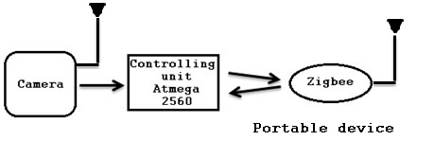

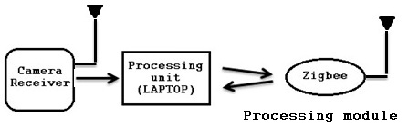

The summary of the operations is as follows:

1. LabView VI is started. All the necessary configurations needed at the start are done. This includes selecting appropriate COM port, camera device to be configured, setting up the baud rate, optional manual crop, etc.
2. Manual operator then places the portable device, with the camera casing, on the target. The next step includes switching on the synchronising device ( in this case Firebird robot).
3. The device ensures proper signalling for the start of further processes. It uses the Zigbee module for doing so. Proper indications are shown on the lcd unit for the operator.
4. Once the image is captured, the further processing of character extraction and recognition is done and the read string is displayed.
5. Also provisions for testing the images from database are made available and correction from database is provided.

**5. Testing Results and Data:**

The portable device will send captured images and synchronizing signals to the system where image is to be processed and character recognition is required to be done. At the end of processing a window named “result” will be generated (as shown in following figure). This window displays the final output of the process.

**Wireless camera AV to USB convertor Prototype from**

**Phase 1**

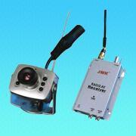 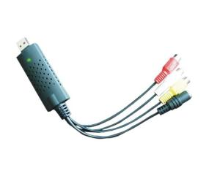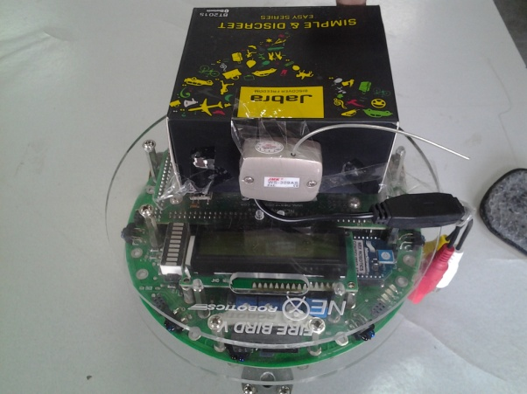

**Real world targets:**

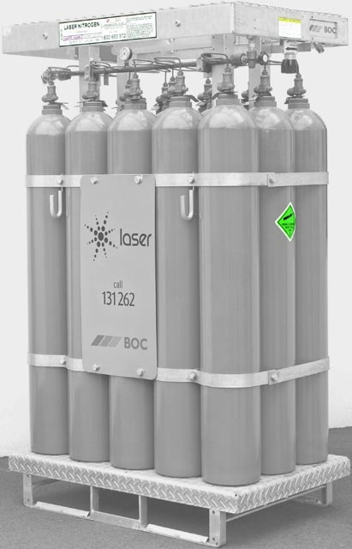 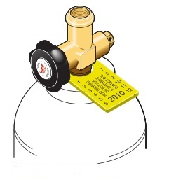

**GUI for the user:**

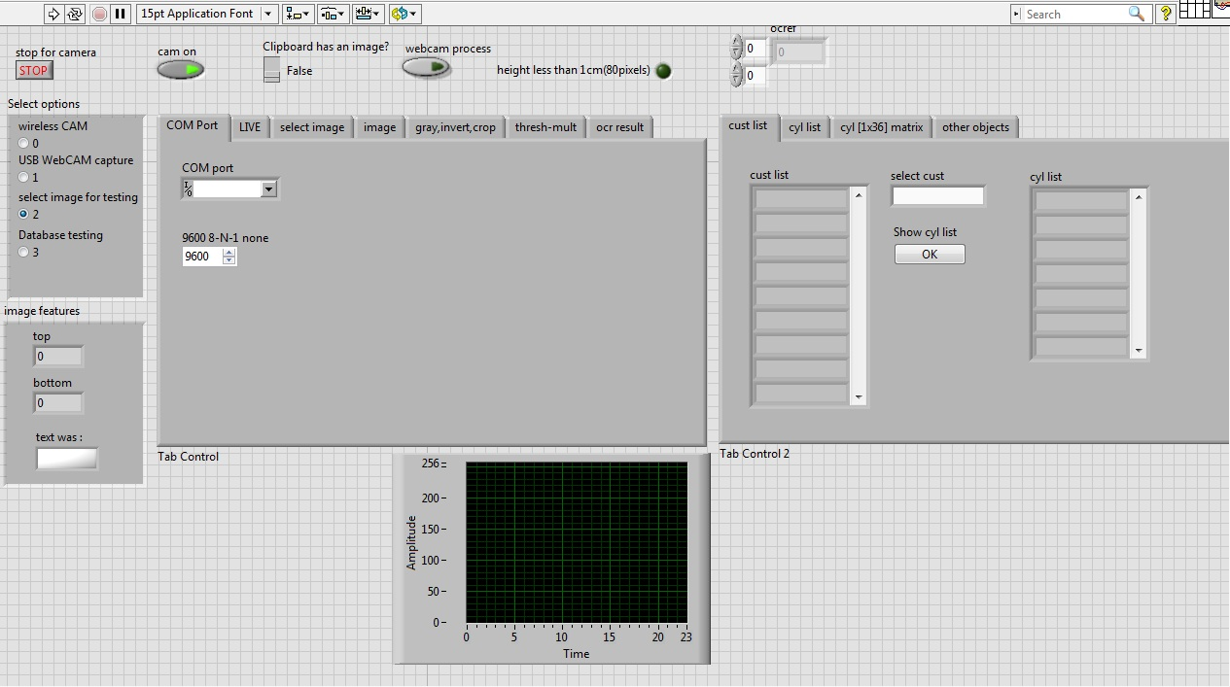

**Results after Image Processing**

**Test file**

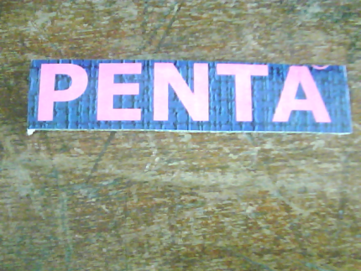

**Intermediate process results**

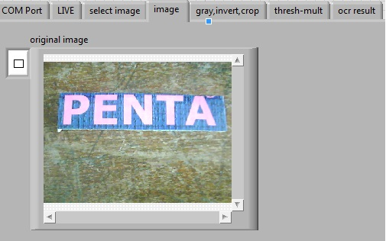

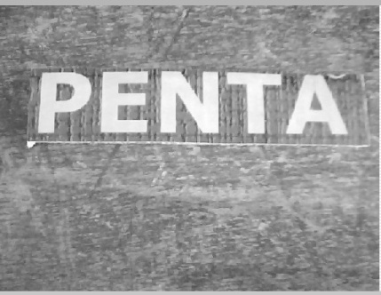 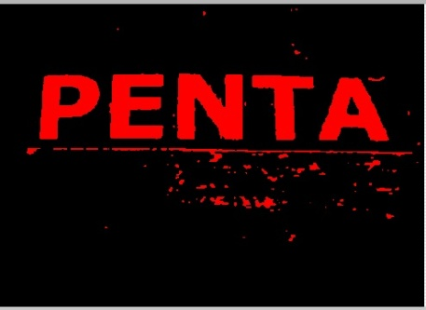 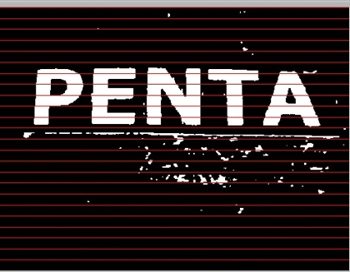

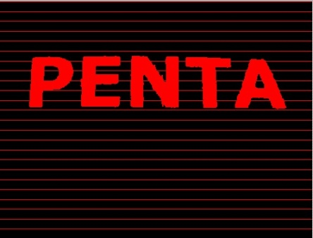 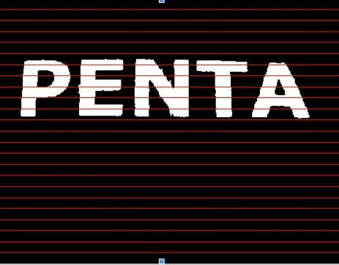

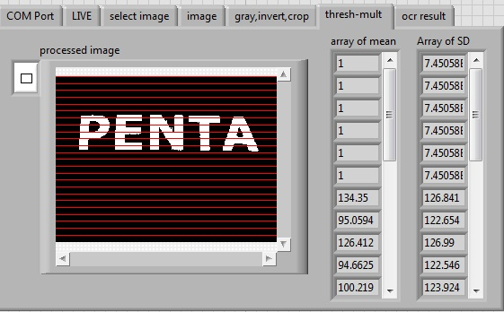

**Output**

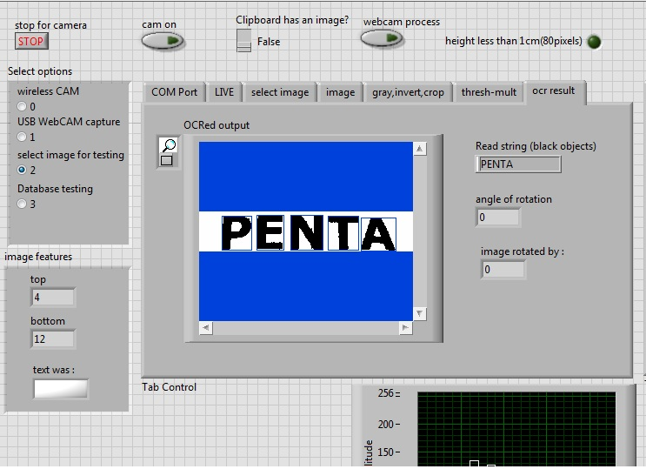

**6. Discussion of System:**

1. **Some code snippets:**
2. Regarding communication: Serial input, serial output, user Comport selection is included in the GUI. This makes it possible for ease in using the developed GUI.
3. Zigbee initialization and communication with the software. Use of LCD, buzzer, led-bar indicator makes the device more user-friendly and interactive in nature.
4. Wireless camera interfacing facilitated. Also wired camera interfacing provided with developing the camera drivers using *.dll files.
5. Database management provided for better results and easy error correction.
6. Calculating the centroid of the bounding box detected and hence simultaneous calculation of the angle by which the image is rotated. Also alternative process of rotating the image by ‘x’ degrees (in a loop) and process the image in all iteration is implemented.
7. Black on white (i.e. dark on light background) and white on black (i.e. light on dark background) detection is possible.
8. The VI calculates the region of interest (ROI) automatically. This is done by the process of horizontal and vertical segmentation and neglecting the parts touching the ROI.
9. Particle filter is designed for removal of noise. It removes the bounded particles with area less than that specified pixels.
10. Character training is possible for different type of font styles. Hence character set file development is easily possible. This makes the system more robust.
11. The process is developed considering the standard programming flow style. Hence implementation of standard state machine is done.
12. Character recognition is done by morphological (shape) matching. (Initial tests and trials proved that edge detection techniques resulted in loss of data)
13. Also provision for running C codes for certain processes is made. This helps in the future development of the system.

**(B) Changes made in plan:**

**Use of a wired camera:**

Initially, we implemented the entire system with wireless camera. But the resolution of the camera available was not adequate to give desired results. Hence we switched to use of a wired camera for further development of the image processing codes.

**Switching on to reading of printed test benches:**

After a good study regarding the recent trends for the labeling of the goods it was found that the standardization is being achieved by use of the plastic tags and barcodes. It hence was the necessary to develop the system as per the industry standards.

**(C) Problems faced and solutions:**

Camera interfacing:

**Problem**: Wireless camera selected initially was only compatible with Windows XP. No driver support for interfacing was available.

**Solution**: Labview opens the “exescript” ” using systemexec.vi. The exescript opens the camera viewer and then maximises the window. Using library nodes, Labview takes the screenshot (print-screen function) of the image being received. In the next state, the IMAQclipboard to image converts the screenshot to IMAQimage.IMAQextract then crops the image received to remove the unwanted part like the taskbar, titlebar, etc. It hence converts the screenshot to a virtual image with desired ROI.

**Problem**: Wired camera drivers were not supported on Windows 7. **Solution**: Camera drivers were developed using the *.dll files. And thus the wired camera interfacing is successful.

Segmentation of/in tilted images: **Problem:**Tilted images when processed in raw form are of no use and no information extraction is possible. Processing results in faulty results. **Solution**: The methods used for face detection techniques where the centroids detected for the ROIs of the eyes are used to generate the angle of tilt have proved useful. Similar technique is used in the system.

**7.**

**7. Future work:**

**Viewing it as a product:**

Considering the system as a finished product, it is vital that the system be robust. Hence shaping it considering the same aspect of a finished product is necessary.

**Image processing:**

For the system to work for all the tagging methods, it is a must that the image processing algorithms should be more accurate. Extracting information from even engraved codes should be possible. Working on tilted images, background filling, autonomous ROI for complicated images, etc. are the next steps.

**Barcode reading:**

Recent trends now have increased the use of barcode system. Hence barcode reading is a must for the system.

**Hardware module:**

Designing a permanent low cost hardware module with other features, also is important.

**8. Conclusions:**

Our work can be generalized as the first step to product development. Use of this product can be various according to the application. Some of the real-world applications in which this can be applied are cylinders in the warehouses, wooden objects, objects exposed to water where barcodes and RFID tags are most likely to get destroyed, metal parts used in civil construction, corrosive environments like parts in marine ships. Dividing the codes in four modules makes the system easy to implement with other hardware and database management systems. Making the system robust, be it in the terms of image processing algorithms, hardware interfacing, friendly GUI, etc. is the most important issue to act on as a product.

**. References**

**8. References:**

[1]LabVIEW Machine Vision and Image Processing Course Manual

[2] NI Vision Assistant tutorial manual.

[3]Firebird V Manual. Nex-Robotics. Web. [http://www.nexrobotics.com/images/robots_pdf/Fire%20Bird%20V%20flyer.pdf](http://www.nexrobotics.com/images/robots_pdf/Fire%20Bird%20V%20flyer.pdf%20)

[4] Talele, K.T and Kadam, S., “*Face Detection and Geometric Face Normalization*,” TENCON,2009,SINGAPORE- 2009 IEEE Region 10 Conference, 2009.

[5] "Cylinder Manufacturing Process." *Everest Kanto Cylinder Ltd*. Web. <http://www.everestkanto.com/manufacturingprocess/manufacturing_process.html>

[6] Klinger, Thomas. *Image Processing with LabVIEW and IMAQ Vision*. Upper Saddle River, NJ: Prentice Hall PTR, 2003. Print.

[7] Relf, Christopher G. *Image Acquisition and Processing with LabVIEW*. Boca Raton: CRC, 2004. Print.