Summary

As I’m currently pursuing my engineering in VGEC college in IT branch I have no industrial experience but I had done projects using various languages like HTML, CSS, PHP, JavaScript, Java, MySQL, Python.

Skill Highlights

|  |  |
| --- | --- |
| * Leadership * Strong decision maker * Complex problem solver | * Creative design * Innovative * Focused |

Experience

**Project :** e-banking, SSIP(Society Management)

**Project Details :**

* I had worked on a project named e-banking in which we have used **HTML, CSS, JavaScript, MySQL**.
* We have done it in a group of 5 members.
* We group of 5 members also created an app for society management using **HTML, CSS, MySQL, JavaScript, PHP.**
* This project was also granted by government and we had given a grant of 10,000 INR for this too.
* We had published this project on Play Store also.

Education

**Pursuing**  
Graduation  
Vishwakarma Government Engineering College

**2019**  
HSC  
Nalanda Vidhyalaya

**2017**  
SSC  
Shri Satya Sai Vidhya Mandir

Certifications

Programming Languages: **JavaScript, Java, HTML5, PHP, CSS, Python**.

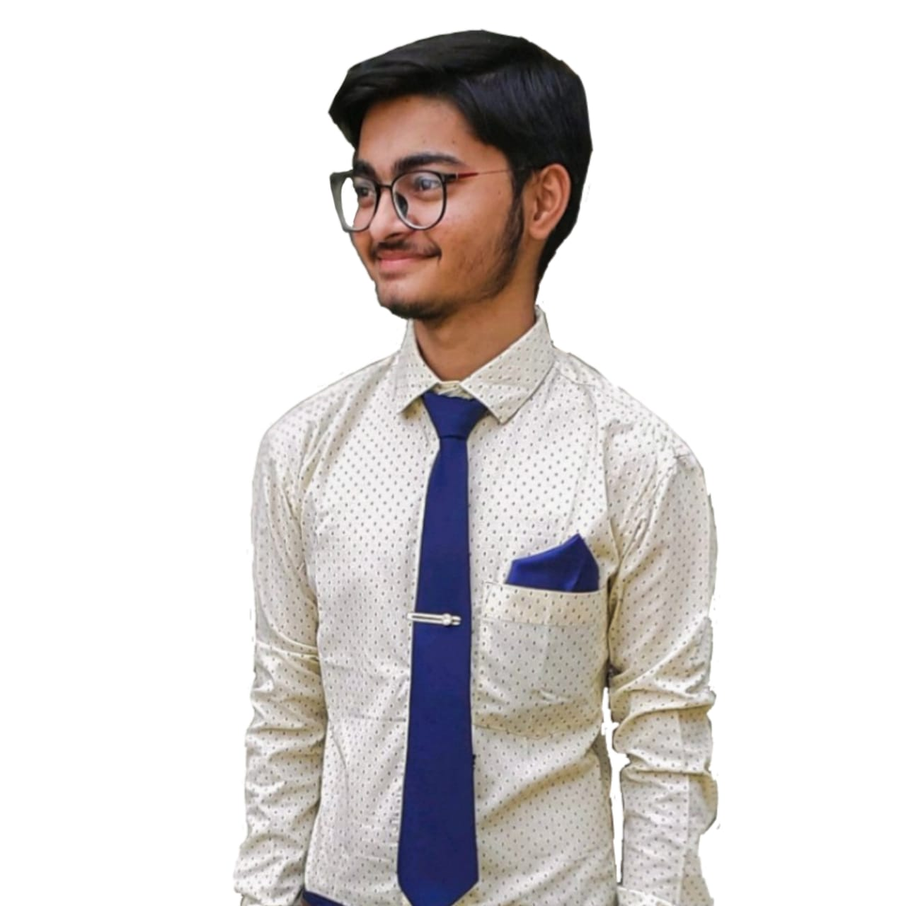

Ronak Adroja

Contact

**Address:**

Sarvad, Morbi, Gujarat - 363660

**Phone:**

[+91 95109 20621](phone.html)

**Email:**

[ronakadroja1234@gmail.com](mailto:ronakadroja1234@gmail.com)

**LinkedIn:**

<https://www.linkedin.com/in/ronak-adroja-004839190/>

**Portfolio:**

<https://ronakadroja.github.io>

Languages

Gujarati

Hindi

English

Hobbies

* Coding
* Learning New Updates
* Listening Songs
* Watching Movies