44-563 Developing Web Applications and Services

Project 08

In this project, you will implement an application that inputs an ice cream order from a user. The application will obtain the total price of the order from a servlet by using AJAX.

You will need to implement the following:

1. An HTML file for the order form.
2. A JavaScript file that extracts the information the user entered in the order form and uses AJAX to submit the information to a servlet. YOU MUST USE AJAX TO INVOKE THE SERVLET.
3. A servlet that uses the choices made by the user to compute the total price of the order. The servlet returns this amount formatted as US currency. ALL CALCULATIONS MUST BE DONE IN THE SERVLET.

Here is the order form:

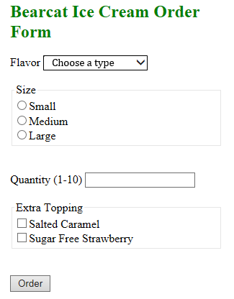

When the user enters the requested information and clicks on the Order button, the total amount of the order and a message must be displayed as shown below.

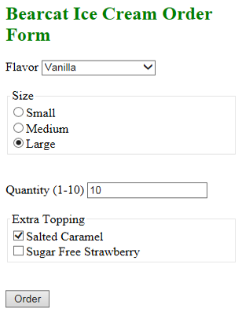

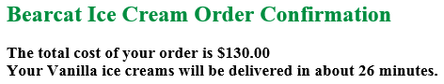

**Details:**

1. The total price must be calculated on the server-side. The information the user enters must be submitted (as request parameters) to a servlet using AJAX.
2. All validation of user input is done on the client-side using JavaScript.
3. If the user does not select an ice cream flavor, size or quantity and the Order button is clicked, use alert() to display an appropriate error message. The web page must not be changed in any way.
4. If all information is entered and the Order button is clicked,
   1. The order total must be displayed along with an estimated delivery time as shown above. The delivery time should be a random integer in the range 25-45.
   2. The message must appear at the bottom of the page. Note that the message includes the type of ice cream ordered.

**Calculation:**

Price List

Small 6.00, Medium 9.00, Large 11.00

For the flavor, add 1.00 for Chocolate, 1.25 for Mint Chocolate Chip, 1.50 for Strawberry, and 1.50 for Vanilla.

Salted Caramel topping costs an additional 0.50 and Sugar Free Strawberry costs 0.70.

Example

For the ice cream order shown above, the cost is

10 * (11.00 + 1.5+ 0.5) = 10 * 13.00 = 130.00