44-563 Developing Web Applications and Services

Project 07

In this project, you will implement an order page for the “Bearcat Ice Cream Order Form” again (i.e., Project03), this time using a servlet to do the calculations. You will need

* an HTML file for the order form
* a CSS file for the order form
* a servlet that uses the values of the request parameters to compute the price and returns an order confirmation page
* a CSS file for the confirmation page

**DO NOT USE JAVASCRIPT IN THIS PROJECT.**

Here is the required user interface:

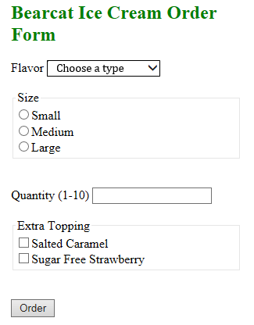

The heading must be displayed in the color green.

The available types of ice cream and the prices are the same as in Project 03, except that the first item in the type list is "Choose a type".

After the customer makes the selections and clicks on the Order button, the servlet returns a confirmation page. Suppose the user makes the selections shown below:

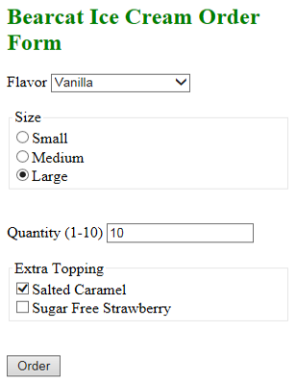

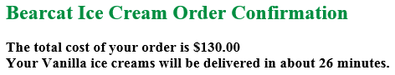

Note that the price contains a dollar sign and exactly two digits after the decimal point. If you order only one ice cream, the second sentence in the confirmation message must contain **"ice cream" instead of "ice creams"**. The delivery time should be a random integer in the range 25-45. The heading must be displayed in the color green.

**Validation Requirements:**

The application must validate that the user selected a flavor and a size, and entered the quantity. An appropriate error message must be displayed for each missing value, and the confirmation page should display only the error messages. Here is an example confirmation page where the user did not select anything:

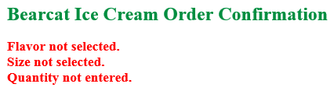

The error messages must be displayed in the color red. If the user selects everything but does not enter quantity, the confirmation page looks like this:

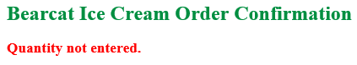

**Calculation:**

Price List

Small 6.00, Medium 9.00, Large 11.00

For the flavor, add 1.00 for Chocolate, 1.25 for Mint Chocolate Chip, 1.50 for Strawberry, and 1.50 for Vanilla.

Salted Caramel topping costs an additional 0.50 and Sugar Free Strawberry costs 0.70.

Example

For the ice cream order shown above, the cost is

10 * (11.00 + 1.5+ 0.5) = 10 * 13.00 = 130.00