44-563 Developing Web Applications and Services

Project 06

**NOTE: You must follow the generic guideline posted on the course website in the unit “Projects”**

* There will be only two files in your web application--an html file for the start page and a servlet.
* Do NOT use JavaScript in this project.

Do Project 02 again, this time using **a servlet** to do the calculations. The start page must look like this:

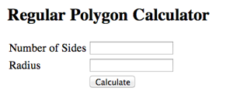

After the user enters data and clicks on the Calculate button, a servlet is invoked that returns a response page like the one shown below:

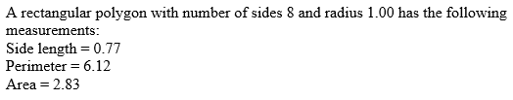

**Details:**

1. You should not make any radical change in the user interface.
2. The number of sides and the radius that the user entered must be displayed in the response page as shown in the example above.
3. The calculated values must have the labels shown above.
4. The calculated values must be formatted to have exactly two digits after the decimal point.