Computer Architecture Project Report
1. Introduction
This project implements a basic 16-bit computer architecture capable of executing 11 instructions. The design follows the classical Morris Mano basic computer model, built and simulated at the component level.
The instruction word is 16 bits wide, structured as follows:
Bit 15 | Bits 14–12 | Bits 11–0
I (Indirect bit) | Opcode (3 bits) | Address (12 bits)

2. Instruction Set

2.1 Memory Reference Instructions (MRI)
These instructions operate on memory using the 12-bit address field.
Mnemonic | Opcode | Operation
AND | 000 | AC ← AC ∧ M[AR]
ADD | 001 | AC ← AC + M[AR]
LDA | 010 | AC ← M[AR]
BUN | 011 | PC ← AR
2.2 Register Reference Instructions (RRI)
These instructions operate directly on registers. The indirect bit I = 0 and opcode = 111, with a unique bit pattern in the address field identifying each instruction.
Mnemonic | Operation
CLA | AC ← 0
CMA | AC ← AC'
CIR | Circular shift AC right through E
CIL | Circular shift AC left through E
INC | AC ← AC + 1
SPA | Skip next instruction if AC > 0
SNA | Skip next instruction if AC < 0

3. Components
Component | Size | Role
RAM | 4096 × 16-bit | Stores instructions and data
AR (Address Register) | 12-bit | Holds the memory address for read/write
PC (Program Counter) | 12-bit | Holds the address of the next instruction
DR (Data Register) | 16-bit | Temporarily holds data fetched from memory
AC (Accumulator) | 16-bit | Primary register for all arithmetic and logic operations
IR (Instruction Register) | 16-bit | Holds the currently fetched instruction
Bus | 16-bit | Shared data path connecting all components
ALU | 16-bit | Executes AND, ADD, complement, and shift operations
Sequence Counter | — | Generates timing signals T0 through Tn to control micro-operations
Instruction Decoder | 3-to-7 | Decodes the 3-bit opcode to activate the appropriate instruction logic

4. Memory Unit (RAM)
Specifications
Property | Value
Size | 4096 × 16-bit
Address Input | AR_OUT (12-bit)
Data Output | MEM_OUT (16-bit)
Operation | Read Only

Control Logic
RAM read is activated under three conditions:
Read = T1 + (D7' · I_BIT · T3) + (T4 · (D0 + D1 + D2))
Condition | Purpose
T1 | Fetch instruction from memory
D7' · I_BIT · T3 | Indirect cycle — fetch effective address
T4 · (D0 + D1 + D2) | Execute cycle — fetch operand for AND, ADD, LDA

Micro-operations
Timing | Condition | Operation
T1 | — | IR ← M[AR]
T3 | I=1, D7' | AR ← M[AR]
T4 | D0+D1+D2 | DR ← M[AR]

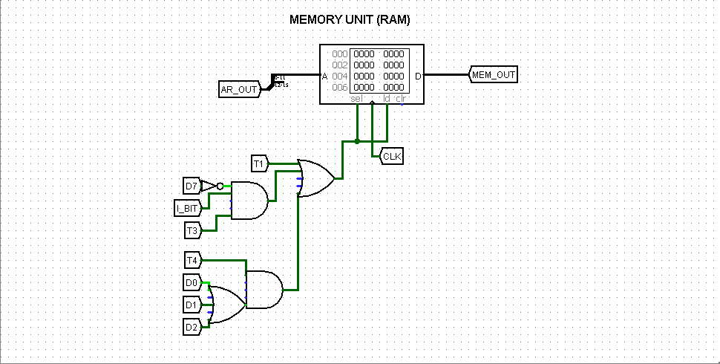

5. Address Register (AR)
Specifications
Property | Value
Size | 12-bit
Input | BUS_OUT (bits 0–11)
Output | AR_OUT (12-bit)
Control | CLK, ld

Control Logic
AR_load = T0 + T2 + (T3 · D7' · I_BIT)
Condition | Operation
T0 | AR ← PC (fetch cycle)
T2 | AR ← IR(0–11) (decode cycle)
T3 · D7' · I_BIT | AR ← M[AR] (indirect cycle)
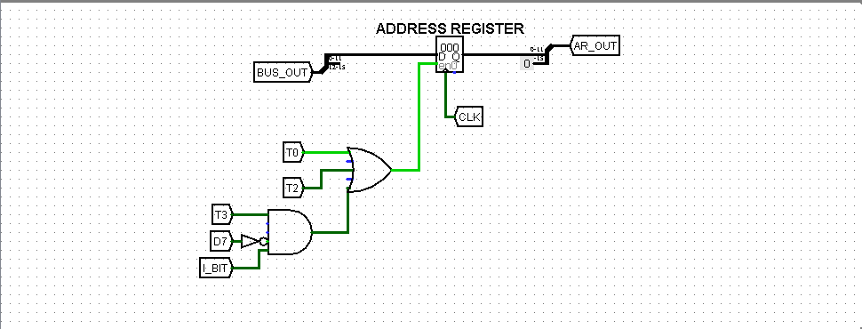

6. Program Counter (PC)
Specifications
Property | Value
Size | 12-bit
Input | BUS_OUT via MUX, PC_INC
Output | PC_OUT (12-bit)
Control | CLK, ld

Control Logic
Increment condition:
PC_INC = T1 + (T3 · (B3 + B4) · D7 · I')
Load condition:
PC_load = T1 + (T3 · ((B3*AC[15]’) + (B4*AC[15])) · D7 · I') + (T4 · D4)
Condition | Operation
T1 | PC ← PC + 1 (fetch cycle)
T3 · (B3+B4) · D7 · I' | PC ← PC + 1 (skip — SPA/SNA satisfied)
T4 · D4 | PC ← AR (BUN instruction)

MUX Role
The MUX selects between BUS_OUT (for load via BUN) and PC+1 (incremented value) before feeding into the PC register.

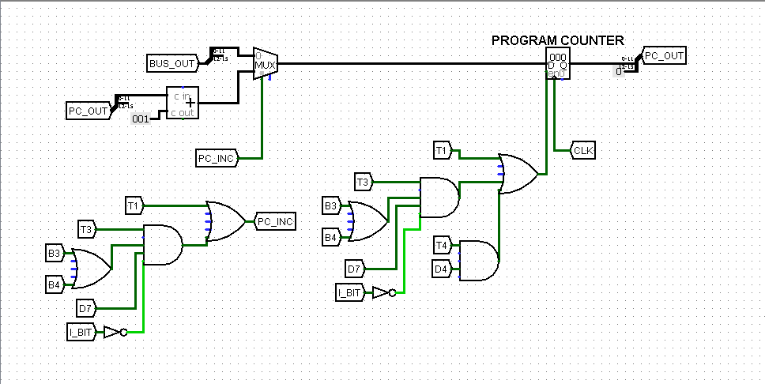

7. Data Register (DR)
Specifications
Property | Value
Size | 16-bit
Input | BUS_OUT
Output | DR_OUT (16-bit)
Control | CLK, ld

Control Logic
DR_load = T4 · (D0 + D1 + D2)
Condition | Operation
T4 · D0 | DR ← M[AR] (AND operand fetch)
T4 · D1 | DR ← M[AR] (ADD operand fetch)
T4 · D2 | DR ← M[AR] (LDA operand fetch)
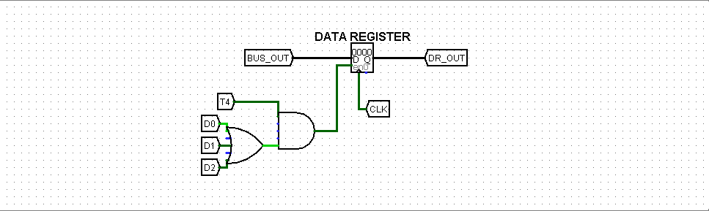

8. Accumulator (AC)
Specifications
Property | Value
Size | 16-bit
Input | ALU_OUT
Output | AC_OUT
Control | CLK, ld, clr

Control Logic
AC_load:
AC_load = (T3 · I' · (B9 + B5) · D7) + (T5 · (D0 + D1 + D2))
AC_clr:
AC_clr = (T3 · D7 · B11 · I')

Condition | Operation
T3 · I' · B9 · D7 | AC ← 0 (CLA)
T3 · D7 · B11 · I' | AC ← 0 (SNA — clear condition)
T3 · I' · B5 · D7 | AC ← AC' (CMA)
T5 · D0 | AC ← AC ∧ DR (AND)
T5 · D1 | AC ← AC + DR (ADD)
T5 · D2 | AC ← DR (LDA)

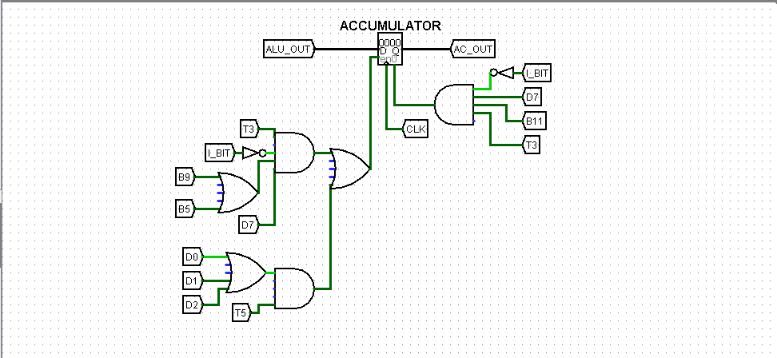

9. Instruction Register (IR)
Specifications
Property | Value
Size | 16-bit
Input | BUS_OUT
Output | IR_OUT (16-bit)
Control | CLK, ld

Control Logic
IR_load = T1
Condition | Operation
T1 | IR ← M[AR] (fetch instruction from memory)


10. Bus System
Specifications
Property | Value
Type | 16-bit Multiplexed Bus
Inputs | AR_OUT, PC_OUT, IR_OUT, MEM_OUT
Output | BUS_OUT
Select Lines | S2, S1, S0 (3-bit)

MUX Selection
S2 | S1 | S0 | BUS_OUT
0 | 0 | 0 | AR_OUT
0 | 0 | 1 | PC_OUT
0 | 1 | 0 | IR_OUT
0 | 1 | 1 | MEM_OUT

Select Line Equations
S2 = (D7' · T3 · I_BIT) + T1 + (T4 · (D0 + D1 + D2)) + T2
S1 = (D7' · T3 · I_BIT) + T1 + (T4 · (D0 + D1 + D2)) + T0
S0 = (D7' · T3 · I_BIT) + T1 + (T4 · (D0 + D1 + D2)) + T2 + (T4 · D4)
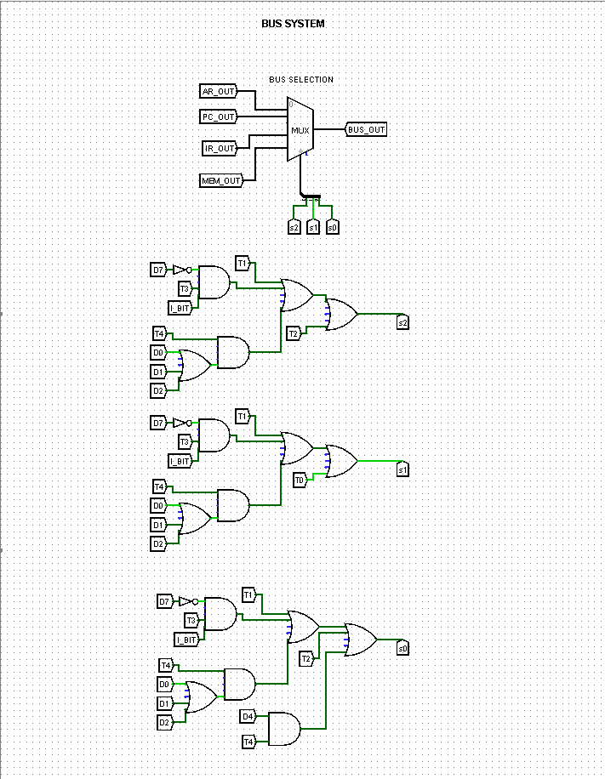

11. Arithmetic Logic Unit (ALU)
Specifications
Property | Value
Inputs | AC_OUT, DR_OUT
Output | ALU_OUT
Select Lines | a2, a1, a0 (3-bit MUX)
Operations | CMA, INC, AND, ADD, CIR, CIL, Pass DR

ALU Operations
MUX Input | Operation | Result
CMA_AC | Complement AC | AC'
INC_AC | Increment AC | AC + 1
M_AND | AND | AC ∧ DR
M_ADD | Add | AC + DR
DR_OUT | Pass DR | DR
CIR | Circular Shift Right | AC >> 1
CIL | Circular Shift Left | AC << 1

Select Line Equations
a2 = (D0 · T5) + (T3 · I_BIT' · B7 · D7) + (T3 · I_BIT' · B6 · D7) + (D2 · T5)
a1 = (T3 · I_BIT' · D7 · (B5 + B7 + B6)) + (D1 · T5)
a0 = (T3 · I_BIT' · D7 · (B9 + B6)) + (T5 · (D1 + D2))

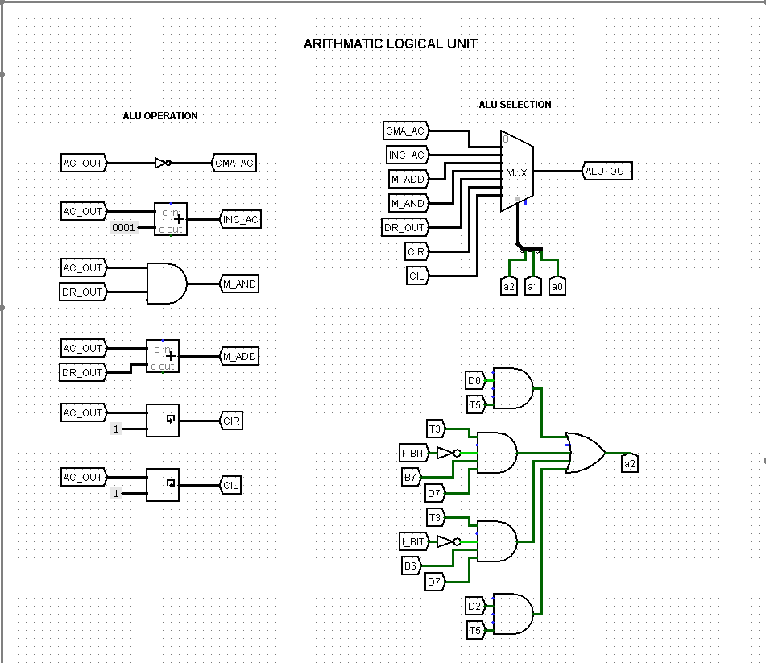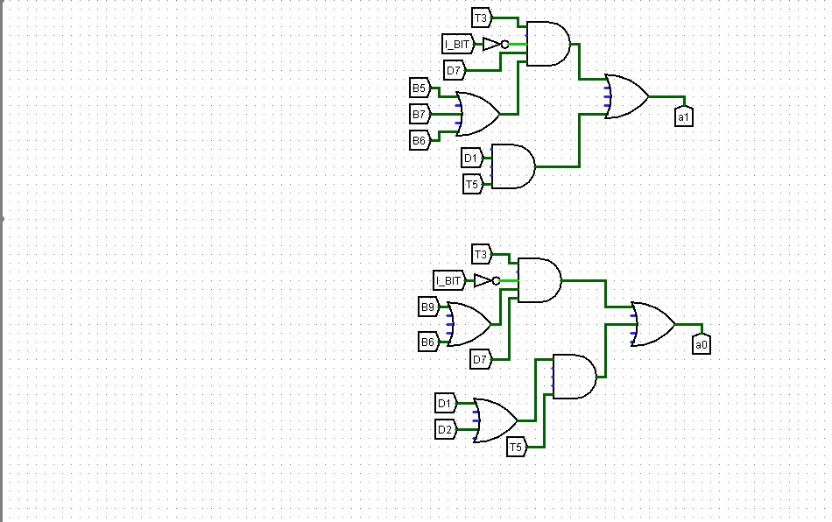
12. Sequence Counter (SC)
Specifications
Property | Value
Output | T0 – T6 (via 3-to-7 decoder)
Control | CLK, SC_CLR

Control Logic
SC resets to T0 when SC_CLR is asserted.
SC_CLR = (D7 · I_BIT' · T4) + T6 + (T6 · (D0 + D1 + D2)) + (T5 · D4)
Condition | Reason
D7 · I_BIT' · T4 | RRI instructions complete at T4
T6 | Maximum timing cycle reached
T6 · (D0 + D1 + D2) | MRI instructions complete at T6
T5 · D4 | BUN completes at T5
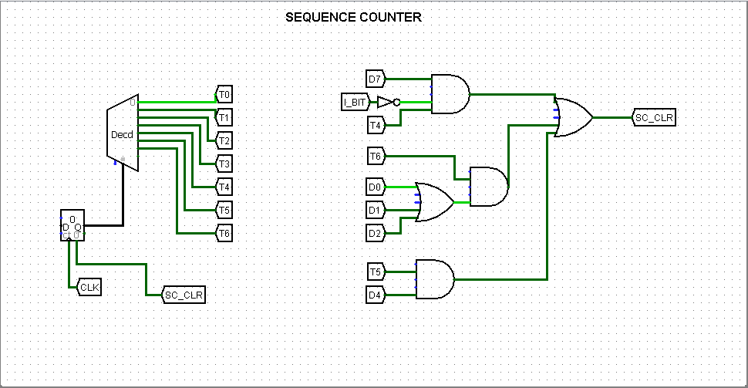
13. Instruction Decoder (Opcode Decoding)
Specifications
Property | Value
Input | IR_OUT (16-bit)
Opcode Output | D0 – D4, D7 (3-to-8 decoder)
Address Bits Output | B3, B4, B5, B6, B7, B9, B11
Control | Enable = 1

IR Decoding
IR_OUT is split into three fields:
Field | Bits | Signal
Indirect bit | IR[15] | I_BIT
Opcode | IR[14–12] | OPCODE
Address field | IR[11–0] | ADD_FLD

Opcode Decoder Output
D | Instruction
D0 | AND
D1 | ADD
D2 | LDA
D4 | BUN
D7 | RRI (Register Reference Instruction)

Address Field Bits for RRI
Bit | RRI Instruction | Full Form
B11 | CLA | Clear Accumulator
B9 | CMA | Complement Accumulator
B7 | CIR | Circular Shift Right
B6 | CIL | Circular Shift Left
B5 | INC | Increment Accumulator
B4 | SPA | Skip if Plus Accumulator
B3 | SNA | Skip if Negative Accumulator

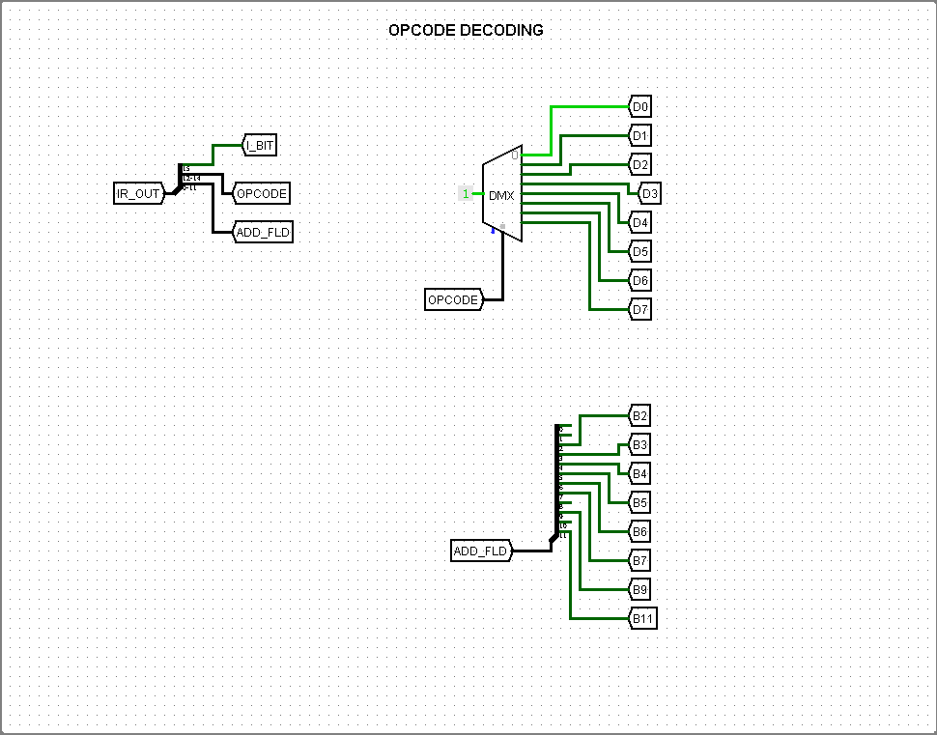
14. Output Window
The Output Window provides real-time visibility into the state of all major signals and registers during simulation.

Register Outputs
Signal | Width | Displays
MEM_OUT | 16-bit | Current memory data
AR_OUT | 12-bit | Address register value
PC_OUT | 12-bit | Program counter value
DR_OUT | 16-bit | Data register value
AC_OUT | 16-bit | Accumulator value
IR_OUT | 16-bit | Current instruction

Timing Signals
Signal | Purpose
T0 – T6 | Active timing step indicator

Decoded Instruction Signals
Signal | Purpose
D0 – D7 | Active instruction decoder output

Address Field Bits
Signal | Purpose
B2, B3, B4, B5, B6, B7, B9, B11 | Active RRI instruction bit

Clock
Signal | Purpose
CLK | Master clock pulse driving all registers and sequence counter
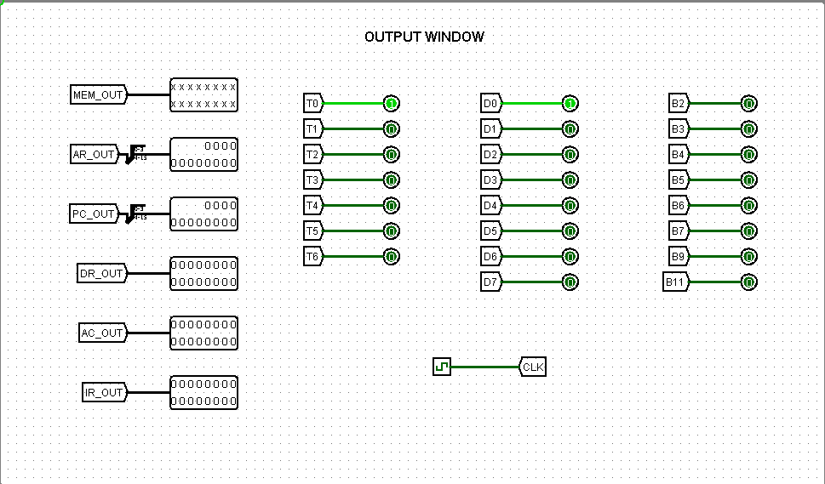

15. Conclusion
- Implements a 16-bit basic computer capable of executing 11 instructions — MRI (AND, ADD, LDA, BUN) and RRI (CLA, CMA, CIR, CIL, INC, SPA, SNA).
- All components (RAM, AR, PC, DR, AC, IR, Bus, ALU, Sequence Counter, Instruction Decoder) designed and simulated at gate level with precise control logic equations.
- Fetch, decode, and execute cycles correctly sequenced through timing signals T0–T6.
- Sequence Counter resets automatically upon completion of each instruction via SC_CLR.
- 3-bit MUX Bus efficiently routes data between all components.
- ALU handles all arithmetic and logic operations, feeding results directly into AC.
- Output Window validates correct real-time operation of all registers, timing signals, decoded instruction outputs, and RRI address bits.

