MADE BY :
KATAKIYA RONAK

Project Brief Description:
The project “Elevator Control System” is a digital circuit designed using Logisim software to simulate the logical operation of an elevator moving between multiple floors.
The system uses combinational and sequential logic to control the elevator’s movement, direction, and floor indication.
It aims to demonstrate the practical application of digital electronics concepts like logic gates, flip-flops, and with the help of sequential circuit to build a real-world control mechanism.
This project provides a logical understanding of how elevators decide their direction, respond to floor calls, and ensure smooth movement between floors using digital signals.

Circuit Screenshot:
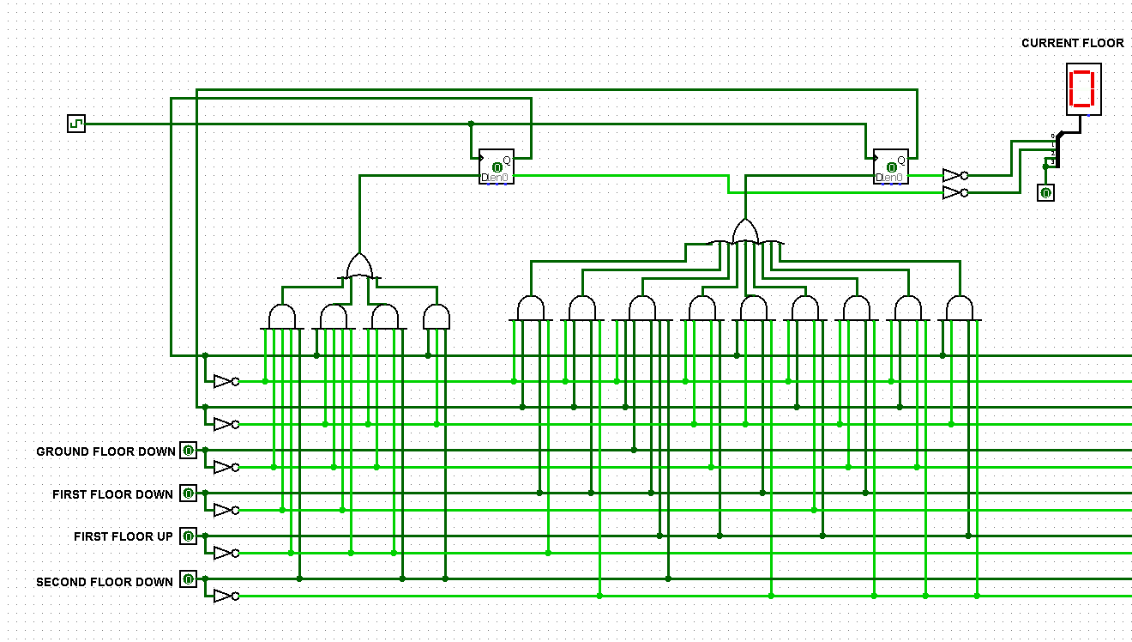
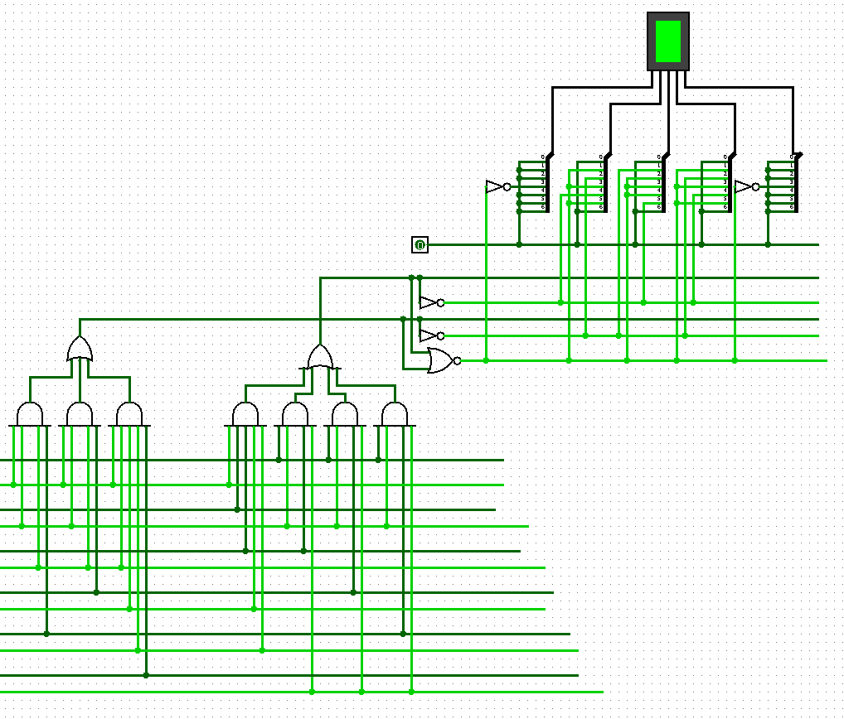
Working Explanation:
Overview:
The circuit simulates an elevator that operates between Ground Floor, First Floor, and Second Floor.
Each floor has Up and Down call buttons, and the elevator responds based on the current position and requested direction.
Step-by-Step Working:
- Input Section:
  - Each floor has input buttons such as:
    - Ground Floor UP
    - First Floor UP / DOWN
    - Second Floor DOWN
  - When a floor button is pressed, it sends a HIGH logic signal to request elevator movement.
- Control Logic:
  - The control logic uses AND, OR, and NOT gates to determine the direction and the next floor.

Next state equation:
$$\boxed{\begin{aligned} F(A)=A^{'}BDE^{'} + A^{'}BDF^{'} + A^{'}BCF + A^{'}B^{'}C^{'}E + AB^{'}EF^{'} + AB^{'}DF^{'} \\ + A^{'}BD^{'}E + B^{'}C^{'}DF^{'} + A^{'}BC^{'}F^{'} \end{aligned}}$$
$$\boxed{F(B)=A^{'}BCE+AB^{'}DF^{'}+AB^{'}EF^{'}+A^{'}BDE^{'}+A^{'}BD^{'}E+A^{'}BC^{'}F^{'}+A^{'}C^{'}DF^{'}+A^{'}B^{'}C^{'}E}$$

 | F(A) | F(B)
GROUND FLOOR | 0 | 0
FIRST FLOOR | 0 | 1
THIRD FLOOR | 1 | 0

  - Based on the request and current floor, the elevator moves upward or downward.
- Direction Indicator:
  - The ELEVATOR DIRECTION block (green LED) indicates whether the elevator is moving up or down.
  - Logic gates connected to the floor selection inputs control this signal.

$\boxed{ F(first)=A^{'}C^{'}D^{'}E^{'}F + A^{'}B^{'}C^{'}E + A^{'}B^{'}C^{'}D }$
$$\boxed{ F\left(A,B,C,D,E,F\right)=A^{'}BCD^{'}E^{'} + AB^{'}CF^{'} + AB^{'}DF^{'} + AB^{'}EF^{'} }$$

 | F(first bit) | F(second bit)
NO change | 0 | 0
Down Direction | 0 | 1
Up Direction | 1 | 0

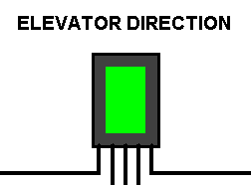

- Current Floor Display:
  - The CURRENT FLOOR indicator (red LED or 7-segment display) shows the present floor of the elevator.
  - This is achieved by connecting output logic to represent floor status.
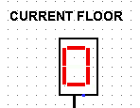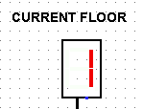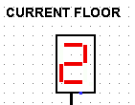

- Sequential Movement:
  - When multiple floors are requested, the elevator logic prioritizes floors in the current direction (up or down) before reversing direction.
  - This mimics the working of a real elevator control system.

Components Used:
Component Name | Symbol/Type | Function / Purpose
Logic Gates (AND, OR, NOT) | Combinational Devices | Used to implement decision-making logic for direction and floor movement
Flip-Flops (D) | Sequential Elements | Store the current floor status
LEDs Matrix | Output Indicators | Display elevator direction and floor position
Switches | Input Devices | Represent floor call buttons (Up/Down)
Clock Pulse | Input Timing Source | Synchronizes sequential operations
Wires / Connectors | — | Used for interconnections between components

Conclusion:
The Elevator Control System project effectively demonstrates how digital electronics can be used to design control logic for automated systems.
By combining combinational and sequential circuits, the elevator can make logical decisions similar to real-world implementations.
This project enhances the understanding of circuit design, logical reasoning, and real-time problem-solving in digital systems.

