1. Introduction
In today’s computing world, managing data efficiently is one of the most important tasks of an operating system. The file system is responsible for organizing, storing, retrieving, and managing data on storage devices. Although these concepts are taught in Operating Systems courses, they are often difficult to visualize because they work internally within the system.
To solve this problem, we developed a File System and Memory Block Simulator, which is an interactive web-based application designed to demonstrate how a real file system operates internally. Instead of just reading about concepts like disk blocks, inodes, and file allocation, users can actually see and interact with these components in real time.
This project simulates key functionalities of a Linux file system, including:
- Creation and deletion of files and directories
- Disk block allocation
- Inode structure and metadata management
- Execution of Linux-like terminal commands
- Visualization of disk usage
The main idea behind this project is to convert theoretical concepts into practical understanding. By interacting with the simulator, users can clearly see how files are stored in disk blocks, how directories are structured, and how commands affect the system internally.
This project was developed collaboratively by us as part of our academic learning, and it significantly helped us understand the working of file systems in a deeper and more practical way.

2. Objectives
The main objectives of this project are:
- To understand the internal structure and working of file systems
- To simulate disk memory management techniques
- To implement Linux-like file operations and commands
- To visualize how data is stored in disk blocks
- To demonstrate different file allocation strategies
Through this project, we aimed to make complex operating system concepts more intuitive and easier to grasp.

3. Concepts Used
This project is based on several important concepts from Operating Systems, which are explained below:
3.1 Memory Management (First Fit Algorithm)
In addition to file system concepts, our project also incorporates the concept of memory management, which is a fundamental part of Operating Systems. Memory management focuses on how memory is allocated and utilized efficiently so that system resources are not wasted.
In our simulator, disk blocks are treated similarly to memory blocks. Whenever a file is created, the system needs to allocate free blocks to store its data. This process closely resembles how memory is allocated to processes in RAM.
To simulate this behavior, we used the First Fit allocation algorithm, which is one of the simplest and widely used memory allocation techniques.
Working of First Fit Algorithm:
The First Fit algorithm works by scanning the available memory blocks from the beginning and selecting the first free block (or set of blocks) that is large enough to satisfy the requirement.
The steps followed are:
- Start scanning from the first block
- Check if the block (or consecutive blocks) is free
- If the required size is satisfied, allocate it immediately
- If not, move to the next block and repeat the process
Implementation in Our Project:
In our project:
- The disk consists of 64 blocks
- When a file is created, the system searches for free blocks sequentially
- The first suitable free space is allocated to the file
This approach is mainly visible in the contiguous allocation strategy, where the system looks for the first continuous sequence of free blocks to store the file.
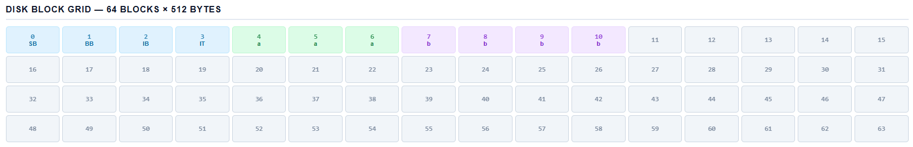
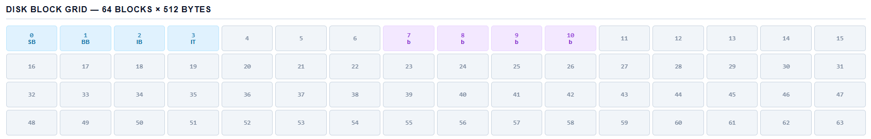
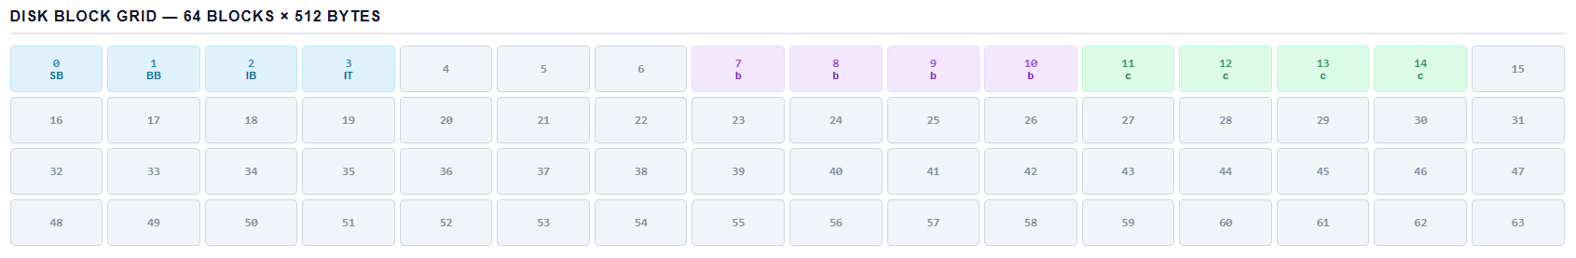
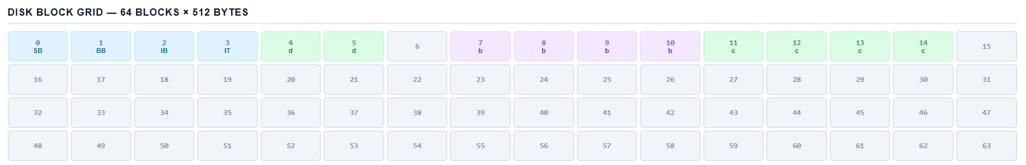

3.2 File System
A file system is a structured way of storing and organizing files on a storage device. It allows users to create, read, update, and delete files efficiently.
In our simulator:
- Files are stored in blocks
- Directories maintain a hierarchical structure
- Users can navigate using absolute and relative paths
This closely mimics the behavior of a real Linux file system.
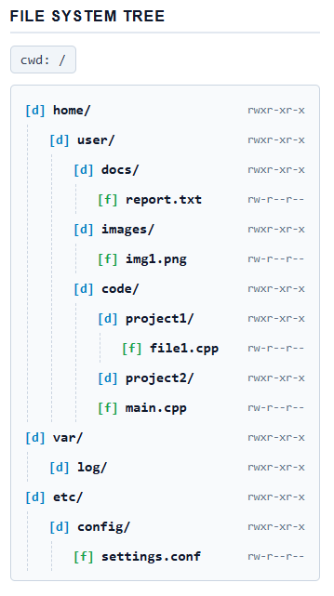
3.3 Inode Structure
In Linux, every file is represented using an inode, which stores metadata about the file rather than the file name itself.
The inode contains:
- File size
- Permissions
- Block addresses
- Creation time
- File type
In our project, we implemented this using a Python class called Inode, which manages all file-related information and relationships.
This helped us simulate how the operating system tracks files internally.
3.4 Disk Blocks
The disk in our simulator is divided into fixed-size units called blocks.
- Total blocks: 64
- Block size: 512 bytes
Out of these:
- The first 4 blocks are reserved for system use:
  - Superblock
  - Block bitmap
  - Inode bitmap
  - Inode table
The remaining blocks are used for storing file data. This structure helps in managing storage efficiently.
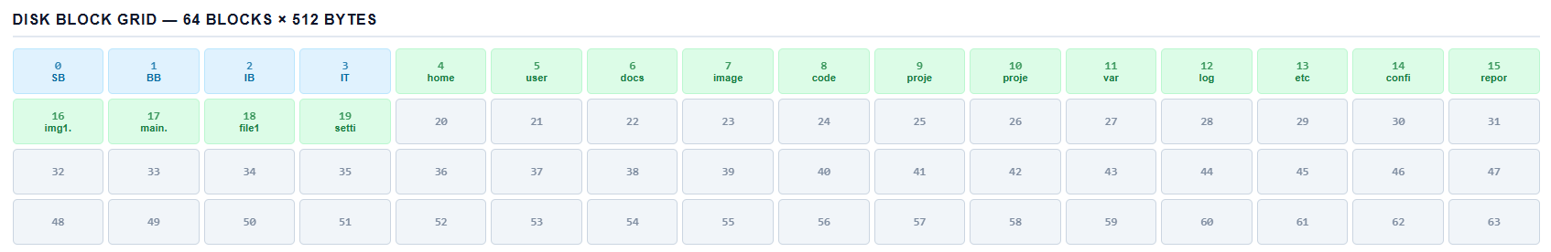

3.5 File Allocation Strategies
To make the simulation realistic, we implemented three types of file allocation strategies:
Contiguous Allocation
In this method, file data is stored in continuous blocks.
Linked Allocation
In this method, each block contains a pointer to the next block.
Indexed Allocation
In this method, a separate index block stores addresses of all data blocks.

3.6 Linux Command Simulation
The simulator supports various Linux commands such as:
- ls – to list files
- cd – to change directory
- mkdir – to create directories
- rm – to delete files
- chmod – to change permissions
- stat – to view file details
This allows users to interact with the system just like a real Linux environment.
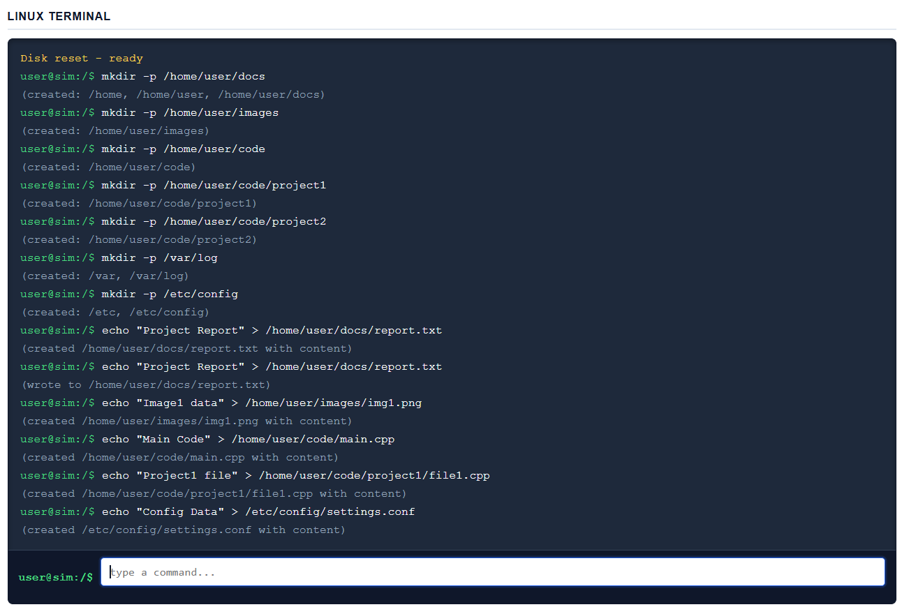

4. System Architecture
The project follows a client-server architecture, where the frontend interacts with the backend through APIs.
Frontend
The frontend is developed using:
- HTML for structure
- CSS for styling
- JavaScript for interactivity
The frontend provides:
- Disk block visualization
- Terminal interface
- File system tree
- User input controls
Backend
The backend is built using Python Flask.
It handles:
- Disk simulation
- File operations
- Command execution
- Data processing
Data Flow
- User enters a command or file details
- JavaScript sends request to Flask server
- Backend processes logic
- Disk state is updated
- Updated data is returned
- UI updates automatically

5. Features of the Project
Disk Block Visualization:
The simulator displays a grid of 64 blocks where:
- Each block represents memory
- Colors indicate different types (free, used, system)
This helps users understand how storage is utilized.
Linux Terminal Interface:
A built-in terminal allows users to run commands like a real Linux system. This makes the simulator interactive and realistic.
File Allocation System:
Users can:
- Enter file path
- Choose allocation strategy
- Specify file size
- Add content
The system then allocates blocks accordingly.
Directory Tree Structure:
The file system tree shows:
- Folder hierarchy
- File names
- Permissions
- Inode details
Disk Access Log:
Every operation generates logs showing:
- READ operations
- WRITE operations
- Blocks accessed
This provides a step-by-step understanding of internal processes.
Permission Management:
Each file has permissions like:
rwxr-xr-x
Users can modify permissions using the chmod command.

6. Working of the Project
6.1 Initialization
- Disk is initialized with 64 blocks
- System blocks are reserved
- Root directory / is created
6.2 File Creation Process
When a file is created:
- Path is resolved
- Free blocks are identified
- Allocation strategy is applied
- Inode is created
- Disk is updated
6.3 Command Execution
- User enters command
- Backend parses it
- Corresponding function executes
- Disk and inode structures update
6.4 Visualization
- Updated data is sent to frontend
- Disk grid and tree refresh
- Logs are displayed

7. Output
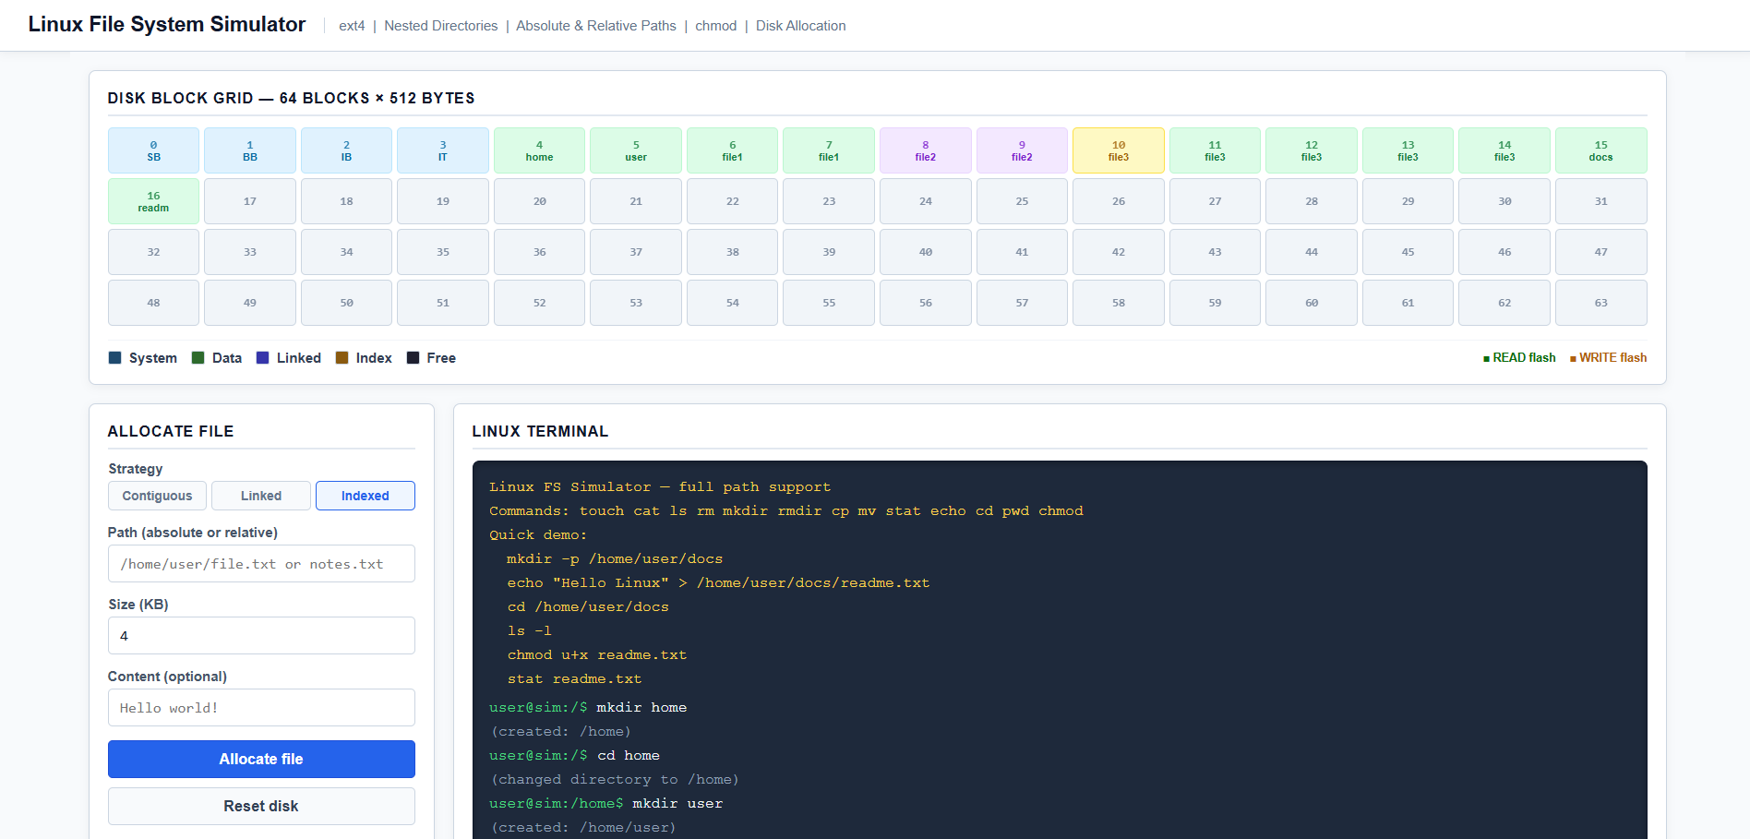
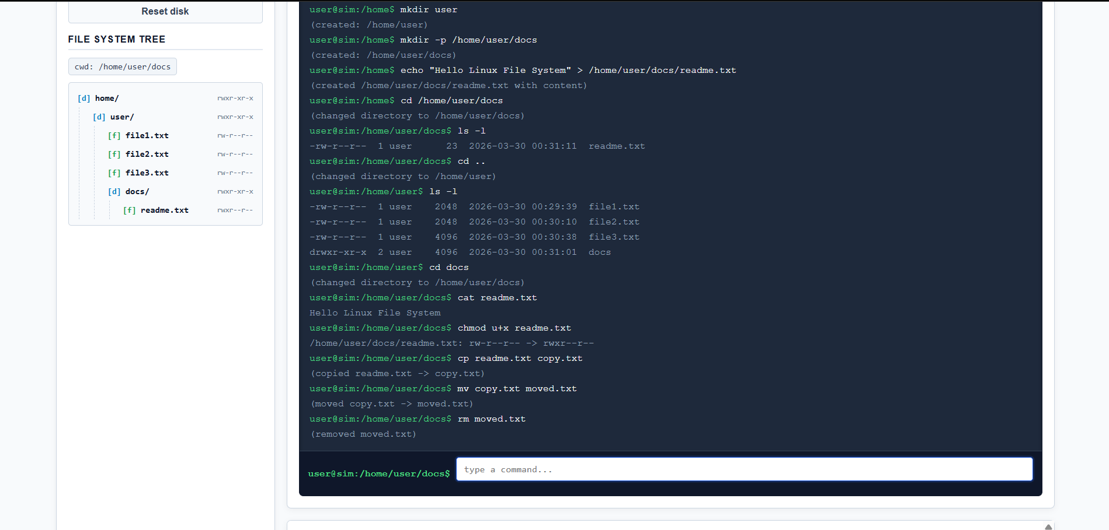
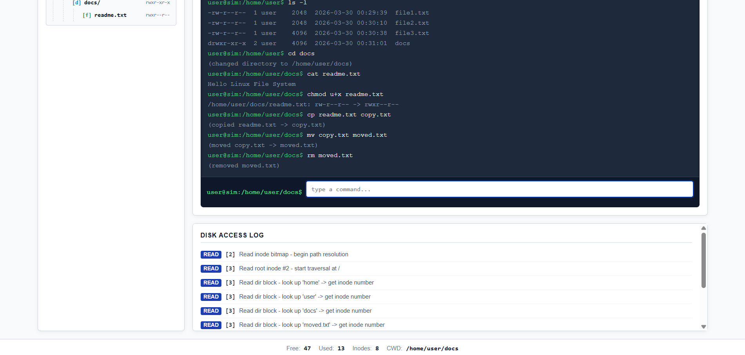
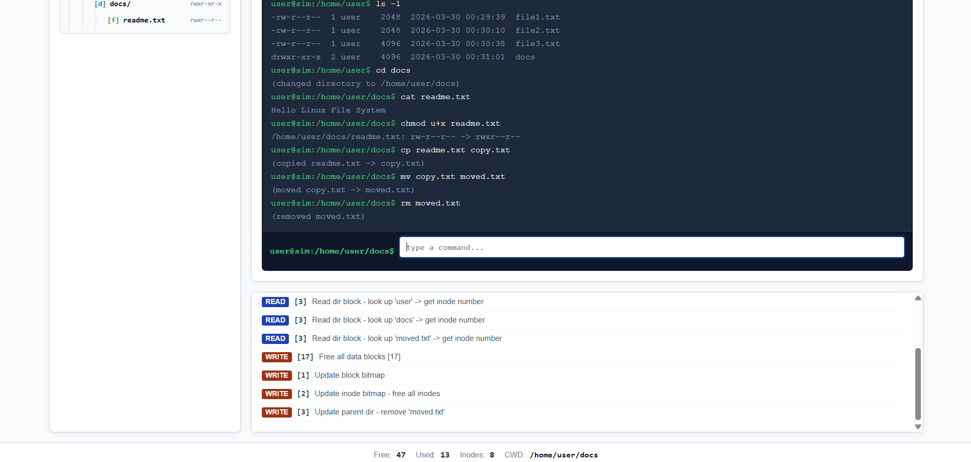

8. Conclusions
This project developed by us successfully demonstrates the internal working of a file system in an interactive and easy-to-understand way. This project helped us convert theoretical concepts of Operating Systems into a practical experience.
Through features like disk block visualization, inode management, and file allocation strategies, users can clearly understand how data is stored and managed in a system. The inclusion of a Linux-like terminal further enhances the project by allowing users to execute commands and observe their effects in real time.
Working on this project improved our understanding of file systems, disk management, and command execution. It also helped us develop our programming, problem-solving, and teamwork skills. Although the project is a simulation with certain limitations, it effectively achieves its goal of acting as a learning tool.
Overall, this project provides a strong foundation for understanding file system concepts in a clear and practical manner.

9. References
https://www.w3schools.com/
https://www.geeksforgeeks.org
https://www.kernel.org/doc/html/latest/filesystems/index.html

