

INNOVATIVE ASSIGNMENT REPORT

SUBJECT : DATA COMMUNICATION
SUBMITTED TO : Dr. SHARADA VALIVETI

MADE BY :
KATAKIYA RONAK DARSHAN BUDDHDEV
24BCE225 24BCE233

1. Introduction
In modern computer networks, reliable communication of data is essential. Data transmitted over a network may get corrupted due to noise, interference, or signal degradation. To ensure accurate delivery, communication systems follow structured models and error-handling mechanisms.
One of the most widely used frameworks is the OSI Model (Open Systems Interconnection Model), which divides communication into seven layers, each responsible for a specific function. It standardizes how data is transmitted from one system to another.
Additionally, error detection and correction techniques such as Parity Check, Checksum, Cyclic Redundancy Check (CRC), and Hamming Code are used to maintain data integrity during transmission.
This project presents a web-based simulator that visually demonstrates:
- The working of the OSI model (encapsulation & decapsulation)
- Real-time error detection and correction techniques
The simulator bridges the gap between theoretical concepts and practical understanding through interactive visualization.

2. Objectives
The main objectives of this project are:
- To simulate the working of the OSI model in a visual and interactive manner
- To demonstrate data encapsulation and decapsulation across all 7 layers
- To implement error detection techniques like Parity, Checksum, and CRC
- To implement error correction using Hamming Code
- To allow users to manually introduce errors (noise) in transmitted data
- To verify and correct errors at the receiver side
- To enhance conceptual understanding of data communication through visualization

3. Concepts Used in Data Communication
This project is based on fundamental concepts of data communication:
a) OSI Model
- 7-layer architecture: Application → Physical
- Each layer performs a specific function in communication
- Provides standardization and modular design
- Helps in troubleshooting and interoperability between systems
b) Encapsulation & Decapsulation
- Encapsulation: Adding headers at each layer (Sender side)
- Decapsulation: Removing headers at each layer (Receiver side)
- Ensures proper delivery and interpretation of data
c) Error Detection Techniques
- Parity Check: Adds a parity bit to ensure even/odd count of 1s
- Checksum: Uses 1’s complement addition of data segments
- CRC (Cyclic Redundancy Check): Uses polynomial division for high accuracy
- These techniques help detect errors caused during transmission
d) Error Correction
- Hamming Code: Detects and corrects single-bit errors
- Uses redundant parity bits placed at specific positions
- Improves reliability of communication without retransmission
e) Noise in Communication
- Represents disturbances in signal transmission
- Can be caused by interference, attenuation, or hardware issues
- Simulated in the project by flipping bits manually

4. How the Project Works
The system works in multiple stages:
Step 1: Input Message
User enters a text message in the simulator.

Step 2: OSI Layer Simulation (Sender Side)
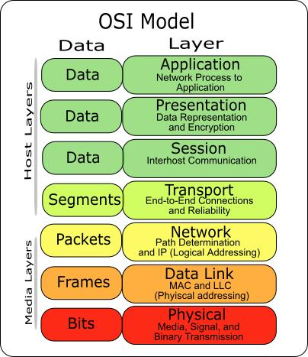
- Data starts at Application Layer (L7)
- Moves downward to Physical Layer (L1)
- At each layer, headers are added:
  - PH (Presentation Header)
  - SH (Session Header)
  - TH (Transport Header)
  - NH (Network Header)
  - DH (Data Link Header)

Step 3: Error Detection Encoding
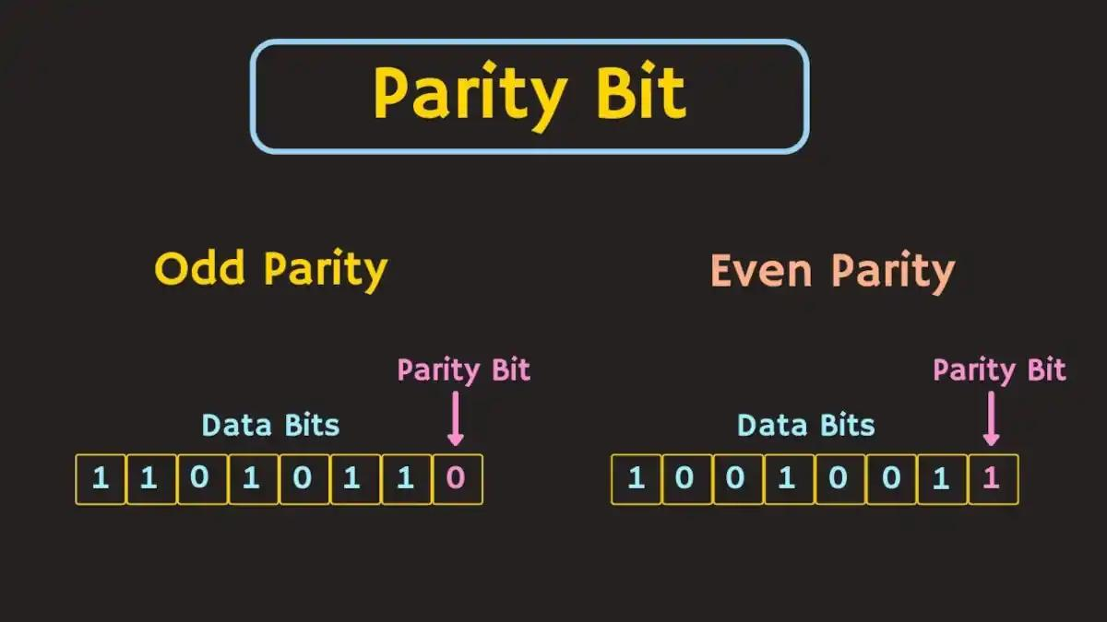
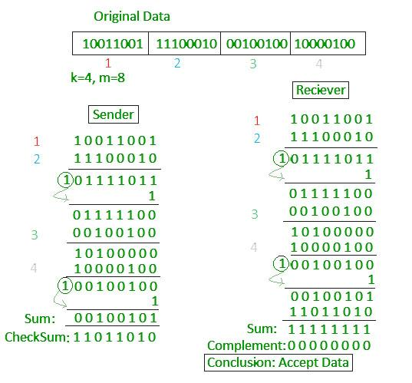
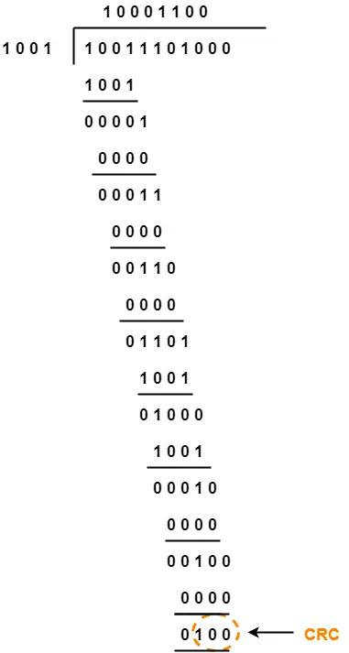

At the Data Link Layer:
- User selects a method:
  - Parity
  - Checksum
  - CRC
  - Hamming Code
- Backend (Python + Flask) performs calculations step-by-step

Step 4: Transmission & Noise Injection

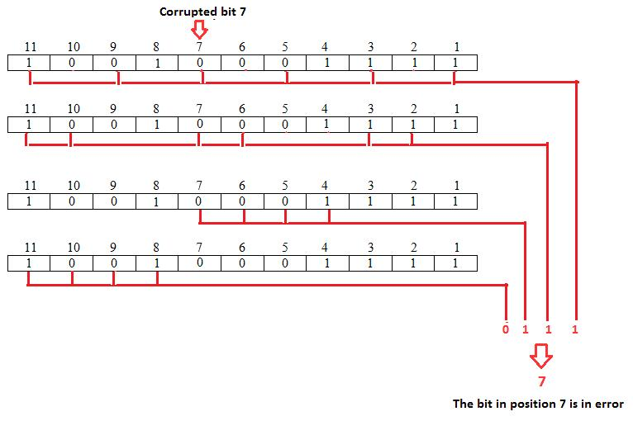

- Data is converted into binary
- Sent through simulated channel
- User manually flips bits to simulate noise

Step 5: Receiver Side Processing
- Received data is verified:
  - Parity / Checksum / CRC → Error detection
  - Hamming Code → Error detection + correction
- If error detected:
  - System alerts user
  - Hamming automatically corrects error

Step 6: Decapsulation
- Data moves upward from L1 → L7
- Headers are removed one by one
- Original message is reconstructed

5. Code Output / Result (Screenshot Representation):
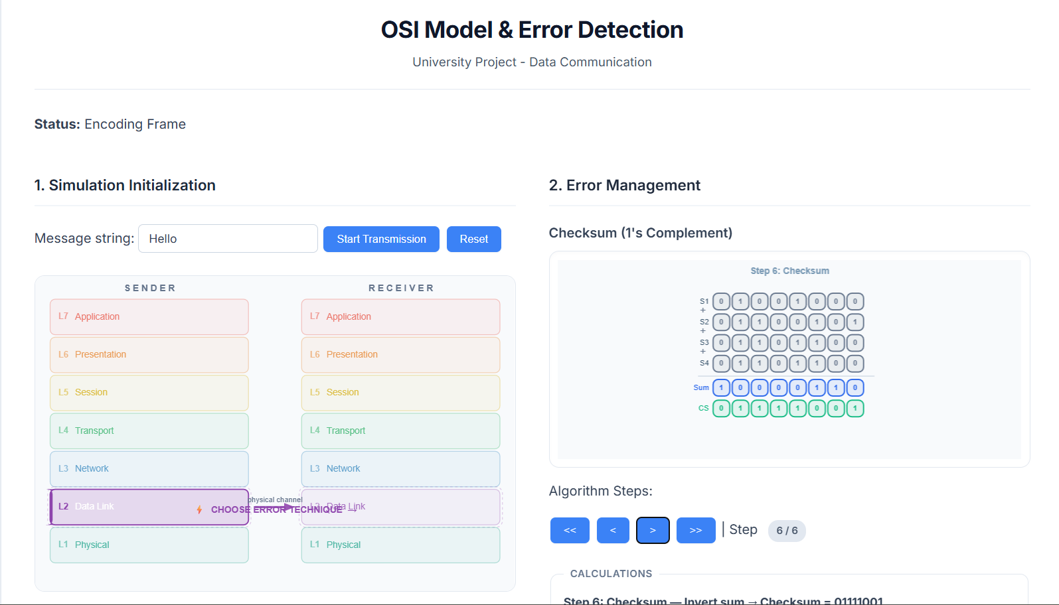
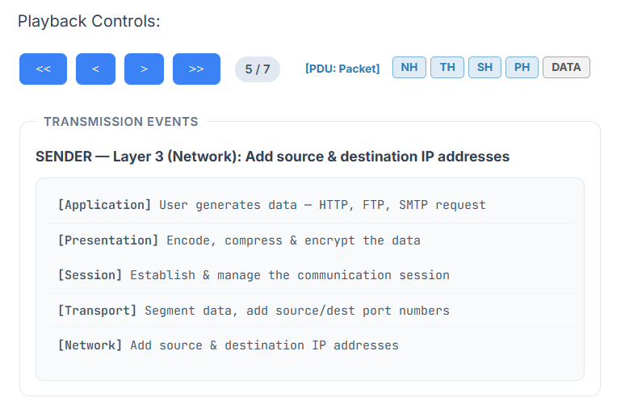
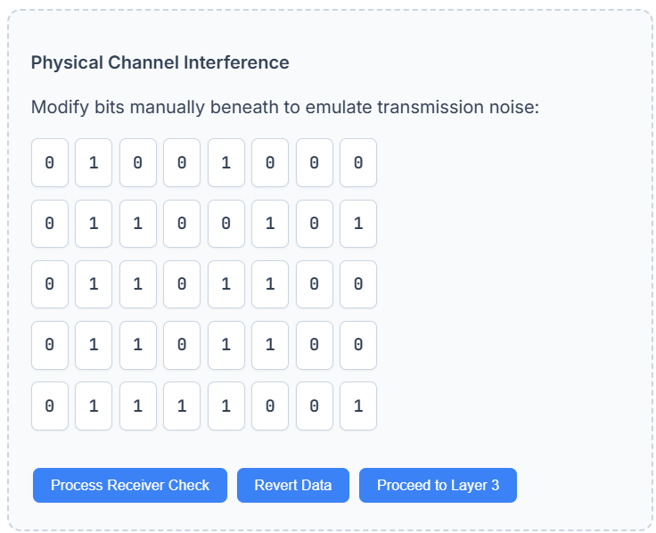
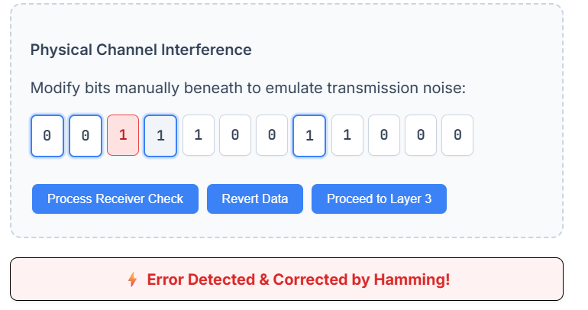
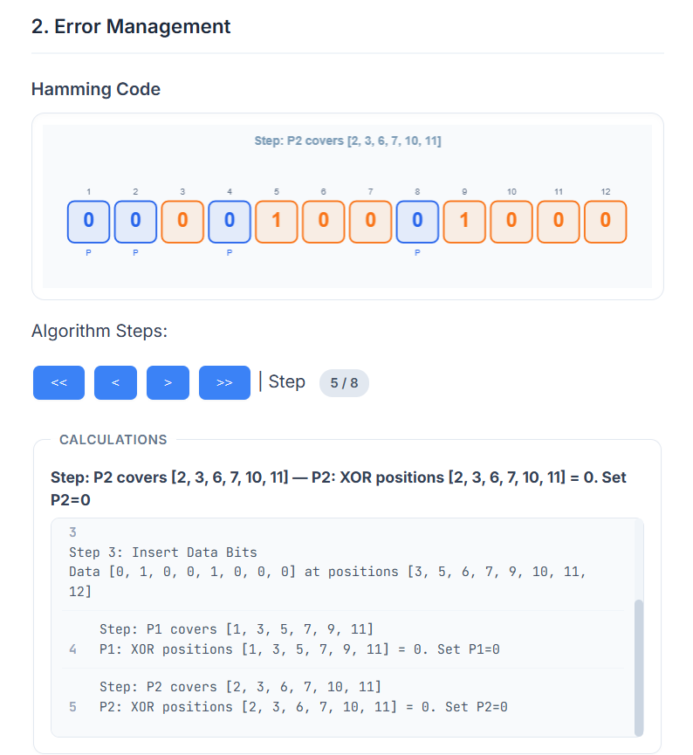
6. Final Conclusion
The DC Simulator successfully demonstrates key concepts of data communication in an interactive and visual manner. It transforms complex theoretical topics such as OSI layering, data encapsulation, and error detection into an intuitive learning experience.
By integrating backend computation with frontend visualization, the project:
- Enhances conceptual clarity
- Provides hands-on understanding of network communication
- Simulates real-world transmission errors and recovery mechanisms
Overall, this project serves as an effective educational tool for students to understand how data travels across networks and how errors are detected and corrected, thereby bridging the gap between theory and practical implementation.
-------------------------------------------------------------------------------------------------------------------------------

