|  |  |
| --- | --- |
| **Name:** |  |
| **Roll No & Branch:** |  |
| **Class/Sem:** | BE/VII |
| **Experiment No.:** |  |
| **Title:** | Installation of Unity and Visual Studio, setting up Unity for VR development, understanding documentation of the same. |
| **Date of Performance:** |  |
| **Date of Submission:** |  |
| **Marks:** |  |
| **Sign of Faculty:** |  |

**Aim:** Installation of Unity and Visual Studio

**Theory:**

Virtual Reality (VR) is a transformative technology that leverages computer-generated environments to immerse users in simulated realities, typically facilitated through specialized headsets. It has gained widespread use due to its ability to transport users to entirely different worlds, whether for entertainment in gaming, immersive storytelling, or the creation of lifelike training simulations for industries like aviation, medicine, and engineering. In education, VR enables dynamic and interactive learning experiences, from exploring historical sites to understanding complex scientific concepts. Additionally, it is employed in therapeutic settings, offering treatment options for conditions like PTSD or phobias. As VR technology advances, its applications continue to expand, revolutionizing how we engage with information, experiences, and virtual spaces.

**Procedure:**

1. Install Unity and Visual Studio.
2. Choose your VR platform and install the respective SDK.
3. Create a new Unity 3D project and enable VR support.
4. Import the VR SDK and assets.
5. Set up a VR camera rig (e.g., OVRPlayerController for Oculus).
6. Design your VR environment with 3D models and terrain.
7. Refer to official documentation for your VR platform and Unity for guidance.
8. Learn how to use the SDK's features, such as hand tracking and controllers.
9. Explore scripting for VR interactions (grabbing, throwing) in Unity.
10. Join VR developer communities and seek tutorials or courses for additional learning and support.

**Result:**

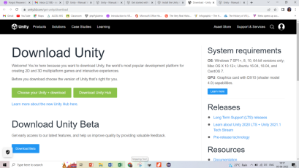

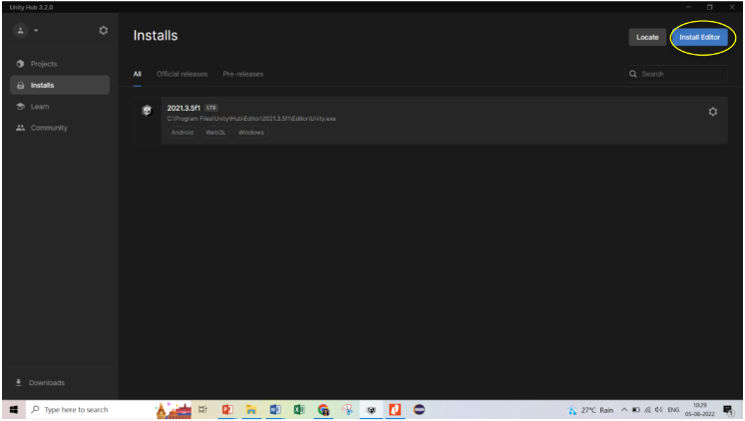

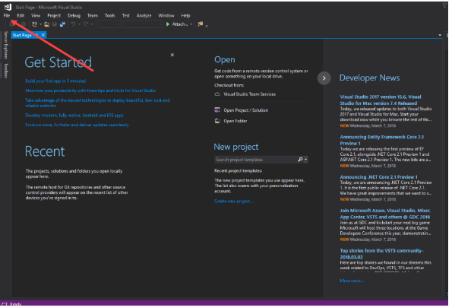

**Conclusion:**

In conclusion, the installation process of Unity and Visual Studio proved to be a crucial foundation for the seamless development of robust and feature-rich applications. Navigating through the technical intricacies of each installation step offered valuable insights into the interplay between these two powerful tools. Unity's intuitive interface and Visual Studio's comprehensive development environment synergize seamlessly, creating a dynamic ecosystem for crafting cutting-edge projects.

The meticulous setup not only ensured a stable working environment but also laid the groundwork for efficient collaboration between different aspects of the development process. Understanding the technical nuances of integrating Unity and Visual Studio is pivotal for harnessing their full potential in creating immersive and high-performance applications.