|  |  |
| --- | --- |
| **Name:** |  |
| **Roll No & Branch:** |  |
| **Class/Sem:** | BE/VII |
| **Experiment No.:** | 03 |
| **Title:** | To develop a scene in Unity that includes: i. a cube, plane and sphere, apply transformations on the 3 game objects.  ii. add a video and audio source. |
| **Date of Performance:** |  |
| **Date of Submission:** |  |
| **Marks:** |  |
| **Sign of Faculty:** |  |

**Aim :-**

To develop a scene in Unity that includes:

1. a cube, plane and sphere, apply transformations on the 3 game objects.
2. add a video and audio source.

**Theory:-**

In Unity, you can create a dynamic scene by adding various game objects and components. In this context, we aim to create a scene that involves a cube, plane, and sphere, and apply transformations to these objects. Transformations, including translation, rotation, and scaling, alter the position, orientation, and size of game objects, respectively. This manipulation of transformations is fundamental for positioning and animating objects within the Unity environment. Additionally, we will add a video and audio source to enhance the scene's interactivity. A video source allows for the playback of video content within the scene, enriching the visual experience. Meanwhile, an audio source provides the capability to integrate sound and music, further engaging users in the immersive environment

**Procedure:-**

1. **Create Project**: Start a new 3D Unity project and ensure you have the required Unity version and video/audio packages installed.
2. **Create & Position Objects**: In the Hierarchy, create game objects (Cube, Plane, Sphere) and adjust their properties.
3. **Import Assets**: Import video (MP4 or WebM) and audio files into the project's "Assets" folder.
4. **Create Materials**: Generate materials for game objects by right-clicking in the Project window, then assign these materials in the Inspector.
5. **Add Video & Audio Components**: For video, create a Video Player component and assign the video clip. For audio, add an Audio Source component and assign the audio clip.
6. **Configure Playback**: Write scripts if needed to control video and audio playback.
7. **Testing**: Save the scene and press Play to verify video/audio playback, object transformations, and material settings

**Result:-**

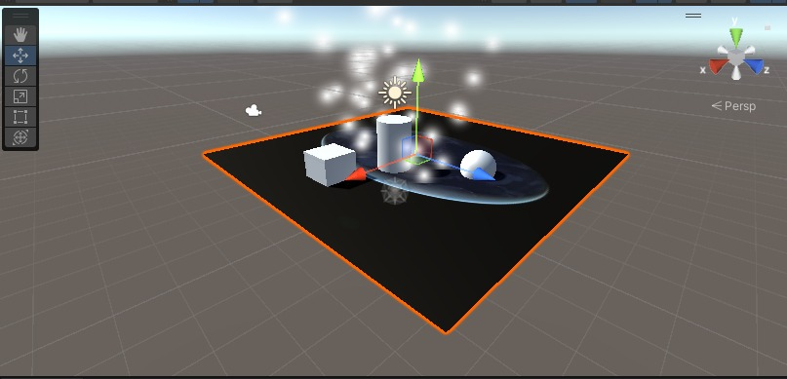

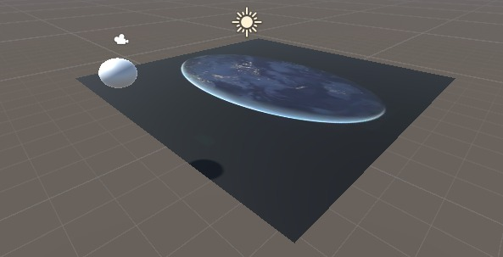

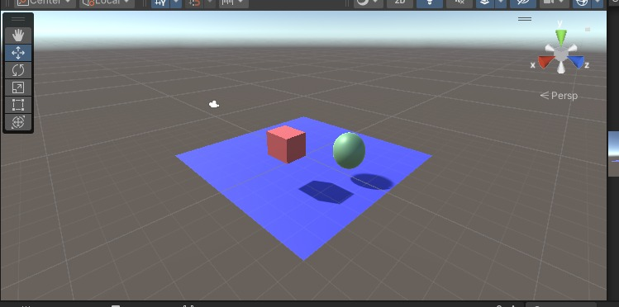

**Conclusion:-**

In wrapping up this Unity practical, exploring the technical intricacies of creating a dynamic scene has been both challenging and rewarding from my perspective. Manipulating the fundamental game objects—cube, plane, and sphere—through various transformations provided a hands-on understanding of spatial manipulation within the Unity environment. Experimenting with scale, rotation, and position not only honed my skills in object manipulation but also underscored the importance of precision and order in creating visually compelling scenes.

The integration of a video and audio source elevated the immersive quality of the scene. Incorporating video seamlessly into the Unity environment required a nuanced approach to texture mapping and video playback controls. Concurrently, the addition of an audio source enhanced the overall sensory experience, emphasizing the significance of synchronizing visual and auditory elements for a cohesive virtual environment. As I manipulated these digital building blocks, the practical not only deepened my understanding of Unity's capabilities but also underscored the intricate balance between visual aesthetics and technical functionality in the realm of game development.