|  |  |
| --- | --- |
| **Name:** |  |
| **Roll No & Branch:** |  |
| **Class/Sem:** | BE/VII |
| **Experiment No.:** |  |
| **Title:** | Develop a scene in Unity that includes a sphere and plane . Apply Rigid body component, material and Box collider to the game Objects.Write a C# program to grab and throw the sphere using vr controller |
| **Date of Performance:** |  |
| **Date of Submission:** |  |
| **Marks:** |  |
| **Sign of Faculty:** |  |

**Aim:** Develop a scene in Unity that includes a sphere and plane . Apply Rigid body component, material and Box collider to the game Objects.

**Theory:** Virtual Reality (VR) is a cutting-edge technology that immerses users in digital environments, making them feel as if they are physically present in those spaces. Within Unity, a popular game development platform, it is entirely feasible to apply essential components to game objects, such as the Rigid body for simulating physical behaviours, Box Colliders for defining collision shapes, and Materials for controlling the objects' visual properties. Moreover, in Unity, developers can craft a dynamic VR experience that enables users to pick up and throw a sphere with a VR controller. This is accomplished by incorporating a VR software development kit (SDK), configuring a VR camera rig to replicate the user's perspective, and implementing custom scripts to facilitate the interaction. The XRGrabInteractable script, often used for this purpose, tracks the controller's input and applies forces to the Rigid body component of the sphere, allowing users to manipulate and launch it within the VR environment, fostering an engaging and immersive VR interaction.

**Procedure:**

1. Create a new Unity 3D project.
2. Import VR SDK for your hardware.
3. Import assets (sphere, plane, materials).
4. Create sphere and plane objects.
5. Add Rigid body components to both.
6. Apply materials to objects.
7. Add Box Collider to the sphere.
8. Implement VR controller interaction using provided SDK components.
9. Write a script for picking up and throwing the sphere.
10. Attach the script to the VR controller object.
11. Test the scene in your VR environment.

**Result:**

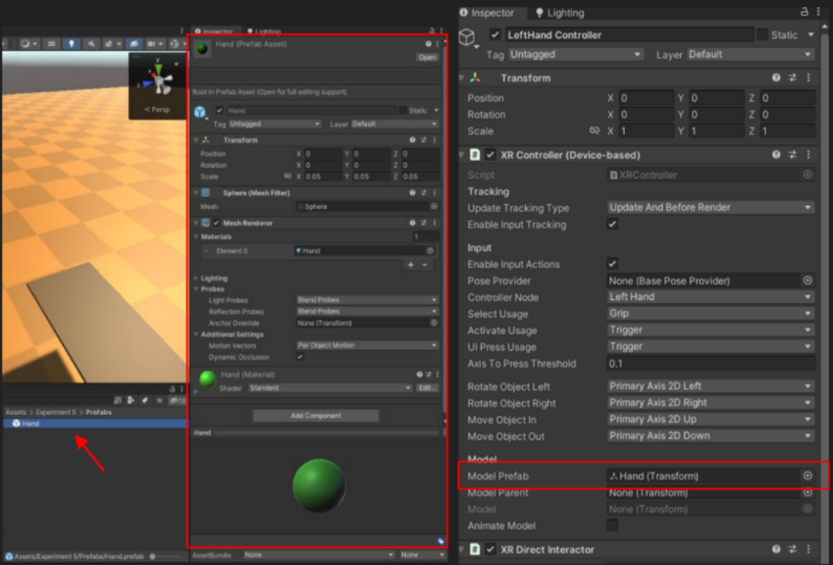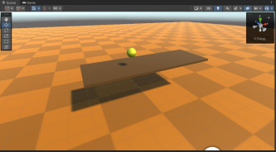

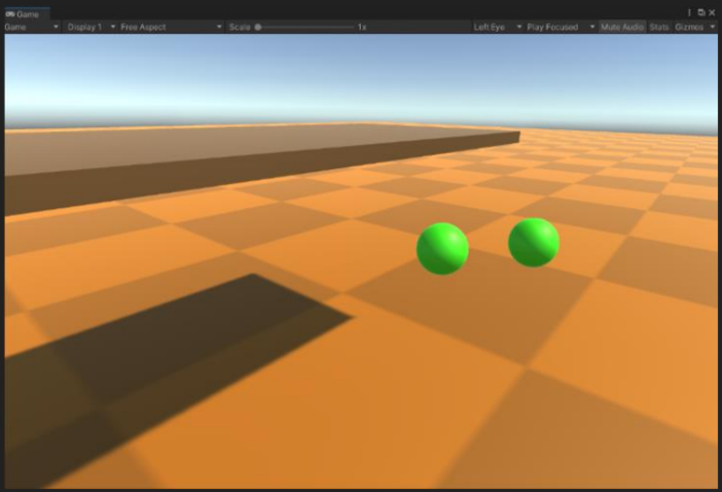**Conclusion:**

**Conclusion:**

In conclusion, this practical allowed me to delve into the technical intricacies of Unity's game development environment. By incorporating a sphere and a plane, applying Rigid Body components, materials, and Box Colliders to these game objects, I gained valuable hands-on experience in enhancing realism and interactivity within a virtual space.

The integration of the Rigid Body component facilitated the simulation of physical interactions, adding a layer of dynamics to the scene. This not only deepened my understanding of Unity's physics engine but also provided a practical foundation for creating more realistic and engaging gaming experiences.

Furthermore, the application of materials contributed to the visual appeal of the objects, allowing for the manipulation of their appearance and surface properties. This aspect of the practical emphasized the importance of aesthetic considerations in game development and how they can be seamlessly integrated with the underlying physics.

The inclusion of Box Colliders played a pivotal role in defining the boundaries and collision interactions within the scene. This component served as a crucial element in creating a responsive and immersive environment, showcasing the significance of precise collision detection for a seamless user experience. The hands-on approach provided a solid foundation for understanding the practical implications of theoretical concepts, equipping me with valuable insights into the intricate world of game development.