**Comparison of cloud platforms- Amazon and Google app engine**

**Amazon S3:**

Here we are comparing costs of two cloud platforms: Amazon S3 and Google app engine. It is given that dataset and workload is increased by 1 million times so following will be summary of dataset and workload-

* Total Number of Files: 411 million
* Files will store data of size: 311 TB
* Time period: 1 Month

Amazon S3:

Following is summary of rates provided at <http://aws.amazon.com/s3/pricing/> according to US standard.

s

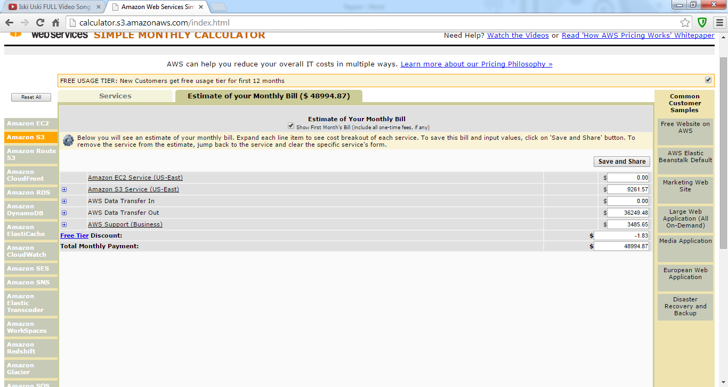

* **Data Transfer to Amazon S3: $0.000 per GB**

For 311 TB = $0 (No Charges)

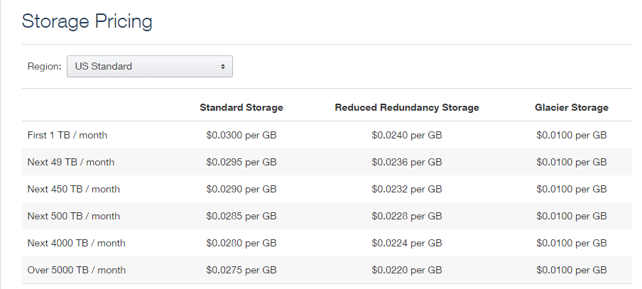

* **Storage Rates:**

|  |  |
| --- | --- |
| First 1 TB / month | $0.03 per GB |
| Next 49 TB / month | $0.0295 per GB |
| Next 450 TB / month | $0.0290 per GB |
| Next 500 TB / month | $0.0285 per GB |
| Next 4000 TB / month | $0.0280 per GB |

We calculated total cost using amazon monthly calculator at following link:

<http://calculator.s3.amazonaws.com/calc5.html>

So storage charges at Amazon S3 Services = **$9261.57**

* **Retrieval of data from amazon S3:**

To retrieve data from amazon S3 the rates are specified and on calculating the transfer of data at

<http://calculator.s3.amazonaws.com/index.html> then:

Total size of data set = 622 TB = 636,928 GB

So total cost will be: **$36249.48**

**So total cost will be: Cost of data transfer to amazon + Storage Cost + Data retrieval Cost + support cost**

**$0 + $9261.57+ $36249.48 + 3485.65= $48994.87 ($1.83 discount)**

**Google App Engine:**

Standard rates of google app engine are given at: <https://developers.google.com/storage/docs/pricingandterms#pricing> .

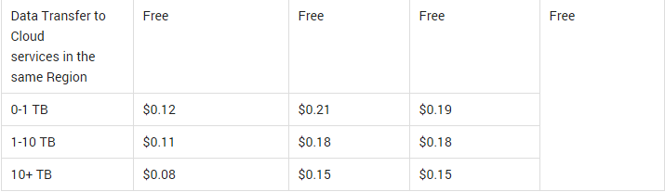

* **Data Transfer in to Google Cloud Storage: $0 (Free)**

So there will be no charge for data transfer.

* **Storage :**

Monthly storage charges are shown in following table.

|  |  |
| --- | --- |
| Monthly Usage | Standard Storage(per GB per month |
| First 0-1 TB | $0.026 |
| Next 9 TB | $0.076 |
| Next 90TB | $0.067 |
| Next 400TB | $0.063 |

**For 1TB (1024 GB) Storage = $26.62, so for 90TB (92160GB) storage = $26.62*90=$ 2396.16**

Since, 5 GB storage is free. (311-100 = 211TB)

(211TB – 5GB) = (216059GB) storage = $5617.534

**Total Standard Storage Cost =** $5617.534 +$2396.16 **= $8279.93**

* **Retrieve the Data from Google Cloud Storage:**

20 GB to Americas and EMEA*; 5 GB to Asia-Pacific is free so we will have 25 GB of free download.

622TB – 25GB = 621.97TB or 63,6903GB only will be priced.

Monthly network charges are as follows:

|  |  |
| --- | --- |
| Monthly Usage | Network Egress (per GB) |
| 0-1 TB | $0.12 |
| Next 9TB | $0.11 |
| Next 90TB | $0.08 |

1TB (1024GB) data retrieval = $0.12*1024=$122.88

9TB (9216GB) data retrieval = $0.11*9216=$700.42

90TB (92160GB) data retrieval = $0.08*92160= $7372.8

**Total Cost for 100TB data retrieval = $8196.1**

For more than 90TB data need to contact sales.

Total data left to retrieve= 621.97 – 100 = 521.97TB.

Assume that cost of transferring data is $0.08/GB.

So cost of 521.97 TB will be= **$42,759.78**

Total cost = Data transfer to cloud + Storage + Data retrieve from cloud

= $0 + $8279.93 + $42,759.78

**= $51039.71**

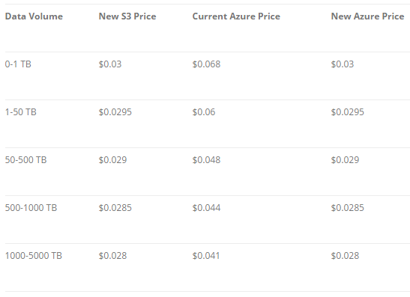

**Conclusion:**

Above calculation shows that cost for both clouds doesn’t differ a lot. But google cloud storage gives somewhat good facilities than S3 and at cost lower than S3. Google demands higher for retrieval of data but storage charges are less than amazon. So we can use any cloud platform. Each platform has its own advantages and disadvantages.