**Performance:**

Following graphs shows performance of system for upload, delete and find operations. We are considering **single**, **multithreading, withmemcache and withoutmemcache** as a cases.

1. **Throughput of uploading 411 and 822 files on cloud using single and multithreading with memcache:**

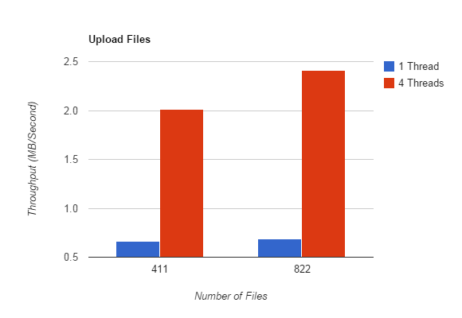

**Above graph shows the throughput of uploading 411 and 822 files with memcache using single and 4 threads. Blue bar shows throughput using 1 thread and red bar shows the throughput with 4 threads.**

**Throughput for single thread is low while for 4 threads we get higher throughput.**

1. **Throughput of uploading 411 and 822 files on cloud using single and multithreading without memcache:**

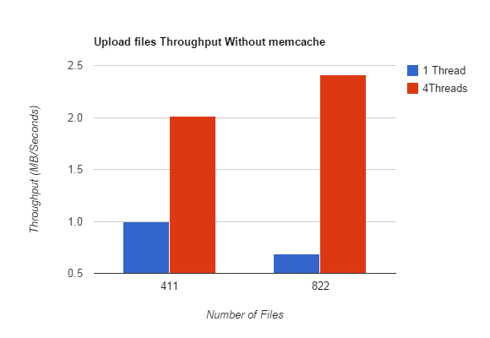

**Above graph shows the throughput of uploading 411 and 822 files without memcache using single and 4 threads. Blue bar shows throughput using 1 thread and red bar shows the throughput with 4 threads.**

**Throughput for single thread is low while for 4 threads we get higher throughput.**

**Performance decreases when we don’t use memcache.**

1. **Latency of uploading 411 and 822 files on cloud using single and multithreading with memcache:**

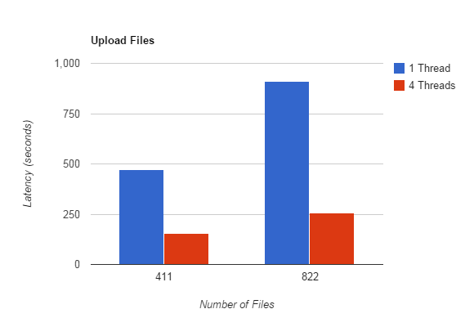

**Above graph shows the latency of uploading 411 and 822 files with memcache using single and 4 threads. Blue bar shows latency using 1 thread and red bar shows the latency with 4 threads.**

**Latency for single thread is high as it will take more time while for 4 threads we get low latency as it uploads in parallel.**

**.**

1. **Latency of uploading 411 and 822 files on cloud using single and multithreading without memcache:**

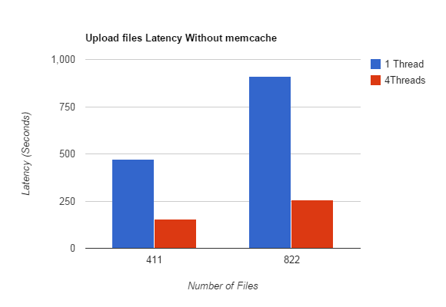

**Above graph shows the latency of uploading 411 and 822 files without memcache using single and 4 threads. Blue bar shows latency using 1 thread and red bar shows the latency with 4 threads.**

**Latency for single thread is high as it will take more time while for 4 threads we get low latency as it uploads in parallel. Using memcache our operation works faster.**

1. **Deleting files with and without memcache using single threads.**

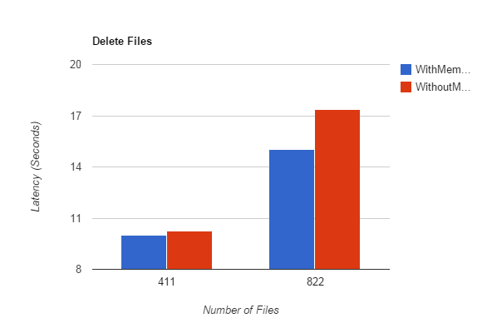

**Above graph shows the latency of deleting 411 and 822 files with single threads using memcache and without memcache. Blue bar shows latency using memcache and red bar shows the latency without memcache.**

**Using memcache we can achieve delete operation faster than without memcache. We can see difference in time in graph.**

1. **Deleting files with and without memcache using 4 threads.**

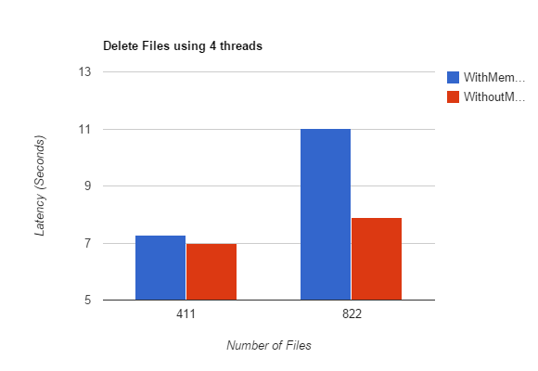

**Above graph shows the latency of deleting 411 and 822 files with 4 threads using memcache and without memcache. Blue bar shows latency using memcache and red bar shows the latency without memcache.**

**Using memcache we can achieve delete operation little bit slower while working with 4 threads. We can see difference in time in graph.**

1. **Finding files with and without memcache using single thread.**

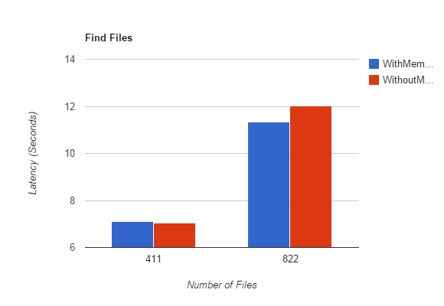

**Above graph shows the performance of finding files from cloud and memcache using single thread. Blue bar shows latency using memcache and red bar shows the latency of finding without memcache. For 411 files we get good performance using memcache and somewhat same performance for 811 file.**

1. **Finding files with and without memcache using 4 threads.**

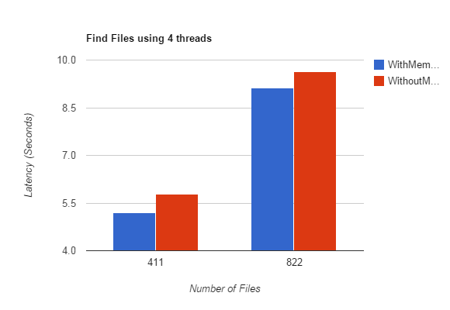

**Above graph shows the performance of finding files from cloud and memcache using 4 thread. Blue bar shows latency using memcache and red bar shows the latency of finding without memcache. For 411 files we get good performance without memcache and same performance for 811 file.**