**DAY -10 Ronak Patel :-**

1. Create **virtual environment** using
   * Anaconda
   * Virtualenv
   * venv

Name them as **env_conda**, **env_virtual_env** and **env_venv** respectively.

1. Anaconda env :-

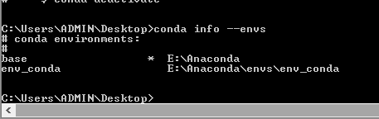

1. Virtualenv :-

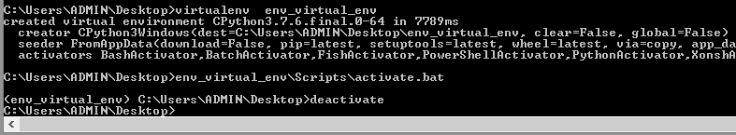

1. Venv:-

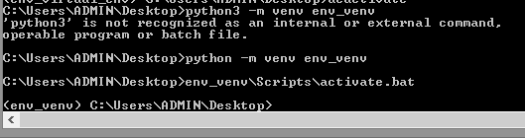

* + Clone the repository on EC2 Machine.
  + Make sure to create a virtual environment on EC2 using virtualenv and name it as Virtual_on_ec2
  + Activate the virtual environment
  + Install all the dependencies from cloned requirements.txt
  + do **PIP FREEZE**
  + **Share the Screenshot :)**

For Python2 version on AWS LINUX Machine

virtualenv -p /usr/bin/python Virtual_on_ec2 //Created

source Virtual_on_ec2/bin/activate //Activated

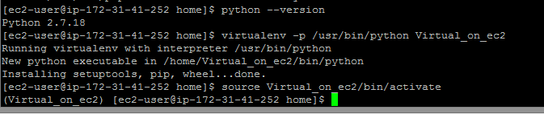

Perform below command to check python packages

sudo yum list | grep python3

then I found latest is python36 on my linux ec2 instance

sudo yum install python36 python36-virtualenv python36-pip

above command installs python package36,update virtualenv to 15.1.0 and also updates pip

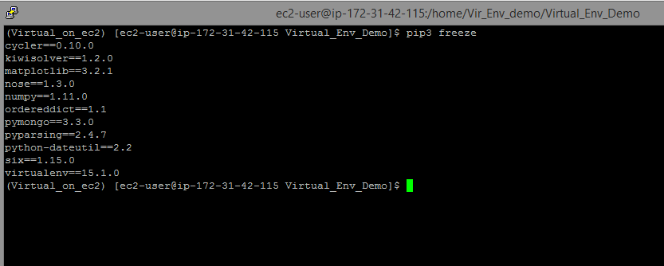

1. Static & Dynamic Website.

Ans:-

There are basically two main types of website - static and dynamic.  
A static site is one that is usually written in plain HTML and what is in the code of the page is what is displayed to the user.

A dynamic site is one that is written using a server-side scripting language such as PHP, ASP, JSP, or Coldfusion. In such a site the content is called in by the scripting language from other files or from a database depending on actions taken by the user.

**Static Website Pros:**

* fast—no lengthy load times when displaying the page
* cheap—often cheaper to host static files on Netlify, S3, etc than a hosted environment
* simpler for a developer to setup
* easy to integrate forms, payments, login via API calls

**Static Website Cons:**

* updates-requires a developer to update content, not a nice CMS as provided by WordPress and others

**Dynamic Website Pros:**

* dynamic content generated for each user
* easy to update with a CMS like Wordpress
* more powerful with features like login, payments, etc.

**Dynamic Website Cons:**

* expensive—setting up, maintaining, and scaling a database is costly
* complex—much more steps involved to setup and deploy vs a static site