1. Calculating avg of 5 Subjects :-

Ans :-

var num = [50,60,70,82,65,57];

var Sum = 0;

for(var i in num) {

Sum += num[i];

}

var Count = num.length;

var average = Sum / Count;

document.write('Average is: ' + average);

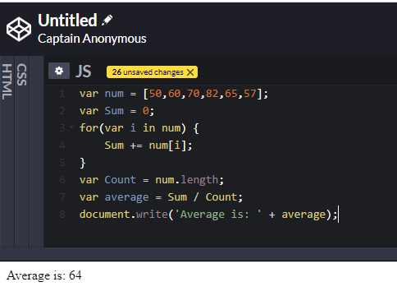

1. Decision Making (If Else Statement)

Ans :-

var num1=10;

var num2=true;

var num3=num1%2

if(num3==0 & num2){

document.write("Number is Divible by 2");

}

else{

document.write("Number not divisible by 2");

}

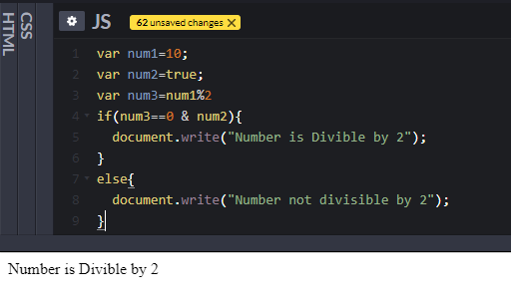

1. Write a program to ask users to enter the number in the range of 1-20 and see if the number is sorted or not. If not write a program to sort them. Also can enter maximum 5 values.

no=window.prompt("How many numbers would you like to enter?");

if (no<=5){

var array=[];

for (var i=0; i<no;i++){

array[i]=prompt("Enter number ");

}

array.sort(function(a, b){return a-b});

document.write(array);

}

else{

window.alert("You can't enter more than 5 numbers!")

}

