**DAY -9 Task**

**Ronak Patel**

**TASK 01:**

* Create an EC2 Instance:
  + AMI Linux
  + t2.micro - Instance Type
  + Enable Termination Protection
  + Security Group
    - Open it for:
      * SSH
      * HTTP
      * HTTPS
  + Tag:
    - Key
      * Name
    - Value
      * ProdInstance
  + Key Pair

Ans :- Linux AMI t2 Instance Created :-

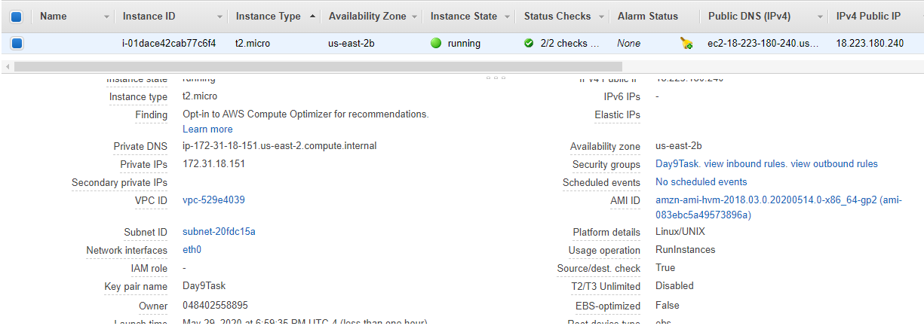

**TASK 02:**

* Connect with an instance using SSH on Mac/Linux and Windows users can use Putty

Ans :- 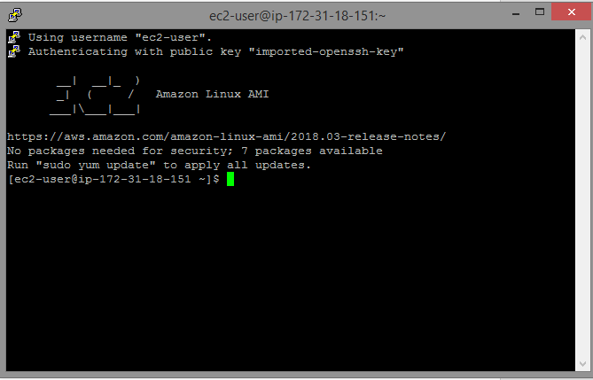

**TASK 03:**

* Install Apache Web Server
* Run the Public IP and see the output
* Make sure to Configure the index.html with Custom data.
* Create three more files in the same directory /var/www/html/
  + Home.html
  + Payment.html
  + Login.html
* Run all these pages from EC2 Public IP by Passing the URL.

Ans:-

**For installing Apache Web Server commands:-**

**Sudo yum update (checking for update)**

**Sudo yum install httpd -y**

**Sudo service httpd start (starts server)**

**Output after starting server :-**

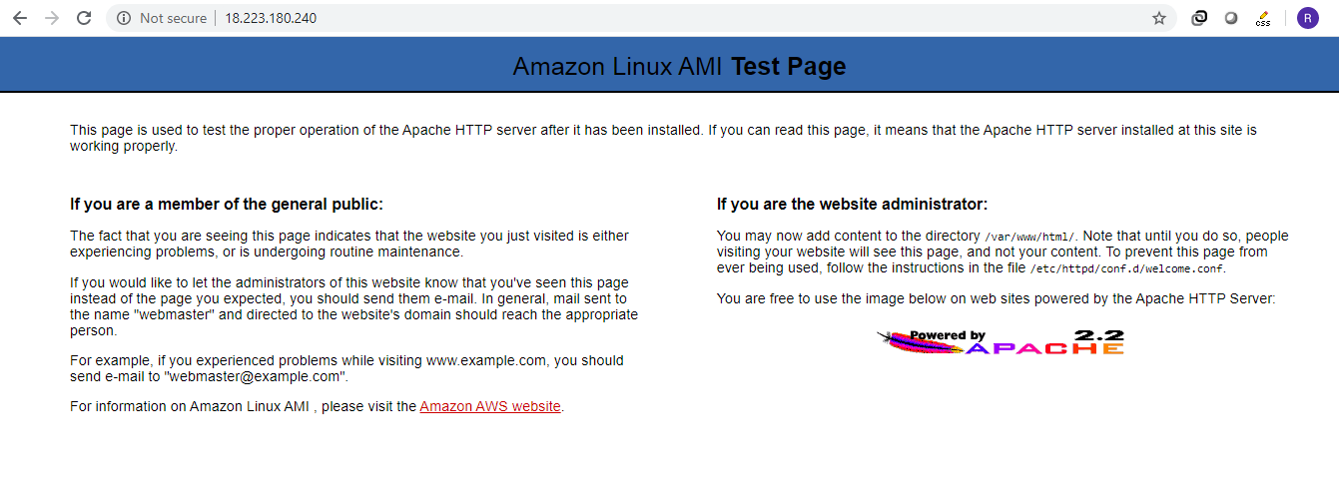

Created Index.html & other file through virtual Linux CLI:-

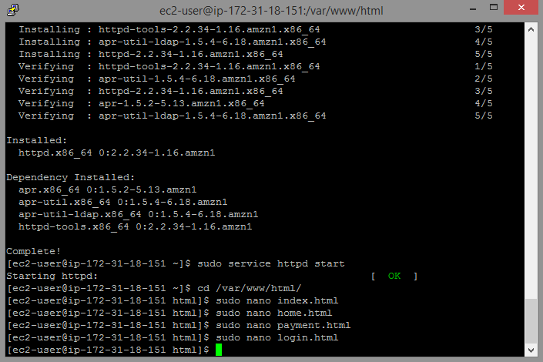

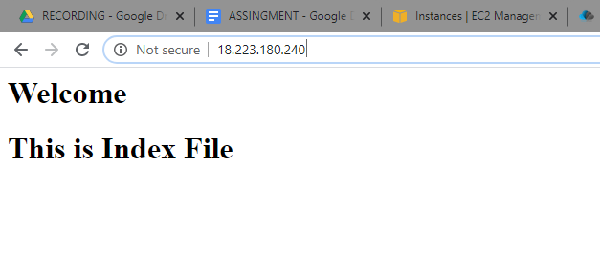

**Home.html**

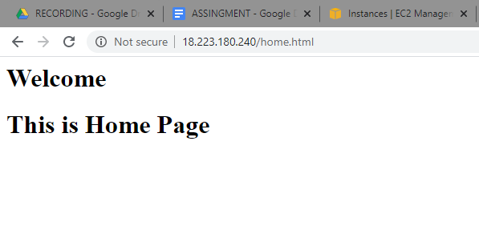

**Payment.html**

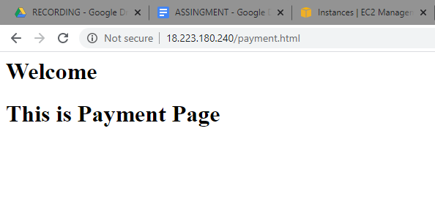

**Login.html**

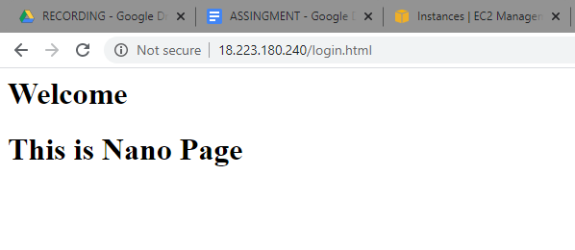

**TASK 04:**

* Install Git on EC2 and Clone all your repositories separately on EC2 in the folder called “repoonec2”.

**Ans** :- I wasn’t able to change permission of home dir I tried doing in octal as well as symbolic ways but error was **operation not permitted** so I Created repoonec2 inside tmp dir

Octal mode I tried :- chmod -R 777 home

Symbolic mode I tries :- chmod a=rwx home

