**Ronak Patel**

**DAY -14 & 15**

**CONSTRAINT: 01**

-- Give the name of the project as BootProject

-- Give the name of the application as Bootapp

-- Allow views.py to be get properly mapped with urls.py file.

-- Use a template to create a generic HTML file that can display data like- Hi! Welcome to the innovation with Bootcamp training.

-- While working with the template make sure you give name "TEMPLATE_PATH" to actually connect to the os path.

* Give the name of the project as BootProject

Django-admin startproject BootProject

* Give the name of the application as Bootapp

Django-admin startapp Bootapp

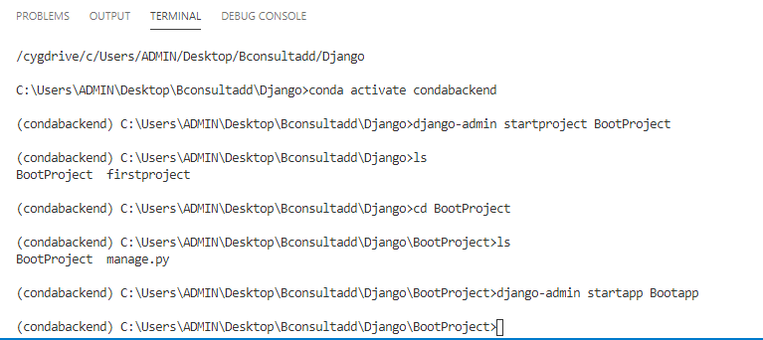

Allow views.py to be get properly mapped with urls.py file.

Configuration Steps:-

1. Import library in views.py under bootapp :- from django.http import HttpResponse
2. Create view like :-

def index(request):

return render(request,"firstapp/first.html")

#here firstapp is folder under Templates and file first.html inside it.

1. Import under BootProject/url.py from Bootapp import views
2. Then under urlpatterns add following :-

path('', views.index),path('bootcamp/',views.index1)

#'' it means whenever u run server first page load will be of function #named index under Bootapp\views.py file and 'bootcamp/' is url when u #specify after default host ip generated by django will redirect you to

#page of index1 function under Bootapp\views.py file

Use a template to create a generic HTML file that can display data like- Hi! Welcome to the innovation with Bootcamp training.

* Create html file under templates\Bootapp folder under BootProject Directory and specify the path into views.py under under Bootapp and whatever url like to give under url.py in BootProject.

-- While working with the template make sure you give name "TEMPLATE_PATH" to actually connect to the os path.

* Make variable TEMPLATE_PATH=os.path.join(BASE_DIR,'templates') under setting.py in BootProject dir
* And mention ur variable name as value in dictionary inside TEMPLATES List.

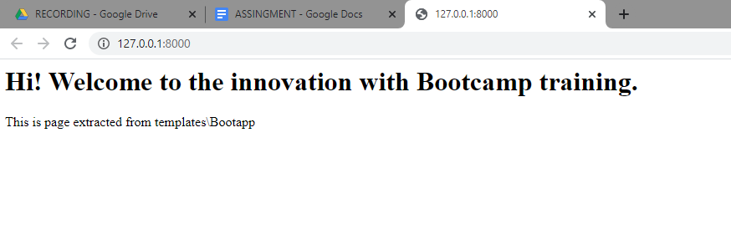

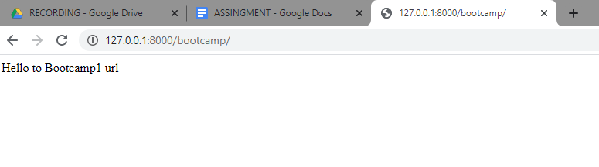

**CONSTRAINT: 02**

-- Make use of the Static files concept to display jpg file on the web page.

-- Make use of some other static files like CSS or JavaScript to change the font or color of the text.

-- Create one models classes as - Name, ID, Contact, Address and migrate them into the database.

-- Initially migrate them to Django SQLLite

-- Make sure to create a super user & Get into the admin console

-- Connect with PostgreSQL

-- I need to install psycopg2-binary

**-- Make use of the Static files concept to display jpg file on the web page.**

Add under settings.py :-

STATIC_URL = '/static/'

STATICFILES_DIRS = [

    os.path.join(BASE_DIR, "static"),

    '/var/www/static/',

]

MEDIA_URL ='/images/'

Then under ur html file add code:-

{% load static %}

<img src="{% static 'images/django.jpg' %}" alt="My image">



**-- Make use of some other static files like CSS or JavaScript to change the font or color of the text.**

Add this code into ur html file under templates

{% load static %}

<link rel="stylesheet" href="{% static '/css/test.css' %}">



**-- Create one models classes as - Name, ID, Contact, Address and migrate them into the database.**

**-- Initially migrate them to Django SQLLite**

Models.py is under Bootapp

* class Boot_Table(models.Model):
* Name=models.CharField(max_length=20,blank=False)
* ID=models.CharField(max_length=20,primary_key=True)
* Contact=models.IntegerField(max_length=20)
* Address=models.CharField(max_length=100)

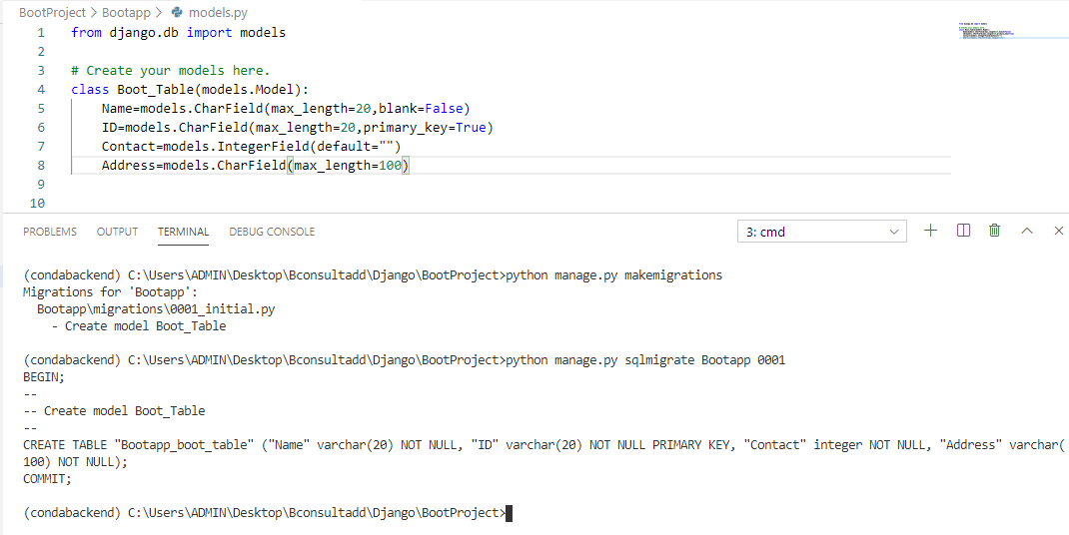

Migrated to sqllite

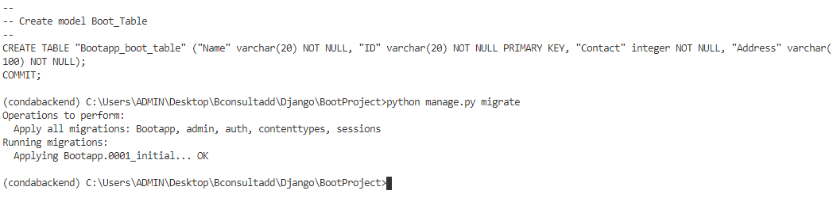

Now register ur model under admin.py under Bootapp

from django.contrib import admin

from .model import Boot_Table

# Register your models here.

admin.site.register(BootTable)

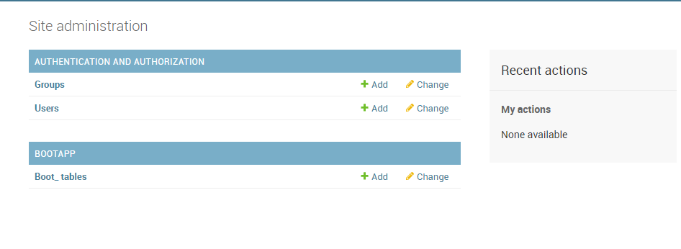

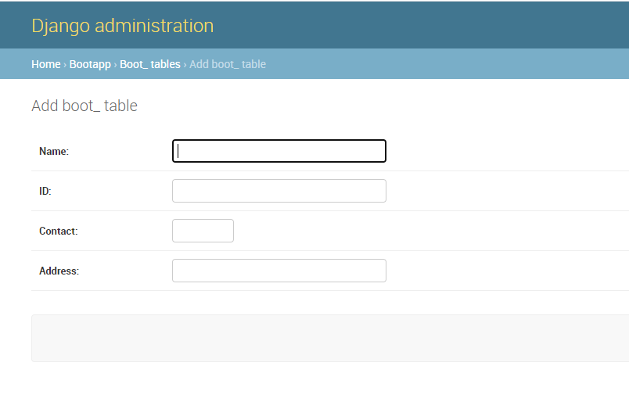

**-- Connect with PostgreSQL**

**-- I need to install psycopg2-binary**

Migrate data to Postgresql :- changes made under setting.py

DATABASES = {

    'default': {

        'ENGINE': 'django.db.backends.postgresql',

        'NAME':'Bootappdb',

        'USER': 'postgres',

        'PASSWORD':'root',

        'HOST': 'localhost',

    }

}

