Robotics and Drones Laboratory (22 MEC37N)
Project Report
On
Color Detection and pixel transition using OpenCV
By
Name of the student | Roll Number
Ronak Sarda | 160125737123
Sai Bhardwaj reddy | 160124737124
Abhinay | 160125737103
Pranav | 160125737091
Gauri Nandan | 160126737080

Under the Mentorship of
Dr. Kiran Kumar Amireddy
Assistant Professor
Branch: Department of Mechanical Engineering
Submitted to
Department of Mechanical Engineering
CHAITANYA BHARATHI INSTITUTE OF TECHNOLOGY (A)
(Affiliated to Osmania University)
Gandipet, Hyderabad-500075
2024 - 2025
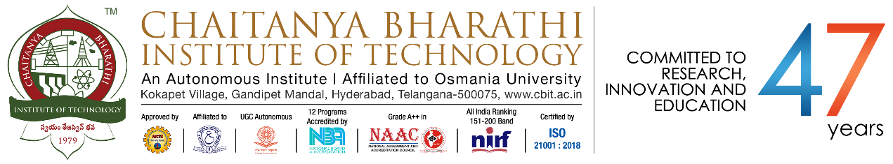
CERTIFICATE
This is to certify that the project entitled "Color Detection and pixel transition using OpenCV" by the following students has been carried out under my mentorship.
Name of the student | Roll Number
Ronak Sarda | 160125737123
Sai Bhardwaj reddy | 160124737124
Abhinay | 160125737103
Pranav | 160125737091
Gauri Nandan | 160126737080

Dr. Kiran Kumar Amireddy
Assistant Professor

1. Aim
To develop an interactive Color Detection System using OpenCV that can precisely identify colors from images and perform smooth pixelated transitions between states using mathematical interpolation and color quantization.

2. Background and Motivation
Color detection is a fundamental task in computer vision, especially for Robotics and Drones where real-time object tracking and environment mapping are required. This project is motivated by the need for accurate color categorization (mapping raw RGB values to human-readable names) and visualizing state transitions in a pixelated, compressed /pixelate format for referencing.

3. Apparatus and Tools used
Software Environment:
- Python 3.10+
- OpenCV (cv2): For image processing and UI.
- Pandas: For color dataset management.
- NumPy: For vectorized Euclidean distance calculations.
- OS: Windows
-Visual Studio code : For running the program

4. Detailed procedure
1. Dataset Loading: Read 'colors.csv' containing 865 named colors.
2. Interface: Create an OpenCV window with a mouse callback to track coordinates.
3. Detection: Calculate Euclidean Distance between the pixel under mouse and all CSV entries.
4. Shape Generation: Procedurally draw objects (Apple, Ball, Car, etc.) on a canvas.
5. Pixelation: Use AREA interpolation to downsample and NEAREST to upsample.
6. Morphing: Implement Linear Interpolation (LERP) using cv2.addWeighted to transition between images smoothly.

5. Hardware/Software Architecture
The system follows a modular architecture:
- Input Layer: Image file (pallete.jpg) or generated canvas.
- Processing Layer: Euclidean distance matching and Quantization.
- Visualization Layer: Smooth transition engine (to transform the given image into desired shape using letters).
- UI Layer: Real-time tooltip overlay.

6. Program/Code

7. Output
Pressing 'A' morphs the image into a pixelated Apple. Pressing 'C' morphs it into a Car. The 'R' key restores the original image through a 15-step smooth transition. The UI provides real-time RGB values and color names (e.g., 'Midnight Blue').

8. Conclusions
The project successfully demonstrates the power of OpenCV for interactive systems. By using vectorized NumPy operations, we achieved high-performance color matching across 865 entries. The smooth morphing logic provides a visually appealing and professional way to transition between image states.

9. References
- OpenCV Documentation (docs.opencv.org)
- Python-Docx API Documentation
- Pandas Data Analysis Library
-OpenCV color detection repo on github.

