TEAM LOGICX
S1 — Wafer Yield Root Cause & Defect Pattern Analyser
Complete Technical, Image-Analysis and Judge-Preparation Documentation
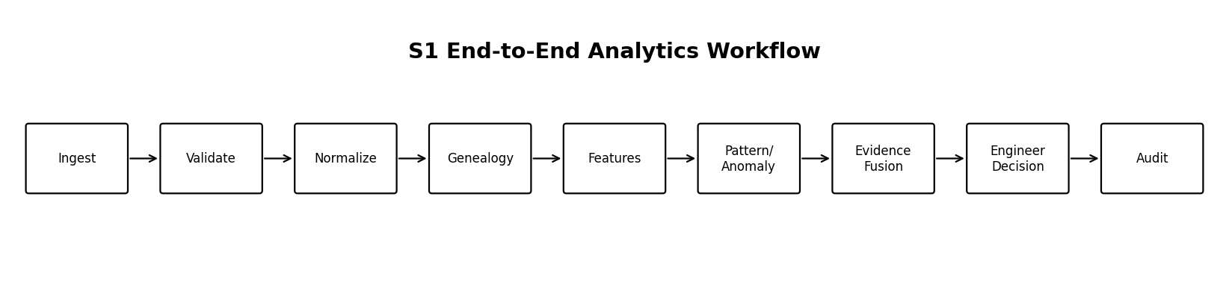
ChatGpt : Chat Link Complete Project Understandtion problem solve It .

Chat Link : Chat Link Complete Project Understanding

1. Executive Summary
Team LogicX is developing a semiconductor manufacturing analytics control tower. It ingests fab-style records, validates and links genealogy, extracts process and spatial features, detects anomalies and wafer-map patterns, ranks evidence-supported root-cause candidates, recommends engineer-reviewed actions, and flags upcoming lots using pre-run-safe information.
Core positioning
This is a software engineering analytics system, not an AI chatbot. The critical analytics path must remain independently testable, deterministic where required, explainable and auditable.

Current prototype boundary
- Demonstration data is deterministic synthetic fab-style data, not confidential production-fab data.
- Current wafer-pattern analysis is primarily based on structured defect coordinates and wafer-map representations.
- Raw inspection-image computer vision should be described as a future extension unless a verified image-ingestion and inference path is present.
- Root-cause ranking produces candidates, not guaranteed causal conclusions.
- Corrective actions require engineer approval; the system does not directly control manufacturing equipment.

2. Industry Problem
Yield loss is difficult to investigate because relevant evidence is distributed across equipment traces, recipes, chamber history, maintenance, metrology, inspection, genealogy and yield systems. Engineers must connect time, location and process context before forming a credible hypothesis.
Problem | System response
Fragmented data | Unified ingestion, validation and genealogy
Process drift | Baseline comparison and anomaly features
Spatial defect signatures | Wafer-map pattern classification
Repeated chamber behavior | Recurrence and historical similarity
Unsupported AI conclusions | Deterministic evidence fusion and audit fields
Unsafe automation | Engineer review and approval workflow

3. End-to-End Workflow
Stage | What happens
Ingest | Receive synthetic, CSV or future authorized database/equipment records
Validate | Check schema, IDs, timestamps, units and required values
Normalize | Standardize names, units, process labels and identifiers
Genealogy | Link lot → wafer → run → tool/chamber → recipe → inspection → yield
Features | Create process, temporal, spatial and recurrence features
Pre-run risk | Use only information known before the target lot begins
Anomaly/pattern | Detect process deviations and classify wafer-map distributions
Similar lots | Retrieve comparable historical conditions
Evidence fusion | Combine seven signals into candidate rankings
Action/audit | Recommend reviewable actions and store decisions

4. Data Extraction and Genealogy
The current prototype uses a synthetic generator to create linked records. The architecture is designed around structured data contracts so future authorized CSV, database or equipment connectors can be added without changing the core analytics concepts.
Entity | Important information
Lot | lot_id, product, route, start time
Wafer | wafer_id, lot_id, slot and status
Tool/chamber | equipment and chamber identifiers
Process run | run ID, recipe, start/end time
Recipe | recipe ID, version and process step
Trace | timestamped parameter, value and unit
Metrology | measurement type, value and timestamp
Defect | defect ID, wafer ID, X/Y, class and severity
Maintenance | event type, tool/chamber and timestamp
Yield | wafer/lot outcome and source timestamp

Data lineage example
LOT-1042 → W07 → RUN-8842 → ETCH-03 / CH-2 → ETCH-RCP-11 → trace window → inspection defects → yield outcome
Judge answer: How is data extracted?
In the current demo, deterministic synthetic records are generated programmatically. The ingestion layer validates and normalizes those records and links them using IDs and timestamps. We do not claim live proprietary fab connectivity.

5. Wafer Defect Pattern Analysis
Important distinction
A wafer map is a spatial representation of defect coordinates. It is not automatically the same as a raw optical inspection image. The current capability should be presented as coordinate-based spatial analytics unless raw-image processing is verified.

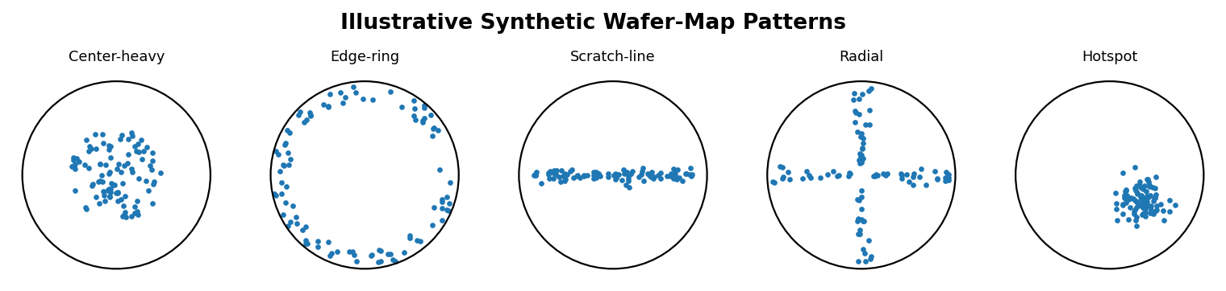

Coordinate processing
- Read defect records containing wafer ID, X/Y coordinates, defect class and optional severity.
- Normalize coordinates relative to wafer center and radius.
- Calculate radial distance: r = √(x² + y²).
- Calculate normalized radius: r_norm = r/R.
- Partition the wafer into radial bands, angular sectors or regions.
- Calculate counts and density by region.
- Compare the observed distribution with baseline or configured scenario thresholds.
- Store the metrics and label as evidence for downstream fusion.
Pattern | Recognition method | Possible investigation areas
Center-heavy | High inner-radius concentration | Center-region nonuniformity or process variation
Edge-ring | High outer-radius concentration | Edge uniformity, clamping, cleaning or process-edge effects
Scratch-line | Defects aligned along a narrow line | Handling, contact or transport interaction
Radial | Spoke-like directional distribution | Flow, rotation or spatial process variation
Localized hotspot | Dense local cluster | Local contamination, excursion or inspection artifact

Pattern labels are indicators. A pattern does not prove one physical failure mode and must be correlated with process and equipment evidence.

6. Future Raw-Image Computer Vision Extension
Step | Possible technique | Output
Image ingestion | TIFF/PNG plus metadata | Image linked to wafer/run
Quality validation | Resolution, orientation and scale checks | Validated image
Wafer alignment | Center/radius and orientation normalization | Standard coordinate frame
Segmentation | Thresholding, morphology, connected components or ML | Candidate defect regions
Feature extraction | Area, shape, intensity, direction and position | Structured defect features
Classification | CNN, vision transformer or validated classifier | Defect class probabilities
Spatial analysis | Cluster, radial and regional statistics | Wafer pattern vector
Fusion | Combine image and process evidence | Candidate causes with evidence

Judge-safe response
We separate implemented capability from future capability. We will not claim to have trained or deployed a raw-image model without showing the dataset, training pipeline, evaluation metrics and inference code.

7. Algorithms
Subsystem | Algorithmic approach
Validation | Schema, type, range, timestamp and referential checks
Baseline | Mean/standard deviation, robust statistics or control limits
Anomaly | Z-score, robust deviation, rolling-window or change-point methods
Spatial patterns | Radial bands, regional density, directional alignment and clustering
Similar lots | Feature normalization and controlled distance/similarity
Pre-run risk | Leakage-controlled classifier or score using pre-run whitelist
Root cause | Deterministic weighted evidence fusion
Alerts | Configurable thresholds and event rules
Audit | Evidence IDs, algorithm version, timestamp and reviewer state

Anomaly example
z = (x − μ) / σ
Here x is the observed value, μ is the comparable baseline mean, and σ is the baseline standard deviation. The method must be selected and validated according to the actual data distribution.

8. Root-Cause Evidence Fusion
The critical root-cause path should not ask an LLM to guess. It combines measurable signals and returns ranked candidate causes for engineering review.
- Historical association: similar conditions were previously linked with the outcome.
- Anomaly strength: magnitude and persistence of the process deviation.
- Defect-pattern consistency: compatibility between spatial signature and candidate.
- Chamber recurrence: repeated related behavior in a tool or chamber.
- Temporal precedence: suspected signal occurs before the observed outcome.
- Maintenance relationship: association with maintenance or time since maintenance.
- Similar-lot evidence: comparable lots with related conditions and outcomes.
Simplified score: S(c) = Σ w_i × e_i(c). This prioritizes investigation; it does not prove causality.
Output field | Purpose
Candidate cause | Candidate failure mode
Score/confidence | Configured ranking and uncertainty information
Evidence IDs | References to supporting records/calculations
Algorithm version | Reproducibility
Generated at | Calculation timestamp
Recommendation | Engineer-reviewable next step
Approval status | Pending, approved, rejected or needs investigation

9. Pre-Run Risk and Leakage Prevention
The pre-run model must use only information available before the target lot starts.
Allowed | Forbidden
Tool/chamber assignment | Target lot future yield
Recipe ID/version | Target lot future defect map
Historical chamber behavior | Target lot future metrology
Completed prior maintenance | Future maintenance events
Historical process stability | Downstream runtime anomalies
Similar completed lots | Post-process inspection results

Why leakage matters
If future target-lot outcomes enter the feature set, evaluation can become artificially optimistic and the model will not represent real pre-run operation.

10. Industry Scenarios
Scenario | Detected evidence | Engineer review
Etch drift | Parameter deviation, chamber recurrence and similar lots | Review chamber traces, recipe and maintenance
Overlay excursion | Metrology deviation plus tool/recipe context | Review lithography and measurement evidence
Particle excursion | Cluster or count increase plus temporal recurrence | Review contamination and handling evidence
Cycle-time exposure | Time since maintenance, sequence and historical behavior | Review exposure window and comparable runs

11. Architecture and UI
Layer | Technology/responsibility
Frontend | React, TypeScript, Vite, Tailwind
Backend | Python, FastAPI, SQLAlchemy
Analytics | pandas, NumPy, SciPy, scikit-learn
Persistence | PostgreSQL with SQLite fallback
Migrations | Alembic
Testing | pytest and TypeScript compiler
Deployment | Docker and Docker Compose
Bob | Plan, implementation, diagnosis, review and structured development workflows

- Monitor: fleet health, yield indicators and excursions.
- Investigate: lot/wafer genealogy, anomalies and similar lots.
- Wafer Pattern Lab: spatial maps and regional metrics.
- Predict: pre-run risk and feature provenance.
- Alerts: active and historical alerts.
- Evidence: calculations, IDs, timestamps and algorithm versions.
- Actions: recommendations, review and audit status.

12. IBM Bob Integration
Bob mode | Use
Plan | Architecture, contracts and implementation plan
Agent | Implementation, refactoring and tests
Ask | Diagnosis of errors and integration issues
Review | Acceptance against requirements and guardrails
MCP | Structured tool-assisted workflows where configured

Bob is the development/SDLC agent. It is not the prediction engine and should not be treated as the authority that declares a physical root cause.

13. QA and Validation
Test | Purpose
Data integrity | IDs, timestamps, units and relationships
Regression | Known synthetic scenarios remain stable
Leakage | Pre-run feature whitelist rejects downstream fields
LLM exclusion | Critical root-cause module has no LLM dependency
API contracts | Typed inputs, outputs and errors
Frontend typing | TypeScript interfaces compile
Auditability | Evidence ID, algorithm version and timestamp present
Human approval | No action is executed without reviewer sign-off
Reproducibility | Fixed seed recreates synthetic scenarios

The repository README reports approximately 100 backend tests and TypeScript checks. The team should run and show actual terminal output during judging.

14. Live Demo Sequence
- Start the backend, frontend and database.
- Show the Monitor screen.
- Select a synthetic lot with an injected excursion.
- Open genealogy and show lot, wafer, run, chamber, recipe and timestamps.
- Open the wafer map and explain coordinate-to-feature conversion.
- Show the detected spatial pattern and supporting metrics.
- Show process anomaly evidence and baseline comparison.
- Open similar lots and historical association.
- Show candidate root causes with score, evidence IDs and algorithm version.
- Open pre-run risk and demonstrate the feature boundary.
- Create or review an action and show pending engineer approval.
- Approve/reject and display the audit record.
- Run tests or show verified recorded results.

15. Judge Counter-Questions
Q: Are you analyzing raw wafer images?
A: The current capability is structured defect-coordinate and wafer-map analysis. Raw-image computer vision is a future extension unless the implementation is verified.
Q: How is data extracted?
A: The demo uses deterministic synthetic fab-style records. The ingestion layer validates, normalizes and links records; authorized CSV/database/equipment connectors are future integration points.
Q: Why synthetic data?
A: Production data is confidential. Synthetic data enables repeatable demonstration without exposing proprietary information.
Q: Does the system guarantee the cause?
A: No. It ranks candidates using evidence. Causal confirmation requires engineering validation.
Q: Why not let an LLM decide?
A: Manufacturing decisions need reproducibility, traceability and controlled behavior. The critical ranking path is separated from LLM inference.
Q: How do you avoid leakage?
A: A strict pre-run feature whitelist excludes future target-lot yield, defects, metrology, maintenance and downstream anomalies.
Q: What if multiple chambers match?
A: The system keeps multiple candidates and compares recurrence, temporal order, genealogy and similar lots instead of forcing certainty.
Q: Can it control machines?
A: No. It provides decision support. Engineer approval is required.
Q: What is the business impact?
A: Potential benefits include faster investigation, earlier recurrence visibility and better prioritization. Actual savings require a controlled pilot.

16. Limitations and Claim Discipline
- Synthetic data is not production validation.
- Spatial patterns can have multiple physical explanations.
- Correlation is not causation.
- Performance metrics must identify dataset, split strategy, scenario balance and baseline.
- Raw-image ML requires labelled images, preprocessing, training/evaluation separation and monitoring.
- Production deployment requires fab-specific integration, security, change management and validation.
- Never claim 100% accuracy, guaranteed savings or plug-and-play deployment in a named fab.

17. Final Judge Statement
Team LogicX converts fragmented semiconductor manufacturing evidence into an auditable investigation workflow. It links ingestion, validation, genealogy, process analytics, wafer-map spatial analysis, leakage-controlled pre-run risk, evidence fusion, engineer recommendations and audit history. The system does not ask an LLM to guess the cause and does not directly control machinery. It demonstrates a practical foundation for validation with authorized industrial data.

Appendix — Repository Reference
Repository: https://github.com/ronaksavsani181/bob-ai-hackathon-LogicX
Repository README facts used: React/TypeScript/Vite frontend; FastAPI/Python backend; pandas/NumPy/SciPy/scikit-learn analytics; PostgreSQL/SQLite; Docker; synthetic deterministic data; spatial pattern categories; pre-run feature controls; deterministic seven-signal fusion; human approval and testing claims. Verify implementation details by running the repository before final submission.

