Market Basket Analysis In Multi-Store Environment

Project submitted in partial fulfillment of requirements
for the Degree of

BACHELOR OF ENGINEERING

By
Bhavin Patel
Ronak Shah
Dakshay Nerkar

Under the guidance of
Prof. Jyoti Ramteke
Assistant Professor

Department of Computer Engineering
Sardar Patel Institute of Technology
University of Mumbai
2012-2013



BHARTIYA VIDYA BHAVAN’S
SARDAR PATEL INSTITUTE OF TECHNOLOGY
MUNSHI NAGAR, ANDHERI (W),
MUMBAI - 400 058.
2012-13



UNIVERSITY OF MUMBAI

Bharatiya Vidya Bhavan’s

SARDAR PATEL INSTITUTE OF TECHNOLOGY

DEPARTMENT OF COMPUTER ENGINEERING
2012-2013

Certificate

THIS IS TO CERTIFY THAT

Bhavin Patel
Ronak Shah
Dakshay Nerkar

Have satisfactorily carried out the project titled,

Market Basket Analysis In Multi-Store Environment

In partial fulfillment of the Bachelor of Engineering in Computers as laid down by the University of Mumbai during the academic year 2012-2013.

_____________________
Guide

_____________________ _____________________
Head of Department Principal

_____________________ _____________________
Internal Examiner External Examiner

Computer Engineering Department
Year 2012-2013

Acknowledgements

Any accomplishment requires the efforts of many people, and our project is no different.
We are highly indebted to our guide, Prof. Jyoti Ramteke whose help, stimulating suggestions and encouragement helped us in each phase of the project. Her constant encouragement coupled with refreshments provided while working late hours helped us maintain our momentum in difficult times.
We thank our Principal, Dr. Prachi Gharpure, for allowing us to undertake this project and providing all the technical support needed for successful completion of this project. We thank Mr. Nandkumar and Mr. Nalawade, our Laboratory Assistants for their patience and assistance throughout the project.
We thank our Institution and particularly, the Computer Department, for providing us with a dedicated state-of-the-art laboratory equipped with all the required computing and networking resources. Finally, we express our heartfelt gratitude to our respective families; without their support, this project would have been a distant reality.

Abstract

Market basket analysis is an important component of analytical system in retail organizations to determine the placement of goods, designing sales promotions for different segments of customers to improve customer satisfaction and hence the profit of the supermarket.

These issues for a leading supermarket are addressed here using frequent itemset mining. The frequent itemsets are mined from the market basket database using the efficient Apriori algorithm and then the association rules are generated.

Because the information obtained from the analysis can be used in forming marketing, sales, service, and operation strategies, it has drawn increased research interest.

The existing methods, however, may fail to discover important purchasing patterns in a multi-store environment, because time-analysis is not considered substantial in these methods .Our time-based method shows that the proposed method is computationally efficient and that it has advantage over the traditional method when stores are diverse in size, product mix changes rapidly over time, and larger numbers of stores and periods are considered.

Table of Contents
- Overview……………………………………………………………………………….1

  - Introduction……………………………………………….…………….…….……1
  - Motivation……………………………………………………………………….…3
  - Aims & Objectives………………………………………………………………....4
  - Problem Statement……………………………………………………………........5
  - Scope……………………………………………………………….………………6
- Literature Survey…...…………………………….………………………………….....7
- System Architecture…..………………………………………………….…………….16
  - Design Approach…………………………………………….……….…….……...16
  - Proposed System Architecture…………………………….……………….……..18
  - Representation of Analysis…………………………….…………….…………….20
  - Proposed Algorithms…………………………….………….…………….………23
- System Modeling…………………………………………………….……………..….26
  - Relational Database Model………………………………………………………..26
  - Activity Diagram…………………………………………………………………..27
  - Use Case Diagram…………………………………………………………………28
  - Sequence Diagram…………………………………………………………………29
- Development and implementation ………………………………….……...…............30
  - Tools And Technologies Implemented ...………………………………………….30
  - Database Implement………………………………………………………………..32
  - Work Break Down Structure……………………………………………………….34
  - System Implementation…………………………………………………………….35
- Testing………………………………………………………………………..…..…….45
  - Unit testing………………………………………………………………..…...…...45
  - System Testing….………………………….……………………………..….…….47

- Result And Analysis…………………………………………………………..……..…48
- Conclusion……………………………………………………………………….…......50
- Future Scope……………………………………………………………………………51
- Limitations……………………………………………………………………………..52
References………………………………….………………………………………......53

Overview

1.1 Introduction

One of the challenges for companies that have invested heavily in customer data collection is how to extract important information from their vast customer databases and product feature databases, in order to gain competitive advantage. Several aspects of market basket analysis have been studied in academic literature, such as using customer interest profile and interests on particular products for one to-one marketing, purchasing patterns in a multi-store environment to improve the sales. Market basket analysis has been intensively used in many companies as a means to discover product associations and base a retailer’s promotion strategy on them.
Informed decision can be made easily about product placement, pricing, promotion, profitability and also finds out, if there are any successful products that have no significant related elements. Similar products can be found so those can be placed near each other or it can be cross-sold. A retailer must know the needs of customers and adapt to them. Market basket analysis is one possible way to find out which items can be put together. Market Basket Analyses gives retailer goods information about related sales on group of goods basis. Customers who buy’s bread often buys several products related to bread like milk, butter or jam. It makes sense that these groups are placed side by side in a retail center so that customers can access them quickly. Such related groups of goods also must be located side-by-side in order to remind customers of related items and to lead them through the center in a logical manner. Market basket analysis is one of the data mining methods focusing on discovering purchasing patterns by extracting associations or co-occurrences from a store’s transactional data. Market basket analysis determines the products which are bought together and to reorganize the supermarket layout, and also to design promotional campaigns such that products’ purchase can be improved.
Hence, the Market consumer behaviors need to be analyzed, which can be done through different data mining techniques. Data mining finds interesting patterns from databases such as association rules, correlations, sequences, classifiers, clusters and many more of which the mining of association rules is one of the most popular problems.
Association rule mining finds interesting association or correlation relationships among a large set of data items.

“Association rules” are derived from the frequent item sets using “support” and “confidence” as threshold levels. The sets of items which have minimum support are known as
“Frequent Item set.”

NOTE:

Support of an item set is defined as the proportion of transactions in the data set which contain the item set.

Confidence is defined as the measure of certainty or trustworthiness associated with each
Discovered pattern.
Association rules derived depends on confidence. Frequent item set generation is done using data mining algorithms like Apriori , FP-Growth Algorithm , Eclat and K-Apriori .

Affinity analysis is a data analysis and data mining technique that discovers co-occurrence relationships among activities performed by (or recorded about) specific individuals or group.

1.2 Motivation

Data mining has now become the solution for many of the business areas and commercial institutes. Affinity analysis is a data analysis and data mining technique that discovers co-occurrence relationships among activities performed by (or recorded about) specific individuals or groups.

The term market basket analysis in the retail business refers to research that provides the retailer with information to understand the purchase behavior of a buyer.

This information will enable the retailer to understand the buyer's needs and rewrite the store's layout accordingly, develop cross-promotional programs, or even capture new buyers (much like the cross-selling concept).

An apocryphal early illustrative example for this was when one super market chain discovered in its analysis that customers that bought diapers often bought beer as well, have put the diapers close to beer coolers, and their sales increased dramatically.

Although this urban legend is only an example that professors use to illustrate the concept to students, the explanation of this imaginary phenomenon might be that fathers that are sent out to buy diapers often buy a beer as well, as a reward. This kind of analysis is supposedly an example of the use of data mining.

A widely used example of cross selling on the web with market basket analysis : Amazon.com's customers who bought History of Portugal were also interested in Naval History

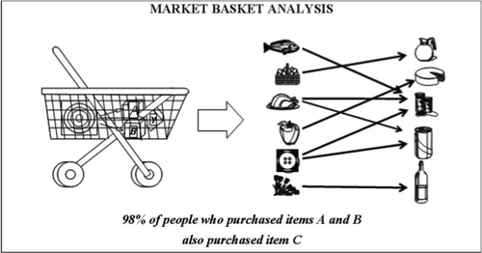
Fig: 1.2.1

1.3 Aims and Objectives

- To build an application which can support and analyze many multi store databases and draw precise conclusions.

- To design a structured but easy-to-use Market Basket Analysis tool.

- To include time as one of the major parameters to generate candidate sets in the Apriori algorithm.

- To make use of time-series analysis to generate patterns over a period of time

- To implement efficient data mining algorithms and advanced association rules to mine the database and represent the associations made graphically so that the end user can perceive the analysis done in a better fashion

- To empower the retail planners to help them with the planning and strengthen their negotiating position with vendors by providing them with better information about customer buying behavior.

- To help the retailers to avoid unnecessary discounts by understanding when and where discounts will make a difference to top-line sales knowing that a reduction in unnecessary discounts markdowns will improve gross margins.

- To implement a new dashboard concept which is easy to read, real time user interface to enable instantaneous and informed decision making at a glance.

1.4 Problem Statement

In this we are trying to develop the better solution for market basket analysis in a multi-store environment which is easy for the administrator to make strategical changes to increase his sales based of association rules. We provide a technical solution to the problem that time is not vastly considered in market basket analysis.

By using time-series analysis to mine patterns on basis of time, we ensure that periodic analysis help generate better and more useful patterns based on which the sales patterns can be analyzed.

Also, by providing conclusions in terms of graphs and charts by implementing a dashboard for analysis, we make decision-making simpler since a dashboard is the most effective way of viewing the overall sales across all the stores.

1.5 Scope
In this project we will use some front end graphical user interface which will help to add transactions and apply data mining on these transactions, on-the-go.
The date and time of the transactions are also considered, which are further used for time-series analysis. This helps to produce strong rules for some particular period in time.
As a part of output, we generate graphs and charts by implementing a real-time dashboard .This dashboard gives a view of transactions and frequent item sets taking place in different stores of a super-market, on-the-go.
Market basket analysis of futuristic models use statistical analysis, artificial intelligence, and machine learning technologies to identify patterns that could not be found by manual analysis alone.

Literature Survey

The papers read by us gave us an insight into different aspects of data mining in a multiple-store environment. The study of all the papers goes this way.

1. Title: Market Basket Analysis in a Multiple Store Environment

Brief Description of Research Issues:

Market basket analysis (also known as association-rule mining) is a useful method of discovering customer purchasing patterns by extracting associations or co-occurrences from stores transactional databases. Because the information obtained from the analysis can be used in forming marketing, sales, service, and operation strategies. It has drawn increased research interest.

The existing methods, however, may fail to discover important purchasing patterns in a multi-store environment, because of an implicit assumption that products under consideration are on shelf all the time across all stores.

In this paper, we propose a new method to overcome this weakness. Our empirical evaluation shows that the proposed method is computationally efficient, and that it has advantage over the traditional method when stores are diverse in size, product mix changes rapidly over time, and larger numbers of stores and periods are considered.

Data generation method and Data Format :

In the experiment, we randomly generate the synthetic transactional data sets by applying the data generation algorithm proposed . Since this study focus on identifying important purchasing patterns in a multi-store environment, three more factors are considered in the study:
(1) the numbers of stores and periods
(2) the store size
(3) the product replacement ratio.

The factors considered in the simulation
are listed in Table 1. In addition, we generate the time and store information for each
transaction in the data sets.

Table 1. Parameters used in data generation

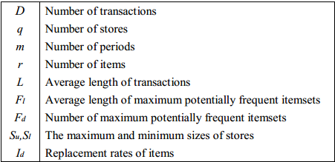

To generate the store sizes, we use two parameters, Su and Sl, to represent the
largest and smallest store sizes, respectively, and the size of store i for 1 ≤ i ≤ q,
denoted by Si, is generated by a uniform distribution between Su and Sl. We assume
that the total number of transactions and the number of products are dependent on a store’s size. In addition, we also allow the stores to have different product
replacement (turnover) ratios. In the simulation, these relationships are established by
generating m random numbers for the store i from a Poisson distribution with mean Si,
and we use the jth number, denoted by Wij , as the weight of store i in period j. Let Dij
denote the number of transactions of store i in period j. The total number of
transactions, D, is distributed to the store i, and period j is determined by :

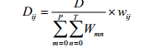

Further ,we assume that the number of products in a store is proportional to square root of its size. Thus , let IS_{i} = S_{i} for i= 1,2,3………q. Then, the number of product in store i, denote by N_{i} , is determined by the following formula :
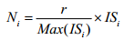

IV. Parameters Setting :

To generate the nine types of data sets shown in Table 2, we use the following
parameter values: r = 1000, D = 100K, L = 6, Fl = 4, and Fd = 1,000. For each type of
the data sets, 10 replications are generated for statistical analysis of the results.

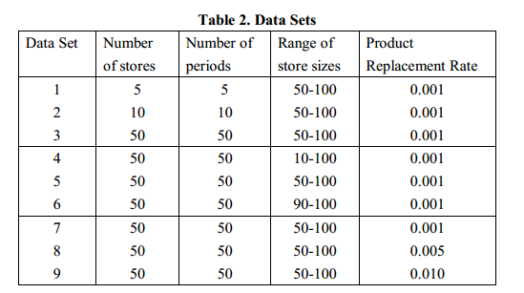

2. Title: Fast Algorithms for Mining Association Rules

The problem of discovering all association rules can be decomposed into two sub problems :

1. Find all sets of items (item sets) that have transaction support above minimum support. The support for an item set is the number of transactions that contain the item set. Item sets with minimum support are called large item sets, and all others small item sets.

2. Use the large item sets to generate the desired rules. The general idea is that if, say, ABCD and AB are large item sets, then we can determine :
if the rule AB =) CD holds by computing the ratio conf = support(ABCD)/support(AB).

if conf >= minconf, then the rule holds.

Rules were limited to only one item. In the consequent, we allow multiple items in the consequent.
The algorithms generate such multi-consequent rules.

Discovering Large Item sets :
Algorithms for discovering large item sets make multiple passes over the data. In the first pass, we count the support of individual items and determine which of them are large, i.e. have minimum support. In each subsequent pass, we start with a seed set of item sets found to be large in the previous pass. We use this seed set for generating new potentially large item sets, called candidate item sets, and count the actual support for these candidate item sets during the pass over the data.

At the end of the pass, we determine which of the candidate item sets are actually large, and they
become the seed for the next pass. This process continues until no new large item sets are found.
The Apriori Tid algorithm has the additional property that the database is not used at all for
Rather, an encoding of the candidate item sets used in the previous pass is employed for this purpose. In later passes, the size of this encoding can become much smaller than the database, thus saving much reading . We will explain these points in more detail when we describe the algorithms.

Notation: We assume that items in each transaction are kept sorted in their lexicographic order.
It is straightforward to adapt these algorithms to the case where the database D is kept normalized and each database record is a <TID, item> pair, where TID is the identier of the corresponding transaction.

We call the number of items in an item set its size, and call an item set of size k a k-item set.
Items within an item set are kept in lexicographic order.
It is straightforward to adapt these algorithms to the case where the database D is kept normalized and each database record is a <TID, item> pair, where TID is the identier of the corresponding transaction.

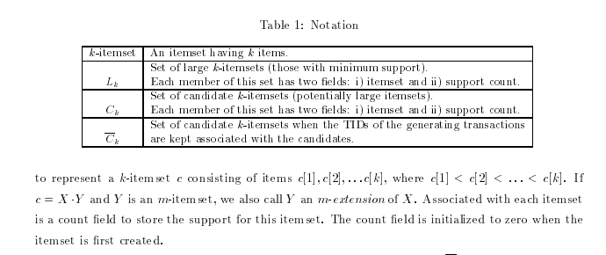

3.Title:Data Mining Using Time Series Analysis

Time Series Analysis:
Time Series Analysis concerns the analysis of data collected over time .Weekly values, monthly values, quarterly values, yearly values, etc. Usually the intent is to discern whether there is some pattern in the values collected
to date, with the intention of short term forecasting (to use as the basis of
business decisions).

yt = response of interest at time t

Applications:

The usage of time series models is twofold:
Obtain an understanding of the underlying forces and structure that produced the observed data
Fit a model and proceed to forecasting, monitoring or even feedback and feed forward control.

Time Series Analysis is used for many applications such as:
- Economic Forecasting
- Sales Forecasting
- Budgetary Analysis
- Stock Market Analysis
- Yield Projections
- Process and Quality Control
- Inventory Studies
- Workload Projections
- Utility Studies
- Census Analysis.

Standard analyses of business time series involve :

1) smoothing/trend assessment
2) assessment of/accounting for seasonality
3) assessment of/exploiting "serial correlation"

These are usually/most effectively done on a scale where the "local" variation in yt is approximately constant.

Smoothing Time Series :

There are various fairly simple smoothing/averaging methods.
Two are "ordinary moving averages" and "exponentially weighted moving averages."

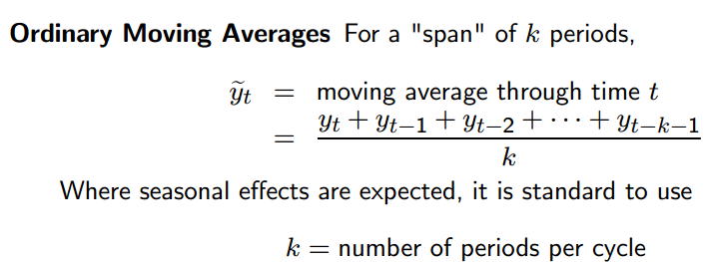

Where seasonal effects are expected, it is standard to use :

k = number of periods per n summary

We state that :
The "simple" , “average” or “mean” of all past observations is only a useful estimate for forecasting when there are no trends. If there are trends, use different estimates that take the trend into account. The average "weighs" all past observations equally.

For example, the average of the values 3, 4, 5 is 4. We know, of course, that an average is computed by adding all the values and dividing the sum by the number of values. Another way of computing the average is by adding each value divided by the number of values, or
3/3 + 4/3 + 5/3 = 1 + 1.3333 + 1.6667 = 4.

The multiplier 1/3 is called the weight. In general:

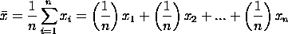

The are the weights and of course they sum to 1.

Temporal database and association rule mining :
"The time dimension is the one dimension virtually guaranteed to be present in every data warehouse, because virtually every data warehouse is a time series".
A temporal database is a database with built-in time aspects, for example a temporal data model and a temporal version of Structured Query Language (SQL).
More specifically the temporal aspects usually include valid-time and transaction-time. These attributes go together to form bi-temporal data.
Valid time denotes the time period during which a fact is true with respect to the real world. Transaction time is the time period during which a fact is stored in the database.

Let T = { . . ., t₀, t₁, t₂, . . . } be a set of times, countably infinite, over which a linear order <_{T} is defined, where t_{i} <_{T} t_{j} means t_{i} occurs before or is earlier than t_{j}([21]). We will assume that T is isomorphic to N ( natural numbers) and restrict our attention to closed intervals [t_{i}, t_{j}].

Definition :
Let R = { A₁, . . ., A_{p}} where the A_{i}’s are called items, d is a collection of subsets of R called the transaction database. Each transaction s ind is a set of items such that s Í R. The definition of R includes every item of d, independently of the moment in which it appears. Associated to s we have a time stamp t_{s} which represents the valid time of transaction s.
Every item has a period of life or lifespan in the database, which explicitly represents the temporal duration of the item information, i.e. the time in which the item is relevant to the user. The lifespan of an item A_{i} is given by an interval [t₁, t₂], with t_{1 £} t₂.
The problem of the discovery of association rules comes from the need to discover patterns in transaction data in a supermarket. But transaction data are temporal. For example, when gathering data about products purchased in a supermarket, the time of the purchase is registered in the transaction. This is called transaction time, in temporal databases jargon, which matches the valid time, corresponding to the time of the business transaction confirmation at the register.

In large data volumes, as used for data mining purposes, we may find information related to products that did not necessarily exist throughout the data gathering period. So we can find some products that, at the moment of performing that mining, have already been discontinued. There may be also new products that were introduced after the beginning of the gathering. Some of these new products should participate in the associations, but may not be included in any rule because of support restrictions. One way to solve this problem is by incorporating time in the model of discovery of association rules. We will call these rules Temporal Association Rules, one sub-product of this idea is the possibility of eliminating outdated rules, according to the user criteria. Moreover, it is possible to delete obsolete item sets as a function of their lifetime, reducing the amount of work to be done in the determination of the frequent item sets and, hence, in the determination of the rules.
The temporal association rules introduced in this paper are an extension of the non-temporal model. The basic idea is to limit the search for frequent sets of items or item sets to the lifetime of the item set’s members. For that reason, the concept of temporal support is introduced. Thus, each rule has an associated time frame, corresponding to the lifetime of the items participating in the rule . If the extent of a rule’s lifetime exceeds a minimum stipulated by the user, we analyze if the rule is frequent in that period. This concept allows us to find rules that, with the traditional frequency viewpoint, it would not be possible to discover.

TEMPORAL RULES DISCOVERY :

The discovery of all the association rules in a transaction set d can be made in two phases :

Phase 1 :
Find every set of items (item sets) X Í R that is frequent, i.e. their frequency exceeds the established minimum support s .

Phase 2 :
Use the frequent item sets X to find the rules: test for every Y Ì X, with Y ¹ Æ , if the rule X \ Y Þ Y satisfies with enough confidence, i.e. it exceeds the established minimum confidence q .

In the following paragraph, we introduce suitable modifications to support temporal association rules discovery:

Phase 1 :
Find every item set X Í R such that X is frequent in its lifespan l_{X}, i.e. s(X,l_{X}, d) ³ s and |l_{X}| _{³} t .

Phase 2 :
Use the frequent item sets X to find the rules: verify for every Y Ì X, with Y ¹ Æ , if the rule X \ Y Þ Y [t₁, t₂] is satisfied with enough confidence, in other words, exceeds the minimum confidence q established in the interval [t₁, t₂].

System Architecture

3.1 Design Approach
Analysis based applications are built using several components connected to one another, each providing a specific functionality. Components that perform similar types of functions are generally grouped into layers. These layers are further organized as a stack in which components in a higher layer use the services of components in the layer below. A component in a given layer will generally use the functionality of other components in its own layer or the layers below it. The diagram below shows a popular layer structure for an analysis application.

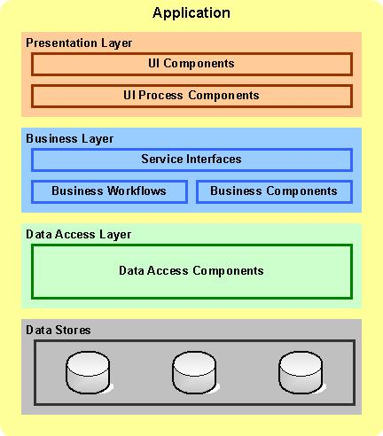
Fig: 3.1.1

- Presentation Layer: The presentation layer contains components needed to interact with the user of the application. Examples of such components are web pages, rich-client forms, user interaction process components etc.

- Business Layer: The business layer encapsulates the core business functionality of the application. Simple business functions can be implemented using stateless components whereas complex long running transactions can be implemented using stateful workflows. The business components are generally front-ended by a service interface that acts as a facade to hide the complexity of the business logic. This is commonly known as Service-Oriented Architecture (SOA).

- Data Access Layer: The data access layer provides a simple API for accessing and manipulating data. The components in this layer abstract the semantics of the underlying data access technology thus allowing the business layer to focus on business logic. Each component typically provides methods to perform Create, Read, Update, and Delete (CRUD) operations for a specific business entity.

- Data Stores: Enterprise applications store their data in one or more data stores. Databases and file systems are two very common types of data stores.

Note that layers are simply logical groupings of components that make up an application. How these layers are deployed on physical machines can vary widely depending on several factors. In the very simplistic scenario all the layers can reside on one machine. In a slightly more complex scenario, the presentation layer can reside on one machine, the business and data access layers on a second machine and the database on a third machine. More elaborate scenarios are possible. For example, a high traffic web site can deploy the presentation layer on a web farm consisting of tens of machines.

3.2 Proposed System Architecture
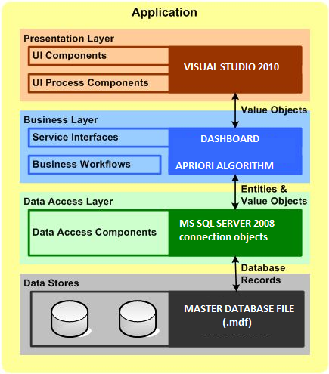

3.2.1 Presentation Layer: Our UI consists of an environment run in Visual Studio 2010 .It is supported by user-friendly buttons and check boxes to help even the lay-man use the application. Graphs, pie-charts and bar charts are also displayed as part of displaying strong rules and frequently appearing item-sets.

3.2.2: Business Layer: The business layer generated by our application consists primarily of services that generated from classes defined in the model. These services can be used directly as application code. Apriori algorithm is applied with the combination of time series to analyze the data with their time stamps.

3.2.3: Data Access Layer: To connect to the database, SQL SERVER 2008 connection objects are used. Using the basic connection strings of the SQL server, the database is connected to the application.

3.2.4: Data Stores : Multiple-databases from different locations are connected together through relational databases. The database are updated real-time when transactions are added and the admin can see these changes in the database. An MDF file database is generated to export to remote locations to run on different local machines.

3.3 REPRESENTATION OF ANALYSIS

Dashboard is:

"An easy to read, often single page, real-time user interface, showing a graphical presentation of the current status (snapshot) and historical trends of an organization’s key performance indicators (KPIs) to enable instantaneous and informed decisions to be made at a glance."

Dashboards often provide at-a-glance views of KPIs relevant to a particular objective or business process (e.g. sales, marketing, human resources, or production). The term dashboard originates from the automobile dashboard where drivers monitor the major functions at a glance. Dashboards give signs about a business letting you know something is wrong or something is right. The corporate world has tried for years to come up with a solution that would tell them if their business needed maintenance or if the temperature of their business was running above normal. Dashboards typically are limited to show summaries, key trends, comparisons, and exceptions.

There are four Key elements to a good dashboard:
1. Simple, communicates easily
2. Minimum distractions…it could cause confusion
3. Supports organized business with meaning and useful data
4. Applies human visual perception to visual presentation of information

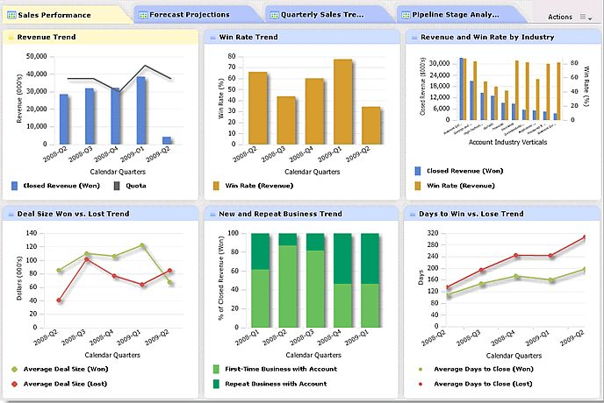

Dashboards can be broken down according to role and are either strategic, analytical, operational or informational. Strategic dashboards support managers at any level in an organization and provide the quick overview that decision makers need to monitor the health and opportunities of the business. Dashboards of this type focus on high level measures of performance, and forecasts.

Strategic dashboards benefit from static snapshots of data (daily, weekly, monthly, and quarterly) that are not constantly changing from one moment to the next. Dashboards for analytical purposes often include more context, comparisons, and history, along with subtler performance evaluators.
Analytical dashboards typically support interactions with the data, such as drilling down into the underlying details.

Dashboards for monitoring operations are often designed differently from those that support strategic decision making or data analysis and often require monitoring of activities and events that are constantly changing and might require attention and response at a moment's notice.

Balanced Scoreboards and Dashboards have been linked together as if they were interchangeable. However, although both visually display critical information, the difference is in the format: Scoreboards can open the quality of an operation while dashboards provide calculated direction. A balanced scoreboard has what they called a “prescriptive” format. It should always contain these components :
• Perspectives – groupings of high level strategic areas
• Objectives – verb-noun phrases pulled from a strategy plan
• Measures – also called Metric or Key Performance Indicators (KPIs)
• Spotlight Indicators – red, yellow, or green symbols that provide an at-a-glance view of a measure’s performance.

Each of these sections ensures that a Balanced Scorecard is essentially connected to the businesses critical strategic needs.
The design of a dashboard is more loosely defined. Dashboards are usually a series of graphics, charts, gauges and other visual indicators that can be monitored and interpreted.

Even when there is a strategic link, on a dashboard, it may not be noticed as such since objectives are not normally present on dashboards. However, dashboards can be customized to link their graphs and charts to strategic objectives.

3.4 Proposed Algorithms

Apriori Algorithm:

Apriori is a classic algorithm for learning association rules. Apriori is designed to operate on databases containing transactions (for example, collections of items bought by customers, or details of a website frequentation).

As is common in association rule mining, given a set of item sets (for instance, sets of retail transactions, each listing individual items purchased), the algorithm attempts to find subsets which are common to at least a minimum number C of the item sets.

Apriori uses a "bottom up" approach, where frequent subsets are extended one item at a time (a step known as candidate generation), and groups of candidates are tested against the data. The algorithm terminates when no further successful extensions are found.

The purpose of the Apriori Algorithm is to find associations between different sets of data. It is sometimes referred to as "Market Basket Analysis". Each set of data has a number of items and is called a transaction. The output of Apriori is sets of rules that tell us how often items are contained in sets of data.

Apriori uses breadth-first search and a Hash tree structure to count candidate item sets efficiently. It generates candidate item sets of length k from item sets of length k-1 .Then it prunes the candidates which have an infrequent sub pattern.

According to the downward closure lemma, the candidate set contains all frequent -length item sets. After that, it scans the transaction database to determine frequent item sets among the candidates.

Bottom-up subset exploration (essentially a breadth-first traversal of the subset lattice) finds any maximal subset S only after all 2^{|s|}-1 of its proper subsets.

Pseudo Code :

The pseudo code for the algorithm is given below for a transaction database T, and a support threshold of .

T - is a multiset.
C_{k} - candidate set for level k.

Generate() - generate the candidate sets from the large itemsets of the preceding level, heeding the downward closure lemma.

Count[c] accesses a field of the data structure that represents candidate set c which is initially assumed to be zero.

Many details are omitted below, usually the most important part of the implementation is the data structure used for storing the candidate sets, and counting their frequencies.

Apriori
large 1-itemsets
while
for transactions
for candidates
return 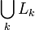
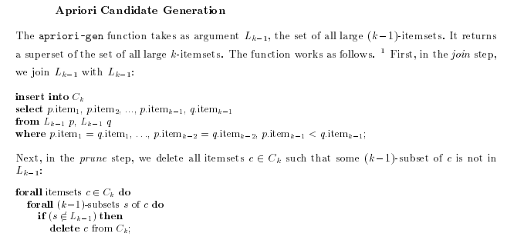

System Modeling

4.1 RELATIONAL DATABASE MODEL

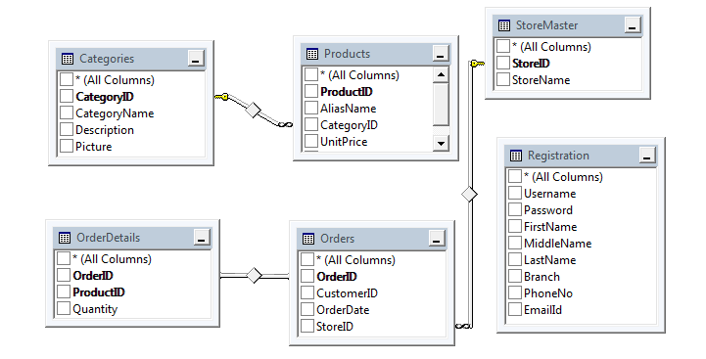
Fig: 4.1.1
We have created a Relational Databsse model since it is the most efficient way of managing large data itemsets.
Relational Database: A relational database has a collection of tables of data items in contrast to only one table as the database, and in contrast to other models which also have many tables in one database. The tables in a relational database are formally described and organized using the relational model.
In the relational model each table schema must identify a primary column used for identifying a row called the primary key (YELLOW KEYS).

4.2 Activity Diagram
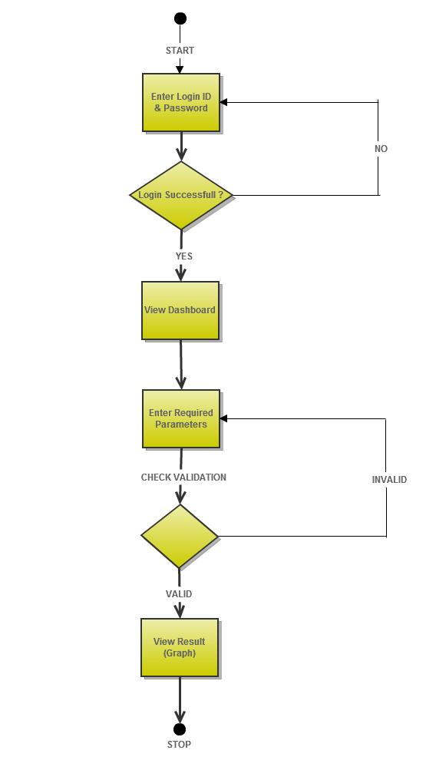
Fig 4.2.1

The above activity represents the activity performed by the administrator as he starts using the tool. The login of the admin is validated. After successful login, the admin can see the current status of the multi-store databases.
The admin can then enter various parameters like support , confidence and other time-related constraints .
After this, the results are displayed to the admin in the form of graphs and charts. Thus he can observe his sales pattern efficiently.

4.3 Use Case Diagram

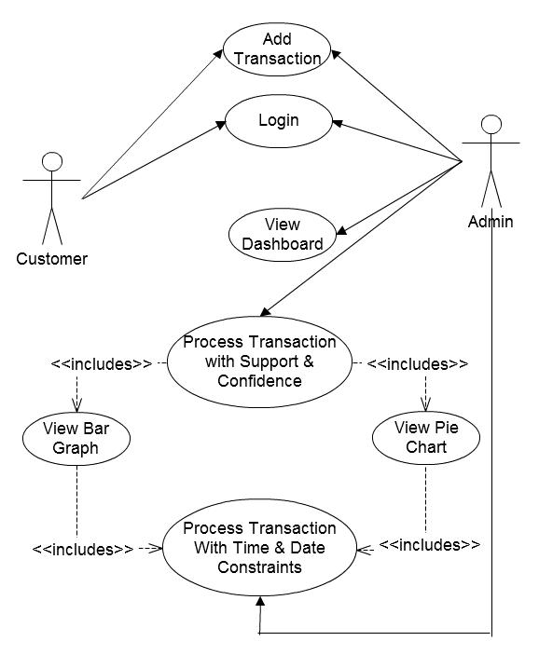
Fig: 4.3.1

The use case diagram has two actors, the customer and the admin. Both these actors can login and add transactions.
The admin can also view the dashboard , process the transactions with various constraints like the weekday list , date time stamps and view the graphs.

4.4 Sequence Diagram

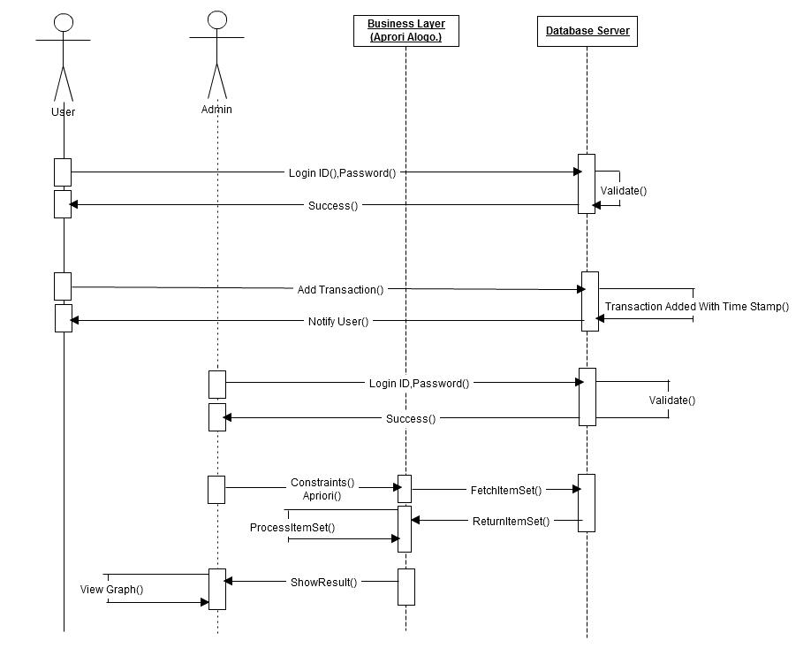
Fig: 4.4.1
Sequence diagram shows the flow of activity on the basis of time. User will login and his login data will be validated by the data server and notification will be given on successful login. The user will then add transactions and it will be added in the database server with the timestamp and the user will be notified.
The administrator can login using his credentials and add transactions in the database. The admin will then pass the required parameters to the business layer to process it. The business layer will fetch the corresponding item sets and process it. The admin can then view the results and view the graph.

5. Development and Implementation

5.1 Tools and Technologies Implemented

We have implemented the Apriori algorithm for our Windows based Market Basket Analysis. Our application is based on Software Oriented Architecture.

Tools Used for System Development:

Serial No. | Tool/ Language | Purpose
1 | Microsoft Visual Studio 2010 | With Visual Studio 2008, organizations will find it easier than ever before to capture and  analyze information to help them make effective business decisions
2 | Microsoft SQL Server 2008 | MySQL is a relational database management system (RDBMS) that runs as a server by providing multi-user access to a number of databases.
3 | Visual C Sharp | It is a programming language that has been used for implementation.

MICROSOFT VISUAL STUDIO 2010

Microsoft Visual Studio 2010 delivers on the Microsoft vision of smart client applications by enabling developers to rapidly create connected applications that deliver the highest quality, rich user experiences. With Visual Studio 2010, organizations will find it easier than ever before to capture and analyze information to help them make effective business decisions. Visual Studio 2010 enables organizations of every size to rapidly create more secure, manageable, and reliable applications that take advantage of Windows Vista and the 2007 Office system.
Moreover, Visual Studio 2010 provides advanced development tools, debugging features, database functionality, and innovative features for quickly creating tomorrow's cutting-edge applications across a variety of platforms. Visual Studio 2008 includes enhancements such as visual designers for faster development with the .NET Framework 3.5, substantial improvements to Web development tools and language enhancements that speed development with all types of data. The program also provides developers with all the tools and framework support required to create compelling, expressive, AJAX-enabled Web applications. Developers will be able to take advantage of these rich client-side and server side, frameworks to easily build client-centric Web applications that integrate with any back-end data provider, run within any modern browser, and have complete access to ASP.NET application services and the Microsoft platform.
MICROSOFT SQL Server 2008

Microsoft SQL Server is a relational database management system developed by Microsoft. As a database, it is a software product whose primary function is to store and retrieve data as requested by other software applications, be it those on the same computer or those running on another computer across a network (including the Internet). There are at least a dozen different editions of Microsoft SQL Server aimed at different audiences and for different workloads (ranging from small applications that store and retrieve data on the same computer, to millions of users and computers that access huge amounts of data from the Internet at the same time).

SQL Server 2008 aims to make data management self-tuning, self-organizing, and self-maintaining with the development of SQL Server Always On technologies, to provide near-zero downtime. SQL Server 2008 also includes support for structured and semi-structured data, including digital media formats for pictures, audio, video and other multimedia data. In current
versions, such multimedia data can be stored as BLOBs (binary large objects), but they are generic bit streams. Intrinsic awareness of multimedia data will allow specialized functions to be performed on them. According to Paul Flessner, senior Vice President, Server Applications, Microsoft Corp., SQL Server 2008 can be a data storage backend for different varieties of data: XML, email, time/calendar, file, document, spatial, etc as well as
perform search, query, analysis, sharing, and synchronization across all data types.

C Sharp:

C# (pronounced "C sharp") is a programming language that is designed for building a variety of applications that run on the .NET Framework. C# is simple, powerful, type-safe, and object-oriented. The many innovations in C# enable rapid application development while retaining the expressiveness and elegance of C-style languages.
Visual C# is an implementation of the C# language by Microsoft. Visual Studio supports Visual C# with a full-featured code editor, compiler, project templates, designers, code wizards, a powerful and easy-to-use debugger, and other tools. The .NET Framework class library provides access to many operating system services and other useful, well-designed classes that speed up the development cycle significantly.

5.2 Database Implementation

The database has been implemented using Microsoft SQL Server 2008. A relational database has been designed to manage multiple stores in a single database.
The following tables were made:-

Primary Key: CategoryID Primary Key: OrderID
Foreign Key: CustomerID
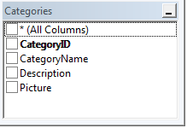 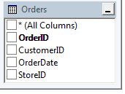

Primary Key: OrderID, ForiegnID Primary Key: Username
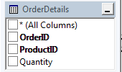 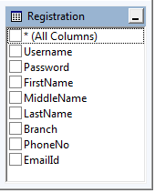

Primary Key: ProductID
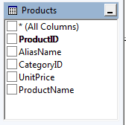

5.3 Work Break down Structure

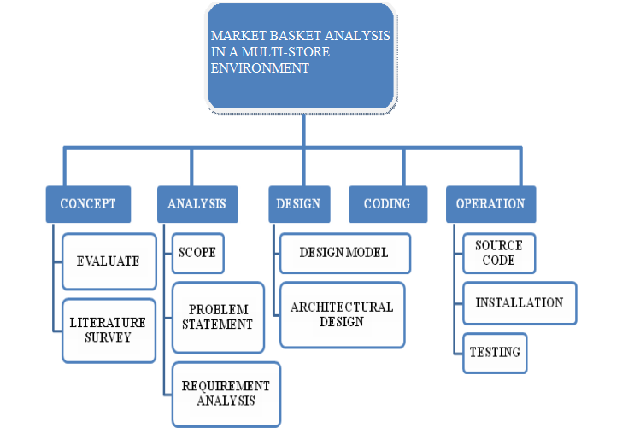
Fig: 5.3.1

TASK DISTRIBUTION
The work breakdown structure (WBS) for our project, Market Basket Analysis in a Multi-Store Environment is a deliverable, oriented decomposition of our project into smaller components. It defines and groups our project's discrete work elements in a way that helps to organize and define the total work scope of our project.

5.4 System Implementation
SCREEN SHOTS
HOMESCREEN
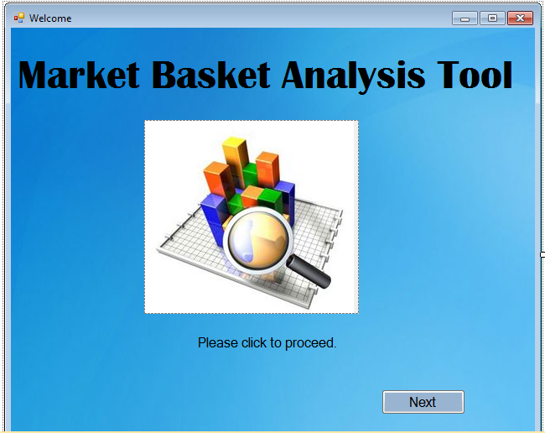
Fig: 5.4.1

LOGIN PAGE :

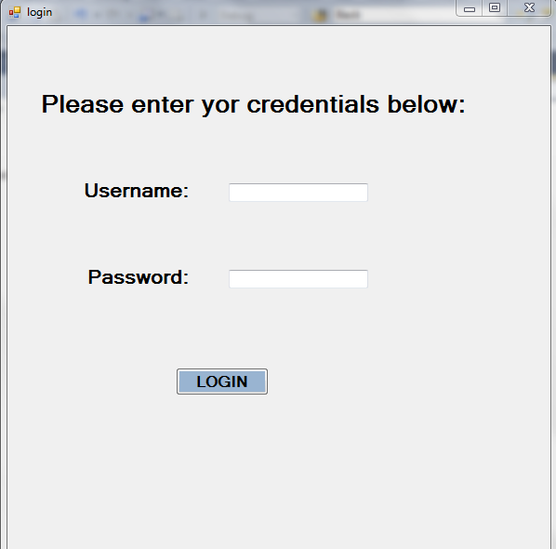
Fig: 5.4.2

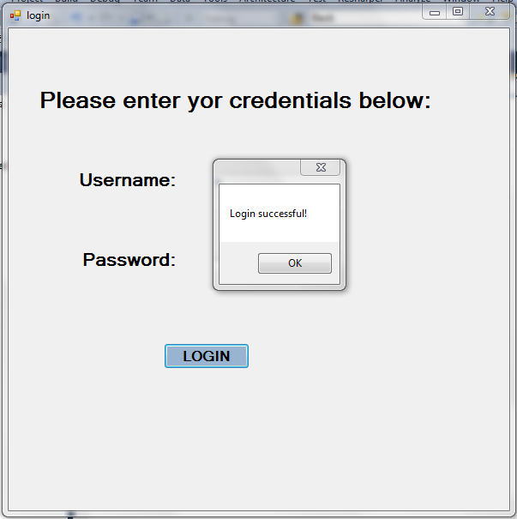
Fig: 5.4.3

WELCOME ADMIN AFTER LOGIN :

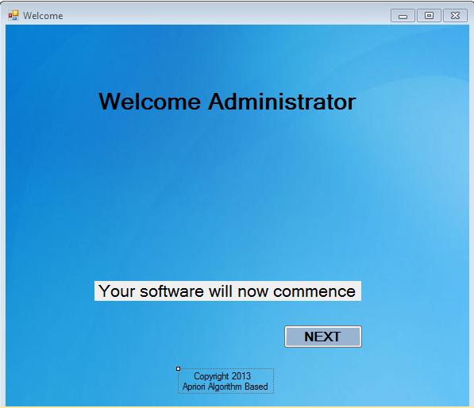
Fig: 5.4.4

BLUE DASHBOARD :

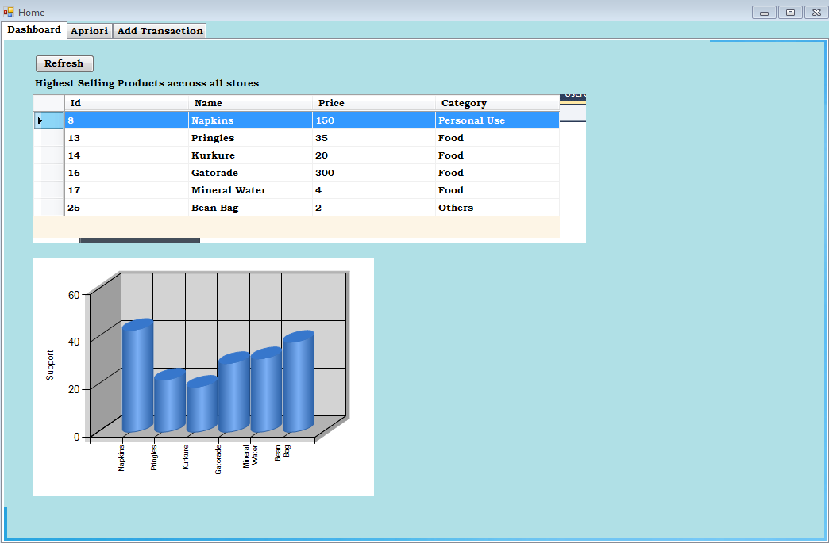
Fig: 5.4.5

ENTER CONSTRAINTS :

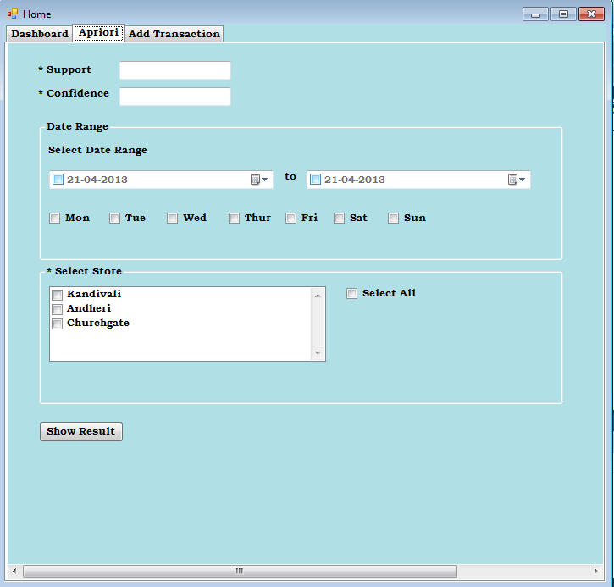
Fig: 5.4.6

ADD TRANSACTIONS:

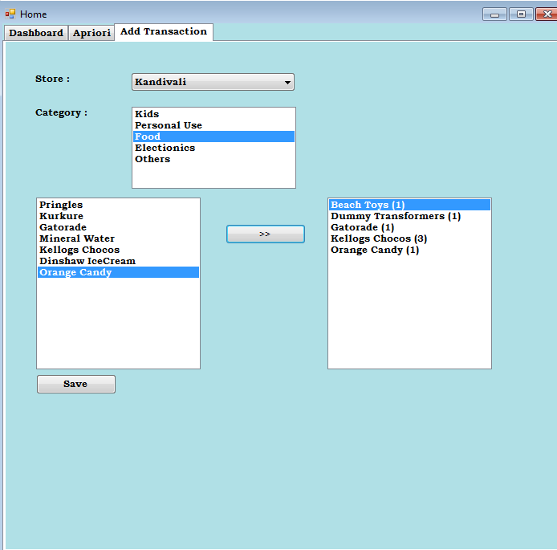

Fig: 5.4.7

TRANSACTION SUCCESSFULLY ADDED :

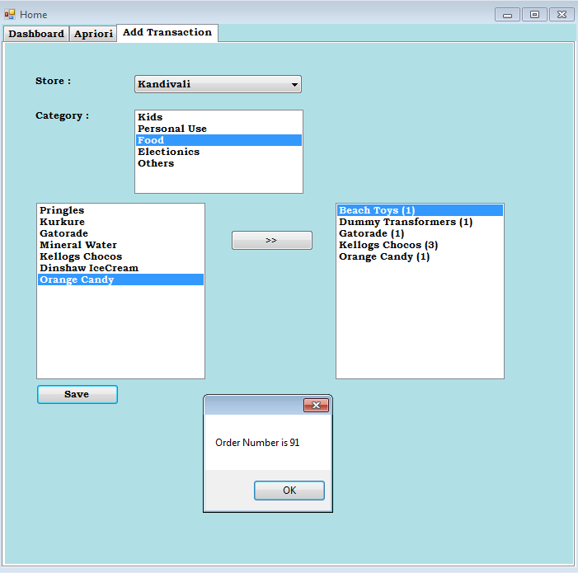

Fig: 5.4.8

VIEW RESULT 1 (BAR GRAPH) :

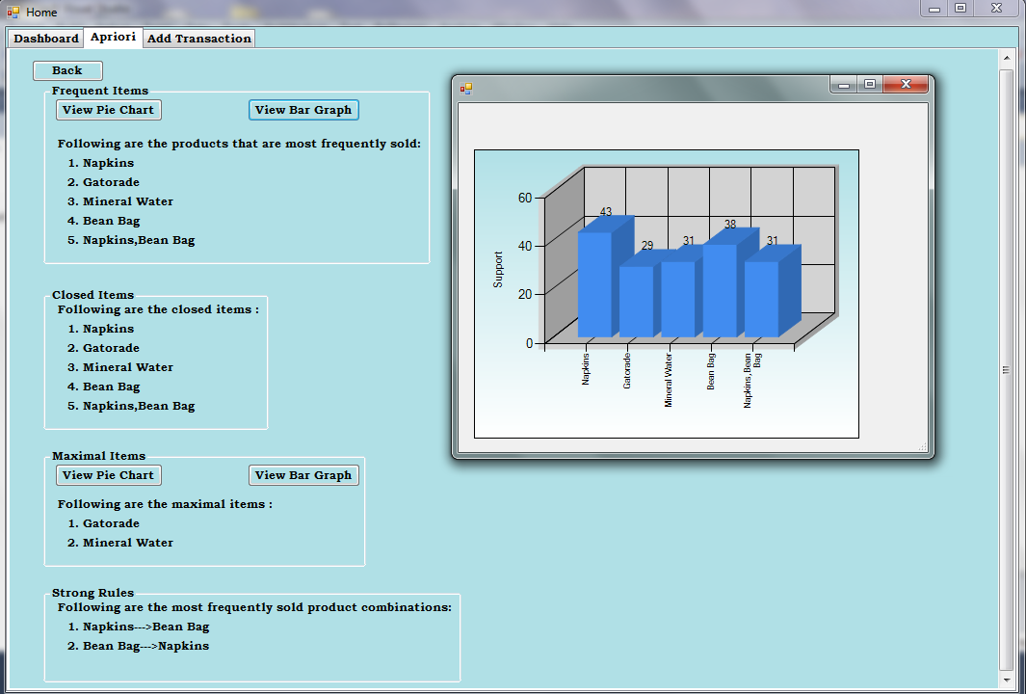
Fig: 5.4.9

VIEW RESULT 2(VIEW PIE CHART):

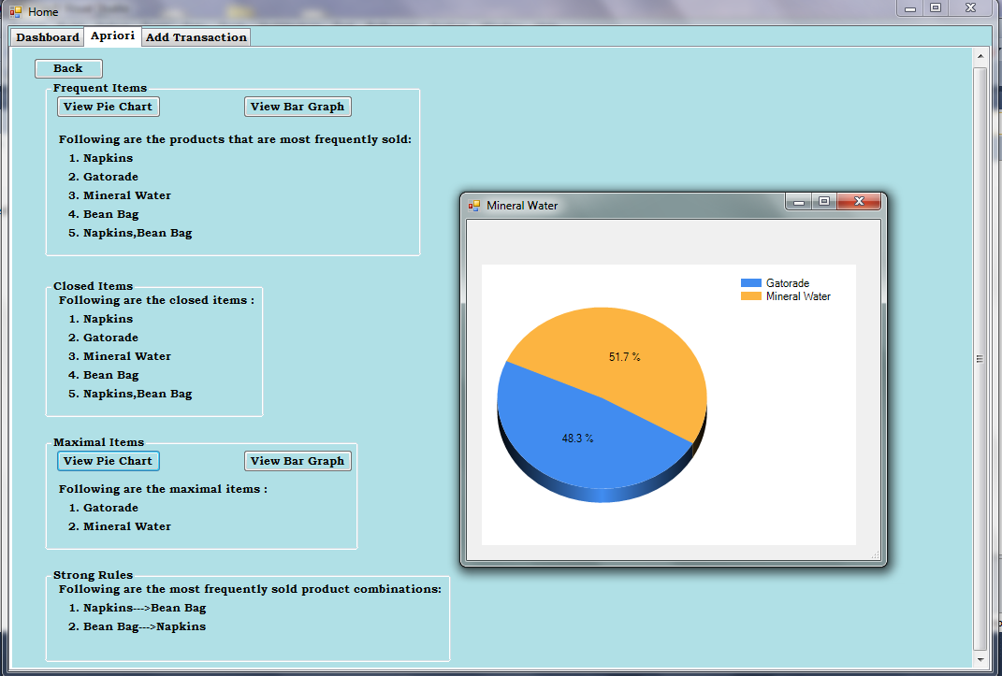
Fig: 5.4.10

VIEW RESULT 3 (FOR MAXIMAL ITEMS):

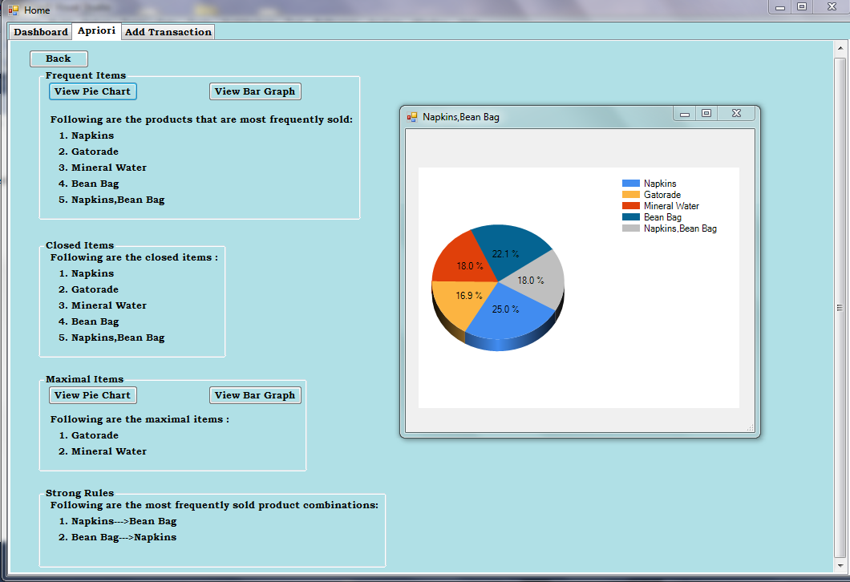
Fig: 5.4.11

6. Testing

We tested our application on a machine that has a configuration of an i3 core processor, n series 3Ghz, 2GB RAM in Microsoft Visual Studio 2010 and Microsoft SQL Server 2008.
6.1 Unit Testing
Sr No. | Test Case | Expected Result | Actual Result
1. | User Enters his LoginID and Password | If the credentials match, then he is logged into the application. | Same as expected
2 | User makes transactions | The transaction made should be added into the database with the time stamp and his order number is displayed in a dialog box | Same as expected
3 | Admin enters his LoginID and Password | If the credentials match, then he is logged into the application. | Same as expected
4 | Admin views the dashboard | The most frequent items sold across all the stores is calculated and displayed in the form of a DataGrid and a Bar Graph | If the transactions in the database have a support of 50% then corresponding items are displayed otherwise its empty
5. | Admin enters a character value of the Support parameter | Since only integer values are allowed, the application must show an error | Error: Input string not in the correct format
6 | Admin enters integer values for Support and Confidence | The result must be displayed | Error :Object reference not set to an instance of an Object
7 | Admin enters all the values of the parameters | Corresponding to the parameters the result must be displayed | Same as Expected
8 | Admin does not select a particular store | The application must show a Dialog Box which says | Select at-least one store of the following
9 | Admin enters a very high value of support | Result should be displayed according to the transactions | Since there are no transactions with a high support the list generated is empty
10 | Admin does not select the From Date | Error: Please select the From Date and the End Date | Same as expected.
11 | Admin does not select the End Date | Error: Please select the From Date and the End Date | Same as expected.
12 | Admin adds a few transactions to the database | Data should be added along with the time stamp | Same as expected
13 | Admin clicks on the View Pie Graph Button | The admin can view the results in the form of a pie graph | Same as expected.
14 | Admin clicks on the back button after viewing the results | The main tab of Apriori should open | Same as expected.
15 | Admin clicks on the dash board tab after viewing the Adding transactions | The dashboard tab must be refreshed showing new results if any | The dash board still shows the old results

6.2 System Testing

Sr. No. | Test Case | Expected Result | Actual Result
1 | Admin enters his LoginID and Password | The Admin is logged in the application and can proceed with the analysis he wants to make | Same as expected
2 | Enter the values of the parameters | According to the values of the parameters entered the results are calculated and displayed in the form of a Datagrid showing Frequent Item sets , Closed Items , Maximal Items and the Strong Rules generated. | Same as expected.
3 | Admin adds a few transactions to the database | Transactions successfully added and the Order number is displayed in a dialog box | Same as expected.
4 | Admin clicks on the dash board tab after viewing the Adding transactions | The dashboard tab must be refreshed showing new results | Same as expected.

7. Results and Analysis

After applying apriori algorithm on the transactional database in combination with time series analysis we can come across very interesting sales trends, patterns and customer behavior.
When the support of 35% and confidence of 50% were passed as parameters to the algorithm to do a weekend analysis, following associations were observed :
1) Customers who bought Beach Toys were also found to buy sunglasses.
2) Customers who bought Remote Controlled Cars also bought Rechargeable Batteries.
Thus, from the above patterns we can make strategic changes in the product placement in the multi store such that there is an increase in the overall sales.
When the support of 20% and a confidence 30% were passed as parameters to the algorithm to do an analysis for a short period of time , following things are observed:

- Frequent Items sold

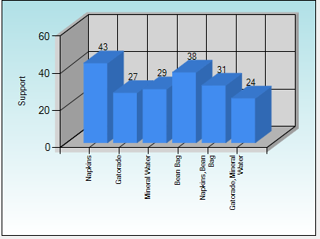
Fig: 7.1

- Maximum items old
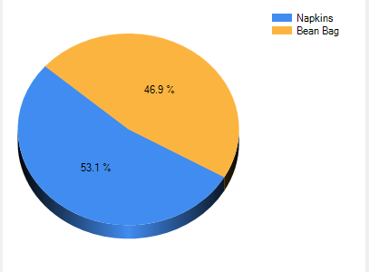
Fig: 7.2

8. Conclusion

The project demonstrates the use of Apriori Algorithm to project the generation of various association rules.

Traditional Associations rule mining was introduced in 1993 by Agrawal fail in multi store environment.

To overcome this, store-chain association rule is proposed where store and period are involved.

A simulation is used to compare the proposed and traditional methods. We have seen that algorithm is computationally efficient.

The outcomes would be used for general or local marketing strategies. Moreover for product procurement, inventory, distribution strategies for store-chain.

This is the promising research area in data mining ,lot of work is left to do like generating store-chain association rules accurately and efficiently, to extend this algorithm for multiple levels in distributed environment.

9.Future Scope

Recent advances in the ability to collect and process transaction-level (TLog) data, coupled with exponential increases in computational power and much cheaper storage, all made it possible for grocers, c-stores and other retailers to build in-house or purchase market basket analytic software. Unfortunately, almost all of these solutions deliver non-actionable insights based on affinity analysis.
The healthcare practitioners , often feel as though they are drowning in a sea of gathered data that continues to swell. To help the life sciences community sustain the pace of discovery -- and deliver next-generation treatments more quickly and affordably -- the industry is embracing advanced data-mining techniques and technologies.
Market basket analysis of futuristic models use statistical analysis, artificial intelligence, and machine learning technologies to identify patterns that could not be found by manual analysis alone.
Continued maturation of the technology in recent years has expanded its capabilities and stature as a vital tool in the drug discovery process. New data-mining applications feature expanded analytics, user-friendly interfaces, and powerful algorithms that allow researchers to analyze structured and unstructured data. “With training, data mining can now be done on a personal computer with a number of different commercial and open source data mining software packages.”
In a healthcare delivery environment, providers can use predictive analytics to forecast medical outcomes; find factors associated with the highest-cost patients, doctors, and care facilities; and even detect insurance fraud. In addition, pharmaceutical manufacturers can use the technology to increase the efficiency and effectiveness of their marketing initiatives, predicting which doctors are most likely to prescribe new drugs and identifying patients most likely to be high-value customers.
Predictive analytics isn’t a panacea. “Garbage in; garbage out” still applies -- but it’s based on the concept that some advanced (and highly automated) analysis is better than no analysis.
Text mining enables, for the first time, automated integration of unstructured clinical data and structured genomic data. There is tremendous data in patient files that -- when anonymized and harvested, combined with genomic, proteomic, and phenotypic data, and then data-mined -- will yield amazing new discoveries. For example, a healthcare facility may have extensive information on a local population’s health histories, eating, and exercise habits. With text and data mining, it could harvest and analyze this information, potentially identifying patients with the greatest risk for chronic long-term hypertension, cancer, and many other diseases.

10.Limitations

The concept of market basket analysis, so simple yet so ingenious, has mesmerized merchants and marketers for at least the last two decades. Yet in its traditional form, known as affinity analysis, or what do customers buy when they also buy item X, it has also been quite opaque to the insights if the client mind. This is because affinity analysis attributes correlation, as opposed to causation, never delivering on its promise of getting inside the shopper’s mind.
Affinity analysis tells us little about optimal pricing (e.g. should we discount diapers so that customers come in, buy discounted diapers but also grab a pack of beer with a healthy margin?), optimal promotional strategy (e.g. should we place diapers, beer or both in the ad?) or optimal merchandising tactics (e.g. which product should be placed on the end cap?).

REFERENCES

- Temporal databases and association rules
http://www.acm.org/conferences/sac/sac2000/Proceed/FinalPapers/DB-04/
- Dashboard concepts
http://en.wikipedia.org/wiki/Dashboard_(business)
- Market basket analysis in a multi store environment
http://moe.ecrc.nsysu.edu.tw/Chinese/DatabaseC/10-1_Chen.pdf
- Leading Practices in Market Basket analysis
http://factpoint.com/pdf2/1.pdf
- Aproiri algorithm and time series analysis
http://www.cs.sunysb.edu/~cse634/lecture_notes/07apriori.pdf
- Time series analysis methods ( simulation and modeling by law and kelton )
- Advance association algorithms ( data mining by margaret dunham).

