**NAME: KSHATRIYA RONAK OMPRAKASH**

**COURSE: SOFTWARE TESTING (MANUAL AND AUTOMATION)**

**ASSIGNMENT: Module – 5 (Selenium IDE)**

**1. What is Automation Testing?**

Automation testing is a software testing technique that uses tools and scripts to automatically validate software functionality and ensure it meets requirements. It's also known as test automation or automated QA testing.

Automation testing allows organizations to run tests at a faster pace without the need for human testers. It's more efficient than manual testing, which takes longer.

Some tools used for automation testing include:

* **Selenium**: An open-source tool for testing web applications across various browsers
* **QTP (Quick Test Professional)**: A functional testing tool for web and desktop applications
* **Sikuli**: A GUI-based automation tool that interacts with web page elements using screenshots
* **JUnit**: A popular unit testing framework for Java

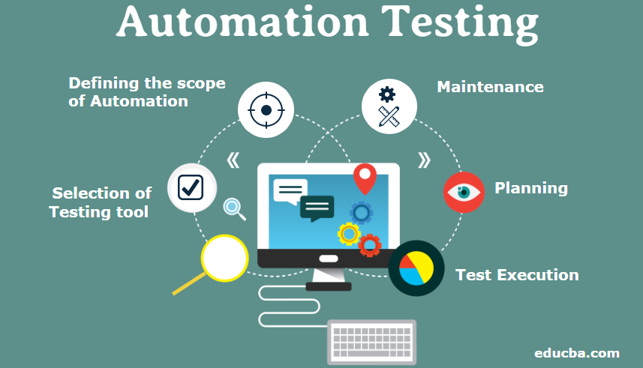

**2. Which Are The Browsers Supported By Selenium Ide?**

Browsers Supported in Selenium WebDriver

* Google Chrome.
* Mozilla Firefox.
* Safari.
* Internet Explorer.
* Microsoft Edge.



**3.** What are the benefits of Automation Testing?

**Core Benefits of Automation Testing**

* Saving Costs.
* Faster Feedback Loop.
* Better Allocation of Resources.
* Guarantees Higher Accuracy.
* Increased Test Coverage.
* Detects bugs earlier.
* Test at Scale.
* Maximizes ROI.

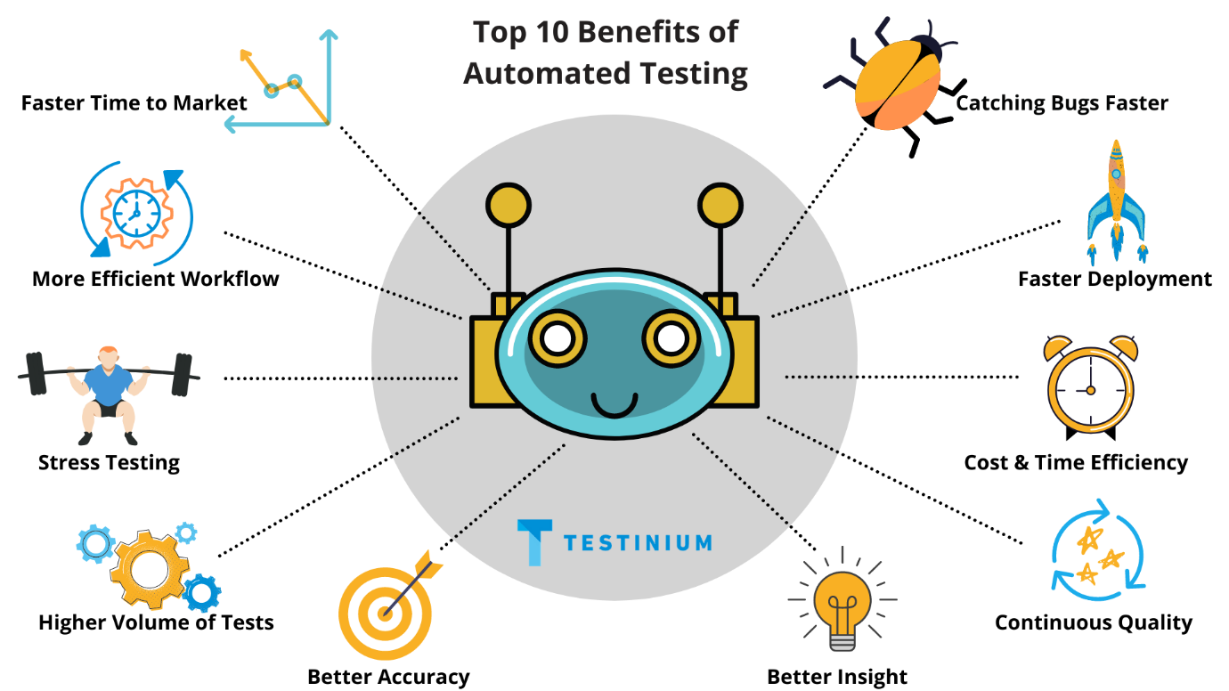

**4. What are the advantages of Selenium?**

**Advantages of Selenium for Automated Testing**

* Language and Framework Support. ...
* Open Source Availability. ...
* Multi-Browser Support. ...
* Support Across Various Operations. ...
* Ease of Implementation. ...
* Reusability and Integrations. ...
* Flexibility. ...
* Parallel test execution and faster market launch.

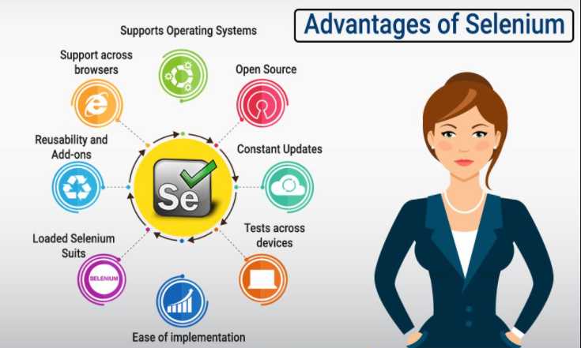

**5. Why testers should opt for Selenium and not QTP?**

