Install golang on Ubuntu 18.04 desktop

The Go project's official download page is at https://golang.org/dl/

There are some other options for Debian based systems like Ubuntu. These packages were not created by the Go project, but make installation process easy.

$ sudo add-apt-repository ppa:gophers/archive
$ sudo apt-get update
$ sudo apt-get install -y golang-go
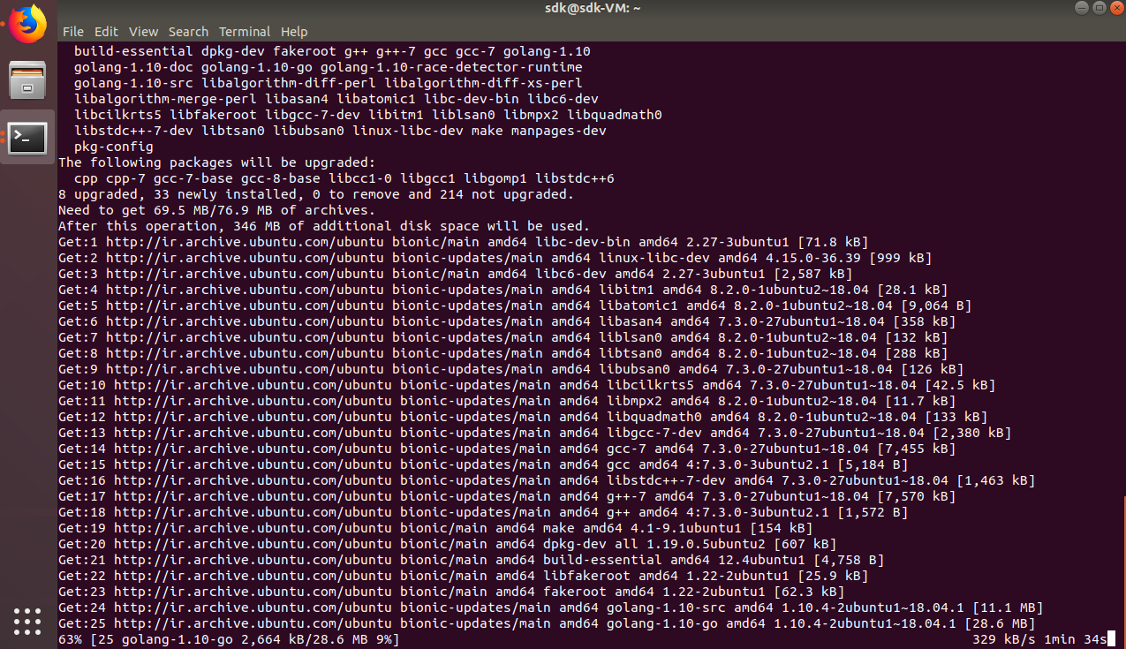
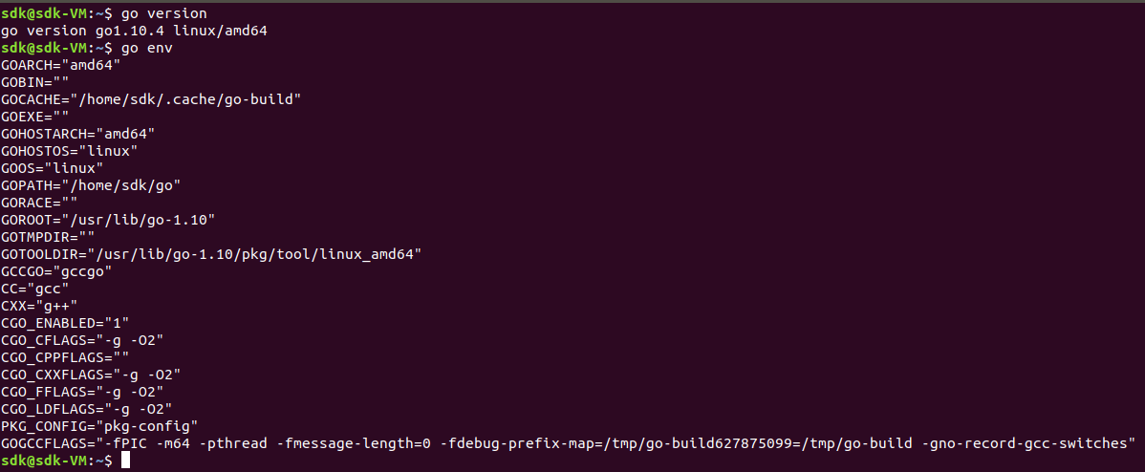
$ go version
$ go env

Install Visual Studio Code on Ubuntu 18.04 desktop

The Visual Studio Code official download page is at https://code.visualstudio.com/Download

Open your browser and go to the Visual Studio Code download page.
Click on the .deb link for Linux 64 Bit.
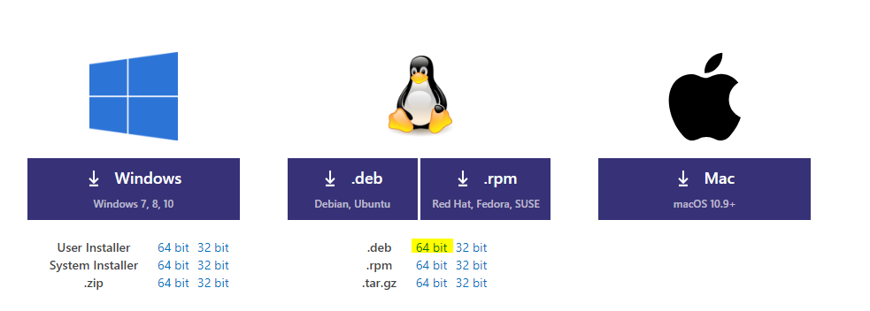
If prompted, click on Save File.
After the file downloads, open your terminal and go to the Downloads folder.

$ cd ~/Downloads

Next, run this command to install Visual Studio Code

$ sudo dpkg i code_x.xx.x-xxxxxxxxxx_amd64.deb

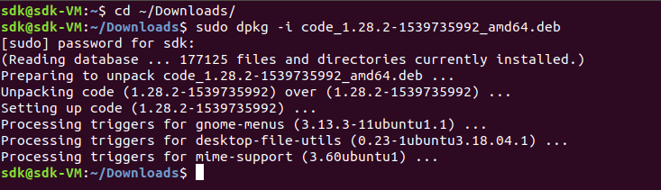

Visual Studio Code in now installed.
Click on the applications icon and type visual studio code in the Search Box to find it.

Install Go extension and Go tools on VS Code

Open Visual Studio Code select extension tab search for go and install Go extension

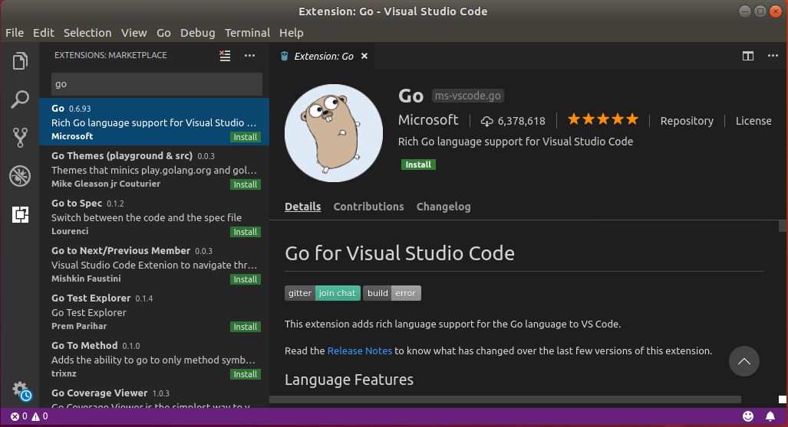

Press Ctrl+Shift+P to open command bar and type Go: Install/Update Tools .
Select all packages and perss OK to install

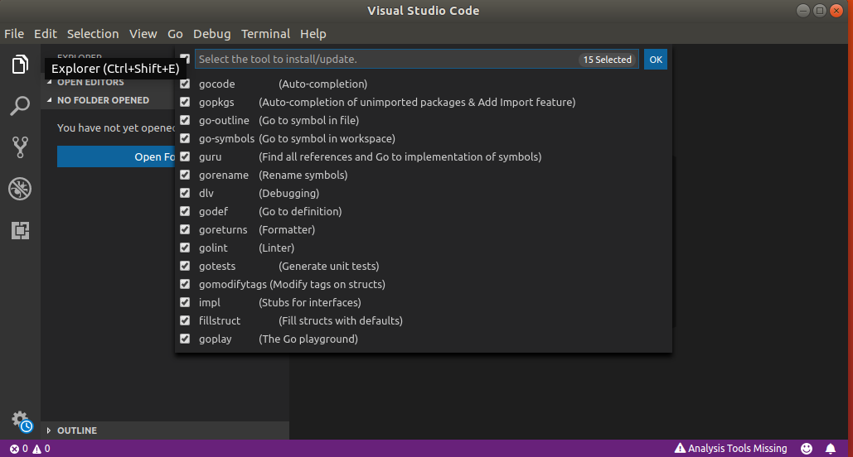

Clone sdk-river project repository

Make sure you have git, you can install it by this command if its not already installed.

$ sudo apt install git

Now clone project repository from http://git.ronaksoftware.com/ronak/sdk-river

$ mkdir -p ~/go/src/git.ronaksoftware.com/ronak/
$ cd ~/go/src/git.ronaksoftware.com/ronak/
$ git clone http://git.ronaksoftware.com/ronak/sdk-river
$ cd sdk-river/
$ git branch -a
$ git checkout user/q6int
$ git pull --all

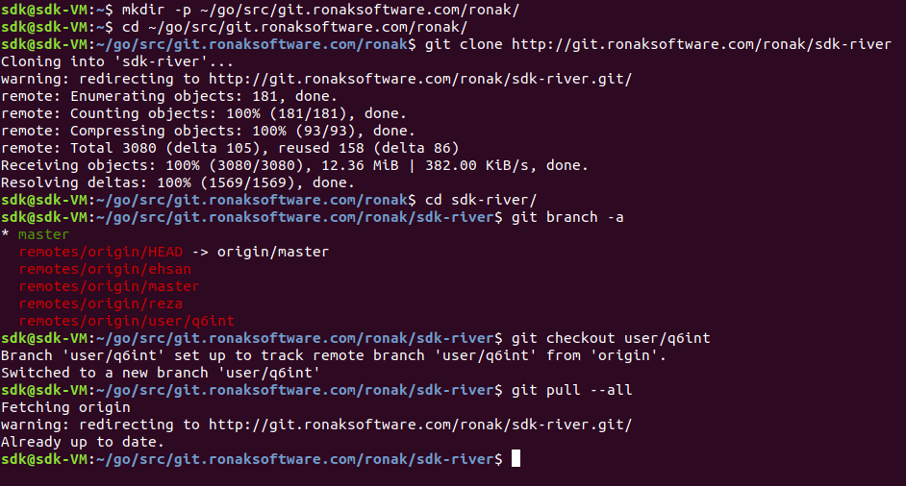

Install/Update govendor and dependencies

Install govendor and update dependencies by this commands

$ cd ~/go/git.ronaksoftware.com/ronak/sdk-river
$ rm -R vendor
$ env GIT_TERMINAL_PROMPT=1 go get -v --insecure
$ sudo apt-get install govendor
$ govendor init
$ govendor remove +u
$ govendor add +e
$ govendor update +v

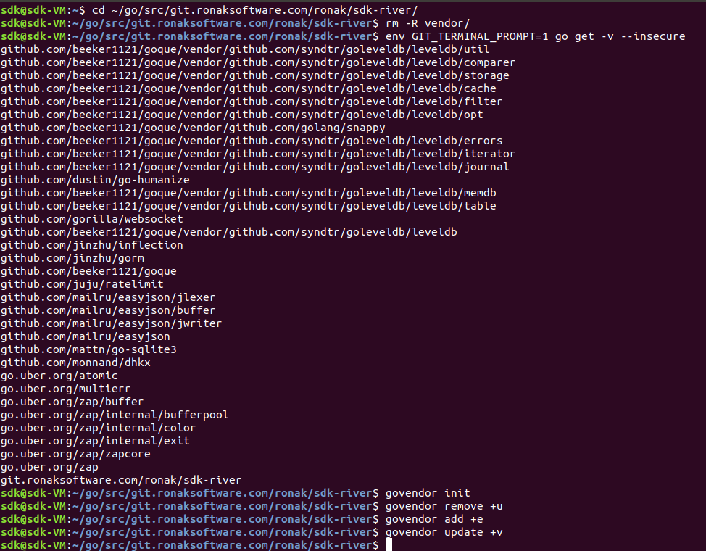

Project and it’s all dependencies has been pulled and installed.

In order to open project with Visual Studio Code open terminal and enter this command

$ code ~/go/src/git.ronaksoftware.com/ronak/sdk-river

SDK-River Flow Diagram

This schema displays the project structure / units and how they interact with each other.
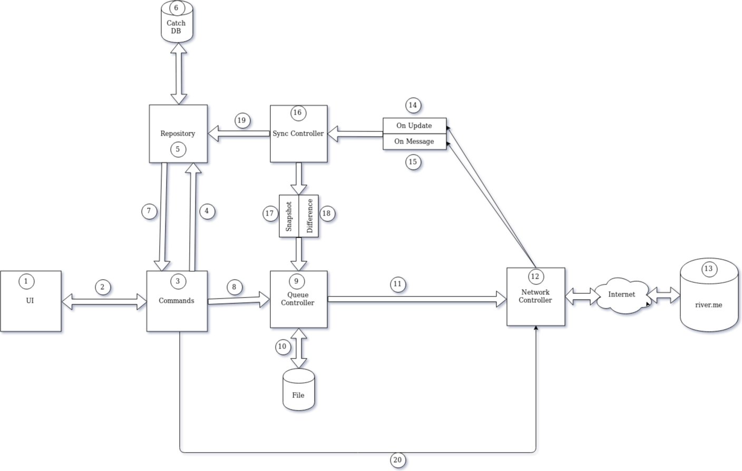
- Android / IOS / Web Clients
- UI passes its request to Command unit / Receive update notification
- Command unit process UI request and also it notify UI from new updates, also it'll check if UI request already cached or not if not cached it'll pass request to Queue Unit to hand it over network
- Check request is already cached or not
- Repository layer to store and fetch data from cache
- Cache DB currently using Sqlite database
- cached response or received new updates that already been saved in DB
- requests that does not exist in cache DB should be sent to server
- Queue unit is persistent that saves requests to disk and pass them to Network unit
- Persistent storage to save queued items currently using LevelDB
- Queued request that handed over to Network unit
- Network unit role is to receive and send request from/to server
- River server
- Updates from server that are sent in response of other sessions/users request related to you
- Updates from server that are direct response of this session requests
- Sync unit role is to sync/cache client with server
- Snapshot sync occurs when client needs a state point in order to check its state from that point forward/backward to cache requests/updates
- Difference sync occurs when there is a minor changes from snapshot point, less than 1000 updates
- Pass received updates from server to Repository unit in order to be cached and notify UI to change itself
- Real time requests that should not be queued and handed over to network directly

River CLI Test Console

There is a CLI for test and interact with river server through SDK.

Compile CLI:

$ cd ~/go/src/git.ronaksoftware.com/ronak/sdk-river/extra/console
$ go build -o main *.go
$ ./main

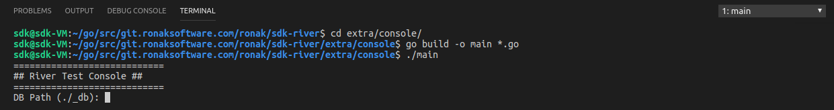
Registeration

$ >>> Auth SendCode
$ Phone : XXXXXXXXXXX
$ Phone, PhoneCodeHash: XXXXXXXXXXX, 5oRljahb
$ $ >>> Auth Register
$ Phone: XXXXXXXXXXX
$ Phone Code: YYYY
$ Phone Code Hash: 5oRljahb
$ First Name: FName
$ Last Name: LName
$ FName LName (35013678194907)

Login

$ >>> Auth SendCode
$ Phone : XXXXXXXXXXX
$ Phone, PhoneCodeHash: XXXXXXXXXXX, uKFfAAOJ
$ $ >>> Auth Login
$ Phone: XXXXXXXXXXX
$ Phone Code: YYYY
$ Phone Code Hash: uKFfAAOJ
$ FName LName (35013678194907)

In order to see / select other command / options press Tab in CLI.

CLI Console Commands

Auth :
SendCode returns a hash code and send a code via sms
Register register new account
Login login with existing account
Logout logout
Recall send recall request to receive update via websocket
Init create new auth key

Contact :
Import add new contact
Get display existing contacts

Messages :
Send send new message
GetDialogs display all existing chat dialogs
GetDialog display certain chat dialogs
MessageGetHistory display messages by MinID and MaxID
MessageReadHistory send message seen request
MessageSetTyping send is typing request
MessagesGet get certain message by its id

SDK :
ConnInfo display connection info
SetLogLevel change logs level to see more/less details
GetDiffrence sync request

User :
UsersGet get certain user by its id

Debug :
SendTyping burst set typing requests
MessageSendByNetwork burst send message requests directly on wire
MessageSendByQueue burst send message requests to queue

