ENERGY AUDIT REPORT

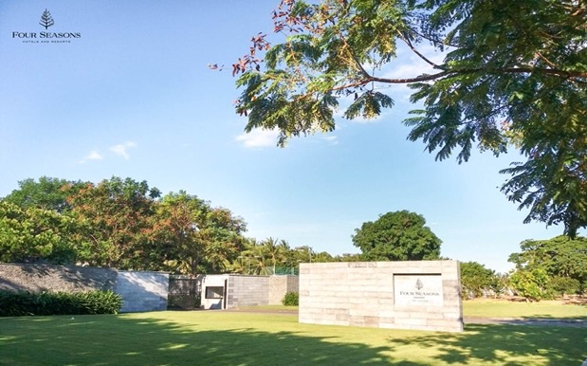

INDOCHINA RESORT COMPANY LIMITED (HOI AN)
FOUR SEASONS RESORT THE NAM HAI
Block Ha My Dong B, Dien Duong Ward, Dien Ban Town, Quang Nam Province

Quang Nam, August 2022

 | Energy Auditing Consultancy  POLYTECHNICAL ENERGY AND ENVIRONMENT JOINT STOCK COMPANY  Address: No.4, 19th House, Bach Khoa quarter, Bach Khoa ward, Hai Ba Trung district, Hanoi  Điện thoại: +(84) 24.3623.1060 Website: www.polytee.com.vn

ENERGY AUDIT REPORT

INDOCHINA RESORT COMPANY LIMITED (HOI AN)
FOUR SEASONS RESORT THE NAM HAI
Block Ha My Dong B, Dien Duong Ward, Dien Ban Town, Quang Nam Province

Quang Nam, August 2022

Energy Auditing Consultancy
POLYTECHNICAL ENERGY AND ENVIRONMENT JOINT STOCK COMPANY
Address: No.4, 19th House, Bach Khoa quarter, Bach Khoa ward, Hai Ba Trung district, Hanoi
Điện thoại: +(84) 24.3623.1060 Website: www.polytee.com.vn

Confirmed by Energy User
INDOCHINA RESORT COMPANY LIMITED (HOI AN)

Date: 20/08/2022

Confirmed by Energy Auditing Consultancy
POLYTECHNICAL ENERGY AND ENVIRONMENT JSC

Date: 05/08/2022

Confirmed by Energy Auditors

No. | Full name and Position | Signature/Certificate Register No.
1 | Pham Van Tan  Major Expert  Lecturer of Hanoi University of Science and Technology  National Lecturer on Energy Auditing, Certified by Ministry of Industry and Trade  National Energy Auditor Certificated by MOIT
2 | Nguyen Đuc Quyen  National Energy Auditor Certificated by MOIT  Lecturer of Hanoi University of Science and Technology
3 | Pham Van Tuyen  Energy Engineer from Hanoi University of Science and Technology  National Energy Auditor Certificated by MOIT

TABLE OF CONTENTS
TABLE OF CONTENTS i
LIST OF TABLES ii
LIST OF FIGURES iv
Chapter 1 1
SUMMARY 1
1.1. Summary Information of the Audited Enterprise 1
1.2. Energy Saving Potentials in Brief 1
1.3. Possibility to Implement the Solutions 3
1.4. Proposed Implementation Plan 3
Chapter 2 4
GENERAL INTRODUCTION 4
2.1. Energy Audit site and Energy Audtit Team 4
2.2. Energy Audit Scopes 6
2.3. Measurement Methodology and Instrumentation Used 6
2.4. Energy Audit Report Layout of Main Contents 8
Chapter 3 9
COMPANY ACTIVITIES 9
3.1. Formation and Development Progress 9
3.2. Operation regime and business situation 12
3.3. Current Status of Energy Management System 14
3.4. Successfully Applied Energy Saving Solutions 16
Chapter 4 19
BUSINESS ACTIVITIES DESCRIPTION 19
4.1. Business activities description 19
4.2. Current Measurement Instruments and Metering System 20
4.3. Energy equipment system 22
4.4. Potentials of energy savings 40
Chapter 5 41
DEMANDS AND CAPABILITY OF ENERGY SUPPLY 41
5.1. Energy prices 41
5.2. Energy consumption database 41
5.3. Specific energy consumption and energy baselines 53
Chapter 6 60
FINANCIAL - TECHNICAL CONSTRAINTS 60
6.1. Basic Finacial Constraints 60
6.2. Energy and Standards 61
6.3. Evaluation of Energy Saving Solutions 62
6.4. Energy Utilization Strategy of the Company 63
Chapter 7 65
PROPOSAL OF ENERGY SAVING SOLUTIONS 65
7.1. List of Energy Saving Opportunities 65
7.2. Energy Saving Opportunities Analyses and Detail Technical Proposals 65
7.3. Request 99
Appendix 101
ENERGY AUDITORS CERTIFICATE 101

LIST OF TABLES
Table 1.1. Summary of Energy Saving Potentials and Estimated Investment Cost 2
Table 1.2. Energy Saving Solutions Implementation Plan 3
Table 2.1. Consumption of energy and water 4
Table 2.2. List of Instrument Used in Energy Auditing Process 6
Table 3.1. Room occupancy in the period of 2019 - 06/2022 13
Table 3.2. Energy management matrix 15
Table 4.1. List of major transformers 28
Table 4.2. Permissible maximum current harmonic distortion for electrical loads 32
Table 4.3. The results of measuring lighting in some typical areas 33
Table 4.4. Thông số hoạt động của lò hơi 34
Table 5.1. The electricity tariffs for business 41
Table 5.2. Average energy price in period 2019 - 06/2022 41
Table 5.3. Statistics on electricity situation and cost by 3 time frames in 2019 42
Table 5.4. Statistics on electricity situation and cost by 3 time frames in 2020 43
Table 5.5. Statistics on electricity situation and cost by 3 time frames in 2021 43
Table 5.6. Statistics on electricity situation and cost by 3 time frames in 2022 44
Table 5.7. Statistics of Electricity Consumption in period 2019 - 06/2022 45
Table 5.8. Statistics of Diesel Oil Consumption in period 2019 - 06/2022 46
Table 5.9. Statistics of LPG Consumption in period 2019 - 06/2022 48
Table 5.10. Statistics of Energy Consumption Converted to TOE 49
Table 5.11. Statistics of Energy Consumption Percentages 50
Table 5.12. Statistic of Water Consumption in period 2019 - 06/2022 51
Table 5.13. Statistics of Energy Consumption Costs in period 2019 - 06/2022 52
Table 5.14. The Electricity Consumption Rate in period 2019 - 06/2022 54
Table 5.15. The Diesel oil Consumption Rate in period 2019 - 06/2022 55
Table 5.16. The Energy Consumption Rate in period 2019 - 06/2022 56
Table 5.17. Energy baseline equation 59
Table 6.1. Main constraints on energy and standards 61
Table 6.2. Energy conversion factors 61
Table 6.3. Summary of result test energy consumption and capacity analysis at systems and equipments 62
Table 7.1. List of Energy Saving Opportunities 65
Table 7.2. Heat loss on steam valves 73
Table 7.3. Estimated Energy Saving Opportunity: “Strengthening the protective cover for the steam system: Covering the valves on the steam pipe” 73
Table 7.4. Estimated cost of investment solution: “Strengthening the protective cover for the steam system: Covering the valves on the steam pipe” 74
Table 7.5. Estimated cost of investment solution: “Strengthening the protective cover for the steam system: Covering the valves on the steam pipe” 74
Table 7.6. Maximum allowable current harmonic distortion for electrical loads 75
Table 7.7 . Harmonic of system (61000-3-2 standard) 77
Table 7.8. Estimated Energy Saving Opportunity: “Improving power quality, reducing losses due to harmonic waves at S1 transformers” 84
Table 7.9. Estimated cost of investment solution: “Improving power quality, reducing losses due to harmonic waves at S1 transformers” 85
Table 7.10. Estimated cost of investment solution: “Improving power quality, reducing losses due to harmonic waves at S1 transformers” 85
Table 7.11. Estimated Energy Saving Opportunity: “Improving power quality, reducing losses due to harmonic waves at S2 and S5 transformers” 87
Table 7.12. Estimated cost of investment solution: “Improving power quality, reducing losses due to harmonic waves at S2 and S5 transformers” 88
Table 7.13. Estimated cost of investment solution: “Improving power quality, reducing losses due to harmonic waves at S2 and S5 transformers” 88
Table 7.14. Recommended excess air armament of some fuels 90
Table 7.15. Estimated Energy Saving Opportunity: “Constant monitoring of residual oxygen, through control system aimed at optimal adjustment the flow of air, fuel for boiler” 93
Table 7.16. Estimated cost of investment solution: “Constant monitoring of residual oxygen, through control system aimed at optimal adjustment the flow of air, fuel for boiler” 94
Table 7.17. Estimated cost of investment solution: “Constant monitoring of residual oxygen, through control system aimed at optimal adjustment the flow of air, fuel for boiler” 94
Table 7.18 . Technical calculation of the solution to install solar power system 98
Table 7.19. Summary of the results of economic calculation solutions for installation of solar power systems 98
Table 7.20. Grouping energy-saving solutions by investment size and technical complexity 99

LIST OF FIGURES
Figure 2.1 - Detail procedure for energy audit diagram 7
Figure 3.1 - The organization diagram 10
Figure 3.2 - The site layout 11
Figure 3.3 - Some pictures of the Resort's areas and rooms 12
Figure 3.4 - Room occupancy chart in the period of 2019 - 06/2022 13
Figure 3.5 - EnMS Assessment Results 16
Figure 3.6 - Power factor is always high 17
Figure 3.7 - Inverter for exhaust fan motor 17
Figure 3.8 - Condensate recovery tank 18
Figure 3.9 - The system of solar panels providing hot water 18
Figure 4.1 - Pictures of some areas of Four Seasons Resort 20
Figure 4.2 - Electrical Measurement 21
Figure 4.3 - Water pressure meter 21
Figure 4.4 - Power quality parameters measure of electricity supply to laundry room 22
Figure 4.5 - Power quality parameters measure at Eng Workshop electrical cabinet 23
Figure 4.6 - Power quality parameters measure at DB-S3-1 - Kitchen electrical cabinet 23
Figure 4.7 - Power quality parameters measure of power supply to Hotel E9 - E16 24
Figure 4.8 - Power quality parameters measure of power supply to Hotel E19 - E22 and F19 - F22 24
Figure 4.9 - Power quality parameters measure of power supply to Hotel E23 - E26 and F5 - F8 25
Figure 4.10 - Power quality parameters measure of electricity supply to Villa 1020 25
Figure 4.11 - Power quality parameters measure of electricity supply to Villa 2040 26
Figure 4.12 - Power quality parameters measure of power supply to Villa B7 - B12 26
Figure 4.13 - Power quality parameters measure of electricity supply to Villa 3010 26
Figure 4.14 - Power quality parameters measure of electricity supply to Villa C6 27
Figure 4.15 - Power quality parameters measure of electricity supply to Villa H9 27
Figure 4.16 - Transformers and backup generator 29
Figure 4.17 - Power quality parameters measure of power supply to S1 transformer 29
Figure 4.18 - Power quality parameters measure of power supply to S2 transformer 30
Figure 4.19 - Power quality parameters measure of power supply to S3 transformer 30
Figure 4.20 - Power quality parameters measure of power supply to S5 transformer 31
Figure 4.21 - Power quality parameters measure of power supply to S6 transformer 31
Figure 4.22 - Lighting image of Company 32
Figure 4.23 - The audit team conducts the lighting quality test 33
Figure 4.24 - Boiler system 35
Figure 4.25 - Valve system is not insulated with high temperature 36
Figure 4.26 - Power quality parameters measure of power supply to boiler 36
Figure 4.27 - The system of solar panels providing hot water 37
Figure 4.28 - Air conditioning system 37
Figure 4.29 - Refrigeration compressor system 37
Figure 4.30 - Domestic water pump system 38
Figure 4.31 - Power quality parameters measure of power supply to No.1 domestic water pump 39
Figure 4.32 - Power quality parameters measure of total power supply to domestic water pumping system 39
Figure 4.33 - Fire pump system 40
Figure 5.1 - The electrical single-line diagram 42
Figure 5.2 - Electricity Consumption Chart in period 2019 - 06/2022 46
Figure 5.3 - Diesel Oil Consumption Chart in period 2019 - 06/2022 47
Figure 5.4 - LPG Consumption Chart in period 2019 - 06/2022 48
Figure 5.5 - Total of TOE Consumption Chart in period 2019 - 06/2022 50
Figure 5.6 - Energy consumption rates (converted to TOE) 50
Figure 5.7 - Water Consumption Chart in period 2019 - 06/2022 52
Figure 5.8 - Chart of rate energy cost 53
Figure 5.9 - Electricity Consumption Rate Chart in period 2019 - 06/2022 57
Figure 5.10 - Diesel Oil Consumption Rate Chart in period 2019 - 06/2022 57
Figure 5.11 - Energy Consumption Rate Chart in period 2019 - 06/2022 57
Figure 5.12 - Electricity baseline 58
Figure 5.13 - Diesel Oil baseline 58
Figure 5.14 - Energy baseline 58
Figure 7.1 - ISO 50001:2018 Energy Management System 67
Figure 7.2 - Diagram inplementation of energy management system 67
Figure 7.3 - Energy Planing Process 68
Figure 7.4 - Energy saving sticker 70
Figure 7.5 - Conditions of office facilities (Black Bowl area) 70
Figure 7.6 - Temperature of valves on steam pipes 72
Figure 7.7 - Protective vests for valves 73
Figure 7.8 - Harmonic at S1 transformer 75
Figure 7.9 - The result of measuring a cluster of devices without harmonic 76
Figure 7.10 - Harmonics in the electricity system 76
Figure 7.11 - Harmonic waves from input rectifier system 77
Figure 7.12 - Harmon alter the current form 78
Figure 7.13 - Harmonic cause overvoltage 78
Figure 7.14 - Harmonics resonance 79
Figure 7.15 - Harmonics cause explosion of capacitor and transformer 79
Figure 7.16 - Harmonic affect the motor 80
Figure 7.17 - Reactor 80
Figure 7.18 - Passive filter 81
Figure 7.19 - Priciple of active filter 81
Figure 7.20 - Active filter 81
Figure 7.21 - Inverter with low harmonics in an installed unit 82
Figure 7.22 - The power quality measured at the motor uses a low harmonic inverter 82
Figure 7.23 - Harmonic at S2 transformer 86
Figure 7.24 - Harmonic at S5 transformer 86
Figure 7.25 - Schematic diagram of industrial boiler system 89
Figure 7.26 - Effect of excess air entering the furnace and composition of flue gas 91
Figure 7.27 - O₂ sensor mounted on the chimney 91
Figure 7.28 - Plan to continuously adjust the wind supply system to the boiler 92
Figure 7.29 - Map of solar energy in Quang Nam 95
Figure 7.30 - Independent solar power Generation system 96
Figure 7.31 - Solar energy system at a plant has been implemented 97

Chapter 1

SUMMARY

1.1. Summary Information of the Audited Enterprise
Company name : Indochina Resort Co., Ltd (Hoi An)
Facility name : Four Seasons Resort The Nam Hai
Address : Block Ha My Dong B, Dien Duong ward, Dien Ban town, Quang Nam province
Phone : +(84) 235 394 0000
Fax : +(84) 235 394 0999
Website : www.fourseasons.com
General Director : Mr. Marcel Oostenbrink
Business sector : Hotel and restaurant business services.

1.2. Energy Saving Potentials in Brief
After doing surveys, measurements and analytical evaluation of the current energy consumptions and energy management situation in Indochina Resort Co., Ltd (Hoi An), energy auditing consultant company, Polytechnical Energy and Environment JSC (POLYTEE) finds out several energy saving solutions that have been identified and listed in Table 1.1 below, summaring the saving potentials and estimated investment cost for the proposed opportunities to be scheduled for implementation.

Table 1.1. Summary of Energy Saving Potentials and Estimated Investment Cost
No. | Energy Savings Opportunity | Estimated Annual Energy Savings |  |  | CO₂ reduction  (ton/yr) | Estimated implementation cost  (10⁶ VND) | Estimated annual cost savings  (10⁶ VND/yr) | Simple payback period  (Month)
No. | Energy Savings Opportunity | Electricity  (kWh/yr) | Diesel oil  (liter /yr) | Total saved energy converted to primary source  (TOE/yr)
1 | Strengthening inner energy management activities and equipment maintenance plan | 54.533 | 1.536 | 9,9 | 48,3 | 150,0 | 139,1 | 12,9
2 | Strengthening the protective cover for the steam system: Covering the valves on the steam pipe | - | 1.835,6 | 1,7 | 5,3 | 22,2 | 22,6 | 11,8
3 | Improving power quality, reducing losses due to harmonic waves at S1 transformers | 16.357 | - | 2,5 | 13,2 | 95,0 | 36,1 | 31,6
4 | Improving power quality, reducing losses due to harmonic waves at S2 and S5 transformers | 43.185 | - | 6,7 | 34,7 | 225,0 | 95,2 | 28,4
5 | Installation of residual oxygen monitoring equipment for boilers, through the control system to optimally adjust the wind flow, fuel for the boiler system | - | 4.309,0 | 4,0 | 12,5 | 199,5 | 52,9 | 45,2
6 | Installation and use of solar power supply system | 42.657 |  | 6,6 | 34,3 | 675,0 | 94,1 | 86,1
 | Total | 114.075 | 7.680,5 | 24,8 | 114,0 | 691,7 | 345,9 | -

1.3. Possibility to Implement the Solutions
Table 1.1 presents the results of all the energy saving solutions proposed. The solutions have showed the great saving potentials and impressively reducing capability of cost of energy consumption for the company. The investment costs of the solutions have been estimated and will be calculated in details prior to the implementation.
According to our evaluations, the above mentioned energy saving solutions are technically and economically feasible.

1.4. Proposed Implementation Plan
There are numerous potentially energy saving opportunities for the Company. For the energy-saving opportunities to be put into the practice, the Company needs to build an implementation plan for energy-saving projects. The energy audit team would like to propose an implementation plan in order of priority as follows:
Table 1.2. Energy Saving Solutions Implementation Plan
No. | Energy Saving Solutions | Implementation Progress
No. | Energy Saving Solutions | Phase  2022 - 2023 | Giai đoạn  2023 - 2024 | Giai đoạn sau 2024
1 | Strengthening inner energy management activities and equipment maintenance plan | x | x | x
2 | Strengthening the protective cover for the steam system: Covering the valves on the steam pipe | x
3 | Improving power quality, reducing losses due to harmonic waves at S1 transformers |  | x
4 | Improving power quality, reducing losses due to harmonic waves at S2 and S5 transformers |  |  | x
5 | Installation of residual oxygen monitoring equipment for boilers, through the control system to optimally adjust the wind flow, fuel for the boiler system |  | x | x
6 | Installation and use of solar power supply system |  | x

Chapter 2

GENERAL INTRODUCTION

2.1. Energy Audit site and Energy Audtit Team

2.1.1. Energy audit site's information of consumer
Company name : Indochina Resort Co., Ltd (Hoi An)
Facility name : Four Seasons Resort The Nam Hai
Address : Block Ha My Dong B, Dien Duong ward, Dien Ban town, Quang Nam province
Phone : +(84) 235 394 0000
Fax : +(84) 235 394 0999
Website : www.fourseasons.com
General Director : Mr. Marcel Oostenbrink
Business sector : Hotel and restaurant business services.
Number of employees : 460 employees
Hours worked : 24 hours/day
Avarage opreration days/ year : 365 days
Gross floor area : 350.000 m²
Energy consumption source:
- Electricity: is supplied from the national grid through 22 kV distribution transformer station to six transformer of the company and distributed to power distribution cabinets in the whole area.
- Diesel oil: is used as burning fuel for boiler, providing heat for steam production.
- LPG: Used for the needs of kitchen areas, restaurants and backup heating systems supplying hot water for villas.
Statistics of energy and water consumption:
Table 2.1. Consumption of energy and water
No. | Energy and water | Unit | Total Comsumption
No. | Energy and water | Unit | 2019 | 2020 | 2021 | 01-06/2022
1 | Electricity | MWh | 9.089 | 3.031 | 2.849 | 2.639
2 | Diesel oil | liter | 255.989 | 95.800 | 88.796 | 77.864
3 | LPG | kg | 195.865 | 83.256 | 26.472 | 43.035
4 | Water | m³ | 118.500 | 88.576 | 87.891 | 45.911

2.1.2. Referred Laws and Decrees
1 - The Law no. 50/2010/QH12 dated 17 June, 2010 on Economical and Efficient Use of Energy and Measures for its Implementation.
2 - The Government's Decree no. 21/2011/NĐ-CP dated 29 March, 2011 detailing the Law no. 50/2010/QH12 on Economical and Efficient Use of Energy and Measures for its Implementation.
3 - The Government's Decree no. 134/2013/NĐ-CP dated 17 October, 2013 taking effect on the expiry of the Decree no. 73/2011/NĐ-CP dated 08 August, 2011 stipulating the sanction against administrative violation in the field of electricity, safety of hydroelectric dam, and economical and effective use of energy.
4 - The MOIT's Circular Letter no. 25/2012/TT-BCT dated 29 September, 2020 stipulating the Energy Audit and the Report Form.

2.1.3. Time for Doing Energy Audit
The time for doing energy audit is from June 2022 to August 2022.

2.1.4. Member of the Energy Audit Team
Energy audit program for Indochina Resort Co., Ltd (Hoi An) is implemented by Polytechnical Energy and Environment JSC (POLYTEE), works in conjuction with the technical staff, production operation staff of Indochina Resort Co., Ltd (Hoi An).
Energy Audit Consultant Organization: Polytechnical Energy and Environment JSC (POLYTEE), includes:
Full name | Position
Mr. Pham Van Tan | Major Energy Expert, National Certificeted  Energy Auditor
Mr. Nguyen Duc Quyen | National Certificeted Energy Auditor
Mrs. To Thi Kim Ngan | Economic and Finance Analysis Expert
Mr. Pham Van Tuyen | National Certificeted Energy Auditor
The technicians | Assist in testing, data processing and drafting of Energy Audit report segments
Company of Major Energy Consumer: Indochina Resort Co., Ltd (Hoi An), Includes:
Full name | Position
Mr. Nguyen Thai Son | Director of Engineering
Mr. Tran Thanh Ngoc | Assistant of chief engineer
Mr. Tran Hai Hoang | Assistant of chief engineer
And the technicians in the technical room, the maintenance room.
The energy audit team expresses sincere thanks to the Board of Directors of the Company, the staff of Indochina Resort Co., Ltd (Hoi An) for their support, assistance and creation for the energy audit team to complete their tasks.

2.2. Energy Audit Scopes
The energy audit was performed for all key energy equipment & whole auxiliary systems in Indochina Resort Co., Ltd (Hoi An), at the address: Block Ha My Dong B, Dien Duong ward, Dien Ban town, Quang Nam province.

2.3. Measurement Methodology and Instrumentation Used
The list of instruments used in the auditing process is presented in Table 2.2. In addition, the energy audit team also uses measuring devices, DCS Monitoring System and directive clocks which are available in the Company.
Table 2.2. List of Instrument Used in Energy Auditing Process
No. | Name of Measurement Equipment | Model | Quant. | Made in
1 | Kew Power quality analyzer (Kyoritsu) | KEW-6315 | 01 | Japan
2 | Power Analyzer (Kyoritsu) | KEW-6305 | 01 | Japan
3 | Kyoritsu AC Digital Clamp Meters | 2002PA | 01 | Japan
4 | Kewtech AC Digital Clamp Meters | KT200 | 01 | Thailand
5 | Light meter | LX -1102 | 01 | Taiwan
6 | Infrared thermometer (Extech) | 42509 | 01 | USA
7 | Infrared thermometer Hioki | FT3700-20 | 01 | Japan
8 | Testo 320 Flue Gas Analyzer | Testo 320 | 01 | USA
9 | Mini 4 in 1 Environmental Quality Meter (Anemometer + Humidity meter + Light meter + Thermometer) | LM-8000A | 01 | Taiwan
10 | Sony camera and on-site meters | DSC-WX220 | 01 | Vietnam

Summary of detail procedure for energy audit is presented in Figure below:
(According to the provisions of Circular No. 25/2020 / TT-BCT issued by the Ministry of Industry and Trade)
Figure 2.1 - Detail procedure for energy audit diagram

2.4. Energy Audit Report Layout of Main Contents
The energy audit report includes main contents, followed by The MOIT's Circular Letter no. 25/2020/TT-BCT, as below:
Chapter 1. Summary
- Summary of explorations of energy saving potentials, arranged in order of priority.
- Propose solutions for investment priority.
Chapter 2. General Introdution
- Brief overview of the company to be audited.
- Organization of the audit team.
- Overview and scope of works.
- Energy audit procedures and report contents.
Chapter 3. Company Activities
- Formation and development progress of the company and the current status.
- Structure and production activities.
Chapter 4. Business Activities Description
- Types of accommodations, service areas.
- Energy saving potentials.
Chapter 5. Demands and Capacity of Energy Supply
- Demands for energy and water consumption.
- Parameters and characteristics of fuels and energy used.
Chapter 6. Financial-technical Constraints
- Technical and environmental issues.
- Solutions and economic evaluations.
Chapter 7. Proposed Energy Saving Solutions and Detail Calculations & Analyses
- Indentify and describe in details the energy saving solutions.
- Selected technical solutions.
- Analysis of finance, energy and the environment.

Chapter 3

COMPANY ACTIVITIES

3.1. Formation and Development Progress

3.1.1. Development process
Four Seasons Resort The Nam Hai is known as the standard for a luxury beach in Vietnam and the top luxury resort in Southeast Asia. Four Seasons Resort The Nam Hai was built on an area of ​​ 311,605 square meters, including sixty beautiful guestrooms and forty swimming pool villas, each with its own landscape and facing the East Sea. The hotel has been in operation since January 2006.
Four Seasons Resort is a 30-minute drive from Da Nang International Airport and a 10-minute drive form Hoi An Ancient. Located on the pristine coast of Hoi An beach, Four Seasons Resort The Nam Hai is designed with luxurious villas with three large beachfront swimming pools in the center and one large spa area located separately.
The villas are equipped with cable TV, flat-screen TV and modern entertainment sound system. Bathrooms have indoor and outdoor showers and luxurious eggshell tubs. There is a mini bar with coffee makers, tea makers and fridges with a variety of drinks.
Hotel provides diverse customer service. Tourists can choose to play tennis, badminton or ball or can also enjoy the swimming pool with international standards in the center with the family. The hotel also has its own library for travelers who love to read and a kids club with indoor and outdoor play areas.
Café Nam Hai restaurant offers travelers a luxurious dining space and the best dishes of Vietnam and international. The bar serves a wide range of premium drinks, cocktails and snacks. La Sen Restaurant with open space and mainly Vietnamese traditional cuisine as well as grilled seafood will give tourists great experiences on the beach.
Some awards won:
- Listed for Best Long haul Holidauys by The Irish Independent 50 Fab Holidays for 2016;
- TripAdvisor Travellers’ Choice™ Winner - No. 2 of Top 25 Hotels in Vietnam;
- Named in Mr and Mrs Smith Hotel Awards for The Best Spa Hotel;
- Top 25 Resorts in Asia in the Conde Nast Traveler UK Readers' Choice Awards (no. 12);
- Top 10 Overseas Hotel Spas (ranked No. 6) by Conde Nast Traveller UK Readers’ Travel Awards;
- Ranked No. 1 in Top 25 Leisure Hotels & Resorts in Asia by Smart Travel;
- Listed No. 7 in Top 25 Spa Hotels and Resorts by Smart Travel Asia;
- Listed in Travel+Leisure list of 500 The World’s Best Hotels;
- TripAdvisor ‘Hall of Fame’ Award (five-time winner of TripAdvisor's Certificate of Excellence);
- Named in ‘37 gorgeous pools everyone should swim in once’ by Business Insider;
- Listed No. 9 in Best Overseas Resort by Luxury Travel Magazine Gold List Awards;
- Named in the 8 Most Indulgent Spa Treatment Resorts on Earth by Conde Nast Johansens UK;
- Listed in Condé Nast Traveler China Gold List 2015;
- TripAdvisor Travellers’ Choice™ Winner - No. 25 of Top 25 Hotels in Asia;
- TripAdvisor Travellers’ Choice™ Winner - No. 2 of Top 25 Hotels in Vietnam;
- TripAdvisor Travellers’ Choice™ Winner - No. 3 of Top 25 Luxury Hotels in Vietnam;
- TripAdvisor Travellers’ Choice™ Winner - No. 25 of Top 25 Hotels for Romance;
- TripAdvisor Travellers’ Choice™ Winner - No. 22 of Top 25 Hotels for Service.

3.1.2. The organization diagram
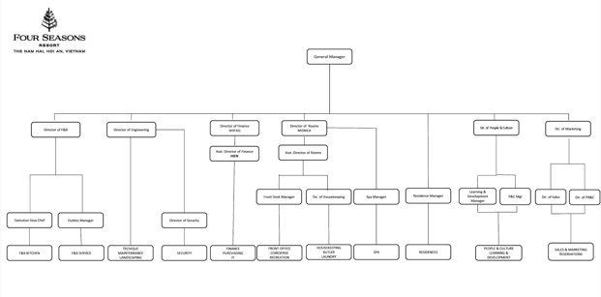
Figure 3.1 - The organization diagram

3.1.3. The site layout
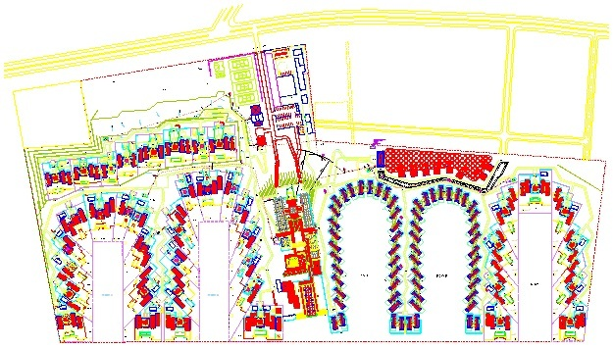
Figure 3.2 - The site layout

3.2. Operation regime and business situation
Four Seasons Resort The Nam Hai stretches along the beautiful coastline, which is one of the most famous beaches in the world voted for. The hotel consists of one hundred villas designed in the style of an innovative Vietnamese house (traditional house), combined with modern and luxurious amenities and furniture.
The interior at Four Seasons Resort The Nam Hai is mainly designed with high quality natural wood, bringing elegance and luxury to the villas.
One of the highlights of hotel is three large swimming pools with a unique overflowing design suitable for all hobbies of tourists.
Pictures of some rooms of hotels and villas:
 | 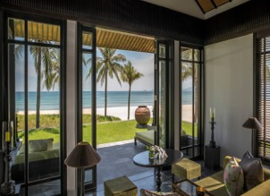
 | 
 | 
Figure 3.3 - Some pictures of the Resort's areas and rooms
Room occupancy is listed as in the following table:
Table 3.1. Room occupancy in the period of 2019 - 06/2022
Month | Room occupancy (%)
Month | 2019 | 2020 | 2021 | 2022
Jan | 68 | 50 | 6 | 4
Feb | 82 | 54 | 6 | 14
Mar | 87 | 12 | 9 | 11
Apr | 87 | 0 | 25 | 37
May | 68 | 0 | 8 | 25
June | 71 | 0 | 2 | 28
July | 73 | 21 | 2 | -
Aug | 83 | 0 | 4 | -
Sep | 64 | 3 | 3 | -
Oct | 67 | 0 | 0 | -
Now | 56 | 0 | 0 | -
Dec | 49 | 5 | 0 | -
Average | 71 | 12 | 5 | 20
The chart of room occupancy by month and year for the period 2019 - 06/2022 is as follows:
Figure 3.4 - Room occupancy chart in the period of 2019 - 06/2022
Nhận xét: Room occupancy at Four Seasons Resort dropped in 2020 - 2021 due to the impact of the Covid-19 pandemic, which caused a sharp decrease in the number of tourists coming to the resort. In 2022, when the pandemic situation is controlled, the occupancy rate at the Resort has increased again.

3.3. Current Status of Energy Management System
Energy costs at the Company account for a significant proportion of the operating costs of business equipment. Therefore, the Company pays great attention to energy saving and effective use of energy, avoiding waste to reduce service costs. The Board of Directors of the Company has oriented in applying and implementing energy-saving activities, reducing energy costs.
The company has made a decision to establish an Energy Management Board in charge of issues related to equipment systems that consume energy and has assigned staff in charge of monitoring and managing electrical and energy equipment, ready to invest in innovative solutions, and invest in energy-saving equipment at a relatively large cost. The company also develops detailed regulations on energy saving.
To develop sustainable energy management system, company need to assess the current state of energy management.
Target assessment of current status of energy management is to identify the current situation, confirming areas that need further strengthened to ensure the implementation of sustainable EM system. We use energy management matrix as assessment tools.
Energy management matrix has 6 columns, 5 rows. Each column represents one of six energy management aspects as follows:
1) Energy policy in factory
2) Energy Management organizational structure
3) The mechanisms promoted to achieve higher energy efficiency
4) Energy management information systems
5) Marketing integrated with energy efficiency achievements and environment
Protection
6) Investment standards and criteria targeted at energy conservation and efficiency solutions
It increases gradually in line from (0 ÷ 4), represents the degree of acceptance of each aspect of energy management: 0 is the lowest and 4 is the highest. The cells were completed as the opinions of the leaders and managers.
Analyzing the energy management of the business, we will know the strengths and weaknesses in the management process in terms of energy saving. Here are the criteria used to review a given Energy Management System (EnMS or EMS):

Table 3.2. Energy management matrix
Level | (1) Energy Policy | (2) Organization | (3) Motivation | (4) Information system | (5) Marketing | (6) Investment
4 | Energy policy, Action Plan and regular review have active commitment of top management | Fully integrated into management structure with clear accountability for energy consumption. | The formal and informal traditional channels are used frequently by managers and other energy management staff its energy level | Comprehensive system includes targets , monitoring consumption , identifying faults , quantifies savings and provides budget tracking | Merketing to promote the energy using efficiency and energy management inside and outside company | Positive discrimaination in favour of’green’schemes, with detailed invesment appraisal of all new-build and refrublishment opportunities
3 | Formal energy policy, but no active commitment from top management. | The energy manager has responsibility with the energy management representative for all users, is headed by a member of the senior leadership team | Energy management division is used as a main channel and contact to major users | The monitoring report is based on the result of measurement at each energy mesurements equitment of consumers, but the savings were not informed for consumers | Set up program to raise awareness of staff and advertising frequently | Same appraisal criteria used as for other cost reduction projects
2 | Unadopted energy policy set by energy manager or senior departmental manager | Contact to users mainly through irregular management (Ad-hoc Committee) , the responsibilities and authorities are not clear. | Contact to users primarily through infrequently management councils, led by senior management of the department | The monitoring report is based on the result of measurement at each energy mesurements equitment of consumers. Energy costs have not formally mentioned in the budget | Unofficial training about staff’s awareness | Low or medium cost measures considered if short payback period
1 | An unwritten set of guidelines | Informal communication between engineers and some users | Informal communication between engineers and some users | Energy cost only be reported based on the invoice . Engineers write the report only for internal using in the engineering department | The unofficial activity to improve the energy using efficiency | Only low cost measures taken
0 | No explicit energy Policy | No contact to users | No contact to users | No information system. No calcutale energy consumption | The unofficial activity to improve the energy using efficiency | No investment in improving energy efficiency

Based on the results of interviews, investigation and assessment of energy management system in Indochina Resort Co., Ltd (Hoi An), the results are presented in the table below:
4
3
2
1
0
 | Energy Policy | Organization of EnMS | Motivation and promoted mechaniasms | Measurements and Information System of EnMS | Marketing | Investment criteria
Figure 3.5 - EnMS Assessment Results
Nhận xét: The Energy Management System of the Company is good. The company should build energy policies comprehensively and regularly monitor implementation results. The energy management board needs to be trained more and more in depth. The company needs to develop a more detailed mechanism with energy saving measures such as planning and implementation, with monitoring and evaluation of results not only by internally but also in conjunction with independent expert advisory units to continually promote energy efficiency improvement activities. Besides, the company need to set up specific goals, built action plans and strenthen monitoring the energy saving process after investment; need to apply energy management system method like ISO 50001:2018 Standard; need to strengthen propaganda; frequently set up training courses for technicians and employees in the Company.

3.4. Successfully Applied Energy Saving Solutions
There are some implemented energy saving solutions which gained certain efficiency. The implemented energy saving solution of the company are given as the following:

3.4.1. The energy-saving solution of the lighting system
In order to save energy consumption for the lighting system, the Company has completely replaced the fluorescent lamps with LED lights for office, canteens, rooms in the Resort,... The lamps are designed with suitable heights to ensure stable and satisfactory lighting quality.
LEDs have several advantages and superior features like save from 50-80% power compared with traditional lampsLED lamp life can be from 30.000 to 50.000 hours, much higher than conventional lamps. On the issue of the environment, LEDs do not contain mercury and toxic chemicals, do not emits UV ; There is not cost to handle hazardous waste such as fluorescent lamps. The power factor of the LED is about more than 0,9 (other discharge luminaires only reach 0,8), which saves the apparent power of the electrical system, facilitating quick repair and replacement. The use of high-efficiency lamps also helps the environment to benefit from the reduction of CO₂ emissions due to energy savings.

3.4.2. Install and use capacitor system
The company has installed capacitor system cosφ. The coefficient cosφ of the company always reach the requirement level of the power industry. Compensation of the power factor helps the motor operate more stably, performance closer to the norm, and reduce a small amount of power consumption on the wires from the station to the distribution cabinets.
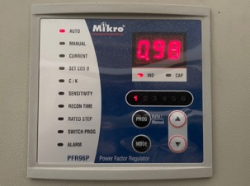
Figure 3.6 - Power factor is always high

3.4.3. Install inverters for some exhaust fan motors
The company installs inverters for some exhaust fan motors in the restaurants, laundry rooms, and kitchens. The installation of the inverter saves part of the power consumption when the load demand is low.
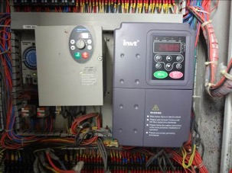 | 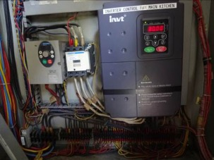
Figure 3.7 - Inverter for exhaust fan motor

3.4.4. The energy-saving solution of the boiler system
- The company has insulated the furnace wall and the steam supply system to the use area. This avoids heat loss to the environment through convection, helping the Company save a part of the cost of buying fuel.
- Recover condensate after use: After the heat exchanging process, the condensed steam into high temperature water is recovered and fed back into the boiler, saving a large amount of fuel and clean water.
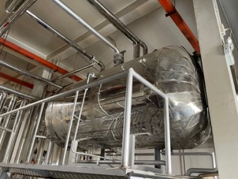
Figure 3.8 - Condensate recovery tank

3.4.5. Using VRV Inverter air conditioning system
The company used Daikin's VRV air conditioning system (Japan). This is a VRV air-conditioning system using refrigerant gas as a heat carrier, using latent heat to cool and cooled by the wind, including many VRV outdoor units assembled in series until the total cooling load for the whole building is met, each outdoor unit will be connected to many indoor units and many different capacity scales, making it easy for you to choose equipment that is suitable for architectural requirements, ensuring aesthetics as well as being very flexible in layout and distribution. subdivided into later regions.

3.4.6. Using solar energy to provide hot water
The company has installed and used solar panels utilizing solar energy to provide hot water for thirty-six villas. The use of this clean energy source significantly reduces the cost of using fuel for gas furnaces.
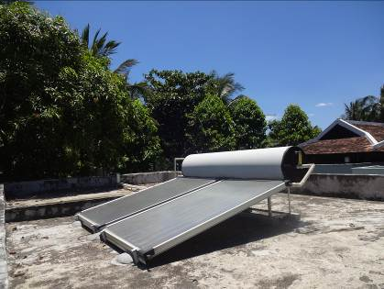 | 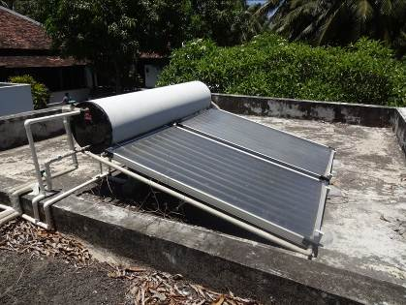
Figure 3.9 - The system of solar panels providing hot water

Chapter 4

BUSINESS ACTIVITIES DESCRIPTION

4.1. Business activities description
Four Seasons Resort The Nam Hai has one-hundred villa-style rooms, designed in an innovative house style, combined with modern and luxurious amenities and furniture. Including sixty one-bedroom villas and forty pool villas spread over thirty-five hectares of tropical gardens and along the pristine coastline of Ha My Beach.
Inside The Nam Hai’s room is furnished with a large twin bed, a desk, a sofa and a high-class bathtub. Bathroom has a door leading to a private garden with an outdoor shower. The villa is suitable for 3 adults, or 2 adults and 1 child.
The special thing about villas with private pools is the meticulous design style of every small detail that reaches the level of sophistication that is shown throughout each bedroom of the villa. The multi-level floor is connected by graceful steps, making the layout inside the villa airy but still cozy.
The common style of each villa at Four Seasons Resort The Nam Hai includes a walkway across the garden courtyard into the living and dining areas. There is also a kitchen and bedroom for the butler. And yet, each private pool can also adjust the water temperature to suit the outdoor temperature, allowing guests to enjoy themselves in the water at any time of the year.
Four Seasons Resort has two luxury restaurants for customers, serving almost all day and night. The centrally located restaurant serves a good selection of international dishes, with nice seating both indoors and outdoors. The Bar upstairs serves alcoholic beverages, snacks and soft drinks until late night.
In addition, The Beach Restaurant right next to the beach and outdoor swimming pool will serve fresh seafood, grilled dishes, and local dishes - the quintessence of traditional Vietnamese cuisine. Guests can choose their own suitable restaurant and enjoy meals with their family.
Step into a world of peaceful natural beauty, the spa at Four Seasons Resort consists of 8 tranquil areas surrounded by a calm lotus lagoon. Each zone is divided into two cottages, one for relaxation, the other with its own bathroom and dressing room.
There are three large swimming pools in the main area, in which the pool near the reception area can be adjusted to suit the weather conditions all year round. Three swimming pools are designed to overflow the shore and face the sea to create maximum relaxation for visitors to the resort.
 | 
 | 
 | 
Figure 4.1 - Pictures of some areas of Four Seasons Resort

4.2. Current Measurement Instruments and Metering System

4.2.1. Electrical Measurement System
The electrical measurement system is installed completly and modernly. The company also installed the measurement system for each equipment and main equipment groups.
At the power stations, the company has digital, analog panel meters measure and display all types electrical variables, such as current, voltage, power factor in an alphanumeric or numeric format. The measuring equipments of the company are operating correctly, stable.
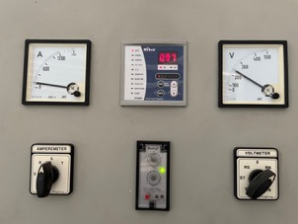 | 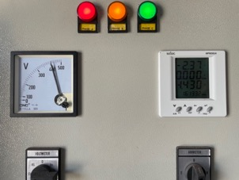
Figure 4.2 - Electrical Measurement

4.2.2. Thermal measuring system
The thermal measuring equipments were equipped relatively complete, from the first day. For boiler system, heat network: Company has fully equipped with thermal measurement to monitor temperature and pressure of steam line, feed water line. The measuring equipments of the company are operating correctly, stable.
For refrigeration system: Company equips a local temperature display system in some cold storages. The electrical cabinet both displays and controls the temperature for the rooms in the cold storage.

4.2.3. Water Measuring System
As same as other systems, the company has installed measurement devices fully for the water supply system.
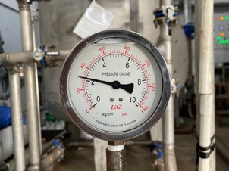
Figure 4.3 - Water pressure meter

4.2.3. Other measuring systems
In addition to the above measuring equipment systems, Company is also equipped with many other measurement and monitoring systems such as humidity measurement system and working time for equipment according to specific requirements in massage and sauna service rooms.

4.3. Energy equipment system

4.3.1. The Main Energy Consumption Equipment
The energy system and equipment consumption of Company is very rich and diverse. Some of the main energy consuming system equipment in Company such as air conditioning system, lighting system, water pump motor, sewage pump, exhaust fan system and office equipment (such as computers, printer, projector),… Most of the equipment works effectively, with few major problems due to good maintenance. Company has specialized departments so it is easy, quick and effective to maintain and fix.
The audit team conducted the measurement and evaluation of the quality of power supplied major equipment and clusters of equipment, the results are presented as follows:
Laundry room:
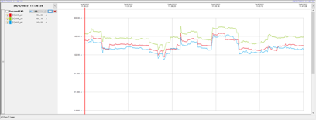 |  |  | 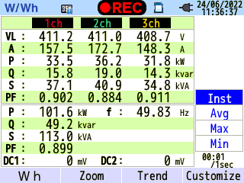
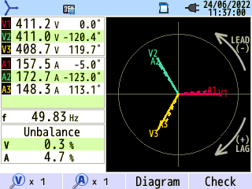 | 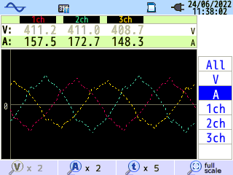 | 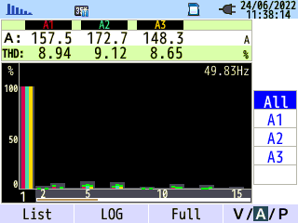
Figure 4.4 - Power quality parameters measure of electricity supply to laundry room
Comment: The graph of laundry room current changes continuously. The quality of the power supply to laundry room is relatively good, power factor is high (0,899), large phase difference and Harmonic TDD are all within the allowable range.
Eng Workshop electrical cabinet:
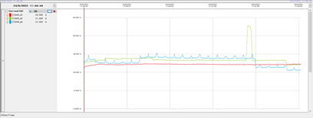 |  |  | 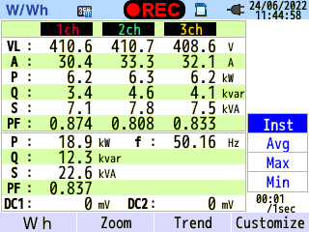
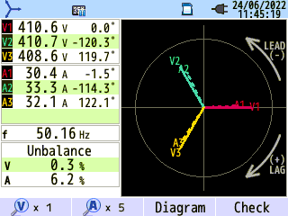 | 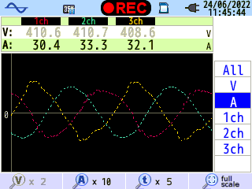 | 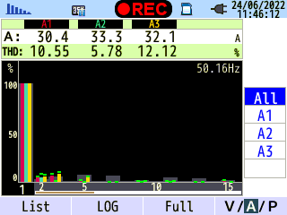
Figure 4.5 - Power quality parameters measure at Eng Workshop electrical cabinet
Comment: The electrical graph of Eng Workshop electrical cabinet fluctuates, but not too much. The electrical quality of Eng Workshop electrical cabinets is not really good, the power factor is high (0.837), the current does not appear harmonics, but the current phase difference is high (6.2%).
DB-S3-1 - Kitchen electrical cabinet:
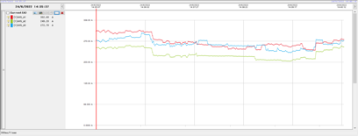 |  |  | 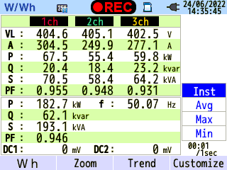
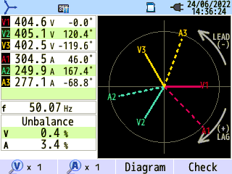 | 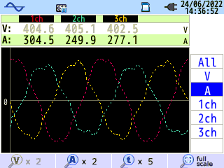 | 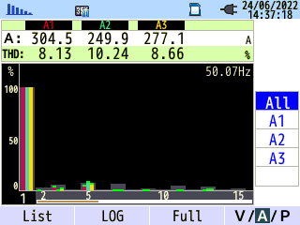
Figure 4.6 - Power quality parameters measure at DB-S3-1 - Kitchen electrical cabinet
Nhận xét: The electrical graph of DB-S3-1 - Kitchen electrical cabinet fluctuates, but not too much. The electrical quality of DB-S3-1 - Kitchen electrical cabinet is really good, power factor is high (0,946), phase difference and total current harmonic distortion are both within the allowable level.

Power supply to Hotel E9 - E16:
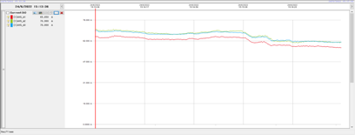 |  |  | 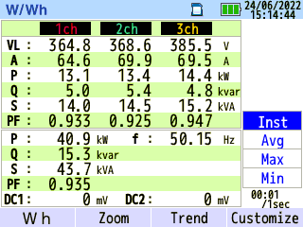
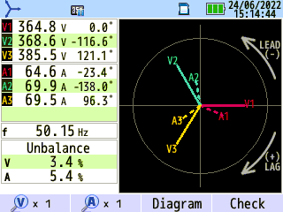 | 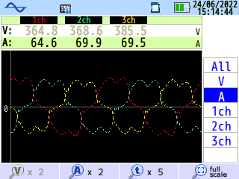 | 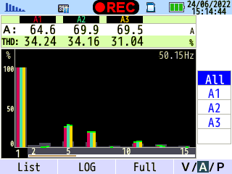
Figure 4.7 - Power quality parameters measure of power supply to Hotel E9 - E16
Power supply to Hotel E19 - E22 and F19 - F22:
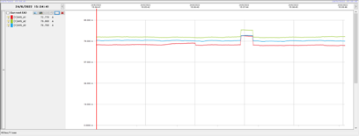 |  |  | 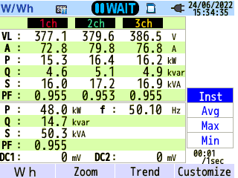
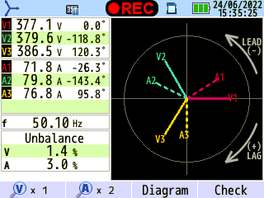 | 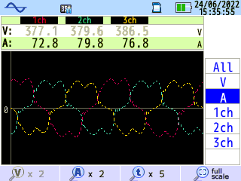 | 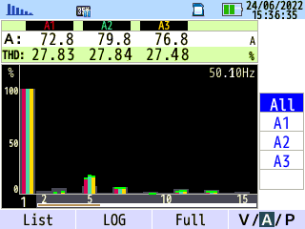
Figure 4.8 - Power quality parameters measure of power supply to Hotel E19 - E22 and F19 - F22
Power supply to Hotel E23 - E26 and F5 - F8:
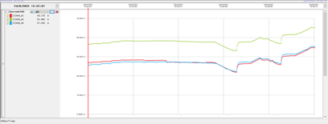 |  |  | 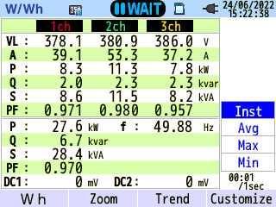
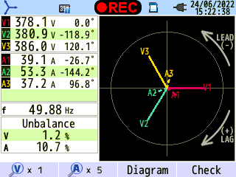 | 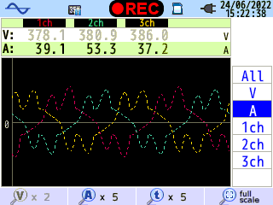 | 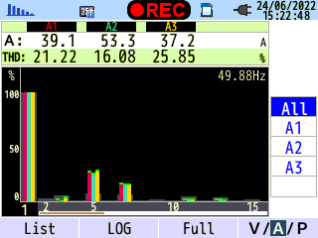
Figure 4.9 - Power quality parameters measure of power supply to Hotel E23 - E26 and F5 - F8
Comment: The electrical graph of power supply to Hotel relatively stable. The electrical quality of power supply to Hotels are not really good, power factors are high (greater than 0,9). But phase difference of power supply to Hotel E9 - E16 and Hotel E23 - E26, F5 - F8 are really high (such as 5,4% and 10,7%). In those electrical cabinets, there are also harmonic noise that distorts the sine wave of the current, the total harmonic distortion is quite high (ranging from 16 - 34%).
Villa 1020:
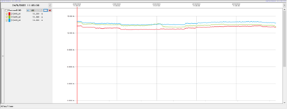 |  |  | 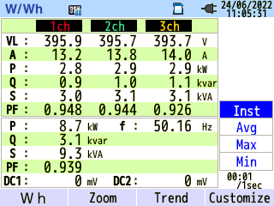
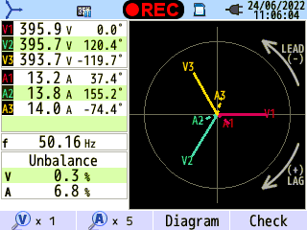 | 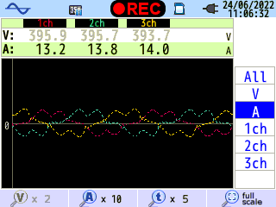 | 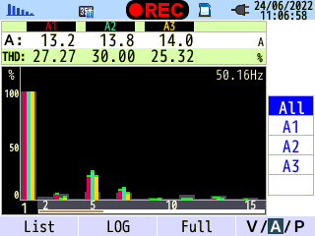
Figure 4.10 - Power quality parameters measure of electricity supply to Villa 1020
Villa 2040:
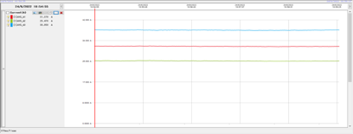 |  |  | 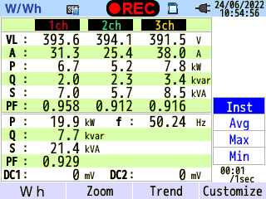
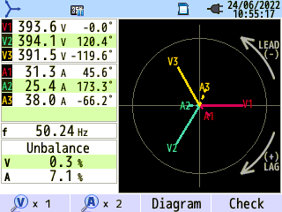 | 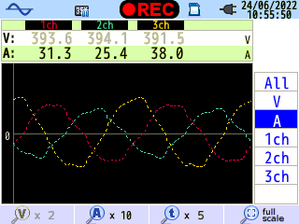 | 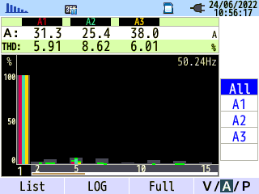
Figure 4.11 - Power quality parameters measure of electricity supply to Villa 2040
Power supply to Villa B7 - B12:
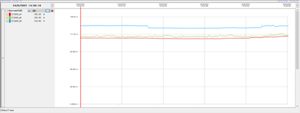 |  |  | 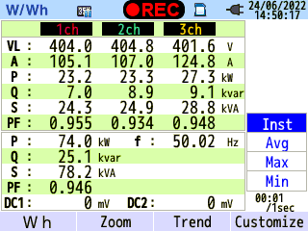
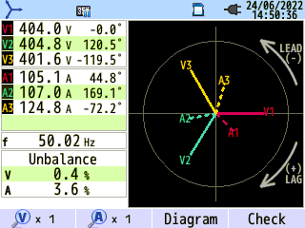 | 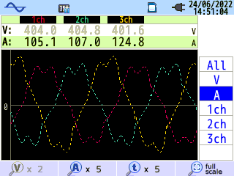 | 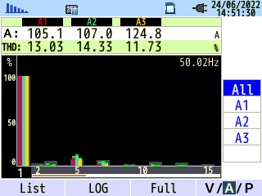
Figure 4.12 - Power quality parameters measure of power supply to Villa B7 - B12
Villa 3010:
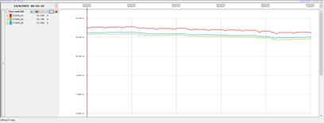 |  |  | 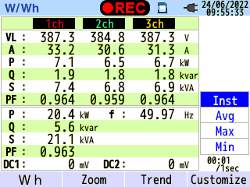
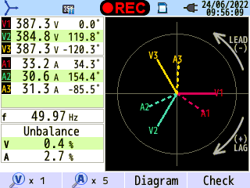 | 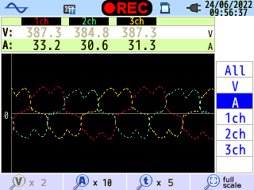 | 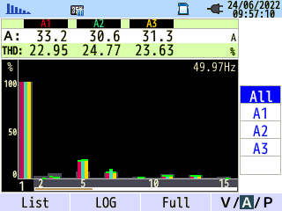
Figure 4.13 - Power quality parameters measure of electricity supply to Villa 3010
Villa C6:
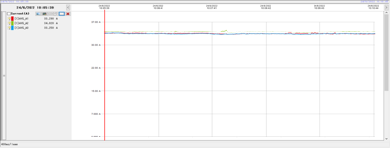
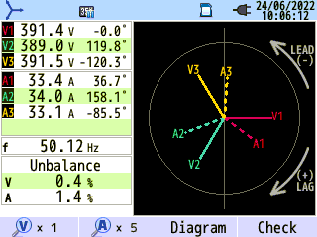 | 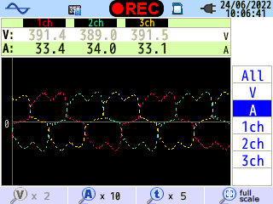 | 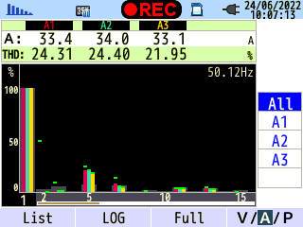
Figure 4.14 - Power quality parameters measure of electricity supply to Villa C6
Villa H9:
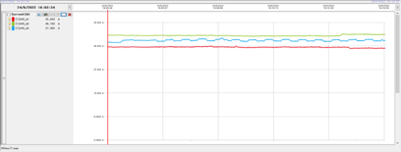 |  |  | 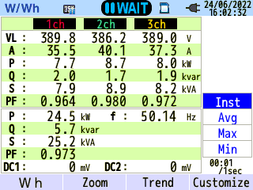
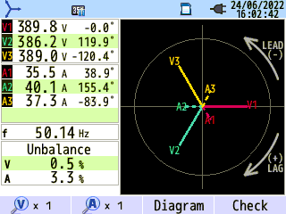 | 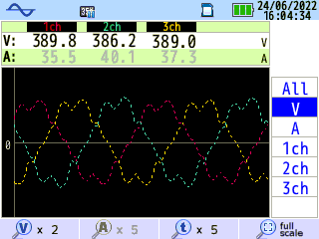 | 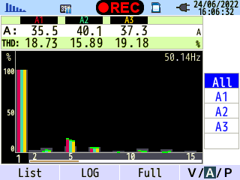
Figure 4.15 - Power quality parameters measure of electricity supply to Villa H9
Comment: Most of the graph currents for the Villas are relatively stable. Quality of electricity supplied to the Villas is not really good, the power factors of the electrical cabinets are all high (above 0,9). However, the current phase difference in some electrical cabinets is relatively high (such as: at the power supply of villa 1020 and 2040, the current phase difference is 6,8% and 7,1%). Some electrical cabinets appear harmonic interference that distorts the sine wave of the current, the total harmonic distortion is quite high (such as Villa 1020 power supply with total harmonic distortion TDD ranging from 25 to 30%, Villa 3010 power supply has total harmonic distortion TDD ranging from 22 to 25%,…).
General comment: From the measurement and survey results, the audit unit found that the quality of electricity supplied to some areas was not really good. In some cabinets, harmonics appear much higher than the allowable level, some cabinets have quite high current phase difference.
The reason is that Company uses a lot of nonlinear loads that transform the sine waveform of voltage/current; inverters with different power ranges for the motors. Many devices use single-phase power, and the density of use does not simultaneously cause phase difference in some local distribution cabinets.
In order for electrical equipment and control equipment to operate stably and economically, Company should install harmonic filters. In addition, it is also necessary to take into account the options for redistribution of the electrical load to reduce the deviation of the current phases).

4.3.2. Electrical system
Company’s Electrical system is supplied from the 22 kV power grid through 06 transformers with a total capacity of 3.810 kVA to supply power to the main electrical cabinets and energy consuming equipment areas of the whole area.
Table 4.1. List of major transformers
No. | Transformers | Voltage  (input/output) | Installed capacity (kVA) | Actual load (kW) | Power factor
1 | Transformer S1 | 22kV/400V | 315 | 120 | 0,971
2 | Transformer S2 | 22kV/400V | 500 | 235 | 0,967
3 | Transformer S3 | 22kV/400V | 1250 | 360,7 | 0,935
4 | Transformer S4 | 22kV/400V | 630 | - | -
5 | Transformer S5 | 22kV/400V | 315 | 162 | 0,971
6 | Transformer S6 | 22kV/400V | 800 | 180 | 0,954
In addition, Company is also equipped with a backup generator.
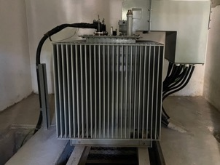 | 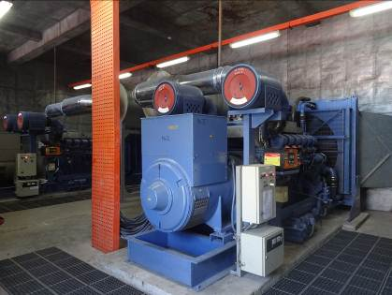
Figure 4.16 - Transformers and backup generator
Through a survey, the auditors found that the Company's power station was reasonably arranged, the space in the station was well ventilated. The measuring and monitoring equipment is relatively complete. The station's on-site measuring devices such as voltage meter, amperage, power, cosφ work well. In addition, The company also installs an automatic cosϕ compensation cabinet for the electrical system to avoid having to pay for reactive power and limit power loss on transmission lines.
The audit unit has measured the electricity consumption and quality of electricity at the transformers, the results are shown as follows:
Transformer S1:
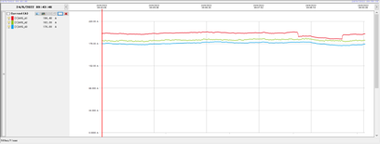 |  |  | 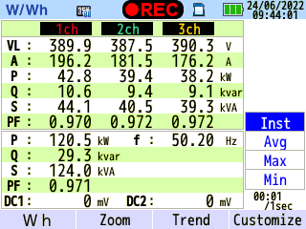
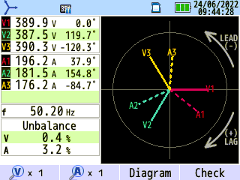 | 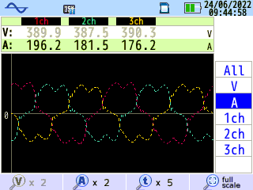 | 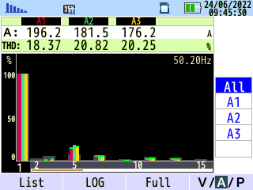
Figure 4.17 - Power quality parameters measure of power supply to S1 transformer

Transformer S2:
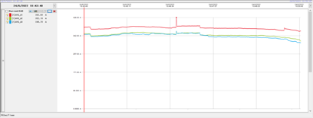 |  |  | 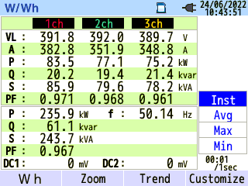
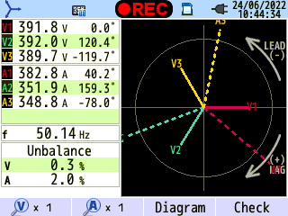 | 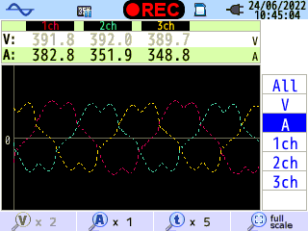 | 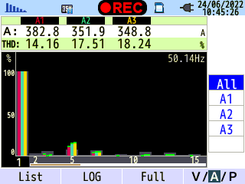
Figure 4.18 - Power quality parameters measure of power supply to S2 transformer
Transformer S3:
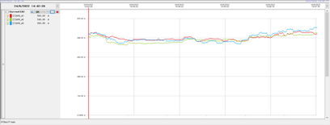 |  |  | 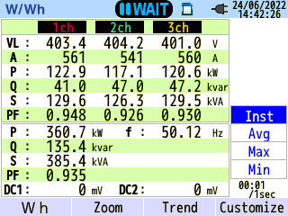
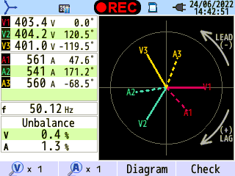 | 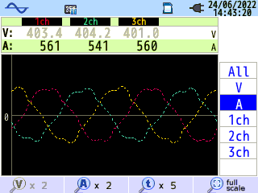 | 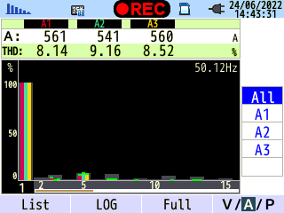
Figure 4.19 - Power quality parameters measure of power supply to S3 transformer
Transformer S5:
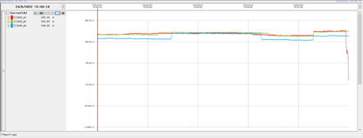 |  |  | 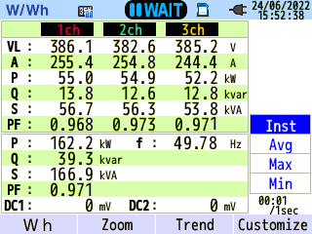
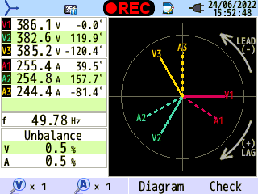 | 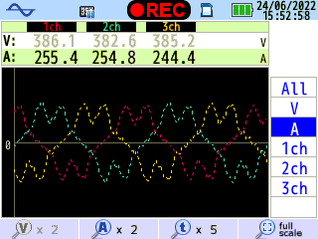 | 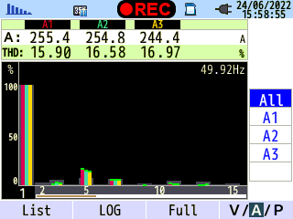
Figure 4.20 - Power quality parameters measure of power supply to S5 transformer
Transformer S6:
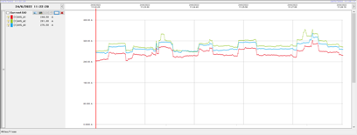 |  |  | 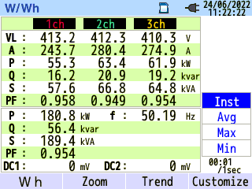
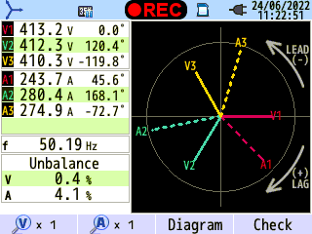 | 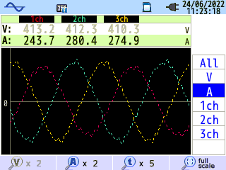 | 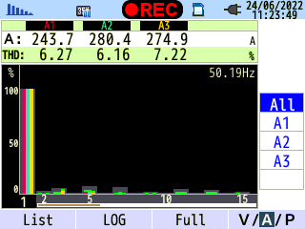
Figure 4.21 - Power quality parameters measure of power supply to S6 transformer
Comment: In general, power consumption in transformers is quite low (most consume less than 50% of design capacity). Most of the current graphs of the transformers are relatively stable, particularly, transformer S6 has changed, but not much. The power quality of the transformers S3 and S6 is quite good, the cosφ coefficient is always high (above 0,9), the current phase difference and the total harmonic distortion are within the allowable range. The power quality of digital transformers S1, S2, S5 is not really good, the cosφ coefficient is always high (above 0.9), the current phase difference is low however, the current appears harmonic causing distortion of the sine wave of the current, the total harmonic distortion TDD is high (34 - 21%).
The reason for this is that Company uses a lot of nonlinear loads that transform the sine waveform of voltage/current; inverters with different power ranges for the motors.
According to Circular No.30/2019/TT-BCT dated November 18, 2019 of the Ministry of Industry and Trade (supplementing and replacing Circular No.39/2015/TT-BCT dated November 18, 2015) regulating the Current harmonic distortion at the connection point is shown in the following table:

Table 4.2. Permissible maximum current harmonic distortion for electrical loads
Voltage | Total deformation | Individual deformation
110 kV | 4% | 3,5%
Middle voltage | 8% | 7%
Low voltage | 12% if the load ≥ 50 kW  20% if the load < 50 kW | 10% if the load ≥ 50 kW  15% if the load < 50 kW
Considering that the harmonics at power supply to transformers S1, S2 and S5 are still relatively higher than the allowable threshold compared to regulations, Company needs to take measures to reduce harmonics and improve power quality such as impedance coil, passive harmonic filter, active harmonic filter or use low harmonic inverters to help electrical equipment and control equipment operate stably and save a part of energy due to harmonics causing heating of conductors.

4.3.3. Lighting systems
Company uses many types of lights for different purposes. T8 LEDs are mainly used for the dynamic workshop area, internal areas such as technical offices, equipment and machinery rooms, electrical cabinets area, laundry room or cafeteria for officials and employees. In addition, there are some decorative lights and some special lamps for each function are also replaced by LED bulbs.
Those lamps in use have high efficiency and long life, which saves a lot of energy for Company's lighting system.
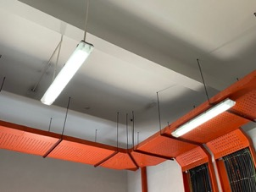 | 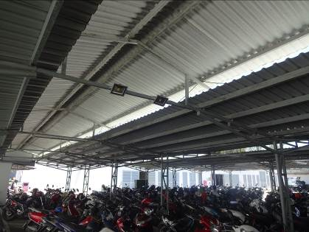
Figure 4.22 - Lighting image of Company
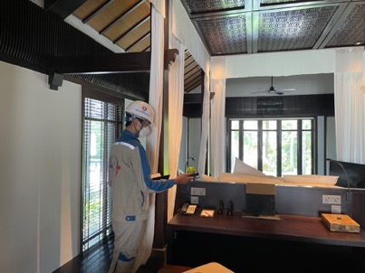
Figure 4.23 - The audit team conducts the lighting quality test
The audit team has measured the quality of lighting in the office and workshop areas of Company and below is summarized the measurement results of typical areas, compared with TCVN-7114-1:2008 lighting standards.
Table 4.3. The results of measuring lighting in some typical areas
No. | Name | Location | Average Lux Level (lux) | Lighting standards (lux)
1 | DOE’s office | Reception desk | 296 | 200
1 | DOE’s office | Desk | 224 | 200
1 | DOE’s office | Next to the cupboard | 212 | 200
1 | DOE’s office | Under the light | 300 | 200
2 | Engineering office | Desk 1 | 247 | 200
2 | Engineering office | Desk 2 | 218 | 200
2 | Engineering office | Under the light | 361 | 200
2 | Engineering office | Note table | 218 | 200
2 | Engineering office | Location for profile | 227 | 200
2 | Engineering office | Walkway | 278 | 200
3 | Laundry room | Middle of the room | 233 | 200
3 | Laundry room | Hamper | 122 | 200
3 | Laundry room | Walkway | 132 | 200
4 | Canteen | Dining table 1 | 240 | 150
4 | Canteen | Dining table 2 | 227 | 150
4 | Canteen | Dining table 3 | 225 | 150
4 | Canteen | Dining table 4 | 194 | 150
4 | Canteen | Food pick up location | 154 | 150
4 | Canteen | Under the light | 298 | 150
4 | Canteen | Walkway | 128 | 150
5 | Villa and hotel area | Next to bed | 154 | 100
5 | Villa and hotel area | Desk | 123 | 100
5 | Villa and hotel area | Wardrobe | 123 | 100
5 | Villa and hotel area | Walkway | 172 | 100
Comparing with TCVN 7114-1: 2008 Vietnamese lighting standards, it can be seen that the lighting quality at the Company is very good, meeting and exceeding the working needs of staff and employees.

4.3.4. Heat supply system
Company is currently using 04 oil-fired boilers (including 02 boilers with a capacity of 500 kg/hour and 02 boilers with a capacity of 400 kg/hour), produce saturated steam at a pressure of 5,0 - 6,0 bar for laundry and through heat exchangers to supply hot water. Within one week, 02 boilers are put into operation, the remaining 02 boilers stop working for maintenance, cleaning and repair. The operating parameters of the boilers are as follows:
Table 4.4. Thông số hoạt động của lò hơi
No. | Model | Quantity | Pressure max (kg/cm²) | Operating pressure (kg/cm²) | Capacity (kg/h) | Manufacturer
1 | NH-400-10 | 2 | 12 | 5,5-6,5 | 400 | Q&D Coporation
2 | NH-500-10 | 2 | 15 | 5,5-6,5 | 500 | Martech Company
Pictures of the boiler system:
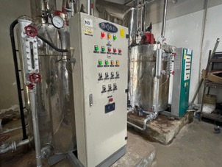 | 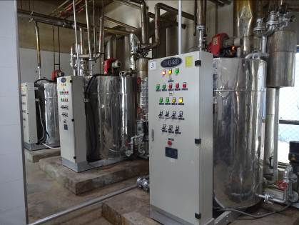
 | 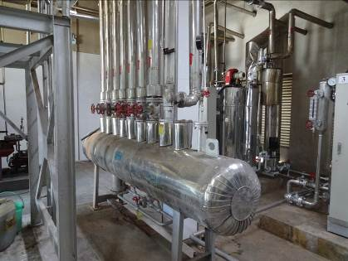
Figure 4.24 - Boiler system
The additional feed water for the boiler is treated to a good quality of the boiler feed water. Boilers are regularly added with chemical to check the pH in the boilers. Company takes advantage of the recovery of condensate and brings it to the feed water tank. Steam after the indirect heat exchange stages is recovered to the intermediate storage tank before being supplied to the boiler. The hot water circulation pumps are operated continuously to prevent the water from cooling down in the reservoir.
Through the survey, the audit unit found that the pipeline system, chimney system, steam supply and condensate were all insulated. However, most of the valves on the steam pipeline are not insulated, the surface temperature of these valves is quite high, causing significant heat loss. Insulating these valves takes less time and cost, but the effect is obvious and long-lasting, contributing to operational safety as well as saving costs for the heating system.
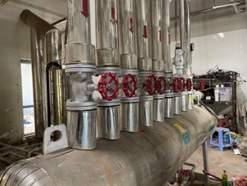 | 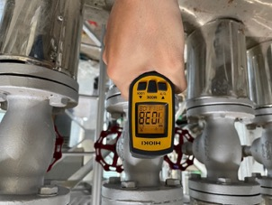
Figure 4.25 - Valve system is not insulated with high temperature
Through the survey and unit test, the temperature of the exhaust fumes released into the environment is still relatively high (about 185ºC), causing energy loss. Company can take advantage of this temperature source to heat the feed water before it is put into the furnace, helping to save energy consumption for steam production.
The audit unit has measured the quality of the current supplied to the boiler system, the results are as follows:
Power supply to boiler:
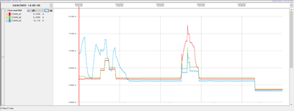 |  |  | 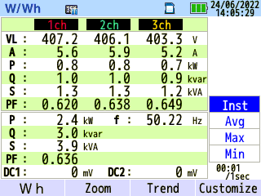
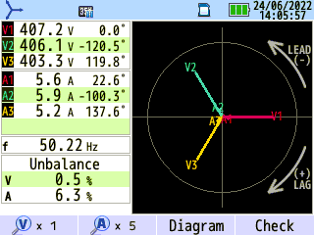 | 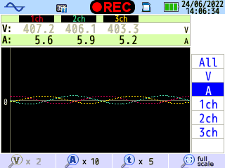 | 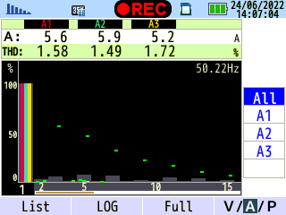
Figure 4.26 - Power quality parameters measure of power supply to boiler
Comment: Continuously variable boiler feed flow graph. The quality of power supply to the boiler is not really good. The current does not appear noise, harmonics and the total harmonic distortion of the current is low. However, the current phase difference is still relatively high (6,3%).
In addition, Company has installed many devices utilizing solar energy through solar panels to provide hot water for use areas.
Figure 4.27 - The system of solar panels providing hot water

4.3.5. Air conditioning system
The company uses Daikin's VRV air conditioning system for most of the needs of the entire hotel and luxurious villas. Besides, the Company uses a number of local air conditioners for some specific areas.
In the cold storage, the Company uses refrigeration compressors and fans to maintain the temperature in the warehouse.
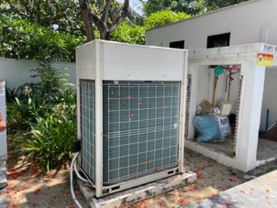 | 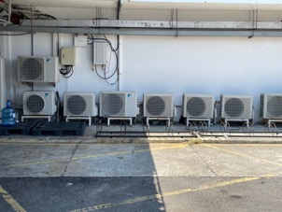
Figure 4.28 - Air conditioning system
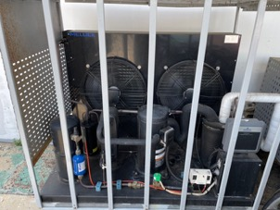 | 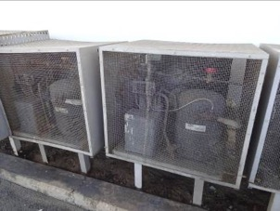
Figure 4.29 - Refrigeration compressor system
Comment: The air conditioning system consists of many devices, so it consumes quite a lot of energy in the main energy source at Company. Company needs to pay attention to maintenance and cleaning to make the machine operate well, stably, and avoid wasting energy.

4.3.6. Water systems and wastewater treatment system
The company uses water from the borehole system through the filter to be able to use it. The water pumping station includes two storage tanks with capacities of 300 and 500 m³. The main engines of the system include 03 pumps (01 pump with rated capacity 5,5kW, 02 pumps with rated capacity 7,5kW). At the time of survey, there were 02 pumps in operation, 01 pump stopped as a backup. The water supply system for the boiler system, hot water, cold water supply and domestic services of Company has been fully installed with flow and pressure measuring devices.
Pictures of domestic pumping system:
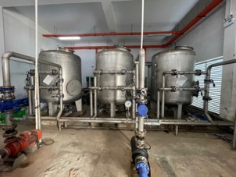 | 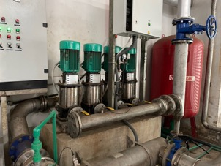
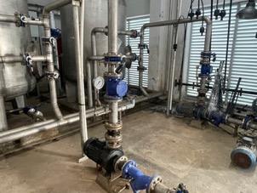 | 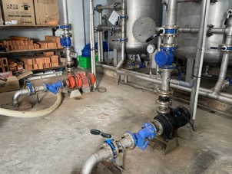
Figure 4.30 - Domestic water pump system
The results of measuring the capacity and quality of electricity supplied to the domestic water pump are as follows:

No.1 Domestic water pump:
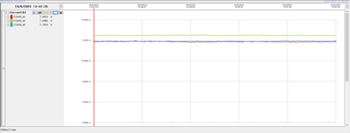 |  |  | 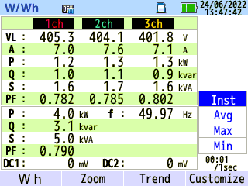
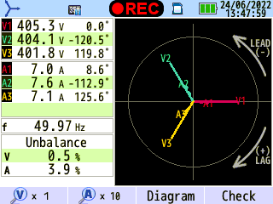 | 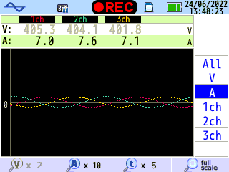 | 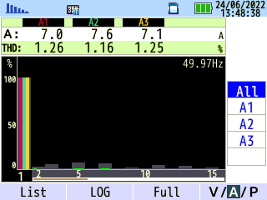
Figure 4.31 - Power quality parameters measure of power supply to No.1 domestic water pump
Total power supply to domestic water pumping system:
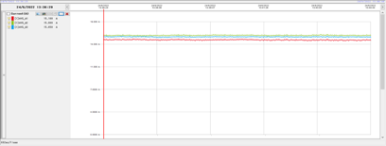 |  |  | 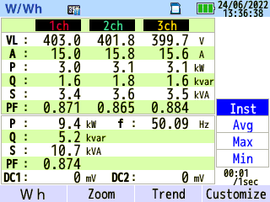
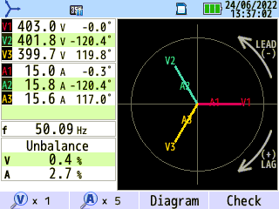 | 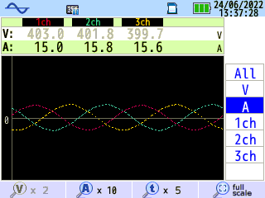 | 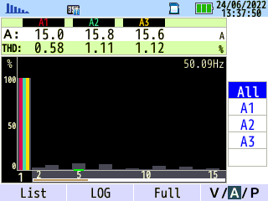
Figure 4.32 - Power quality parameters measure of total power supply to domestic water pumping system
Comment: The graph of the total power supply of domestic water pump system as well as No.1 domestic pump is relatively stable. The quality of the power supply to the system is relatively good: phase difference and total current harmonic distortion are both within the allowable level.
Company takes advantage of the water circulation as much as possible. The water system is treated through filtration systems and is regularly added with the appropriate chemicals to meet domestic water supply standards. In addition, Company has treated wastewater before releasing it into the environment.
The company is equipped with a fire fighting pump system when there is an incident. All these pumps operate infrequently, with low savings potential.
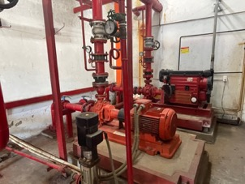
Figure 4.33 - Fire pump system

4.3.7. Other equipment system
Office equipment (computers, printers, fax machines, copiers, ...) at Company is used depending on the area with a large number of devices. However, the power saving for these devices still depends on the consciousness of each employee in the Company (turning off when not in use) and that has been propagated by Company, so the Energy Audit Unit also realized that that there is no possibility of this device system.

4.4. Potentials of energy savings
The facility has implemented some energy saving solutions (learn more at section 3.4). However, there are some positions and areas, whose equipments can be improved, repaired or upgrated or installed with controllers to save more energy:
- For the lighting system: Company has replaced the entire lighting system to LEDs, so the potential savings depends mainly on the ON/OFF of devices when there are no users in the Company.
- For heat supply system: The valve system on pipelines still has the potential to be insulated, helping to reduce heat loss to the environment. Besides, it is possible to take advantage of the heat of the exhaust smoke to heat the feed water into the boiler.
- For air conditioning system: The system is relatively optimal, so there are only some notes on cleaning the outdoor units.
- For electrical system: The quality of electricity supplied in some independent electrical cabinets and at the Company's power stations is not really good. Noise, harmonics are much higher than allowed. There is still the ability to save energy, especially to reduce the negative impact on motors and equipment while improving the quality of electricity by equipping with active filters to minimize harmonics at independent electrical cabinets.

Chapter 5

DEMANDS AND CAPABILITY OF ENERGY SUPPLY

5.1. Energy prices
Electricity is the main source of energy consumed, which are used for operating of Indochina Resort Co., Ltd (Hoi An). The factory uses electricity from national general grid at 22 kV. Electricity prices is costed by general electricity tariffs of Electricity of Vietnam (EVN):
Table 5.1. The electricity tariffs for business
No. | Description | Electricity Price  (VND/kWh)
1 | Voltage from 22 kV and above
 | a) Standard hour | 2.442
 | b) Off-peak hour | 1.361
 | c) Peak hour | 4.251
2 | Voltage from 6 kV to below 22 kV
 | a) Standard hour | 2.629
 | b) Off-peak hour | 1.547
 | c) Peak hour | 4.400
3 | Voltage below 6 kV
 | a) Standard hour | 2.666
 | b) Off-peak hour | 1.622
 | c) Peak hour | 4.587
Base on data consumption and statistics energy costs, which is provided by the Company, the audit team has evaluated the average energy price:
Table 5.2. Average energy price in period 2019 - 06/2022
No. | Type of energy | Unit | Average energy price
No. | Type of energy | Unit | 2019 | 2020 | 2021 | 01-06/2022
1 | Electricity | VND/kWh | 2.544 | 2.192 | 2.205 | 2.566
2 | Diesel oil | VND/liter | 14.544 | 13.106 | 12.285 | 24.114
3 | LPG | VND/kg | 23.774 | 10.522 | 21.886 | 28.775

5.2. Energy consumption database
Total main energy consumption (converted to TOE) and the costs of energy consumption are listed fully below.

5.2.1. Electricity consumption situation
Electricity is used for almost systems in the Company. Below is the electrical single-line diagram of the Company:
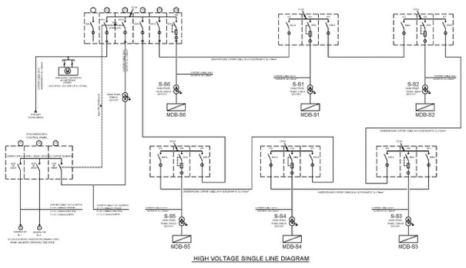
Figure 5.1 - The electrical single-line diagram
The situation of electricity consumption in phase 2019 - 06/2022 of the facility are listed fully in table below:
Table 5.3. Statistics on electricity situation and cost by 3 time frames in 2019
Mths | Electricity  (kWh) |  |  | Total  (kWh) | Cost  (million VND) |  |  | Total  (million VND)
Mths | Normal hours | Peak hours | Off-peak hour | Total  (kWh) | Normal hours | Peak hours | Off-peak hours | Total  (million VND)
Jan | 313.720 | 105.600 | 120.120 | 539.440 | 707,1 | 414,3 | 150,9 | 1.272,3
Feb | 367.840 | 122.760 | 132.000 | 622.600 | 829,1 | 481,6 | 165,8 | 1.476,5
Mar | 417.560 | 144.320 | 150.920 | 712.800 | 968,5 | 583,5 | 195,9 | 1.747,8
Apr | 482.330 | 161.202 | 167.747 | 811.279 | 1.177,8 | 685,3 | 228,3 | 2.091,4
May | 538.617 | 182.746 | 181.491 | 902.854 | 1.315,3 | 776,9 | 247,0 | 2.339,2
June | 561.200 | 193.199 | 197.381 | 951.780 | 1.370,5 | 821,3 | 268,6 | 2.460,4
July | 623.089 | 204.072 | 217.454 | 1.044.615 | 1.521,6 | 867,5 | 296,0 | 2.685,0
Aug | 593.441 | 205.202 | 209.425 | 1.008.068 | 1.449,2 | 872,3 | 285,0 | 2.606,5
Sep | 446.993 | 147.284 | 145.192 | 739.469 | 1.091,6 | 626,1 | 197,6 | 1.915,3
Oct | 413.163 | 142.766 | 136.328 | 692.257 | 1.008,9 | 606,9 | 185,5 | 1.801,4
Now | 311.879 | 107.932 | 109.730 | 529.541 | 761,6 | 458,8 | 149,3 | 1.369,8
Dec | 314.974 | 99.778 | 119.431 | 534.183 | 769,2 | 424,2 | 162,5 | 1.355,9
Total | 5.384.806 | 1.816.861 | 1.887.219 | 9.088.886 | 12.970,4 | 7.618,6 | 2.532,5 | 23.121,4
Table 5.4. Statistics on electricity situation and cost by 3 time frames in 2020
Mths | Electricity  (kWh) |  |  | Total  (kWh) | Cost  (million VND) |  |  | Total  (million VND)
Mths | Normal hours | Peak hours | Off-peak hour | Total  (kWh) | Normal hours | Peak hours | Off-peak hour | Total  (million VND)
Jan | 347.677 | 118.011 | 127.419 | 593.107 | 849,0 | 501,7 | 173,4 | 1.524,1
Feb | 278.967 | 89.782 | 101.200 | 469.949 | 681,2 | 381,7 | 137,7 | 1.200,6
Mar | 184.543 | 57.250 | 67.745 | 309.538 | 450,7 | 243,4 | 92,2 | 786,2
Apr | 60.009 | 17.021 | 22.582 | 99.612 | 139,6 | 68,8 | 29,3 | 237,7
May | 86.103 | 26.428 | 29.608 | 142.139 | 120,5 | 68,3 | 26,8 | 215,7
June | 107.682 | 31.281 | 37.971 | 176.934 | 133,3 | 72,5 | 31,9 | 237,6
July | 292.811 | 94.258 | 99.401 | 486.470 | 515,2 | 301,6 | 105,8 | 922,6
Aug | 89.031 | 24.171 | 34.624 | 147.826 | 217,4 | 102,8 | 47,1 | 367,3
Sep | 71.090 | 22.415 | 31.656 | 125.161 | 173,6 | 95,3 | 43,1 | 312,0
Oct | 43.992 | 13.174 | 23.293 | 80.459 | 107,4 | 56,0 | 31,7 | 195,1
Now | 67.452 | 22.582 | 29.691 | 119.725 | 164,7 | 96,0 | 40,4 | 301,1
Dec | 159.829 | 53.987 | 65.863 | 279.679 | 172,9 | 118,4 | 50,9 | 342,3
Total | 1.789.186 | 570.360 | 671.053 | 3.030.599 | 3.725,7 | 2.106,2 | 810,4 | 6.642,3
Table 5.5. Statistics on electricity situation and cost by 3 time frames in 2021
Mths | Electricity  (kWh) |  |  | Total  (kWh) | Cost  (million VND) |  |  | Total  (million VND)
Mths | Normal hours | Peak hours | Off-peak hour | Total  (kWh) | Normal hours | Peak hours | Off-peak hour | Total  (million VND)
Jan | 154.308 | 50.935 | 64.190 | 269.433 | 376,8 | 216,5 | 87,4 | 680,7
Feb | 162.839 | 51.854 | 66.532 | 281.225 | 397,7 | 220,4 | 90,6 | 708,6
Mar | 192.699 | 58.755 | 68.456 | 319.910 | 470,6 | 249,8 | 93,2 | 813,5
Apr | 289.465 | 97.520 | 101.785 | 488.770 | 706,9 | 414,6 | 138,5 | 1.260,0
May | 226.737 | 67.118 | 80.667 | 374.522 | 553,7 | 285,3 | 109,8 | 948,8
June | 151.214 | 47.088 | 55.241 | 253.543 | 235,1 | 135,2 | 55,6 | 426,0
July | 161.168 | 51.145 | 58.796 | 271.109 | 250,6 | 146,8 | 59,2 | 456,7
Aug | 112.448 | 32.325 | 39.937 | 184.710 | 174,9 | 92,8 | 40,2 | 307,9
Sep | 69.000 | 20.868 | 24.881 | 114.749 | 107,3 | 59,9 | 25,1 | 192,3
Oct | 60.469 | 17.981 | 21.578 | 100.028 | 94,0 | 51,6 | 21,7 | 167,4
Now | 17.605 | 55.410 | 20.199 | 93.214 | 86,2 | 50,5 | 20,3 | 157,0
Dec | 59.842 | 17.564 | 20.826 | 98.232 | 93,1 | 50,4 | 21,0 | 164,5
Total | 1.657.794 | 568.563 | 623.088 | 2.849.445 | 3.546,8 | 1.973,9 | 762,5 | 6.283,2

Table 5.6. Statistics on electricity situation and cost by 3 time frames in 2022
Mths | Electricity  (kWh) |  |  | Total  (kWh) | Cost  (million VND) |  |  | Total  (million VND)
Mths | Normal hours | Peak hours | Off-peak hour | Total  (kWh) | Normal hours | Peak hours | Off-peak hour | Total  (million VND)
Jan | 160.205 | 49.513 | 62.225 | 271.943 | 391,2 | 210,5 | 84,7 | 686,4
Feb | 178.980 | 57.499 | 68.164 | 304.643 | 437,1 | 244,4 | 92,8 | 774,3
Mar | 191.821 | 61.849 | 67.452 | 321.122 | 468,4 | 262,9 | 91,8 | 823,1
Apr | 301.382 | 102.705 | 110.233 | 514.320 | 736,0 | 436,6 | 150,0 | 1.322,6
May | 284.740 | 88.780 | 98.397 | 471.917 | 695,3 | 377,4 | 133,9 | 1.206,7
June | 450.297 | 153.180 | 151.131 | 754.608 | 1.099,6 | 651,2 | 205,7 | 1.956,5
July | - | - | - | - | - | - | - | -
Aug | - | - | - | - | - | - | - | -
Sep | - | - | - | - | - | - | - | -
Oct | - | - | - | - | - | - | - | -
Now | - | - | - | - | - | - | - | -
Dec | - | - | - | - | - | - | - | -
Total | 1.567.425 | 513.526 | 557.602 | 2.638.553 | 3.827,7 | 2.183,0 | 758,9 | 6.769,5

Table 5.7. Statistics of Electricity Consumption in period 2019 - 06/2022
Mths | 2019 |  | 2020 |  | 2021 |  | 01-06/2022
Mths | Electricity  (kWh) | Cost  (million VND) | Electricity  (kWh) | Cost  (million VND) | Electricity  (kWh) | Cost  (million VND) | Electricity  (kWh) | Cost  (million VND)
Jan | 539.440 | 1.272,3 | 593.107 | 1.524,1 | 269.433 | 680,7 | 271.943 | 686,4
Feb | 622.600 | 1.476,5 | 469.949 | 1.200,6 | 281.225 | 708,6 | 304.643 | 774,3
Mar | 712.800 | 1.747,8 | 309.538 | 786,2 | 319.910 | 813,5 | 321.122 | 823,1
Apr | 811.279 | 2.091,4 | 99.612 | 237,7 | 488.770 | 1.260,0 | 514.320 | 1.322,6
May | 902.854 | 2.339,2 | 142.139 | 215,7 | 374.522 | 948,8 | 471.917 | 1.206,7
June | 951.780 | 2.460,4 | 176.934 | 237,6 | 253.543 | 426,0 | 754.608 | 1.956,5
July | 1.044.615 | 2.685,0 | 486.470 | 922,6 | 271.109 | 456,7 | - | -
Aug | 1.008.068 | 2.606,5 | 147.826 | 367,3 | 184.710 | 307,9 | - | -
Sep | 739.469 | 1.915,3 | 125.161 | 312,0 | 114.749 | 192,3 | - | -
Oct | 692.257 | 1.801,4 | 80.459 | 195,1 | 100.028 | 167,4 | - | -
Now | 529.541 | 1.369,8 | 119.725 | 301,1 | 93.214 | 157,0 | - | -
Dec | 534.183 | 1.355,9 | 279.679 | 342,3 | 98.232 | 164,5 | - | -
Total | 9.088.886 | 23.121,4 | 3.030.599 | 6.642,3 | 2.849.445 | 6.283,2 | 2.638.553 | 6.769,5

Base on data in the table to build the chart of electricity consumption as below:
Figure 5.2 - Electricity Consumption Chart in period 2019 - 06/2022
Comment: Total annual electricity consumption in the period of 2019 - 2021 decreased sharply due to the impact of the Covid-19 pandemic. Electricity consumption in the first 6 months of 2022 increased by 32.76% compared to the same period in 2021.

5.2.2. Diesel Oil Consumption Situation
The company uses Diesel oil as fuel for boilers. In addition, Diesel oil is used to run a backup generator. Diesel oil consumption in period 2019 - 06/2022 is detailed in the table below:
Table 5.8. Statistics of Diesel Oil Consumption in period 2019 - 06/2022
Mths | 2019 |  | 2020 |  | 2021 |  | 01-06/2022
Mths | DO  (liter) | Cost  (million VND) | DO  (liter) | Cost  (million VND) | DO  (liter) | Cost  (million VND) | DO  (liter) | Cost  (million VND)
Jan | 21.701 | 289,0 | 27.116 | 399,1 | 15.268 | 166,1 | 14.150 | 238,0
Feb | 18.049 | 240,4 | 21.950 | 313,9 | 15.452 | 177,6 | 4.741 | 245,7
Mar | 22.901 | 321,9 | 13.677 | 195,6 | 18.143 | 221,7 | 8.572 | 151,6
Apr | 26.086 | 395,6 | 812 | 11,6 | 18.077 | 225,8 | 19.670 | 441,3
May | 19.462 | 305,9 | 0 | 0,0 | 10.358 | 131,1 | 14.858 | 373,7
June | 18.169 | 280,6 | 1.074 | 15,4 | 3.926 | 57,6 | 15.873 | 427,3
July | 22.935 | 338,8 | 13.211 | 140,6 | 4.704 | 69,0 | - | -
Aug | 21.352 | 322,6 | 407 | 4,3 | 412 | 6,0 | - | -
Sep | 20.468 | 296,4 | 0 | 0,0 | 432 | 6,3 | - | -
Oct | 20.203 | 298,1 | 3.149 | 33,5 | 0 | 0,0 | - | -
Now | 17.836 | 253,8 | 2.496 | 24,5 | 0 | 0,0 | - | -
Dec | 26.827 | 380,0 | 11.908 | 117,0 | 2.024 | 29,7 | - | -
Total | 255.989 | 3.723,0 | 95.800 | 1.255,6 | 88.796 | 1.090,9 | 77.864 | 1.877,6
Base on date in the table to built the chart of Diesel oil consumption:
Figure 5.3 - Diesel Oil Consumption Chart in period 2019 - 06/2022
Comment: Similar to electricity consumption, oil consumption also decrease sharply in this period. Diesel oil consumption in the first 6 months of 2022 decreased by 4.14% compared to the same period in 2021.

5.2.3. LPG consumption situation
LPG consumption in period 2019 - 06/2022 is detailed in the table below:

Table 5.9. Statistics of LPG Consumption in period 2019 - 06/2022
Mths | 2019 |  | 2020 |  | 2021 |  | 01-06/2022
Mths | LPG  (kg) | Cost  (million VND) | LPG  (kg) | Cost  (million VND) | LPG  (kg) | Cost  (million VND) | LPG  (kg) | Cost  (million VND)
Jan | 54.948 | 1.270,7 | 43.534 | 1.116,2 | 9.720 | 209,1 | 6.856 | 149,2
Feb | 43.774 | 1.034,2 | 23.048 | 556,4 | 8.770 | 188,7 | 12.717 | 346,9
Mar | 7.681 | 198,3 | 6.910 | 155,3 | 1.765 | 40,4 | 4.741 | 146,1
Apr | 5.421 | 133,0 | 294 | 6,6 | 1.735 | 39,7 | 13.082 | 416,5
May | 4.086 | 107,5 | 0 | 0,0 | 1.765 | 38,4 | 3.353 | 106,8
June | 3.813 | 100,4 | 0 | 0,0 | 353 | 7,7 | 2.288 | 72,8
July | 3.743 | 98,5 | 1.471 | 33,0 | 588 | 12,8 | - | -
Aug | 5.316 | 139,9 | 0 | 0,0 | 294 | 6,4 | - | -
Sep | 6.333 | 166,7 | 0 | 0,0 | 294 | 6,4 | - | -
Oct | 5.540 | 120,9 | 0 | 0,0 | 471 | 10,2 | - | -
Now | 10.382 | 226,5 | 0 | 0,0 | 205 | 5,9 | - | -
Dec | 44.828 | 1.059,7 | 7.999 | 156,1 | 512 | 13,7 | - | -
Total | 195.865 | 4.656,5 | 83.256 | 876,0 | 26.472 | 579,4 | 43.035 | 1.238,3
Base on date in the table to built the chart of LPG consumption:
Figure 5.4 - LPG Consumption Chart in period 2019 - 06/2022
Commet: LPG consumption decreased sharply in the period of 2019 - 2021. Consumption in the first 6 months of 2022 increased by 78.5% compared to the same period in 2021. LPG consumption in the winter months and the first months of the year is usually larger due to the increased demand to heat the swimming pool.

5.2.4. Summary of Energy Consumption Situation
According to the statistical data above and using converting unit from all types of energy to TOE (Tone of Oil Equivalent), the audit team evaluates the amount of all energy consumption presented in table below:
Table 5.10. Statistics of Energy Consumption Converted to TOE
Mths | 2019 | 2020 | 2021 | 01-06/2022
Jan | 162 | 163 | 66 | 62
Feb | 160 | 117 | 67 | 65
Mar | 139 | 67 | 67 | 62
Apr | 154 | 16 | 93 | 111
May | 161 | 22 | 69 | 90
June | 167 | 28 | 43 | 133
July | 185 | 88 | 47 | -
Aug | 180 | 23 | 29 | -
Sep | 139 | 19 | 18 | -
Oct | 131 | 15 | 16 | -
Now | 109 | 21 | 15 | -
Dec | 155 | 62 | 17 | -
Total | 1.841 | 643 | 547 | 523
Base on the table above, build the chart of energy consumption converted to TOE:
Figure 5.5 - Total of TOE Consumption Chart in period 2019 - 06/2022
Table 5.11. Statistics of Energy Consumption Percentages
No. | Type of Energy | 2019 |  | 2020 |  | 2021 |  | 01-06/2022
No. | Type of Energy | TOE | % | TOE | % | TOE | % | TOE | %
1 | Electricity | 1.402 | 76,17 | 468 | 72,76 | 440 | 80,43 | 407 | 77,91
2 | Diesel oil | 225 | 12,24 | 84 | 13,12 | 78 | 14,29 | 69 | 13,11
3 | LPG | 213 | 11,60 | 91 | 14,12 | 29 | 5,28 | 47 | 8,98
 | Total | 1.841 | 100 | 643 | 100 | 547 | 100 | 523 | 100
From the statistics table, we have a chart of the consumption of energy in accordance with the TOE standard unit as follows:
Figure 5.6 - Energy consumption rates (converted to TOE)
Through the energy chart, it is easy to track the total amount of energy used in each month, each year of the Company. Thereby assessing and detecting the production stages that consume a lot of energy, and promptly offering treatment plans. In addition, the Company also statistics the power capacity of each area.

5.2.5. Water Consumption Situation
The water consumption in period 2019 - 06/2022 is detailed in the table below:
Table 5.12. Statistic of Water Consumption in period 2019 - 06/2022
Mths | 2019 |  | 2020 |  | 2021 |  | 01-06/2022
Mths | Water  (m³) | Cost  (million VND) | Water  (m³) | Cost  (million VND) | Water  (m³) | Cost  (million VND) | Water  (m³) | Cost  (million VND)
Jan | 5.485 | 0,0 | 7.318 | 0,0 | 4.658 | 0,0 | 7.088 | 0,0
Feb | 9.759 | 0,0 | 7.516 | 0,0 | 6.168 | 0,0 | 6.430 | 0,0
Mar | 12.459 | 0,0 | 7.930 | 0,0 | 7.725 | 0,0 | 6.772 | 0,0
Apr | 12.090 | 0,0 | 8.341 | 0,0 | 11.465 | 0,0 | 9.290 | 12,3
May | 13.379 | 0,0 | 9.414 | 0,0 | 11.712 | 0,0 | 7.723 | 16,5
June | 11.675 | 0,0 | 11.130 | 0,0 | 10.834 | 0,0 | 8.608 | 5,1
July | 14.053 | 0,0 | 11.641 | 0,0 | 10.403 | 0,0 | - | -
Aug | 12.278 | 0,0 | 8.581 | 0,0 | 10.610 | 0,0 | - | -
Sep | 6.557 | 0,0 | 9.405 | 0,0 | 4.772 | 0,0 | - | -
Oct | 8.373 | 0,0 | 1.973 | 0,0 | 3.073 | 0,0 | - | -
Now | 5.559 | 0,0 | 2.590 | 0,0 | 2.807 | 0,0 | - | -
Dec | 6.833 | 0,0 | 2.737 | 0,0 | 3.664 | 0,0 | - | -
Total | 118.500 | 0,0 | 88.576 | 0,0 | 87.891 | 0,0 | 45.911 | 33,9
In the period of 2019 - 03/2022, the Company uses self-exploited water through the filter so there is no water cost.
Base on data in the table to build the chart of water consumption:
Figure 5.7 - Water Consumption Chart in period 2019 - 06/2022
Nhận xét: Water consumption decreased in this period. Specifically, water consumption in 2020 decreased by 25,25% compared to 2019, in 2021 it decreased by 0,77% compared to 2020. Consumption in the first 6 months of 2022 decreased by 12.65% compared to the same period in 2021.

5.2.6. Energy costs
Total of energy consumption costs from 2019 to June 2022 are listed as the table below:
Table 5.13. Statistics of Energy Consumption Costs in period 2019 - 06/2022
No. | Energy | Annual Costs (million VND)
No. | Energy | 2019 | 2020 | 2021 | 01-06/2022
1 | Electricity | 23.121,4 | 6.642,3 | 6.283,2 | 6.769,5
2 | Diesel oil | 3.723,0 | 1.255,6 | 1.090,9 | 1.877,6
3 | LPG | 4.656,5 | 876,0 | 579,4 | 1.238,3
 | Total | 31.500,9 | 8.773,9 | 7.953,5 | 9.885,5
Based on the data from the above table, we can build the energy cost chart of the Company:
Figure 5.8 - Chart of rate energy cost
Comment: The cost for electricity consumption accounts for the highest proportion, mainly in the Company, usually over 68%. The second highest cost ratio for Diesel oil, accounting for over 11%, tends to increase during this period. The lowest cost ratio for LPG, accounting for over 7%, tends to decrease in 2019 - 2021 and increase again in 2022. Therefore, the Company should regularly monitor and evaluate the performance of equipment. main power consumption equipment, Diesel oil and having solutions to save electricity will help reduce energy costs for the Company.

5.3. Specific energy consumption and energy baselines

5.3.1. Specific Energy Consumption Rate
Through the survey to collect data on energy consumption and room use, we can see that the data provided by the Company can know the basic situation of energy use in the building. In addition, with detailed measuring devices for each system (electricity, water), the Company can completely calculate the consumption rate for each area. The formula for calculating the energy consumption rate is as follows:
The electricity consumption rate = | The electricity consumption
The electricity consumption rate = | Room occupancy (%)
The Diesel oil consumption rate = | The Diesel oil consumption
The Diesel oil consumption rate = | Room occupancy (%)
The energy consumption rate = | The energy consumption
The energy consumption rate = | Room occupancy (%)
Below are the monitoring and evaluation data of electricity, Diesel oil and energy consumption rates for room occupancy at the Company shown in the following table:

Table 5.14. The Electricity Consumption Rate in period 2019 - 06/2022
Mths | 2019 |  |  | 2020 |  |  | 2021 |  |  | 01-06/2022
Mths | Electricity  (MWh) | Room occupancy  (%) | Rate (kWh/  % room use) | Electricity  (MWh) | Room occupancy  (%) | Rate (kWh/  % room use) | Electricity  (MWh) | Room occupancy  (%) | Rate (kWh/  % room use) | Electricity  (MWh) | Room occupancy  (%) | Rate (kWh/  % room use)
Jan | 539 | 68 | 7.932,9 | 593 | 50 | 11.862,1 | 269 | 6 | 44.905,5 | 272 | 4 | 61.805,2
Feb | 623 | 82 | 7.592,7 | 470 | 54 | 8.702,8 | 281 | 6 | 46.870,8 | 305 | 14 | 21.760,2
Mar | 713 | 87 | 8.193,1 | 310 | 12 | 25.794,8 | 320 | 9 | 35.545,6 | 321 | 11 | 30.583,0
Apr | 811 | 87 | 9.325,0 | 100 | 0 | - | 489 | 25 | 19.550,8 | 514 | 37 | 13.863,1
May | 903 | 68 | 13.277,3 | 142 | 0 | - | 375 | 8 | 46.815,3 | 472 | 25 | 18.876,7
June | 952 | 71 | 13.405,4 | 177 | 0 | - | 254 | 2 | 126.771,5 | 755 | 28 | 26.950,3
July | 1.045 | 73 | 14.309,8 | 486 | 21 | 23.165,2 | 271 | 2 | 135.554,5 | - | - | -
Aug | 1.008 | 83 | 12.145,4 | 148 | 0 | - | 185 | 4 | 46.177,5 | - | - | -
Sep | 739 | 64 | 11.554,2 | 125 | 3 | 41.720,3 | 115 | 3 | 38.249,7 | - | - | -
Oct | 692 | 67 | 10.332,2 | 80 | 0 | - | 100 | 0 | - | - | - | -
Now | 530 | 56 | 9.456,1 | 120 | 0 | - | 93 | 0 | - | - | - | -
Dec | 534 | 49 | 10.901,7 | 280 | 5 | 55.935,8 | 98 | 0 | - | - | - | -
Avg | 757 | 71 | 10.630,3 | 151 | 2 | 94.106,3 | 237 | 5 | 43.837,6 | 440 | 20 | 22.172,7

Table 5.15. The Diesel oil Consumption Rate in period 2019 - 06/2022
Mths | 2019 |  |  | 2020 |  |  | 2021 |  |  | 01-06/2022
Mths | DO  (liter) | Room occupancy  (%) | Rate (liter/  % room use) | DO  (liter) | Room occupancy  (%) | Rate (liter/  % room use) | DO  (liter) | Room occupancy  (%) | Rate (liter/  % room use) | DO  (liter) | Room occupancy  (%) | Rate (liter/  % room use)
Jan | 21.701 | 68 | 319,1 | 27.116 | 50 | 542,3 | 15.268 | 6 | 2.544,7 | 14.150 | 4 | 3.215,9
Feb | 18.049 | 82 | 220,1 | 21.950 | 54 | 406,5 | 15.452 | 6 | 2.575,3 | 4.741 | 14 | 338,6
Mar | 22.901 | 87 | 263,2 | 13.677 | 12 | 1.139,8 | 18.143 | 9 | 2.015,9 | 8.572 | 11 | 816,4
Apr | 26.086 | 87 | 299,8 | 812 | 0 | - | 18.077 | 25 | 723,1 | 19.670 | 37 | 530,2
May | 19.462 | 68 | 286,2 | 0 | 0 | - | 10.358 | 8 | 1.294,8 | 14.858 | 25 | 594,3
June | 18.169 | 71 | 255,9 | 1.074 | 0 | - | 3.926 | 2 | 1.963,0 | 15.873 | 28 | 566,9
July | 22.935 | 73 | 314,2 | 13.211 | 21 | 629,1 | 4.704 | 2 | 2.352,0 | - | - | -
Aug | 21.352 | 83 | 257,3 | 407 | 0 | - | 412 | 4 | 103,0 | - | - | -
Sep | 20.468 | 64 | 319,8 | 0 | 3 | 0,0 | 432 | 3 | 144,0 | - | - | -
Oct | 20.203 | 67 | 301,5 | 3.149 | 0 | - | 0 | 0 | - | - | - | -
Now | 17.836 | 56 | 318,5 | 2.496 | 0 | - | 0 | 0 | - | - | - | -
Dec | 26.827 | 49 | 547,5 | 11.908 | 5 | 2.381,6 | 2.024 | 0 | - | - | - | -
Avg | 21.332 | 71 | 299,4 | 7.983 | 12 | 660,7 | 7.400 | 5 | 1.366,1 | 12.977 | 20 | 654,3

Table 5.16. The Energy Consumption Rate in period 2019 - 06/2022
Mths | 2019 |  |  | 2020 |  |  | 2021 |  |  | 01-06/2022
Mths | TOE | Room occupancy  (%) | Rate (TOE/  % room use) | TOE | Room occupancy  (%) | Rate (TOE/  % room use) | TOE | Room occupancy  (%) | Rate (TOE/  % room use) | TOE | Room occupancy  (%) | Rate (TOE/  % room use)
Jan | 162 | 68 | 2,39 | 163 | 50 | 3,26 | 66 | 6 | 10,93 | 62 | 4 | 14,06
Feb | 160 | 82 | 1,95 | 117 | 54 | 2,17 | 67 | 6 | 11,09 | 65 | 14 | 4,65
Mar | 139 | 87 | 1,59 | 67 | 12 | 5,61 | 67 | 9 | 7,47 | 62 | 11 | 5,93
Apr | 154 | 87 | 1,77 | 16 | 0 | - | 93 | 25 | 3,73 | 111 | 37 | 2,99
May | 161 | 68 | 2,37 | 22 | 0 | - | 69 | 8 | 8,60 | 90 | 25 | 3,58
June | 167 | 71 | 2,35 | 28 | 0 | - | 43 | 2 | 21,48 | 133 | 28 | 4,75
July | 185 | 73 | 2,54 | 88 | 21 | 4,20 | 47 | 2 | 23,31 | - | - | -
Aug | 180 | 83 | 2,17 | 23 | 0 | - | 29 | 4 | 7,30 | - | - | -
Sep | 139 | 64 | 2,17 | 19 | 3 | 6,44 | 18 | 3 | 6,14 | - | - | -
Oct | 131 | 67 | 1,95 | 15 | 0 | - | 16 | 0 | - | - | - | -
Now | 109 | 56 | 1,94 | 21 | 0 | - | 15 | 0 | - | - | - | -
Dec | 155 | 49 | 3,16 | 62 | 5 | 12,47 | 17 | 0 | - | - | - | -
Avg | 153 | 71 | 2,15 | 54 | 12 | 4,43 | 46 | 5 | 8,41 | 87 | 20 | 4,39

Based on the data from the above table, we can build Electricity Consumption Rate chart, Diesel oil Consumption Rate chart and Energy Consumption Rate chart of the Company:
Figure 5.9 - Electricity Consumption Rate Chart in period 2019 - 06/2022
Comment: Electricity consumption rate in 2019 is relatively stable. Electricity consumption rate in the period 2020 - 2022 changes continuously. The highest electricity consumption in August 2021.
Figure 5.10 - Diesel Oil Consumption Rate Chart in period 2019 - 06/2022
Comment: Diesel Oil consumption rate in 2019 is relatively stable. Diesel Oil consumption rate in the period 2020 - 2022 changes continuously. The highest Diesel Oil consumption in January 2022.
Figure 5.11 - Energy Consumption Rate Chart in period 2019 - 06/2022
From the energy consumption chart, the Company can identify the times when the demand for energy is high, thereby promptly making an appropriate plan for business activities.

5.3.2. Energy Baselines
Based on this energy baseline one can predict the expected energy consumption when the energy usage is realized. However, due to limited statistics, representativeness will not be high. Here, the Auditor typically calculates electricity consumption, DO oil and total energy converted to TOE form. To build the energy baseline for each area, department is exactly the same. Due to the nature of the Company's operations, which are always different from time to time, the calculation of consumption rate or energy baseline is only for reference and for monitoring and reporting of energy use.
Electricity baseline:
Figure 5.12 - Electricity baseline
Diesel oil baseline:
Figure 5.13 - Diesel Oil baseline
Energy baseline:
Figure 5.14 - Energy baseline
Table 5.17. Energy baseline equation
No. | Type of energy | Equation  (y = a.x + c) | Corner  coeficient  (a) | Free  coefficient  (c) | Statistical  deviation  (R²)
1 | Electricity for business | y = 7329,1x + 238536 | 7329,1 | 238536 | 0,7647
2 | Diesel oil for business | y = 179,73x + 9257,2 | 179,73 | 9257,2 | 0,5742
3 | Energy for business | y = 1,4975x + 48,679 | 1,4975 | 48,679 | 0,8412
Base on the baseline, we can estimate quite exactly the energy consumption required when we know the plan each type of business with coefficient of root mean square deviation R². This c coefficent tell us how much electricity consumption when system unload (eqiupment operate but not for business). We need to reduce c coefficient to minimum (by manage equipment, which operate unload, efficiently).
The "a" angle factor is the energy comsumption rate, indicating the additional energy required as the room occupancy increases.
When the energy is used effeciently, the points, which reprensent the values of energy and room occupancy, are under the baseline and contrary. To estimate more exactly the baseline for room occupancy, we need more statistical data in 3 to 5 years. Base on the baseline to identify the energy cost of each area. If the energy consumption is larger, energy was wasted at that production time.
Besides, base on the other consumptions, the Company may also build energy baselines for each area stage or equipment.
From there, the Energy Management Division will have two methods to improve the efficiency of energy operations:
- Save energy through reducing the background energy indicator by: operation Management, optimum on/off device, periodic maintenance inspection, periodic organization advocacy, training for energy saving awareness;
- Saving energy through reduced energy coefficient by: investment in technical innovation, technological change.

Chapter 6

FINANCIAL - TECHNICAL CONSTRAINTS

6.1. Basic Finacial Constraints
Based prices and costs are on the year of 2021.
Prices and costs based on Vietnam and US Dollar exchange rate that is: 1USD = 23.249 VND (State Bank Vietnam 23 - 06 - 2022).
To confirm the attractiveness of an energy-saving project, project evaluation criteria must be used. There isn't a criterion of rating that can perfectly describe the attractiveness of a project, so investment projects often have to use multiple standards to evaluate different aspects of each project. The basic economic and financial indicators include:
+ Net Present Value (NPV): is the difference between the present value of cash inflows and the present value of cash outflows over a period of time. NPV is used in investment planning to analyze the profitability of a projected investment or project.
NPV > 0: the project is profitable, it is economically acceptable.
NPV = 0: the project is not profitable, it is not economically attractive.
NPV < 0: the project loss, it is not economically acceptable.
+ Discount factor (r): is used to calculate the net present value of future cash flows and to compare this amount to the present cash flows. In investment projects, r is the interest rate on the use of capital.
+ Internal Rate of Return(IRR): is the discount rate that makes the net present value (NPV) of a project zero. When NPV = 0, the interest rate generated by the project is sufficient to cover the cost of capital.
IRR > r: An actual rate of return is higher than the discount rate, the project is accepted.
IRR = r: The project has an actual rate of return equal to the discount rate, accept it or not depends on the importance of the project.
IRR < r: An actual rate of return is less than the discount rate, the project is not accepted.
+ Payback period (T_{hv}): Is the time required for the total annual savings to cover the investment costs, the time for the project owner to fully recover the initial investment.
+ Benefit/Cost (B/C): The ratio of the total present value of the revenue and the total present value of the project cost.
B/C > 1: the project is accepted.
B/C < 1: the project is not accepted.
B/C = 1: Accepted project or disapproved project depends on the importance of the project.

6.2. Energy and Standards
Energy cost and current fuel consumption were collected from documents and energy bills of the Company. In Vietnam, CO₂ emission factor is: 0,8041 tấn CO₂/MWh (according to CV 1316/CLIMATE-TTBVTOD dated December 31, 2021). Table 6.1 summarizes the main constraints on energy and standard.
Table 6.1. Main constraints on energy and standards
Type of fuel/standard | Unit | Calorific/unit | CO₂ emission
Type of fuel/standard | Unit | MJ/unit | kg/GJ | kg/MWh
Electricity | MWh | 3.600 | 223,4 | 804,1
Diesel oil | lít | 36,24 | 74,10 | -
LPG | kg | 47,41 | 63,10 | -
Conversion from kinds of energy to primary energy TOE:
- Energy of coal, DO, LPG (direct conversion formula):
TOE = L x M /41,87
Trong đó: L - Calorific value of fuel (GJ/ton)
M - Mass (ton), Conversion coefficient: 41,87 (GJ/TOE)
- According to 3505/BCT-KHCN Document, which the Ministry of Industry and Trade promulgates on 19/04/2011 about regulating the conversion coefficients from unit of energy to TOE.
Table 6.2. Energy conversion factors
No. | Fuel type | Unit | TOE/unit
1 | Electricity | Kwh | 0,0001543
2 | Coke | Ton | 0,70-0,75
3 | Coal Type 1, 2 | Ton | 0,70
4 | Coal Type 3, 4 | Ton | 0,60
5 | Coal Type 5, 6 | Ton | 0,50
6 | DO (Diesel Oil) | Ton | 1,02
6 | DO (Diesel Oil) | m³ | 0,88
7 | FO (Fuel Oil) | Ton | 0,99
7 | FO (Fuel Oil) | m³ | 0,94
8 | LPG | Ton | 1,09
9 | Natural Gas | million.m³ | 900
10 | Gasoline | Ton | 1,05
10 | Gasoline | m³ | 0,83
11 | Biomass | Ton | 0,42
12 | Jet Fuel | Ton | 1,05

6.3. Evaluation of Energy Saving Solutions
Basically, the following values are defined to evaluate the energy-saving solutions:
- Energy- savings per unit of heat or electricity (kJ or kWh)
- Saved energy per unit of mass, and volume (tons, liters, m³)
- Savings of annual energy costs (million VND/year)
- Invest capital to implement energy-saving solutions (VND, million VND)
- Simple payback period (month, year).
The formula for calculating the payback period is as below:
Payback period = | The cost of investment [thousands of dong]
Payback period = | Saving of annual energy cost [thousands of dong/year]
Table 6.3. Summary of result test energy consumption and capacity analysis at systems and equipments
No. | Area / Equipment | Results at the time of measurement
No. | Area / Equipment | I  (A) | ∆I  (%) | Cosφ | P  (kW) | TDD  (%)
1 | Laundry room | 172,7 | 4,7 | 0,899 | 101,6 | 9,12
2 | Eng Workshop electrical cabinet | 33,3 | 6,2 | 0,837 | 18,9 | 12,12
3 | DB-S3-1 - Kitchen electrical cabinet | 304,5 | 3,4 | 0,946 | 182,7 | 10,24
4 | Power supply to Hotel E9 - E16 | 385,5 | 5,4 | 0,935 | 40,9 | 34,24
5 | Power supply to Hotel E19 - E22 and F19 - F22 | 386,5 | 3,0 | 0,955 | 48,0 | 27,84
6 | Power supply to Hotel E23 - E26 and F5 - F8 | 386,0 | 10,7 | 0,970 | 27,6 | 25,85
7 | Villa 1020 | 14,0 | 6,8 | 0,939 | 8,7 | 30,0
8 | Villa 2040 | 38,0 | 7,1 | 0,929 | 19,9 | 8,62
9 | Power supply to Villa B7 - B12 | 124,8 | 3,6 | 0,940 | 74,0 | 14,33
10 | Villa 3010 | 33,2 | 2,7 | 0,963 | 20,4 | 24,77
11 | Villa C6 | 34,0 | 1,4 | 0,960 | 21,7 | 24,40
12 | Villa H9 | 389,6 | 3,3 | 0,973 | 24,5 | 19,18
13 | Transformer S1 | 196,2 | 3,2 | 0,971 | 120,5 | 20,82
14 | Transformer S2 | 382,8 | 2,0 | 0,967 | 235,9 | 18,24
15 | Transformer S3 | 561 | 1,3 | 0,935 | 360,7 | 9,16
16 | Transformer S5 | 386,1 | 0,5 | 0,971 | 162,2 | 16,97
17 | Transformer S6 | 280,4 | 4,1 | 0,954 | 180,8 | 7,22
18 | Power supply to boiler | 5,9 | 6,3 | 0,636 | 2,4 | 1,72
19 | No.1 Domestic water pump | 7,6 | 3,9 | 0,790 | 4,0 | 1,25
20 | Total power supply to domestic water pumping system | 15,8 | 2,7 | 0,874 | 9,4 | 1,12

6.4. Energy Utilization Strategy of the Company

6.4.1. Restrictions
It is a business company on the list of key energy consumption enterprises. The company has tried to improve, and invest in new technology and equipment and energy efficiency; however, the investment is limited by the investment funds while the prices of equipment applied to new technology are a bit expensive.

6.4.2. Discuss current energy using the strategy of the Company
To improve electricity savings and efficiency, the company is focusing on the following issues:
Gradually invest in equipment of new generation, advanced technology, and low energy use
The investment in machines and equipment of new technology and saving energy is an interested direction of the company; in recent years the company has already invested in the equipment for new generation.
Arrange equipment properly
Calculate, arrange and select suitable equipment power, and avoid operating equipment in low-load mode to reduce losses and improve the devices' working conditions.
Arrange properly the lighting system, focus on necessary points, adjust lighting time seasonally, and utilize natural light for lighting.
Solutions in equipment operation adjustment
Arrange the production line properly, utilize all devices' capacity, limit working in low-load mode.
Limit using high-capacity electric devices during peak hours (crushers, breakers ...) and maximize the number of devices working during off-peak hours of the day. Develep and promulgate rules of saving electricity in company.
Regularly inspect and evaluate the technical conditions of electricity uses and supply, propose technical solutions to consolidate, improve the power grid, ensure safety, reduce losses and save power.
Improve working conditions of devices using electricity
Perform properly inspection regime, conduct periodic maintenance of equipment to ensure good working conditions, guarantee equipment repair quality.
Replace, use protective devices of high reliability and well calibration to ensure selective protection not affecting the overall grid, ensuring a stable grid.
Do not run at overload the devices, force shutdown when in shift breaks or not working.
Improve the working conditions of devices, renovate old and crushed wire lines, replace low-load machines, review for liquidation of engines, devices which are outdated or repaired many times operate inefficiently.
Applying for technical advances
Use soft or impedance start-up equipment to reduce start-up current and install inverters for engines with large capacity or with changing loads;
Use digital relays with automatic disconnection and adjust lighting hours seasonally.

6.4.3. Long-term strategies
Develop an investment plan for new equipment, and apply technical advances to improve energy efficiency.
Access to the new equipment, and new technology for efficient energy savings.
Continue to follow the deployed solutions in the industry and evaluate the effectiveness of the application.
The audit team has proposed to review all the specifications before deciding new build energy using strategy, expanded or modernized production.

Chapter 7

PROPOSAL OF ENERGY SAVING SOLUTIONS

7.1. List of Energy Saving Opportunities
Table 7.1. List of Energy Saving Opportunities
TT | Giải pháp tiết kiệm năng lượng | Vị trí
1 | Strengthening inner energy management activities and equipment maintenance plan | Whole company
2 | Strengthening the protective cover for the steam system: Covering the valves on the steam pipe | Boiler system
3 | Improving power quality, reducing losses due to harmonic waves at S1 transformers | Electrical system
4 | Improving power quality, reducing losses due to harmonic waves at S2 and S5 transformers | Electrical system
5 | Installation of residual oxygen monitoring equipment for boilers, through the control system to optimally adjust the wind flow, fuel for the boiler system | Boiler system
6 | Installation and use of solar power supply system | Electrical system

7.2. Energy Saving Opportunities Analyses and Detail Technical Proposals

7.2.1. Solution no.1: “Strengthening inner energy management activities and equipment maintenance plan”
a. Current status
Through monitoring and surveying the operation of the Company it is shown that the company has developed and issued full procedures of operating and maintaining equipment, the production and energy conversion are attended and controlled quite well. However, some major operating and maintaining procedures are still mainly to ensure the technical requirements, therefore the energy conservation factors need to be more considered closely.
The Board of Directors of the Company has committed to apply and implement the saving energy activities. The Company has plurality employee who monitor and manage electrical and energy equipment. The Company is ready to invest in energy saving solutions and equipment with high investment cost.
Based on the results of the survey and evaluation of the current situation of energy management at the factory, in general, the energy management of the Company and some criteria are good when compared with the standards based on the standards that must be achieved if the ISO 50001:2018 is applied.
b. Recommendation and proposal of opportunities
Some inner energy management activities and equipment maintenance need to be strengthened as follows:
- Periodic statistics, checking the energy consumption parameters. Base on that to calculate energy consumption rate by times. Then promulgates rewards and punishment policy for individuals, groups, departments or proposes solutions to improve systems, equipments in time.
+ For electricity system: Statistics, recording, and calculating power consumption for operations and areas. Set consumption norms for energy consumption areas to raise employee awareness.
+ For air conditioning system: For local air conditioning system serving offices, the Company installs the adjusted temperature level in the range of 24 - 27oC instead of a wide temperature range, paste the air conditioning temperature level notices right at the handheld control or wall-mounted control position.
- Checking whole enegy system in Company (once in 1 month) to estimate the current status, then propose the maintenence plan to improve the efficiency of energy comsumption.
- Cleaning of power consumption equipment: electric motors and lights, light plates, air compressors, air conditioners to improve equipment performance.
- Carry out periodic inspections of the entire energy system in the Company (once a month or quarter ) to assess the current state of operations, thereby providing a maintenance and maintenance plan to improve the efficiency of using energy consumption equipment.
- Disposing production plan suitalbly to avoid idiling time for energy equipment, especially big equipments.
- Evaluate and adjust the operating mode of pumps, fans regularly.
- Develop an internal management process on energy saving, integrated with daily tasks.
- Awareness and expertise training frequently about energy efficiency for employees.
The Company needs to consider the plan to put into operation the energy management system, including key contents such as:
- Develop the energy policy (electricity, oil, coal).
- Set up the process of internal management.
- Awareness and expertise training frequently about energy efficiency for employees.
The Company shoud apply the energy management system ISO 50001: 2018:
Figure 7.1 - ISO 50001:2018 Energy Management System
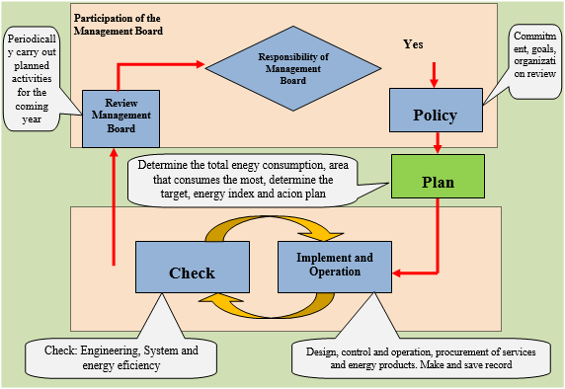
Figure 7.2 - Diagram inplementation of energy management system
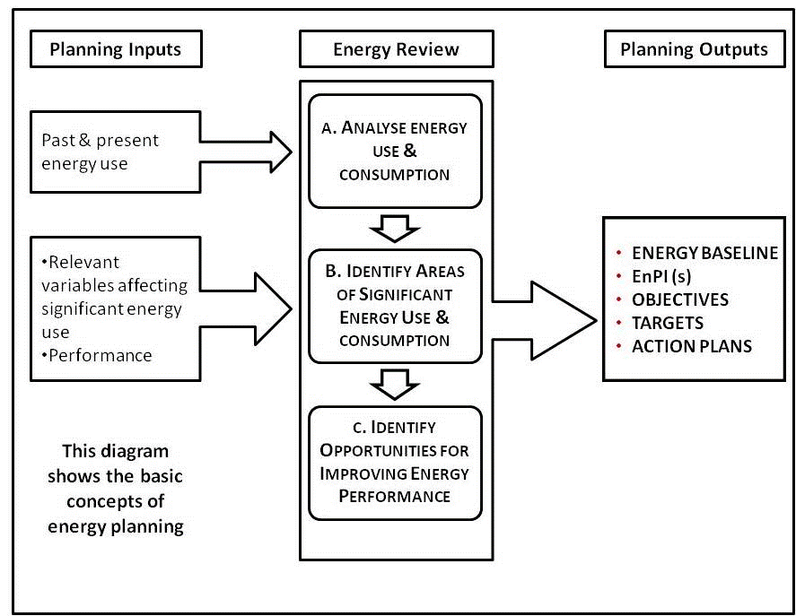
Figure 7.3 - Energy Planing Process
To achieve the highest efficiency of ISO 50001:2018 system, them members of energy management committee neet to do their duties well:
* Functions & Duties of the Energy Management Committee:
+ Assess current energy usage and energy management of the Company;
+ Evaluate pros and cons of energy management activities of the Company;
+ Prepare energy policy;
+ Identify key energy consumption area in the Company;
+ Establish and approve all energy management process and tools;
+ Approval energy consumption rate for the whole Company;
+ Coordinate the common energy efficiency activities for all employees in the company;
+ Scheduling and approve the energy saving solutions of the Company;
+ Monitor energy management implementation;
+ Support energy management implementation and energy management solutions;
+ Approval assessment indicators of the implementation;
+ Review regularly to evaluate energy management implementation;
+ Adjust energy policy, plan and target for energy conservation.
Strenghening internal management and equipment maintenance plays an important role. Implement those activities always brings significantly energy efficiency and conservation in despite of low investment cost.
c. Calculation of Saving
Principle of energy saving: Minimizes energy wastes due to inefficient operation, overcoming energy loss, enhancing maintenance to improve equipment’s performance and stabling of operation. Minimizing the idling time of the machine, monitoring closely and effectively evaluate the efficiency of energy saving projects. Improving the management procedures, small repairing, continuous implementation on a full scale, will save a lot of energy. Simplify the management procedures, monitoring, counting to increase the efficiecncy of energy-saving activities.
Saving potential: Based on the experience has been summarized both from the domestic and foreign companies, through the summary reports presented at international and domestic conferences, when aplly ISO 50001: 2018, the enterprise will continuously control and evaluate energy consumption norms, the performance of their equipment and monitor energy costs. The results show that the potential for energy savings could be about 1% to 5% of the total energy consumption of the enterprise depending on the amount of energy wasted current and scale investment in upgrading energy management system. The enterprise that has medium technology has the potential to save up to > 5% of annual energy consumption.
If the activities of auditing, managing and monitoring energy saving activities are applied step by step in accordance with the ISO standard, If the target is set quite modestly, it is expected to save energy up to: 54.533 kWh kWh/yr and 1.536 liters Diesel oil/yr equivalent to 139,1 million VNĐ/yr. In the early years, when the company apply the Energy Management System, the amount of saving is greater.
Example:
Example 1: Labeling the notice to turn off lights and electricity in the office, the area without working employees
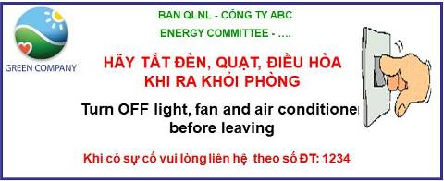
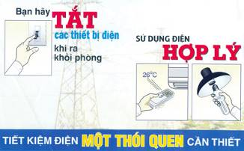 | 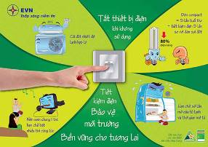
Figure 7.4 - Energy saving sticker
Power savings may not be much, but it is a premise and builds a greater sense of responsibility for all employees to save energy.
Example 2: Use air conditioner at set 25 - 28 degrees C
Keeping the temperature is too cold does not only affect health, but it also consumes more energy. Thermal comfort conditions are often used by two main factors to evaluate the dry bulb temperature and relative humidity. The following figure illustrates the comfortable area of heat in the room for office work.
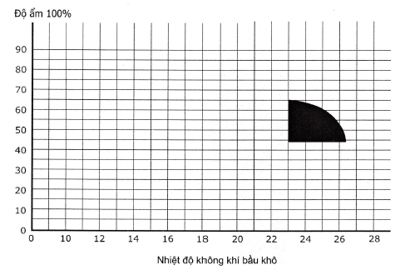
Figure 7.5 - Conditions of office facilities (Black Bowl area)
The boundary of the comfort zone can be increased by reducing the thermal radiation (caused by sunlight entering the room) and increasing the flow of the air (by using more fans).The best temperature in Vietnam is from 25 to 28ºC (keep the temperature stable throughout the use). At this level of thermal, the working intensity of the machine will decrease, so it will save electricity and avoid the amplitude of large heat oscillations with the outside. In addition, some of the proper use of air conditioner is as follows::
- Reduce leakage of heat through the gap: When the air-conditioned room has a gap, it will not cool quickly and prone to escape cold air. If the new air conditioner can cool quickly, but old models have been used for a long time, the cold air is reached outside from the rift making the machine always operate at high capacity.
- When using, make sure the room is closed (not open for too long) as well as avoid sunlight in the room to reduce waste electricity and overload. In addition, you can turn off the air conditioner 30 minutes before returning home. When the air conditioner is turned off, the room temperature remains low and it takes a while to reach the outside ambient temperature, still ensuring the working conditions of the staff, moreover saving a lot of large cost for air conditioner without investment.
- Periodic maintenance: Although the air conditioner is still operating well, periodic maintenance is essential to provide clean air and helps air conditioner to stabilize and economize operation.
The company should also paste air conditioning temperature temperature notifications right at the handheld control or wall-mounted control position to remind and raise the awareness of employees as well as customers to use.
Actually, this solution is easy to implement for the technology but not for human.
The amount of savings from this solution is difficult to determine. However, it brings high effective, contributing to increase productivity, enhance energy using awareness everywhere and everytime. This solution can be interpreted simply as the way we organize the production with large extent. The prodiction has to be monitored and estimated to improve all aspects of produciton, include not only saving energy, increasing productivity but also general developement, accessing to modern production.
The energy management system, was established and applyed to operation, will improve energy wasting in whole company. Moreover, it gets more benefit with more energy saving when the system be operated substantially.
d. Estimated investment cost for solution
Common investment cost items:
+ Monitoring, statisticaling energy consumption; evaluating energy consumption rate; setting up energy auditing.
+ The cost of minor repairing, replacing measurement equipment, leakage of steam; repairing valves, and tabs in the piping system.
+ The cost of setting up standard operating process for each type of equipment.
+ Cost of hiring to develop and evaluate the performance of ISO 50001:2018.
+ Cost of tranning every year.
+ Cost of reseaching, commending.
Total suggested investment cost for the solution, approximately: 150 million VND/year and half reduced for the next year.

7.2.2. Solution no.2: “Strengthening the protective cover for the steam system: Covering the valves on the steam pipe”
a) Current status
The steam pipe system is an integral part of the structure of the steam supply and distribution system. Steam pipes or steam pipes are slightly stopped, steam valves want to operate well and increase life, limit corrosion, it is necessary to have a good insulation design.
Through the survey, the Company has wrapped insulation for most of the equipment in the boiler system, transmission and use of steam. Besides, there are still some uninsured positions such as the the valves at the steam manifold, the outside surface temperature of the valve above 100ºC.
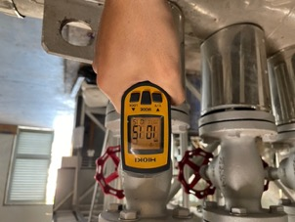 | 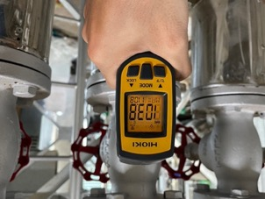
Figure 7.6 - Temperature of valves on steam pipes
Protecting steam pipes and steam valves will contribute to help the whole production system be operated more smoothly, save energy consumption and limit heat loss to the environment during the movement of the airflow. At the same time, ensure the safety of operators and operations in the surrounding area.
b) Proposed solutions
Based on the current situation, the audit team proposed the opportunity: “Strengthening the protective cover for the steam system: Covering the valves on the steam pipe”.
Below are some actual pictures of insulation wrap for steam valves:
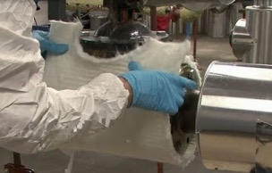 | 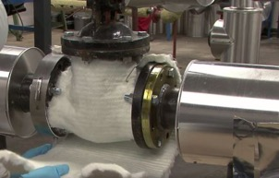
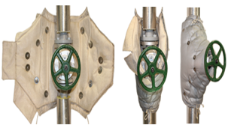 | 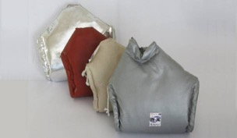
Figure 7.7 - Protective vests for valves
c) Calculating energy savings
Estimate the amount of heat loss out of the environment from the valves examined interpolated from the following table:
Table 7.2. Heat loss on steam valves
Energy save (kJ/h)
ºC | Valve size (cm)
 | 5 | 7,6 | 10,2 | 15,2 | 20 | 25,4 | 30,5
38 |  | 359 | 506 | 707 | 1.002 | 1.277 | 1.551
93 | 538 | 844 | 1.150 | 1.646 | 2.321 | 3.060 | 3.482
104 |  | 1.029 | 1.396
149 | 1.181 | 1.804 | 2.427 | 3.482 | 5.064 | 6.541 | 7.596
204 | 2.533 | 3.060 | 3.587 | 6.119 | 8.757 | 11.395 | 13.188
260 |  | 4.748 | 6.541 | 9.496 | 13.716 | 17.830 | 20.785
316 |  | 7.069 | 9.601 | 14.032 | 20.257 | 26.587 | 30.913
371 |  | 10.023 | 14.771 | 19.202 | 27.431 | 35.766 | 43.785
Energy-saving potential
Calculation of savings for the solution shown in the following table:
Table 7.3. Estimated Energy Saving Opportunity: “Strengthening the protective cover for the steam system: Covering the valves on the steam pipe”
NO. | PARAMETER | UNIT | VALUE
 | Operation Information
1 | Average operating hours per day | Hour/day | 12
2 | Average operating days per year | day/year | 365
3 | Usage factor | % | 85
 | Operating situation
4 | The number of valves has not been insulated | pcs | 15
5 | Valve size | cm | 7,6
6 | Temperature of valve | ºC | 104
7 | Heat loss | kJ/h | 1.029
8 | Total annual heat loss | GJ/year | 57,5
9 | Boiler efficiency | % | 80,0
 | Savings calculation
10 | Fuel savings in a year | Líter/year | 1.836
11 | Standard Energy Savings | TOE | 1,7
12 | Reducing CO₂ emissions | Tons/year | 5,3
d) Preliminary analysis of investment feasibility for the solution
Implement cost
Table 7.4. Estimated cost of investment solution: “Strengthening the protective cover for the steam system: Covering the valves on the steam pipe”
No. | Divice | Unit | Quantity | Unit price  (million VND/unit) | Total  (million VND)
1 | Insulation | set | 15 | 1,2 | 18,0
2 | Assessories | set | 15 | 0,2 | 2,7
3 | System installation and adjustment costs | All set | 1 | 1,5 | 1,5
 | Total invest |  |  |  | 22,2
Below is the calculation of economic and financial indicators for the solution:
Table 7.5. Estimated cost of investment solution: “Strengthening the protective cover for the steam system: Covering the valves on the steam pipe”
NO. | PARAMETER | UNIT | VALUE
1 | Total investment | Million VND | 22,2
2 | Energy saved (Diesel Oil) each year | Liter /year | 1.836
3 | Energy prices (Diesel Oil) | VND/liter | 12.285
4 | Total annual energy savings brought after implementing solutions | Million VND/year | 22,6
5 | Repair and maintenance costs per year | Million VND/year | 1,1
6 | Expected life of the investment project (in years) | year | 5
7 | Discount factor | % | 10
8 | Simple payback period | month | 11,8
9 | Discounted Payback Period | month | 13,8
10 | Internal Rate of Return (IRR) | % | 97,2
11 | Net Present Value (NPV) | Million VND | 66
12 | Benefit/cost ratio (B/C) |  | 3,4

7.2.3. Solution no.3: “Improving power quality, reducing losses due to harmonic waves at S1 transformers”
a) Current Status
The electrical loads in the Company include many nonlinear loads (current and voltage converters: inverters, ...) generating harmonic noise affecting the overall power quality in the system. Through the process of survey - measurement at the Company, the audit team found that the power quality is not good in some electrical cabinets at the consumption areas. The current graph appears noisy, does not keep the basic sine waveform, the total harmonic distortion is high. Harmonics affect the transformers, affecting the quality of power supplied to equipment in the Company, especially transformer S1. The power quality measurement results at transformer S1 will show this:
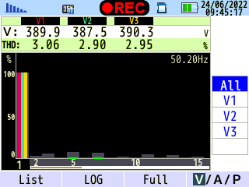
Figure 7.8 - Harmonic at S1 transformer
According to the international standard IEEE 519-1992, the maximum allowed value: Total harmonic distortion - THD does not exceed 5% of the load current.
According to Circular 30/2019/TT-BCT dated November 18, 2019 of the Ministry of Industry and Trade (supplementing and replacing Circular 39/2015/TT-BCT dated November 18, 2015) regulating the Current harmonic strain at the connection point as shown in the following table.
Table 7.6. Maximum allowable current harmonic distortion for electrical loads
Voltage supply | Total distortion | Individual distortions
110 kV | 4% | 3,5%
Medium voltage | 8% | 7%
Low voltage | 12% if load ≥ 50 kW  20% if load < 50 kW | 10% if load ≥ 50 kW  15% if load < 50 kW
Considering that the total harmonic deformation at the S1 transformer is quite high compared to the regulations,this article adversely affects the quality of electricity supplied to the equipment in the system, causing waste of electricity due to hot generation on the conductor and negatively affecting the control equipment as well as the company's capacitor system.
b. Proposal of Solution
Based on the status above, we propose the solution: “Improving power quality, reducing losses due to harmonic waves at S1 transformers”.
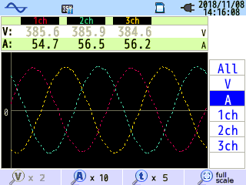 | 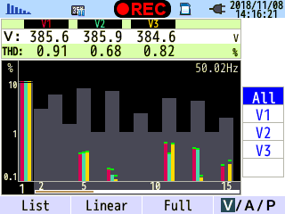 | 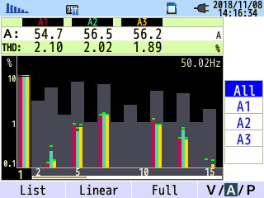
Figure 7.9 - The result of measuring a cluster of devices without harmonic
The quality of electricity greatly affects the economic and technical criteria of electrical households. When the power quality indicators deviate from the rated value, the technical and economic indicators of electrical equipment will be worse, causing the affected technological process to cause economic losses. One of the notable power quality indicators at the Company is harmonic. Reducing the harmonic line in addition to bringing a small amount of savings as above, the tremendous benefit of improving the power quality, making the electrical equipment stable operation with the norm mode.
Harmonics sources
Harmonics can be considered as the sum of sine waveforms whose frequency is an integer multiple of the fundamental frequency.
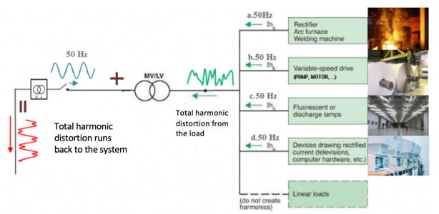
Figure 7.10 - Harmonics in the electricity system
Harmonic sources in the industrial device system are nonlinear relation between current and operating voltage(a nonlinear load has a discontinuous current and does not correspond to the voltage waveform applied to it). Conventional nonlinear loads include engine starters, electric drive systems, computers and other electronic equipment, electronic bulbs, welding sources and transformers.
All electrical energy converters, rectifiers used in various forms in the electrical system can increase harmonic noise by injecting harmonic currents directly into the grid.
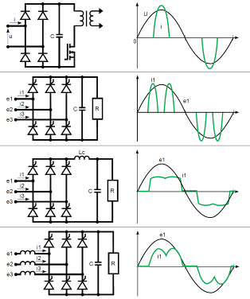
Figure 7.11 - Harmonic waves from input rectifier system
Other harmonic sources:
- Diode;
- Transistor;
- SCR or Thyristor;
- Control the rectifier output;
- Frequency converter;
- Arc furnace, high frequency furnance, arc welding machine.
The main cause of harmonic in the Company is the operation of the frequency converter and frequency inverter.
The effect of harmonic on the electricity system
Harmonic standard in electricity system - IEC 61000-3-2 standard (2005).
Table 7.7 . Harmonic of system (61000-3-2 standard)
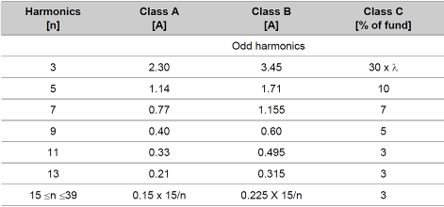
Harmonic waves distort the sine of the current, distorting the supply voltage.
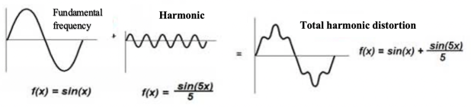
Figure 7.12 - Harmon alter the current form
Other effection of harmonic waves:
- Heating the electrical equipment, causing power loss;
- Affecting the capacity of wire;
- Affecting the operation of protective equipment;
- Afftecting the capacitor: overheat, overload, overvoltage, heat loss;
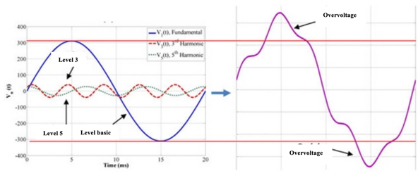
Figure 7.13 - Harmonic cause overvoltage
In most cases, the harmonics resonance cause overload in the and transformer. It cause the explosion of capacitors and transformers and reduce the life time of capacitor and surrounding devices.
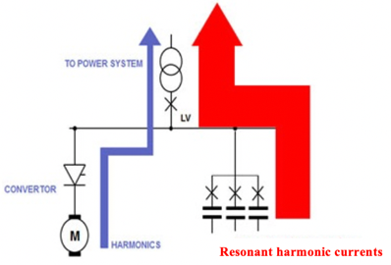
Figure 7.14 - Harmonics resonance
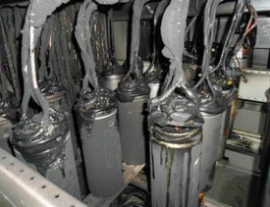 | 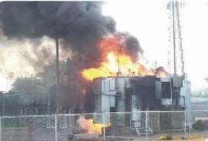
Figure 7.15 - Harmonics cause explosion of capacitor and transformer
- Electrical display and lighting system can be flickering;
- Electromagnetic waves in space that affect the wave transceiver;
- Measurement device: Affect the measurement result;
- Transformer: Increase the loss of iron, loss of copper, temperature of the transformer, loss of electricity;
- Motor:
+ Distorting the torque, reducing the device’s performance;
+ Affecting the insulation ability of material;
+ Causing overheat or vibration, causing noise.
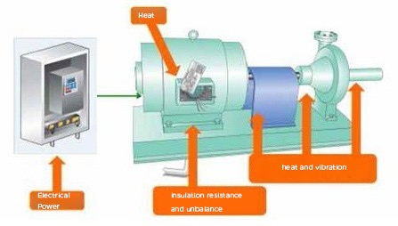
Figure 7.16 - Harmonic affect the motor
In addition, the harmonic filter reduce overheat in wire, improve the efficiency of electric motors.
Hamonic reduction methods
Replacing the damaged equipment caused by harmonics are expensive solutions, increased investment cost and 15% and operating funds to 10%. Therefore, it should choose the least expensive solution to bring highly effective in controlling harmonics. Additionally, the choice of solution to power system depending on the characteristics of the load and power demand of the connected equipment.
Here are some methods commonly used to reduce harmonics:
+ Using AC reactor (line choke) or DC reactor (DC choke) for inverter: Is the best solution for applications requiring filtered for interference sources deeply and requirement reduced harmonic wave is not a top priority.
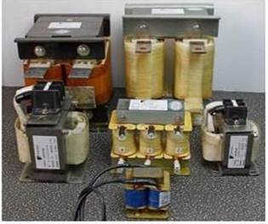
Figure 7.17 - Reactor
+ Solutions rectifier 12 pulses: For the highest performance in reducing harmonics but the most complex processes;
+ Passive filter: Included multiple reactor and capacitor are installed the resonant circuit to eliminate harmonic level. A system consisting of passive filters can remove some harmonic level.
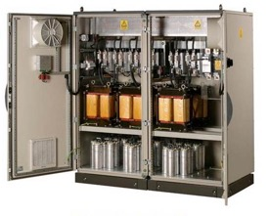
Figure 7.18 - Passive filter
+ Active filter: be applied for mounting multiple inverters in parallel on the same line distributor (PCC common point - the point of common coupling) with the main task of power compensation, compensation harmonic wave of the voltage and compensation harmonic of electrical current.
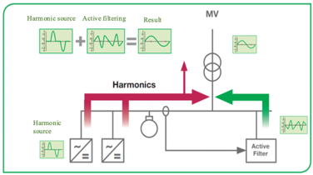
Figure 7.19 - Priciple of active filter
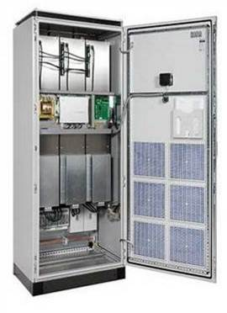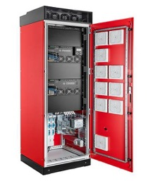
Figure 7.20 - Active filter
+ Using converter have low-harmonic wave: In highly demanding applications in reducing harmonic wave, use low harmonic wave inverter is the optimal solution. Those conventer use reducing harmonic wave technology without external filters or use multi-pulse transformer with a total harmonic distortion of current (THDi) of less than 5%.
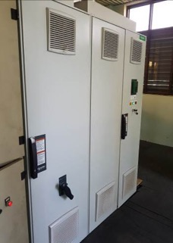
Figure 7.21 - Inverter with low harmonics in an installed unit
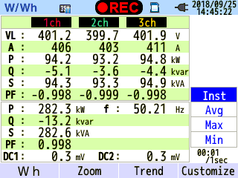 | 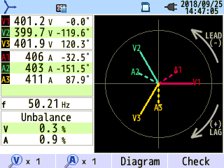 | 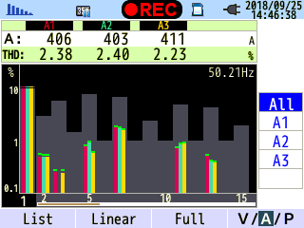
Figure 7.22 - The power quality measured at the motor uses a low harmonic inverter
Selection of harmonic wave filters:
In order to choose a harmonic wave filter suitable for the status quo as well as the needs of the Company, it is necessary to base on the following factors:
- Determine the composition of harmonic waves (tiers) to select filters capable of filtering to higher levels.
- Rely on the maximum current to determine the value of the working current with the reserve of the harmonic filter.
- Working voltage (usually 380V).
- Ability to reduce harmonic waves: depending on the requirements of each unit, it is possible to choose a positive harmonic wave filter, capable of reducing the maximum current harmonic deformation up to < 5%..
- Location of harmonic wave filter:
+ Installation at the total power cabinet:
Advantages: Reduce the cost of installation when there are many loads in the unit, thoroughly reduce the harmonic waves from the unit to the power grid.
Defect: The connected device between the total exposed cabinet and the load is still affected by the harmonic wave. Therefore, this option only applies when the unit has many small and concentrated loads, which are powered directly from the general cabinet.
+ Installation at the output of the load causes harmonic waves.
Advantages: Best filtering effect. Suitable for units with only a few loads and the capacity of large loads.
Defect: With a unit with many small loads, the total investment will be very large.
For the current status of the Company, the consulting unit proposes to install passive filters at the transformer.
c) Calculating energy savings
Calculation details for the solution are presented in the following table:

Table 7.8. Estimated Energy Saving Opportunity: “Improving power quality, reducing losses due to harmonic waves at S1 transformers”
NO. | PARAMETER | UNIT | VALUE
NO. | PARAMETER | UNIT | PHASE 1 | PHASE 2 | PHASE 3 | TOTAL
 | Operation Information
1 | Average operating hours per day | hour |  |  |  | 24
2 | Average active days per year | day |  |  |  | 365
3 | Time factor of equipment operating under calculated conditions | % |  |  |  | 85
 | Status information
4 | Current power consumption | kW | 42,8 | 39,5 | 38,2 | 120,5
5 | Current harmonic distortion | % | 18,4 | 20,8 | 20,3
6 | Voltage harmonic distortion | % | 3,1 | 2,9 | 3,0
7 | Useful power | kW | 42,1 | 38,7 | 37,4 | 118,2
8 | Power consumption | kW | 0,7 | 0,8 | 0,8 | 2,3
9 | Power consumption before solution | kWh/year | 318.689 | 294.117 | 284.437 | 897.243
 | Solution Information
10 | Current harmonic distortion (after filtering) | % | 5,0 | 5,0 | 5,0
11 | Voltage harmonic distortion (after filtering) | % | 0,5 | 0,5 | 0,5
12 | Wasted power (after filtering) | kW | 0,05 | 0,05 | 0,05 | 0,15
13 | Power consumption (after filtering) | kW | 42,1 | 38,7 | 37,5 | 118,3
14 | Power consumption after implementing solution | kWh/year | 313.693 | 288.185 | 279.009 | 880.886
 | Calculation of energy saving
15 | Energy saved after implementing the solution | kWh/year | 4.996 | 5.932 | 5.428 | 16.357
16 | Savings rate after implementing the solution | % | 1,6 | 2,0 | 1,9 | 5,5
17 | TOE savings | TOE | 0,8 | 0,9 | 0,8 | 2,5
18 | Reducing CO₂ emissions | Tons/year | 4,0 | 4,8 | 4,4 | 13,2

d. Preliminary analysis of investment feasibility for the solution
Implement cost:
Table 7.9. Estimated cost of investment solution: “Improving power quality, reducing losses due to harmonic waves at S1 transformers”
No. | Divice | Unit | Quantity | Unit price  (million VND/unit) | Total  (million VND)
1 | Passive harmonic filters | all set | 1 | 75,0 | 75,0
2 | System installation and adjustment costs | All set | 1 | 20,0 | 20,0
 | Total investment |  |  |  | 95,0
Below is the calculation of economic and financial indicators for the solution:
Table 7.10. Estimated cost of investment solution: “Improving power quality, reducing losses due to harmonic waves at S1 transformers”
NO. | PARAMETER | UNIT | VALUE
1 | Total investment | million VND | 95,0
2 | Energy (electricity) saved each year | kWh/year | 16.357
3 | Energy prices (electricity) | VNĐ/kWh | 2.205
4 | Total annual energy cost savings brought after implementing energy saving solutions | million VND/year | 36,1
5 | Maintenance cost per year | million VND/year | 1,0
6 | Calculated life of investment project (rounded in years) | year | 7
7 | Discount factor | % | 10,0
8 | Simple payback period | month | 31,6
9 | Discounted Payback Period | year | 3,1
10 | Internal Rate of Return (IRR) | % | 35,8
11 | Net Present Value (NPV) | million VND | 99,4
12 | Benefit/cost ratio (B/C) |  | 2,0

7.2.4. Solution no.4: “Improving power quality, reducing losses due to harmonic waves at S2 and S5 transformers”
a. Current Status
Similar to transformer S1, the total harmonic distortion at transformers S2 and S5 also exceeds the allowable level according to international standards IEEE 519-1992. The power quality measurement results at transformers S2 and S5 will show this:
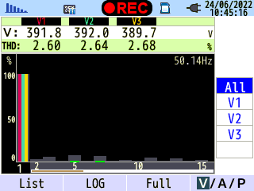
Figure 7.23 - Harmonic at S2 transformer
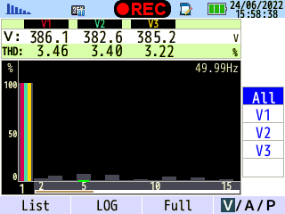
Figure 7.24 - Harmonic at S5 transformer
Considering that the total harmonic distortion at S2 and S5 transformers is quite high compared to regulations, this adversely affects the quality of power supplied to the equipment in the system, causing wasted power due to heating on the conductors. and negatively affect the control equipment as well as the ccapacitor system of the Company.
b. Proposing solutions and calculating energy saving
From the above situation, we propose the solution: “Improving power quality, reducing losses due to harmonic waves at S2 and S5 transformers”.
Calculation details for the solution are presented in the following table:
Table 7.11. Estimated Energy Saving Opportunity: “Improving power quality, reducing losses due to harmonic waves at S2 and S5 transformers”
NO. | PARAMETER | UNIT | VALUE
NO. | PARAMETER | UNIT | TRANSFORMER S2 | TRANSFORMER S5 | TOTAL
 | Operation Information
1 | Average operating hours per day | Hour |  |  | 24
2 | Average active days per year | Day |  |  | 365
3 | Time factor of equipment operating under calculated conditions | % |  |  | 85
 | Status information
4 | Current power consumption | kW | 235,9 | 162,2 | 398,1
5 | Current harmonic distortion | % | 18,2 | 17,0
6 | Voltage harmonic distortion | % | 2,7 | 3,5
7 | Useful power | kW | 232,0 | 159,8 | 391,8
8 | Power consumption | kW | 3,9 | 2,4 | 6,3
9 | Power consumption before solution | kWh/year | 1.756.511 | 1.207.741 | 2.964.253
 | Solution Information
10 | Current harmonic distortion (after filtering) | % | 5,0 | 5,0
11 | Voltage harmonic distortion (after filtering) | % | 0,5 | 0,5
12 | Wasted power (after filtering) | kW | 0,29 | 0,20 | 0,49
13 | Power consumption (after filtering) | kW | 232,3 | 160,0 | 392,3
14 | Power consumption after implementing solution | kWh/year | 1.729.561 | 1.191.507 | 2.921.068
 | Calculation of energy saving
15 | Energy saved after implementing the solution | kWh/year | 26.951 | 16.234 | 43.185
16 | Savings rate after implementing the solution | % | 1,5 | 1,3 | 2,9
17 | TOE savings | TOE | 4,2 | 2,5 | 6,7
18 | Reducing CO2 emissions | Tons/year | 21,7 | 13,1 | 34,7

c. Preliminary analysis of investment feasibility for the solution
Implement cost:
Table 7.12. Estimated cost of investment solution: “Improving power quality, reducing losses due to harmonic waves at S2 and S5 transformers”
No. | Divice | Unit | Quantity | Unit price  (million VND/unit) | Total  (million VND)
1 | Passive harmonic filters for S2 transformer | All set | 1 | 100,0 | 100,0
2 | Passive harmonic filters for S5 transformer | All set | 1 | 85,0 | 85,0
3 | System installation and adjustment costs | All set | 1 | 40,0 | 40,0
 | Total investment |  |  |  | 225,0
Below is the calculation of economic and financial indicators for the solution:
Table 7.13. Estimated cost of investment solution: “Improving power quality, reducing losses due to harmonic waves at S2 and S5 transformers”
NO. | PARAMETER | UNIT | VALUE
1 | Total investment | million VND | 225,0
2 | Energy (electricity) saved each year | kWh/year | 43.185
3 | Energy prices (electricity) | VNĐ/kWh | 2.205
4 | Total annual energy cost savings brought after implementing energy saving solutions | million VND/year | 95,2
5 | Maintenance cost per year | million VND/year | 2,3
6 | Calculated life of investment project (rounded in years) | year | 7
7 | Discount factor | % | 10,0
8 | Simple payback period | month | 28,4
9 | Discounted Payback Period | year | 33,4
10 | Internal Rate of Return (IRR) | % | 41,0
11 | Net Present Value (NPV) | million VND | 290,0
12 | Benefit/cost ratio (B/C) |  | 2,2

7.2.5. Solution no.5: “Installation of residual oxygen monitoring equipment for boilers, through the control system to optimally adjust the wind flow, fuel for the boiler system”
a. Current status
The company currently uses 04 Diesel oil-fired boilers (including 02 boilers with 500 kg/h capacity and 02 boilers with 400kg/h capacity), producing saturated vapors at pressures of 5,0 - 6,0 bars for laundry and through heat exchangers to supply hot water. In one week of operation, there will be 02 boilers run and the other 02 boilers stop working for maintenance, cleaning or repair. Through the actual survey at the boiler, the audit unit found that the residual O2 concentration in the exhaust fumes was still quite high, from 4-7%.
Wind-grade flow and feed fuel levels are adjusted to each other through mechanical structures. When the demand is slightly reduced, the fuel supply valve closes down and the fan's intake valve also closes, reducing the amount of wind leveled into the oven. However, the amount of air supplied to the furnace has not been calculated and fine-tuned continuously and in a timely manner to match the fuel flow to the furnace, leading to excess air.
With such a control mode, it is not enough to determine whether the amount of wind supply is suitable or not. The residual_{O2} concentration in the smoke is often high because the amount of air leveled into the furnace is much higher than the actual amount of air needed to burn out the fuel, thereby leading to a decline in boiler performance. In addition, the process of operating the furnace is usually only installed in a fixed mode, with little continuous calibration according to the actual operation.
b. Proposing solutions
In the boiler system, controlling the amount of oxygen supplied to the combustion chamber is thought to be important because it directly affects the combustion process. The supply of sufficient amount of air to the furnace helps to increase the efficiency of the combustion process, reduce losses, improve the efficiency of the boiler.
We propose the solution: “Constant monitoring of residual oxygen, through control system aimed at optimal adjustment the flow of air, fuel for boiler”.
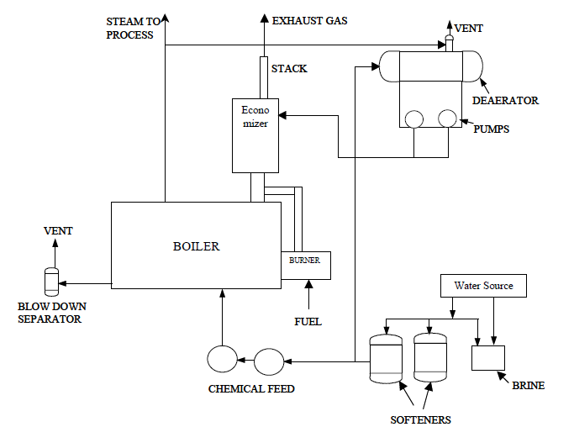
Figure 7.25 - Schematic diagram of industrial boiler system
Boiler efficiency is defined as the ratio of the effective heat received in the boiler to the total heat fed into the boiler:
H = | Q_{useful}.100 | (%)
H = | Q_{inlet} | (%)
The losses of the boiler include:
+ Heat loss due to flue gas (high flue gas temperature)
+ Carbon Monoxide in Flue Gas Loss
+ Unburned Carbon in Residue Loss (in ash)
+ Surface Radiation loss
+ Ash bit loss
The heat loss due to flue gas and Carbon Monoxide in Flue Gas Loss can be determined through analysis of the fuel and flue gas composition.
For each type of fuel: oil, gas, coal, firewood, sawdust,... an appropriate amount of oxygen is required to maintain the best combustion. If high or low, it affects the burning. Under ideal conditions, there will be no oxygen present in the flue gas, however, more excess oxygen than the theoretical requirement is always required to ensure exhaust combustion of the fuel components. Recommended excess air coefficients and oxygen-to-smoke ratios of some fuels are recommended as follows:
Table 7.14. Recommended excess air armament of some fuels
Fuel | Excess air | Residual oxygen ratio (%)
Oil | 1,1 - 1,3 | 2,0 - 5,0
Steam | 1,05 - 1,2 | 1,9 - 3,5
Charcoal
Crushed coal | 1,25 - 1,30 | 4,3 - 4,9
Chainring | 1,35 - 1,40 | 5,5 - 6,6
Coal supply from the bottom of the chainring | 1,40 - 1,60 | 6,1 - 7,9
Wood firewood and peat
Water-cooled chainring | 1,30 - 1,45 | 4,8 - 6,4
Xiclon combustion chamber | 1,20 - 1,35 | 3,5 - 5,4
Combustion chamber with a fixed chainring | 1,35 - 1,55 | 5,4 - 7,4
- If the percentage of excess oxygen in the flue gas is high: Increases fuel consumption because it takes a lot of heat to raise the excess air temperature, reduces the combustion chamber temperature and increases electricity consumption for the fan system.
- If the rate of excess oxygen in the flue gas is low: The fuel is incomplete combustion, the CO content in the flue gas is high.
At the time of the survey, the air supply factor to the furnace was about 1,5 - 1,7 (the amount of air leveled into the actual furnace is up to 1,5 - 1,7 times higher than the actual amount needed), corresponding to the residual O₂ concentration in the smoke ranging from 5-7%. This is not necessary, at the same time cause large losses along the smoke line, reducing incinerator performance.
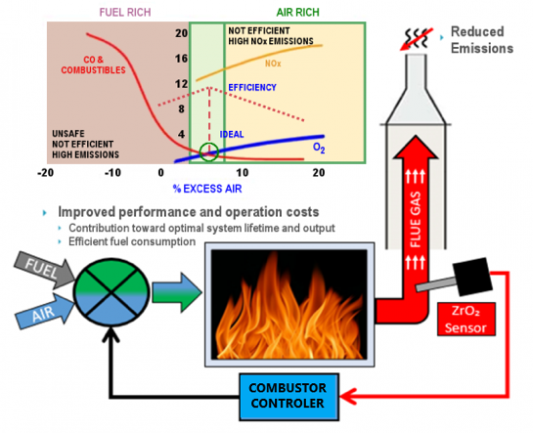
Figure 7.26 - Effect of excess air entering the furnace and composition of flue gas
The adjustment will be based on the following signals: Analysis of fuel composition and calorific value to determine the theoretical excess air factor to be supplied to the furnace; use the signal as the residual O₂ concentration as the signal to control the supply fan; combined with controlling the fuel supply system according to the signal of the combustion chamber temperature. Maintain residual O₂ concentration at 1,9 - 3,5%, then through the analysis of parameters of CO content in smoke to assess the degree of burnout of the fuel and then proceed to adjust the suitable excess air factor.
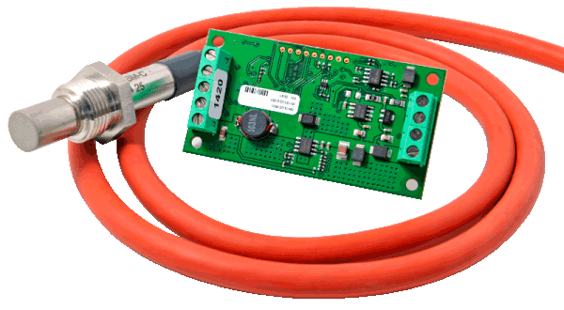 | 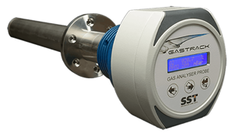
Figure 7.27 - O₂ sensor mounted on the chimney
There are different methods for controlling the excess air coefficient for boilers:
- Using portable O₂ analyzers and gas flow meters to periodically record parameters to help guide the operator Adjust the air flow for optimal operation.
The most common is a continuous O₂ analysis device with a gas flow meter mounted inside to read the parameters, from which the operator can adjust the air flow. Compared to the previous system, this device can help save 10 - 15%.
- The same continuous O₂ analyzer has a remote control valve device, from which parameters will be available in the control room. As a result, operators can remotely control multiple trivia systemsat the same time.
- The most complex equipment is the automatic control valve control system with very high cost, suitable only for the system, but bringing the highest efficiency.
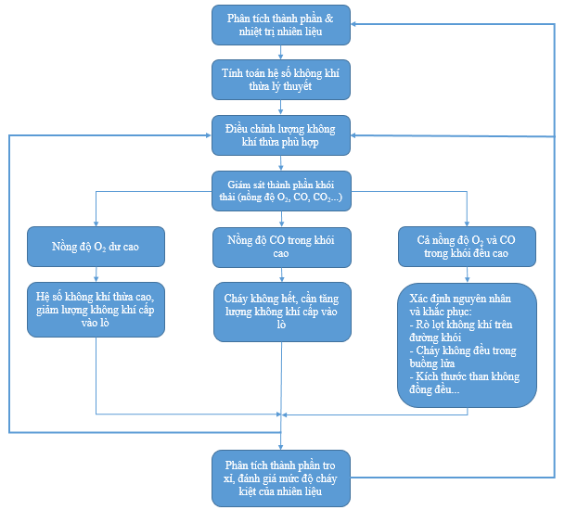
Figure 7.28 - Plan to continuously adjust the wind supply system to the boiler
Principle of savings: Maintaining a lower concentration of residual O₂, and CO in the smoke means reducing exhaust gas, reducing heat loss through flue gas, improving boiler efficiency, thus saving energy. For every 1% reduction in excess air, the furnace's efficiency increases by about 0,6%, which saves 0,6% of DO oil consumption.
c. Calculation of Energy Saving Potentials
An intelligent and comprehensive boiler measurement and monitoring system will help improve the optimal control of operating processes, reflected through the functions:
- Accurate load control according to demand.
- Optimal adjustment of fuel-air ratio.
- Continuous monitoring of flue gas to accurately analyze combustion efficiency based on reflected parameters O₂, CO, CO₂…; Thereby continuously micro-adjusting the amount of air supplied to the boiler.
- Response the environmental requirements of flue gas
Detailed calculation is shown in the following table:
Table 7.15. Estimated Energy Saving Opportunity: “Constant monitoring of residual oxygen, through control system aimed at optimal adjustment the flow of air, fuel for boiler”
NO. | PARAMETER | UNIT | VALUE
 | Operation Information
1 | Average operating hours per day | hour | 12
2 | Average active days per year | day | 365
3 | Usage factor | % | 50
 | Status information
4 | DO consumption in 2021 | liters | 255.989
5 | Average unit price of diesel oil | VND/liter | 12.285
6 | Average percentage of residual oxygen in exhaust gas | % | 7,0
7 | Coefficient of excess air |  | 1,63
8 | Total loss along the smoke path before the implementing the solution | % | 6,55
 | Solution Information
9 | Ratio of residual oxygen after adjustment | % | 3,0
10 | Excess air coefficient after implementing the solution |  | 1,20
11 | Total loss after the implementing the solution | % | 4,87
12 | Fuel saving rate through reasonable adjustment of fresh air flow | % | 1,68
13 | Fuel savings | liters/yr | 4.309
 | Calculation of energy saving
14 | Total cost savings | million VND | 52,9
15 | Energy saving standards | TOE | 4,1
16 | Reducing CO₂ emissions | ton/yr | 12,5
d. Preliminary Feasibility Analysis of Investment for the Solution
Implement cost:
Table 7.16. Estimated cost of investment solution: “Constant monitoring of residual oxygen, through control system aimed at optimal adjustment the flow of air, fuel for boiler”
No. | Device | Unit | Quantity | Unit price  (million VND/Unit) | Total  (million VND)
1 | Exhaust air component analysis  system (measuring device and display meter) | set | 2 | 70,0 | 140,0
2 | Inverter for furnace air supply fan | set | 4 | 5,0 | 20,0
3 | Cost of installation, adjustment, and reinstallation  of the system | All set | 1 | 30,0 | 30,0
4 | Labor cost | All set | 1 | 9,5 | 9,5
 | Total investment |  |  |  | 199,5
Below is the calculation of economic and financial indicators for the solution:
Table 7.17. Estimated cost of investment solution: “Constant monitoring of residual oxygen, through control system aimed at optimal adjustment the flow of air, fuel for boiler”
NO. | PARAMETER | UNIT | VALUE
1 | Total investment | million VND | 199,5
2 | Energy (Diessel oil) saved each year | liters/yr | 4.309
3 | Energy prices (Diessel oil) | VNĐ/liter | 12.285
4 | Total annual energy cost savings brought after implementing energy saving solutions | million VND/yr | 52,9
5 | Repair and maintenance costs per year | million VND/year | 5,0
6 | Calculated life of investment project (rounded in years) | year | 7
7 | Discount factor | % | 10
8 | Simple payback period | year | 3,8
9 | Discounted Payback Period | year | 5,1
10 | Internal Rate of Return (IRR) | % | 18,6
11 | Net Present Value (NPV) | million VND | 63
12 | Benefit/cost ratio (B/C) |  | 1,3

7.2.6. Solution no.6: “Installation and use of solar power supply system”
a. Current status
Vietnam is considered a country with great potential for solar energy. Solar energy in Vietnam is available year-round, quite stable and widely distributed across different regions, especially in the central and southern regions of the country, with an average daily solar radiation intensity of about 5 kWh/m² and the number of sunny days up to about 300 days per year. Meanwhile, the intensity of solar radiation is lower in the northern regions, estimated at 4 kWh/m² due to cloudy weather conditions and drizzle in winter and spring.
In recent years, the trend of using solar power is not only popular in the world but also spread in Vietnam. Especially with the mechanism of encouraging the use of solar power under Circulars no. 16/2017/TT-BCT officially prescribed by the Ministry of Industry and Trade officially took effect on October 26, 2017 has actually put solar power into effect on October 26, 2017. Become one of Vietnam's main energy sources in the near future. It can be said that this is an energy solution that is prioritized and encouraged to choose because of the advantages of saving electricity as well as bringing positive effects to the environment.
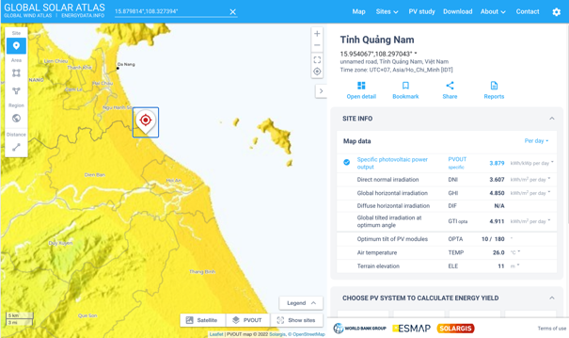
Figure 7.29 - Map of solar energy in Quang Nam
Through the survey, the audit unit found that the company has a large roof area in the office area , there is still great potential in taking advantage of this unused roof area to install solar power systems.
b. Recommendation and Proposal of Solution
The Company should invest in the development of solar energy. the Company should consider implementing the solution: "Installing and using the solar power system” located on the roof of the office area.
Solar power systems are made up of solar panels (photovoltaic batteries). Solar panels in the system play a role in absorbing sunlight, converting photovoltaics into electricity and electricity that is integrated into the Company's general grid or stored directly on the battery for independent operation. The solar power system will convert into a one-way power source (DC) into an ac power source (AC) through an inverter. Basically, solar power systems include:
- Solar Panels
- Solar charging control (helps protect batteries and systems)
- Storage system (battery or rechargeable battery)
- DC/ AC power adapter (if alternating electrical equipment is used).
Operating principle
Solar energy into electricity is based on the photoelectric effect
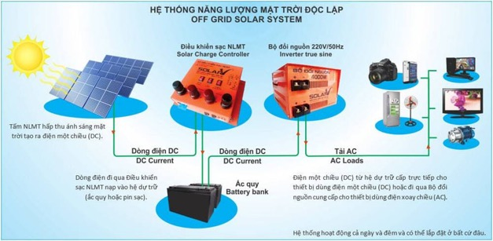
Figure 7.30 - Independent solar power Generation system
Sunlight consists of very small particles called photons that are radiating from the sun. When collisions with silicon atoms of solar batteries, photons transmit their energy to discrete, stimulating electrons that cause electrons to be associated with atoms that are turned off from atoms, and atoms appear blank because of an electron shortage.
However, the release of electrons is only half the work of the solar battery, then it needs to accumulate these electrons scattered into an electric current. This involves the creation of an electrical imbalance in the solar battery, which has the same effect as building a slope so that the electrons flow in the same direction.
This imbalance can be caused by internal silicon. Silicon atoms are arranged together in a tightly binding structure.By squeezing a small amount of other elements into the structure, there will be two different types of silicon created: type N and type P. N-type semiconductor (negative) with impurities are elements of group V, these atoms use 4 electrons to create the link and an outer layer electron is loosely linked to the kernel, which is the main electron lead. P-Type Semiconductor (positive – Positive Semiconductor) with impurities in group III, conductivity mainly with empty holes.
When two types of semiconductors are placed side by side in a solar battery, the n-type primary conduction electron jumps over to fill the p-type gaps. This means that the n-type silicon is positively charged and the p-silicon is negatively charged, creating an electric field on the solar battery. Because silicon is a semiconductor, it can act as an insulator and maintain this imbalance.
When the electrons are associated with atoms that are turned off from silicon atoms, the photon in sunlight takes these electrons into a certain order, providing power to the computer, satellites and all the devices in between.
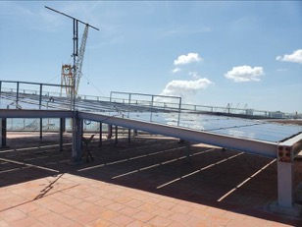 | 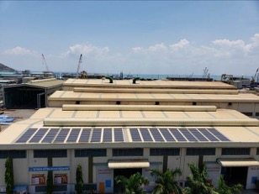
Figure 7.31 - Solar energy system at a plant has been implemented
During the daytime, based on the photoelectric effect through the solar panels generates electricity. Electric power is created partly used directly for some lights, the rest is integrated into the batteries.
Advantages of solar power system:
+ Save electricity, reduce the cost of electricity monthly.
+ Solar power systems are highly efficient from 98%.
+ Proactive energy sources, no fuel supply, no emissions of environmental pollution, no water pollution.
+ It is possible to expand and upgrade the solar energy system easily.
+ Increase the safety of the national grid
Disadvantages of solar power system:
+ Relatively large investment costs, long payback period.
+ The life of solar panels is quite long (from 15-20 years), however, solar panels that expire without good treatment will affect the environment.
c. Calculation of Energy Saving Potentials
Calculation result:

Table 7.18 . Technical calculation of the solution to install solar power system
NO. | PARAMETER | UNIT | VALUE
 | Operation Information
1 | Number of sunny hours in a day | hour | 8
2 | Average active days per year | day | 365
3 | Number of hours of sunshine in a year | hour/year | 2.300
4 | Number of sunny days in a year | day | 288
 | Calculation of energy saving
5 | Number of Wp the panels must provide | Wp | 45.000
6 | Solar energy absorption in Quang Nam | kWh/kWp | 3,9
7 | Minimum Wh solar panels need to provide | Wh | 174.555
8 | Capacity of solar panels | Wp/panel | 450
9 | Number of panels required for the system | panel | 100
10 | Capacity used at maximum time | W | 30.000
11 | Starting current response factor | % | 200
12 | DC-AC inverter capacity | W | 60000
13 | Standard sine inverter total power selection | W | 60.000
14 | Number of standard sine inverters | set | 1
15 | Solar panel efficiency | % | 85
16 | Power obtained after implementing the solution | kWh/day | 148
16 | Power obtained after implementing the solution | kWh/year | 42.657
17 | Convert to TOE | TOE | 7
18 | Reducing CO₂ emissions | tons/year | 34
d. Preliminary Feasibility Analysis of Investment for the Solution
The results of the calculation of financial and economic indicators for the solution:
Table 7.19. Summary of the results of economic calculation solutions for installation of solar power systems
NO. | PARAMETER | UNIT | VALUE
1 | Investment rate | million VND/kWp | 15,0
2 | Total investment | million VND | 675,0
3 | Energy (electricity) saved each year | kWh/year | 42.657
4 | Energy prices (electricity) | VNĐ/kWh | 2.205
5 | Total annual energy cost savings brought after implementing energy saving solutions | million VND/year | 94,1
6 | Maintenance cost per year | million VND/year | 6,8
7 | Calculated life of investment project (rounded in years) | year | 25
8 | Discount Factor | % | 10,0
9 | Simple Payback Period | year | 7,2
10 | Discounted Payback Period | year | 10,8
11 | Internal Rate of Return (IRR) | % | 16,6
12 | Net Present Value (NPV) | million VND | 464,9
13 | Benefit/cost ratio (B/C) |  | 1,2

7.3. Request
All energy saving opportunities presented in the report are highly economical and bring practical benefits to the Company. However, the implementation of energy-saving solutions depends on many factors such as business strategic orientations of leaders, investment capital, influence when implementing solutions to production planning, etc. Therefore, the Company needs to consider and evaluate each solution in detail to have a specific implementation plan.
Below is a grouping of proposed saving solutions to help the Company have more basis when considering planning to implement each specific project in the future:
Group I : The energy-saving solution does not require an investment cost or requires negligible investment costs
Group II : The energy-saving solution is not too complicated, that requires moderate investment costs
Group III : Energy-saving solutions require high investment costs, and there is a requirement of certain disruption to production activities.
Table 7.20. Grouping energy-saving solutions by investment size and technical complexity
Group | Solution name | Solution characteristics
Group I | Solution no.1:  Strengthening inner energy management activities and equipment maintenance plan | These solutions include improvements to operational processes and reducing unnecessary energy waste. For example:  - Unnecessary lighting off  - Apply measures to strengthen stricter management of electrical equipment, lighting, and air conditioning.  - Calibrate the mode of pump operation, fan, and cooling tower.  - Properly use of office equipment.
Group II | Solution no.2:  Strengthening the protective cover for the steam system: Covering the valves on the steam pipe  Solution no.5:  Installation of residual oxygen monitoring equipment for boilers, through the control system to optimally adjust the wind flow, fuel for the boiler system | These solutions require low investment costs, and hardly interrupting production and business activities.  The company can invest gradually, adjusting the business plan quite easy to deploy independently in each region.
Group III | Solution no.3:  Improving power quality, reducing losses due to harmonic waves at S1 transformers  Solution no.4:  Improving power quality, reducing losses due to harmonic waves at S2 and S5 transformers  Solution no.6:  Installation and use of solar power supply system | These solutions require high investment costs, and there are certain interruptions to the operation of large equipment but energy-saving efficiency and economy are of concern.

Appendix

ENERGY AUDITORS CERTIFICATE

